BABYFUND THAILAND | CASE STUDY
Family Savings Coordination Platform
RISK REGISTER
Document Title | Risk Register
Project Name | BabyFund Thailand — Family Savings Coordination Platform
Document Version | Portfolio edition
Status | Simulated BA case study — unvalidated design
Date | October 2026
Prepared By | Tankhun Luengchaicharn, Junior IT Business Analyst
Approved By | Not approved — simulated case study

1. Purpose
This register lists the risks identified for the BabyFund Thailand project across ten categories: regulatory, market, competitive, operational, technical, reputational, macroeconomic, key-person, partner-dependency, and long-horizon risks. All 25 risks have provisional likelihood and impact ratings, proposed mitigations and role owners. Ratings are BA judgments about design exposure, not observed incident frequencies or partner assessments. This register is a proposed risk assessment based on document review, not a validated business viability review and replaces the shorter, generic risk list in the original Project Charter.

2. Risk Register
The table below lists all 25 provisionally scored risks, grouped in the order they were discovered during the business review: regulatory risks first, followed by market, competitive, operational, technical, reputational, macroeconomic, key-person, partner-dependency, and long-horizon risks.
ID | Category | Risk | Prob. | Impact | Mitigation & Contingency | Owner
R-01 | Regulatory | The operating model, licence duties and partner terms have not been validated | High | Critical | Validate a licensed-partner model and BabyFund's own duties with counsel and the regulator; do not accept funds before approval. | Compliance Officer
R-02 | Regulatory | The original child-owned/locked structure lacks validated account and withdrawal rights | High | Critical | Define owner, custody, withdrawal rights and child-goal label with the partner and counsel; treat soft-lock as an unapproved proposal. Block launch until the ownership and withdrawal model has passed partner and legal review. | Legal Counsel / Compliance Officer
R-03 | Regulatory | A private QR is forwarded or payer identity does not match the invitation, creating fraud and compliance exposure | Medium | Major | Confirm provider-led payer checks and payment reference; QR alone does not prove identity. Add expiry/revocation, a payment reference and exception review; validate provider-led payer checks before implementation. | Compliance Officer
R-04 | Regulatory | The proposed child view could apply an incorrect age-specific consent rule | Medium | Major | Obtain an age-specific consent and access design from qualified counsel. Pause the child view feature until this is corrected. | PDPA Officer
R-05 | Market | A declining birth rate weakens a newborn-only growth assumption | High | Major | Target the existing stock of children aged 0–10, not only new births. Do not expand the 0–10 admission rule solely to meet growth targets; any change requires a new risk and product decision. | CEO / Product Manager
R-06 | Market | Addressable demand may be smaller than a births-based estimate implies | Medium | Major | Test demand in a clearly defined parent segment before selecting any launch geography or pricing. Reassess pricing if uptake lags elsewhere. | Marketing Team
R-07 | Competitive | An established incumbent copies the family-gifting feature | High | Critical | Test the standalone-app positioning and possible distribution partnerships; do not assume incumbent cooperation. Be prepared to pivot to licensing the technology directly if cloned. | CEO / Product Manager
R-08 | Competitive | Bank-backed competitors out-market and out-trust BabyFund on scale alone | High | Major | Position BabyFund as a complementary family-coordination layer, not a competing brokerage. Pursue partnership discussions with the same incumbents. | CEO
R-09 | Operational | Actual customer acquisition cost may exceed the hypothetical budget | High | Critical | Use lower-cost embedded distribution channels and organic family referrals. Slow the account-growth timeline rather than overspend. | Marketing Team
R-10 | Operational | The hypothetical delivery budget and dates may not reflect partner, payment and legal costs | High | Critical | Obtain sponsor, partner and supplier estimates before treating any budget or timeline as feasible. Phase the launch, starting with a smaller portfolio demonstration if funding is constrained. | CEO / Business Analyst
R-11 | Technical | Heavy reliance on one login, invite or notification channel could interrupt the journey | Medium | Major | Design approved alternative login and recovery methods plus SMS/email for critical notices. Test channel outage handling. | IT Development Team
R-12 | Technical | Partner investment interface outage or delayed confirmation leaves contribution status unresolved | Medium | Major | Specify retry, idempotency and reconciliation controls. Keep the invested value unchanged until partner confirmation; define an outage escalation and a proposed service-level target with a future partner. | IT Development Team
R-13 | Reputational | Partner custody or contribution-status reconciliation fails; families see an incorrect or unavailable balance | Low | Catastrophic | Require the partner to define custody, segregation, reconciliation and customer access; do not assume sub-account support. Require reconciliation ownership, exception handling and continuity terms in any future partner agreement. | Compliance Officer / CEO
R-14 | Reputational | An S&P 500 downturn near the child's goal date triggers negative word-of-mouth through family networks | High | Major | Use honest, non-guaranteed risk messaging from day one and a proactive downturn communication plan. Offer a contribution-pause option to reduce panic. | Marketing Team
R-15 | Macroeconomic | THB/USD currency volatility distorts how parents perceive fund performance | High | Moderate | Display FX rates transparently and provide education distinguishing currency effects from investment performance. | Product Manager
R-16 | Macroeconomic | An extended market downturn occurs during the long investment horizon | Medium | Critical | Disclose S&P 500 equity and FX risk, test suitability and keep age-near-goal de-risking as an open product decision. Show actual partner withdrawal rights and a clear market-risk explanation; waiting periods and fees remain unapproved proposals. | Product Manager / Compliance
R-17 | Macroeconomic | A Thai economic downturn reduces household disposable income and contribution volume | Medium | Major | Keep contribution amounts flexible subject to approved provider minimums, and offer a "pause" rather than "cancel" option on recurring deposits. | Product Manager
R-18 | Key-Person | Regulatory and product knowledge is concentrated in a small founding team | Medium | Major | Formally document all regulatory and legal decisions, and build an advisory board with compliance and legal expertise early. | CEO
R-19 | Partner-Dependency | Loss of the sole licensed-partner relationship could stop the proposed business model | Medium | Critical | Test partner willingness and commercial terms before a pilot. Propose exit and transition terms; examine alternate partners only if their legal, payment and product routes can be validated. | CEO / Product Manager
R-20 | Long-Horizon | Over a 20-year product life, partners may be acquired and regulations may change materially | High | Critical | Treat every partnership and regulatory assumption as needing structured multi-year review. Maintain a disclosed wind-down policy describing partner-led continuity and transfer options only after contract and legal review. | CEO / Board
R-21 | Technical | A pooled value is presented as independently funding several goals | Medium | Major | Show the child value once; use chronological, deductive scenario results and a standalone-view warning. Test goal order and pending gifts. | Product Manager / BA
R-22 | Technical | A fixed 240-month horizon misstates a 10-year-old child or a later due date | Medium | Major | Calculate months from child and due dates; test 120/132/180 months and date boundaries. | Product Manager / QA
R-23 | Partner-Dependency | Provider rejects third-party payer or the fallback funding route | High | Critical | Do not launch the guest funding route until provider/payer/refund controls and a named owner are agreed. Option C requires separate approval. | Product Manager / Compliance
R-24 | Regulatory | Goal due date or age-20 screen is mistaken for a legal ownership transfer | Medium | Critical | Separate goal date, request, partner decision and confirmed legal transfer; obtain partner/legal review. | Compliance Officer / Legal Counsel
R-25 | Reputational | A monthly reminder is mistaken for a compulsory payment or penalty | Medium | Moderate | Show the plan as optional and pauseable, with no BabyFund missed-payment fine; test guardian comprehension. | Product Manager / UX

3. Risk Heat Map
The heat map plots all 25 provisional likelihood/impact pairs, including R-21–R-25. Ratings are qualitative hypotheses, and the risks requiring a validation gate include: partner role, account ownership, guest payment controls, payer matching, reconciliation, suitability, unit economics and continuity.
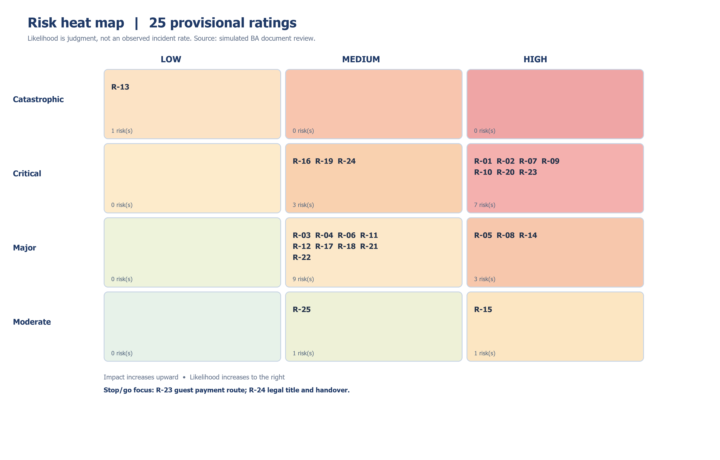
Figure 1: Risk Heat Map — Probability vs. Impact

4. Risk Summary by Category
Category | Number of Risks
Regulatory | 5
Market | 2
Competitive | 2
Operational | 2
Technical | 4
Reputational | 3
Macroeconomic | 3
Key-Person | 1
Partner-Dependency | 2
Long-Horizon | 1
Total | 25

Additional risk assessment rationale
R-21 is Medium × Major because duplicate affordability is plausible in an untested multi-goal UI and could materially mislead a family; source: current pooled-goal design. The rating is judgment, not measured frequency.
R-22 is Medium × Major because a hard-coded 240 months is a common implementation error when eligible children can already be age 10; source: age gate and projector requirements.
R-23 is High × Critical because direct third-party funding has no confirmed partner route and would block the intended guest journey; source: SEC KYC/CDD guidance and the absent partner decision.
R-24 is Medium × Critical because the age-20 proposal could misstate legal rights without a confirmed partner transfer process; source: handover design and ownership unknowns.
R-25 is Medium × Moderate because reminders may be understood as a payment obligation despite the optional design; source: voluntary-plan requirement. User comprehension is untested.

Scoring rule and review trigger
Likelihood: Low / Medium / High; impact: Moderate / Major / Critical / Catastrophic. All 25 rows and category totals now reconcile. R-23 is a stop/go dependency; likelihood labels are provisional and must be revised if partner, provider or user evidence changes.
If partner feasibility fails for third-party payment, legal ownership, product suitability or valuation data, stop the live-route proposal. The portfolio can still document the failed gate as a BA finding.

5. Document Approval
Proposed review roles appear below. No sponsor, partner or regulator has approved this risk assessment.
Role | Name | Signature | Date
Project Sponsor
Compliance Officer
Business Analyst

