BNPL COMMAND CENTER
Cross-Provider BNPL Aggregation & Debt Consolidation Platform — Thailand
FUNCTIONAL REQUIREMENTS DOCUMENT
Document Title | Functional Requirements Document (FRD)
Project Name | BNPL Command Center
Document Version | v1.0
Status | Draft
Related Document | BNPL Command Center — BRD v1.0
Date | September 2026
Prepared By | [Your Name], Business Analyst
Approved By | [Pending Review]

1. Purpose and Relationship to the BRD
The BRD defines why BNPL Command Center is being built and what it needs to achieve. This FRD defines how the system behaves: the screens, the step-by-step flows, the exact rules the system uses to make decisions, and the data it needs. Every functional requirement (FR) in this document is traceable back to a business requirement (BR) in the BRD — see the traceability matrix in Section 7.

2. Actors
Actor | Description
Customer | A retail bank customer who uses one or more BNPL providers
Bank Transaction System | The bank's own core system holding the customer's account and card transaction history (source of detection data)
BNPL Command Center App | The system being specified in this document
Risk & Compliance Staff | Internal bank users who monitor portfolio-level exposure
Product / Marketing Staff | Internal bank users who act on consolidation-eligible customer lists
External Credit Bureau | Provides credit score data used in the screening step

3. User Flows

3.1 Flow: Onboarding and Account Linking
- Customer downloads the app and creates an account.
- Customer links their existing bank account/card (PDPA consent screen shown and must be accepted before any data is read).
- System performs an initial 90-day transaction scan (see Flow 3.2).
- Customer is taken to the Dashboard (Screen S2).

3.2 Flow: Transaction Scanning and BNPL Detection (system-initiated, runs daily)
- System pulls new transactions since the last scan.
- System matches transaction descriptions against the maintained BNPL Provider Name list (e.g., "ATOME", "SPAYLATER", "SHOPEE", "LAZADA", "TRUEMONEY").
- For each match, the system records a Detected Obligation (provider, amount, date).
- System recalculates the customer's Stacking Count (distinct BNPL providers detected in the trailing 90 days).
- System checks for a Late Payment Signal (see Business Rule R-02 in Section 5).
- Dashboard and internal reporting data are refreshed.

3.3 Flow: Viewing the Consolidated Dashboard
- Customer opens the app and lands on the Dashboard (Screen S2).
- System displays every Detected Obligation grouped by provider, with amount and next due date, plus a total owed this month.
- If Auto-Pay is not yet set up, the system shows a prompt to enable it.

3.4 Flow: Enabling Auto-Pay
- Customer opens Auto-Pay Settings (Screen S4) and confirms enrollment — Auto-Pay is free, with no subscription fee.
- Customer authorizes the system to deduct payments from their linked account on a per-provider basis — no single consolidated deduction is authorized.
- On each provider's own due date, the system deducts that provider's payment amount and pays that provider directly; if multiple providers happen to share a due date, this results in separate same-day deductions, not one combined transfer.
- If the deduction fails (insufficient funds), the customer is notified immediately and no partial payments are sent (see Section 6, Edge Cases).

3.5 Flow: Consolidation Loan Screening and Offer
- System flags a customer as a Consolidation Candidate when Business Rule R-03 is met (stacked + late payment signal).
- System runs the Credit Screening Module: pulls credit score, checks income stability from salary-deposit pattern, calculates Debt-Service Ratio (DSR).
- If the customer passes screening (Business Rule R-04), the system generates a personalized consolidation offer and shows it on Screen S5.
- If the customer fails screening (Business Rule R-05), no loan offer is shown; instead the system shows Screen S6 with information about the Bank of Thailand's existing debt-relief programs.
- If the customer accepts the offer, the request is handed to the bank's normal loan origination process (outside the scope of this app).

4. Screens (Functional Wireframes)
These are functional wireframes — they describe what must be on each screen and why, not the final visual design.

S1 — Onboarding & Account Linking
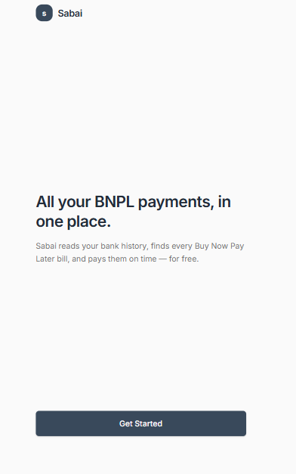
Step 1 — a one-line pitch and a single “Get Started” call to action.
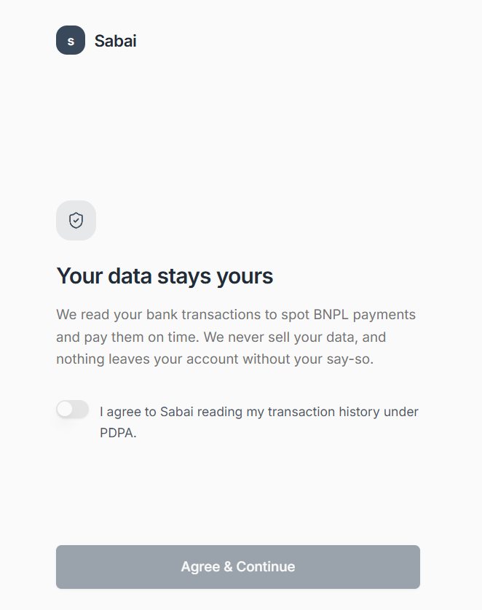
Step 2 — plain-language PDPA consent: what’s read and why, with an explicit opt-in toggle (NFR-01).
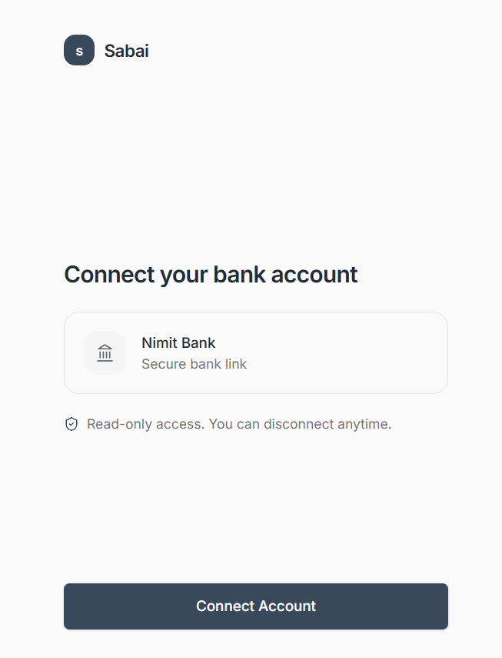
Step 3 — customer connects Nimit Bank with read-only access, disconnectable at any time.
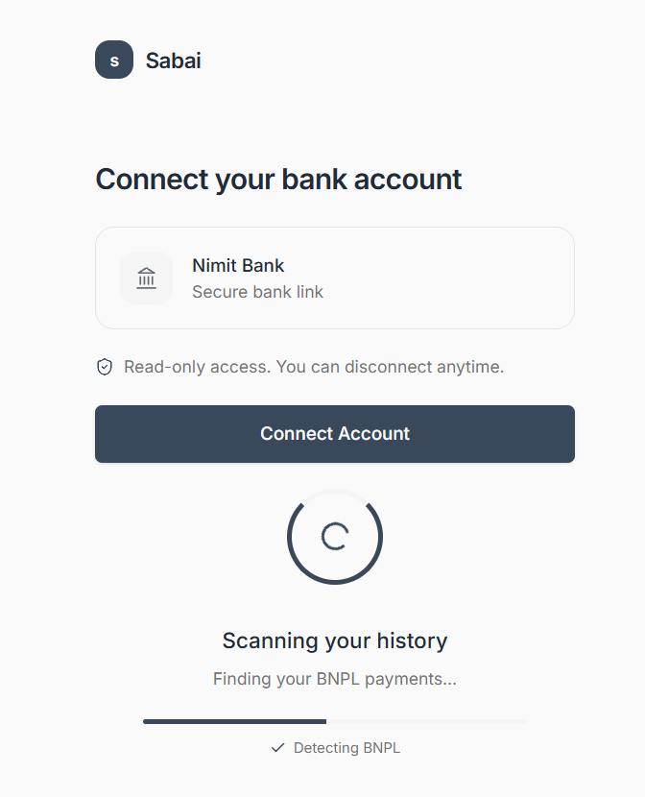
Step 4 — the system scans transaction history to detect BNPL payments before landing on the Dashboard (S2).

S2 — Dashboard (Home Screen)
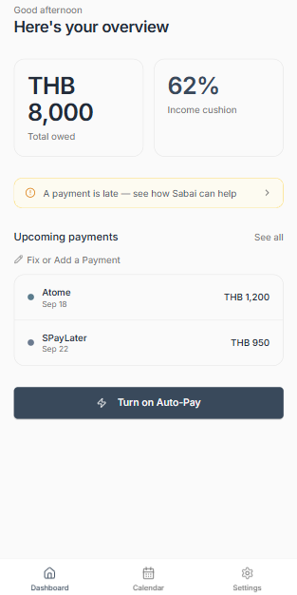
Shows the total amount owed, the income-cushion percentage, and the next 2 upcoming payments — plus a slim banner if a payment is late. Now also includes the “Fix or Add a Payment” entry point beneath Upcoming Payments.

S3 — Payment Calendar
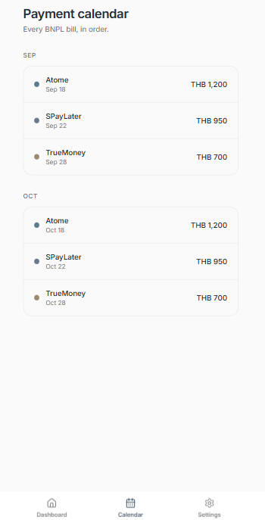
Every detected BNPL payment across providers, grouped by month, in one chronological view.

S4 — Auto-Pay Settings
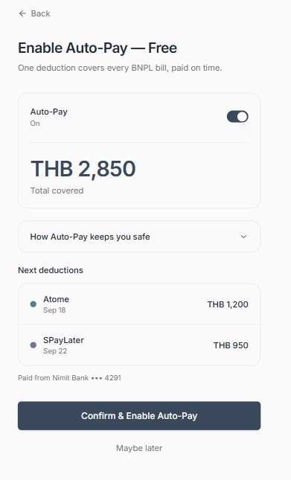
Customer enables the free Auto-Pay deduction, sees the total amount covered, and previews the next 2 deductions before confirming.

S5 — Consolidation Offer (shown only if eligible)
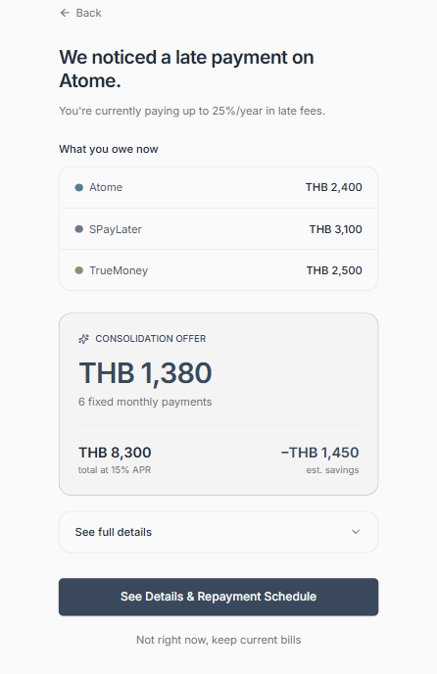
Shown only to eligible customers with a late-payment signal — presents the consolidation terms (monthly payment, APR, estimated savings) before the customer decides.

S6 — Referral Screen (shown only if not eligible for a loan)
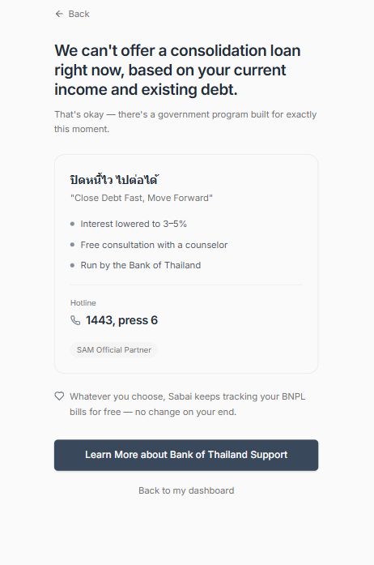
Shown to customers who don't pass the eligibility check — a supportive referral to Bank of Thailand's existing debt-relief program, never framed as a rejection.

S7 — Internal Risk Exposure Dashboard (staff-facing)
This is the internal reporting view used by Risk & Compliance and Product staff. It is built later in this project as the Power BI / Tableau deliverable, not as an in-app screen. It shows: total customers by stacking count, late-payment trend over time, consolidation funnel (all customers → stacked → late-payment signal → passed screening → offer accepted), and estimated revenue.

S8 — Fix or Add a Payment (Hub Screen)
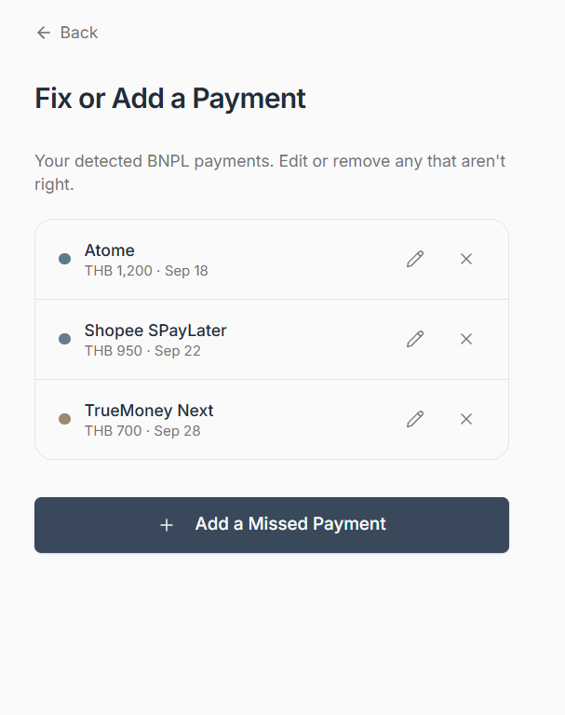
Lists every detected BNPL payment with edit and remove icons, plus a button to add a payment the scan missed.

S9 — Edit a Detected Payment
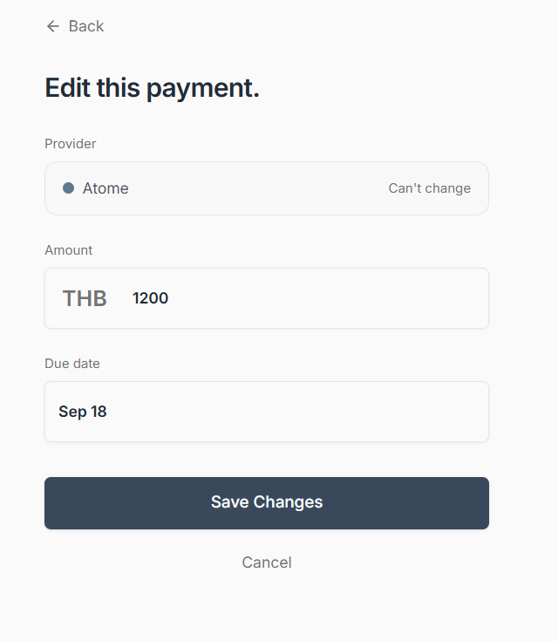
Customer corrects the amount or due date if the scan got it wrong; the provider itself can’t be changed here.

S10 — Remove a Payment (Confirm)
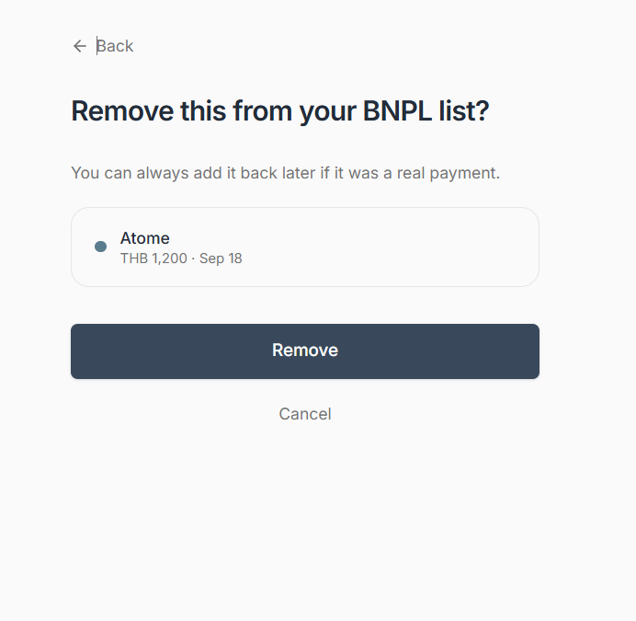
A calm, reversible confirmation before dismissing a detected item as a false positive (Edge Case #3).

S11 — Add a Missed Payment (Choose Path)
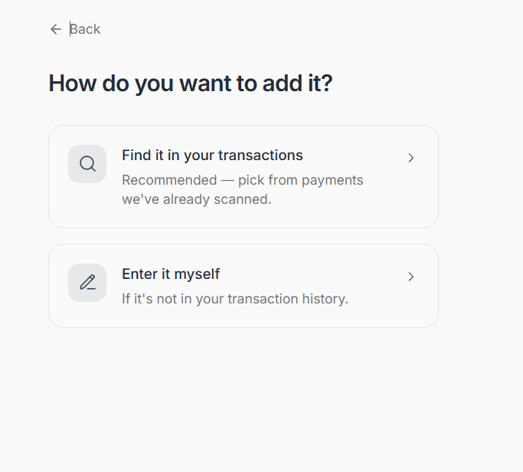
Two equal-weight paths to add a payment the scan missed: match it to a real transaction, or enter it manually.

S12 — Pick from Transactions
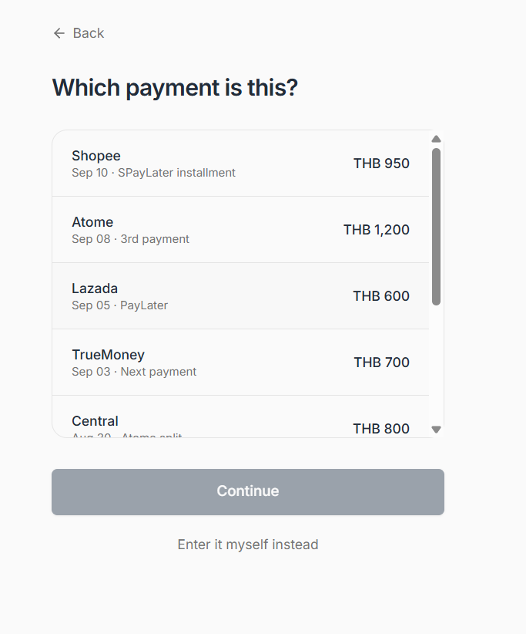
Step 1 — customer matches the missed payment to a transaction already in their scanned history.
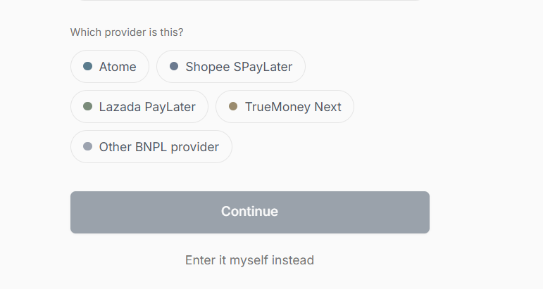
Step 2 — customer tags which BNPL provider the matched transaction belongs to.

S13 — Enter Manually
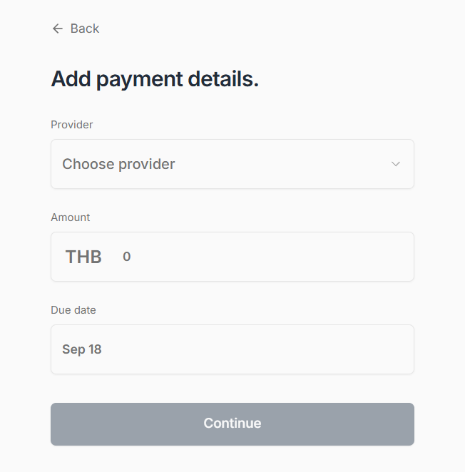
Fallback path when no matching transaction exists — provider, amount, and due date entered directly.

S14 — Confirm & Add
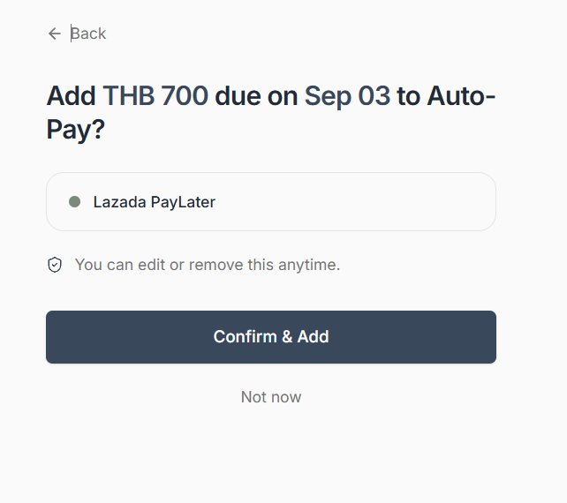
The safety-net screen: every added payment must be confirmed here before it becomes Auto-Pay eligible (BR-14).

5. Business Rules (Decision Logic)
These rules are the heart of the system. They must be implemented as configurable parameters (not hard-coded numbers), because BOT's final regulation and the bank's own risk appetite may change these thresholds over time.
Rule | Logic
R-01 | IF a transaction description matches an entry in the BNPL Provider Name list THEN record it as a Detected Obligation for that customer and provider.
R-02 | IF a Detected Obligation is paid more than [configurable: default 3] days after its expected due date, OR the amount charged is higher than the customer's normal recurring amount for that provider (a proxy for a late fee) THEN raise a Late Payment Signal for that customer.
R-03 | IF a customer has Detected Obligations with 2 or more distinct BNPL providers in the trailing 90 days THEN set Stacking Status = "Stacked". IF a Stacked customer also has a Late Payment Signal THEN set status = "Consolidation Candidate". A customer-added obligation (via Fix or Add a Payment) counts identically to a system-detected one once it has passed its confirmation step; an unconfirmed customer-added obligation does not count toward Stacking Status.
R-04 | IF a Consolidation Candidate shows a stable income pattern (regular salary deposits for 3+ consecutive months) THEN apply a tiered decision: (a) Full eligibility -- Credit Score >= [configurable: default 600] AND Debt-Service Ratio <= [configurable: default 40%] THEN mark "Eligible" and generate a standard consolidation offer; (b) Conditional eligibility -- Credit Score >= [configurable: default 650] AND Debt-Service Ratio > [configurable: default 40%] but <= [configurable: default 60%] THEN mark "Eligible - Limited Offer" and generate a reduced-amount / shorter-term consolidation offer.
R-05 | IF a Consolidation Candidate does NOT meet either tier in R-04 (i.e. Debt-Service Ratio > [configurable: default 60%], OR Credit Score < [configurable: default 600] regardless of DSR, OR income is not stable) THEN mark as "Not Eligible" and route to the Referral Screen (S6). The system must never generate a loan offer for a "Not Eligible" customer, with no exceptions.
R-06 | The free tracking tier (Dashboard, Screen S2) and the Auto-Pay feature — both provided at no cost to the customer — are available to ALL customers regardless of Stacking Status or credit screening; these are not lending products and are not risk-gated.

6. Edge Cases and Exception Handling
Situation | Required Behavior
Auto-Pay deduction fails (insufficient funds) | No partial payment is sent to any provider. Customer is notified immediately with the shortfall amount and given the option to top up before the due date.
Customer unlinks their bank account mid-cycle | Auto-Pay is disabled immediately; customer is warned that upcoming payments will not be made automatically.
A transaction matches a BNPL provider name but is actually a normal purchase (false positive) | Customer can manually dismiss a Detected Obligation; dismissed items are excluded from Stacking Count and reported separately as a data-quality metric.
Customer has BNPL accounts with a provider not on the maintained name list | Customer can self-add the missed payment via Fix or Add a Payment (tag a matching transaction, or enter it manually if no match exists). It is treated as Not Eligible for Stacking Count until it passes the confirmation step (Screen: Confirm & Add), after which it counts identically to a system-detected obligation. The maintained provider list is still reviewed and updated periodically (see FR-01 maintenance note).
Customer's credit score cannot be retrieved from the bureau | Customer is treated as "Not Eligible" for a consolidation offer (fails safe) and routed to Screen S6.

7. Traceability Matrix (FRD to BRD)
FR ID | Functional Requirement | Related BR (BRD)
FR-01 | Transaction Scanning Engine (merchant-name matching) | BR-01
FR-02 | Stacking Counter | BR-02
FR-03 | Consolidated Dashboard (Screen S2) | BR-03
FR-04 | Auto-Pay Engine (per-provider deduction on each provider's own due date, not consolidated) | BR-04
FR-05 | Late Payment Detector | BR-05
FR-06 | Credit Screening Module | BR-06
FR-07 | Referral Module (Screen S6) | BR-07
FR-08 | Auto-Pay Enrollment Module | BR-08
FR-09 | Savings Calculator | BR-09
FR-10 | Regulatory Exposure Report (feeds Power BI / Tableau) | BR-10
FR-11 | Configurable Bank Profile (works for any bank, not just KBank) | BR-11
FR-12 | B2B Licensing & Partner Bank Management | BR-12
FR-13 | Fix or Add a Payment (customer add/edit/delete/confirm a BNPL obligation; scoped to BNPL/installment obligations only) | BR-13
FR-14 | Auto-Pay Confirmation Gate (explicit confirm step before a customer-added obligation is Auto-Pay eligible) | BR-14

8. Data Requirements (Preview)
The full data model is built in the SQL deliverable. At a functional level, the system needs the following entities:
- Customer — basic profile, linked account reference
- Transaction — date, amount, description, linked customer/account
- BNPL_Provider — maintained list of known provider names and matching patterns
- Detected_Obligation — a transaction matched to a provider, with due-date and amount, plus a provenance flag (system_detected vs. customer_added) for audit and data-quality reporting
- Late_Payment_Signal — flagged instances of late or elevated payments
- Credit_Screening_Result — score, income stability flag, DSR, eligibility outcome
- Consolidation_Offer — amount, rate, status (offered / accepted / declined)
- Auto-Pay Enrollment — enrollment and billing status for the free Auto-Pay feature

9. Non-Functional Requirements
ID | Category | Requirement
NFR-01 | Privacy / PDPA | Explicit customer consent required before any transaction data is read; customer can revoke consent and unlink at any time.
NFR-02 | Data Retention | Detected Obligation and transaction data retained only as long as needed for the active feature set; defined retention period to be set by Compliance.
NFR-03 | Performance | Daily transaction scan must complete before the customer's next login (batch overnight processing is acceptable).
NFR-04 | Auditability | Every consolidation offer decision (eligible / not eligible) must be logged with the rule and inputs that produced it, for regulatory audit.
NFR-05 | Configurability | All thresholds in Section 5 (days late, credit score, DSR%) must be adjustable without a code change.
NFR-06 | Privacy / PDPA | Explicit opt-in consent required from the customer before any of their data is shared with a partner bank for B2B licensing purposes (separate from NFR-01, which covers consent to read transaction data). Customer can revoke this B2B-sharing consent independently without disabling the core app.

10. Document Approval
By signing below, the undersigned confirm their review and approval of this Functional Requirements Document.
Role | Name | Signature | Date
Product Manager
IT Development Lead
Compliance Officer
Business Analyst

