Title: Big Mountain Ski Resort Pricing Report

The Problem statement was as following: Improve Big Mountain Resort’s pricing strategy to make up for the $1.5 million increase in operating costs for the upcoming season.

To try and solve this problem required conducting data analysis on existing data regarding ski resorts across the United States. Such data included resort location, ticket prices, skiable area, number of lifts, etc.

To accurately build a model, the data first needed to be cleaned of all ‘useless’ features (such as fast eight lifts) that either most resorts didn’t have or just contained faulty data. Afterwards, filling in any missing data from all remaining features, the most important features had to be identified to base our model around. These included number of fast quad (lifts), snow making area, vertical drop, number of runs, etc. Shown below in the heatmap, the lighter the color, the greater the correlation.

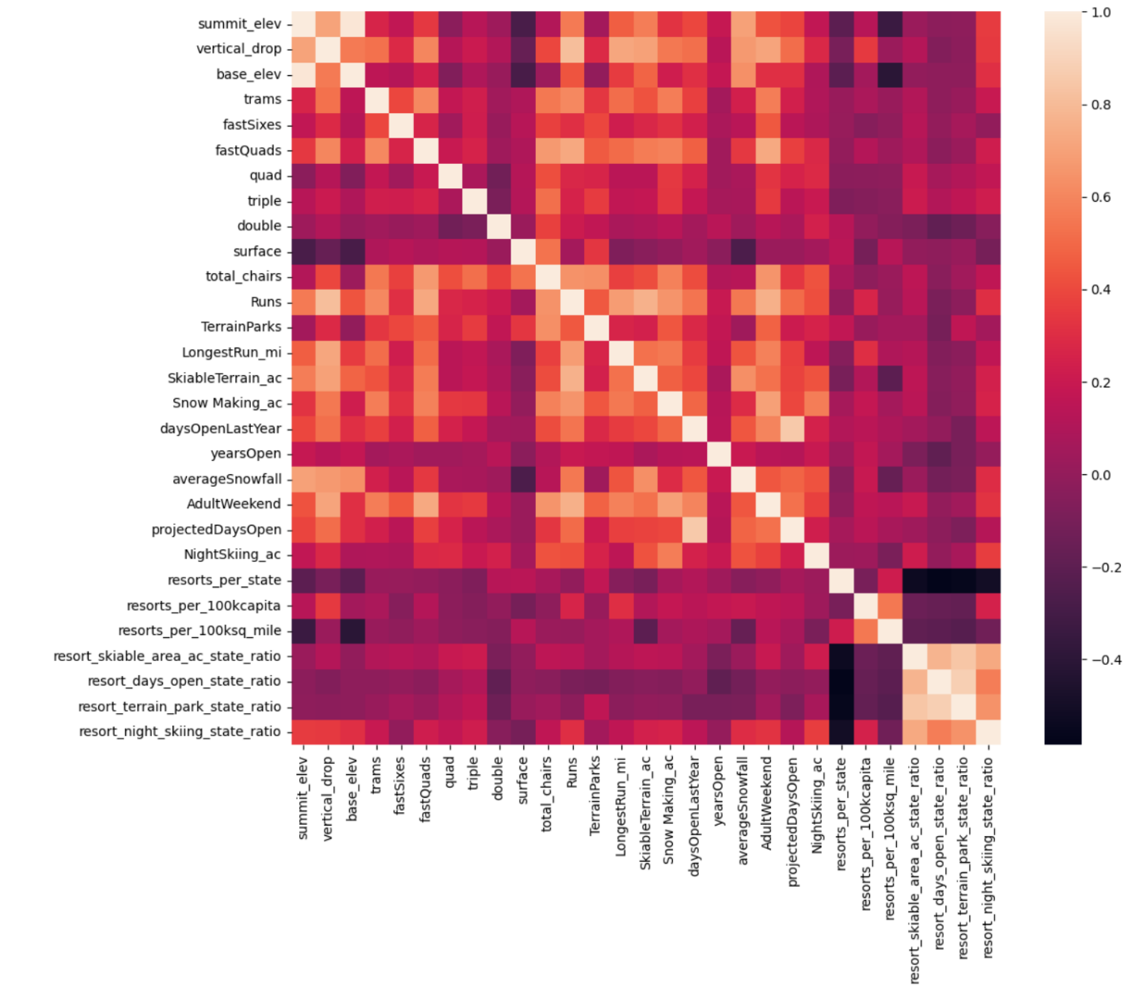

After preprocessing, I created some training and testing datasets and built some models to determine which one produced the least error. The random forest model was determined to be the more optimal option between it and linear regression.

With the model complete, all that was left was to use it to predict an optimal ticket price. Here are the results of said dive regarding how Big Mountain can consider updating its pricing strategy.

**Increase the adult weekend ticket price from $81.00 to $91.00.**

Below show 2 graphs comparing the current ticket price to all resorts in the US, and to all resorts in Montana.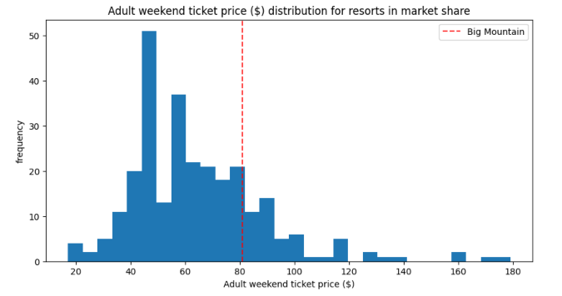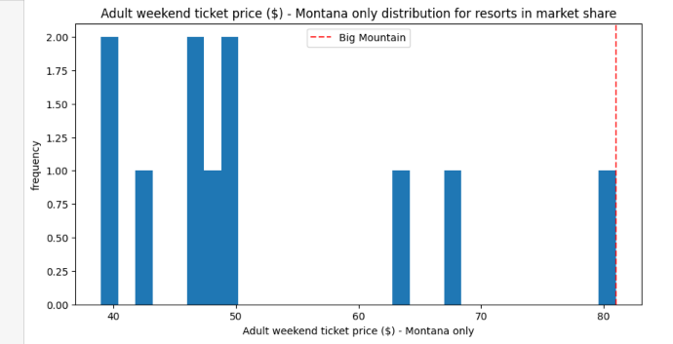

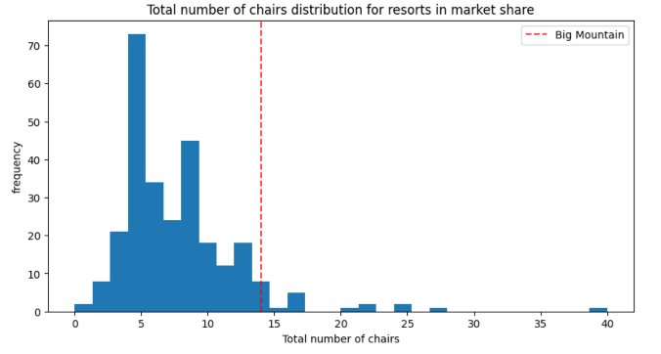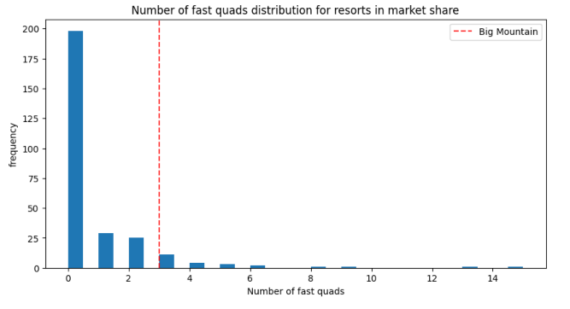Though at first it would seem more logical to reduce the ticket prices, as Big Mountain shown by the red dotted line has the highest price in Montana, the offered services and experience more than enough compensates for the elevated fee.

Seen above, Big Mountain provides a strong number of chair lifts as well as fast quads for resort goers. The opening of the new chair lift will no doubt push the resort further up the spectrum.

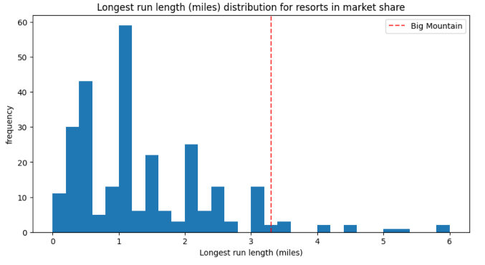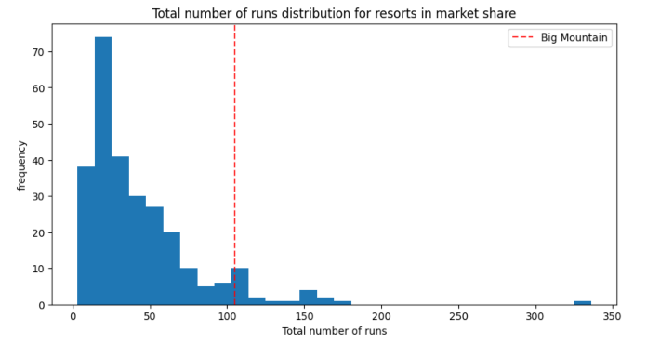

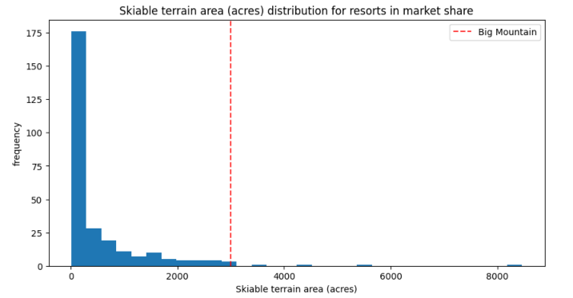Alongside having a plentiful count of chair lifts, Big Mountain has no shortage of runs for visitors to traverse across. Seen in the above figures, indicating Big Mountain to be well above the median and mean in both number of runs and longest run length.

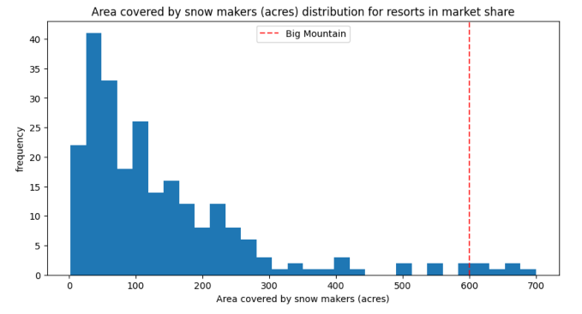

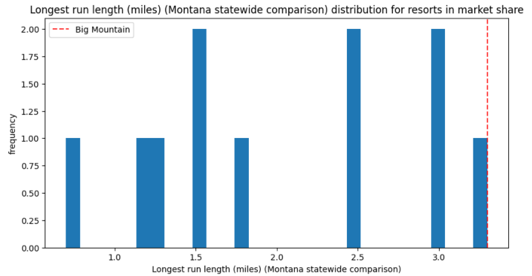In addition to those mentioned above, Big Mountain leads the pack in terms of skiable area and area covered by snow makers, thus not only showing the resort has plenty of runs, but each run is likely not very short. Plenty of runs and skiable area must mean a park of extensive size.

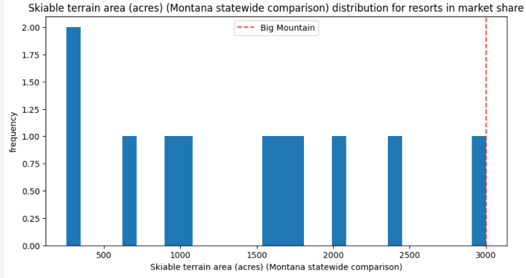

If we were to only compare within the state of Montana, signs showing Big Mountain’s dominance in resort amenities only become more prominent, either near the top or the number 1 statewide, in areas such as skiable terrain area and longest run length.

Note: although this price hike of $81.00 -> $91.00 is recommended for adult weekend tickets, it does not necessarily mean doing a price hike of weekday tickets or children’s tickets should follow suit. That would require further investigation.

The model does also support creating hypothetical scenarios such as closing certain runs, increasing snow making area, or extending the longest run to predict how such actions would affect the revenue of the resort. These can be starting points for further investigations in optimizing or balancing resort operational costs.

A conclusion can be made is given the assumptions of about 350,000 visitors per season, and each visitor skiing an average of 5 days, we can determine a $10,00 increase in ticket prices will yield a **$17,500,000** increase in revenue. Though the bottom line is not known, it should provide a healthy margin to account for the **$1,540,000** increase in operating costs with the new chair lift.