**OLED- ORGANIC LIGHT EMITTING DIODE**

***Seminar Report***

*Submitted in partial fulfilment for the award of degree of*

**Bachelor of Technology**

**in**

**Electronics and Communication Engineering**

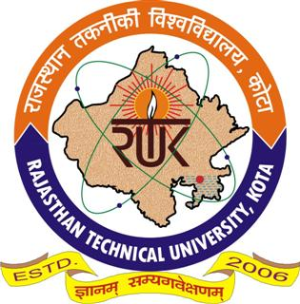

**Submitted by:- Guided by:-**

**Suprbha Kumari Dr. Ajay Khunteta**

**16/392 Associate Professor**

**Department of Electronics Engineering**

**Rajasthan Technical University, Kota**

**May 2020**

**TABLE OF CONTENTS:-**

**S.no TOPIC Page no.**

**1. Acknowledgement………………………………………..4**

**2. Abstract…………………………………………………………5**

**3. Introduction……………………………………………………6**

**4. How OLED emerged……………………………………….7**

**5. What is OLED………………………………………………….8**

**6. OLED components…………………………………………..8-10**

**7. Working of OLED……………………………………………10-12**

**8. Types of OLED………………………………………………….12-16**

**9. Creation of colour in OLED……………………………….17**

**10. Surface construction of OLED illumination……….18**

**11. Making of OLED………………………………………………..19**

**12. Advantages……………………………………………………….20**

**13. Disadvantages…………………………………………………..21**

**14. Latest applications…………………………………………….22-27**

**15. OLED-on-silicon technology………………………………..23**

**16. OLEDs in market………………………………………………..28-29**

**17. Comparison with existing sources……………………..30**

**18. Conclusion………………………………………………………….31**

**19. References…………………………………………………………..32**

**TABLE OF FIGURE:-**

**Fig no. Name of figure Page no.**

1. **OLED structure…………………………..6**
2. **Working of OLED……………………….10**
3. **Passive matrix OLED…………………..13**
4. **Active matrix OLED…………………….14**
5. **Transparent OLED……………………….14**
6. **Top emitting OLED………………………15**
7. **Foldable OLED..……………………………16**
8. **Colour creation………….………………..17**
9. **OLED surface structure………………….18**
10. **OVPD chamber……………………………..19**
11. **OLED micro-display………………………..22**
12. **OLED on silicon micro-display………..23**
13. **Bidirectional OLED…………………………25**
14. **Flexible OLED…………………………………26**
15. **OLED TV………………………………………..26**
16. **Transparent display………………………..27**
17. **OLED market revenue chart…………….29**

**ACKNOWLEDGEMENT:-**

I wish to extend my sincere gratitude to my seminar guide Dr. Ajay Khunteta professor, Department of Electronics and Communication, for his valuable guidance and encouragement which has been absolutely helpful in successful competition of this seminar.

I am also grateful to my parents and friends for their timely aid without which I would not have finished my seminar successfully.

And at last but not the least I thank to almighty for his immense grace.

**ABSTRACT:-**

Organic Light-emitting Diodes (OLEDs) are just like a movie projector screen in the earlier times with a thin sheet hanged on the wall in which the screen was light, paper-thin and could be rolled into portable tube. The materials used in OLEDs need not be crystalline that is composed of a precisely repeating pattern of planes of atoms, so they are easier to make. They are applied in thin layers for slimmer profiles and different materials for different colours that can be patterned on a given substrate for making high resolution images. In the coming years, large screen televisions or computer monitors could roll up for storage.A soldier might unfurl a sheet of plastic showing a real time situation map.Smaller displays could be wrapped around a person’s forearms or incorporated into clothing.The OLED panels could curl around an architectural column or lay almost wall paper like against a wall or ceiling.

**INTRODUCTION**

Can we imagine of having a TV which can be rolled up? Would not you like to be able to read off the screen of your laptop in direct sunlight? Your mobile phone battery to last much longer? On your next flat screen TV to be less expensive, much flatter, and even flexible? Well, now it is possible by an emerging technology based on the revolutionary discovery that , light emitting , fast switching diode could be made from polymers as well as semiconductors.

We know, ordinary LED emits light when electric current is passed through. Organic displays use a material with self luminous property that eliminates the need of backlight. These results in a thin and compact display. While backlighting is a crucial component to improving brightness in LCDs, it also adds significant cost as well as requires extra power. With an organic display, your laptop might be less heavy to carry around, or your battery lasts much longer compared to a laptop equipped with a traditional LCD screen.

A screen based on Poly-LEDs has obvious advantages: the screen is lightweight and flexible, so that it can be rolled up. With plastic chips you can ensure that the electronics driving the screen are integrated in the screen itself. One big advantage of plastic electronics is that there is virtually no restriction on size.

Research and development in the field of OLED is proceeding rapidly and may lead to future applications in heads-up displays, automotive dashboards, billboard-type displays, mobile phones, television screen, home and office lighting and flexible displays.

**HOW OLED HAS EMERGED**

Kodak first discovered that organic materials glow in response to electrical currents, in the late 1970s. Since then Kodak has been working for the improvement of this technology.

In the late 1970s. Eastman Kodak Company scientist Dr.Ching Tang discovered that sending an electrical current through a carbon compound caused these materials to glow. Dr.Tang and Steven Van Slyke continued research in this vein.

In 1987, they reported OLED materials that become the foundation for OLED displays produced today. The first color they discovered in this early OLED research was green.

As early as 1989, the Kodak research team demonstrated color improvements using fluorescent dyes, or dopants , to boost the efficiency and control of color output.

The device was fabricated by vapor deposition using Alq3 and di-amine in a double layer structure. This structure makes the electron and hole recombination effective: the device has a 1% external quantum efficiency, 1.5 lm/W luminous efficiency, and a  
brightness of more than 1000 cd/m2 at a driving voltage of about 10 V.

In 1990 another type of OLED emerged from Richard Friend’s group at Cambridge  
University: they developed a PPV-based LED, which is called polymer-Led or  
PLED.4 The light emission is in the green-yellow part in the spectrum, and the efficiency  
is about 0.05%. Since then, OLEDs have attracted a lot of attention from universities and  
industries and made much progress over the past twenty years

**WHAT IS OLED**

An OLED is a solid state device or electronic device that typically consists of organic thin films sandwiched between two thin film conductive electrodes. When electrical current is applied, a bright light is emitted. OLED uses a carbon-based designer molecule that emits light when an electric current passes through it. This is called electro-phosphorescence. Even with the layered system, these systems are thin usually less than 500 nm or about 200 times smaller than a human hair.

When used to produce displays. OLED technology produces self-luminous displays that do not require backlighting and hence more energy efficient. These properties result in thin, very compact displays. The displays require very little power, i.e., only 2-10 volts.

OLED technology uses substances that emit red, green, blue or white light. Without any other source of illumination, OLED materials present bright, clear video and images that are easy to see at almost any angle. Enhancing organic material helps to control the brightness and color of light, i.e., the brightness of an OLED is determined by how much power you supply to the system.

**OLED COMPONENTS:-**

Like an LED, an OLED is a solid-state semiconductor device that is 100 to 500 nanometers thick or about 200 times smaller than a human hair. OLEDs can have either two layers or three layers of organic material; in the latter design, the third layer helps transport electrons from the cathode to the emissive layer. In this article, we will be focusing on the two layer design.

An OLED consists of the following parts:

* Substrate (clear plastic, glass, foil)-The substrate supports the OLED.
* Anode (transparent)-The anode removes electrons (adds electron holes) when a current flows through the device.
* Organic layers- These layers are made up of plastic molecules that transport “holes” from anode. One conducting polymer used in OLED is poly-anyline.
* Emissive layer- This layer is made of organic plastic molecules (different ones from the conducting layer) that transport electrons from the cathode; this is where light is made. One polymer used in the emissive layer is poly-flourene.
* Cathode- The cathode injects electrons when current flow through the device.

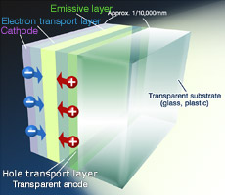

**Fig 1:- OLED structure**

It consists of an emissive layer, a conductive layer, a substrate, and both anode and cathode terminals. The emissive layer, where light is made by the emission of radiation whose frequency is in the visible region is made up of organic plastic molecules that transport electrons from the cathode and the polymer used is poly-florene. The conductive layer is made up of organic plastic molecules that transport holes from the anode and the conducting polymer used is poly-aniline. The substrate that supports OLED is made up of flexible plastic, inexpensive glass or metal foil. Anode, that removes electrons when a current flows through the device, is generally made up of Indium tin oxide and it is transparent and cathode that injects electrons when a current flows through the device is made up of metals like aluminium and calcium, which may or may not be transparent.

**WORKING OF OLED**

How do OLEDs emit light?

OLEDs emit light in a similar manner to LEDs through a process called electro-phosphorescence

The process is as follows:

1. The battery or power supply of the device containing the OLED applies a voltage across the OLED.
2. An electrical current flows from the cathode to the anode through the organic layers(an electrical current is a flow of electrons)

The cathode gives electrons to the emissive layer of organic molecules.

* The anode removes electrons from the conductive layer of organic molecules.(This is the equivalent to giving electron holes to the conductive layer)

3. At the boundary between the emissive and the conductive  
layers, electrons find electron holes.

* When an electron finds an electron hole, the electron fills the hole (it falls into an energy level of the atom that is missing an electron).
* When this happens, the electron gives up energy in the form of a photon of light.

1. The OLED emits light.
2. The color of the light depends on the type of organic molecule in the emissive layer. Manufacturers place several types of organic films on the same OLED to make color displays. The intensity of light depends on the amount of electricity passed.

[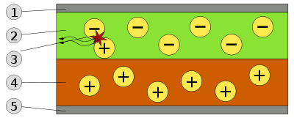](http://en.wikipedia.org/wiki/File:OLED_schematic.svg)

**Fig 2:-Working OLED**

1. Cathode (−), 2. Emissive Layer, 3. Emission of radiation, 4. Conductive Layer, 5. Anode (+).

When electricity is applied to OLED, charge carriers are injected from the electrodes into the organic thin films. They migrate through the device under the influence of of an electric field. The charge carriers then recombine, from excitations.

However, 100% of the excitations can be converted into light using process called electro-phosphorescence. Thus efficiency of OLED is four times higher than conventional LED.

A voltage is applied across the OLED such that the anode is positive with respect to the cathode. This causes a current of electrons to flow through the device from cathode to anode. Thus, the cathode gives electrons to the emissive layer and the anode withdraw electrons from the conductive layer; in other words, the anode gives electron holes to the conductive layer.

**TYPES OF OLED:-**

* Passive-matrix OLED
* Active-matrix OLED
* Transparent OLED
* Top-emitting OLED
* Foldable OLED
* White OLED

Below we are going to have a brief description of the types of OLED. Schematic representation of each type of OLED has been also discussed. Also the use of each type is mentioned.

Later on we will study the making of OLED .

Following categorisation is made on the basis of substrate used or on the basis they produce light.

However the basic principle of light emitting remains same from the organic polymer or organic molecules. The different polymers have been used widely across different applications.

Later part we will also discuss their use in different applications.

**PASSIVE-MATRIX OLED (PMOLED):-**

PMOLEDs have strips of cathode, organic layers and strips of anode. The anode strips are arranged perpendicular to the cathode strips. The intersections of the cathode and anode make up the pixels where light is emitted. External circuitry applies current to selected strips of anode and cathode, determining which pixels get turned on and which pixels get turned off. The brightness of each pixel is proportional to the amount of applied current. PMOLEDs are easy to make, but they consume more power than other types of OLED, mainly due to the power needed for the external circuitry. They are most efficient and are used in cell phones, PDAs and MP3 players.

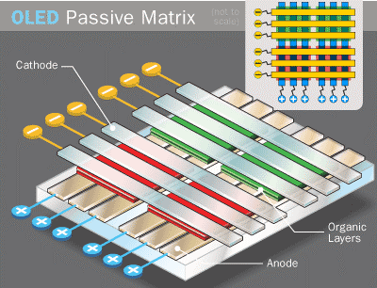

**Fig 3:- Passive matrix OLED**

**ACTIVE**-**MATRIX OLED (AMOLED):-**

TFT array itself is the circuitry that determines which pixels get turned on to form an image. AMOLEDs have full layers of cathode, organic molecules and anode, but the anode layer overlays a thin film transistor (TFT) array that forms a matrix.

The AMOLEDs consume less power than PMOLEDs because the TFT array requires less power than external circuitry, so they are efficient for large displays. They are used in computer monitors, large-screen TVs and electronic signs or billboards. The life expectancy of it is 30,000 hours.

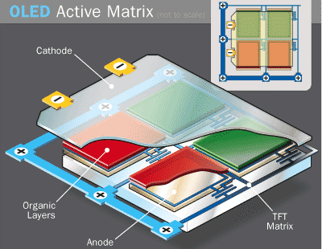

**Fig 4:- Active OLED**

**TRANSPARENT OLED:-**

Transparent OLEDs have only transparent components that are substrate, cathode and anode. When turned off, they are 85% as transparent as their substrate. When a transparent OLED display is turned on, it allows light to pass in both directions. This can be either active or passive matrix. This technology can be used for heads-up displays.

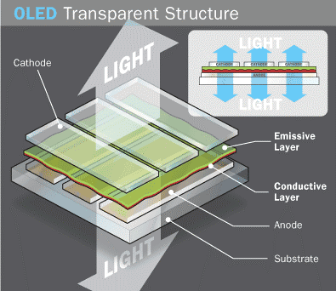

**Fig 5:- Transparent OLED**

**. TOP-EMITTING OLED:-**

Top-emitting OLEDs have a substrate that is either opaque or reflective. The top-emitting OLED display includes providing a handling substrate. A composite layer is formed on the handling substrate. An organic light emitting unit is formed on the composite layer. A top electrode is formed on the organic light emitting unit. A reflective type display and fabrication method thereof is provided. The reflective type display includes providing a handling substrate. A composite layer is formed on the handling substrate; a thin film transistor array is formed on the composite layer.  
They are best suited to active-matrix design. These displays are used in smart cards. The efficiency is 500 cd/m2 and the life span is 17,000 hours.

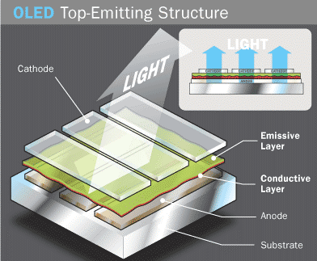

**Fig 6:- Top emitting OLED**

**. FOLDABLE OLED:-**

Foldable OLEDs have substrates made of very flexible metallic foils or plastics. They are very light-weight and durable. Their use in devices such as cell phones and PDAs can reduce breakage, a major cause for return or repair. Potentially, these displays can be attached to fabrics to create smart clothing, such as outdoor survival clothing with an integrated computer chip, cell phone, GPS receiver and OLED display sewn into it.

They are less breakable and more impact resistant – than other displays. With glass breakage a major cause of display-containing product returns, this is a highly desirable commercial alternative.

. They are very flexible i.e., they may be manufactured on a variety of substrates. Such displays may be made to bend, flex and conform to many surfaces. The luminance is 200 cd/m2.

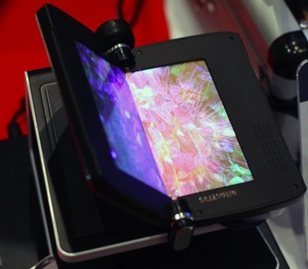

**Fig 7:- Foldable OLED**

**. WHITE OLED:-**

White OLEDs emit white light that is brighter, more uniform and more energy efficient than that emitted by fluorescent lights. They also have the true-colour qualities of incandescent lighting. They can replace fluorescent lights that are currently used in homes and buildings because they can be made in large sheets. Their use could potentially reduce energy costs for lighting. Its efficiency is 90 m/W at a brightness of 1000 cd/m2 .

**CREATION OF COLOR IN OLED:-**

OLED has more control over colour expression because it only expresses pure colours when electric current stimulates the relevant pixels. The primary colour matrix is arranged in red, green and blue pixels which are mounted directly to a printed circuited board. Each individual OLED element is housed in a special micro cavity structure designed to greatly reduce ambient light interference that also improves overall colour contrast. The thickness of the organic layer is adjusted to produce the strongest light to give a color picture. Further, the colors are refined with a filter and purified without using a polarizer to give outstanding color purity.

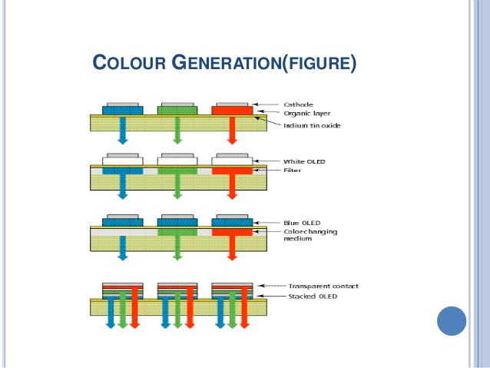

**Fig 8:- colour creation**

**SURFACE CONSTRUCTION OF OLED ILLUMINATIONS:-**

It consists of an emissive layer, a conductive layer, a substrate, and both anode and cathode terminals. The emissive layer, where light is made by the emission of radiation whose frequency is in the visible region is made up of organic plastic molecules that transport electrons from the cathode and the polymer used is polyflurene. The conductive layer is made up of organic plastic molecules that transport holes from the anode and the conducting polymer used is poly aniline. The substrate that supports OLED is made up of flexible plastic, inexpensive glass or metal foil. Anode, that removes electrons when a current flows through the device, is generally made up of Indium tin oxide and it is transparent and cathode that injects electrons when a current flows through the device is made up of metals like aluminium and calcium, which may or may not be transparent depending on the type of OLED.



**Fig 9:- OLED surface structure**

**MAKING OF OLED :-**

The biggest part of manufacturing OLEDs is applying the organic layers to the substrate. This can be done in three ways:-

1. Vacuum deposition or vacuum thermal evaporation(VTE):-

In a vacuum chamber, the organic molecules are gently heated (evaporated) and allowed to condense as thin films onto cooled substrates. This process is very expensive and inefficient.

2.Organic vapor phase deposition:-

In a low pressure, hot-walled reactor chamber, a carrier gas transports evaporated organic molecules onto cooled substrates, where they condense into thin films. Using a carrier gas increases the efficiency and reduces the cost of making OLEDs.

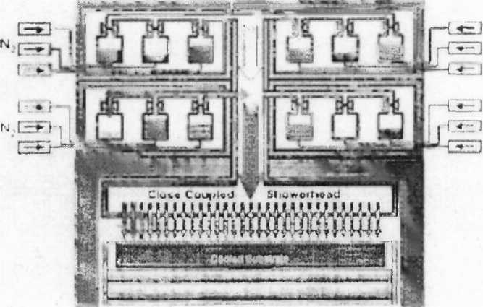 **Fig 10:- OVPD chamber**

3. Inkjet printing:-

With inkjet technology, OLEDs are sprayed onto substrates just like inks are sprayed onto paper during printing. Inkjet technology greatly reduces the cost of OLED manufacturing and allows OLEDs to be printed onto very large dims for large displays like 80 inch TV screens or electronic billboards.

**ADVANTAGES OF OLED:-**

The different manufacturing process of OLEDs lends itself to several advantages over flat-panel displays made with LCD technology.

Although the method is not currently commercially viable for mass production, OLEDs can be printed onto any suitable substrate using an inkjet printer or even screen printing technologies, they could theoretically have a lower cost than LCDs or plasma displays However, it is the fabrication of the substrate that is the most complex and expensive process in the production of a TFT LCD, so any savings offered by printing the pixels is easily cancelled out by OLED's requirement to use a more costly P-Si (or LTPS) substrate - a fact that is born out by the significantly higher initial price of AMOLED displays than their TFT LCD competitors. A mitigating factor to this price differential going into the future is the cost of retooling existing lines to produce AMOLED displays over LCDs to take advantage of the economies of scale afforded by mass production or Use of flexible substrates could open the door to new applications such as roll-up displays and displays embedded in fabrics clothing.

OLEDs can enable a greater artificial contrast ratio (both dynamic range and static, measured in purely dark conditions) and viewing angle compared to LCDs because OLED pixels directly emit light. OLED pixel colors appear correct and unshifted, even as the viewing angle approaches 90 degrees from normal LCDs filter the light emitted from a backlight allowing a small fraction of light through so they cannot show true black, while an inactive OLED element produces no light and consumes no power.

OLEDs can also have a faster response time than standard LCD screens. Whereas LCD displays are capable of a 1ms response time or less offering a frame rate of 1,000 Hz or higher, an OLED can theoretically have less than 0.01 ms response time enabling 100,000 Hz refresh rates.

**DISADVANTAGES:-**

**Lifespan:-**

The biggest technical problem for OLEDs is the limited lifetime of the organic materials. In particular, blue OLEDs historically have had a lifetime of around 14,000 hours to half original brightness (five years at 8 hours a day) when used for flat-panel displays, which is lower than the typical lifetime of LCD, LED or PDP technology—each currently rated for about 60,000 hours to half brightness, depending on manufacturer and model. However, some manufacturers displays aim to increase the lifespan of OLED displays, pushing their expected life past that of LCD displays by improving light auto coupling, thus achieving the same brightness at a lower drive current.

### Screen burn-in

Unlike displays with a common light source, the brightness of each OLED pixel fades depending on the content displayed. Combined with the short lifetime the organic dyes, this leads to screen burn-in, worse than was common in the days of CRT-based displays

### Water damage

Water can damage the organic materials of the displays. Therefore, improved sealing processes are important for practical manufacturing. Water damage may especially limit the longevity of more flexible displays.

**LATEST APPLICATIONS OF OLED TECHNOLOGY**

The most widely used of OLED technology is OLED-on silicon micro-display.

1. **Large-area OLED micro-displays:-**

Silicon micro-display together with ultra-compact optics with the ability to seamlessly combine multiple display chips together enable very high effective display resolutions and a wide field of view for the immensive VR sensations. At the same time the tiling of multiple displays in the system helps to keep the yield and thus costs for the micro-displays in an acceptable range.

The micro-display and optics have been specifically designed to meet VR sensations performance needs, i.e. high resolution, high contrast ratio, high frame rates,schemes necessary to avoid visual and balance discomfort.

e.g. flickering or motion sickness, low power.

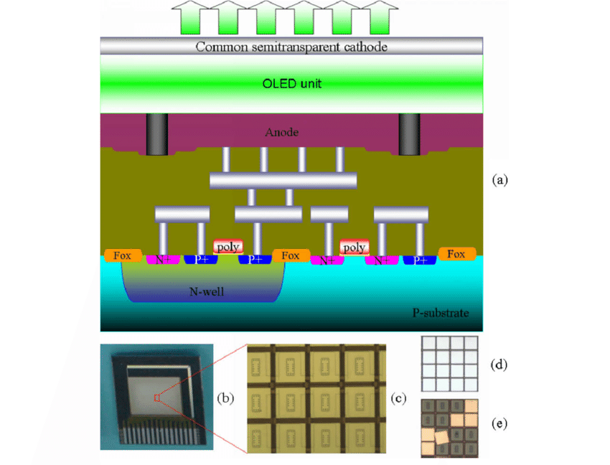

**Fig 11:- OLED micro-display**

**MICRODISPLAY TECHNOLOGY:- “OLED ON SILICON TECHNOLOGY”**

The prominent emissive micro-display technology on the market is OLED-on-silicon technology. A single crystalline silicon CMOS chip provides the active matrix circuitry to address and drive the millions of individual pixels. Since the silicon substrate itself is intransparent in the visible spectrum, a top emission OLED setup is required.

The passivation layer of the CMOS is skipped and thus the last metal layer can be used as one electrode, which enables last CMOS metallization layer. The OLED is deposited on top of the interface, followed by a transparent electrode to complete the organic light emitting diodes. The comp;ete organic stack is covered by a thin film encapsulation to protect it against moisture and oxygen. The individual colours of the red, blue, green subpixels are typically generated from the white un-patterned OLED by using color filters.

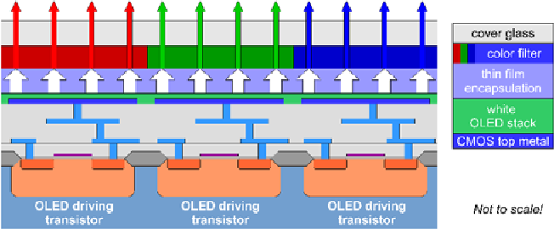

**FIG-12:-OLED-on-silicon-micro-display**

1. **ULTRA LOW POWER OLED MICRODISPLAY:-**

There are plenty of NTE applications which demand long battery life above frame rate and resolutions for such applications it becomes sufficient to display simple graphics and text. Even more, the alteration frequency of screen content is often rather low (<5Hz). Therefore image data can be stored in a static random access memory SRAM-like pixel cell architecture, and the direct pixel-wise addressing scheme enables much lower bandwidth for the display interface as well. That approach allows to drastically reduced display power consumption. At moderate display resolution and frame rate there is even a power advantage for video display. The back plan was designed with focus on minimal pin count, minimal required external components and an easy connection to the data source. The largest reduction in pin count could be achieved by changing the data interface from typical 24 bit parallel RGB data plus additional synchronization signal to a simple four wire SPI interface for data configuration. In this way the realization of minimalistic system with simple microcontroller and without additional video sources or processors is possible.

1. **BI-DIRECTIONAL OLED MICRODISPLAY**

In a typical bidirectional micro-display each pixel comprises five sub-pixels: four sub-pixel for the display (RGBW) and one image sensor pixel. The latter uses the photodiode inside the silicon substrate as sensing element. The circuitry for the sensor pixel can be placed underneath the OLED electrodes and does not further reduce the fill factor of the photoactive area. Without sub-structuring of the OLED at pixel level the organic layers cover the complete active area including the  
photodiodes. The organic layers are almost transparent in the visible range but the semi-transparent counter electrode of the OLED reduces the sensitivity to a certain extend. Figure shows the cross-section and an SVGA sample of such  
bidirectional OLED micro-display.

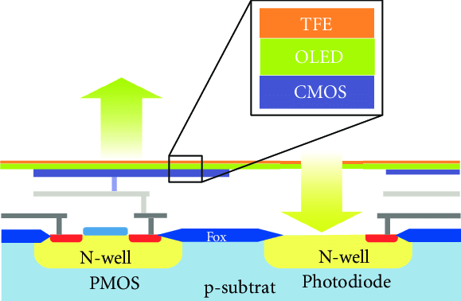

**Fig 13:- cross section of the bi-directional OLED**

OLED-on-Silicon micro-display technology might be best  
suited to bi-directional micro-display techniques too, which  
combine both image display and image acquisition in a single chip.

**D.FLEXIBLE OLED:-**

When we talk about flexible OLEDs, it's important to understand what that means exactly. A flexible OLED is based on a flexible substrate which can be either plastic, metal or flexible glass. The plastic and metal panels will be light, thin and very durable - in fact they will be virtually shatter-proof.

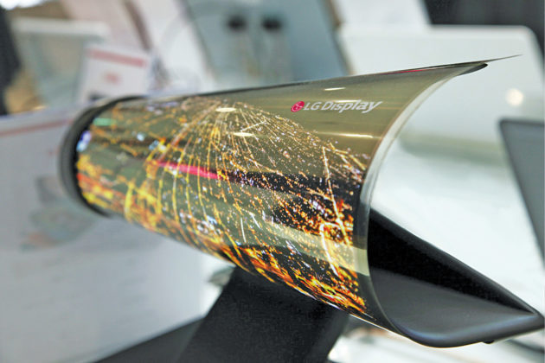

**Fig 14:- Flexible display**

The first range of devices that use flexible OLED displays are not really flexible from the user perspective. The device maker bends the displays, or curves it - but the final user is not able to actually bend the device. These first-genflexible OLEDs are adopted many premium smart phones, for example the Samsung edge-type Galaxy phones or Apple's i-Phone X and Xs. Besides the beautiful designs, a flexible OLED has several advantages especially in mobile devices - the displays are lighter, thinner and more durable compared to glass based displays.

A flexible organic light-emitting diode (FOLED) is a type of organic light-emitting diode **(OLED)** incorporating a flexible plastic substrate on which the electroluminescent organic semiconductor is deposited. This enables the device to be bent or rolled while still operating.

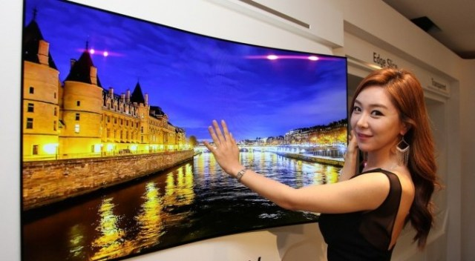

**Fig 15:- Flexible OLED TV**

**E.TRANSPARENT OLED:-**

The OLEDs produce their own light, which allows the screens to be much thinner and they don't require backlighting. The narrow gap between the pixels of the screen as well as the clear cathodes within allow the screens to be transparent. LCD uses natural lighting like the sun instead of electrical backlighting.

TransparentOLEDs have only transparent components (substrate, cathode and anode) and, when turned off, are up to 85 percent as transparent as their substrate. When a transparent OLED display is turned on, it allows light to pass in both directions.

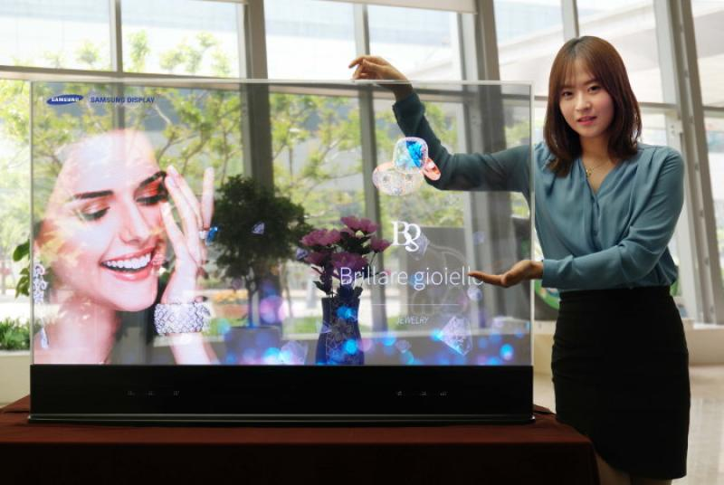

**Fig 16:- OLED transparent TV display**

**OTHER APPLICATIONS OF OLED:-**

* Due to its light-weight, they can be used in cellular phones, PDAs, notebooks, digital cameras, DVD players, car stereos, televisions, etc.
* They can be used as solid-state light sources.
* In heads-up displays, automotive dashboards, billboard-type displays, home and office lighting and flexible displays.
* Due to its faster response than LCDs almost 1000 times faster, a device with an OLED display could change information almost in real time.
* In video images for more realistic and constant updates.
* It has been widely used in digital cameras and wearable devices.
* Wearable devices include multi-purpose tools that use advanced sensing technologies such as voice command recognition, gesture recognition, and face and fingerprint recognition. OLED technology brings advantages of thinner and curved display form factor to wearable devices.

**OLEDs IN MARKET:-**

October 1, 2007. Sony become the first company to announce an OLED television for commercial sale. The XEL-1 11" OLED Digital Television sells for $2,499.99 in the United States and Canada.

December 2007 - July 2008. OLED applications include signs and lighting.

January 2009. Handheld computer manufacturer OQO introduce the smallest Windows Vista computer with an OLED display.

March 2009. Samsung Electronics launch a 2.8" AMOLED capacitive touch screen phone called the S8300 Ultra TOUCH.

April 2009. Samsung bring the first phone using an AMOLED display to the United States, the Impression on AT&T. The Impression has a 3.2" WQVGA AMOLED.

May 2009. Philips Lighting commercializes the first OLED lights, opening a web shop where OLED lighting samples under the brand name 'Lumiblade' can be ordered online.

May 2009. Samsung Electronics launch a 3.7" nHD AMOLED capacitive touch screen phone called the i8910 Omnia HD.

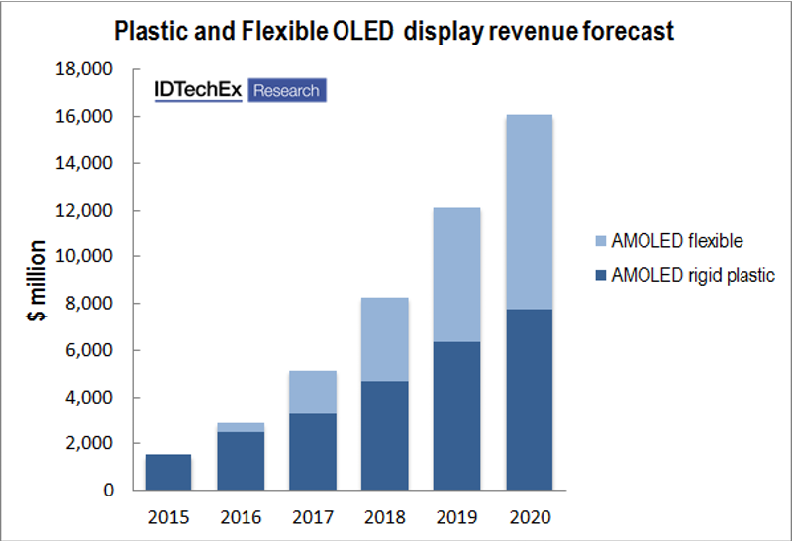

Fig 17:- OLED market revenue

# 2016, mobile OLED power friendly camera system latest version was launched by china.

April, 2019 LG latest OLED TV was launched.

Many products are still emerging in the market and continue to explore the technology of OLED.

COMPARISON WITH EXISTING SOURCES:-

|  |  |  |  |  |
| --- | --- | --- | --- | --- |
|  | **OLED lighting** | **Incandescent light bulbs** | **Fluorescent lamps** | **LED** |
| Illustration | 有機EL照明 | 白熱電球 | 蛍光灯 | LED |
| Principle of light emission | Emits light by applying a voltage to organic matter | Emits light by sending an electric current to a metallic filament | Ultraviolet rays generated by an electric current collide with fluorescent material to produce visible light | Emits light by applying a voltage to an inorganic semiconductor |
| Characteristics | com_ex04Illuminates large area (surface light source) com_ex04Energy efficient com_ex04Low heat-generation com_ex04Slim, lightweight com_ex04Flexible (when plastic substrate used) com_ex04Environmentally sound | com_ex03Illuminates small area (point light source) com_ex02High power consumption com_ex02High heat-generation com_ex01Closely approximates natural light | com_ex03Size of area illuminated is between point light source and surface light source (linear light source) com_ex01Energy efficient com_ex02Uses hazardous substance (mercury) | com_ex03Illuminates small area (point light source) com_ex01Energy efficient com_ex01Long life com_ex01Easy to reduce size com_ex01Environmentally sound |
| Uses | Anticipated applications include living spaces, offices, decorative illumination, car interior lighting, and POP lighting | Photographic lighting, living spaces such as dining rooms or bedrooms, etc. | Living spaces, offices, commercial premises, etc. | Indirect lighting, floor level lighting, spotlights for retail spaces, etc. |

CONCLUSIONS:-

OLEDs offer many advantages over both LEDs and LCDs. They are thinner, lighter and more flexible than the crystalline layers in an LED or LCD. They have large fields of view as they produce their own light.

Research and development in the field of OLEDs is proceeding rapidly and may lead to future applications in heads up displays, automotive dash boards, billboard type displays etc. Because OLEDs refresh faster than LCDs, a device with OLED display could change information almost in real time. Video images could be much more realistic and constantly updated.

Organic light emitting diodes promise to make electronic viewing more convenient and ubiquitous as they are more energy efficient. OLED is so revolutionary that in the field of illumination it is being hailed as “the first discovery since Edison”. Today, OLED technology is widely seen as a next generation component for flat panel displays and is expected to become a key technology in the development of flexible displays.

**REFERENCES:-**

1.Kovac, J.; Peternai, L.; Lengyel, O. *Thin Solid Films* **2003**, *433*, 22–26.  
2. Pope, M.; Kallman, H.; Magnante, P. *J. Chem. Phys.* **1963,** *38*, 2042-2043.  
3. Tang, C.W.; Van Slyke, S.A. *Appl. Phys. Lett.* **1987**, *51*, 913-915.  
4. Burroughes, J. H.; Bradley, D. D. C.; Brown, A. R.; Marks, R. N.; Mackay, K.; Friend, R. H.;  
Burns, P. L.; Holmes, A. B. *Nature* **1990,** *347*, 539-541.  
5. Hosokawa, C.; Fukuoka, K; Kawamura, H. *SID Digest* **2004**, *35*, 780-783  
6. http://www.shsu.edu/~chemistry/chemiluminescence/JABLONSKI.html (accessed 9/18/2005)  
7 Kraft, A.; Grimsdale, A.; Holmes, A.B.*. Chem. Int. Ed.* **1998,** *37*, 402-428.  
8. Shinar, J. *Organic light emitting devices*; AIP press: New York, 2005.  
9. Scott, J. C.; Malliaras, G. G.; Salem, J.R.; Brock, P. J.; Bozano, L.; Carter, S. A. *SPIE Proc.* **1998**,  
*3476*, 111-122.  
10. Hung, L.S.; Chen, C.H. *Mater. Sci. Eng.* **2002**, *R39*, 143-222.  
11. Sugiyama, K.; Ishii H.; Ouchi, Y.; Seki, K. *J. Appl. Phys*. **2000**, *87*, 295-298.  
12. Braun, D.; Heeger, A. J. *Appl. Phys. Lett* **1991,** *58*, 1982-1984.  
13. Broms, P.; Birgersson, J.; Johansson, N.; Lögdlund, M.; Salaneck, W. R. *Synth. Met.* **1995**, *74*,  
179-181.  
14. Malliaras, G. G.; Scott, J. C. *J. Appl. Phys.* **1998**, *83*, 5399-5403.  
15. Carter, S. A.; Angelopoulos, M.; Karg, S.; Brock, P. J.; Scott, J. C. *Appl. Phys. Lett.* **1997**, *70*,  
2067-2069.  
16. Hill, I. G.; Rajagopal, A.; Kahn, A.; Hu, Y. *Appl. Phys. Lett.* **1998**, *73*, 662-664.  
17. Tang, J.X.; Lee, C.S.; Lee, S.T.; Xu, Y.B. *Chem. Phys. Lett.* **2004**, *396*, 92-96.  
18. Ishii, H.; Sugiyama, K.; Ito, E.; Seki, K. *Adv. Mater.* **1999**, *11*, 605-625.  
19. Koch, N.; Kahn, A.; Ghijsen, J.; Pireaux, J.-J.; Schwartz, J.; Johnson, R.L.; Elschner, A. *Appl.  
Phys. Lett.* **2003**, *82*, 70-72.  
20. Crispin, X.; Geskin, V.; Crispin, A.; Cornil, J.; Lazzaroni, R.; Salaneck, W.R.; Brédas, J.L. *J. Am.  
Chem. Soc.* **2002**, *124*, 8131-8141.  
21. Yan, L.; Watkins, N.J.; Zorba, S.; Gao, Y.; Tang, C.W. *Appl. Phys. Lett.* **2002**, *81*, 2752-2754.  
22. Yan, L.; *Thin Solid Films* **2002**, *417*, 101-106.  
23. Aziz, H.; Popovic, Z.; Tripp, C.; Xie, S.; Hor, A.; Xu, G. *Appl. Phys. Lett.* **1998**, *72*, 2642-2644