

**NETAJI SUBHAS UNIVERSITY OF TECHNOLOGY**

**AZAD HIND FAUZ MARG SECTOR 3 DWARKA, NEW DELHI-78**

**AIRPORT MANAGEMENT SYSTEM**

**PROJECT REPORT**

Submitted by:

Kushagra Anand(2022UCS1587)

Abhishek Verma(2022UCS1588)

Tanmay Jain(2022UCS1596)

Hrishabh Thakur(2022UCS1600)

Contents

**PROJECT DESCRIPTION** 3

**Requirements of the system:** 3

**Entity Relationship Diagram** 5

**ER Diagram Relations** 5

**REALTIONAL SCHEMAS** 6

**Queries to insert records** 10

# **PROJECT DESCRIPTION**

## **Requirements of the system:**

* The system is based on airport management. Airport management system primarily deals with management of airport, airlines and passengers. The system provides broad overview of underlying operational factors that influence the airport management.
* The database system has the data of the most visited commercial service airports of India
* An airport is located in a state.

|  |  |
| --- | --- |
| AP_name | State |
| Indira Gandhi International Airport | DELHI |
| Chhatrapati Shivaji International Airport | MAHARASHTRA |
| Kempegowda International Airport | KARNATAKA |
| Chennai International Airport | TAMIL NADU |
| Rajiv Gandhi International Airport | TELANGANA |
| Netaji Subhas Chandra Bose Airport | WEST BENGAL |
| Sardar Vallabhbhai Patel International Airport | GUJARAT |
| Dabolim Airport | GOA |
| Jaipur International Airport | RAJASTHAN |
| Cochin International Airport | KERELA |

* Every airline is identified uniquely by an airline Id. Airline Id is a 3 character airline designator. Airline also has three-digit code which is printed on an air ticket.
* All airlines operating through various cities/states across the country have their offices located in all major cities and airports they cover.

|  |  |
| --- | --- |
| AL_name | AirlineID |
| Air India | 101 |
| IndiGo | 102 |
| SpiceJet | 103 |
| Vistara | 104 |
| GoAir | 105 |
| AirAsia | 106 |
| Akasa Air | 107 |

* A passenger can book one or multiple tickets. The day on which he books an air ticket is a booking date. Similarly, a passenger can cancel one or multiple tickets. The day on which he cancels an air ticket is cancellation date and there will be a surcharge that a passenger has to pay after cancelling a ticket.
  + A Passenger can be identified uniquely by his/her Passport Number
  + Passenger details includes Age, Sex, FName, MName, LName, Phone, Address
* For a passenger to travel by a flight, he needs a ticket. A ticket or air ticket is used to confirm that an individual has reserved a seat on a flight. With the ticket, a passenger is allowed to board the flight.
  + A Ticket consists of a unique combination of TicketNo, Source, and Destination. It includes Price, Class, SeatNo, DateOfTravel and FlightCode.
  + Ticket also includes DateOfBooking and a column for DateOfCancellation.
* Every airport has employees working for it. Every employee is identified by SSN. Every employee has an information such name, address, phone, age, sex, salary.
* Relations-
  + Airport contains Airline
  + Airport has Employees
  + Employees serves Passengers
  + Airline has Flights from Source to Destination
  + A Fight can be
    - Connecting Flight
    - Non-Stop Flight
  + Flight carries Passengers from Source to Destination
  + Passenger can book Tickets
  + Passenger can cancel Tickets
  + Passenger can make payment for multiple TicketNo to an Airline

# **Entity Relationship Diagram**

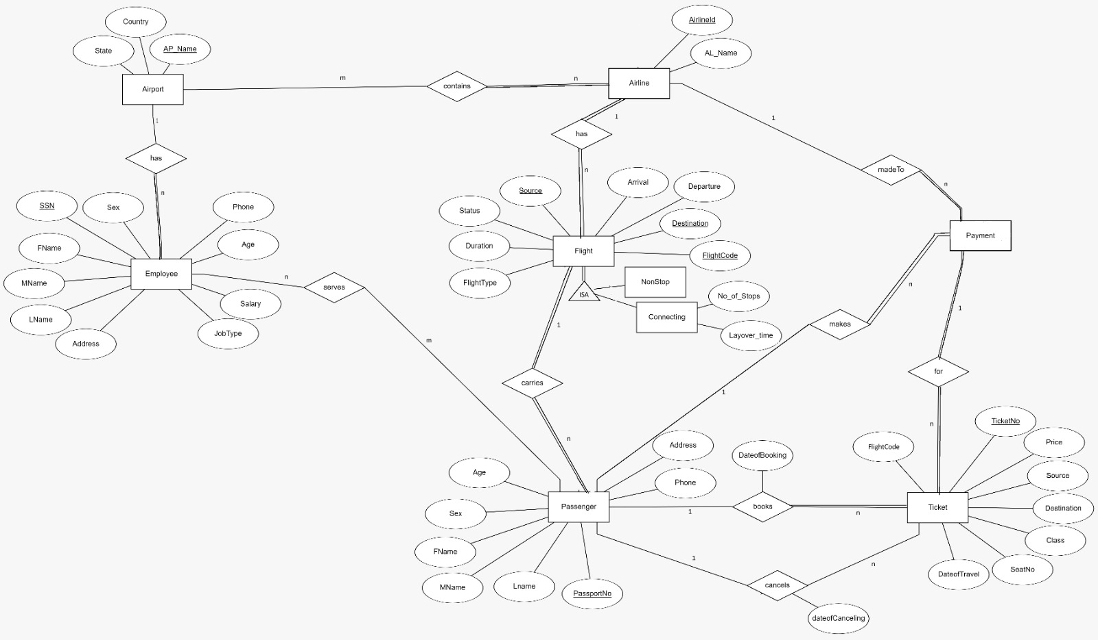

Airport Management System ER Diagram

## **ER Diagram Relations**

|  |  |  |  |
| --- | --- | --- | --- |
| Entity 1 | Name of Relation | Entity 2 | Cardinality |
| Airport | Contains | Airline | m:n |
| Airport | Has | Employee | 1:n |
| Employee | Serves | Passenger | m:n |
| Flight | Carries | Passenger | 1:n |
| Airline | Has | Flight | 1:n |
| Passenger | Books | Ticket | 1:n |
| Payment | For | Ticket | 1:n |
| Payment | Made to | Airline | n:1 |
| Passenger | Cancels | Ticket | 1:n |
| Payment | for | Ticket | 1:n |
| Passenger | Makes | Payment | 1:n |

# **REALTIONAL SCHEMAS**

**AIRPORT**

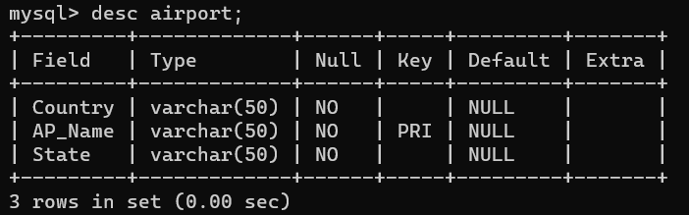

**EMPLOYEE**

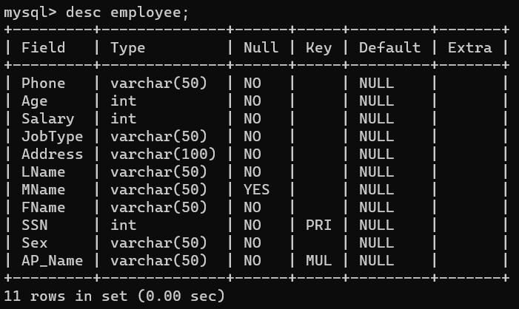

**AIRLINE**

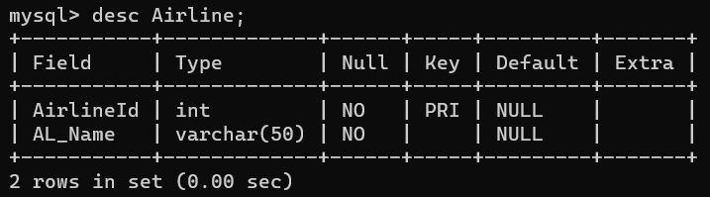

**FLIGHT**

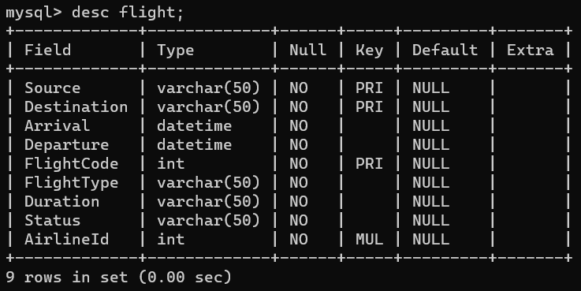

**CONNECTING**

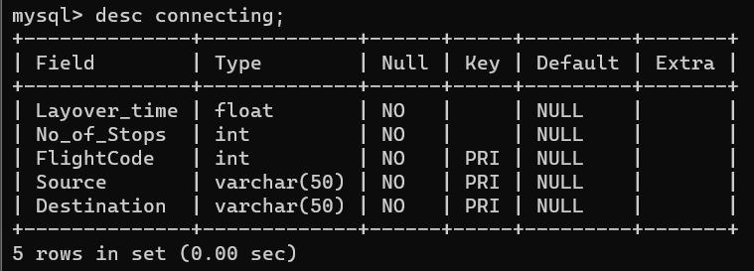

**NONSTOP**

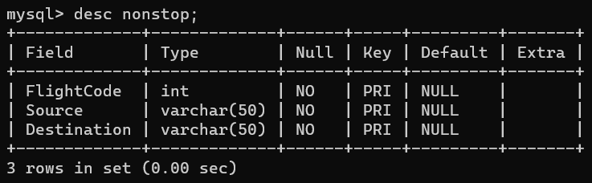

**PASSENGER**

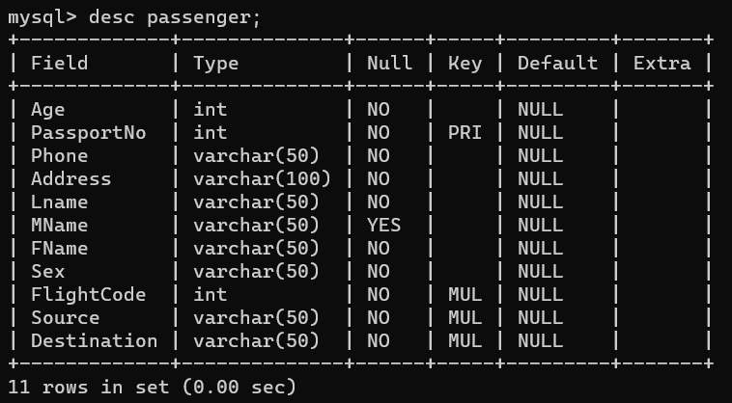

**TICKET**

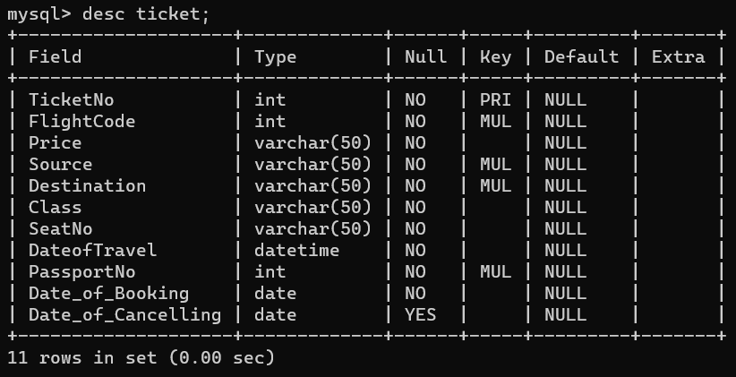

**CONTAINS**

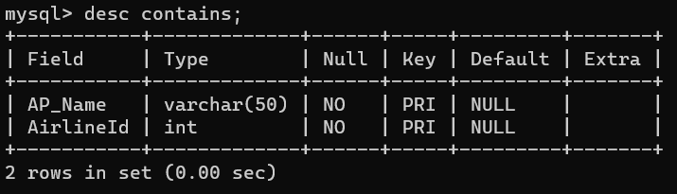

**SERVES**

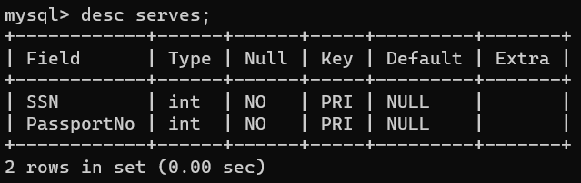

**PAYMENT**

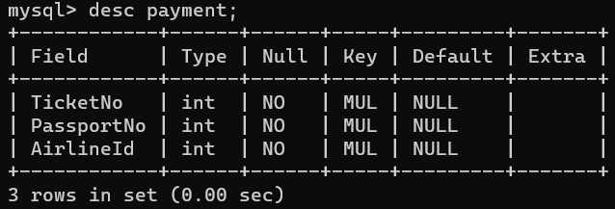

# **Queries to insert records**

INSERT INTO Flight (Source, Destination, Arrival, Departure, FlightCode, FlightType, Duration, Status, AirlineId)

VALUES

('Mumbai', 'Delhi', '2023-10-31 08:00:00', '2023-10-31 06:00:00', 10108, 'Domestic', '2 hours', 'On Time',102),

('Delhi', 'Bangalore', '2023-10-31 10:15:00', '2023-10-31 08:45:00', 10204, 'Domestic', '1 hour 30 minutes', 'On Time',104),

('Chennai', 'Kolkata', '2023-10-31 12:30:00', '2023-10-31 10:45:00', 10341, 'Domestic', '1 hour 45 minutes', 'On Time',101),

('Hyderabad', 'Ahmedabad', '2023-10-31 14:45:00', '2023-10-31 13:15:00', 10445, 'Domestic', '1 hour 30 minutes', 'Delayed',102),

('Kolkata', 'Mumbai', '2023-10-31 18:30:00', '2023-10-31 16:45:00', 10514, 'Domestic', '1 hour 45 minutes', 'On Time',107),

('Bengaluru', 'Chennai', '2023-10-31 20:15:00', '2023-10-31 18:30:00', 10678, 'Domestic', '1 hour 45 minutes', 'Delayed',105),

('Delhi', 'Goa', '2023-10-31 06:30:00', '2023-10-31 04:45:00', 10798, 'Domestic', '1 hour 45 minutes', 'On Time',105),

('Mumbai', 'Jaipur', '2023-10-31 09:00:00', '2023-10-31 07:15:00', 10824, 'Domestic', '1 hour 45 minutes', 'On Time',103),

('Chennai', 'Kochi', '2023-10-31 13:15:00', '2023-10-31 11:30:00', 10931, 'Domestic', '1 hour 45 minutes', 'Delayed',104),

('Hyderabad', 'Vizag', '2023-10-31 15:45:00', '2023-10-31 14:00:00', 11040, 'Domestic', '1 hour 45 minutes', 'On Time',101),

('Kolkata', 'Patna', '2023-10-31 18:00:00', '2023-10-31 16:15:00', 11199, 'Domestic', '1 hour 45 minutes', 'On Time',105),

('Delhi', 'Mumbai', '2023-10-31 21:30:00', '2023-10-31 19:45:00', 11247, 'Domestic', '1 hour 45 minutes', 'On Time',106),

('Chennai', 'Bengaluru', '2023-10-31 07:45:00', '2023-10-31 06:00:00', 11123, 'Domestic', '1 hour 45 minutes', 'Delayed',102),

('Mumbai', 'Hyderabad', '2023-10-31 09:45:00', '2023-10-31 08:00:00', 11477, 'Domestic', '1 hour 45 minutes', 'On Time',104),

('Kolkata', 'Chennai', '2023-10-31 12:15:00', '2023-10-31 10:30:00', 11516, 'Domestic', '1 hour 45 minutes', 'On Time',101);

--------------------------------------------------------------------------------------------------------------------------

INSERT INTO Airport (Country, AP_Name, State)

VALUES

('India', 'Indira Gandhi International Airport', 'Delhi'),

('India', 'Chhatrapati Shivaji International Airport', 'Maharashtra'),

('India', 'Kempegowda International Airport', 'Karnataka'),

('India', 'Chennai International Airport', 'Tamil Nadu'),

('India', 'Rajiv Gandhi International Airport', 'Telangana'),

('India', 'Netaji Subhas Chandra Bose International Airport', 'West Bengal'),

('India', 'Sardar Vallabhbhai Patel International Airport', 'Gujarat'),

('India', 'Dabolim Airport', 'Goa'),

('India', 'Jaipur International Airport', 'Rajasthan'),

('India', 'Cochin International Airport', 'Kerala');

----------------------------------------------------------------------------------------------------------------------

INSERT INTO Employee (Phone, Age, Salary, JobType, Address, LName, MName, FName, SSN, Sex, AP_Name)

VALUES

('123-456-7890', 30, 60000, 'Pilot', '123 Main St, Delhi', 'Smith', 'A', 'John', 123456789, 'Male', 'Indira Gandhi International Airport'),

('987-654-3210', 25, 45000, 'Flight Attendant', '456 Elm St, Maharashtra', 'Johnson', 'B', 'Mary', 987654321, 'Female', 'Chhatrapati Shivaji International Airport'),

('111-222-3333', 28, 55000, 'Mechanic', '789 Oak St, Karnataka', 'Brown', 'C', 'David', 111222333, 'Male', 'Kempegowda International Airport'),

('555-666-7777', 22, 40000, 'Customer Service', '101 Pine St, Tamil Nadu', 'Davis', 'D', 'Linda', 555666777, 'Female', 'Chennai International Airport'),

('999-888-7777', 35, 75000, 'Manager', '321 Cedar St, Telangana', 'Williams', 'E', 'Robert', 999888777, 'Male', 'Rajiv Gandhi International Airport'),

('777-888-9999', 27, 52000, 'Security', '222 Birch St, West Bengal', 'Lee', 'F', 'Sarah', 777888999, 'Female', 'Netaji Subhas Chandra Bose International Airport'),

('222-333-4444', 33, 68000, 'Pilot', '987 Maple St, Gujarat', 'Martin', 'G', 'Kevin', 222333444, 'Male', 'Sardar Vallabhbhai Patel International Airport'),

('333-222-1111', 29, 60000, 'Flight Attendant', '456 Oak St, Goa', 'Taylor', 'H', 'Jennifer', 333222111, 'Female', 'Dabolim Airport'),

('444-555-6666', 32, 70000, 'Mechanic', '555 Elm St, Rajasthan', 'Anderson', 'I', 'Michael', 444555666, 'Male', 'Jaipur International Airport'),

('888-777-6666', 26, 49000, 'Customer Service', '321 Oak St, Kerala', 'Wilson', 'J', 'Elizabeth', 888777666, 'Female', 'Cochin International Airport'),

('777-555-3333', 31, 66000, 'Manager', '222 Pine St, Delhi', 'Miller', 'K', 'Daniel', 777555333, 'Male', 'Indira Gandhi International Airport'),

('222-777-2222', 28, 57000, 'Security', '789 Birch St, Maharashtra', 'Harris', 'L', 'Jessica', 222777222, 'Female', 'Chhatrapati Shivaji International Airport'),

('555-888-4444', 24, 43000, 'Pilot', '123 Cedar St, Karnataka', 'Clark', 'M', 'William', 555888444, 'Male', 'Kempegowda International Airport'),

('777-999-6666', 30, 62000, 'Flight Attendant', '333 Oak St, Tamil Nadu', 'Walker', 'N', 'Samantha', 777999666, 'Female', 'Chennai International Airport'),

('333-555-9999', 29, 59000, 'Mechanic', '444 Elm St, Telangana', 'Turner', 'O', 'Nicholas', 333555999, 'Male', 'Rajiv Gandhi International Airport'),

('111-777-2222', 27, 52000, 'Customer Service', '987 Pine St, West Bengal', 'Hill', 'P', 'Emily', 111777222, 'Female', 'Netaji Subhas Chandra Bose International Airport'),

('999-333-7777', 35, 73000, 'Manager', '555 Birch St, Gujarat', 'Adams', 'Q', 'Matthew', 999333777, 'Male', 'Sardar Vallabhbhai Patel International Airport'),

('666-555-4444', 26, 48000, 'Security', '321 Oak St, Goa', 'Baker', 'R', 'Olivia', 666555444, 'Female', 'Dabolim Airport'),

('555-444-7777', 28, 56000, 'Pilot', '777 Elm St, Rajasthan', 'Gonzalez', 'S', 'Andrew', 555444777, 'Male', 'Jaipur International Airport'),

('444-777-5555', 31, 64000, 'Flight Attendant', '123 Cedar St, Kerala', 'Perez', 'T', 'Sophia', 444777555, 'Female', 'Cochin International Airport');

--------------------------------------------------------------------------------------------------------------------------

INSERT INTO Passenger (Age, PassportNo, Phone, Address, Lname, MName, FName, Sex, FlightCode,Source,Destination)

VALUES

(30, 100001, '123-456-7890', '123 Main St, Delhi', 'Smith', 'A', 'John', 'Male', 10108, 'Mumbai', 'Delhi'),

(25, 100002, '987-654-3210', '456 Elm St, Maharashtra', 'Johnson', 'B', 'Mary', 'Female', 10341, 'Chennai', 'Kolkata'),

(28, 100003, '111-222-3333', '789 Oak St, Karnataka', 'Brown', 'C', 'David', 'Male', 10514, 'Kolkata', 'Mumbai'),

(22, 100004, '555-666-7777', '101 Pine St, Tamil Nadu', 'Davis', 'D', 'Linda', 'Female', 10678, 'Bengaluru', 'Chennai'),

(35, 100005, '999-888-7777', '321 Cedar St, Telangana', 'Williams', 'E', 'Robert', 'Male', 11040, 'Hyderabad', 'Vizag'),

(27, 100006, '777-888-9999', '222 Birch St, West Bengal', 'Lee', 'F', 'Sarah', 'Female', 11199,'Kolkata', 'Patna'),

(33, 100007, '222-333-4444', '987 Maple St, Gujarat', 'Martin', 'G', 'Kevin', 'Male',11247,'Delhi', 'Mumbai'),

(29, 100008, '333-222-1111', '456 Oak St, Goa', 'Taylor', 'H', 'Jennifer', 'Female', 11516,'Kolkata', 'Chennai'),

(32, 100009, '444-555-6666', '555 Elm St, Rajasthan', 'Anderson', 'I', 'Michael', 'Male', 10798,'Delhi', 'Goa'),

(26, 100010, '888-777-6666', '321 Oak St, Kerala', 'Wilson', 'J', 'Elizabeth', 'Female', 10204, 'Delhi', 'Bangalore');

INSERT INTO Ticket (TicketNo, Price,Source, Destination, FlightCode, Class, SeatNo, DateofTravel, PassportNo,Date_of_Booking,Date_of_Cancelling)

VALUES

(10019,6000, 'Delhi', 'Mumbai',11247, 'Economy', 'A25', '2023-11-01', 100007,'2023-10-01',NULL),

(10028,18000,'Delhi', 'Bangalore',10204, 'Business', 'B10', '2023-11-02', 100010,'2023-04-12',NULL),

(10035,4500,'Kolkata', 'Chennai',11516, 'Economy', 'C15', '2023-11-03', 100009,'2023-06-30',NULL),

(10058,8000, 'Chennai', 'Kolkata',10341, 'Business', 'A12', '2023-11-05', 100002,'2023-01-09',NULL),

(10066,2600,'Hyderabad', 'Vizag',11040, 'Economy', 'B05', '2023-11-06', 100006,'2023-09-08',NULL),

(10084,12500, 'Delhi', 'Goa',10798, 'Business', 'D15', '2023-11-08',100009,'2023-02-27',NULL),

(10099,3500, 'Bengaluru', 'Chennai',10678, 'Economy', 'A08', '2023-11-09', 100004,'2023-04-29',NULL);

----------------------------------------------------------------------------------------------------------------------------

INSERT INTO Airline ( AirlineId, AL_Name)

VALUES

( 101, 'Air India'),

( 102, 'IndiGo'),

(103, 'SpiceJet'),

(104, 'Vistara'),

( 105, 'GoAir'),

( 106, 'AirAsia'),

(107, 'Akasa Air');

INSERT INTO contains (AP_Name,AirlineId)

VALUES

('Indira Gandhi International Airport',101),

('Chhatrapati Shivaji International Airport',103),

('Kempegowda International Airport',102),

('Chennai International Airport',107),

('Rajiv Gandhi International Airport',105),

('Netaji Subhas Chandra Bose International Airport',106),

('Sardar Vallabhbhai Patel International Airport',104),

('Dabolim Airport',102),

('Jaipur International Airport',105),

('Cochin International Airport',101);

INSERT INTO NonStop (FlightCode,Source,Destination)

VALUES

(10798,'Delhi', 'Goa'),

(10824,'Mumbai', 'Jaipur'),

(10931,'Chennai', 'Kochi'),

(11040, 'Hyderabad', 'Vizag'),

(11199,'Kolkata', 'Patna'),

(11247,'Delhi', 'Mumbai'),

(11123,'Chennai', 'Bengaluru'),

(11477,'Mumbai', 'Hyderabad'),

(11516,'Kolkata', 'Chennai');

INSERT INTO Connecting (Layover_time, No_of_Stops, FlightCode, Source, Destination)

VALUES

(3.0, 2, 10108, 'Mumbai', 'Delhi'),

(1.0, 1, 10204, 'Delhi', 'Bangalore'),

(3.5, 2, 10341, 'Chennai', 'Kolkata'),

(2.5, 2, 10445, 'Hyderabad', 'Ahmedabad'),

(1.0, 1, 10514, 'Kolkata', 'Mumbai'),

(2.0, 2, 10678, 'Bengaluru', 'Chennai')

;

INSERT INTO serves (SSN, PassportNo)

VALUES

(123456789, 100001),

(987654321, 100002),

(333555999, 100002),

(111222333, 100005),

(222333444, 100008),

(555888444, 100009);

INSERT INTO Payment (TicketNo, PassportNo, AirlineId)

VALUES

(10019,100007,106),

(10028,100010,104),

(10035,100009,101),

(10058,100002,101),

(10066,100006,101),

(10084,100009,105),

(10099,100004,105);

**Implementation:**

