* **Alter**

**1)Alter the column size.**

**Student Table.**

**desc students;**

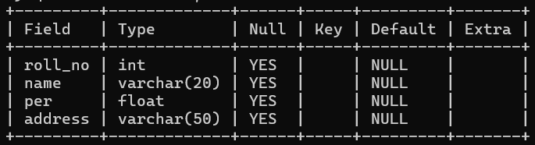

**alter table students modify column address varchar(75);**

**desc students;**

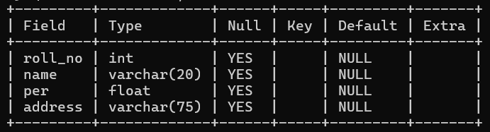

**2)Add column**

**desc students;**



**alter table students add column phone int(11);**

**desc students;**

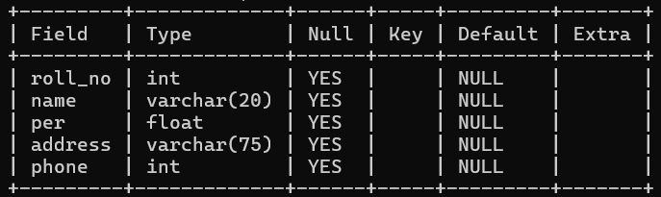

**3)drop column**

**desc students;**



**alter table students drop column phone;**

**desc students;**

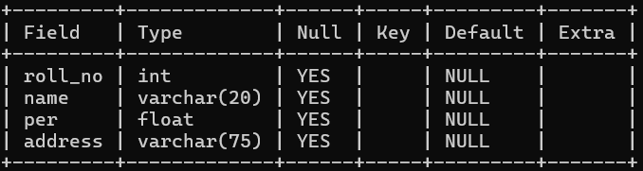

**4)Change/Rename column name.**



**alter table students change column name stud_name varchar(20);**

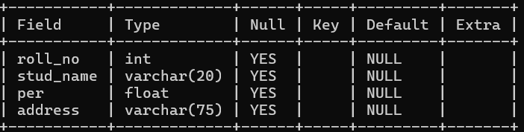

* **Constraints**

**1)Not Null**

**create table person ( id int not null, LastName varchar(255), FirstName varchar(255), age int);**

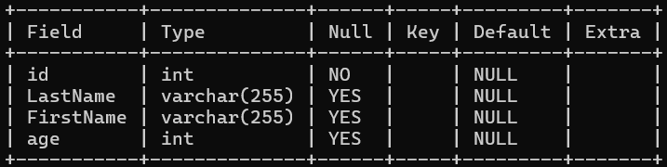

**2)Unique**

**create table person1 ( id int not null unique, LastName varchar(255), FirstName varchar(255), age int);**

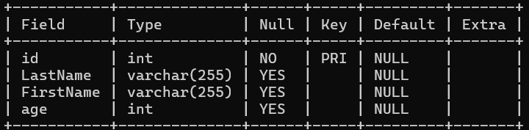

**create table persons ( id int not null, lastname varchar(255) not null, firstname varchar(255), age int, unique (id) );**

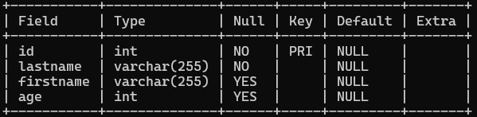

**alter table persons add unique (age);**

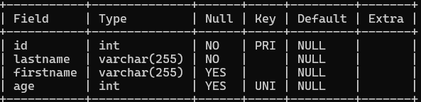

**3)Default**

**create table persons4 (id int not null, lastname varchar(255) not null, firstname varchar(255), age int, city varchar(255) default 'sandnes');**

**ALTER TABLE Persons ALTER City SET DEFAULT 'Sandnes';**

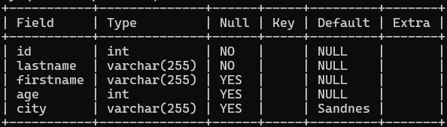

**4)Primary Key**

**create table person1 ( id int not null primary key, LastName varchar(255), FirstName varchar(255), age int);**

