* **Update**

**create table emp(eno int primary key,ename varchar(20),designation varchar(20),salary float,date_of_joining varchar(20));**

**desc emp;**

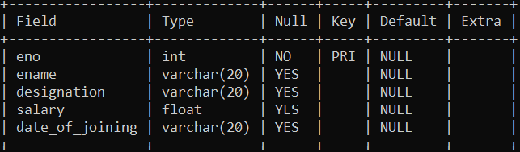

**INSERT INTO oit VALUES(1,'SAKSHI','ASSISTANT',54000,'23/03/2024' );**

**INSERT INTO OIT VALUES(2,'TANMAY','ASSISTANT',54000,'13/04/2024' );**

**INSERT INTO OIT VALUES(3,'SURAJ','MANAGER',74000,'13/01/2024' );**

**INSERT INTO OIT VALUES(4,'ROHAN','ASSISTANT',52000,'13/7/2024' );**

**INSERT INTO OIT VALUES(5,'RAMDASH','MANAGER',80000,'13/04/2023' );**

**INSERT INTO OIT VALUES(6,'MANISH','ASSISTANT',44000,'15/04/2024' );**

**INSERT INTO OIT VALUES(7,'NILAM','ASSISTANT',57000,'13/06/2024' );**

**select * from oit;**

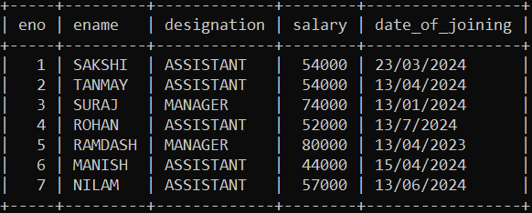

**alter table oit add column email varchar(20);**

**select * from oit;**

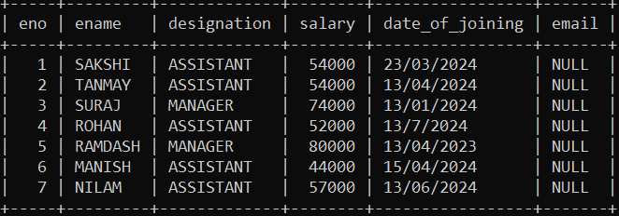

**update oit set email='sakshiexample12@gmail.com' where eno=1;**

**select * from oit;**

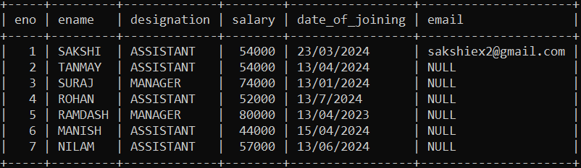

**Update oit set salary=salary+(salary*0.05);**

**select * from oit;**

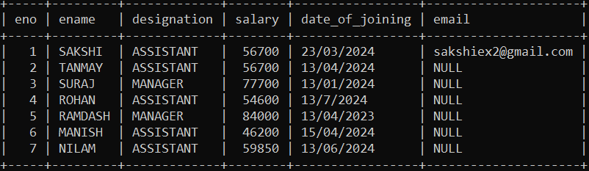

**update oit set ename='Mrs.SAKSHI' where eno=1;**

**select * from oit;**

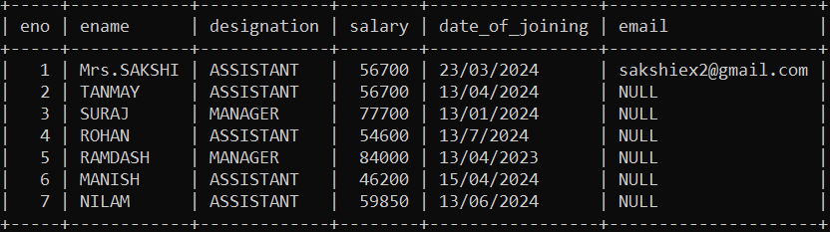

**update oit set designation='Sr.Assistant' where eno=2;**

**select * from oit;**

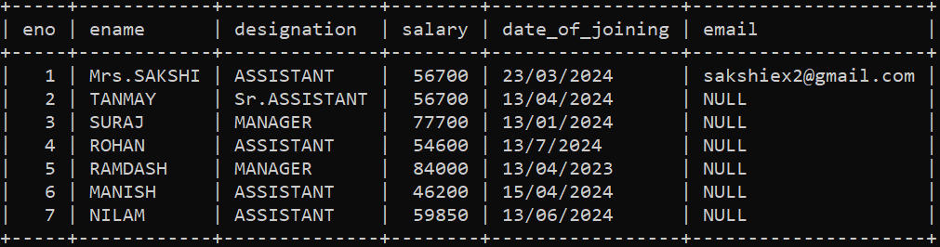

**alter table oit add column city varchar(30);**

**select * from oit;**

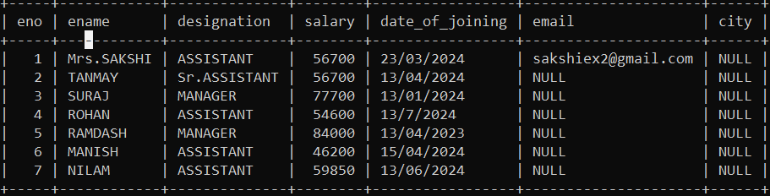

**update oit set city='Pune' where ename='Mrs.SAKSHI';**

**select * from oit;**

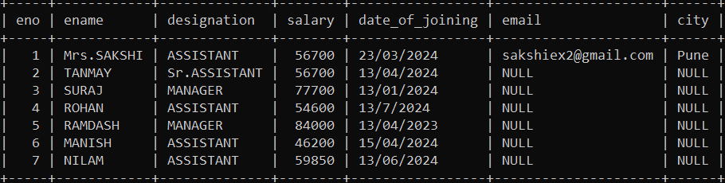

**update oit set salary=salary-(salary*0.05) where ename='NILAM';**

**select * from oit;**

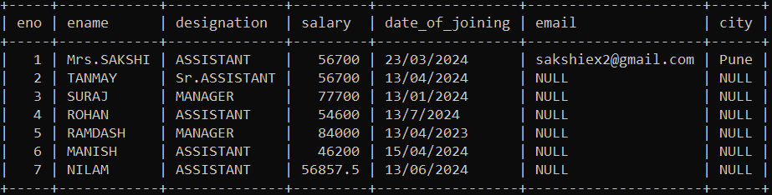

**alter table oit add column phone_no int;**

**select * from oit;**

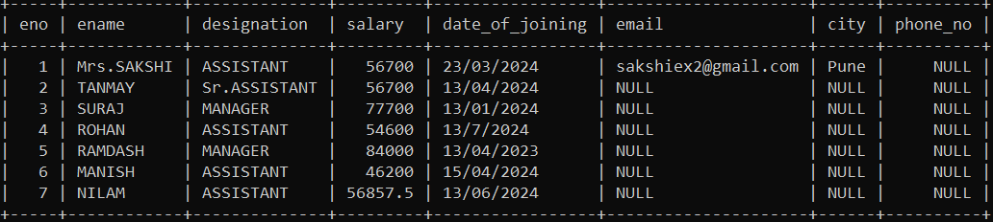

**update oit set city='Mumbai' where ename='TANMAY';**

**select * from oit;**

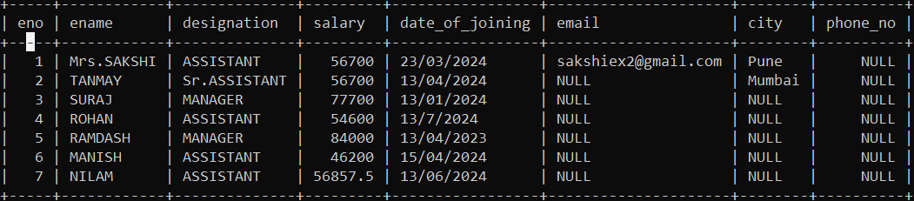

**update oit set date_of_joining='13/7/2024';**

**select * from oit;**

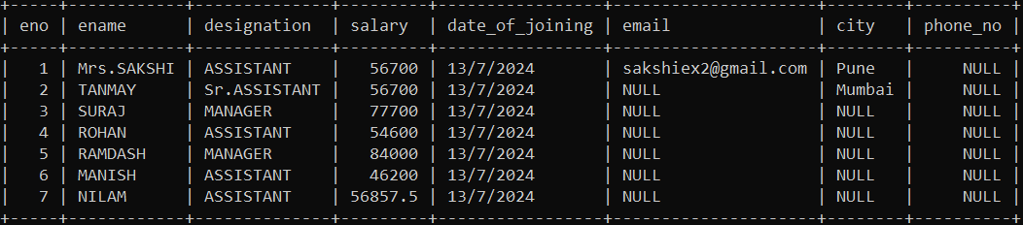

* **Delete**

**select * from oit;**



**delete from oit where eno=7;**

**select * from oit;**

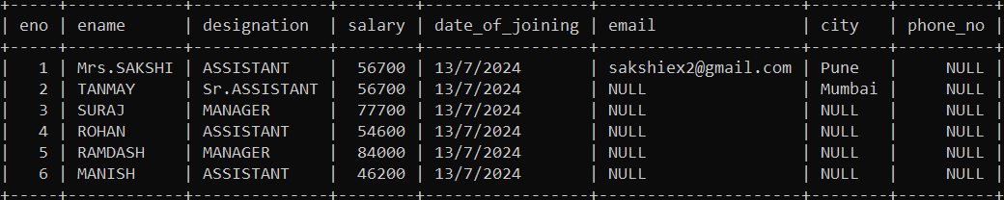

**delete from oit;**

* **SELECT**

**select * from oit;**



**select * from oit where eno=2;**

**select * from oit where ename='TANMAY';**

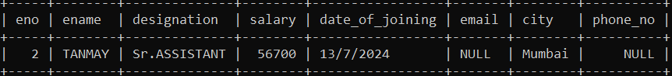

**select salary, designation from oit where eno=4;**

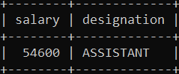

**select * from oit where designation='MANAGER';**

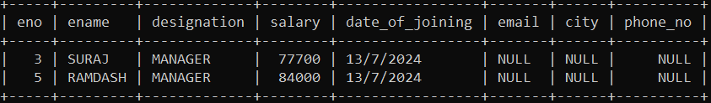

**select date_of_joining from oit where eno=6;**

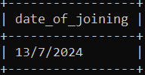

**SELECT eno,ename,salary FROM `oit` WHERE salary>50000;**

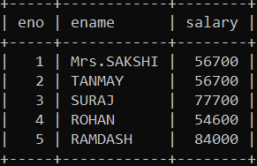

**SELECT * FROM `oit` WHERE salary<50000;**

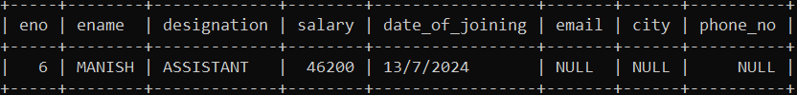

**SELECT * FROM `oit` WHERE salary>56700;**

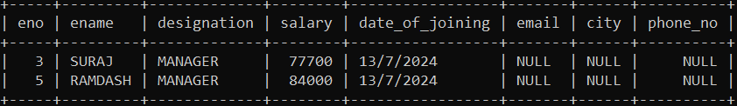

**SELECT * FROM `oit` WHERE salary>=56700;**

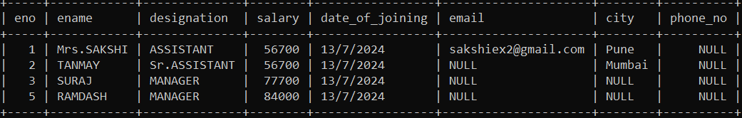

**SELECT * FROM `oit` WHERE salary<>56700;**

