**select designation, ename from oit where salary>=100000 and designation='Manager';**

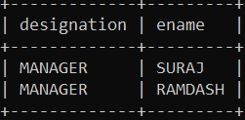

**select ename from oit where city='pune' or city='mumbai';**

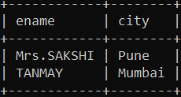

**select * from oit where salary>=50000 and (designation='MANAGER' or designation=' Sr.ASSISTANT');**

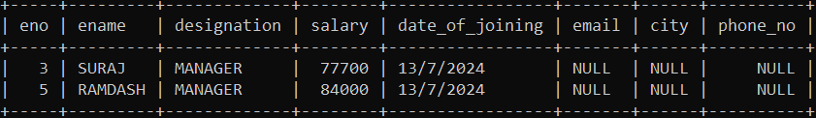

**update oit set salary=salary+(salary*0.05) where salary>=50000 and ename='TANMAY';**

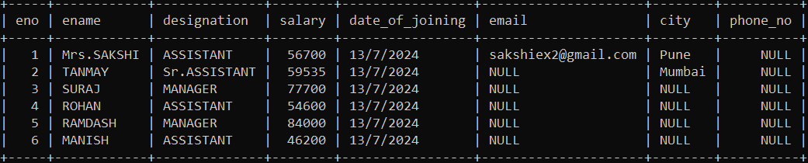

**insert into oit values(7,'Mrs.SALONI','ASSISTANT',55000,'23/7/2024','saloni@gmail.com','pune',1234567890);**

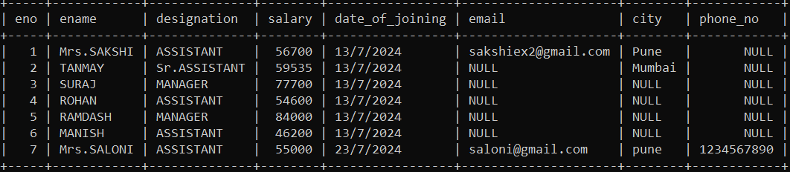

**delete from oit where eno=4;**

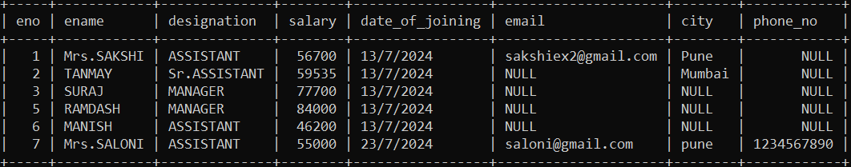

**insert into oit values(8,'Mr.AKASH','ASSISTANT',58000,'23/7/2024','akash@gmail.com','pune',1234567890);**

**select * from oit;**

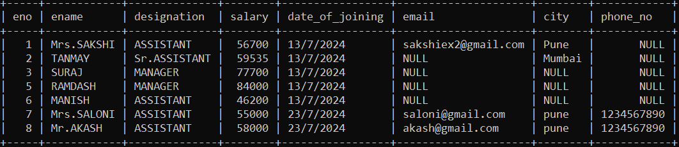

* **Distinct**

**Select Distinct * from oit where city='pune';**

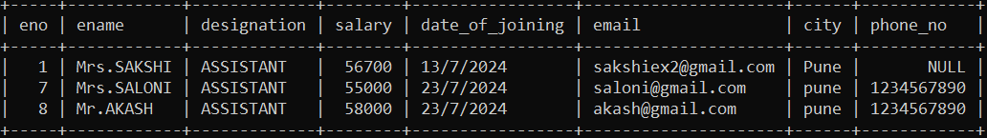

**select distinct city from oit where designation='MANAGER';**

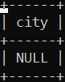

**select ename,designation from oit where eno between 1 and 4;**

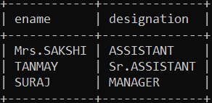

**select ename from oit where eno between 1 and 4 or ename='SURAJ';**

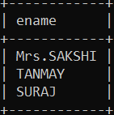

**select ename from oit where eno between 1 and 4 and ename='SURAJ';**

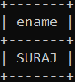

**update oit set city='Pune' where salary between 40000 and 100000;**

**select * from oit;**

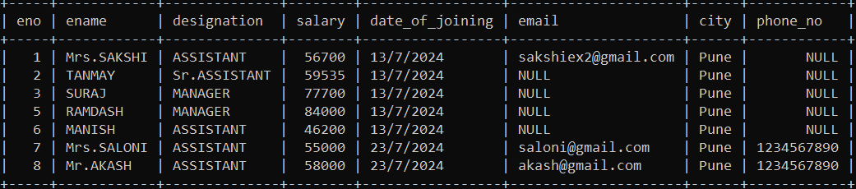

* **In**

**select * from oit where city in ('Mumbai');**

