 | Department Of Computer Engineering Academic Year 2025 - 2026

Microproject Title: | Smart Event Registration

- Group Members:
23203A0037 – Shriraj Arote
23203A0048 – Eshan Shirasekar
24203A1004 – Gitesh Kadam

- Introduction:
The Smart Event Registration System is a web-based application developed using React. It allows users to register for different events through an interactive form and view registered participants in a structured format.
The system performs real-time validation, stores user data dynamically, and provides additional features such as search, deletion, and event pass generation. This project demonstrates the use of modern client-side scripting techniques using React components and hooks.

- Problem Statement
Manual event registration is time-consuming and prone to errors. There is a need for a system that can:
- Collect user details efficiently
- Validate input data
- Store and manage registrations
- Provide quick access to participant details
The proposed system solves these problems using a web-based interface.

- Methodology
The application follows a component-based architecture:
Components Used:
- App.js → Main controller (handles data & state)
- RegistrationForm.jsx → Handles user input & validation
- RegistrationList.jsx → Displays users & search functionality
- EventPass.jsx → Generates event pass

Working Flow:
- User fills registration form
- Data is validated
- Data is stored using useState
- Registered users are displayed in table
- User can search, delete, or view pass

- Features of the System
- User Registration Form
- Real-time Form Validation
- Dynamic Data Storage
- Search Functionality
- Delete User Option
- Event Pass Generation
- Print Event Pass
- Responsive UI Design

- Working Explanation
- The application uses React functional components
- useState is used to manage user data
- Form validation ensures correct input (email, phone, etc.)
- .map() is used to display users dynamically
- Conditional rendering is used for:
  - Empty state
  - Search results
  - Event pass modal

- Output:
- Registration Form
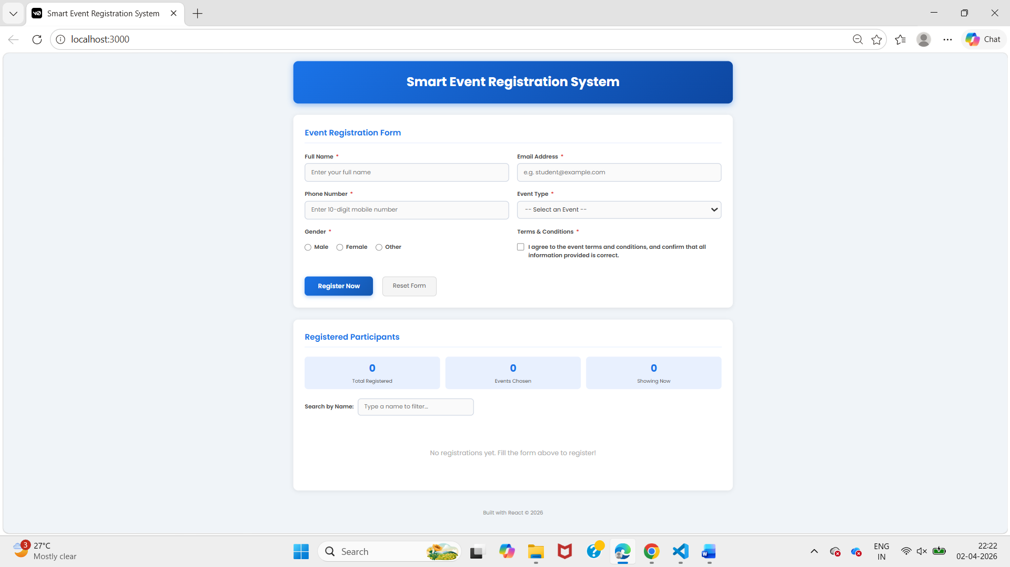
- Registered Users Table
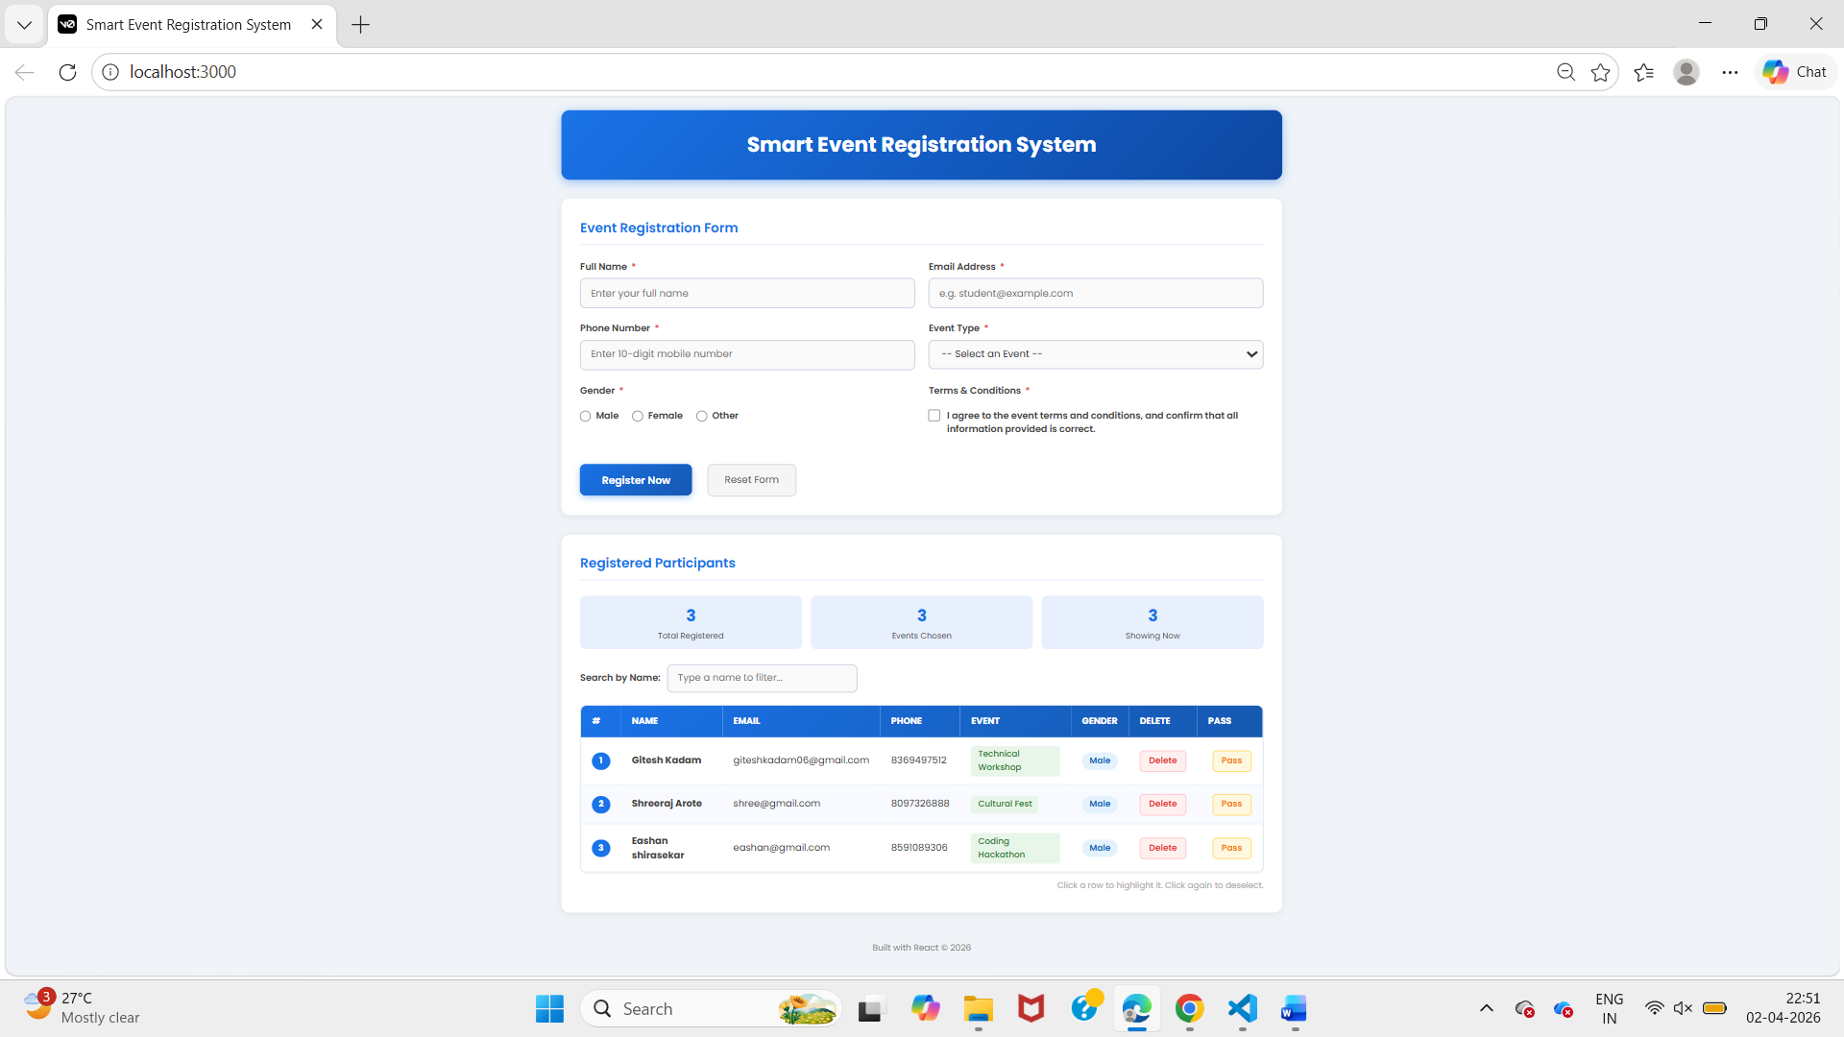

- Search Functionality
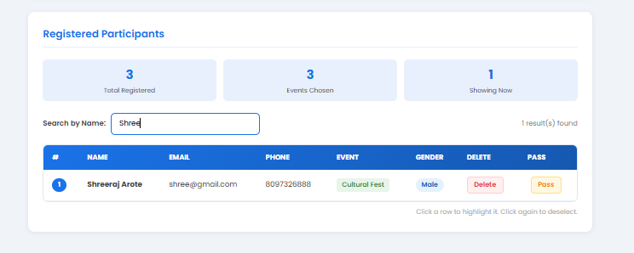

  - Future Scope
- Add database (MongoDB/Firebase)
- Add login/signup system
- Email confirmation
- Admin dashboard
- Export data to Excel

- Conclusion: The Smart Event Registration System successfully demonstrates the use of React for building dynamic and interactive web applications. It simplifies event registration and improves efficiency through automation and validation.

