Chatrasahaya’s User Manual

Version 1.0

Team Member

Vikas Sabbi ( 2836919 )

Keshav Singhal ( 2822290 )

Tanmay Rajgor ( 2827074 )

Table of Contents

1. Introduction 1

1.1 Overview 1

2. Getting Started 2

2.1 Set-up Considerations 2

2.2 User Access Considerations 2

2.3 System Organization & Navigation 2

2.4 Exiting the System 2

3. Using the System 3

3.1 Home Page 3

3.2 About Page.....................................................................................................4

3.3 Join Us Page....................................................................................................5

3.4 Programs Page................................................................................................6

3.3 Contact Us Page..............................................................................................7

3.3 Request Us Page.............................................................................................8

3.3 Search ..........................................................................................................10

4. Troubleshooting & Support 11

4.1 Error Messages 11

4.2 Special Considerations 11

List of Figures

|  |  |  |
| --- | --- | --- |
| **FIGURE_NO** | **NAME** | **PAGE No** |
| Fig 1 | Home Page | 3 |
| Fig 2 | About Page | 4 |
| Fig 3 | Join Us Page | 5 |
| Fig 4 | Programs Page | 6 |
| Fig 5 | Contact Us Page | 7 |
| Fig 6 | Request Us Page | 8 |
| Fig 7 | Mail Notification | 9 |
| Fig 8 | Map & Count View | 10 |
| Fig 9 | Search Icon | 10 |
| Fig 10 | Search Text Box | 10 |
| Fig 11 | Search Results | 11 |

## Introduction

This software will help the Chatrasahaya to be more efficient in submitting of their requests such as money,food and other needs…and tracking of submission on the maps. It also sends the mails to the internal team to check the submissions quickly. The purpose of this project is to computerize all details regarding submissions from request us,Users can submit their required needs likes education,financial,Health…from the **Request Us for Self /For Others** Page by using some fields such as **Name** -- Full Name of the requester , **Phone Number** -- Phone/mobile Number of the Requester , **Location** -- The place of the request where books,chairs,tables are needed for the schools , **Category--** Its was type of the request such as education,financial,Health **Description** -- Its was the description/overview of the needs , **Aaadhar Number** -Its was unique identity number of the requester, **Documents** --- Proof of the documents needs to be uploaded here.

**Modules/Features as list below:**

* **Home**-It helps to access the other modules in the application from the home page
* **About**-It helps to know the chatrasahaya website details and activities
* **Join Us**-Its helps the people/end users to join in the team by submitting the form
* **Programs** -It helps to know the chatrasahaya programs conducted
* **Contact Us**-Its was useful to the people/end users to contact the team for any issues/queries
* **Request Us-**Its was useful to request the service from the chatrasahaya by submitting the form based on the category
* **Search** -Its was use to search any features or modules.

### Overview

It is meant to delineate the features of Request Us & Maps Menus for the existing application, so as to serve as a guide to the developers on one hand and as a software validation document for the prospective client on the other.Request Us & Maps are two enhancements for the existing application called **chatrasahaya** for a web application. Our application is designed for User/Customer for requesting of required categories likes education,financial,Health to gain best education for less budget schools or free schools for the existing application.Maps can show the count for the each state based on requests completed by the users/team.

## Getting Started

### Internal team/End Users should have the laptop and browser installed in their machines to access the application with proper internet connection.

### Set-up Considerations

User should have the browser installed and should the known the website url (https://chatrasahaya.org/) to access the application

### User Access Considerations

User should have the email id,aadhar id,phone number,proofs of documents while trying to submit the request us page

### System Organization & Navigation

System organization and navigation of the application should be as follows

* **Home**-It helps to access the other modules in the application from the home page
* **About**-It helps to know the chatrasahaya website details and activities
* **Join Us**-Its helps the people/end users to join in the team by submitting the form
* **Programs** -It helps to know the chatrasahaya programs conducted
* **Contact Us**-Its was useful to the people/end users to contact the team for any issues/queries
* **Request Us-**Its was useful to request the service from the chatrasahaya by submitting the form based on the category
* **Search** -Its was use to search any features or modules.

### Exiting the System

User should simply close the browser tab after using the application.

## Using the System

Using of the application should be stated by the features wise of the pages how does its works as below in the next section.

### Home Page(https://chatrasahaya.org/)

This helps the user to access the other modules in the application from the home page

**Steps :**

1. Open the browser and Enter the Url of the application
2. Home page will be displayed

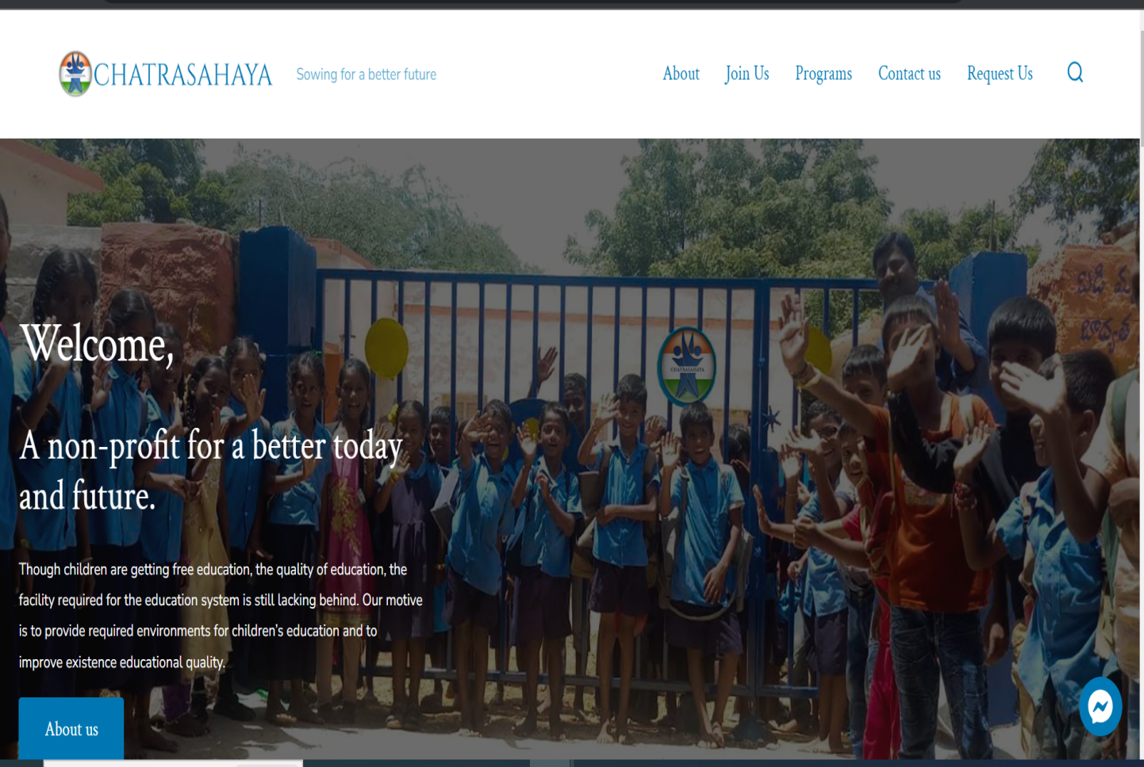

**Fig 1: Home Page**

### About

It helps to know the chatrasahaya website details and activities

**Steps :**

1. Open the browser and Enter the Url of the application
2. Home page will be displayed
3. Click on About link in the Home Page
4. About Page will be displayed

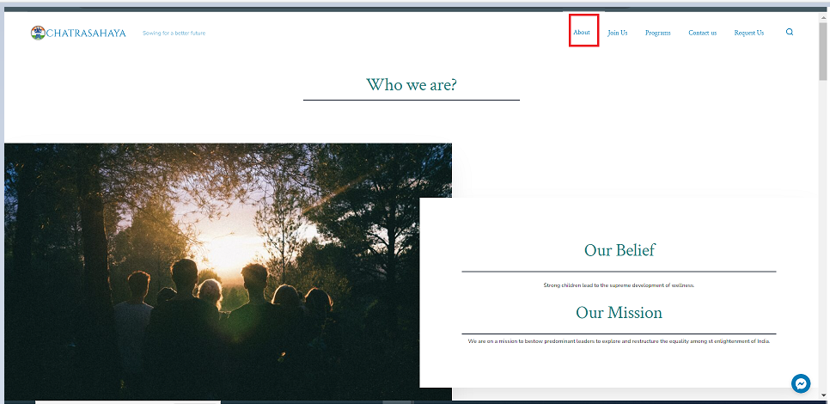

**Fig 2: About Page**

### Join Us

Its helps the people/end users to join in the team by submitting the form

**Steps :**

1. Open the browser and Enter the Url of the application
2. Home page will be displayed
3. Click on Join Us link in the Home Page
4. Join Us Page will be displayed

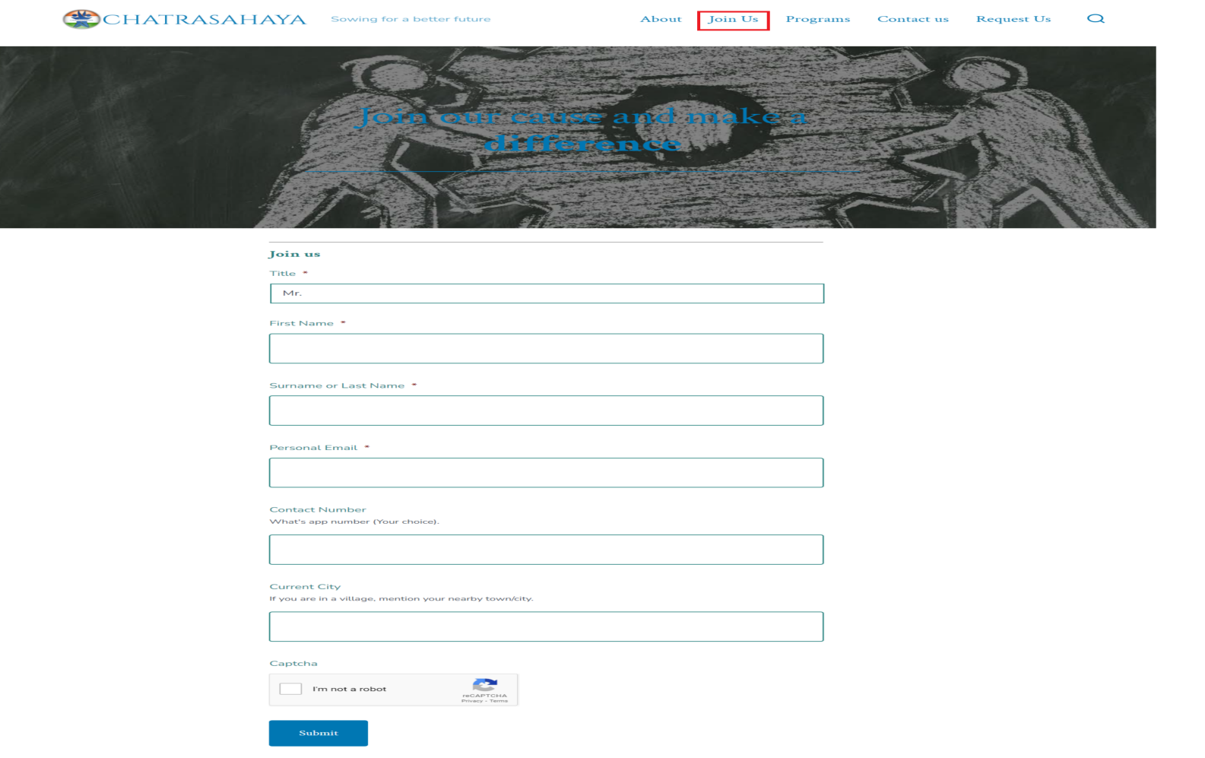

**Fig 3:Join Us Page**

### Programs

It helps to know the chatrasahaya programs conducted

**Steps :**

1. Open the browser and Enter the Url of the application
2. Home page will be displayed
3. Click on Programs link in the Home Page
4. Programs Page will be displayed



**Fig 4:Programs Page**

### Contact Us

Its was useful to the people/end users to contact the team for any issues/queries by submitting the form

**Steps :**

1. Open the browser and Enter the Url of the application
2. Home page will be displayed
3. Click on Contact Us link in the Home Page
4. Contact Us Page will be displayed

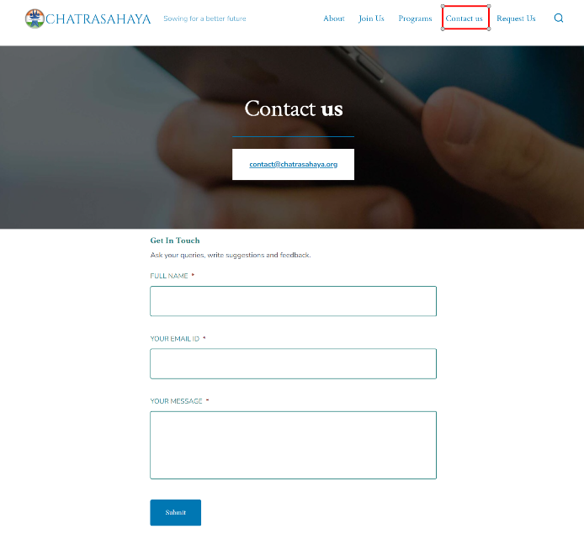

**Fig 5: Contact Us Page**

### Request Us

Its was useful to request the service from the chatrasahaya by submitting the form based on the category

**Steps :**

1. Open the browser and Enter the Url of the application
2. Home page will be displayed
3. Click on Request Us link in the Home Page
4. Request Us Page will be displayed
5. Enter the Name,Phone in the Page
6. Enter the Valid Email,Valid Aaadhar Id in the Page
7. Enter the Request Description
8. Upload the Proof of the documents for the request to the team
9. Enter any fields such as Category,City,State,Country,Zip if required as per your needs
10. Click on **Request Us** Button

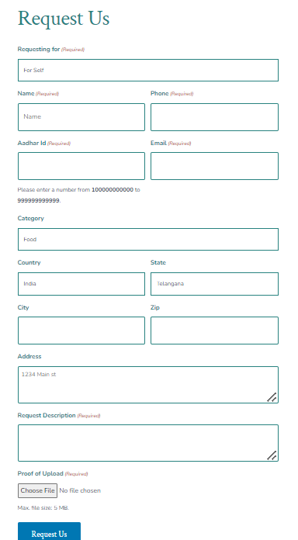

**Fig 6: Request Us Page**

After User submitting the Request Us form, End Users can receive the email notification from the website as below screenshot

**Fig 7: Email Notification**

Based on the Request Submissions from the Request Us Form, User can view the counts of the Request Submissions and Categories in the Map & Count View

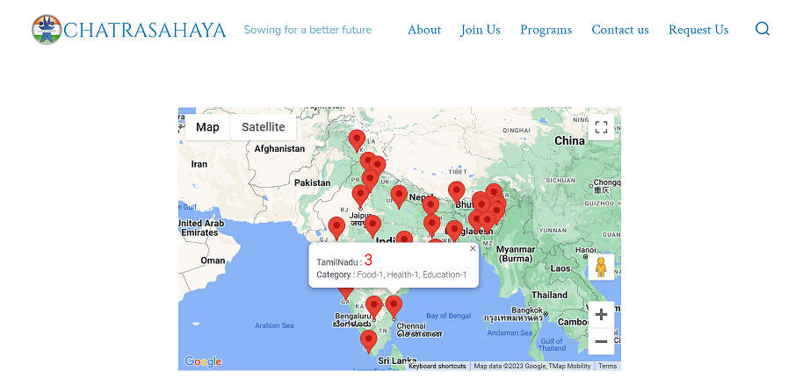

**Fig 8: Map & Count View**

### Search Icon

Its was use to search any features or modules.

**Steps :**

1. Open the browser and Enter the Url of the application
2. Home page will be displayed
3. Click on Search Icon in the Home Page

**Fig 9: Search Icon**

1. Enter the Search Text



**Fig 10: Search Text Box**

1. Results Will be displayed as below after search



**Fig 11: Search Results**

## Troubleshooting & Support

Internal team can troubleshooting the errors while running the application in the console

### Error / Confirmation Messages

Internal team can troubleshooting the errors while running the application in the console

1. **Thanks for contacting us! We will get in touch with you shortly.**-- This means user has successfully submitted the join us,request us,contact us forms
2. **There was a problem with your submission. Please review the fields below.** -- This means user have entered invalid data or missing data fields in the form

Note : Red Indicates Error Message and Green indicates confirm message

### Special Considerations

N/A

Contact us for any questions.

Email: chatrasahya.org