Seminar Report
On
India’s Telecom landscape
Submitted by
Tanmay Talmale Registration No. 12215422
Bachelor of Technology
IN
(Computer Science and Engineering)
Under the Supervision of

Name of the Faculty
Designation


LOVELY PROFESSIONAL UNIVERSITY PUNJAB
(---April, 2026 )

DECLARATION

I hereby declare that the seminar report titled “India’s Telecom Landscape” submitted in partial fulfilment of the requirements for the award of the degree of Bachelor of Technology in Computer Science and Engineering is a record of my own work carried out during the academic session 2022-2026.
I further declare that this report has not been submitted, either in part or in full, to any other institution or university for the award of any degree or diploma.
I confirm that the content of this report is original and prepared by me. Any references used have been duly acknowledged. I also declare that the use of Artificial Intelligence (AI) tools, if any, has been minimal and the AI-generated content in this report is less than 10%, ensuring that the majority of the work reflects my own understanding and effort.
I take full responsibility for the authenticity and originality of the work presented in this report.


Name of the Student: Tanmay Talmale
Registration Number: 12215422
Course: B.Tech CSE
Signature of the Student:
Date: --/04/2026

Chapter 1: Introduction

  - Title of the Seminar Topic
India’s Telecom Landscape: State-wise Penetration and Growth Analysis

  - Background and Importance of the Topic
India’s telecom sector is one of the largest and fastest-growing industries in the world, serving as a critical economic driver for digital development. With over 1.16 billion subscribers in 2022, mobile networks and internet services have expanded rapidly across the country. However, this growth is highly uneven — some states dominate in absolute numbers while others show explosive percentage growth. Rural penetration is steadily improving, yet urban areas continue to lead in high-value subscribers.

For a telecom company (e.g., Reliance Jio, Bharti Airtel, or Vodafone-Idea), understanding these trends is critical for:

- Strategic network expansion
- Targeted marketing campaigns
- Resource allocation between rural and urban circles
- Competitive positioning and revenue forecasting

This project positions me as a Data/Business Analyst who can deliver high-impact insights from raw public data.

1.3 Objectives of the Seminar

- To analyse 15 years of state-wise telecom subscriber data (2008–2022).
- To identify top-performing states, fastest-growing markets, and rural vs urban penetration patterns.
- To develop Python-based visualisations for clear business storytelling.
- To derive actionable recommendations that a telecom operator can directly implement for market expansion and customer acquisition.

1.4 Brief Overview of the Approach

Publicly available TRAI data (Table 3.1) was analysed using a custom Python program (Telecom.py). The workflow included data cleaning with pandas, followed by visualisation using matplotlib and seaborn. Five key business dashboards were generated to support strategic insights. All analysis was performed locally, ensuring reproducibility and zero external cost. The complete project, including code and visualisations, is hosted on GitHub for future reference or extension by any telecom analyst.

Chapter 2: Literature Review

The Indian telecom sector has been extensively studied by TRAI, GSMA, and academic researchers. Key findings from recent literature include:

- Rapid shift from wireline to wireless subscribers (wireline share dropped from ~13% in 2008 to ~2% in 2022).
- Rural subscriber base grew from 76.5 million (2008) to 519.63 million (2022), yet rural penetration still lags urban areas.
- Post-2016 Jio effect: overall subscriber base peaked around 2017–2018 and then stabilised due to market consolidation.
- State-level disparities: Uttar Pradesh, Bihar, Maharashtra, and Rajasthan consistently dominate total subscriber numbers and growth.
Previous studies have focused on national aggregates. This project fills the gap by providing state-level, rural-urban, and growth-trend analysis with ready-to-use Python code that any telecom analyst can run and customise.

Chapter 3: Conceptual Study / Seminar Work

3.1 Core Concepts

Subscriber Metrics: Total, Wireline, Wireless, Rural, Urban, Public, Private operators.
Key Business KPIs: Market size, Year-on-Year growth, Rural penetration %, Urban dominance.

3.2 System Architecture / Workflow

The complete workflow (as implemented in Telecom.py):
- Load CSV → Data Cleaning (remove national totals).
- Convert Year to integer.
- Generate analytical visualisations.
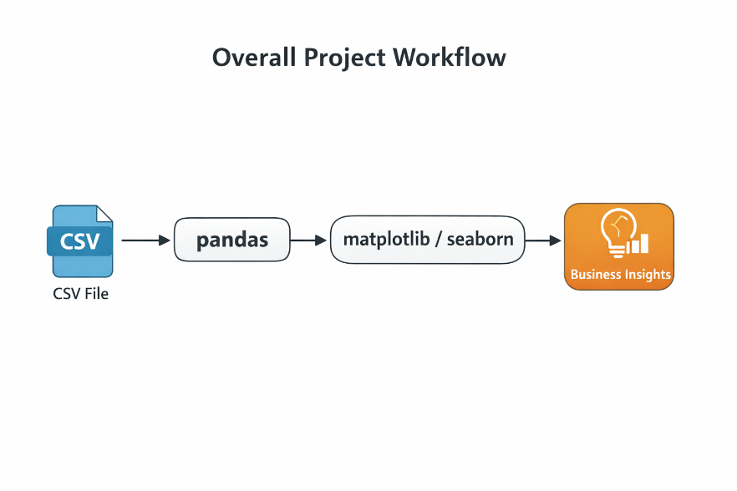
Figure 3.1

3.3 Technologies and Tools Used

- Programming Language: Python 3
- Libraries: pandas, matplotlib, seaborn
- IDE: VS Code
- Data Source: TRAI public dataset (Table 3.1)
Chapter 4: Results and Discussion

All visualisations were generated by executing Telecom.py. Below are the key business insights:

4.1 Top 10 States by Total Subscribers (2022)
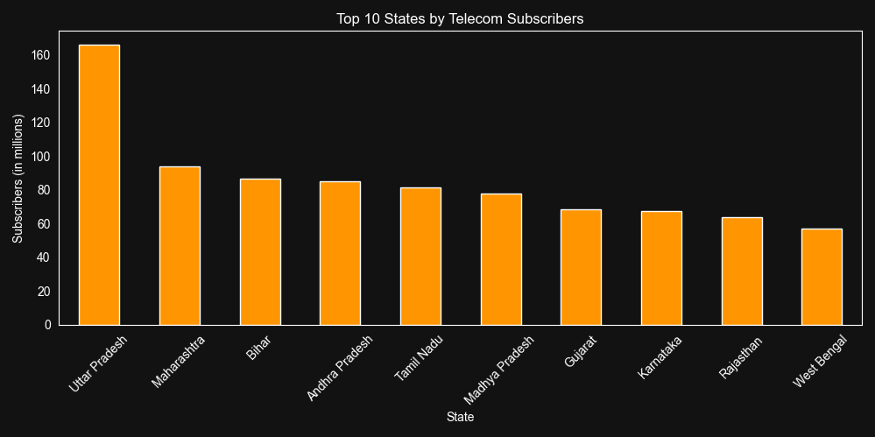
Figure 4.1 (Top 10 States by Telecom Subscribers)
- Uttar Pradesh - 165 million
- Maharashtra - 95M
- Bihar - 87M
- Andhra Pradesh - 85M
- Tamil Nadu - 82M
- Madhya Pradesh - 78M
- Gujarat - 68M
- Karnataka - 67M
- Rajasthan - 64M
- West Bengal - 57M
Business Insight: These ten states account for nearly 70% of India’s total telecom base. Operators should prioritise 5G spectrum allocation and tower infrastructure in these circles for maximum ROI.

4.2 Top 10 Fastest Growing States (2008–2022)
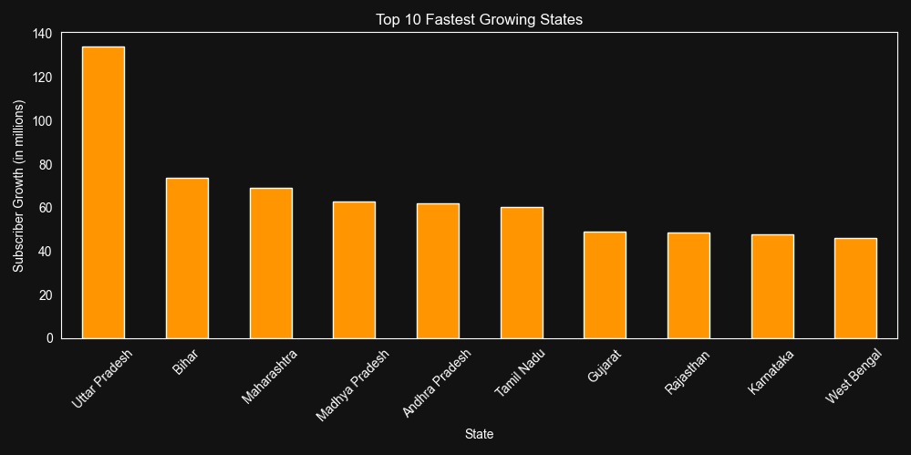
Figure 4.2 (Top 10 Fastest growing States)

Uttar Pradesh recorded the highest absolute growth of 135 million subscribers, followed by Bihar (≈75M), Maharashtra (≈70M), Madhya Pradesh (≈63M), Andhra Pradesh (≈62M), Tamil Nadu (≈61M), and others.

Business Insight: High-growth states represent future revenue opportunities. Early investment in network capacity here can capture significant market share before saturation.

4.3 Rural vs Urban Analysis
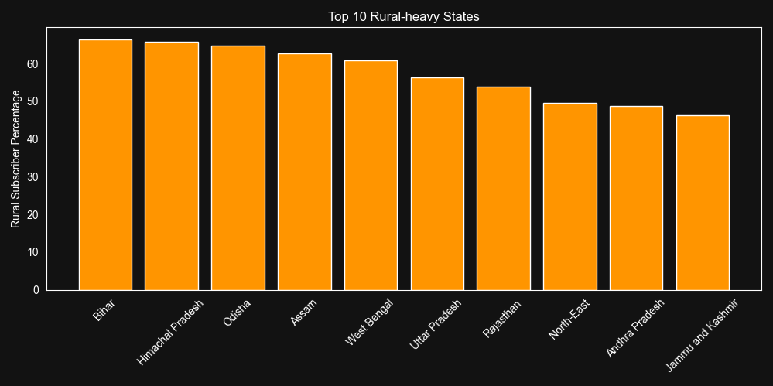
Figure 4.3.1 (Top 10 Rural-heavy states)

Bihar, Himachal Pradesh, Odisha, Assam, and West Bengal show the highest rural subscriber percentages (55–66%).

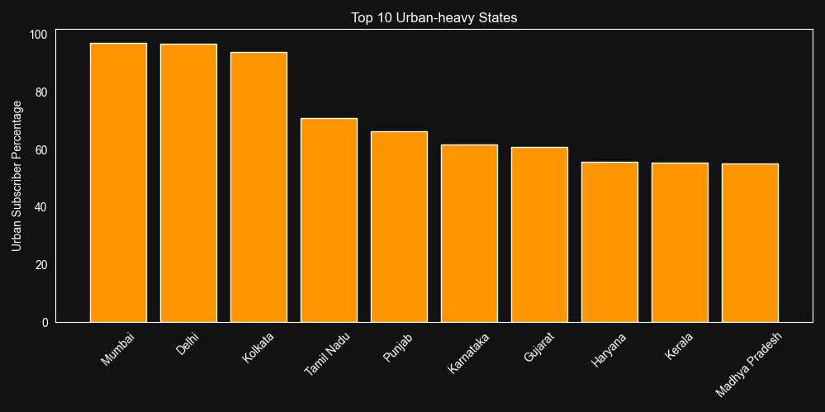
Figure 4.3.2 (Top 10 Urban-heavy States)

Mumbai, Delhi, and Kolkata dominate with 94–97% urban subscribers, followed by Tamil Nadu, Punjab, and Karnataka.

Business Insight: Rural-heavy states offer massive untapped potential for low-cost data plans and feature-phone reactivation campaigns. Urban-heavy circles require premium 5G, enterprise solutions, and high-ARPU services.

4.4 Year-wise Heatmap (State vs Year)
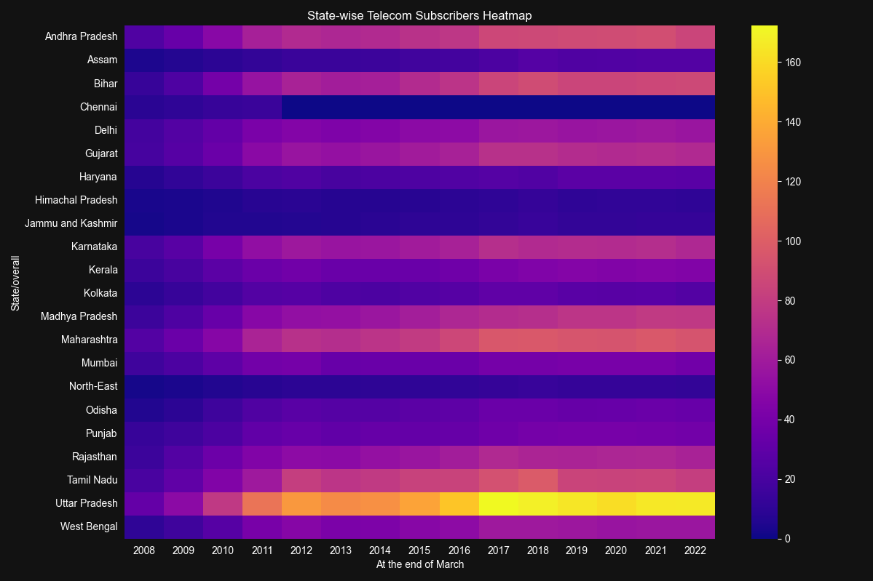
Figure4.5(State-wise Telecom Subscribers Heatmap)

The heatmap clearly shows consistent upward growth across most states, with Uttar Pradesh exhibiting the brightest intensity (highest subscriber addition) in recent years.

4.5 Advantages, Limitations & Insights
Key Findings:
- Uneven growth across states; few states dominate total subscribers.
- Strong growth momentum in northern and central states.
- Urban penetration remains significantly higher than rural, but rural usage is increasing steadily.
Advantages:
- Completely reproducible analysis.
- Identifies high-ROI states for expansion.
- Supports data-driven budgeting for marketing and infrastructure.

Limitations:
- Data is till 2022 only (2023–2025 data can be appended).
- Does not include ARPU or revenue data (can be merged with additional datasets).

Major Learning Outcome: As a Business Analyst, I can turn raw government data into strategic recommendations worth crores in potential revenue for any telecom operator.

Chapter 5: Conclusion and Future Scope

5.1 Summary of the Seminar Work
This individual project successfully analysed 15 years of state-wise telecom subscriber data using Python and delivered five professional business visualisations that clearly demonstrate penetration and growth patterns across India.

5.2 Major Learning Outcomes
- Advanced data cleaning and visualisation skills using pandas, matplotlib, and seaborn.
- Ability to translate raw government data into strategic business recommendations.
- Understanding of how telecom growth directly impacts digital economy and business strategy.
5.3 Conclusions Drawn
Indian telecom growth is highly state-specific and rural-urban skewed. Companies that strategically focus on high-growth rural-heavy states while maintaining premium offerings in urban metros will capture the next phase of subscriber addition and revenue growth.

5.4 Future Scope
- Integrate real-time TRAI API for live interactive dashboards.
- Add ARPU, churn, and revenue forecasting using time-series machine learning models.
- Build an interactive Power BI/Tableau version for C-level presentations.
- Incorporate population data to calculate actual penetration percentages.
- Develop predictive models for 2026–2030 subscriber forecasts.
Professional Profile & Repository Details
- GitHub Project repository Link:
- LinkedIn Profile Link:

