Expectations : 1. basic understanding of document object

2. Basic understanding of how to select elements in a document object (getElementbyId and getElementByClassName , querySelector , querySelectorAll)

3. basic understanding of collections which holds document elements [HTML collections , nodelists] … and how to convert them into array in order to manipulate them

4. basic understanding of innerText , textContent , and innerHTML and understanding the difference between them

5. Practical task to change the headings of the Wikipedia page

Below is a collection of links … These are not arrays… from observation I have learnt that this is an HTML collection …like this there is another data type called as node list … These are not HTML arrays … However you can convert them into arrays so that you can use their functionality of an array

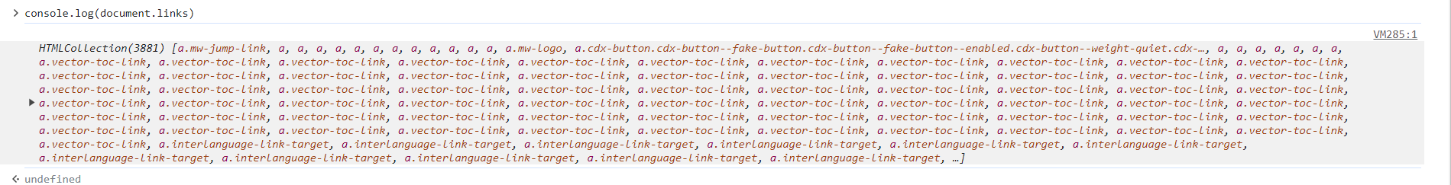

You can zoom and see

You can even select a particular link in that collection

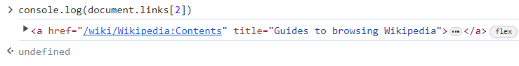

Changing the text of webpage using the below line

document.getElementById('firstHeading').innerHTML="<h3>Tanmay Bhurke<h3/>"

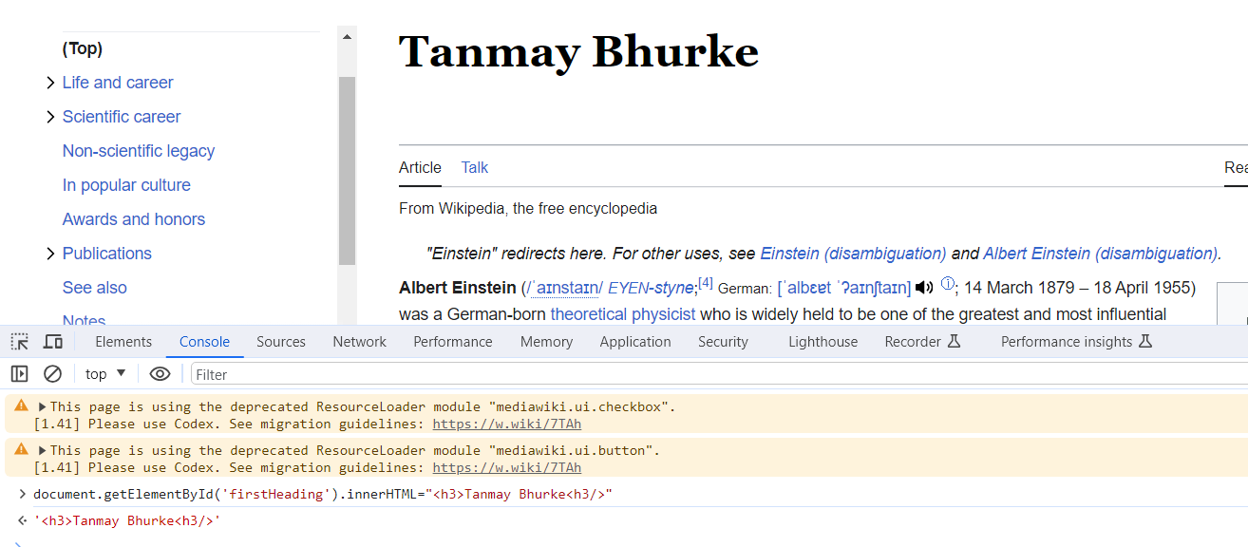

Now we shall learn about DOM selectors

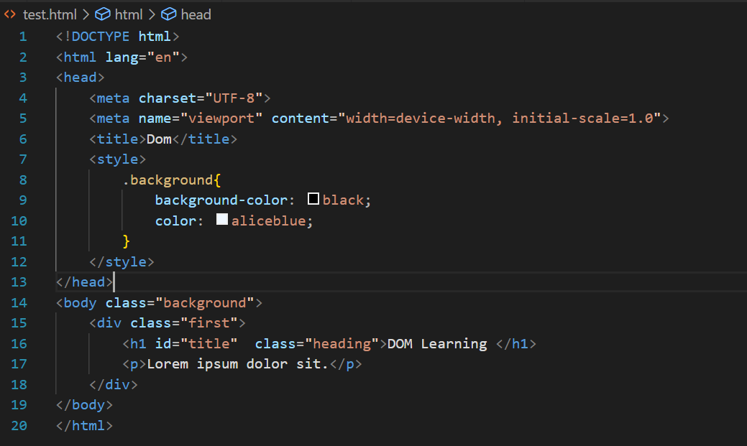

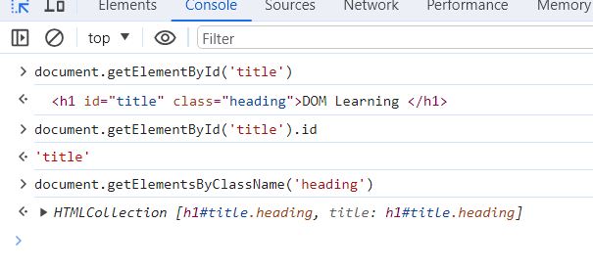

getElementById() – he purna tag sobat result denar

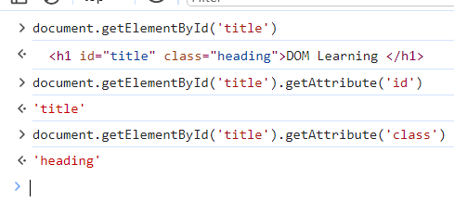

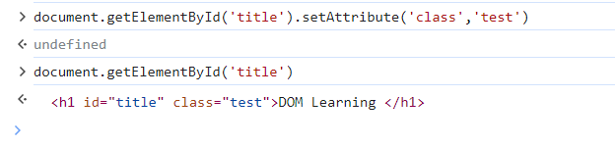

SetAttribute hamesha overwrite karnar

How to set style via browser console

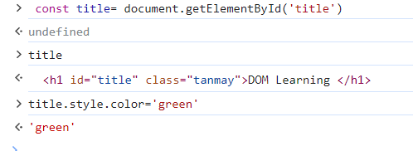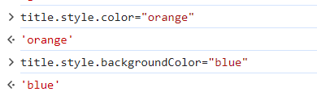

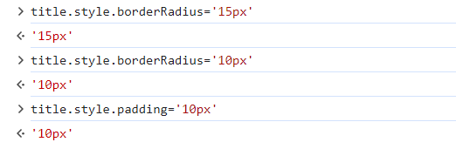



Difference between innerText, innerHTML, textContent:

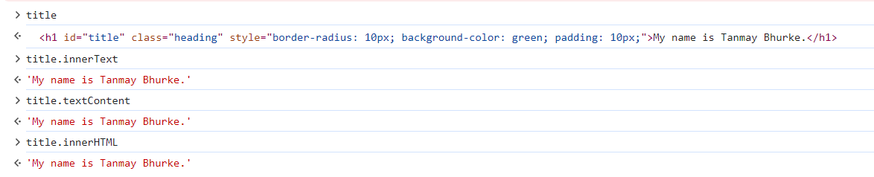

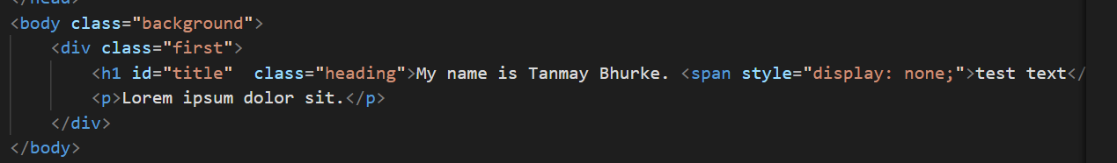

Heading madhe span tag add karun test text add kela ahe + style madhe display none kela ahe so that browser madhe toh span tag render nahi honar

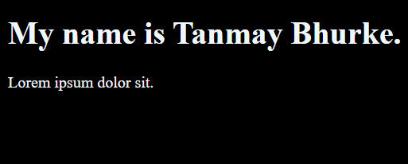

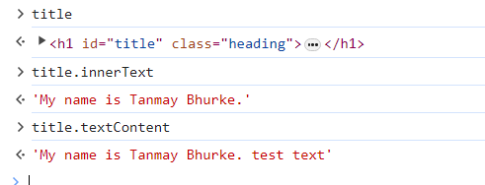

Learning : title.innerText Browser madhe je kay disat ahe tela as a text denar (nuste visual changes karyche astil tr innertext)

Whereas

title.textContent VS code madhlya HTML file cha content show karnar

(hidden things pn distat)

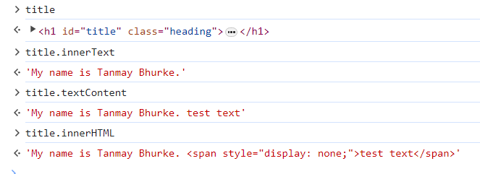

Query Selectors:

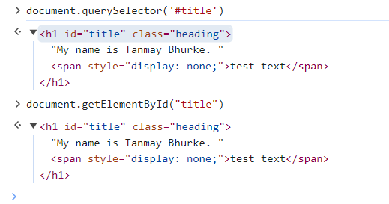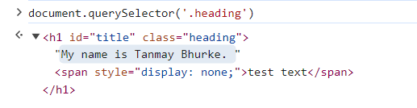

Query selectors pn getElementById/className sarkhach kam karnar

3 rows che unordered list banavtana

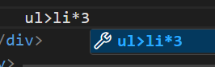

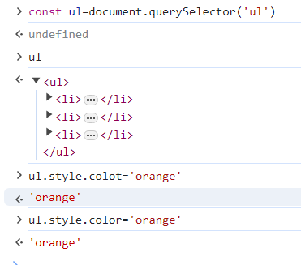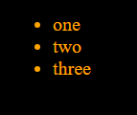

Task:

Making the background of first list item green and giving it a padding of 10px

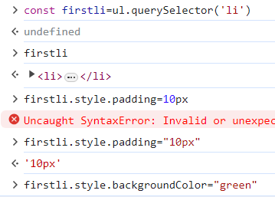

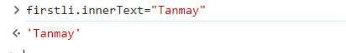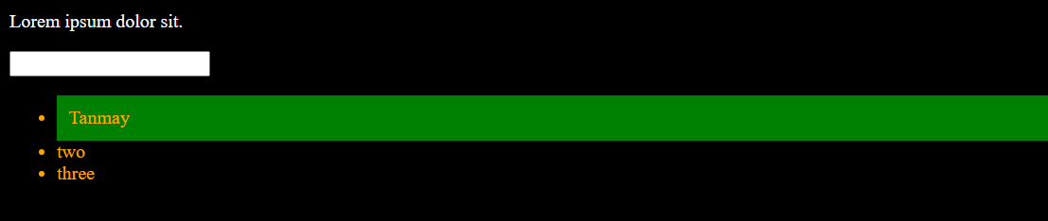

Learning about querySelectorAll(‘li’)

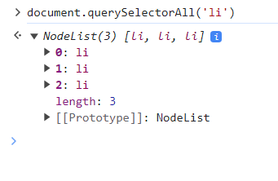

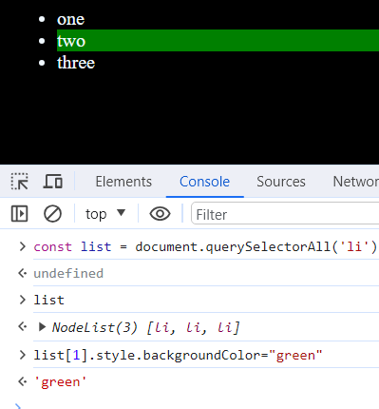

Ekach h1 tag ahe in my browser

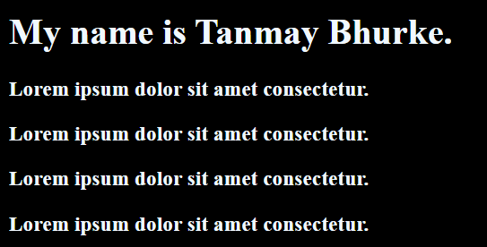

What will happen if we use querySelectorAll and to change the color to green…

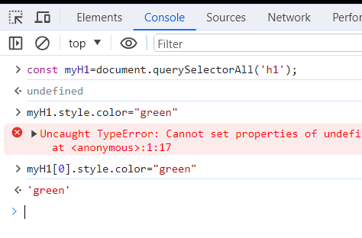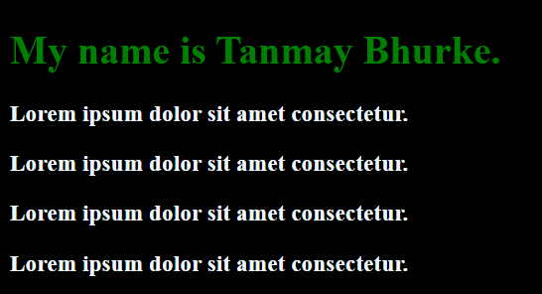

Learning : Since querySelectorAll will return a nodelist so you are supposed to use index while using it

Nodelist varti iterate karun we can perform changes to its properties.. One of the example can be given as follows

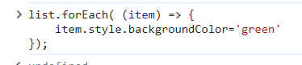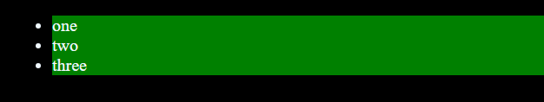

2 Learnings from observation :

document.getElementByClassName kelyavr HTML Collections data type milte which we could convert it into arrays to use later

document.querySelectorAll() kelyavr nodeList milte which again we can convert into

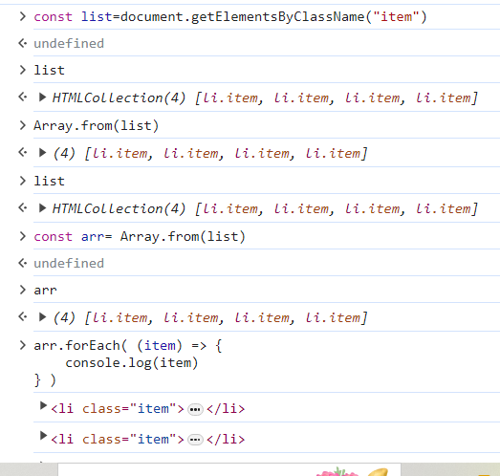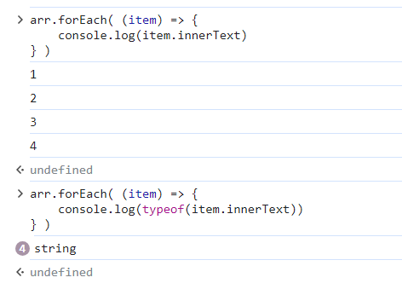

Task is to change the background color of all the li items to green using getElementByClassName()

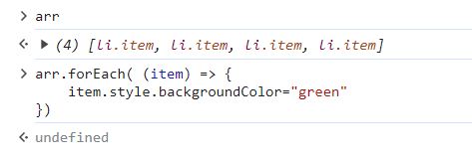

Task : Visit a Wikipedia page and change all the titles of it to your own name and also add style to it (change the color and background color of the text)

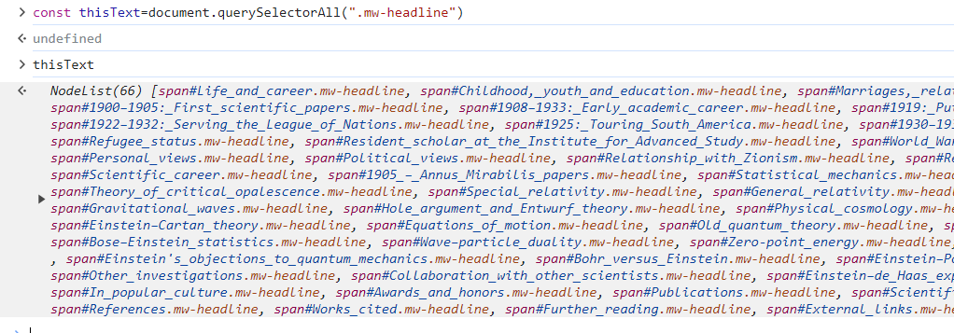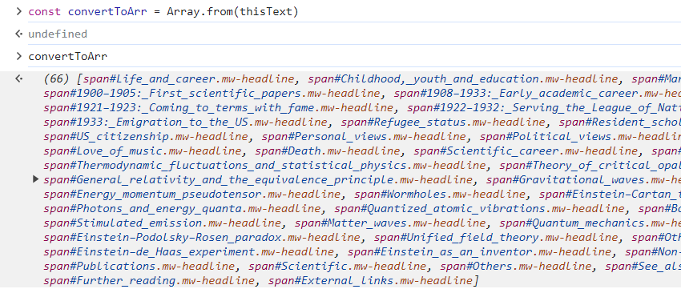

Now applying forEach loop

