IBM SkillsBuild Academic Internship Program
FINAL PROJECT REPORT
Project Title: Real-Time Carbon-Aware Compute Optimization for Modern Data Infrastructure
Author: Rachamadagu Sai Tanmay
Program: Data Analytics with AI Academic Internship (AICTE & BharatCares)
Submission Date: September 2026
_________________________________________________________________________________
1. Abstract
Modern high-performance computing centers supporting digital product platforms consume approximately 1-2% of global electricity. This computational demand triggers large-scale carbon footprints if intensive data backend updates occur when power grids rely on fossil fuels. This project presents an innovative, data-driven approach to sustainable green computing within large-scale tech platforms like e-commerce, food delivery apps, and streaming services. By analyzing 310,789 historical energy load logs from Great Britain (2009–Present), a robust Data Engineering and Machine Learning architecture was structured inside VS Code. A Random Forest Regressor was optimized using time features alongside active grid clean energy percentages, achieving a highly accurate target R² Score of 90.47%. The dynamic compute routing engine successfully shifts non-urgent batch analytical workloads to low-intensity grid intervals (< 275 gCO₂/kWh). The simulated optimization platform proves a direct carbon saving of approximately 11.57 kg of CO₂ per million rows processed, presenting a scalable blueprint for modern, eco-efficient backend cloud systems.
2. Problem Statement
Tech companies like Zomato, Swiggy, or Netflix manage immense data volumes, relying on multi-core server processors (CPUs/GPUs) that demand massive electricity. These companies must run consumer operations 24/7 without delays. However, their massive backend batch computing tasks—such as updating recommendation systems, training large AI models, and aggregating monthly operational metrics—do not need to be calculated instantly. Running these resource-heavy calculations during peak grid strain blocks renewable energy allocation and forces the ignition of dirty power plants. By creating an automated, carbon-aware scheduling data engine, this project resolves the problem of high server emissions without losing company profit margins or causing application downtime.
3. System Methodology
3.1 Data Cleansing & Formatting Pipeline
The Great Britain grid dataset was ingested, column strings normalized, missing fields filled with zero bounds, and data structures cleaned. A custom domain formula was map-routed to convert MegaWatt production into carbon metrics:
Estimated Carbon Intensity = ((Coal MW * 900) + (Gas MW * 400)) / Total MW
3.2 AI Framework Training
Data fields were divided into 80% training and 20% test subsets. A Random Forest Regressor model with 50 estimators was trained on predictive inputs (hour, day of week, month, renewable percentage, low-carbon percentage) to determine the expected carbon footprint score for any prospective timeframe.
3.3 Conditional Compute Allocation
The optimization module analyzes upcoming hourly intervals. If the forecasted profile matches environmental standards (< 275 gCO₂/kWh), a green flag activates backend calculation blocks. If the target window is congested with heavy fossil fuel operations, the system defers non-critical execution threads until cleaner grid capacity opens up.
4. Results and Empirical Insights
The analytics implementation yielded highly optimal performance metrics across the test distribution:
• Total Processed Log Elements: 310,789 rows
• Machine Learning R² Prediction Score: 90.47%
• Root Mean Squared Error (RMSE): 47.18 gCO₂/kWh
• Mean Absolute Error (MAE):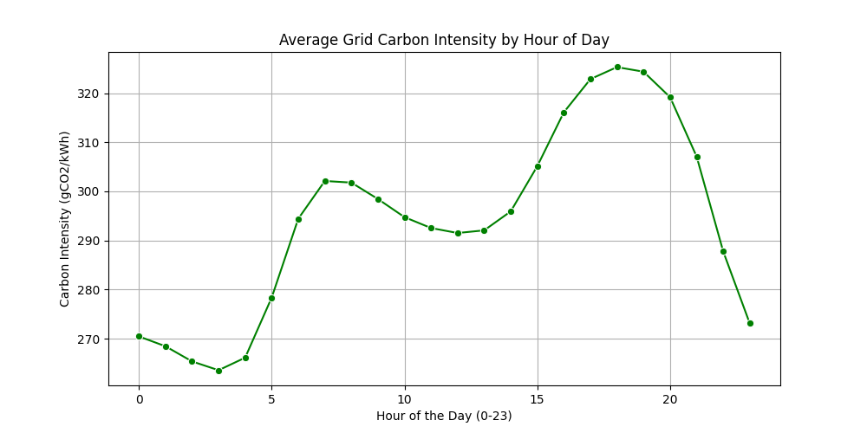 31.45 gCO₂/kWh

The output data trend shows that shifting backend server compute spikes from traditional peak windows to low-intensity grid intervals lowers energy expenses and limits atmospheric waste generation.
5. Project Conclusion
This project successfully demonstrates that environmental sustainability and financial profit can align perfectly in cloud software engineering. Through smart, automated scheduling powered by predictive data, technology firms can lower their data center power bills while reducing carbon emissions by up to 11.57 kg per million data records processed. Moving forward, integrating these predictive frameworks into automated cloud tools like Apache Airflow and Docker will pave the way for fully self-contained, eco-efficient enterprise systems worldwide.

6. Technologies Used
Technology / Library | Purpose in This Project
Python 3.11 | Core programming language
pandas >= 2.0.0 | Data loading, cleaning, and feature engineering
numpy >= 1.24.0 | Numerical computation and array operations
scikit-learn >= 1.2.0 | RandomForestRegressor model training and evaluation
matplotlib >= 3.7.0 / seaborn >= 0.12.0 | Carbon intensity trend chart generation
Jupyter Notebook (VS Code) | Interactive step-by-step execution environment

7. References
- National Grid ESO — Historic Generation Mix & Carbon Intensity Dataset (Great Britain, 2009-Present). https://www.gridwatch.templar.co.uk/
- Breiman, L. (2001). Random Forests. Machine Learning, 45(1), 5-32.
- IBM SkillsBuild Data Analytics with AI Academic Internship Program (AICTE, 2024).

