ArthaGrid
Project Report
A simple walkthrough of what this project is, how it works, and what it can do.

Quick Facts
What it is | A backend API (server) for tracking income and expenses
Built with | Node.js, Express, MongoDB
Who it's for | Anyone needing to track money — one person or a small team
Type | REST API — no visual app yet, but ready for a website or mobile app to be built on top of it
Status | Working backend, security-hardened, tested, documented, and containerized

1. What is ArthaGrid?
ArthaGrid is the "engine" behind a finance-tracking app. It’s the part that runs on a server, stores data safely, and answers questions like:
- "Add this expense."
- "Show me everything I spent last month."
- "How much did I save this year?"
It doesn’t have a visible app screen of its own (yet) — it’s built so that a website or mobile app can be connected to it later. Think of it like the kitchen of a restaurant: customers don’t see it, but it’s where all the real work happens.
The name comes from "Artha" (Sanskrit for wealth) and "Grid" (a structured system) — a structured system for managing money.

2. Who Uses It
The system supports three types of users, so it works for a single person or a small team:
Role | Can do
👀 Viewer | See transactions and reports, manage their own account
📊 Analyst | Everything a Viewer can, plus see deeper analytics
🛠️ Admin | Everything above, plus add/edit/remove transactions and manage other users

3. How It Works (The Big Picture)
At its simplest, this is how every request flows through the system:
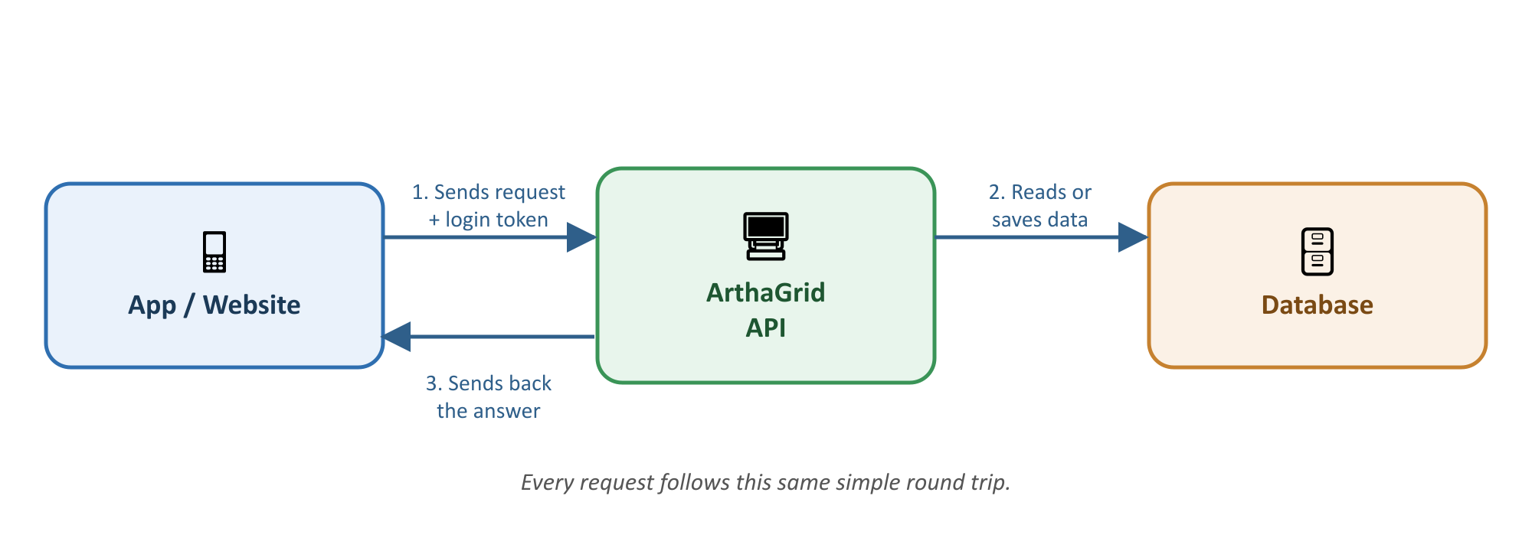
An app sends a request (like "give me my spending summary") along with proof of who’s asking (a login token). The server checks that the person is allowed to see this, fetches or updates the data in the database, and sends the answer back as a simple response.

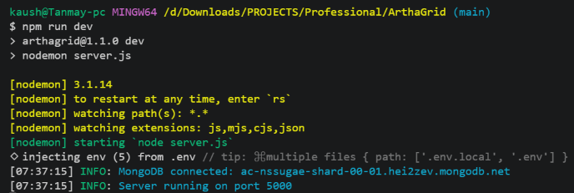

4. A Day in the Life (How Someone Would Actually Use It)
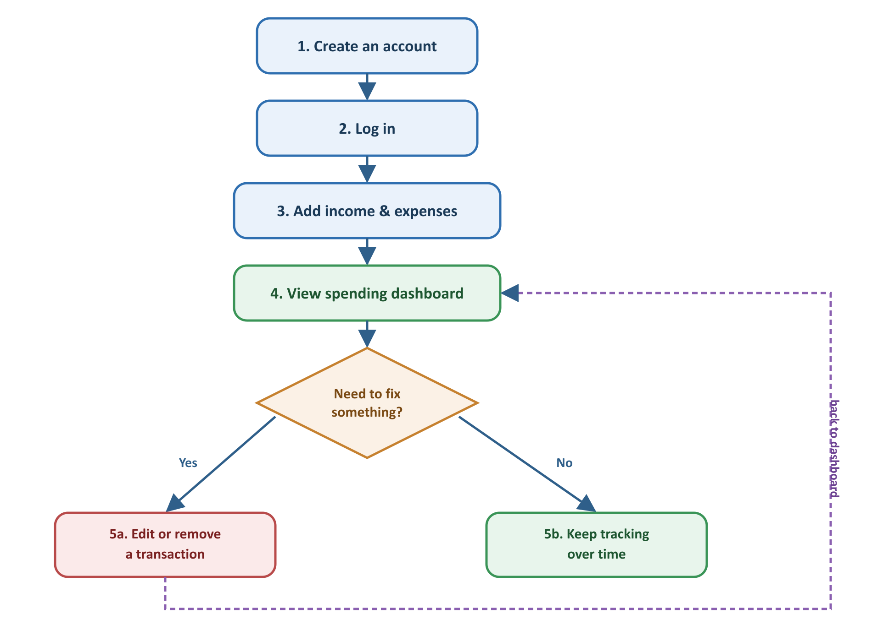
- Create an account — sign up with a name, email, and password.
- Log in — get a "pass" (a token) proving who you are, without needing to type your password again on every request.
- Add transactions — record money coming in (salary, freelance work) or going out (rent, groceries, bills).
- View the dashboard — see totals, spending by category, and trends over time, calculated automatically.
- Edit or fix mistakes — update or remove a transaction if something was entered wrong. Nothing is ever truly erased — a record is kept of what changed and who changed it, which matters for anything involving money.

5. What You Can Do With It (Endpoints)
An "endpoint" is just a specific thing you can ask the API to do. Here’s the full list, grouped by purpose, in plain language:

Account & Login
Action | Who can do it
Create an account | Anyone
Log in | Anyone with an account
Stay logged in without re-entering a password | Anyone with a valid session
Log out | Anyone logged in

Transactions (Income & Expenses)
Action | Who can do it
View all transactions (with filters, search, sorting) | Viewer, Analyst, Admin
View one transaction | Viewer, Analyst, Admin
Add a new transaction | Admin
Edit a transaction | Admin
Remove a transaction | Admin

Dashboard & Reports
Action | Who can do it
See totals (income, expenses, net balance) | Analyst, Admin
See spending broken down by category | Analyst, Admin
See trends over time (weekly/monthly) | Analyst, Admin
See the most recent activity | Analyst, Admin
See everything above in one combined report | Analyst, Admin

User Management
Action | Who can do it
View/update your own profile | Anyone logged in
View all users | Admin
Change a user's role or turn their account off | Admin

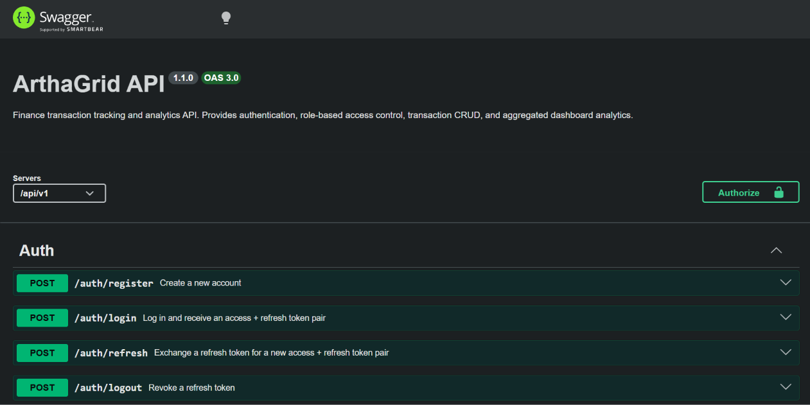
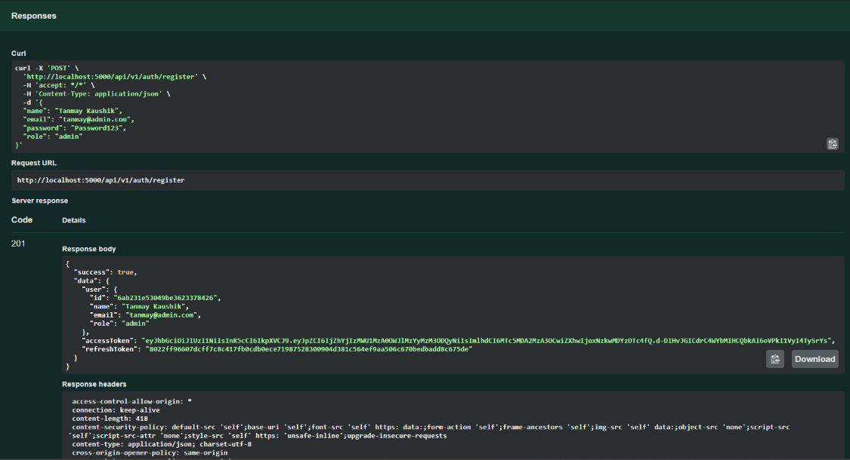
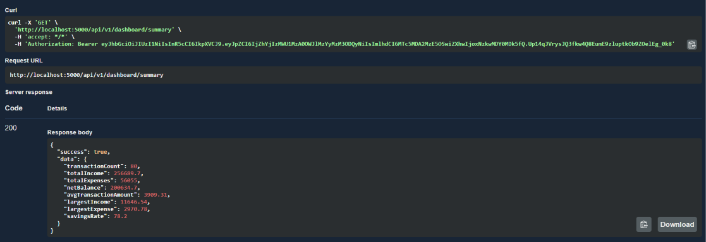

6. Important Decisions (and Why They Were Made)
A few choices shape how this project behaves. Here’s each one in plain language:
- MongoDB as the database — because financial records (a transaction, a user) are simple, self-contained pieces of information that don’t need complicated cross-references, and MongoDB makes it easy to grow the system later.
- Two kinds of login tokens, not one — instead of one long-lasting "pass" that can’t be taken back once handed out, the system uses a short-lived pass (15 minutes) plus a longer-lasting one used only to quietly renew it. If a pass is ever stolen, it naturally stops working fast — and if someone tries to reuse an old, already-replaced pass, the system treats it as a red flag and shuts down every active session for that account.
- Roles instead of per-person permissions — rather than deciding permissions person-by-person, everyone is put into one of three roles (Viewer, Analyst, Admin) with a fixed set of things they can do. This is simple to explain and simple to check.
- Nothing is ever truly deleted — "deleting" a transaction just hides it and records who removed it and when. This matters for money: you should always be able to explain how a number came to be, even after something was changed or removed.
- Calculations happen inside the database — reports (like "total spent this month") are calculated by the database itself rather than by pulling all the data out and doing math in the code. This is much faster as the amount of data grows.
- Fail loudly, not quietly — if something important is missing when the server starts (like a security key), it refuses to start at all with a clear error, instead of running in a broken or insecure state.
(For the full reasoning behind every decision, including trade-offs, see decisions.md in the project’s docs folder.)

7. Built to Be Production-Ready
Beyond "it works," the project has been hardened the way a real, launched product would need to be:
- Tested — an automated test suite checks that logins, permissions, transactions, and reports all behave correctly, and catches mistakes before they reach real users.
- Secure by default — passwords are never stored in plain text or shown in logs, common attack patterns (like malicious database queries) are blocked automatically, and repeated login attempts are slowed down to prevent guessing attacks.
- Traceable — every important action on a financial record (created, changed, removed) records who did it.
- Observable — the server produces clean, structured logs instead of scattered debug text, making it realistic to monitor once it’s running somewhere other than a developer’s laptop.
- Documented — every endpoint is described in an interactive page (/api-docs) that anyone can open and try out.
- Portable — the whole system (server + database) can be started with a single command using Docker, so it runs the same way on any machine.
- Continuously checked — every change is automatically tested before it’s allowed to be merged, using GitHub Actions.

8. What’s Next
The system is a solid, working foundation, but a few things are intentionally left for later — not forgotten, just not needed yet:
- A full history of every change to a record (right now it remembers the latest change, not every past one).
- The ability to create custom roles beyond Viewer/Analyst/Admin.
- Extra safeguards a bank or finance company would eventually want, like requiring a second login step for admins, or storing money amounts in a way that avoids tiny rounding errors at large scale.

