
SCHOOL OF COMPUTING AND INFORMATION TECHNOLOGY

A MINI-PROJECT REPORT
ON
MediMind
Submitted in partial fulfilment of the requirements for the award of the Degree of
BACHELOR OF TECHNOLOGY
IN
Information Science and Engineering/ Computer Science and Engineering (Artificial Intelligence and Machine Learning)/ Computer Science and Systems Engineering/ Computer Science and Information Technology
Submitted by
Tanmay C Jain R23EA127
Sujal Giri Sanyasi R23EA164
Suraj H R23EA125
Hari Prasad R23EA143

Under the guidance of
Prof Praveenaj
School of C&IT

REVA University
Rukmini Knowledge Park, Kattigenahalli, Yelahanka,Bengaluru-560064
www.reva.edu.in
December 2025

Contents
1. Introduction
1.1 Overview of MediMind
1.2 Problem Statement & Motivation
1.3 Objectives of the Project
1.4 Scope of the System
2. Requirement Analysis
2.1 Functional Requirements
2.2 Non-Functional Requirements
2.3 User Requirements
2.4 System Constraints
3. Design and Architecture
3.1 System Architecture Overview
3.2 Data Flow: Upload → Processing → Summary
3.3 Database & Storage Structure
3.4 Frontend–Backend Interaction
4. Development
4.1 Technology Stack
4.2 Frontend Development (React)
4.3 Backend & Supabase Edge Functions
4.4 AI/ML Integration (Embeddings & RAG)
4.5 PDF Report Generation
5. Testing
5.1 Functional Test Cases
5.2 Error Handling & Validation Tests
5.3 Interface & Usability Testing
6. Deployment
6.1 Firebase Hosting Setup
6.2 Supabase Configuration & Security
6.3 Final Application Screenshots
7. Conclusion

1. INTRODUCTION

1.1 Overview of the Project
MediMind is an AI-based medical report analysis system designed to make complex diagnostic documents easier to understand. It allows users to upload radiology, pathology, MRI, CT, and lab reports and instantly receive structured insights, key findings, detailed summaries, and recommendations. By combining modern web technologies with advanced machine learning models, MediMind offers fast, clear, and meaningful interpretations of medical text.

1.2 Problem Statement & Motivation
Medical reports are often long, technical, and difficult to interpret quickly. Users may struggle to identify the most important observations or understand the terminology. Traditional manual reading is time-consuming and inconsistent.
MediMind aims to solve this challenge by using AI-driven text processing and retrieval techniques to automatically extract important information and present it in a simple, structured format that improves clarity and decision-making.

1.3 Objectives of the Project
- To create a web platform for uploading and analyzing medical reports.
- To use machine learning models for text extraction, embeddings, and summarization.
- To generate structured outputs such as findings, reasoning steps, and recommendations.
- To ensure secure data handling and fast processing through Supabase and vector search.
- To provide a smooth, intuitive, and responsive user experience.

1.4 Scope of the System
- Uploading and processing PDF or text-based medical reports.
- Automatic chunking, vectorization, and semantic retrieval of information.
- AI-generated summaries using modern language models.
- A dashboard for viewing previous analyses and accessing reports.
- A floating assistant for quick questions and explanations.
- Downloadable summaries for easy sharing and documentation.

2. REQUIREMENT ANALYSIS

2.1 Functional Requirements
The functional requirements define the essential operations that MediMind must perform for the user. These include:
- User Authentication
  - Users should be able to register, log in, and securely access their dashboard.
- Report Uploading
  - The system must allow users to upload medical reports in PDF or text format.
- Text Extraction & Processing
  - Uploaded files should be processed automatically to extract report content.
- Chunking and Vectorization
  - The extracted text must be divided into chunks and converted into embeddings using AI models.
- AI Summary Generation
  - The system should generate structured insights such as:
    - Reasoning Steps
    - Recommendations
    - Detailed Summary
- Data Storage and Retrieval
  - All reports, embeddings, and summary outputs must be stored securely in the database and be retrievable on demand.
- Report History Management
  - Users should be able to view a list of previously analyzed reports.
- PDF Report Download
  - Users must be able to download a formatted PDF version of the AI-generated summary.
- Interactive AI Assistant
  - A floating chat assistant should allow users to ask follow-up questions about their report.

2.2 Non-Functional Requirements
These requirements focus on quality attributes and performance expectations of the system.
- Performance
  - AI processing and summary generation should complete within a reasonable time (typically a few seconds).
- Scalability
  - The system should handle multiple users, reports, and embeddings efficiently, supported by Supabase and PostgreSQL with pgvector.
- Security
  - User data must be protected through authentication, authorization, and secure storage.
  - Environment keys and API credentials must not be exposed.
- Usability
  - The interface should be responsive, intuitive, and accessible on both mobile and desktop devices.
- Reliability and Availability
  - The deployed system must remain stable and accessible through Firebase Hosting with minimal downtime.
- Maintainability
  - The codebase should follow modular, well-organized structure to allow future improvements.

2.3 User Requirements
These outline what end-users expect from the system:
- Simple and clean user interface.
- Ability to upload reports without technical knowledge.
- Quick and accurate AI-generated insights.
- Easy navigation between dashboard, history, and analysis pages.

2.4 System Constraints
The following limitations must be considered:
- Dependency on external APIs such as Google Gemini and HuggingFace models.
- Internet connectivity is required for uploading reports and generating summaries.
- API rate limits on free tiers may restrict the number of analyses.
- Browser compatibility must be maintained for consistent user experience.

3. DESIGN AND ARCHITECTURE

3.1 System Architecture Overview
MediMind is built using a three-layer architecture that works together to process medical reports and generate AI-driven summaries.

1. Frontend (React + TypeScript)
- Provides pages for uploading reports, viewing summaries, history, and AI chat.
- Communicates with the backend using the Supabase SDK.
- Uses TailwindCSS and shadcn components for a clean, responsive UI.

2. Backend (Supabase Services)
- Handles authentication, secure file storage, and database operations.
- Uses PostgreSQL with pgvector for storing embeddings and enabling semantic search.
- Includes two Edge Functions:
  - process-document: extracts text, chunks it, and generates embeddings.
  - generate-summary: retrieves relevant chunks and produces the structured AI summary.

3. AI Processing (External ML Models)
- Gemini text-embedding-004 for embedding text into vectors.
- Gemini 2.5 Flash for generating summaries, findings, and recommendations.
- (Optional) BiomedNLP model for enhanced domain understanding.

3.2 Data Flow:

Upload → Processing → Summary

The system processes reports in four main steps:

Step 1: Upload
- User uploads a PDF or text file.
- File is stored in Supabase Storage, and a new entry is created in the reports table.

Step 2: Document Processing
- The process-document function extracts text from the file.
- Text is split into overlapping chunks and converted into embeddings using Gemini.

Step 3: Vector Storage
- Each chunk and its embedding are stored in the report_chunks table.
- pgvector enables efficient semantic search across these embeddings.

Step 4: Summary Generation
- When requested, generate-summary performs a similarity search to find relevant chunks.
- These chunks, along with the original text, are sent to Gemini 2.5 Flash.
- The AI returns: Key Findings, Reasoning Steps, Recommendations, and Full Summary.
- The result is stored in the summaries table and displayed to the user.
This workflow ensures accurate and context-aware AI summarization.

3.3 Database and Storage Structure
Supabase PostgreSQL is used to store reports, embeddings, and summaries.

Key Tables
- reports
  - Stores metadata such as user ID, file URL, report type, status, and timestamps.
- report_chunks
  - Stores text chunks and their vector embeddings for semantic search.
- summaries
  - Stores AI-generated findings, reasoning, recommendations, and full summary.

Storage
- Supabase Storage saves uploaded PDF files securely.
- Files are organized by user and report ID for quick retrieval.

3.4 Frontend–Backend Interaction
The system workflow follows a simple and secure communication pattern:
- Frontend Actions: Users upload files, request analysis, view results, or chat with the assistant.
- Supabase SDK: Handles authentication, file uploads, and database operations.
- Edge Functions: Execute heavy processing tasks such as embeddings, vector search, and summary generation.
- Frontend Rendering: The generated summary is displayed instantly in the Summary Viewer.
This architecture ensures fast performance, modularity, and a smooth user experience across devices.

4. DEVELOPMENT

4.1 Technology Stack
MediMind is built using a modern, scalable tech stack suitable for AI-driven applications.

Frontend
- React + TypeScript for building a fast, interactive UI.
- Vite for efficient development and builds.
- TailwindCSS and shadcn/ui for responsive styling and reusable components.
- Framer Motion for smooth animations.

Backend & Database
- Supabase for authentication, database, storage, and serverless functions.
- PostgreSQL + pgvector for storing text embeddings and enabling semantic search.
- Supabase Edge Functions for document processing and summary generation.

AI / Machine Learning
- Gemini text-embedding-004 for generating 768-dimensional vector embeddings.
- Gemini 2.5 Flash for producing structured medical summaries using RAG.
- BiomedNLP-PubMedBERT (optional) for additional medical context.

Deployment
- Firebase Hosting provides fast, secure global deployment for the frontend.

4.2 Frontend Development
The frontend focuses on clarity, simplicity, and smooth navigation.

Main Pages
- Authentication Page: User login and signup via Supabase Auth.
- Dashboard: Displays recent reports and navigation options.
- Upload Report Page: Allows uploading PDF/text files with validation and status messages.
- Summary Viewer: Shows four AI-generated sections—Key Findings, Reasoning Steps, Recommendations, and Full Summary.
- History Page: Lists all previously analyzed reports.

Integrations
- TanStack Query for reliable data fetching.
- Connections to Supabase Storage for file uploads.
- Calls to Edge Functions for document processing and AI summaries.
- Floating AI Assistant for interactive queries.

4.3 Backend Development & Edge Functions
Supabase Edge Functions (TypeScript, Deno runtime) handle heavy processing.

process-document Function
- Downloads uploaded files from storage.
- Extracts text and splits it into overlapping chunks.
- Generates embeddings using Gemini.
- Stores chunks and vectors in the report_chunks table.
- Updates report status to processed.

generate-summary Function
- Embeds user query and performs vector similarity search.
- Retrieves top chunks from pgvector.
- (Optional) Enhances context with BiomedNLP.
- Sends combined context to Gemini for summary generation.
- Stores Key Findings, Reasoning, Recommendations, and Full Summary in the summaries table.
These functions ensure secure, fast, and accurate AI processing.

4.4 AI / Machine Learning Integration
- Embeddings are generated using Gemini text-embedding-004, allowing semantic understanding of medical text.
- RAG (Retrieval-Augmented Generation) combines embeddings with contextual text for accurate summaries.
- Gemini 2.5 Flash returns structured outputs that are easy for users to read and interpret.

4.5 PDF Report Generation
MediMind lets users download clean, professional summaries.

PDF Features
- Organized sections for findings, reasoning, recommendations, and summary.
- Proper formatting and layout for readability.
- Easy to store and share as documentation.

5. TESTING
Testing ensures that MediMind functions correctly, handles errors properly, and delivers a smooth user experience. The testing process includes functional testing, validation/error-handling tests, and basic usability checks.

5.1 Functional Testing

FT-1: User Login
- Objective: Verify that users can log in and access the dashboard.
- Steps:
  - Open application
  - Enter valid email/password
  - Click “Login”
- Expected Result: User is authenticated and redirected to Dashboard.
- Status: Pass / Fail

FT-2: Report Upload & Processing
- Objective: Verify that a valid PDF report is uploaded and processed.
- Steps:
  - Go to “Upload Report”
  - Select a valid PDF
  - Click “Upload”
- Expected Result: Report uploads, processes, and appears in History.
- Status: Pass / Fail

FT-3: AI Summary Generation
- Objective: Check if AI generates structured summary successfully.
- Steps:
  - Open processed report
  - Click “Generate Summary”
- Expected Result: Key Findings, Reasoning, Recommendations, and Full Summary appear.
- Status: Pass / Fail

5.2 Validation & Error-Handling Testing

VT-1: Invalid File Upload
- Objective: Ensure unsupported formats are rejected.
- Steps: Upload a .jpg or .exe file.
- Expected Result: Error message shown; file not uploaded.
- Status: Pass / Fail

VT-2: Unauthorized Page Access
- Objective: Prevent access without login.
- Steps: Log out → try opening /dashboard or /upload-report.
- Expected Result: User is redirected to Login page.
- Status: Pass / Fail

5.3 Usability & Interface Testing (Informal)

Observations
- Upload flow is simple and quick.
- Summary Viewer is clean and easy to understand.
- Floating AI assistant enhances interactivity.
- Interface works smoothly on both mobile and desktop.

User Feedback
- Application is fast and easy to use.
- Summaries are well-structured and readable.
- Loading indicators improved clarity during processing.

6. DEPLOYMENT
Deployment involves hosting the frontend, configuring backend services, and ensuring the system is accessible to users in a stable and secure manner.

6.1 Firebase Hosting (Frontend Deployment)
The MediMind frontend is deployed using Firebase Hosting because of its speed, global CDN, and simple deployment workflow.

Deployment Steps (Short):
- Build the React project using npm run build.
- Initialize Firebase: firebase init hosting.
- Select the build folder as the public directory.
- Deploy the application: firebase deploy --only hosting.
- The live URL is generated and can be shared with users.
Firebase ensures fast loading times and SSL security by default.

6.2 Supabase Configuration (Backend Setup)
Supabase handles authentication, storage, database, and serverless functions.

Key Setup Steps:
- Create a Supabase project and enable Authentication for user login.
- Run SQL script to create tables: reports, report_chunks, summaries.
- Enable pgvector extension for semantic search.
- Upload Edge Functions:
  - process-document
  - generate-summary
- Add API keys (Gemini, HuggingFace) using supabase secrets set.
- Update allowed redirect URLs to match Firebase Hosting.
Supabase manages all backend logic securely and efficiently.
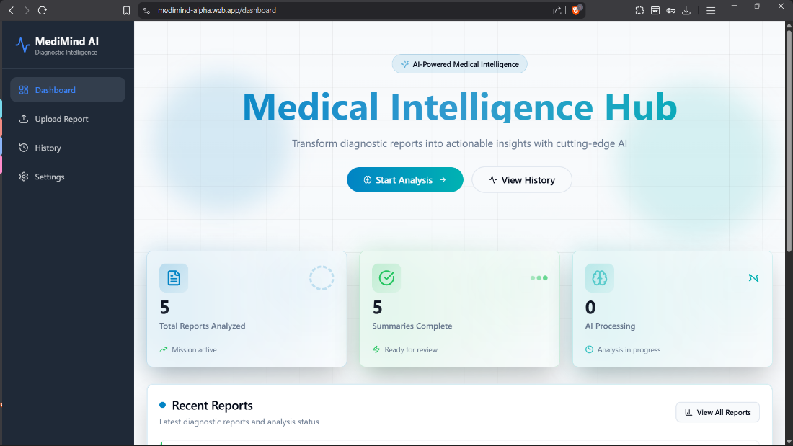
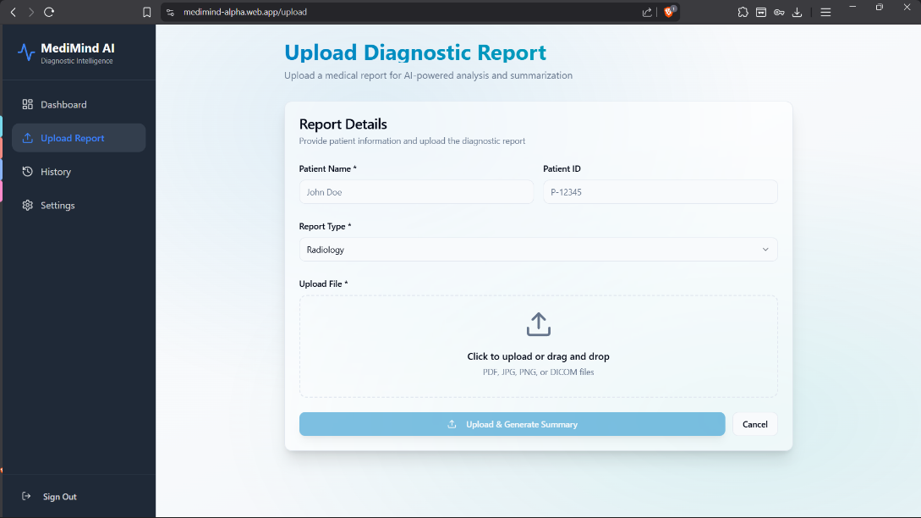
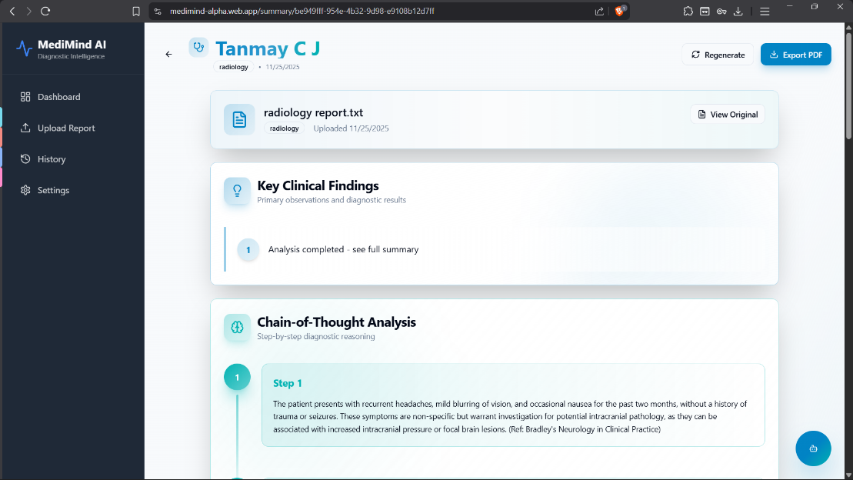
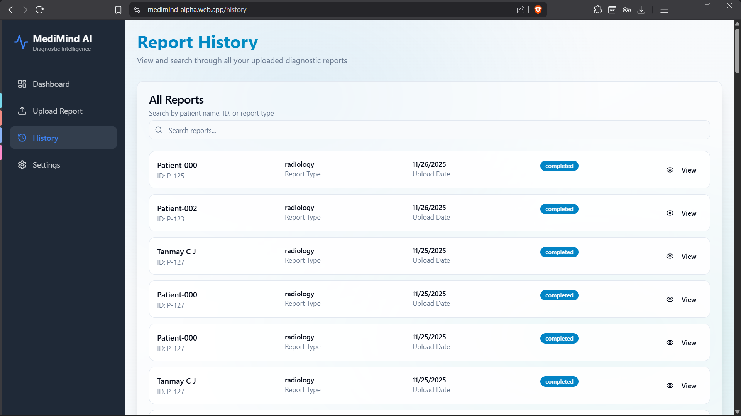
Conclusion
MediMind successfully demonstrates how modern AI and web technologies can be used to simplify the interpretation of complex medical reports. By combining secure data handling, vector-based text processing, and advanced summarization models, the system provides users with clear insights, key findings, reasoning steps, and recommendations in an easy-to-read format. The project achieves its goals of delivering a responsive interface, efficient backend processing, and accurate AI-generated summaries. Overall, MediMind showcases a practical and innovative solution for enhancing medical report understanding and sets a strong foundation for future improvements and expanded capabilities.

