**source code of the program:**

**Main Screen File:**

(Main\_screen.py))

from tkinter import \*  
  
root = Tk()  
root.geometry("350x450") # width x height  
root.title("SPACE INVADERS")  
root.configure(bg="dark blue")  
  
text = Label(root**,** text="𝐒𝐏𝐀𝐂𝐄 𝐈𝐍𝐕𝐀𝐃𝐄𝐑"**,** padx=**11,** pady=**11,** bg="cyan"**,** fg="black"**,** font="helvetica,10,bold"**,** borderwidth=**2,** relief=GROOVE)  
text.pack()  
  
photo = PhotoImage(file="project.png")  
labelphoto = Label(root**,** image=photo)  
labelphoto.pack()  
  
  
def command():  
 import Game\_loop  
  
  
  
  
btn = Button(root**,** text="𝙉𝙀𝙒 𝙂𝘼𝙈𝙀"**,** bg="orange"**,** padx=**48,** pady=**12,** font="Gotham,10,bold"**,** command=command)  
btn.pack()  
btn1 = Button(root**,** text="𝙀𝙓𝙄𝙏"**,** bg="orange"**,** padx=**80,** pady=**12,** font="Gotham,10,bold"**,** command=quit)  
btn1.pack()  
  
root.mainloop()

**Game loop:**

(Game\_loop.py)

# importing modules  
  
import pygame  
import math  
import random  
from Exit\_screen import game\_over  
from pygame import mixer  
  
# initialise pygame  
pygame.init()  
  
#adding background music  
  
mixer.init()  
mixer.music.load("Space\_Invaders\_Music.ogg")  
mixer.music.play(-**1**)  
  
#adding screen and background image  
screen = pygame.display.set\_mode((**800, 600**))  
  
background = pygame.image.load('back.png')  
  
  
# Adding caption to screen  
pygame.display.set\_caption("space invaders")  
icon = pygame.image.load(r'spaceship.png')  
pygame.display.set\_icon(icon)  
  
# initial score  
score = **0**# player constants and image  
  
playerimg = pygame.image.load(r'playerimg.png')  
playerx = **370**playery = **480**player\_hzt = **0**player\_vert = **0**# enemiy empty lists and constants  
  
q=**1**x = " "  
enemyimg = []  
alienx = []  
alieny = []  
vel\_x = []  
vel\_y = []  
x\_speed = **0.9**y\_speed = **5**# bullets image and constants  
  
bulletimg = pygame.image.load(r'bullet1.png')  
bulletx = **0**bullety = **480**bulletx\_change = **0**bullety\_change = **10** # speed at which bullets y coordinate changes i.e speed of bullet  
bullet\_state = "ready"  
  
# bringing player to screen  
def player(x**,** y):  
 screen.blit(playerimg**,** (playerx**,** playery)) # blit function used to draw on screen  
  
# bringing player to screen  
def enemy(x**,** y**,** i):  
 screen.blit(enemyimg[i] **,**(x**,** y) )  
  
# bringing bullets to screen  
def fire\_bullet(x**,** y):  
 global bullet\_state  
 bullet\_state = "fire"  
 screen.blit(bulletimg**,** (x + **16,** y + **10**))  
  
  
# collision logic  
def is\_collision(bulletx**,** bullety**,** alienx**,** alieny):  
 distance = math.sqrt((math.pow(bulletx - alienx**, 2**)) + (math.pow(bullety - alieny**, 2**)))  
 if distance < **28**:  
 return True  
 else:  
 return False  
  
  
# enemy collision image  
v = **1**m = **0**n = **0**# GAME LOOP : every in game related action should be in the game loop  
running = True  
  
while running:  
  
 screen.fill((**0, 0, 0**))  
  
 screen.blit(background**,** (**0, 0**))  
 # screen.blit(text, text\_rect)  
  
  
  
 # CREATING ENEMIES  
 num\_of\_enemies = q  
 colm = **5** for i in range(num\_of\_enemies):  
 for j in range(colm):  
 if j == **0**:  
 enemyimg.append(pygame.image.load('enemyimg.png'))  
 if j == **1**:  
 enemyimg.append(pygame.image.load('en1\_2.png'))  
 if j == **2**:  
 enemyimg.append(pygame.image.load('en2\_2.png'))  
 else:  
 enemyimg.append(pygame.image.load('en3\_2.png'))  
 alienx.append(**140** + j \* **90**)  
 alieny.append(**100** + i \* **70**)  
 vel\_x.append(**2**)  
 vel\_y.append(**40**)  
  
  
  
 # CODE FOR EXITTING WINDOW  
  
 for event in pygame.event.get():  
 if event.type == pygame.QUIT:  
 running = False  
  
 # Making buttons for player movement  
  
 if event.type == pygame.KEYDOWN :  
 if event.key == pygame.K\_UP or event.key == pygame.K\_w :  
 player\_vert = -**3** if event.key == pygame.K\_DOWN or event.key == pygame.K\_s:  
 player\_vert = **3** if event.key == pygame.K\_LEFT or event.key == pygame.K\_a:  
 player\_hzt = -**3** if event.key == pygame.K\_RIGHT or event.key == pygame.K\_d:  
 player\_hzt = **3** if event.key == pygame.K\_SPACE:  
 if bullet\_state == "ready":  
 bulletx = playerx  
 bullety = playery  
 fire\_bullet(bulletx**,** bullety)  
  
 if event.type == pygame.KEYUP:  
 if event.key == pygame.K\_LEFT or event.key == pygame.K\_RIGHT or event.key == pygame.K\_a or event.key == pygame.K\_d:  
 player\_hzt = **0** if event.key == pygame.K\_UP or event.key == pygame.K\_DOWN or event.key == pygame.K\_w or event.key == pygame.K\_s:  
 player\_vert = **0** # Ensuring enemy inside screen  
  
 playerx = playerx + player\_hzt  
 if playerx <= **0**:  
 playerx = **0** elif playerx >= **736**:  
 playerx = **736** playery = playery + player\_vert  
 if playery <= **0**:  
 playery = **0** elif playery >= **536**:  
 playery = **536** # enemy movements  
  
 for i in range(num\_of\_enemies):  
 alienx[i] = alienx[i] + vel\_x[i]  
 if alienx[i] <= **0**:  
 vel\_x[i] = x\_speed  
 alieny[i] = vel\_y[i] + alieny[i]  
 elif alienx[i] >= **736**:  
 vel\_x[i] = -x\_speed  
 alieny[i] = vel\_y[i] + alieny[i]  
  
  
 # Collision of enemy and bullet  
  
 collision = is\_collision(bulletx**,** bullety**,** alienx[i]**,** alieny[i])  
 if collision:  
 bullety = **480** bullet\_state = "ready"  
  
 v = **3** m = alienx[i]  
 n = alieny[i]  
  
 # sound for collision  
 mixer.init()  
 mixer.music.load("coll.wav")  
 mixer.music.play(**1**)  
  
 # score calculation  
 score = score + **1** x = str(int(score))  
  
  
 print(x)  
 # global y  
 y = int(x)  
 alienx[i] = random.randint(**0, 730**)  
 alieny[i] = random.randint(**50, 150**)  
 if alieny == **0**:  
 running = False  
 enemy(alienx[i]**,** alieny[i]**,** i)  
  
 # enemy image collision  
  
 if v > **2** and v < **20**:  
 colli\_image = pygame.image.load("explosionpurple.png")  
 screen.blit(colli\_image**,** (m**,** n))  
 v += **1** # bullet movement  
  
 if bullety <= **0**:  
 bullety = **480** bullet\_state = "ready"  
 if bullet\_state == "fire":  
 fire\_bullet(bulletx**,** bullety)  
 bullety = bullety - bullety\_change  
  
  
 # SCORE AND ENEMY level DEFINING  
  
 if score > **1**:  
 x\_speed = **1** q =**2** if score > **3**:  
 q = **4** if score > **9**:  
 x\_speed = **1.5** q = **6** if score > **12**:  
 q =**10** if score > **15**:  
 x\_speed = **1.7** if score > **18**:  
 x\_speed = **3** # game over window  
  
 if score == **20**:  
 game\_over()  
   
   
  
 font = pygame.font.SysFont("Arial"**, 30**)  
 text = font.render("score:" + x**,** True**,** (**240,240,240**) ) # add parameteres , requires at least 3 parameters  
 text\_rect = text.get\_rect()  
 text\_rect.center = (**60, 30**)  
 screen.blit(text**,** text\_rect )  
  
  
 # updating screen  
  
 player(playerx**,** playery)  
 pygame.display.update()

**Exit\_screen:**

(Exit\_screen.py)

from tkinter import \*  
import Game\_loop  
  
def play\_again():  
 import Game\_loop  
  
def game\_over():  
 rt = Tk()  
 rt.geometry("350x450")  
 rt.configure(bg="orange")  
  
  
 label1 = Label(rt**,** text="GAME OVER"**,** padx=**25,** pady=**15,** bg="orange"**,** fg="black"**,** font=("Arial Bold"**, 20**))  
 label1.pack()  
  
 label1.place(relx=**0.2,** rely=**0.4**)  
  
 but1 = Button(rt**,** text="exit"**,** padx=**30,** pady=**12,** command=quit**,** font=("helvetica bold"**, 12**)**,** bg="purple"**,** fg="white")  
 but1.pack()  
 but1.place(relx=**0.4,** rely=**0.7**)  
  
 but2 = Button(rt**,** text=" play again"**,** padx=**30,** pady=**12,** font=("Arial bold"**, 12**)**,** bg="purple"**,** fg="white"**,** command=play\_again)  
 but2.pack()  
 but2.place(relx=**0.3,** rely=**0.2**)  
  
 rt.mainloop()

**IMAGES USED:**

**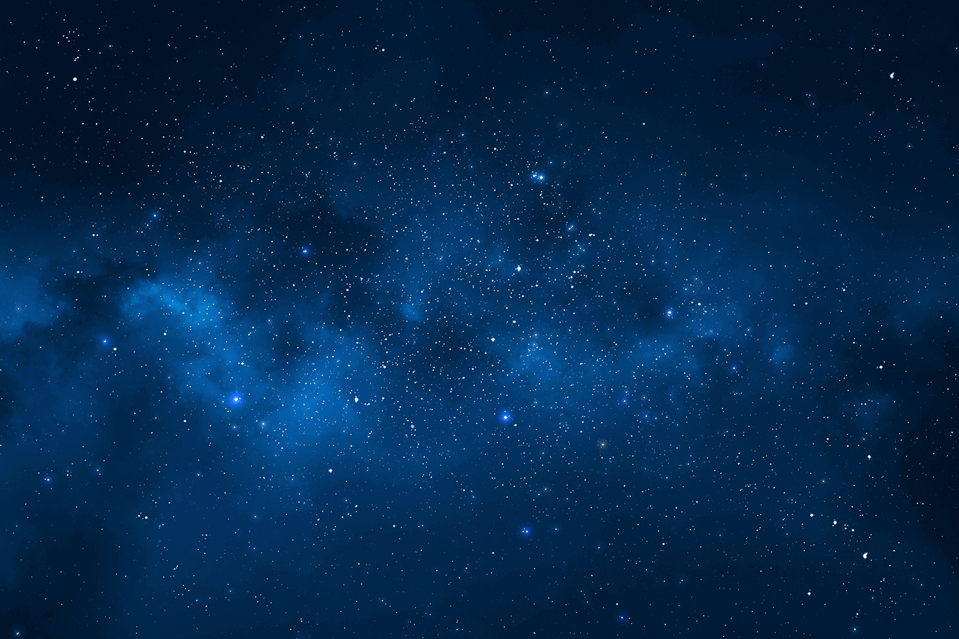 **

Image – back.png IMAGE = spaceship.png

  

Image = enemyimg.png

Image – bullet1.png

Image – playerimg.png

  

Image = en1\_2.png

Images = en3\_2.png

Image = en2\_2.png

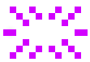

Image = explosionpurple.png

Sound files -

<Space_Invaders_Music.ogg>

<coll.wav>