Abstractive Text Summarization with a From-Scratch Transformer (CNN/DailyMail 3.0.0)

1. Introduction
We implement a full Transformer encoder-decoder (Vaswani et al., 2017) from scratch with only nn.Linear, nn.Embedding, nn.LayerNorm, nn.Dropout and tensor operations, train it on CNN/DailyMail 3.0.0 for abstractive summarization, and evaluate it with ROUGE on the full test set against the extractive Lead-3 baseline. No pretrained model weights are used; only the pretrained bert-base-uncased tokenizer.

2. Dataset and preprocessing
Dataset: cnn_dailymail 3.0.0 (train 287,113 / validation 13,368 / test 11,490). Tokenizer: bert-base-uncased WordPiece (pretrained tokenizer only, uncased); one shared vocabulary of 30,522 tokens for articles and summaries; [CLS] = start token, [SEP] = end token, [PAD] = padding. Articles are truncated to 400 tokens; summaries to 128 tokens including the start and end tokens. Decoder input = summary shifted right (starts with [CLS]); target = summary shifted left (ends with [SEP]). Raw references keep the newline between highlight sentences for ROUGE-Lsum.
Training-set size actually used: 287,113 pairs randomly sampled (seed 42) from the training split only. Validation: a fixed subset of 3,000 pairs for early stopping. Test: 11,490 pairs, used only for final scoring. Batches are length-bucketed and tokenised tensors are cached.
 | Median | 90th pct | Max | % over limit
Article | 756 | 1445 | 2355 | 87.2
Summary | 64 | 106 | 469 | 4.0
Token lengths measured on a 2,000-article validation sample (the test split is never used for statistics).

3. Model architecture
Setting | Value
d_model | 256
Encoder / decoder layers | 3 / 3
Attention heads | 4
d_ff | 1024
Dropout | 0.1
Embeddings | tied: encoder = decoder = output projection
Total parameters | 13,343,232
tied embedding matrix | 7,813,632
encoder layers | 2,369,280
decoder layers | 3,160,320
Components: scaled dot-product attention softmax(QK^T/sqrt(d_k)+mask)V with masked scores set to a large negative finite value and a fp32 softmax; multi-head attention; position-wise FFN; sinusoidal positional encodings; post-LN sub-layers LayerNorm(x + Dropout(Sublayer(x))). Three masks: source padding mask (encoder self-attention and cross-attention) and causal mask combined with target padding mask (decoder self-attention). A final linear layer (tied to the embedding) maps decoder states to vocabulary logits.

4. Training setup and results
Loss: cross-entropy with ignore_index=pad (label smoothing 0.0); optimizer Adam(beta=(0.9,0.98), eps=1e-9) + Noam schedule; warm-up 4000 steps (configured 4000, capped at 20% of the planned 53838 steps so small subsets still decay); teacher forcing; mixed precision (AMP: True); gradient clipping 1.0; batch size 32; device cuda. Validation loss every epoch on 3,000 fixed pairs; early stopping patience 3; the best checkpoint is restored before testing.
Epochs run: 6 of 6 (stop reason: time budget reached). Best epoch: 6 with validation loss 2.7997. Training time: 110.1 min, 50,009 optimizer steps.
Source-ablation check (validation subset, teacher forced): loss with the true article 2.7997 vs 5.5027 when every summary is paired with another example's article (gap +2.7031 nats/token). A model that conditions on its input must be clearly worse with the wrong article; a gap near zero would mean the decoder ignores the source.
Epoch | Train loss | Val loss | Minutes
1 | 5.3943 | 4.1857 | 19.7
2 | 4.0792 | 3.3101 | 19.7
3 | 3.5008 | 2.9903 | 19.7
4 | 3.2427 | 2.8807 | 19.8
5 | 3.1177 | 2.8181 | 19.7
6 | 3.0426 | 2.7997 | 11.4

5. Decoding method
greedy, autoregressive, no teacher forcing, encoder output reused, max 128 tokens (incl. start). Each article batch is encoded once and the encoder output is reused at every step; each sequence stops at [SEP]. Token ids are converted to text (special tokens skipped, spaces cleaned) before scoring. Checkpoint evaluated: best (epoch 6).

6. Quantitative results
ROUGE F1 x 100 on the full test set (11,490 pairs), rouge_score with use_stemmer=True. ROUGE-L treats the summary as one sequence; ROUGE-Lsum works sentence by sentence on newline-separated sentences (generated text split with nltk.sent_tokenize); both are reported and labelled.
System | ROUGE-1 | ROUGE-2 | ROUGE-L | ROUGE-Lsum
Lead-3 (assignment reference) | 40.06 | 17.48 | 25.02 | 36.36
Lead-3 (measured here) | 40.05 | 17.48 | 25.02 | 36.35
Transformer from scratch (ours) | 34.28 | 13.94 | 24.50 | 31.82
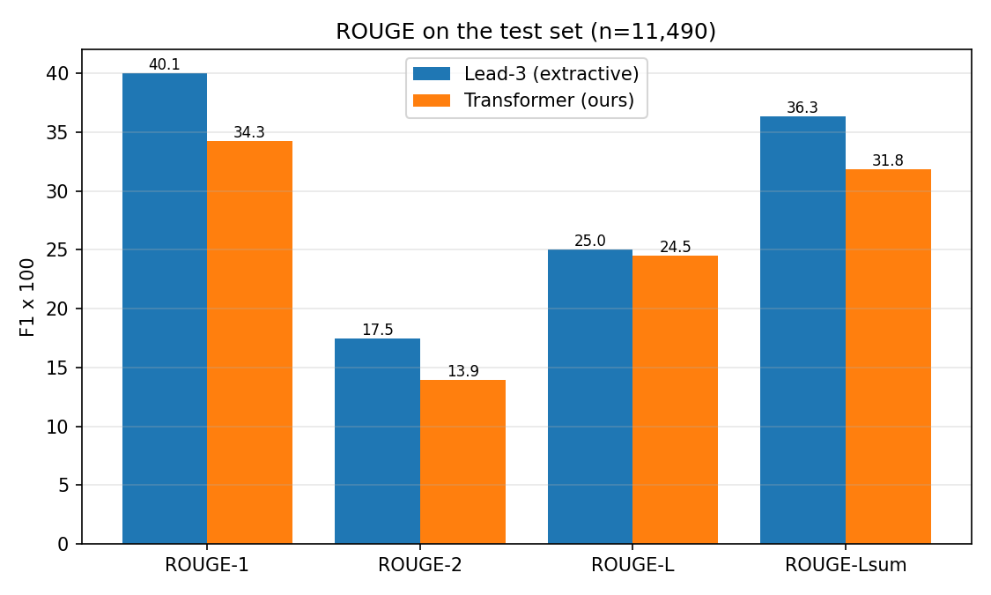
Figure 1: ROUGE vs Lead-3 on the test set.

7. Loss curves
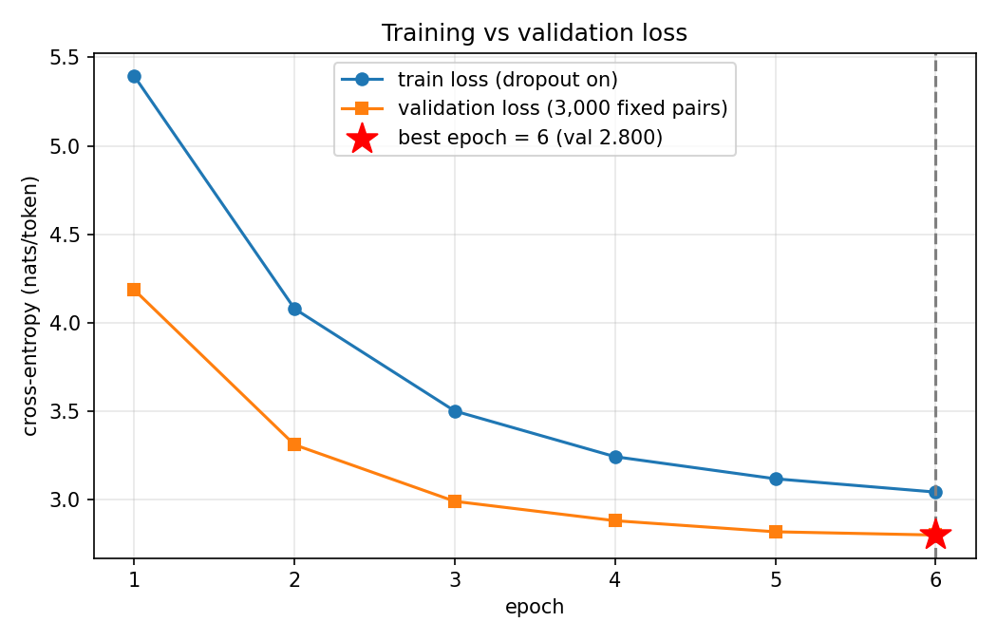
Figure 2: training vs validation loss; the star marks the best epoch.
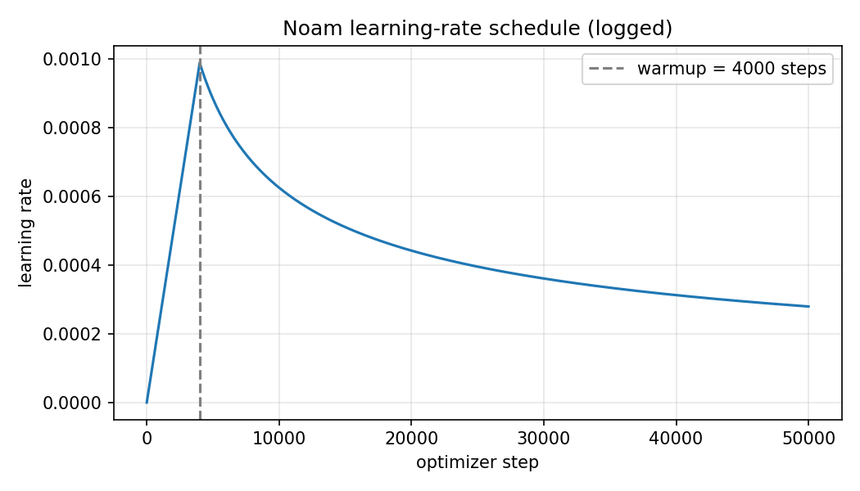
Figure 3: logged Noam learning-rate schedule.

8. Qualitative analysis
Over the 11,490 generated test summaries: 68.1% contain a repeated word trigram, 9.3% contain a number absent from the article, 20.8% contain a word (>=4 letters) absent from the article, and on average 69.2% of summary trigrams are copied verbatim from the article. Mean length: 48.4 generated vs 52.8 reference words. Failure cases were selected with these flags.

typical (test #9700, id 28c3566ff7959cc7070625cff413093e6aa119a2)
Article (start): We have all been there. Wanting to get online but just out of wifi coverage. However in central China, Mother Nature recently appeared to lend a helping hand by giving locals what could be the world's largest 'Wi-Fi cloud'. A cloud formation resembling the Wi-Fi symbol appeared recently in the sky of Xiangtan city in Hunan Province, the People's Daily Online reports. God's router? A cloud formation resembling the Wi-Fi symbol appeared in central China last week . The global Wi-Fi symbol has one dot and three curved lines radiating from it . Shi Chao, a student at the Hunan University of Scienc ...
Reference: Cloud appeared in central China's Hunan province last Friday . | A university student snapped the moment on his way to the library . | Picture has sparked tongue-in-cheek debate on Mother Nature's password .
Generated: chinese internet users have since shared and commented on shi's photo thousands of times on chinese social media. the cloud formation resembling the wi - fi symbol appeared recently recently in the sky of xiang city in hunan province.
ROUGE-1 30.1 | ROUGE-Lsum 30.1. Analysis: 78% of the summary's word trigrams occur verbatim in the article; repeated-trigram ratio 0%; unsupported numbers: 0, unsupported words: 1.

typical (test #1597, id 942fc9db6f3b08d1011d77312ce88f6892ed86c6)
Article (start): MI5 has issued an alert over the threat posed by rogue workers in Britain’s nuclear, transport and public services after suicide pilot Andreas Lubitz killed 150 people in the Alps plane crash disaster. And concerns are so great that one security source has warned: ‘However much physical security you have, if someone is already in there, there’s nothing you can do to stop them committing an act of sabotage or terrorism.’ MI5 is now giving advice on the risk posed by thousands of employees working in sensitive areas – known as ‘insiders’ – highlighted by the Germanwings disaster. Warning: MI5 ha ...
Reference: Alert issued over rogue workers in nuclear, transport and public services . | MI5 giving advice on risk posed by employees working in sensitive areas . | Follows actions of pilot Andreas Lubitz who killed 150 people in the Alps . | A BA pilot claims his airline does not carry out mental health checks .
Generated: mi5 has issued alert over threat posed by rogue workers in the alps plane crash disaster. concerns are so great that one security source has warned :'much physical security you have, if someone is already in there '
ROUGE-1 27.9 | ROUGE-Lsum 25.6. Analysis: 74% of the summary's word trigrams occur verbatim in the article; repeated-trigram ratio 0%; unsupported numbers: 0, unsupported words: 0.

typical (test #349, id 12294954320c496e89fcc0bd5bb91e2dcc5c5d7f)
Article (start): Boston (CNN)Dzhokhar Tsarnaev's bombs tore through their bodies: singeing flesh, shattering bones, shredding muscles and severing limbs. But on Tuesday, jurors also began to hear about the holes his bombs left in the hearts of the survivors and the families of the dead. Now that he has been found guilty on every count, the jury must decide whether Boston Marathon bomber Tsarnaev, 21, should live or die for what he has done. This is the victim impact part of the case, and the testimony was heartbreaking. Four young people are gone, and grief fills the spaces they once occupied. A father with a ...
Reference: The sentencing phase in Dzhokhar Tsarnaev's trial begins in a federal court in Boston . | Prosecutor shows pictures of the four victims and Tsarnaev flipping his middle finger . | Victims testify about the impact of the bombing on their lives .
Generated: dzhokhar tsarnaev's bombs tore through their bodies : singeing flesh, shattering bones, shredding muscles and severing limbs. jurors also began to hear about the holes his bombs left in hearts of survivors. the jury must decide whether boston marathon bomber tsarnaev should live or die for what he has done.
ROUGE-1 33.7 | ROUGE-Lsum 31.5. Analysis: 81% of the summary's word trigrams occur verbatim in the article; repeated-trigram ratio 0%; unsupported numbers: 0, unsupported words: 0.

typical (test #11262, id 12670e6af0ccf95cf8de50f651f0fded33d419b0)
Article (start): Kim Kardashian has launched an outspoken attack on President Obama for refusing to use the word 'genocide' as he marked the 100th anniversary of the massacre of 1.5 million Armenians. The reality star said it was 'very disappointing' that he stopped short of using the word - which he had promised to use when he ran for office. Kardashian, whose Armenian heritage comes from her father, the late Robert Kardashian, has used her celebrity since 2011 to bring awareness to the genocide. Marking the anniversary of the mass murder at the weekend, Kardashian wrote in an op-ed in Time magazine: 'I woul ...
Reference: In 1915, 1.5 million Armenians were killed by Ottoman Turks in what historians have described as the first genocide of the 20th century . | Obama refused to call the mass killings a 'genocide' in official statement despite promising as a presidential candidate that he would . | Turkish officials furiously deny there was a genocide, and Obama has shied away from offending the close U.S. ally . | Kim Kardashian - who is Armenian on her father's side - has called the killings a genocide and says Obama should too . | Kasdashian recently traveled to the country for the first time with her husband Kanye West, sister Khole and cousins Kara and Kourtni .
Generated: reality star said it was'very disappointing'that he stopped short of using word. kardashian has used celebrity since 2011 to bring awareness of genocide.
ROUGE-1 12.0 | ROUGE-Lsum 12.0. Analysis: 70% of the summary's word trigrams occur verbatim in the article; repeated-trigram ratio 0%; unsupported numbers: 0, unsupported words: 0.

FAILURE: repetition (test #5020, id 95f10632700d42d92da36376e9ae7ba80f13941b)
Article (start): Whether you sprout the odd grey hair, spend hours eradicating them or let your silver locks flow free, the latest hair trend is good news for women everywhere. Grey hair is on trend with silver hair lovers the world over posting images on social media under the hashtag #grannyhair. Instagram is awash with the grey haired images - from beauty shots featuring professional models to selfies uploaded by proud grey haired Instagrammers. Scroll down for video . Katja Wassermeyer (katja-wassermeyer-photographer.com) is one of the many photographers who has embraced the trend, with eye-catching be ...
Reference: Grey hair has gone glam with social media awash with images . | Users posting images under the hashtag #grannyhair . | Models are sporting grey hair on professional beauty shoots . | Other Instagrammers are posting selfies in front of the bathroom mirror . | Stars including Kelly Osborne, Nicole Richie and Lady Gaga and Rihanna have helped the trend gain traction .
Generated: katja wassermeyer ( katja ) wassermeyer ( katja - wassermeyer ( katja - wassermeyer ( katja - wassermeyer ( katja - wassermeyer ( katja - wassermeyer ( katja - wassermeyer ( katja - wassermeyer ( katja - wassermeyer ( katja - wassermeyer ( katja - wassermeyer ( katja - wassermeyer ( katja - wassermeyer ( katja - wassermeyer ( katja - wassermeyer ( katja - wassermeyer ( katja ). com.
ROUGE-1 0.0 | ROUGE-Lsum 0.0. Analysis: Repeated-trigram ratio 91%; most repeated trigram: 'katja wassermeyer katja' x17. Typical greedy-decoding loop without coverage/repetition control.

FAILURE: unsupported facts (test #9802, id 41f333d512f52843c065e580fb420de19f50ab6c)
Article (start): President Barack Obama and his wife, Michelle, paid more than $93,000 in federal taxes last year on an adjusted gross income of more than $477,000, according to tax returns released Friday by the White House. Their effective tax rate was 19.6 percent, the returns show. The Obamas lowered their 2014 tax bill by claiming nearly $160,000 in itemized deductions, including $70,712 in charitable donations to 33 different charities. Altogether, they donated nearly 15 percent of their income. The largest was a $22,012 donation to the Fisher House Foundation, which supports military families. SCROLL DO ...
Reference: Barack and Michele Obama's effective tax rate was 19.6 per cent . | They made $70,712 in donations to 33 different charities . | Claimed a whopping $160,000 in itemized deductions . | Nearly $95,000 in income came from sales of the president's books .
Generated: the obamas lowered their 2014 tax bill by claiming nearly $ 160, 000 in itemized deductions, including $ 70, 712 in charitable donations to 33 different charities. they donated nearly 15 percent of their income, they donated nearly 15 percent of their income. the largest was a $ 22, 012 donation to fisher house foundation, which supports military families. they also donated $ 5, 000 in the exclusive private school where daughters malia and sasha are enrolled. the couple also reported making $ 94, 889 from the sale of obama's best - selling books.
ROUGE-1 45.1 | ROUGE-Lsum 45.1. Analysis: Numbers not in the article: ['000', '012', '160', '22', '5', '70', '712', '889', '94']; words not in the article: none. The model substitutes plausible-looking but unsupported content (no pointer/copy mechanism).

9. Attention visualization
Encoder-decoder attention of the last decoder layer, recorded while the model generates (greedy, no teacher forcing) for test example #9700. Figure 4 averages over all 4 heads; Figure 5 shows each head. Rows are generated tokens, columns a window of source tokens 42-121.
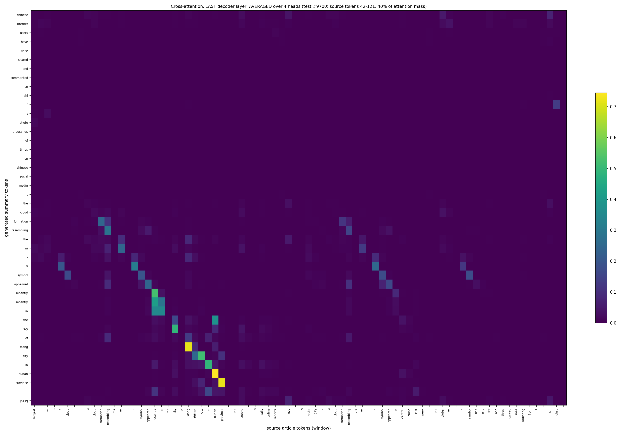
Figure 4: head-averaged cross-attention heatmap.
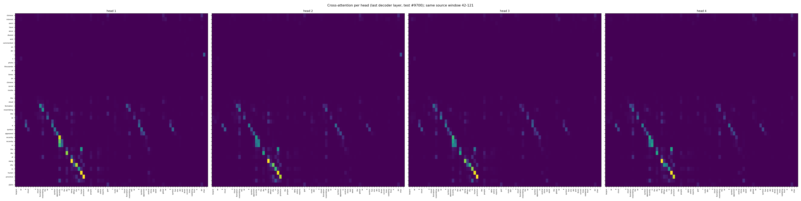
Figure 5: per-head cross-attention.
Averaged over heads, 40% of the attention mass of this example falls inside the shown 80-token window (source tokens 42-121). For 70% of the generated tokens the most-attended source token is the identical word piece (copy-like alignment). The mean attention entropy is 3.19 nats; a perfectly uniform distribution over the 400 source tokens would give 5.99. Attention is clearly concentrated (53% of the uniform entropy), i.e. the decoder focuses on specific source words while generating. 48% of the attention peaks lie in the first 100 source tokens (news puts key facts first). Per-head entropy ranges from 3.01 (sharpest head) to 3.28 nats (most diffuse head), i.e. all heads behave similarly.

10. Limitations and discussion
The from-scratch model scores 31.82 ROUGE-Lsum vs 36.35 for Lead-3 (gap +4.52). It stays below Lead-3, as expected, for these reasons: (1) limited data and epochs: 287,113 of 287,113 training pairs and 6 epochs; (2) Lead-3 is extractive and copies exact reference-style sentences, which is a very strong prior on news, whereas an abstractive model must learn to generate fluent text; (3) copy behaviour: without a pointer-generator mechanism the model must re-generate names and numbers from a 30,522-token word-piece vocabulary and often fails on rare entities; (4) tokenization: lower-cased word pieces split names into fragments and lose casing; (5) exposure bias: training uses gold prefixes, decoding feeds back its own mistakes; (6) greedy decoding without repetition control produces loops (68.1% of summaries); (7) articles are truncated to 400 tokens (87.2% of articles are longer) and the validation subset (3,000) is only a proxy for generalisation.

11. Conclusion
A 13.3M-parameter Transformer with tied embeddings, trained from scratch on 287,113 pairs, reaches ROUGE-1/2/L/Lsum of 34.28/13.94/24.50/31.82 on the full test set (Lead-3 measured: 40.05/17.48/25.02/36.35). All components, masks and the decoder were implemented and verified by sanity checks.

