**Steps To Run**

* **Step-1 -Start File Service server**

First the ‘file service server’ is initiated at any computer in the Lan. (This is only used for monitoring purposes, file transfer can take place without this server as well).

**Click on start button of file service server** which makes them live

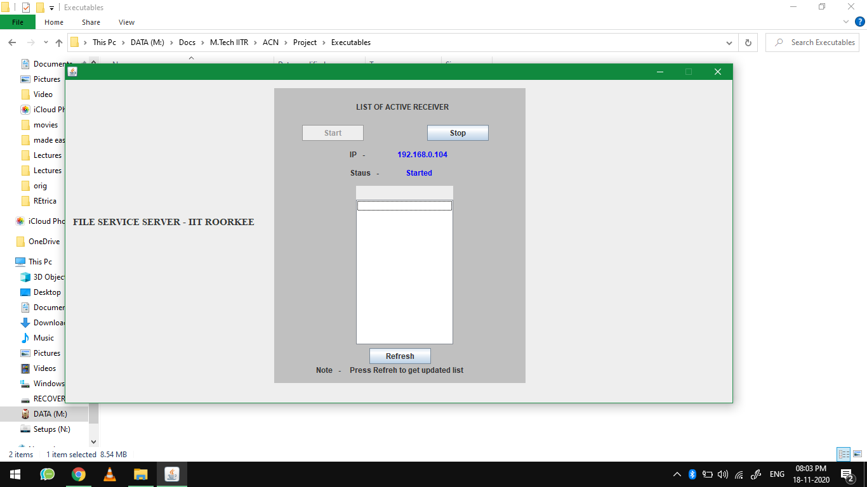

* **Step-2 -Start File Receiver Application**

Configure receiver by giving name themselves and specifying file service IP (IP of machine on which file service server running)

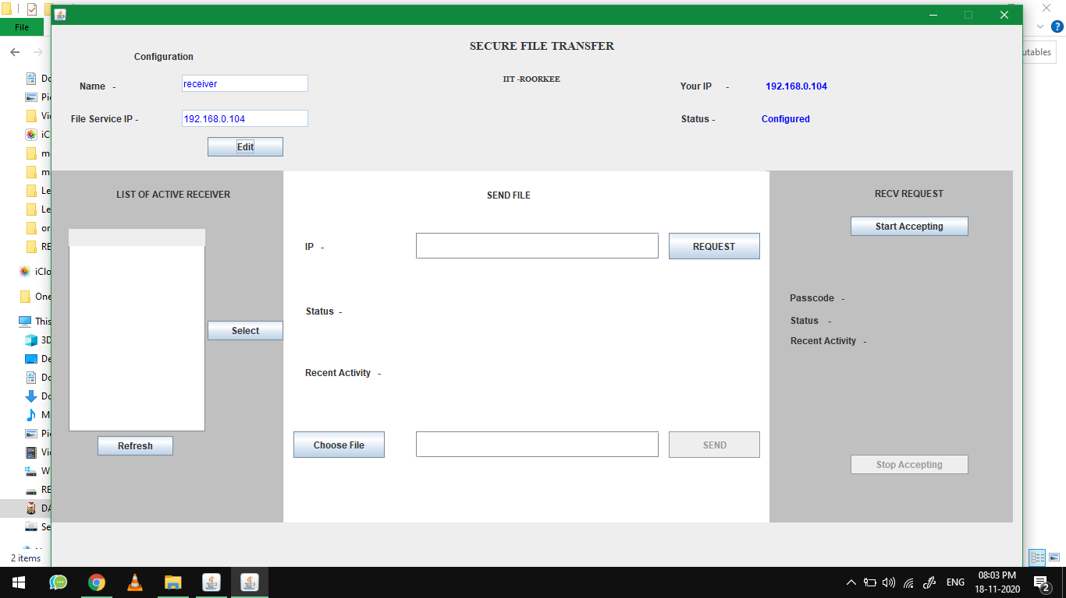

* **Step-3 -Activate Receiver**

1. Once the configuration is done, the receiver will start receiving **by clicking on ‘start accepting’ button .**

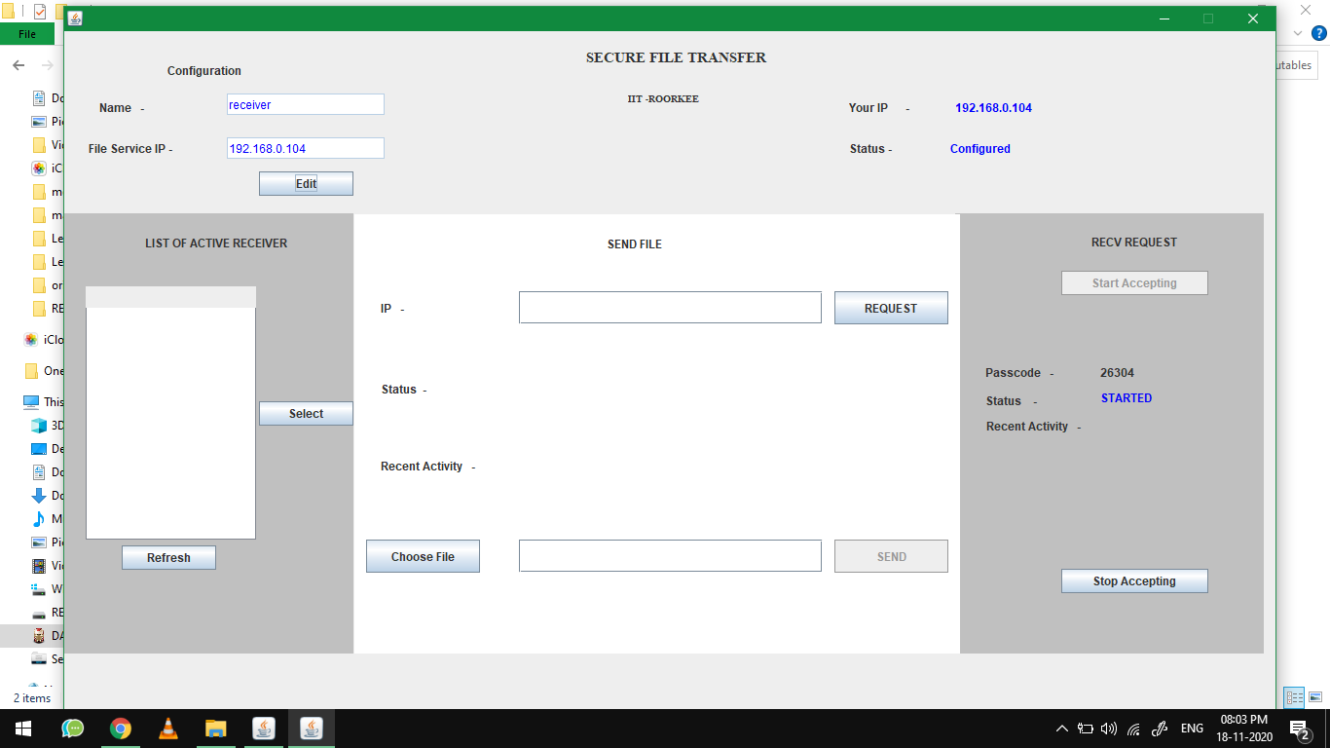

* **Step-4 -Start File Sender Application**

Configure sender by giving name themselves and specifying file service IP (IP of machine on which file service server running) .

* **Step-5 –Fetch Active Receiver (Sender Side)**

Click on refresh **button** which present in left Side panel,

Which fetch list of receiver, Choose one of receivers from list

then **click On Select button.**

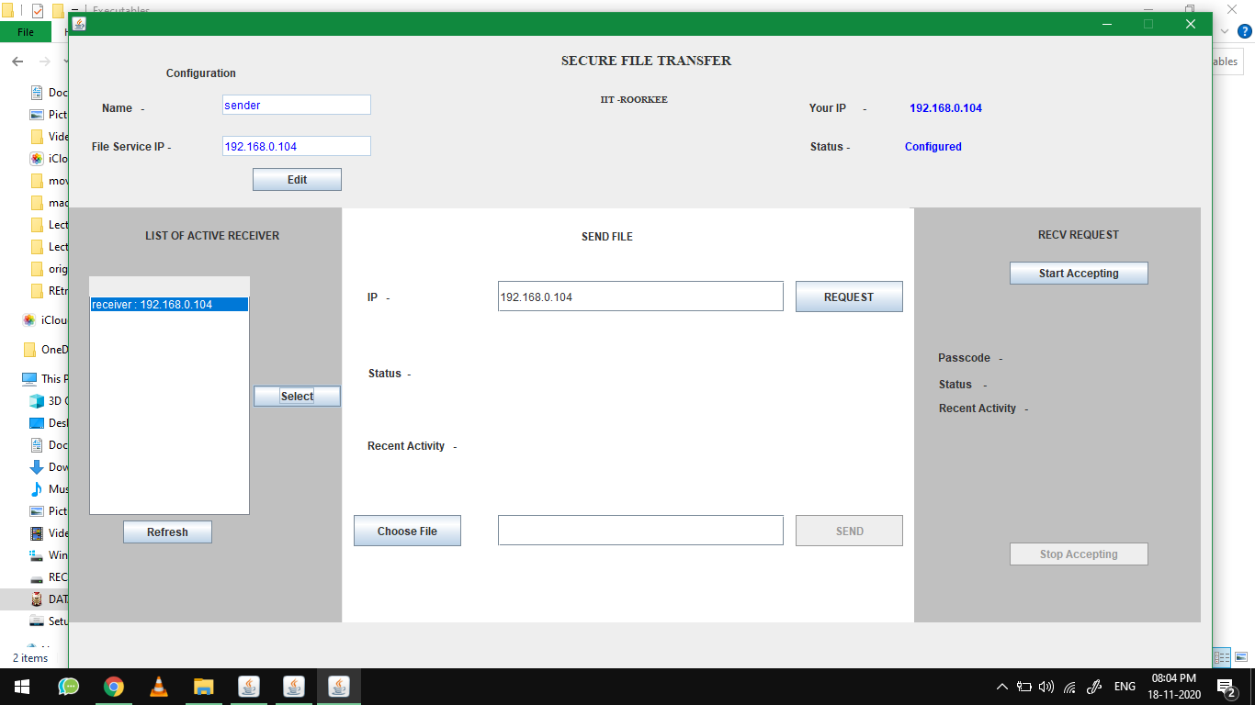

* **Step-6 –Get Public key of Receiver (Sender Side)**

Click on Request button to send request to receiver

* **Step-6 –Accept sender Request(Receiver Side)**

Once the sender click on ‘request’ button a request will be sent to receiver as shown below.

To accept the request, **receiver need to click on ‘accept’ button otherwise receiver can clock on ‘reject’ button.**

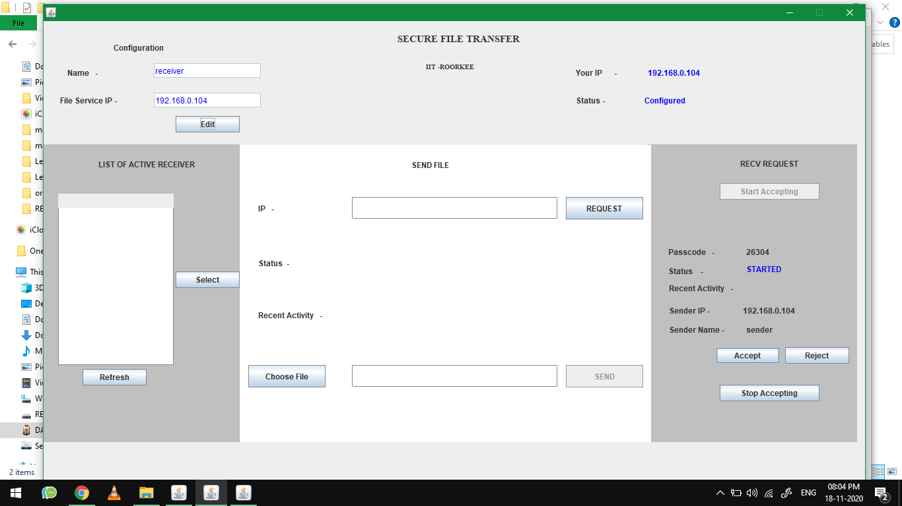

1. If the request is accepted, the status will be updated as “you accepted the sender request”.

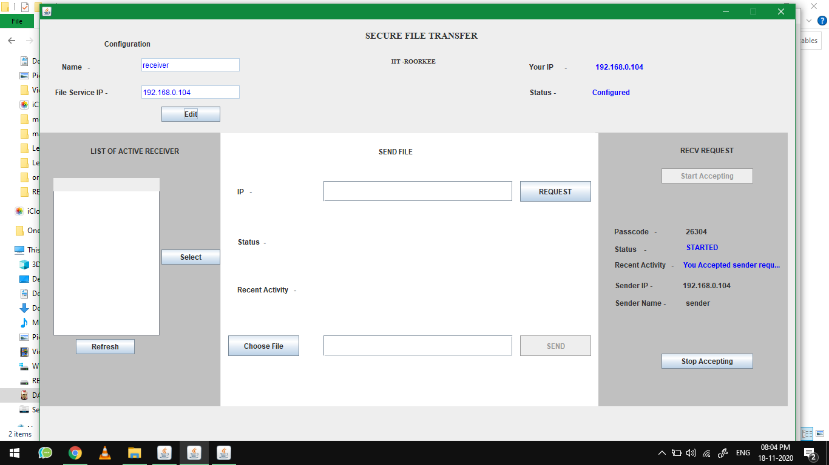

1. At the same time, at senders end, status will be updated as “File Send Initiated”. As shown below.

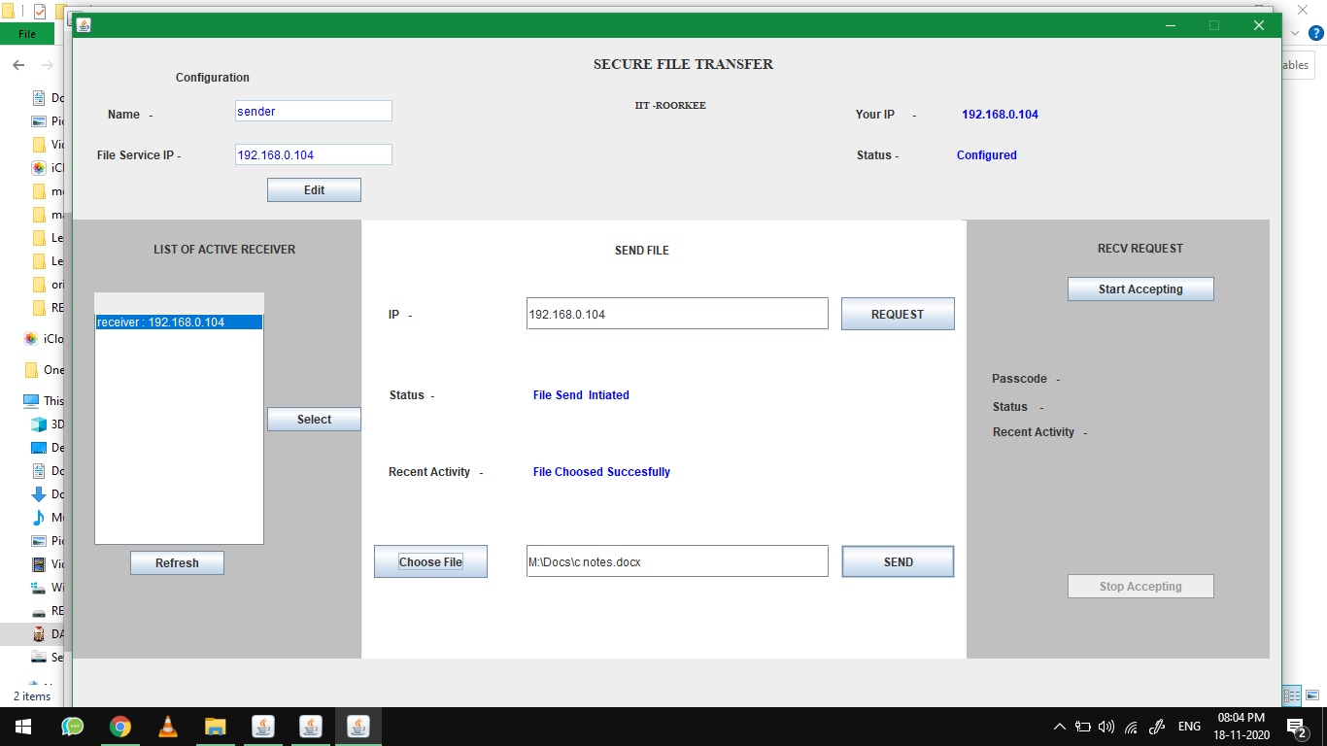

* **Step-7 –Send File(sender Side)**

**Click on Choose file** And select file sender want to send ,After selecting **Click on SEND Button**

Once the transfer is completed, status will be updated as “File send

Successfully”.

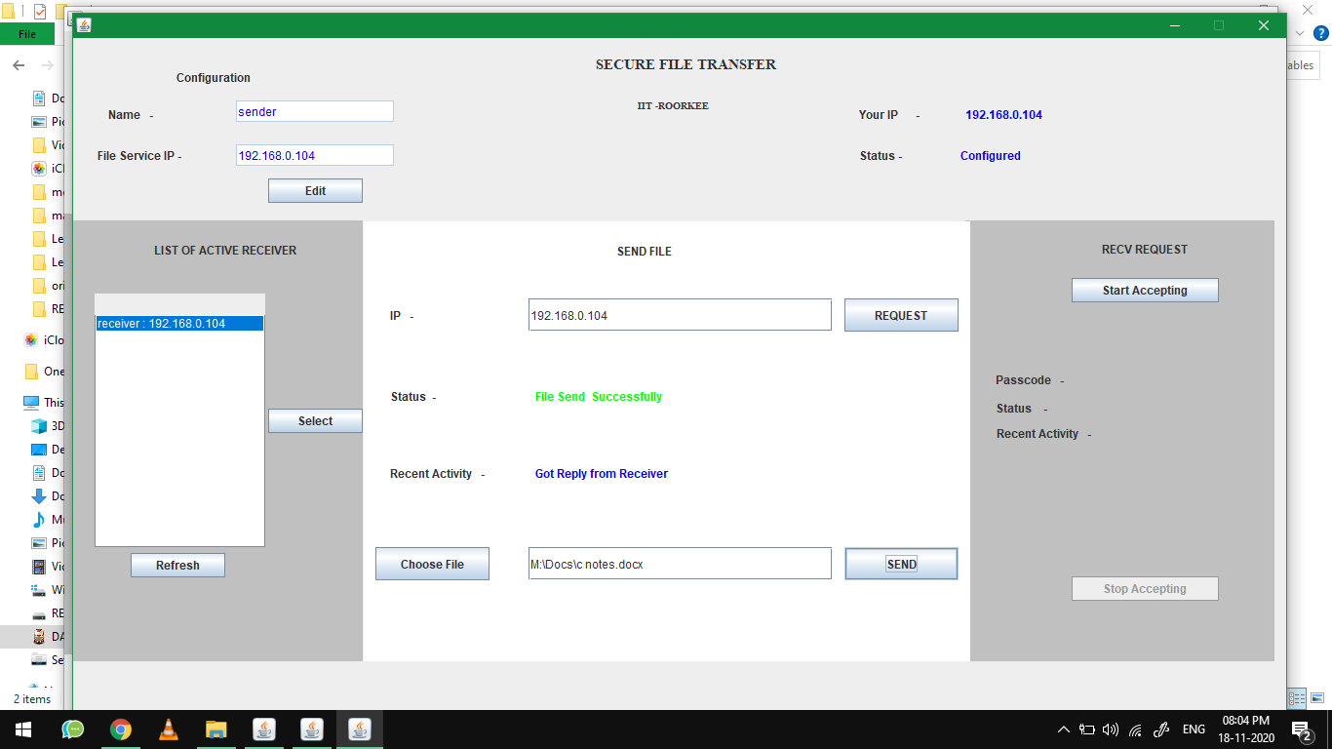

At receiver’s end the status will be updated as “File accepted”.

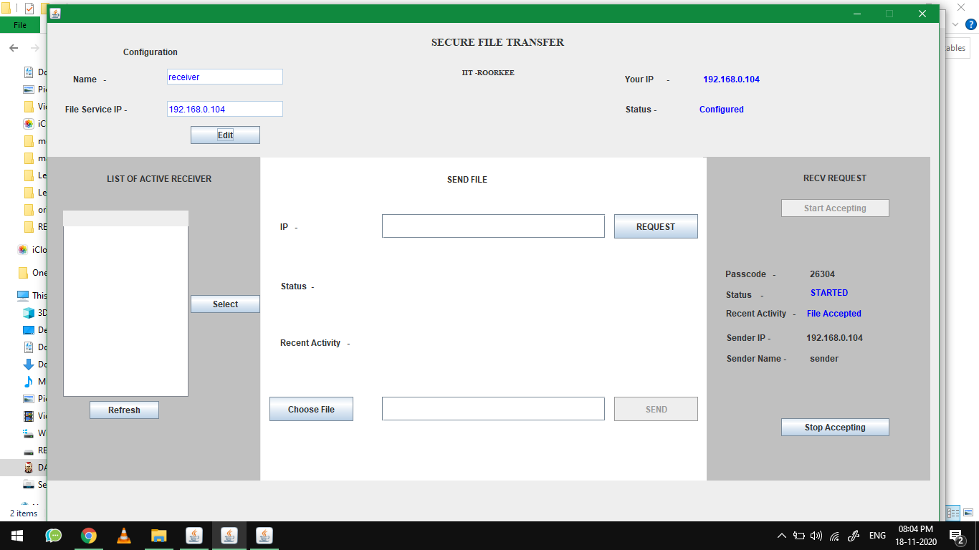

At root folder of receivers computer, a directory will be created as RECEIVED/’IP’/’DATE’/

And the received files can be found here(along with encrypted file).

