COEP Technological University
Department of Computer Science and Engineering
DBMS Project Report
Blood Donor Matching
Submitted by
Tanmay Kangule – 612415081
Shreyas Joshi – 612415072
TY – Div 1 – DVL - 2

1. Problem Statement
In critical medical emergencies, timely access to specific blood groups is often a matter of life and death. Traditional, decentralized blood banking systems suffer from fragmented data, a lack of real-time inventory tracking, and inefficient donor-patient matching. This fragmentation leads to critical delays in sourcing rare blood types, unnecessary blood wastage due to expiration, and imbalances in regional blood distribution. There is an urgent need for a centralized, real-time Database Management System that seamlessly connects voluntary donors, blood banks, and recipients to ensure rapid blood availability and efficient, data-driven inventory management.

2. Objectives
- Centralized Data Management: To design and implement a relational database to securely manage donor profiles, blood bank inventories, and historical donation records without data redundancy.
- Real-Time Matching: To develop a query mechanism that rapidly links emergency blood requests with the nearest stocked blood banks or eligible local donors based on geographic location and blood type compatibility.
- Structural Integrity: To ensure data consistency, eliminate anomalies, and maintain strict data integrity through a fully normalized relational database schema (optimized up to 3NF).
- Workflow Automation: To streamline the administrative workflow of blood banks by digitizing blood transaction histories (both incoming donations and outgoing fulfillments) and dynamically updating stock levels.
- User Accessibility: To provide a reliable, form-based application interface for seamless donor registration, rapid blood requisition, and real-time inventory visibility.

3. Functional Requirements
Donor Management
- Registration: The system must allow new voluntary donors to register by capturing their personal details, contact information, geographic location (city), and verified blood group.
- Eligibility Tracking: The system must log the date of a donor's last donation to ensure they meet the minimum required waiting period before subsequent donations.
Blood Bank & Inventory Operations
- Dynamic Inventory Updates: The system must automatically increment the blood stock quantity in a specific bank's inventory when a donation occurs, and decrement it when a blood request is fulfilled.
- Stock Visibility: The system must allow administrators to view current blood availability grouped by blood type and location in real-time.
Blood Request & Matching System
- Requisition Handling: The system must allow users, hospitals, or administrators to submit a request for a specific volume and type of blood, along with an urgency level.
- Geographic Matching: Upon receiving a request, the system must execute queries to locate the nearest blood bank holding the required stock.
- Donor Alerting (Fallback): If the requested blood type is out of stock at local banks, the system must retrieve a list of eligible donors matching the required blood group within the requester's city.
Transaction & Audit Trail
- Record Keeping: The system must log every individual donation event (linking the donor, blood bank, date, and quantity) to maintain a verifiable audit trail.
- Status Tracking: Blood requests must have trackable statuses (e.g., Pending, Fulfilled, Cancelled) to prevent duplicate processing.

4. ER Diagram
The requirements in Section 3 are modelled with five entities and four one-to-many relationships. Primary keys are marked PK and foreign keys are marked FK. A solid line marks the identifying relationship of the weak entity, and dashed lines mark the other relationships.
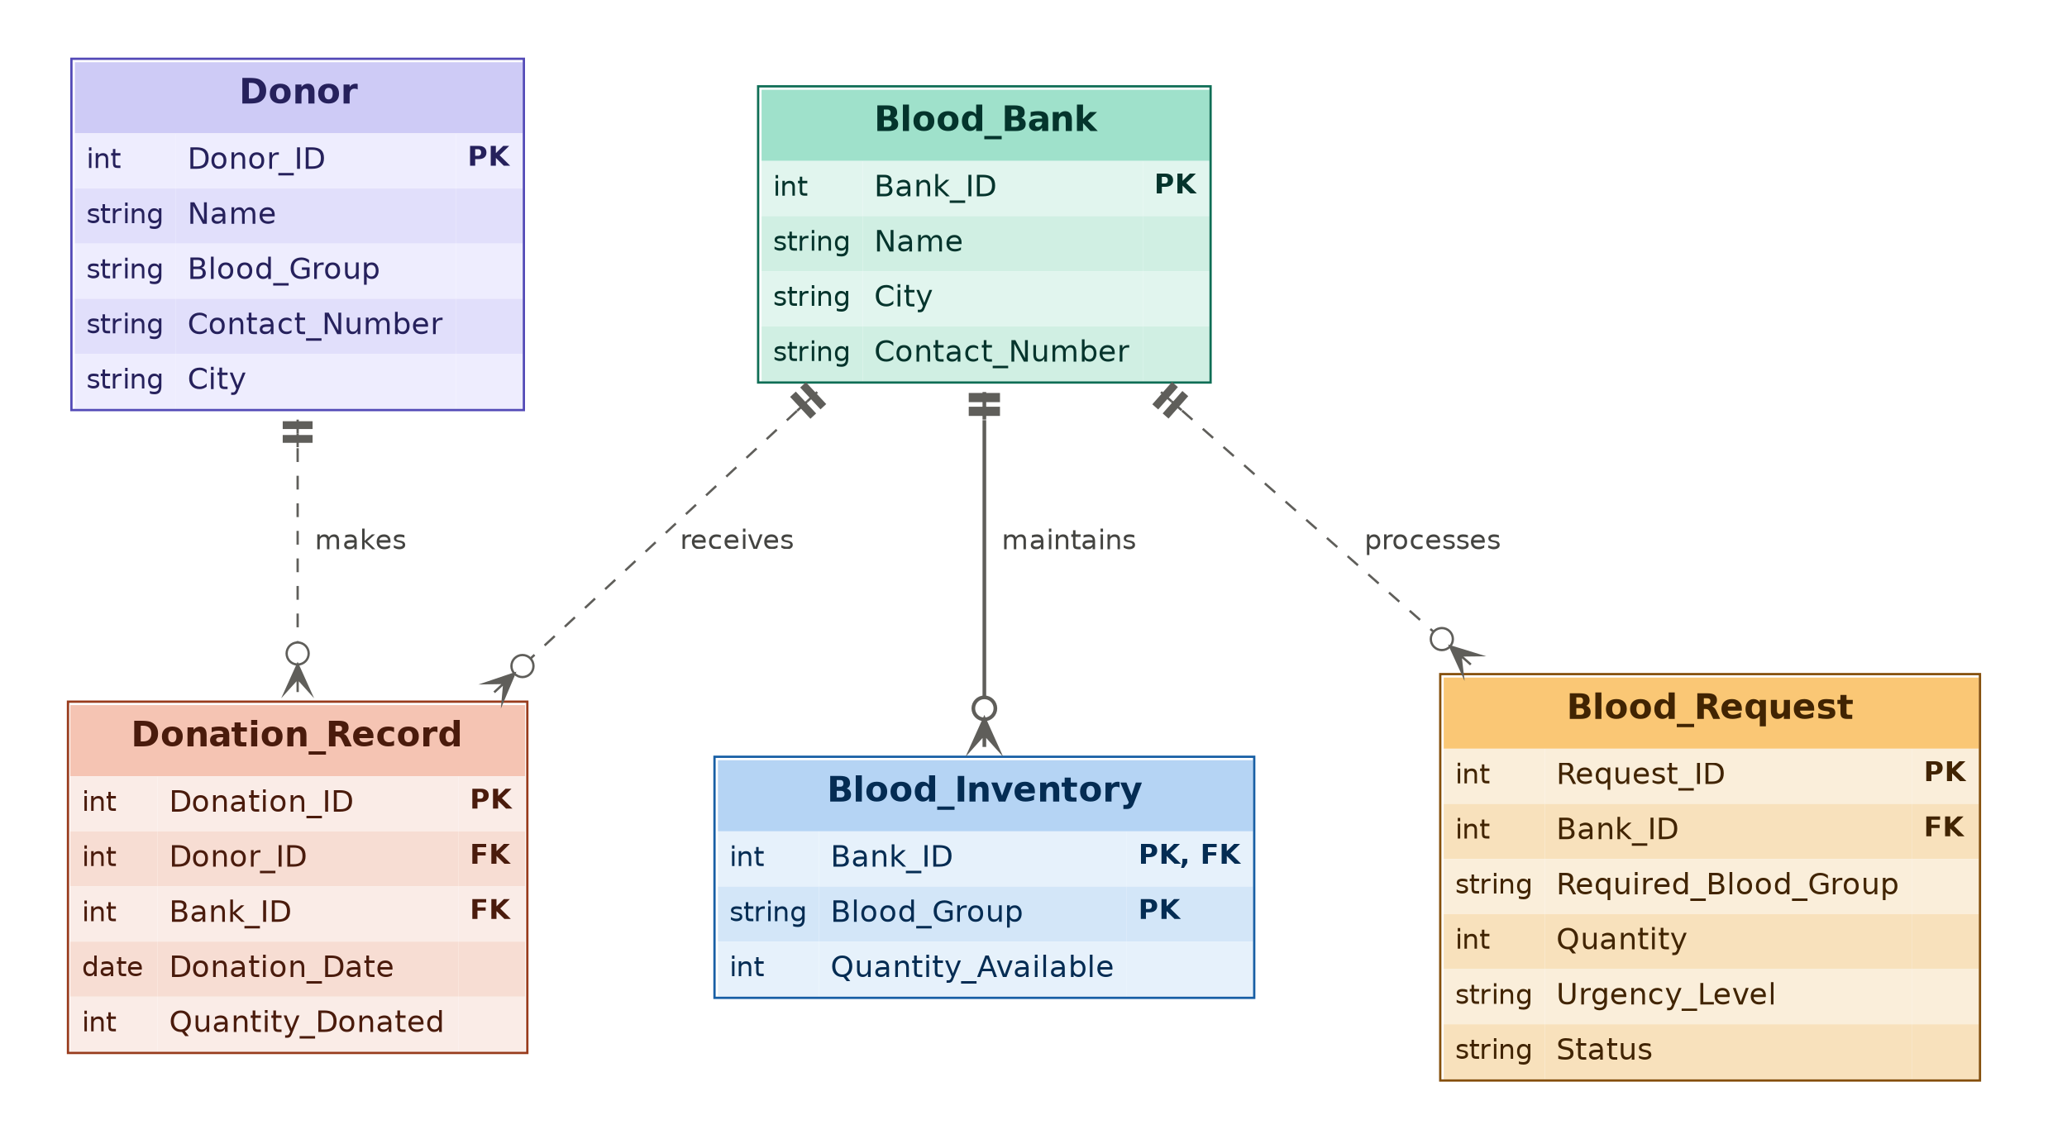
Figure 1: ER diagram of the blood bank database

4.1 Entities and Attributes
Entity | Type | Attributes
Donor | Strong entity | Donor_ID (PK), Name, Blood_Group, Contact_Number, City
Blood_Bank | Strong entity | Bank_ID (PK), Name, City, Contact_Number
Blood_Inventory | Weak entity (depends on Blood_Bank) | Bank_ID (PK, FK), Blood_Group (PK), Quantity_Available
Donation_Record | Transaction entity | Donation_ID (PK), Donor_ID (FK), Bank_ID (FK), Donation_Date, Quantity_Donated
Blood_Request | Transaction entity | Request_ID (PK), Bank_ID (FK), Required_Blood_Group, Quantity, Urgency_Level, Status
Blood_Inventory is a weak entity. It has no key of its own, so its primary key combines the owner key Bank_ID with the partial key Blood_Group. Each bank keeps one inventory record per blood group.

4.2 Relationships and Cardinality
Relationship | Entities | Cardinality | Meaning
MAKES | Donor and Donation_Record | 1:N | One donor can make many donation records. Each donation record belongs to exactly one donor.
RECEIVES | Blood_Bank and Donation_Record | 1:N | One blood bank receives many donation records. Each donation record happens at exactly one bank.
MAINTAINS | Blood_Bank and Blood_Inventory | 1:N | One blood bank maintains many inventory records, one for each blood group. Each inventory record belongs to one bank.
PROCESSES | Blood_Bank and Blood_Request | 1:N | One blood bank can process many blood requests. Each request is directed to one bank.

5. Relational Schemas
The ER diagram in Section 4 is converted into the following relational schemas.

5.1 Mapping Rules Used
- Each strong entity (Donor, Blood_Bank, Donation_Record, Blood_Request) becomes a relation. Its key attribute becomes the primary key.
- The weak entity Blood_Inventory becomes a relation. Its primary key is the owner key Bank_ID, which is also a foreign key, combined with its partial key Blood_Group.
- Each 1:N relationship (MAKES, RECEIVES, MAINTAINS, PROCESSES) is mapped by adding the primary key of the 1-side as a foreign key in the N-side relation.

5.2 Schemas
Notation: relation name in bold, primary key underlined, foreign key in italics. An attribute that is both a primary key and a foreign key is underlined and italic.
Donor ( Donor_ID, Name, Blood_Group, Contact_Number, City )
Blood_Bank ( Bank_ID, Name, City, Contact_Number )
Blood_Inventory ( Bank_ID, Blood_Group, Quantity_Available )
- Bank_ID is a Foreign Key referencing Blood_Bank(Bank_ID)
Donation_Record ( Donation_ID, Donor_ID, Bank_ID, Donation_Date, Quantity_Donated )
- Donor_ID is a Foreign Key referencing Donor(Donor_ID)
- Bank_ID is a Foreign Key referencing Blood_Bank(Bank_ID)
Blood_Request ( Request_ID, Bank_ID, Required_Blood_Group, Quantity, Urgency_Level, Status )
- Bank_ID is a Foreign Key referencing Blood_Bank(Bank_ID)

6. Functional Dependencies
Based on the schemas in Section 5, the following functional dependencies hold on each relation.
Donor
- Donor_ID → Name, Blood_Group, Contact_Number, City
Blood_Bank
- Bank_ID → Name, City, Contact_Number
Blood_Inventory
- (Bank_ID, Blood_Group) → Quantity_Available
Donation_Record
- Donation_ID → Donor_ID, Bank_ID, Donation_Date, Quantity_Donated
Blood_Request
- Request_ID → Bank_ID, Required_Blood_Group, Quantity, Urgency_Level, Status
In every relation the left side of each dependency is a candidate key (a superkey), so all five relations are in BCNF. Blood_Inventory has the composite key (Bank_ID, Blood_Group) because each bank keeps one inventory record per blood group.

7. Normalization up to 3NF
Each relation is checked against 1NF, 2NF and 3NF using the functional dependencies in Section 6.
Relation | 1NF | 2NF | 3NF | Result
Donor | All attributes atomic and single-valued | Primary key Donor_ID is a single attribute, so no partial dependency | Name, Blood_Group, Contact_Number and City depend only on Donor_ID. No transitive dependency | In 3NF
Blood_Bank | All attributes atomic and single-valued | Primary key Bank_ID is a single attribute, so no partial dependency | Name, City and Contact_Number depend only on Bank_ID. No transitive dependency | In 3NF
Blood_Inventory | All attributes atomic and single-valued | Primary key is the composite (Bank_ID, Blood_Group). Quantity_Available depends on the full key, not on Bank_ID or Blood_Group alone | Quantity_Available is the only non-prime attribute, so it cannot depend on another non-prime attribute | In 3NF
Donation_Record | All attributes atomic and single-valued | Primary key Donation_ID is a single attribute, so no partial dependency | Donor_ID, Bank_ID, Donation_Date and Quantity_Donated depend only on Donation_ID. Donor and bank details are not repeated here | In 3NF
Blood_Request | All attributes atomic and single-valued | Primary key Request_ID is a single attribute, so no partial dependency | Bank_ID, Required_Blood_Group, Quantity, Urgency_Level and Status depend only on Request_ID. Bank details are not repeated here | In 3NF
Conclusion: all five relations already satisfy 3NF, so no decomposition is needed and the relational schemas in Section 5 are final. Redundancy is avoided by design: donor details live only in Donor, and bank details live only in Blood_Bank. Other relations refer to them through foreign keys. Every determinant is also a candidate key, so the relations are in BCNF as well.

