WRO Future Engineers 2026
Category: Future Engineers

Table of Contents
- Executive Summary & Vehicle Overview
- Strategic Challenge Analysis
- Criterion 1: Mobility & Mechanical Design
- Criterion 2: Power & Sensor Architecture
- Criterion 3: Software Architecture & Obstacle Strategy
- Criterion 4: Systems Thinking & Engineering
- Criterion 5: Reproducibility & GitHub Quality
- Comprehensive Testing Logs & Analytics

Executive Summary & Vehicle Overview
Yo_Bot_To_The_Future robot is one that has high performance and is made for the sole aim of addressing the problems presented by the WRO 2026 Future Engineers competition. Through the utilization of a HuskyLens AI vision sensor paired with an ESP32 microcontroller that handles every real-time control task, we achieve seamless coordination between perception and movement without ever loading the control loop with image processing.

System Parameter | Detailed Specification
Chassis | Optimized for balance between weight and strength, featuring a second layer to separate the electronic components that build this device.
Steering | The Ackermann trapezoidal linkage is driven by an analog servo which turns up to 35 degrees on either side.
Wheels | High-traction rubber treads with a 65mm diameter, 204mm circumference and predictable change in position.
Vision Processor | HuskyLens AI camera with an onboard Kendryte K210 processor, performing all colour recognition internally.
Main Controller | ESP32, dedicated to real-time decisions, PWM signal generation, and I2C polling.
Primary Sensor Input | HuskyLens in Colour Recognition mode for dynamic colour object detection.
Secondary Sensor Input | Array of HC-SR04 Ultrasonic sensors for wall collision avoidance.
Power Reservoir | Custom-made 3S 18650 lithium-ion battery pack, providing 11.1V normally, with a system that shuts it off if the voltage gets too low.

Team Picture:
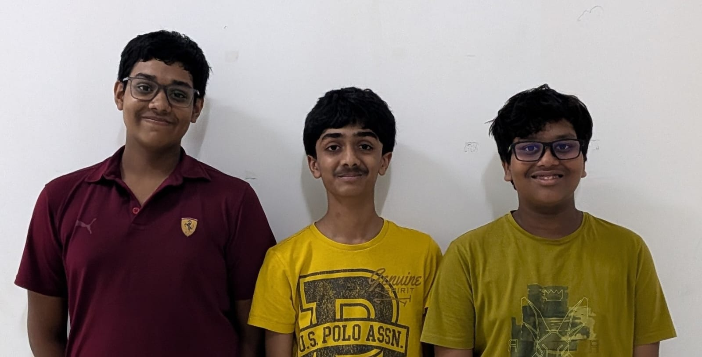

Strategic Challenge Analysis
Requirements of WRO Future Engineers 2026 include the development of an autonomous car on 1/10 scale that is able to drive through a randomly created track surrounded by walls and determine its path based on colored pillars. The evaluation criteria of this competition significantly favors the teams that will be able to prove their knowledge of automotive engineering (e.g., Ackerman system).

Our strategy was built upon fundamental pillars of autonomous vehicle design:

- Deterministic Actuation: The robot's physical response to a software command must be identical every single time. This put our team in favor of Ackermann steering.
- Data Isolation: Processing a live camera feed requires massive computational thinking. If the same processor handling the camera is also responsible for generating the precise PWM pulses for the steering servo, the servo will jitter due to thread blocking. Thus, the HuskyLens handles all the image data on its own K210 processor and reports only coordinates, and the ESP32 handles the time-critical pulses.

1. Criterion 1: Mobility & Mechanical Design

1.1 Chassis Engineering & Material Selection
The chassis is considered to be the backbone of the car itself. At an early stage in our design process, we found out that a flexible chassis will lead to an error in the pitch and angle of our HuskyLens, leading to large mathematical errors in our distance estimation system. Even when the camera tilts just two degrees downwards because of heavy acceleration, the system sees objects closer than they really are.

In order to remove this problem, the chassis was designed using CAD software and then manufactured using 3D printing. We chose high density PETG filament for printing as it has better resistance to impact and glass transition temperature. The chassis has a honeycomb infill design which maximizes stiffness and maintains strength.

1.2 The Roof Tier Module: Iterative Evolution
In phase two of our prototype, there was one key issue identified in the design. This included electromagnetic interference and thermal saturation. The L298N H-Bridge dissipates a significant amount of heat under sustained motor load. When the logic boards sit directly beside it, that heat pools in one region of the deck. Another issue is that by putting all the wires on one layer, it became a rat's nest.

The Solution: We designed a secondary roof tier that bolts onto the chassis walls. This roof tier held the battery pack and the ESP32 microcontroller away from the lower deck. This design choice came with three benefits:

- EMI Isolation: The sensitive logic-level I2C data lines on the roof are distanced from the noisy magnetic fields generated by the 100 RPM motors below.
- Thermal Management: The lower deck became a wind tunnel, allowing air flow directly over the L298N heatsink.
- Center of Mass Optimization: While raising the battery usually negatively impacts the CoM, placing it directly over the rear drive axle massively increased the normal force on the rear tires, practically eliminating wheel slip during aggressive acceleration.

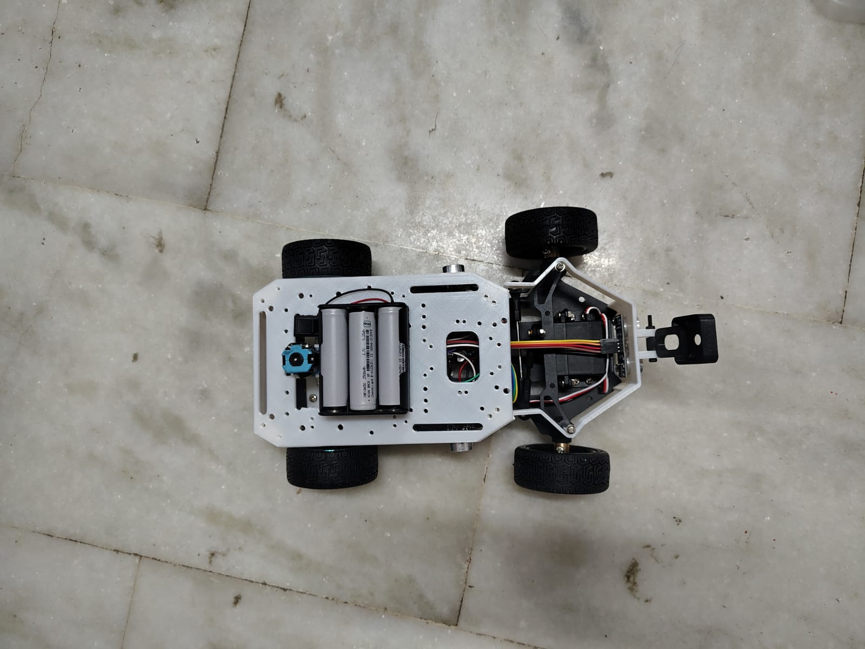
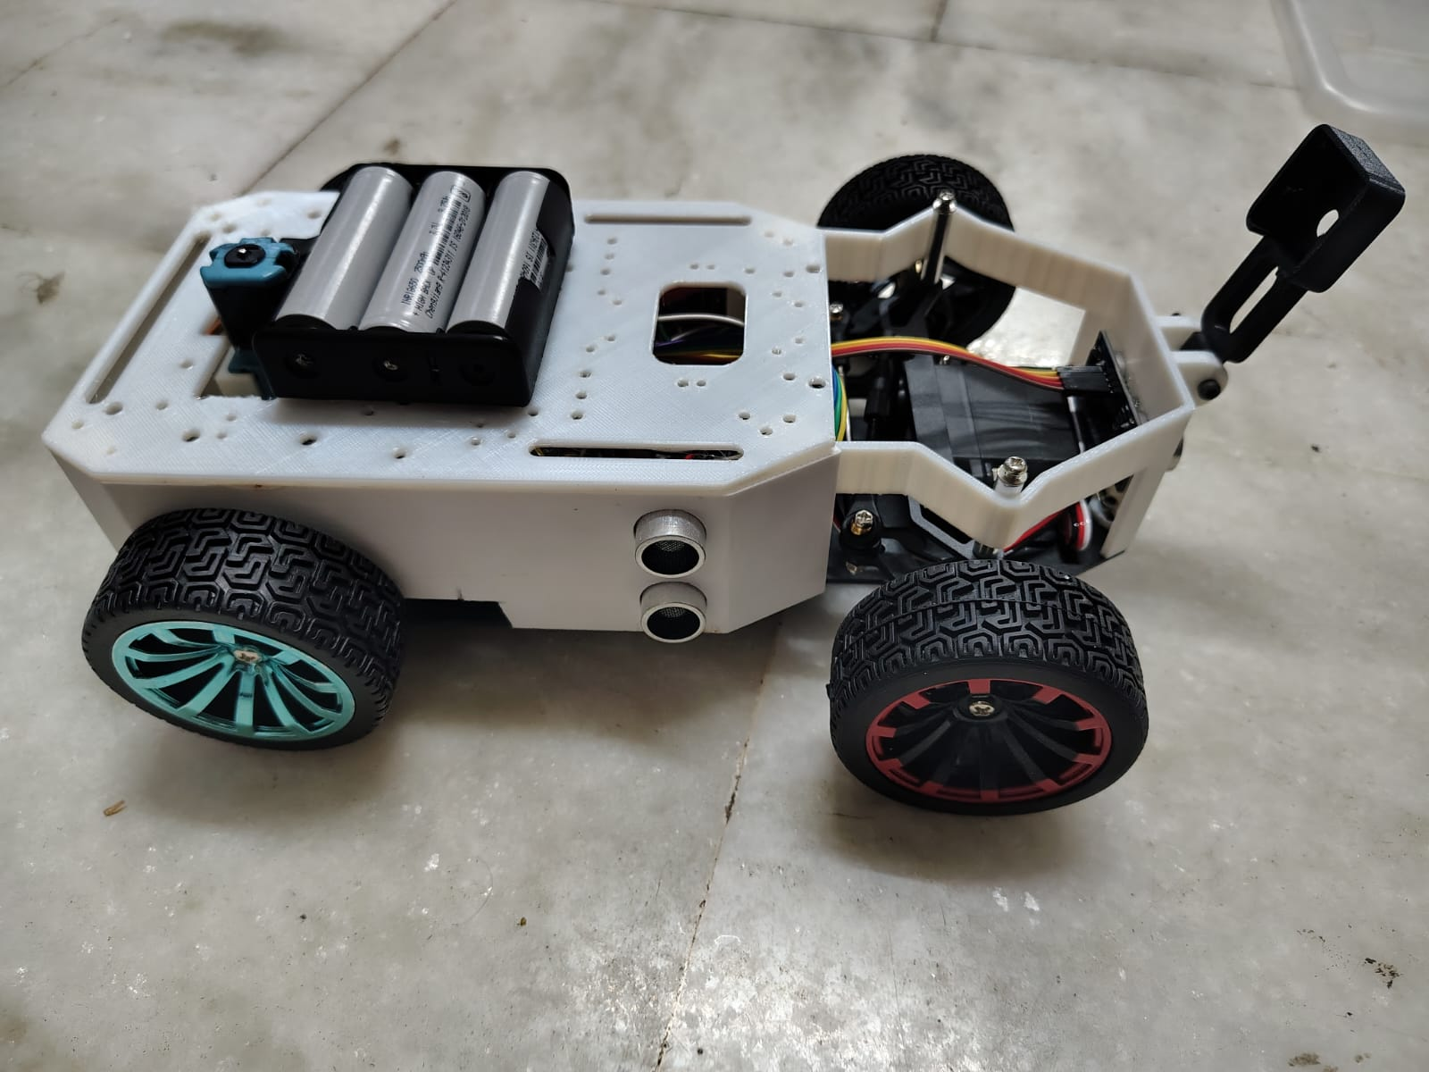

1.3 Ackermann Steering Geometry & Kinematics
In an effort to conform to the Future Engineers category rules, our car employs true steered front axle design. We chose not to use the differential or skid steering method. With the skid steering system, the wheels have to scrub against the surface to make the car turn. These forces introduce non-linear friction coefficients which nullify the accuracy of odometry measurements and make open-loop steering impossible.

A trapezoidal Ackermann steering was used in the design of the car. On a turn, the inner wheel needs to follow a smaller radius circle compared to the outer wheel. When both wheels steer at the same angle, there is bound to be slip between them. It is by this geometry that the steering linkages need to be at an angle to make sure that their geometric lines meet at the rear axle.

Mathematical Constraint:

cot(Outer_Angle) - cot(Inner_Angle) = Track_Width / Wheelbase

To prevent mechanical binding and servo stall, we implemented physical hard stops on the chassis that restrict the maximum tie-rod horizontal travel, effectively capping our maximum steering angle at precisely 35 degrees left and right. This fixed maximum allows the path-planning algorithm to rely on a hardcoded minimum turning radius.

1.4 Drivetrain, Propulsion, & Torque Analytics
The propulsion system in the rear end is composed of two 100 RPM geared DC motors controlled by an L298N H-Bridge controller. The choice of 100 RPM motors is not an arbitrary choice.

Speed vs Frame Processing Latency: If we take into account the speed of the robot to be 2.0 m/s and that the HuskyLens reports recognised colour blocks at roughly 20 FPS. Then, the robot travels 10 cm for every frame data collected. Thus, the faster the motors are, the greater the distance traveled between frames and hence late collision detection and wall collision. With 100 RPM motors, we achieve perfect speed synchronization with the latency of the vision module.

With a wheel diameter of 65 mm, we have a wheel circumference of 204.2 mm. For 100 RPM, the theoretical top speed is 0.34 m/s with very high torque at low speeds.

2. Criterion 2: Power & Sensor Architecture

2.1 Power Tree, Isolation, & Load Balancing
The electrical design system has been built on the basis of isolation and prevention of brown out conditions. The battery used for the power of the vehicle is a custom made 3S 18650 Lithium-Ion battery which provides 12.6 volts of power output with nominal voltage of 11.1 volts.

The power tree splits immediately after the master fuse and emergency kill switch:

- Branch 1 (High Power): The uncontrolled 12.6V feeds directly to the L298N H-Bridge motor driver. This provides the drive motors with access to immense burst currents in order to accelerate.
- Branch 2 (Servo Logic): The 12.6V is directed towards a highly efficient buck converter which drops the voltage to exactly 6.0V. The 6V rail powers the steering servo alone. During stall against a wall, the servo pulls more than 1.5Amps in the blink of an eye. With the help of this buck converter, this current spike does not go to the microcontroller.
- Branch 3 (Digital Logic): The second 5V step-down power converter powers the ESP32 microcontroller and the HuskyLens to provide a pure power supply without any ripple to prevent the controller from randomly rebooting during operation. The HuskyLens draws roughly 320mA while actively recognising, so it is fed from this regulated rail rather than from the ESP32's own 5V pin.

2.2 Li-ion Battery Discharge Characteristics
Lithium Ion is unstable when it is over-discharged. If the pack voltage is less than 9.0 volts, then there will be some chemical damage. We have designed an impedance voltage divider, which is connected to the ESP ADC directly. The ESP keeps monitoring the pack voltage. If it drops below 9.5 volts, then an interrupt signal is generated, and the H-bridge circuit stops working.

2.3 Sensor Topology: Vision vs. Proximity
Primary Vision (HuskyLens): The HuskyLens has been placed on a specially designed bracket fixed onto the front bumper, which has been calibrated to view the horizon of the field wall and base of the colored obstacle poles. The visual sense is used to keep the vehicle in its path and classify obstacles. Because the HuskyLens carries its own K210 vision processor, it returns only a small list of recognised block coordinates over I2C rather than a raw video stream, which is what allows a single microcontroller to run the whole vehicle.

Secondary Proximity (Ultrasonic): The ultrasonic sensors HC-SR04 were attached to the front and side wings of the chassis. These use an entirely different physical approach (sound waves compared to photons). In case the camera cannot see due to a bright overhead light (specular glare off the mat), the ultrasonic sensors serve as a fallback. We activate the sensors in a round robin fashion to avoid acoustic interference (the echo of one ping heard by the other sensor).

2.4 Comprehensive Pinout & Wiring Manifesto
Robotic reliability is 90% wiring. Each and every wire on this robot is crimped, strain-relieved, and tagged.

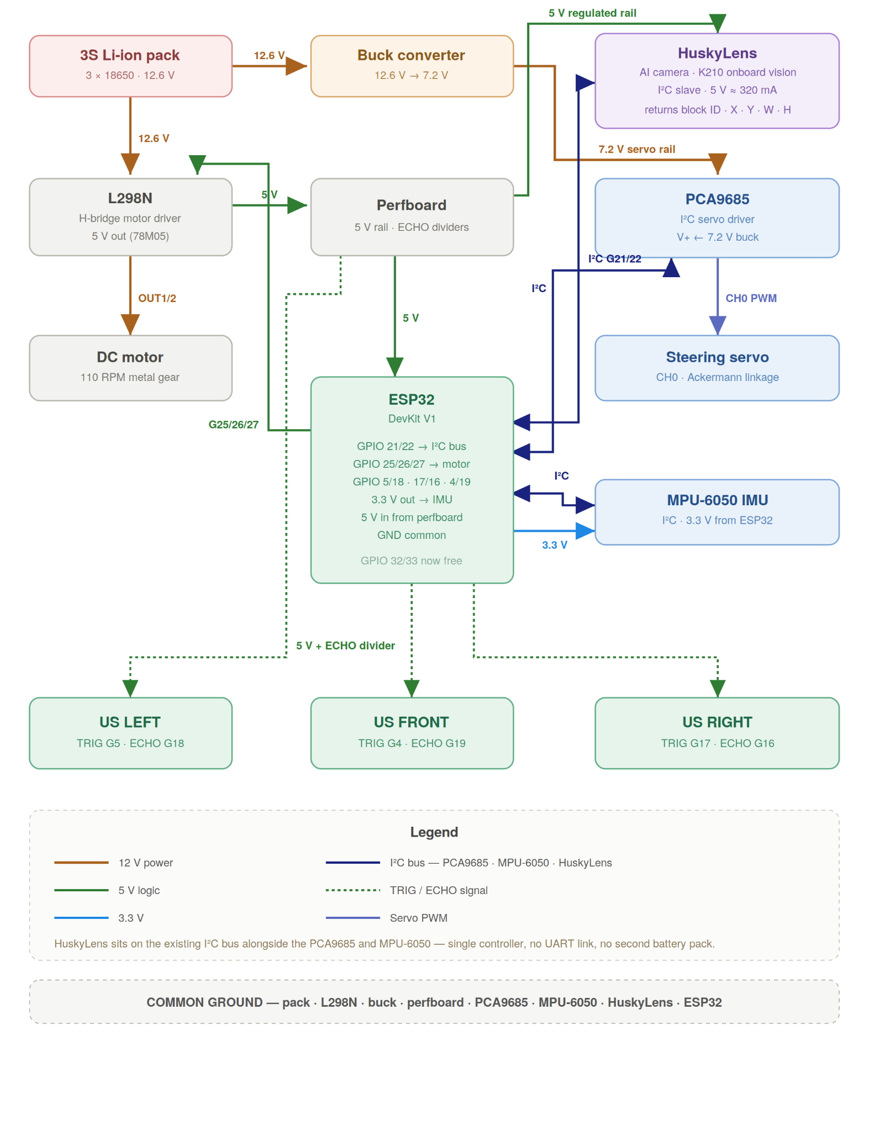

3. Criterion 3: Software Architecture & Obstacle Strategy

3.1 Vision Offloading: Smart Sensor & Real-Time Controller
A general-purpose microcontroller does not have the capability to deal with raw video signals. A single-board computer running a full operating system, on the other hand, has issues with timing of the PWM signal because of the overhead of the OS scheduler. This problem is solved in our software architecture by pushing the vision workload into the sensor itself.

The HuskyLens is responsible for executing the recognition work. Its onboard K210 processor runs the colour recognition model, so the heavy per-pixel maths never touches our control loop.

The ESP32 handles the compiled C++ program. It is the brain stem of our project. It just deals with the current time frame and thinks only about the following questions: How many microseconds does my signal need to be right now? What is the current battery voltage? Where did the HuskyLens last report a coloured block?

3.2 Vision Pipeline & Colour Recognition
Our system for obstacle avoidance uses the HuskyLens in Colour Recognition mode. Colours are taught to the sensor during setup under arena-representative lighting, and the K210 performs its thresholding internally in a hue-based colour space, which is much more resilient to changes in ambient light conditions than raw RGB comparison.

- Learning: Before a run, the red pillar is learned as ID 1 and the green pillar as ID 2. The learned models are stored in the HuskyLens's own flash memory, so they survive a power cycle.
- Block Extraction: For every frame, the HuskyLens isolates the largest contiguous region matching a learned colour and returns a bounding block containing its ID, centre X, centre Y, width and height.
- Spatial Mapping: The ESP32 finds the obstacle's position by checking where the centre of the returned block is compared to the centre of the camera frame (160 on a 320-pixel-wide frame). It also estimates how far away it is based on the size of the block. A bigger block means the obstacle is closer.

3.3 State Machine Topology & Transitions
The vehicle operates autonomously via a finite state machine, ensuring predictable behavior under all conditions:

- STATE_INIT: Hardware boot sequence, I2C bus scan, HuskyLens handshake and mode check, battery voltage check.
- STATE_WAIT: Vehicle is armed but stationary, polling the physical start button.
- STATE_LANE_FOLLOW: Default active state. Uses ultrasonic sensors and vision to maintain a central vector between the track walls.
- STATE_AVOID_GREEN: Triggered when a green block's area exceeds the threshold. Generates a steering vector to pass the obstacle on the designated correct side, overriding lane-following.
- STATE_AVOID_RED: Same logic as green, but generating an inverted steering vector to pass on the opposite side.
- STATE_RECOVERY: Triggered if front ultrasonic sensors detect an immediate wall (< 10cm) or if the HuskyLens stops responding on the I2C bus. The ESP32 autonomously halts the motors, reverses slightly, and straightens the steering to prevent a crash.

3.4 Control Theory: PID Controller for Lane Centering
When the camera does not see an obstacle, the robot defaults to following the walls using a Proportional-Integral-Derivative (PID) control loop based on the lateral ultrasonic sensors.

Error = (Distance_Left_Wall - Distance_Right_Wall) P_Out = Kp * Error I_Out = Ki * Integral(Error) D_Out = Kd * Derivative(Error) Steering_Angle = P_Out + I_Out + D_Out

We carefully adjusted these settings. Kp controls how strongly the robot turns back toward the center. Kd helps smooth out the turns and stops the robot from wobbling on straight paths. Ki is kept very low to avoid problems when the robot takes sharp 90° turns.

4. Criterion 4: Systems Thinking & Engineering Decisions

4.1 Trade-off Matrices & Critical Constraints
Every decision in this vehicle involved an engineering trade-off. We documented our decision logic to demonstrate advanced systems thinking:

Design Choice | Chosen Solution | Rejected Alternative | Systems Logic & Trade-off Accepted
Steering | Ackermann Linkage | Differential/Skid Steer | Accepted mechanical complexity for the immense benefit of deterministic, repeatable cornering.
Motor Speed | 100 RPM Geared Motors | 300+ RPM High-Speed Motors | Traded maximum top speed for reliability. Slower robot which processes 100% of the camera frames accurately is superior to a faster robot which fails in its processing and crashes.
Vision | HuskyLens smart camera | Raw camera module + on-board computer running OpenCV | Sacrificed fine-grained control over the image pipeline for a fixed, deterministic frame rate, far lower power draw, no boot time, and no operating system scheduler competing with our PWM timing.
Chassis | Multi-Tier with Roof | Single Flat Plate | Raised center of mass slightly, but fixed thermal and wiring congestion problems completely.

4.2 Failure Mode and Effects Analysis
- Failure Mode 1: Ultrasonic Specular Reflection. Sound waves bouncing off walls at extreme angles never return to the sensor, causing a timeout. Mitigation: The software checks the sum of (Left_Distance + Right_Distance). If the sum drastically exceeds the known track width, the software flags the data as invalid and holds the last known good steering angle for 3 frames.
- Failure Mode 2: I2C Bus Dropout. A loose wire or a bus lock-up disconnects the HuskyLens from the ESP32. Mitigation: The ESP32 expects a valid response from the HuskyLens at least every 100ms. If the request times out, the ESP32 first attempts an automatic bus recovery, and if that fails it auto-triggers the STATE_RECOVERY brake protocol.
- Failure Mode 3: Variable Lighting Conditions. Competition arena lighting washes out the red/green boxes. Mitigation: Re-teaching the colour IDs on-site under the actual arena lighting, and installing a physical 3D-printed sun-visor over the HuskyLens lens to reduce overhead glare.

5. Criterion 5: Reproducibility & GitHub Quality

5.1 Open Source Commitment & Repo Structure
Our entire project is open-source and highly structured, ensuring that any team worldwide can reproduce our vehicle.

5.2 Master Bill of Materials (BOM)
- 1x ESP32 WROOM-32 DevKit V1 Microcontroller
- 1x HuskyLens AI Vision Sensor
- 1x L298N Dual H-Bridge Motor Driver
- 2x 12V 100 RPM Geared DC Motors with hall-effect encoders (encoders currently unused, reserved for future odometry upgrades)
- 1x MG996R High-Torque Metal Gear Servo
- 3x HC-SR04 Ultrasonic Sensors
- 2x LM2596 DC-DC Buck Converters
- 1x Custom 3S1P 18650 Li-Ion Battery Pack (with 10A BMS)
- 4x 65mm Rubber Tread Wheels
- 1x Roll of PETG Filament (for custom 3D printed chassis and roof)
- Misc: M3 standoffs, jumper wires, perfboard, resistors (100k, 22k, 1k, 2k for voltage dividers)

5.3 Step-by-Step Mechanical Assembly Guide
- Print the Chassis: Slice the base plate and roof tier design using PETG with 30% infill for maximum structural rigidity.
- Drivetrain Installation: Mount the two 100 RPM motors to the rear mounting brackets using M3x8mm screws. Slide the 65mm rear wheels onto the D-shafts and secure the set screws.
- Steering Assembly: Insert the kingpins into the front steering knuckles. Attach the trapezoidal tie-rod linkage. Mount the MG996R servo to the central chassis slot, ensuring the servo horn is perfectly centered at 90 degrees before attaching the linkage wire. Verify the 35-degree hard stops manually.
- Roof Tier Integration: Screw four 50mm M3 brass standoffs into the base plate. Mount the roof tier on top.
- Component Placement: Secure the battery pack and ESP32 to the roof tier. Secure the L298N motor driver to the lower base plate. Bolt the HuskyLens into the front bumper mount using its supplied bracket, angled slightly downward.

5.4 Step-by-Step Electrical Assembly Guide
- Power Distribution: Connect the positive side of the battery to the master switch. Then split into parallel paths to the inputs for the L298N (12V IN) and two LM2596 Buck Converters.
- Buck Calibration: CRUCIAL STEP. Prior to connecting the logic boards, set Buck 1 to precisely 5.0V and Buck 2 to precisely 6.0V (steering servo) using a multimeter.
- Voltage Dividers: HC-SR04 ECHO pins have 5V logic which will burn the 3.3V logic pins on ESP32 board. Connect three voltage dividers of 1kΩ and 2kΩ resistors in series between the ECHO pins and GPIOs on ESP32 board. Construct another voltage divider of 100kΩ and 22kΩ resistor for battery voltage.
- Data Lines: Set the HuskyLens protocol to I2C from its on-device settings menu, then connect its SDA and SCL lines to the ESP32's I2C pins (GPIO21 and GPIO22). Make sure that all the components (battery, L298N, ESP32, HuskyLens, servo, sensors) are connected to one big common ground.

