WRO Future Engineers 2026
Category: Future Engineers

Table of Contents
- Executive Summary & Vehicle Overview
- Strategic Challenge Analysis
- Criterion 1: Mobility & Mechanical Design
- Criterion 2: Power & Sensor Architecture
- Criterion 3: Software Architecture & Obstacle Strategy
- Criterion 4: Systems Thinking & Engineering
- Criterion 5: Reproducibility & GitHub Quality
- Comprehensive Testing Logs & Analytics

Executive Summary & Vehicle Overview
Yo_Bot_To_The_Future is our entry for the WRO 2026 Future Engineers competition: a 1/10 scale self-driving car built for both rounds. The whole vehicle runs on a single ESP32, which reads the sensors, decides what to do and drives the motor and steering itself. The camera it works with, a HuskyLens, has its own processor and does its own recognition, handing the ESP32 finished answers instead of pictures. That is the decision the rest of the design follows from.

System Parameter | Detailed Specification
Chassis | Optimized for balance between weight and strength, featuring a second layer to separate the electronic components that build this device.
Steering | The Ackermann trapezoidal linkage is driven by an analog servo which turns up to 35 degrees on either side.
Wheels | 65mm rubber tread wheels. Four in total, with the rear pair driven together.
Vision Processor | HuskyLens AI camera. It recognises the coloured pillars using its own onboard processor and reports back only where they are.
Main Controller | ESP32. The only controller on the vehicle. Everything the car does is decided here.
Sensor Input | A BNO055 IMU for direction, three HC-SR04 ultrasonic sensors for the walls, and the HuskyLens for the pillars.
Power Reservoir | Custom-made 3S 18650 lithium-ion pack, mounted on the roof tier along with the toggle switch and the start button.

Team Picture:
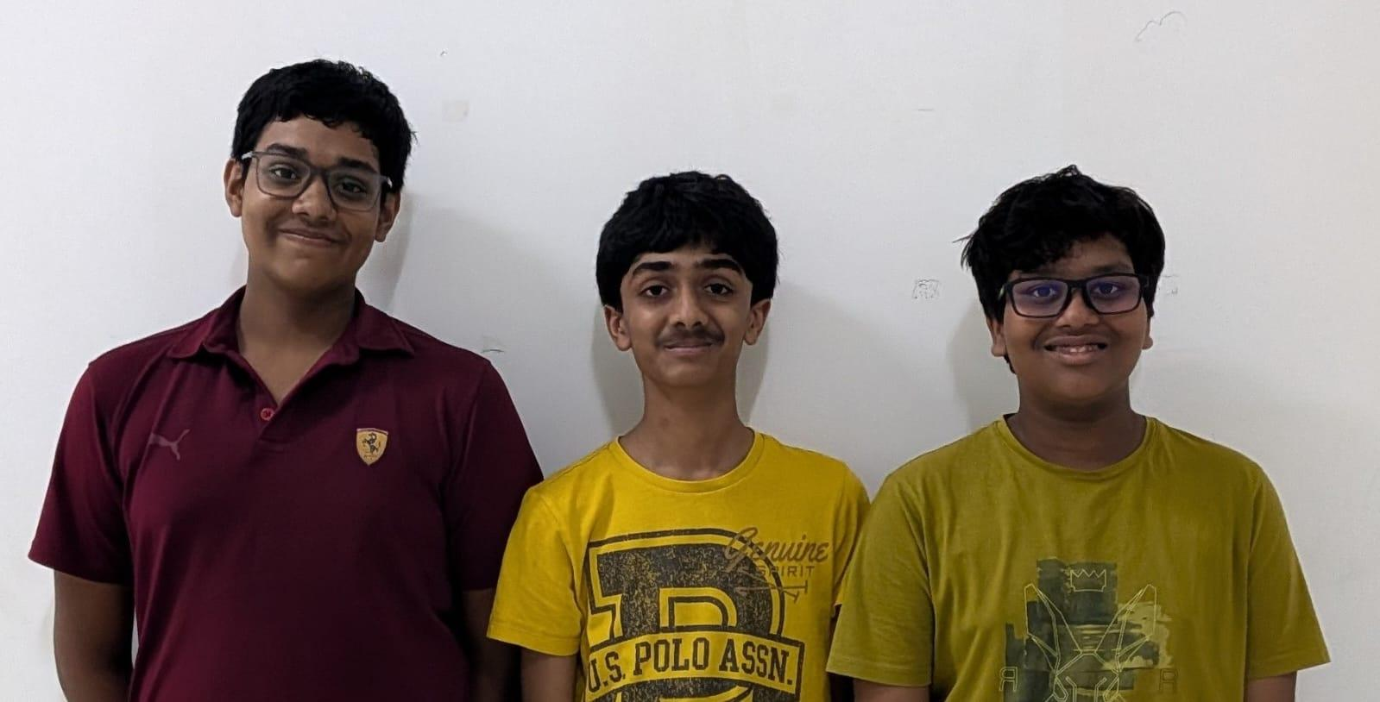

Strategic Challenge Analysis
WRO Future Engineers 2026 asks for a 1/10 scale autonomous car that can drive a randomly generated walled track and choose its path based on coloured pillars. The judging favours teams who can show real automotive engineering, Ackermann steering in particular.

Our strategy was built upon fundamental pillars of autonomous vehicle design:

- Deterministic Actuation: when the software asks for a steering angle, the wheels have to end up in the same place every time. If the same instruction gives a slightly different result on each run, no amount of clever code will make up for it, because the code has no way of knowing what actually happened. This is what pushed us towards Ackermann steering, where the geometry decides the outcome rather than friction.
- Data Isolation: working out what is in a picture is slow, and holding a steering servo steady is a job that cannot wait. Ask one processor to do both and the steering stutters every time the picture takes longer than usual. We kept the two jobs on separate hardware. The camera works on the picture and sends back a short answer, and the ESP32 spends its time on the parts that have to happen on schedule.

Mobility & Mechanical Design

1.1 Chassis Engineering & Material Selection
The chassis is the backbone of the car and everything else is bolted to it, so it was the first thing we got right. A chassis with flex in it does not stay still while the car is driving, and because the camera is mounted to it, the camera moves too. The camera judges distance from how big a pillar looks, so a camera that keeps shifting gives us answers that change for no reason. A stiff chassis is what makes the camera readings mean anything at all.

We designed the chassis in Onshape and 3D printed it. We chose PETG over the more common PLA because it takes an impact without shattering and holds its shape when it gets warm, both of which matter on a car that gets knocked into walls and sits beside a motor driver that heats up. The parts use a honeycomb infill, which gets most of the stiffness of a solid part for a fraction of the plastic. Printing it ourselves also meant that when a mounting point turned out to be wrong, we changed the file and printed it again.

1.2 The Roof Tier Module: Iterative Evolution
Our first prototype put everything on one flat plate, which caused two problems. The motor driver gets hot after the motor has run a while, and crowded onto one level that heat has nowhere to go. The wiring shared the same space too, so battery leads ran alongside sensor wires, which is a good way to get sensor readings that are wrong for no visible reason.

The Solution: We designed a secondary roof tier that bolts onto the chassis walls. The roof tier carries the battery pack, the toggle switch and the start button, and their wiring drops down to the lower deck through a single hole in the plate. Splitting the car across two levels gave us three things at once:

- Power and signal kept apart: the battery wiring now runs on its own level, well away from the sensor wiring below. A motor pulling current throws out electrical interference, and keeping that away from the wires carrying sensor readings means fewer readings that come back wrong for no visible reason.
- Cooling: with the roof lifted clear on standoffs, the lower deck is open on every side and air moves through it while the car drives. Heat from the motor driver gets carried away instead of building up around the electronics.
- Weight where we want it: lifting the battery higher is normally a bad idea, because weight up high makes any vehicle less stable. We accepted that because of where we put it. The battery is the heaviest single item on the car, and sitting it above the rear axle presses the driven wheels into the ground. More weight on the driven wheels means they grip instead of spinning, and that matters every time the car pulls away.

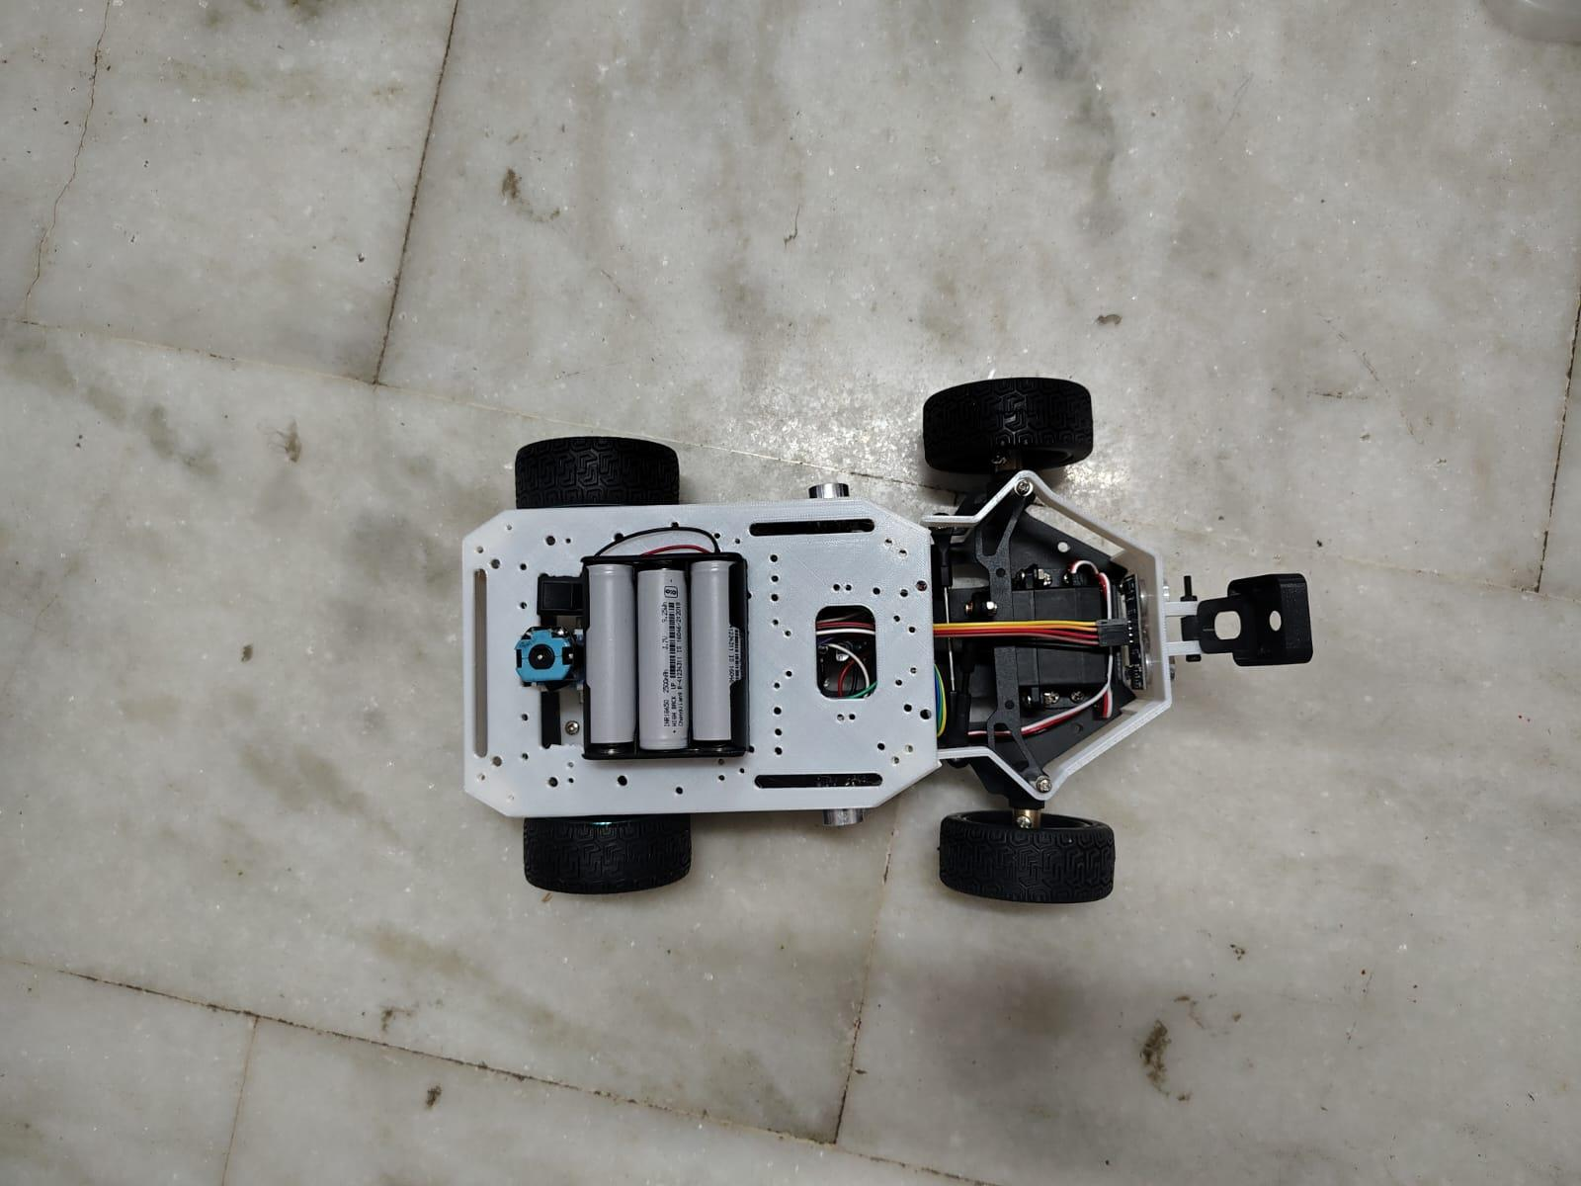
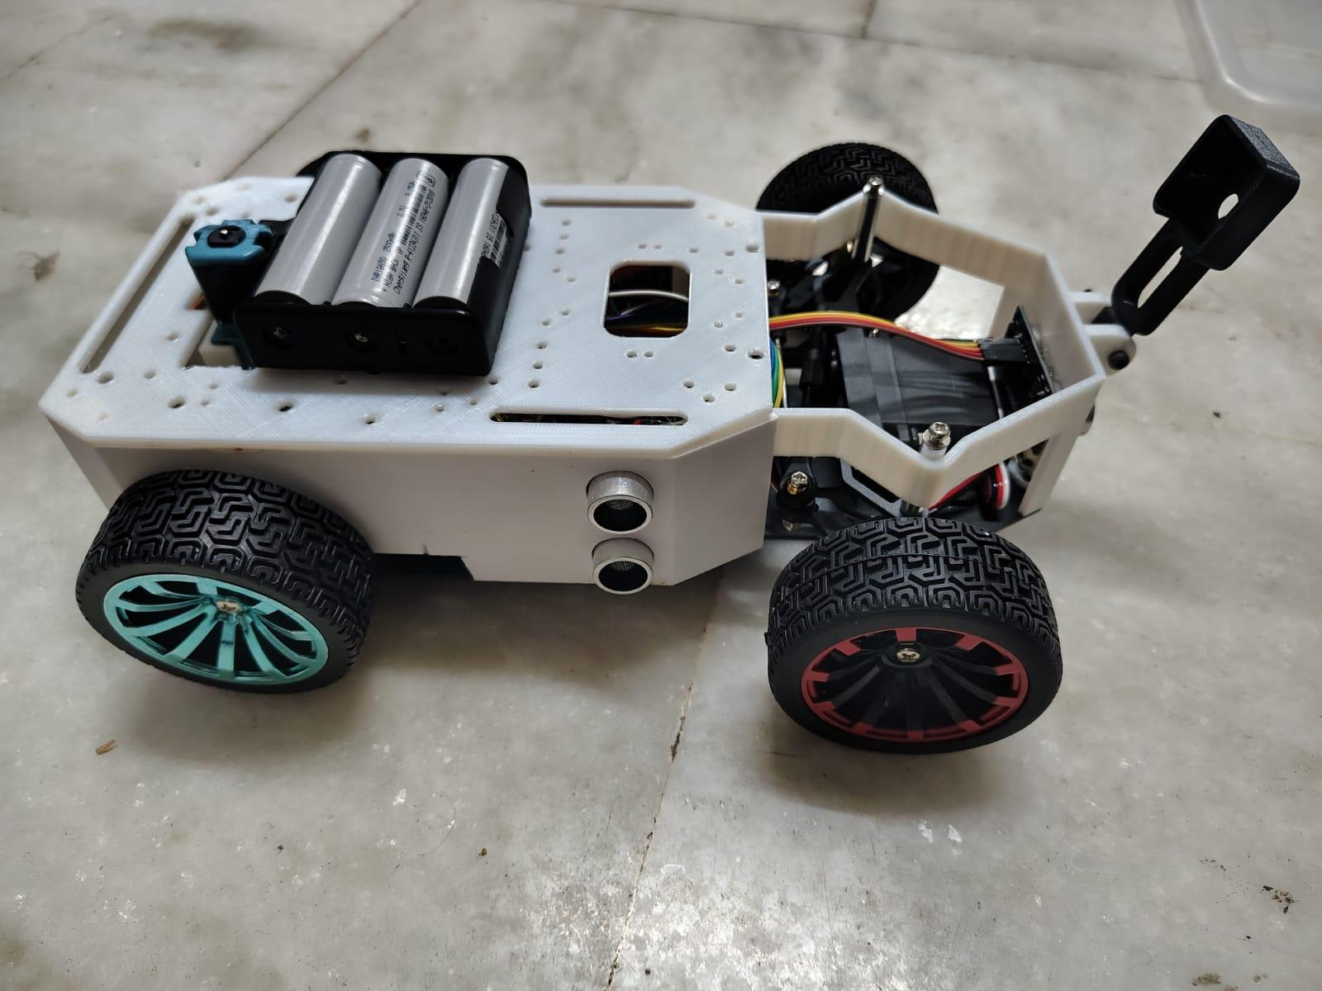

1.3 Ackermann Steering Geometry & Kinematics
In an effort to conform to the Future Engineers category rules, our car employs true steered front axle design. We chose not to use the differential or skid steering method. With the skid steering system, the wheels have to scrub against the surface to make the car turn. These forces introduce non-linear friction coefficients which nullify the accuracy of odometry measurements and make open-loop steering impossible.

Our car uses a trapezoidal Ackermann linkage, the same arrangement used on a real car. Going around a corner, the two front wheels are not travelling on the same circle: the inside wheel follows a tighter path, so it has further to turn. Turn both by the same amount and only one can point the right way, leaving the other to drag sideways for the whole corner. Ackermann angles the steering arms inwards so the inside wheel turns a little further, and both wheels roll around the same centre point.

We also built physical stops into the chassis to limit how far the steering can travel, deliberately as a piece of plastic rather than a limit in code. Software can be flashed with the wrong value, and a servo told to reach somewhere the linkage cannot will keep pushing until it strips its own gears. A physical stop protects the linkage whatever the code does, and it makes the tightest turn a fixed, known quantity the driving code can rely on.

1.4 Drivetrain, Propulsion, & Torque Analytics
The propulsion system is split into two separate jobs. At the front, a single servo steers the wheels through the Ackermann linkage. At the rear, one hobby gear motor drives both rear wheels through a shared axle, controlled by an L298N H-Bridge controller. Keeping drive and steering apart means neither one has to compromise for the other, and the speed we run the motor at is not an arbitrary choice.

The car is deliberately not fast, and that is the part people question most. Every sensor takes time to produce an answer, and the car keeps moving while it waits, so by the time an answer arrives it describes where things were a moment ago. The faster the car drives, the bigger that gap gets. A car that reacts to where a wall used to be will hit it, so we slowed the car down to match the speed its sensors can actually think at.

With a wheel diameter of 65 mm, we have a wheel circumference of 204.2 mm. The gearing also works in our favour at low speed. A geared motor trades away top speed for pulling power, which is exactly the right trade here, because the car spends its time starting, stopping and reversing out of corners rather than going flat out down a straight.

2. Power & Sensor Architecture

2.1 Power Tree, Isolation, & Load Balancing
The electrical design is built around one idea: keep the parts that draw big, sudden bursts of current away from the parts that need a steady supply. The car runs on a pack we built ourselves from three 18650 lithium ion cells in series, giving roughly 12.6 volts fully charged and around 11.1 for most of a run. It sits on the roof tier, and the cells are removable so a flat pack can be swapped for a fresh one between runs rather than charged on the car.

The power tree splits immediately after the toggle switch on the roof tier:

- Branch 1, the motor: full battery voltage goes straight to the motor driver with nothing in the way. The motor is by far the hungriest thing on the car, especially in the moment it starts moving, and putting anything in between would only get in the way.
- Branch 2, the steering: a buck converter steps the battery down to a lower, steady voltage, and that supply feeds the steering and nothing else. Servos are unpredictable customers. Most of the time they draw very little, but the instant one is pushed against something it cannot move, it draws a large amount without warning. Giving it its own supply means that when this happens, it happens somewhere that does not matter.
- Branch 3, the electronics: a second buck converter provides a clean, steady 5 volts for the ESP32, the HuskyLens and the rest of the electronics. This branch is the reason the other two are kept separate. If the voltage here dips even briefly the ESP32 restarts, and a controller that restarts mid run does not pause, it forgets everything and begins again. Worse, it looks exactly like a bug in the code when you are hunting for it.

2.2 Li-ion Battery Discharge Characteristics
Lithium ion cells are permanently damaged if drained too far, and a cell run flat never holds as much charge again. A pair of resistors divides the pack voltage down to a level the ESP32 can measure, and it watches this throughout the run, cutting power to the motor below a safe threshold. We would rather stop a run early than replace the pack. This protects the battery; it is not a safety feature and does not replace the toggle switch.

2.3 Sensor Topology: Vision vs. Proximity
Direction, the BNO055 IMU: this is the sensor the car steers by. An IMU measures how the vehicle is oriented, and the BNO055 does its own processing internally, so we can ask it directly which way the car is facing. Instead of reacting to whichever wall happens to be nearer, the car picks a direction and holds it, so one odd reading never drags it off course.

Distance, three HC-SR04 ultrasonics: one faces forward and one sits on each side, sending out a pulse of sound and timing how long it takes to come back. The forward sensor tells us when a wall is close enough to turn at, and the side sensors tell us which way the track opens up. We fire them one at a time so no sensor mistakes another's echo for its own. Using sensors that work in different ways is deliberate: light and sound fail in different situations, so when a reflection off the mat blinds the camera, the ultrasonics keep working.

2.4 Comprehensive Pinout & Wiring Manifesto
Robotic reliability is 90% wiring. Each and every wire on this robot is crimped, strain-relieved, and tagged.

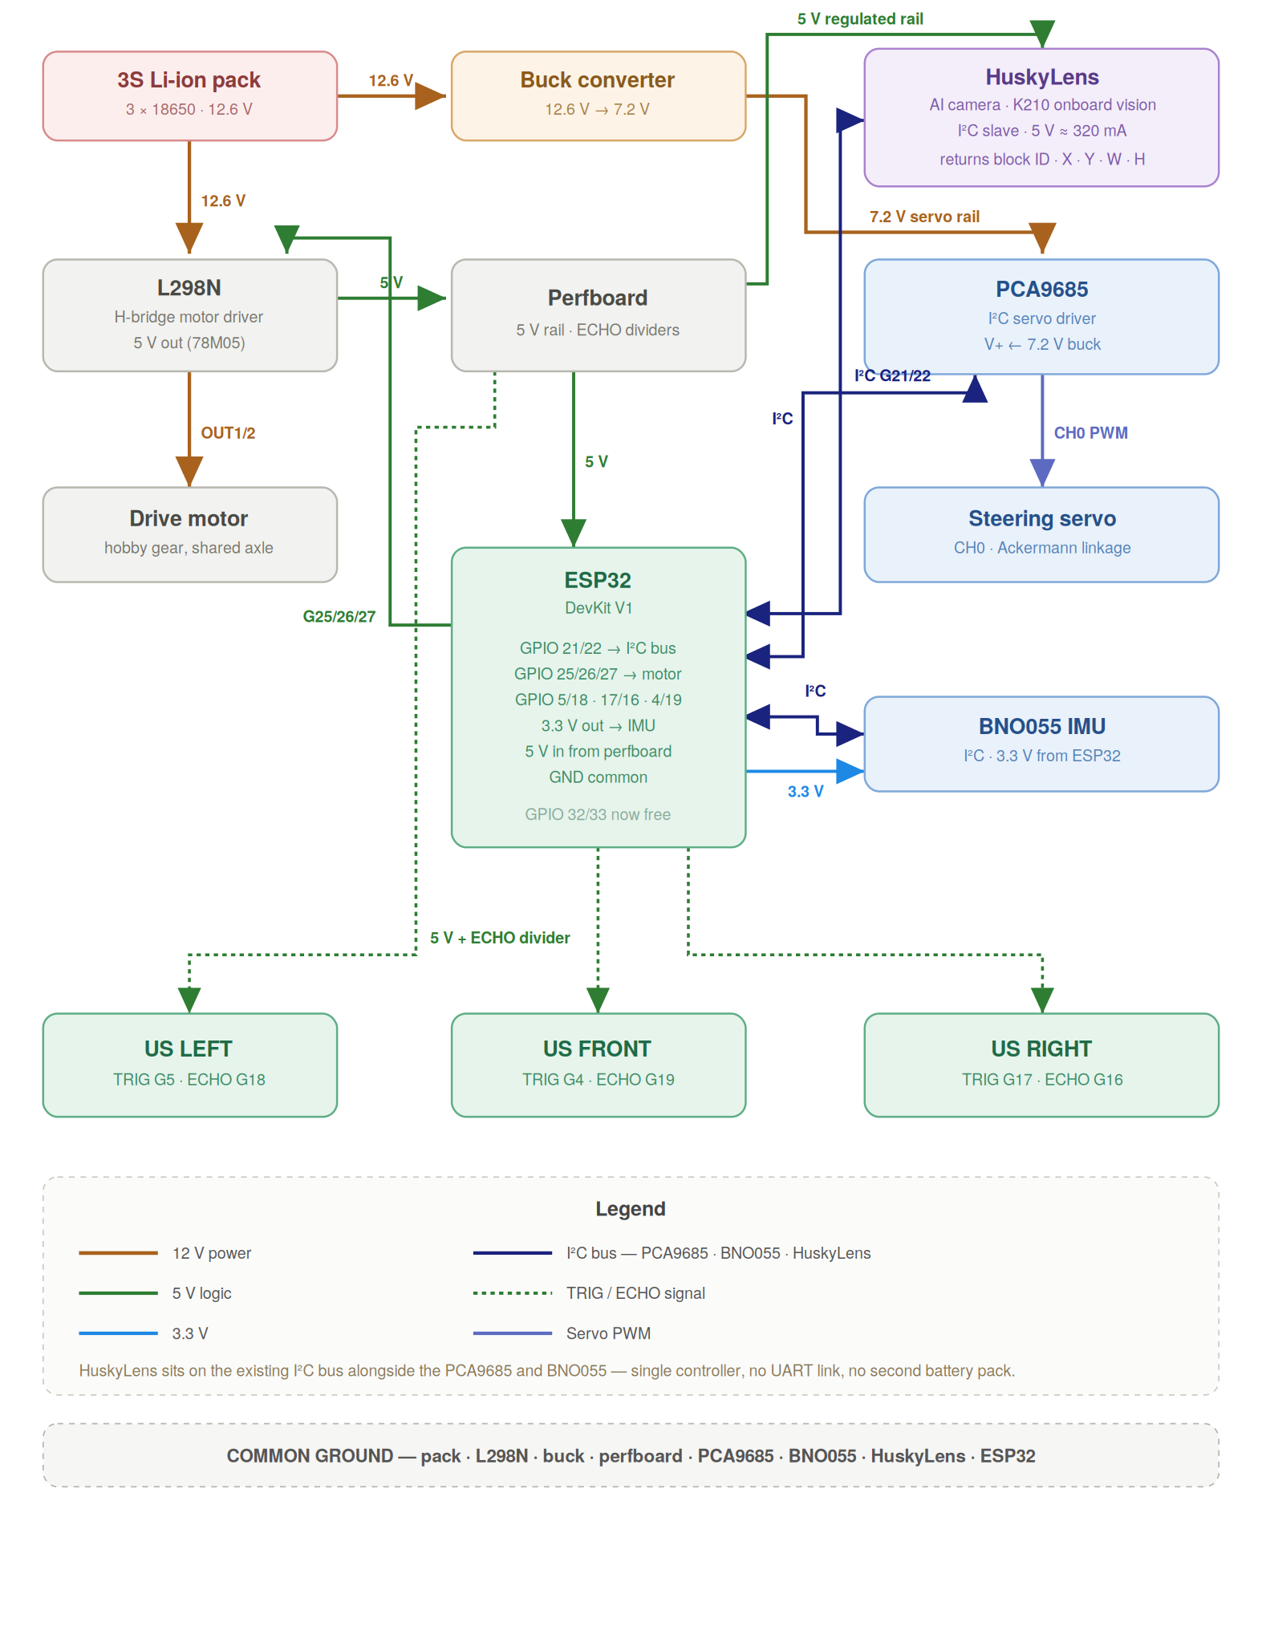

2.5 Safety Precautions
A lithium battery pack holds enough energy to start a fire, and the steering has enough force to pinch a finger. Both are far easier to avoid than to deal with afterwards. These are the rules we work to every time we build, test or compete with this vehicle.
Battery handling
- Cells: the pack is not charged on the vehicle. The 18650 cells are removable, so a flat pack gets swapped for a charged one between runs. Any charging happens away from the car, on a surface that will not burn, never unattended and never inside a closed box. Being able to lift the pack straight off the roof tier is part of why it is mounted there.
- Damaged cells: any cell that swells, is punctured or dented, or feels unusually warm is retired immediately. A damaged lithium cell does not get better and gives little warning before it fails.
- Storage: if the pack is going to sit unused for a while, we leave it part charged rather than full or empty. Both extremes shorten its life.
Electrical safety
- Cutting the power: the toggle switch on the roof tier cuts power to everything on the car, and it sits on top where it can be reached from outside the chassis while the car is moving. It is the first thing any of us goes for if a run starts going wrong.
- Working on the car: the battery is unplugged before any rewiring or component swap, and metal tools stay away from the terminals. Dropping a screwdriver across them is the easiest way to short this vehicle.
- Before powering up: the buck converters are checked with a multimeter before any board is connected, and every exposed joint is covered so no bare wire can touch the chassis once the car vibrates.
Mechanical and operating safety
- Steering: fingers stay clear of the steering linkage whenever the car is powered. The servo has enough torque to pinch and can move without warning if the controller resets.
- Testing: all motor code is tested with the car on blocks and the wheels off the ground. Only once the motor turns the right way and the steering is centred does it go on the floor.
- Starting a run: the car never starts itself when power is applied. We flip the toggle switch, wait a few seconds for the sensors to come up, then press the button. Before every run we check the switch is reachable, the battery and camera bracket are secure, and no loose wire sits near the drivetrain.
- During a run: one of us stays within reach of the switch for the whole run. Everyone else stays outside the track boundary.

3. Software Architecture & Obstacle Strategy

3.1 Vision Offloading: Smart Sensor & Real-Time Controller
There are normally two ways to add a camera to a robot and both cause problems. A small microcontroller cannot handle a video feed at all. A full computer can, but it runs an operating system that decides for itself what to do and when, so the timing our steering depends on is no longer ours. We avoided both by moving the vision work into the camera.

The HuskyLens does the recognising itself, using its own processor and built-in software. This is not OpenCV and not code we wrote. We never see the pixels and cannot change how they are handled, and we accepted that on purpose: in exchange, an answer arrives in the same amount of time on every frame.

That leaves the ESP32 with a much simpler job. It runs one compiled C++ program and deals only with the present moment: which way the car is pointing, how far the wall is, where the last pillar was reported, and what the steering and motor should be doing about it. It never has to stop and think about a picture, which is why a controller this small is enough.

3.2 Vision Pipeline & Colour Recognition
The HuskyLens is used in its Colour Recognition mode. Before a run we show it each pillar and tell it to remember that colour, and it stores this in its own memory so it survives a power cycle. We always teach the colours again at the venue, under the lights we will actually run under, because arena lighting is never the same as our workshop and this is the most common reason a pillar gets missed.

- Learning: the red pillar is taught as ID 1 and the green pillar as ID 2. Which ID belongs to which colour is what the code checks against, so getting these the right way round matters.
- Block extraction: on every frame the camera finds the largest patch of a colour it recognises and describes it as a block, telling us which colour it is, where the middle of it sits in the frame, and how big it is.
- Working out what to do: the ESP32 gets two useful things from that. Where the block sits relative to the middle of the frame tells it which side the pillar is on, and how big the block is tells it roughly how close the pillar is, because something nearer fills more of the picture. The colour decides which way to go around it and the size decides when to commit.

3.3 State Machine Topology & Transitions
We wrote two separate programs, one per round, rather than one that handles both. The open round never needs to see a pillar, so vision code there would only add ways to go wrong. Both share the same wiring, so nothing on the car changes between rounds.

Both work as a state machine, meaning that at any moment there is exactly one answer to what the car is trying to do. That makes its behaviour predictable and makes it possible to work out afterwards why it did something.

- Starting up: the car checks that every sensor is responding and that the battery is charged before it will do anything at all. We would far rather find out something is not answering while the car is sitting still than halfway down the track.
- Waiting: the car is powered and ready but deliberately stationary, waiting for the button to be pressed. It never begins moving on its own when power is applied.
- Driving: the normal state. The car holds its heading using the IMU and watches the forward ultrasonic sensor for a wall coming up.
- Cornering: once the wall ahead is close enough, the side sensors decide which way the track turns and the car makes the turn. Normal steering is suspended while this happens, because during a deliberate turn the car is supposed to be pointing away from its target direction.
- Avoiding a pillar, obstacle round only: when the camera reports a pillar close enough to matter, the car steers to one side to go around it and hands control back once it is past. Which side it goes depends on the colour.
- Recovering: if the car finds itself far too close to a wall, or a sensor stops replying, it stops, reverses a short distance and straightens up before trying again. Trying to steer out of a corner you are already wedged into usually just wedges you in harder.

3.4 Control Theory: Holding a Straight Line
Driving in a straight line is harder than it sounds. Nothing on a small vehicle is perfectly symmetrical, so a car told simply to go forwards will always drift to one side. We steer by direction rather than by distance from the walls: the IMU tells us which way the car is actually pointing, we compare that to the direction we want, and the difference drives the steering. The correction is capped so no single strange reading can throw the wheels hard over, and very small errors are ignored so the car does not twitch constantly. We tuned it by hand on the track.

4. Systems Thinking & Engineering Decisions

4.1 Trade-off Matrices & Critical Constraints
Every decision in this vehicle involved an engineering trade-off. We documented our decision logic to demonstrate advanced systems thinking:

Design Choice | Chosen Solution | Rejected Alternative | Systems Logic & Trade-off Accepted
Steering | Ackermann Linkage | Differential/Skid Steer | Accepted mechanical complexity for the immense benefit of deterministic, repeatable cornering.
Motor Speed | Single geared drive motor | High-speed direct drive | Traded maximum top speed for reliability. Slower robot which processes 100% of the camera frames accurately is better than a faster robot which fails in its processing and crashes.
Vision | HuskyLens smart camera | Raw camera module plus a separate computer running an OpenCV pipeline we would write ourselves | Sacrificed fine-grained control over the image pipeline for a fixed, deterministic frame rate, far lower power draw, no boot time, and no operating system scheduler competing with our PWM timing.
Chassis | Multi-Tier with Roof | Single Flat Plate | Raised center of mass slightly, but fixed thermal and wiring congestion problems completely.

4.2 Failure Mode and Effects Analysis
- A wall reading that makes no sense. Sound hitting a wall at a sharp angle bounces away instead of coming back, so the sensor reports nothing. Because the car steers by direction rather than by wall distance, one bad reading does not move the steering at all. It only affects when the car decides to turn, and the code confirms a reading before acting on it.
- A sensor stops answering. A wire works loose or the data connection locks up. Mitigation: the ESP32 expects a reply from each sensor regularly, and if one goes quiet it first tries to reset the connection. If that does not work, the car stops rather than carrying on using information it knows is out of date.
- Lighting we did not practise in. Venue lighting washes out the colours and the camera stops recognising pillars it had no trouble with at home. Mitigation: a printed visor over the lens to cut glare from overhead lights, and teaching the colours again on site every time.

5. Criterion 5: Reproducibility & GitHub Quality

5.1 Open Source Commitment & Repo Structure
Our entire project is open-source and highly structured, ensuring that any team worldwide can reproduce our vehicle.

5.2 Master Bill of Materials (BOM)
- 1x ESP32 WROOM-32 DevKit V1 microcontroller
- 1x HuskyLens AI vision sensor
- 1x L298N dual H-bridge motor driver
- 1x Hobby Gear DC Motor driving both rear wheels through a shared axle
- 1x MG996R metal gear steering servo
- 1x BNO055 IMU
- 1x PCA9685 servo driver
- 3x HC-SR04 ultrasonic sensors
- 2x LM2596 buck converters
- 1x custom 3S 18650 lithium ion battery pack with BMS
- 4x 65mm rubber tread wheels
- PETG filament for the printed chassis and roof tier
- 1x toggle switch and 1x pushbutton, both mounted on the roof tier
- Misc: 50mm M3 standoffs, M3x8mm screws, jumper wires, perfboard, resistors for the voltage dividers

5.3 Step-by-Step Mechanical Assembly Guide
- Print the chassis: slice the base plate and the roof tier in PETG with a honeycomb infill.
- Drivetrain Installation: Mount the hobby gear motor to the rear mounting bracket using M3x8mm screws. Fit the shared rear axle, then slide the 65mm rear wheels onto it and secure the set screws.
- Steering: fit the kingpins into the front steering knuckles and attach the tie-rod linkage. Mount the servo in the central chassis slot. Centre the servo horn before attaching the linkage, because attaching it off-centre leaves the car permanently crooked. Check the hard stops by hand with the servo unpowered.
- Roof tier: screw the four 50mm M3 standoffs into the base plate and mount the roof tier on top. The battery pack, toggle switch and pushbutton all go up here, wiring dropping through the hole in the plate to the deck below.
- Lower deck: secure the ESP32, the L298N motor driver and the servo driver to the base plate, keeping the sensor wiring away from the motor leads. Bolt the HuskyLens into the front bumper mount using its supplied bracket, angled slightly downward so it sees both the far wall and the bottom of the nearest pillar.

5.4 Step-by-Step Electrical Assembly Guide
- Power distribution: run the positive lead from the battery to the toggle switch on the roof tier, then down through the hole in the plate. From there it splits to the motor driver and to both buck converters.
- Buck calibration: do this before anything else is plugged in. Set each converter to its correct voltage with a multimeter. One left at the wrong setting will destroy every board downstream the moment power is applied.
- Voltage dividers: the ultrasonic sensors reply at 5 volts and the ESP32's pins can only take 3.3, so every one of those lines goes through a pair of resistors that divides the voltage down first. Skipping this will damage the ESP32. A further divider brings the battery voltage into range.
- Data lines: set the HuskyLens to I2C in its own settings menu, then wire it onto the shared I2C bus alongside the IMU and the servo driver. Finally, make sure every component shares one common ground. Boards that do not share a ground behave in ways that make no sense and take a long time to diagnose.

