DAIRY BUSINESS MANAGEMENT SYSTEM
Project Report
A Field-Study Based System for Mumbai's Dairy Retail Sector

TABLE OF CONTENTS
TABLE OF CONTENTS 1
CHAPTER 1: INTRODUCTION 1
1.1 Background 1
1.2 Problem Statement 1
1.3 Purpose of Project 1
1.4 Objectives of Project 1
1.5 Scope of Project 1
1.5.1 Features 1
1.5.2 Exclusions 1
CHAPTER 2: LITERATURE SURVEY 1
2.1 System Name: CaptainBiz Dairy Management Software 1
2.2 Feature List 1
2.3 Technology Overview 1
CHAPTER 3: SYSTEM REQUIREMENTS AND DESIGN 1
3.1 System Modules 1
3.1.1 User Management Module 1
3.1.2 Inventory Management Module 1
3.1.3 Customer and Subscription Module 1
3.1.4 Order Management Module 1
3.1.5 Billing and Payment Module 1
3.1.6 Reporting Module 1
3.1.7 Compliance and Record Module 1
3.2 Hardware and Software Requirements 1
Hardware Requirements 1
Software Requirements 1
3.3 Planning and Scheduling 1
3.3.1 GANTT Chart (Planned vs Actual) 1
3.4 Conceptual Models 1
3.4.1 ER Diagram 1
3.4.2 Data Dictionary 1
3.4.3 Data Flow Diagram 1
3.4.4 Use Case Diagram 1
3.4.5 Activity Diagram 1

CHAPTER 1: INTRODUCTION

1.1 Background
The dairy industry plays a crucial role in meeting the daily nutritional needs of urban populations, and this is especially true in a city as large and densely populated as Mumbai. Mumbai's dairy market is highly competitive and operates at significant scale, with large organised players such as Amul actively expanding their distribution networks across the city and putting pressure on smaller, local dairy retailers to remain efficient and reliable. (MumbaikarNews) In a market of this size, where dairy products are purchased and delivered in high volumes every single day, proper inventory control, timely order processing, accurate billing, and regulatory record maintenance become essential to staying in business. However, a large number of local dairy outlets in Mumbai still depend on manual registers, handwritten notebooks, and basic spreadsheets to manage their daily operations. This traditional approach creates several recurring problems, including product spoilage, stock imbalance, missed subscriptions, delayed deliveries, billing mistakes, and weak decision-making, all of which stem from a lack of real-time, centralised information. Because dairy products such as milk, curd, and paneer are highly perishable, even small operational delays in identifying near-expiry stock or processing an order can lead directly to wastage and financial loss. Industry-focused inventory solutions for the dairy sector have shown that digitising stock tracking, expiry monitoring, and billing can substantially reduce these inefficiencies. (CaptainBiz) A Dairy Business Management System, built specifically for the needs of a Mumbai-based dairy retailer, can help solve these problems by automating stock updates, billing, order handling, delivery scheduling, and record keeping. This not only improves day-to-day efficiency and reduces human error, but also gives the business owner the real-time visibility needed to compete and grow in Mumbai's fast-moving and increasingly organised dairy market.

1.2 Problem Statement
The current working style of many dairy shops in Mumbai, as observed during the field study and survey conducted for this project, is still largely manual and fragmented. Inventory is tracked using physical notebooks or basic registers, bills are prepared by hand at the counter, customer subscriptions for regular home delivery are maintained separately on paper or in the shopkeeper's memory, and the status of deliveries is checked informally rather than through any structured system. Because of this fragmented approach, several operational issues arise on a regular basis. Spoilage of perishable stock often goes unnoticed until the product has already expired, since there is no automated tracking of expiry dates. Stock levels become inaccurate because sales and incoming stock are not reconciled in real time, and customers occasionally receive late, incomplete, or incorrect orders due to the absence of a formal order-tracking process. Billing errors and missed entries further affect the shop's revenue and damage customer trust over time. In addition, the owner or manager lacks access to consolidated, up-to-date information that would help them make informed decisions about restocking, demand patterns, pricing, and regulatory compliance. There is, therefore, a clear and pressing need for a centralised, IT-based Dairy Business Management System that can digitise these daily activities and provide a single, reliable platform for managing inventory, billing, customer orders, deliveries, and business records.

1.3 Purpose of Project
The existing manual system used by Mumbai's local dairy retailers suffers from several limitations, and the proposed system is designed to directly address each of them:
- Problem: Stock registers are maintained on paper, making it difficult to know exact quantities at any given time. Solution: The system will replace manual stock registers with automated, real-time inventory tracking.
- Problem: Perishable products often expire unnoticed, leading to wastage. Solution: The system will monitor expiry dates continuously and generate automatic alerts before stock goes bad.
- Problem: Bills are handwritten, leading to calculation mistakes and inconsistent records. Solution: The system will generate accurate, computerised bills and invoices automatically based on orders.
- Problem: Customer subscriptions and daily delivery schedules are tracked informally, causing missed or delayed deliveries. Solution: The system will manage subscriptions, orders, and delivery schedules digitally and in an organised manner.
- Problem: Business and compliance records are scattered across notebooks and receipts, making audits and reporting difficult. Solution: The system will maintain all compliance and business records securely in digital form for quick reference and reporting.
- Problem: Owners lack consolidated data to make timely business decisions. Solution: The system will support better decision-making through dashboards and automatically generated reports.

1.4 Objectives of Project
- To develop a centralised system for managing dairy inventory, customer records, orders, and billing in a single platform.
- To reduce product spoilage and wastage by tracking expiry dates and monitoring perishable stock levels in real time.
- To improve order and delivery accuracy through structured, digital scheduling of customer subscriptions and daily deliveries.
- To minimise billing errors and revenue leakage by automating invoice generation and payment tracking.
- To support better, faster business decisions by providing the owner with consolidated dashboards and reports on stock, sales, and dues.

1.5 Scope of Project

1.5.1 Features
The features of the proposed system, listed in the chronological order in which a dairy shop would typically use them during daily operations, are as follows:
- User login with secure JWT-based authentication and role-based access for owner and staff.
- Product and stock management, including adding new stock on arrival.
- Expiry date monitoring and automatic alert generation for ageing stock.
- Customer registration and subscription management for regular delivery customers.
- Order placement and delivery scheduling for daily and one-time orders, with order status tracked from pending to processed to delivered.
- Automated billing and invoice generation once an order is fulfilled.
- Payment tracking and management of pending customer dues.
- Dashboard with live KPI tiles and an interactive 3D inventory shelf visualisation, plus report generation for stock, sales, and business performance.
- Record maintenance for compliance and audit purposes.

1.5.2 Exclusions
The following items are outside the scope of the current version of the project but may be considered for future enhancement:
- Native mobile application development in the first version.
- AI-based demand forecasting in the initial release.
- IoT-based cold storage integration.
- ERP integration with large enterprise systems.
- Online milk production or farm management features.

CHAPTER 2: LITERATURE SURVEY

2.1 System Name: CaptainBiz Dairy Management Software
CaptainBiz offers inventory management software designed specifically for dairy businesses. The platform focuses on perishable stock control, expiry date tracking, automated billing, and compliance-oriented record keeping for dairy retailers and distributors. (CaptainBiz) It serves as a useful reference model for this project because it demonstrates, in a real commercial product, how digital tools can reduce manual errors, prevent stock wastage, and support more efficient day-to-day dairy operations — the same core problems identified during the Mumbai field study.

2.2 Feature List
Based on the reviewed system, the key features that inform the design of this project include inventory tracking for perishable products, expiry date monitoring, automated billing and invoicing, sales and stock reporting, secure business record maintenance, and support for scalable dairy operations as a business grows. (CaptainBiz)
- Inventory tracking for perishable products.
- Expiry date monitoring and alerts.
- Automated billing and invoicing.
- Sales and stock reporting.
- Secure business record maintenance.
- Support for scalable dairy operations.

2.3 Technology Overview
The literature and industry examples reviewed indicate that dairy management software is generally built using a web-based architecture, consisting of a user-friendly front end, a backend service layer, and a relational database for storing products, orders, billing, and customer records. (CaptainBiz) Such an architecture is well suited to small and mid-sized dairy shops because it can run on low-cost hardware while still offering centralised data access, faster billing at the counter, and tighter control over stock and deliveries compared to manual registers. For this project, a simple and responsive front end, a secure backend API, and a relational database are chosen because together they offer reliability, ease of use for non-technical shop staff, and room for future expansion as the business grows.

CHAPTER 3: SYSTEM REQUIREMENTS AND DESIGN

3.1 System Modules

3.1.1 User Management Module
This module is the entry point of the system and governs who can access which part of the application. Step 1: A user enters their username and password on the login screen. Step 2: The system validates the credentials against stored, encrypted records. Step 3: Based on the user's assigned role — owner or staff — the system grants access only to the specific features required for that role; for example, staff may access inventory and order screens but not invoices or financial totals. Step 4: The system logs the session and allows the user to log out securely when finished. Step 5: The administrator can create, edit, or deactivate user accounts at any time. This role-based structure improves security and prevents unauthorised actions, such as a delivery staff member editing billing records.

3.1.2 Inventory Management Module
This module is responsible for tracking all dairy products from the moment they arrive at the shop. Stock is tracked in batches, because expiry belongs to each individual delivery of stock rather than to a product as a whole. Step 1: When new stock arrives, staff record it as a stock batch against a product, entering the quantity, purchase price, expiry date, and received date; each product itself carries a name, category, unit (litre, kilogram, or piece), and selling price. Step 2: The system computes the total available quantity of a product as the sum of the quantities of its non-expired batches. Step 3: As orders are fulfilled, the system automatically deducts the sold quantity from the oldest non-expired batch first (first-in, first-out), keeping inventory accurate without manual recalculation; if available stock is insufficient, the order is blocked with a clear error message. Step 4: The system continuously evaluates each batch's expiry date against the current date and classifies the batch as fresh (more than three days to expiry), ageing (three days or fewer remaining), or expired, so that ageing stock can be prioritised for sale or discounting before it spoils. Step 5: Stock levels and expiry statuses are visible on the dashboard, including a 3D ‘inventory shelf’ view in which each product appears as a stack of crates whose height reflects the available quantity and whose colour — green, amber, or red — reflects the worst expiry status among its batches.

3.1.3 Customer and Subscription Module
This module maintains detailed records of each customer and their delivery preferences. Step 1: A new customer is registered with their name, contact details, and address. Step 2: The customer's subscription preferences are recorded, including which products they receive regularly, the quantity, and the delivery frequency, such as a daily milk subscription. Step 3: The system stores the customer's payment status alongside their profile. Step 4: Whenever a subscription needs to be modified, paused, or cancelled, staff can update it directly in the customer's record. Step 5: This centralised record reduces the chances of missed or delayed deliveries that previously occurred when subscriptions were tracked only in the shopkeeper's memory or on paper. In the current version, customer registration and records are fully implemented, while recurring subscription schedules are planned for a future release.

3.1.4 Order Management Module
This module organises and tracks every customer order from creation to fulfilment. Step 1: An order is created by staff against a registered customer, selecting the products and quantities required; automatic order creation from standing subscriptions is planned as a future enhancement. Step 2: The system records each order line with the product, quantity, and the unit price captured at the moment of ordering, so that later price changes do not alter historical orders. Step 3: Staff update the order status as it progresses, moving it from 'pending' to 'processed' once the items are packed, and finally to 'delivered' once it reaches the customer. Step 4: At each stage, the updated status is visible to relevant staff, allowing better coordination between the shop and delivery personnel. Step 5: Completed orders are passed automatically to the billing module for invoice generation.

3.1.5 Billing and Payment Module
This module converts completed orders into accurate financial records. Step 1: Once an order is marked as delivered, the system automatically generates its invoice, calculating the total amount due from the ordered quantities and the unit prices captured at order time. Step 2: The invoice is stored against the order and is visible to the owner; staff accounts cannot view invoices or financial totals. Step 3: When a customer makes a payment, the amount paid is recorded directly against the relevant invoice. Step 4: The system automatically tracks each invoice's status as unpaid, partially paid, or paid based on the amount received, so pending balances are always visible. Step 5: This automation removes the handwritten calculation errors that were common under the manual billing process and speeds up transactions at the counter.

3.1.6 Reporting Module
This module converts the raw data collected by other modules into actionable business insights. Step 1: The system continuously aggregates data on stock levels, sales, expiry-related losses, customer dues, and daily transactions. Step 2: At any time, the owner or manager can generate a report for a chosen date range or category. Step 3: Reports are presented in a clear, readable format showing key figures such as total sales, outstanding dues, and stock nearing expiry. Step 4: These reports allow the owner to understand business performance at a glance and make informed decisions about restocking, pricing, or staffing, replacing the previous guesswork-based approach. In the current version, this module takes the form of a live dashboard presenting key performance indicators — total available stock value, counts of ageing and expired products, today's order count and sales total, and the number of unpaid invoices — alongside the 3D inventory shelf; detailed date-range reports are planned as a future enhancement.

3.1.7 Compliance and Record Module
This module ensures that all important business documentation is stored securely and remains accessible when needed. Step 1: The system automatically stores transaction history, payment records, and stock movement logs as they are generated by other modules. Step 2: Important documents, such as licences or supplier agreements, can also be uploaded and stored digitally. Step 3: Records are organised by date and category, making it easy to retrieve specific information during an audit or regulatory inspection. Step 4: This digital record-keeping replaces the scattered paper-based system observed during the field study and supports audit readiness at all times. This module is scoped for a future release of the system.

3.2 Hardware and Software Requirements

Hardware Requirements
- Processor: Intel Core i5, 11th Generation or above.
- RAM: 8 GB minimum.
- Storage: 512 GB SSD.
- Display: 14-inch or 15.6-inch screen.
- Internet connection with keyboard and mouse support.

Software Requirements
Front End: React 19 with Vite, Tailwind CSS, React Router, and Axios; the 3D inventory shelf is built with react-three-fiber and drei (Three.js).
Back End: Python with Django and Django REST Framework; JWT authentication via djangorestframework-simplejwt.
- Database: PostgreSQL, run locally via Docker Compose.
- IDE: Visual Studio Code.
- Browser: Google Chrome or Microsoft Edge.
- Operating System: Windows 10/11 or Linux.

3.3 Planning and Scheduling

3.3.1 GANTT Chart (Planned vs Actual)
The table below shows the planned duration for each project phase alongside the actual duration taken, allowing easy comparison and identification of any delays.
Phase | Planned Start | Planned End | Actual Start | Actual End | Status
1. Requirement Gathering | Week 1 | Week 1 | Week 1 | Week 1 | On Time
2. Literature Survey | Week 2 | Week 2 | Week 2 | Week 2 | On Time
3. Survey & Field Study | Week 3 | Week 3 | Week 3 | Week 3 | On Time
4. System Analysis & Design | Week 4 | Week 4 | Week 4 | Week 5 | Delayed
5. Database Design | Week 5 | Week 5 | Week 5 | Week 5 | On Time
6. Module Development | Week 6 | Week 7 | Week 6 | Week 8 | Delayed
7. Testing & Debugging | Week 8 | Week 8 | Week 9 | Week 9 | Delayed
8. Documentation | Week 9 | Week 9 | Week 9 | Week 9 | On Time
9. Final Submission | Week 10 | Week 10 | Week 10 | Week 10 | On Time

3.4 Conceptual Models

3.4.1 ER Diagram
The Entity-Relationship diagram below illustrates the main entities of the Dairy Business Management System and how they relate to one another.
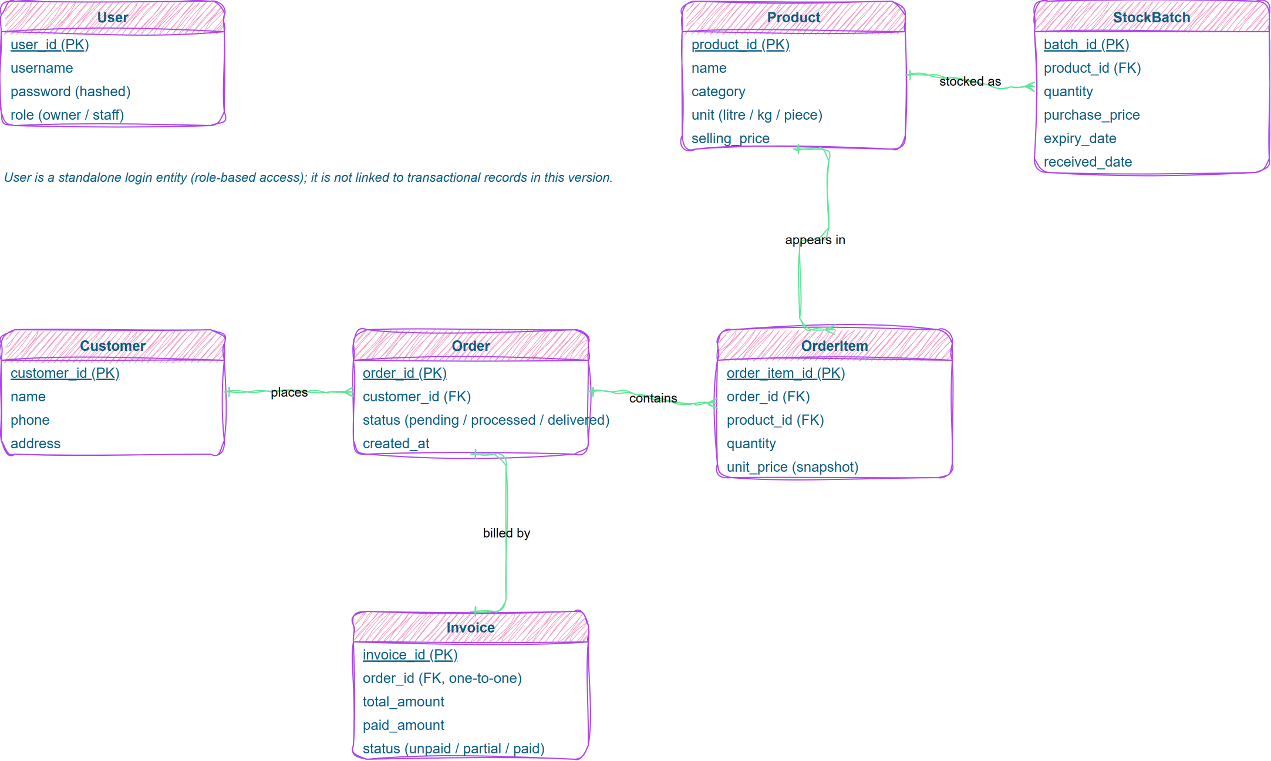
Figure 3.1: ER Diagram of the Dairy Business Management System

3.4.2 Data Dictionary
The data dictionary below provides the metadata for each entity shown in the ER diagram above, ensuring both representations carry identical information. Payment tracking is folded into the Invoice entity (paid amount and status) and delivery tracking into the Order status field; separate Payment, Delivery, Subscription, and Report entities are deferred to a future version.
Entity | Attribute | Data Type | Description
User | user_id | int | Unique user identifier (primary key)
User | username | varchar | Login name
User | password | varchar | Hashed password
User | role | varchar | Owner or staff
Product | product_id | int | Unique product identifier (primary key)
Product | name | varchar | Name of dairy product
Product | category | varchar | Product category
Product | unit | varchar | Litre, kilogram, or piece
Product | selling_price | decimal | Selling price per unit
StockBatch | batch_id | int | Stock batch identifier (primary key)
StockBatch | product_id | int | Product this batch belongs to (foreign key)
StockBatch | quantity | int | Quantity remaining in the batch
StockBatch | purchase_price | decimal | Cost price of the batch
StockBatch | expiry_date | date | Expiry date of this batch
StockBatch | received_date | date | Date the batch was received
Customer | customer_id | int | Unique customer identifier (primary key)
Customer | name | varchar | Name of customer
Customer | phone | varchar | Contact number
Customer | address | varchar | Delivery address
Order | order_id | int | Order identifier (primary key)
Order | customer_id | int | Customer who placed the order (foreign key)
Order | status | varchar | Pending, processed, or delivered
Order | created_at | datetime | Date and time the order was created
OrderItem | order_item_id | int | Order line identifier (primary key)
OrderItem | order_id | int | Parent order (foreign key)
OrderItem | product_id | int | Ordered product (foreign key)
OrderItem | quantity | int | Quantity ordered
OrderItem | unit_price | decimal | Selling price snapshot at order time
Invoice | invoice_id | int | Invoice identifier (primary key)
Invoice | order_id | int | Invoiced order (one-to-one foreign key)
Invoice | total_amount | decimal | Final bill amount
Invoice | paid_amount | decimal | Amount received so far
Invoice | status | varchar | Unpaid, partial, or paid

3.4.3 Data Flow Diagram
Level 0 (Context Diagram)
The Level 0 DFD shows the system as a single process interacting with its external entities: Customer, Staff, and Owner. All of them interact with the central Dairy Business Management System, which in turn reads from and writes to the database to process stock, orders, billing, and reports.
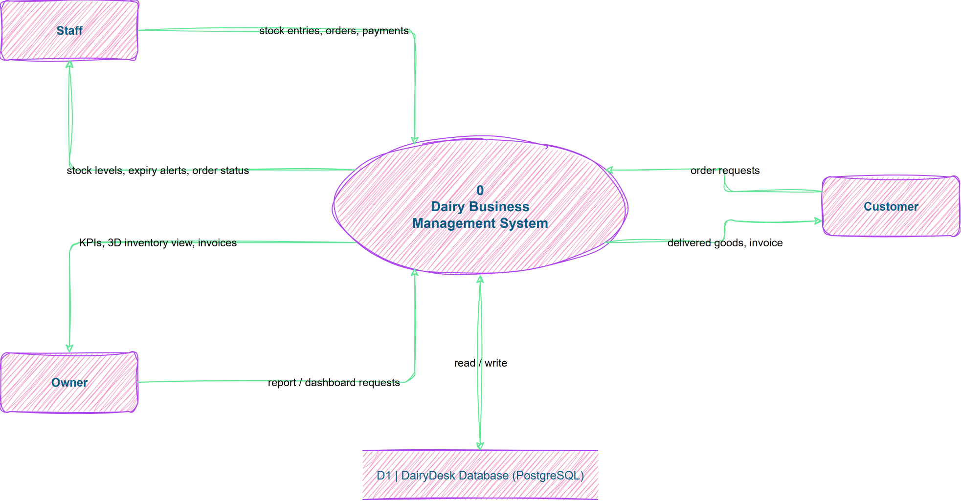
Figure 3.2: Level 0 Data Flow Diagram
Level 1
The Level 1 DFD breaks the single process down into its major sub-processes: login and access control, product and stock management, customer and order management, billing and payment processing, and report generation.
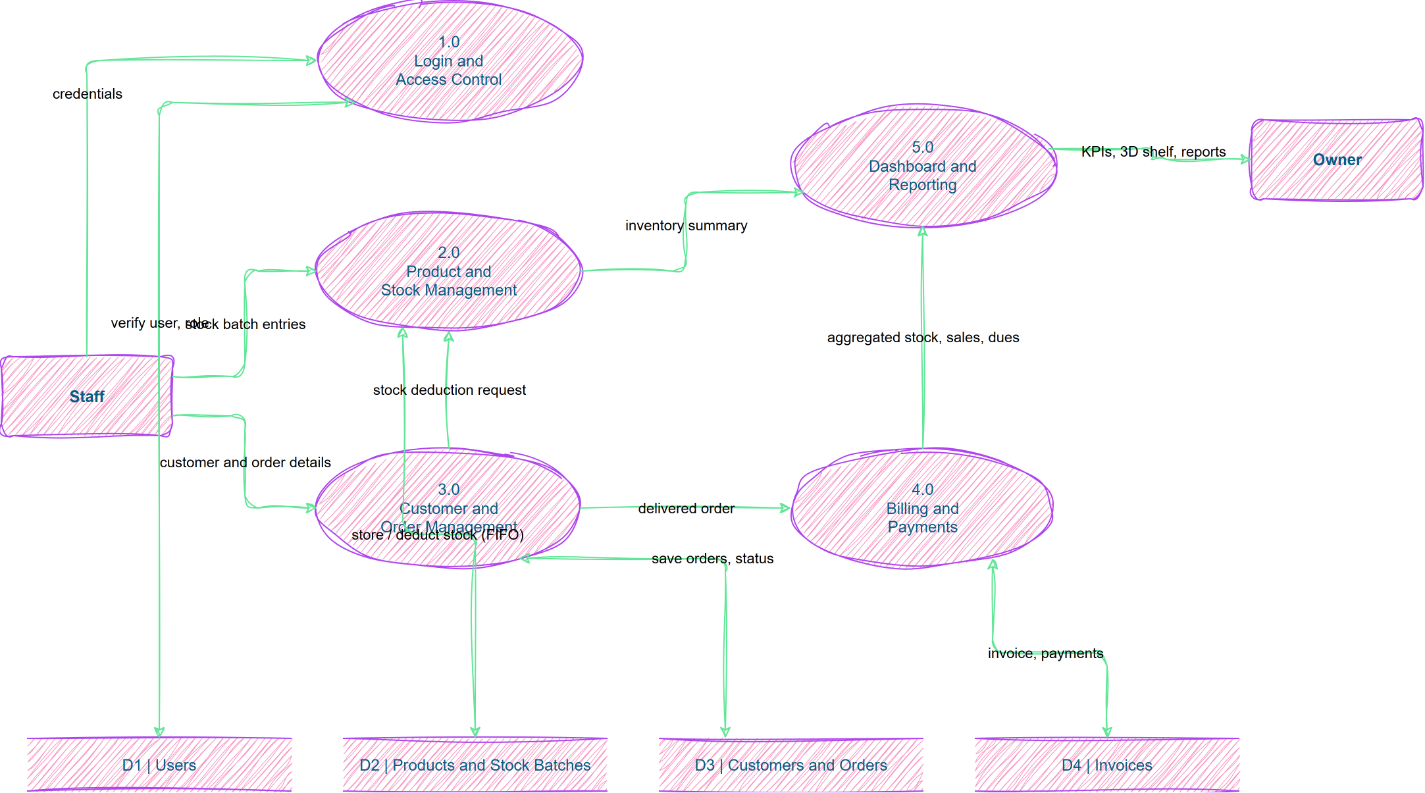
Figure 3.3: Level 1 Data Flow Diagram
Level 2
The Level 2 DFD further decomposes the order and billing sub-processes into individual steps: add stock, update expiry, place order, generate invoice, record payment, and produce report.
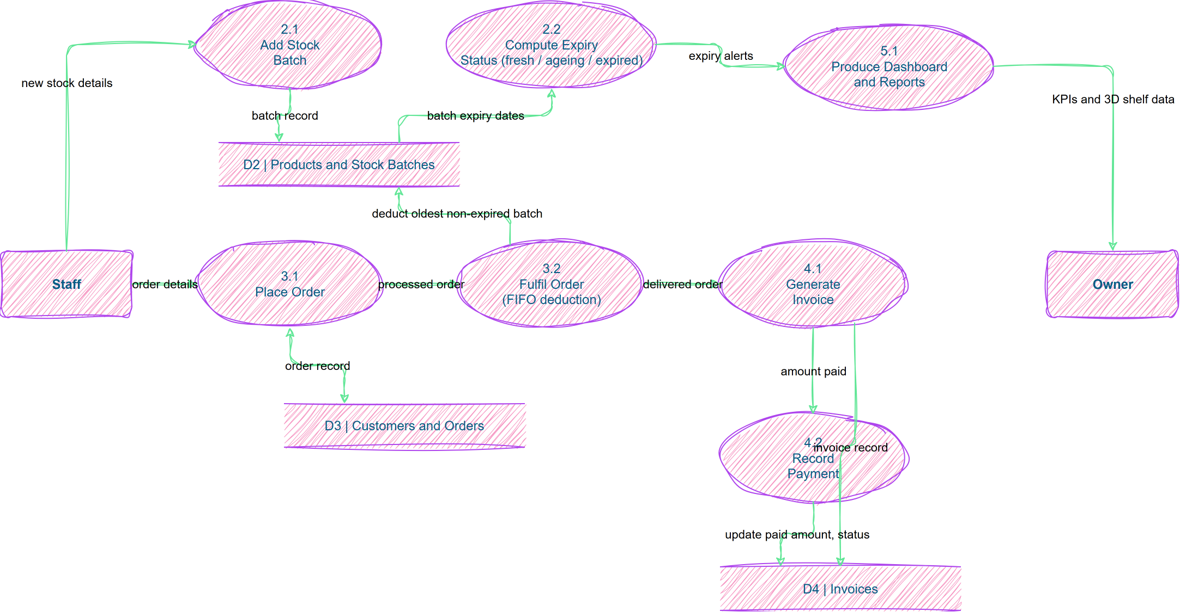
Figure 3.4: Level 2 Data Flow Diagram

3.4.4 Use Case Diagram
The use case diagram identifies three main actors — Owner, Staff, and Customer — and the key use cases they perform within the system, including login, managing inventory, registering customers, placing and processing orders, generating bills, updating payments, and viewing reports.
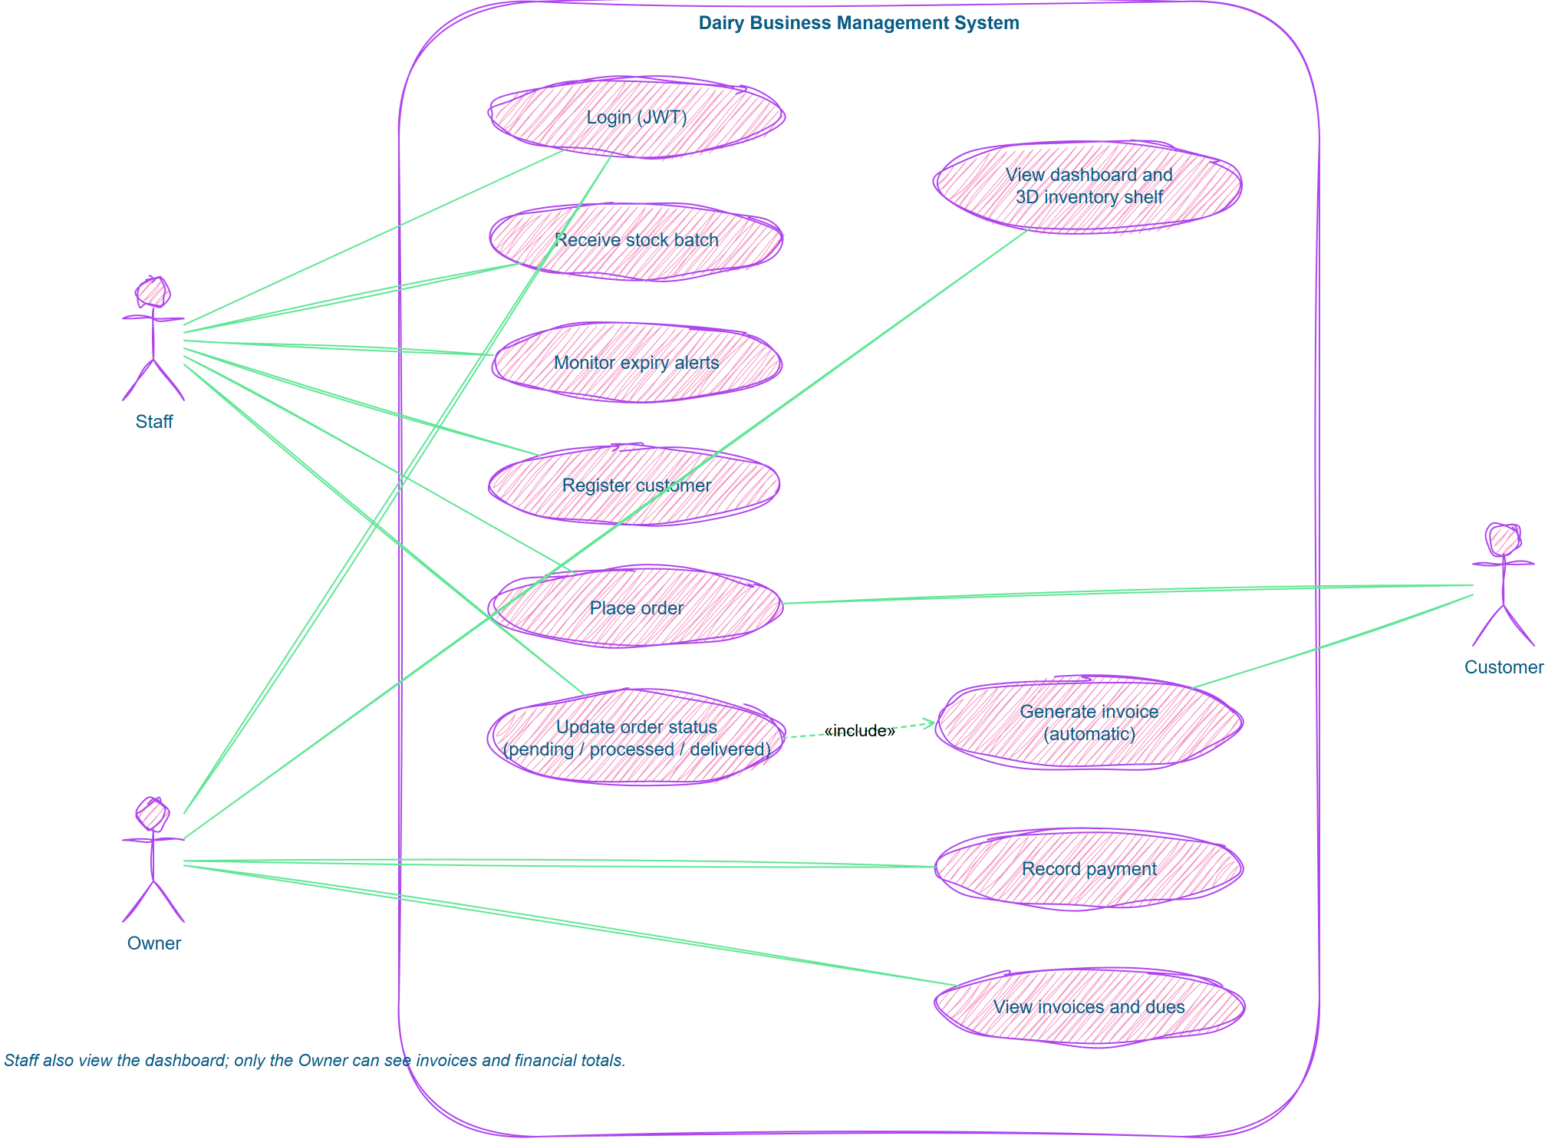
Figure 3.5: Use Case Diagram

3.4.5 Activity Diagram
The activity diagram below traces the main operational flow of the system, from staff login through to final report generation.
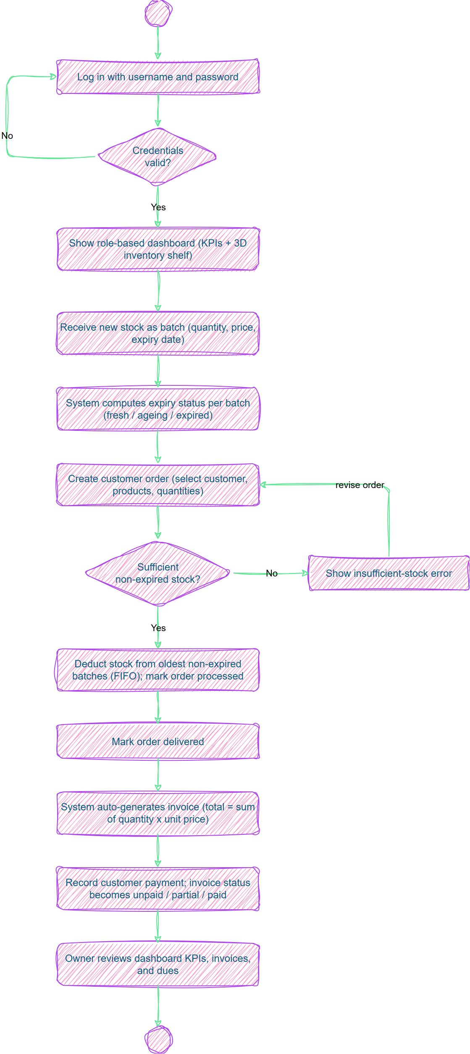
Figure 3.6: Activity Diagram showing the main system flow

