**Aim:** Implementing group communication in distributed computing

**Theory:**

**Communication** between two processes in a distributed system is required to exchange various data, such as code or a file, between the processes. When one source process tries to communicate with multiple processes at once, it is called **Group Communication**. A group is a collection of interconnected processes with abstraction. This abstraction is to hide the message passing so that the communication looks like a normal procedure call. Group communication also helps the processes from different hosts to work together and perform operations in a synchronized manner, therefore increasing the overall performance of the system.

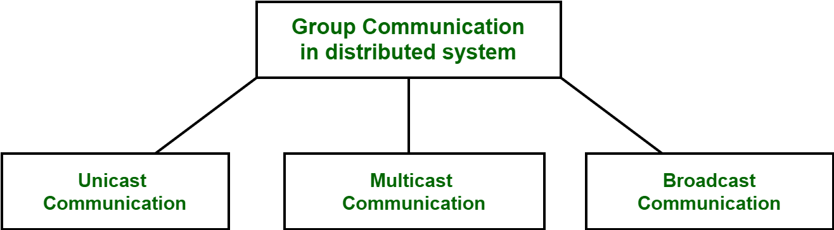

**Types of Group Communication in a Distributed System:**

* **Broadcast Communication :** When the host process tries to communicate with every process in a distributed system at same time. Broadcast communication comes in handy when a common stream of information is to be delivered to each and every process in most efficient manner possible. Since it does not require any processing whatsoever, communication is very fast in comparison to other modes of communication. However, it does not support a large number of processes and cannot treat a specific process individually.

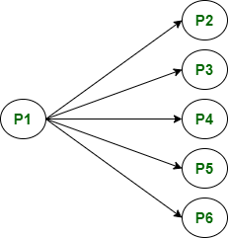

* **Multicast Communication :** When the host process tries to communicate with a designated group of processes in a distributed system at the same time. This technique is mainly used to find a way to address problem of a high workload on host system and redundant information from process in system. Multitasking can significantly decrease time taken for message handling.

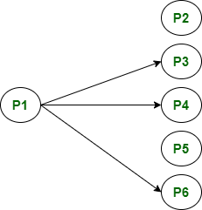

* **Unicast Communication :** When the host process tries to communicate with a single process in a distributed system at the same time. Although, same information may be passed to multiple processes. This works best for two processes communicating as only it has to treat a specific process only. However, it leads to overheads as it has to find exact process and then exchange information/data.

