Foundations of Programming
Assignment No. 18: String Operations in C
Problem Statement
Write a C program that accepts a string from the user and performs: i) Length calculation ii) Reversal iii) Equality check iv) Palindrome check v) Substring check.
Algorithm
Step 1: Start
Step 2: Accept string str1 from user
Step 3: LENGTH — Traverse str1 until '\0', count characters
Step 4: REVERSAL — Swap characters from start and end moving inward
Step 5: Accept second string str2 from user
Step 6: EQUALITY — Compare str1 and str2 character by character
Step 7: PALINDROME — Compare original str1 with its reversed copy
Step 8: SUBSTRING — Search if str2 exists within str1
Step 9: Display all results
Step 10: Stop
Flowchart (Text Representation)
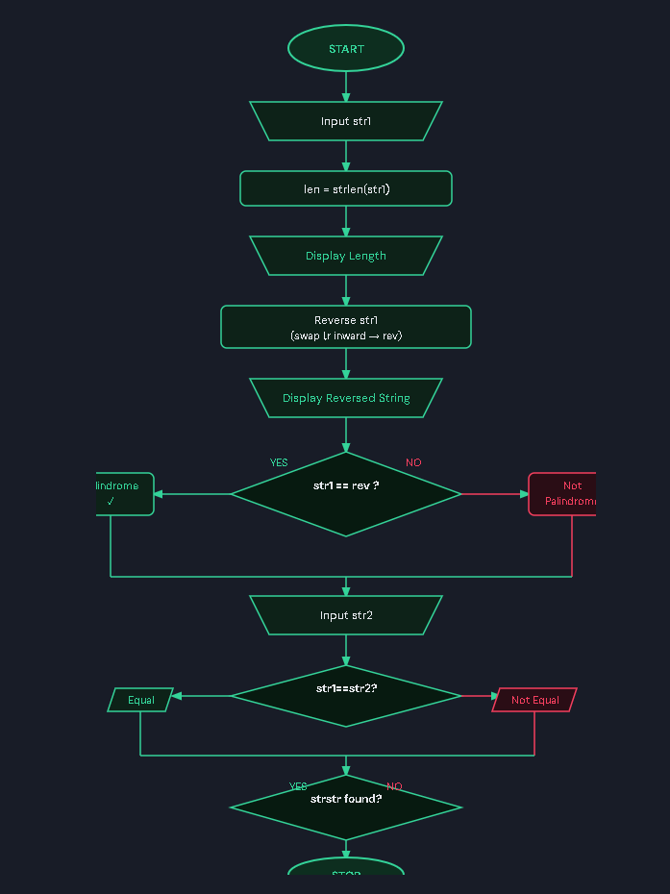
C Program Code
#include <stdio.h>
#include <string.h>

int main() {
char str1[100], str2[100], rev[100], temp;
int len, i;

printf("Enter a string: ");
scanf("%s", str1);

// Length
len = strlen(str1);
printf("Length of string = %d\n", len);

// Reversal
strcpy(rev, str1);
int l = 0, r = len - 1;
while (l < r) {
temp = rev[l]; rev[l] = rev[r]; rev[r] = temp;
l++; r--;
}
printf("Reversed string = %s\n", rev);

// Palindrome
if (strcmp(str1, rev) == 0)
printf("The string is a Palindrome\n");
else
printf("The string is NOT a Palindrome\n");

// Equality
printf("Enter another string: ");
scanf("%s", str2);
if (strcmp(str1, str2) == 0)
printf("Strings are equal\n");
else
printf("Strings are not equal\n");

// Substring
if (strstr(str1, str2) != NULL)
printf("Substring found in main string\n");
else
printf("Substring NOT found\n");

return 0;
}

Sample Input / Output
Input: str1 = madam, str2 = mad
Output: Length=5 | Reversed=madam | Palindrome=Yes | Equal=No | Substring=Found

