Foundations of Programming
Assignment No. 19: Employee Structure in C
Problem Statement
Create a structure EMPLOYEE storing Name, Designation, Gender, Date of Joining, and Salary. Implement functions to: a) Count total employees b) Count male/female c) Employees with salary > 10,000 d) Employees with designation 'Asst Manager'.
Algorithm
Step 1: Start
Step 2: Define structure EMPLOYEE with fields: name, designation, gender, doj, salary
Step 3: Input number of employees n
Step 4: For each employee i from 0 to n-1, accept all fields
Step 5: Count total = n
Step 6: Traverse array, count gender=='M' for males and gender=='F' for females
Step 7: Traverse array, print name where salary > 10000
Step 8: Traverse array, print name where designation == 'Asst Manager'
Step 9: Display all results
Step 10: Stop
Flowchart (Text Representation)
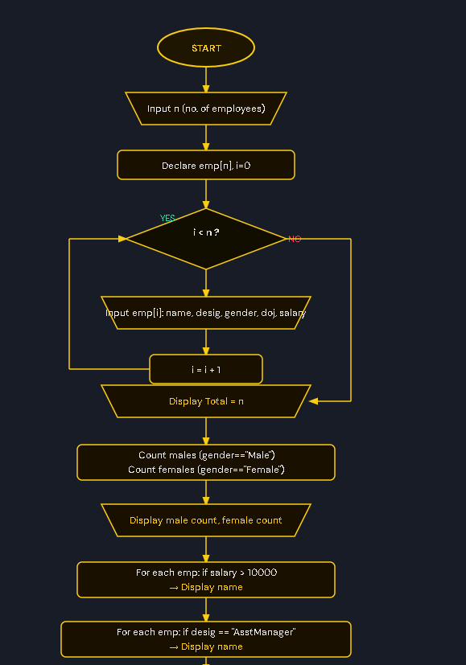
C Program Code
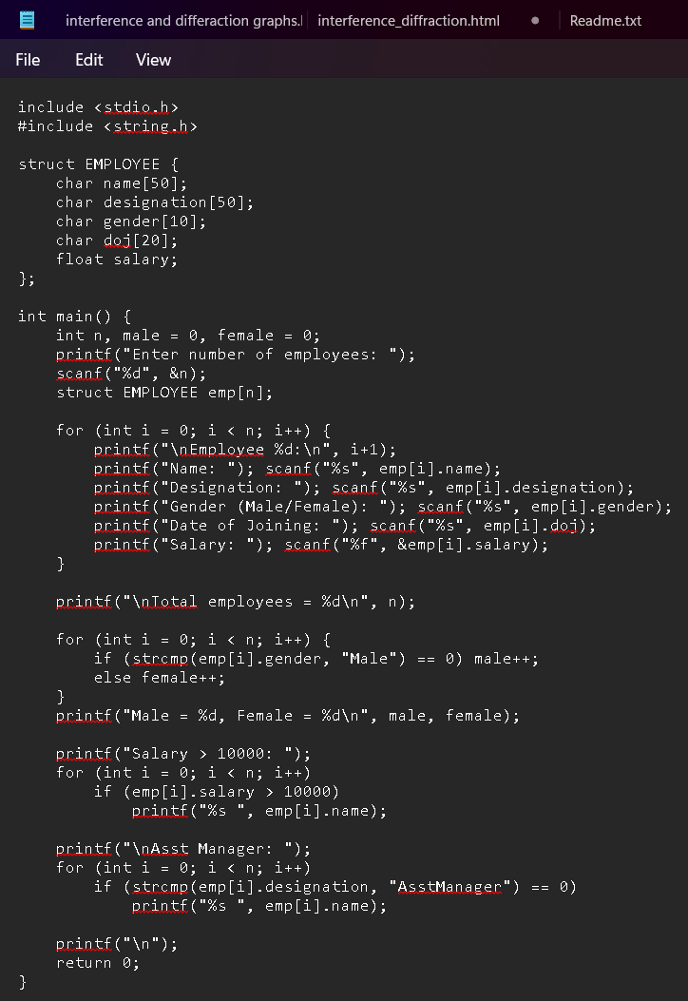
Sample Input / Output
Input: 2 employees — Ravi (AsstManager, Male, 15000), Anita (Clerk, Female, 8000)
Output: Total=2 | Male=1, Female=1 | Salary>10000: Ravi | AsstManager: Ravi

