Foundations of Programming
Assignment No. 20: Swapping with and without Pointers
Problem Statement
Write a C function to swap two numbers with and without using pointers (demonstrating call by value vs. call by reference).
Algorithm
Step 1: Start
Step 2: Input two integers a and b
Step 3: SWAP WITHOUT POINTERS (Call by Value):
a. Pass a and b to function swapByValue(x, y)
b. Inside function: temp = x; x = y; y = temp
c. Note: changes do NOT reflect in main (copies are swapped)
Step 4: SWAP WITH POINTERS (Call by Reference):
a. Pass &a and &b to function swapByRef(px, py)
b. Inside function: temp = *px; *px = *py; *py = temp
c. Changes reflect in main (original values are swapped)
Step 5: Display both results
Step 6: Stop
Flowchart (Text Representation)
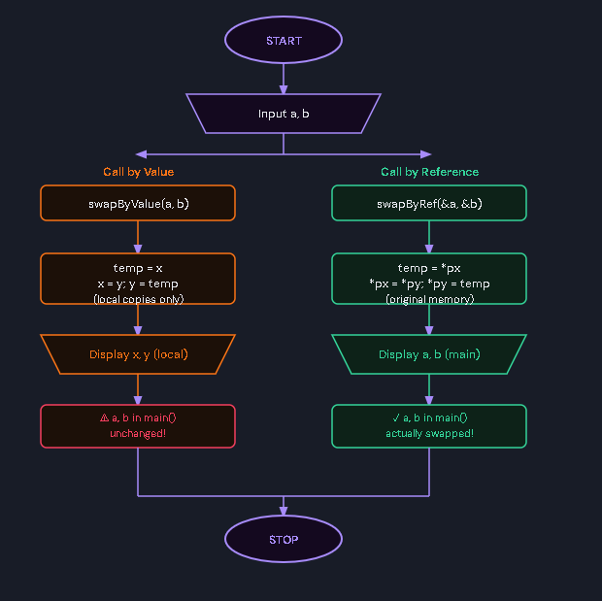C Program Code
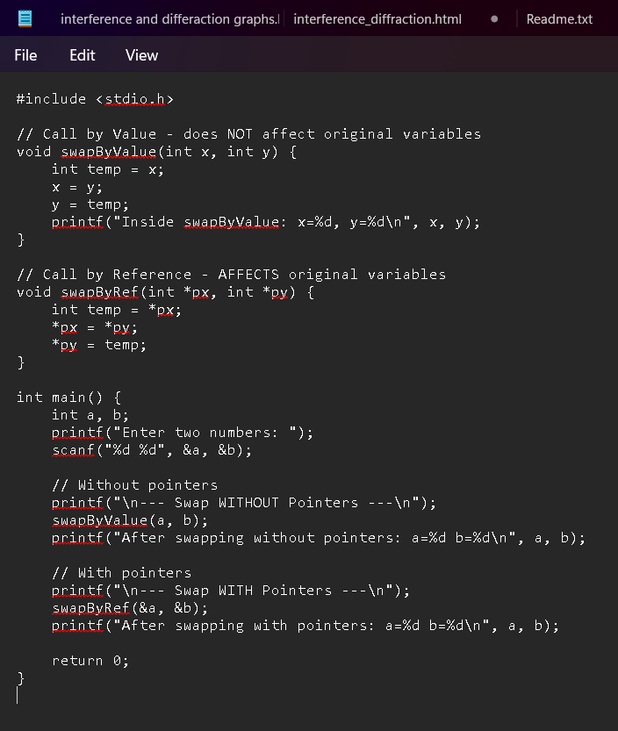
Sample Input / Output
Input: a = 10, b = 20
After swap without pointers: a=10 b=20 (unchanged in main)
After swap with pointers: a=20 b=10 (original values changed)

