Foundations of Programming
Assignment No. 22: Menu Driven String Operations
Problem Statement
Write a menu driven program in C to perform various string operations using built-in functions: length, copy, concatenation, comparison, and reversal.
Algorithm
Step 1: Start
Step 2: Input two strings str1 and str2 from user
Step 3: Display menu with options: 1. Length 2. Copy 3. Concatenate 4. Compare 5. Reverse 6. Exit
Step 4: Accept user's choice
Step 5: Based on choice, execute corresponding string function
1 → strlen(str1) → Display length
2 → strcpy(dest, str1) → Display copied string
3 → strcat(str1, str2) → Display concatenated string
4 → strcmp(str1, str2) → Display equal/not equal
5 → strrev(str1) [or manual reverse] → Display reversed string
6 → Exit
Step 6: Repeat from Step 3 until user selects Exit
Step 7: Stop
Flowchart (Text Representation)
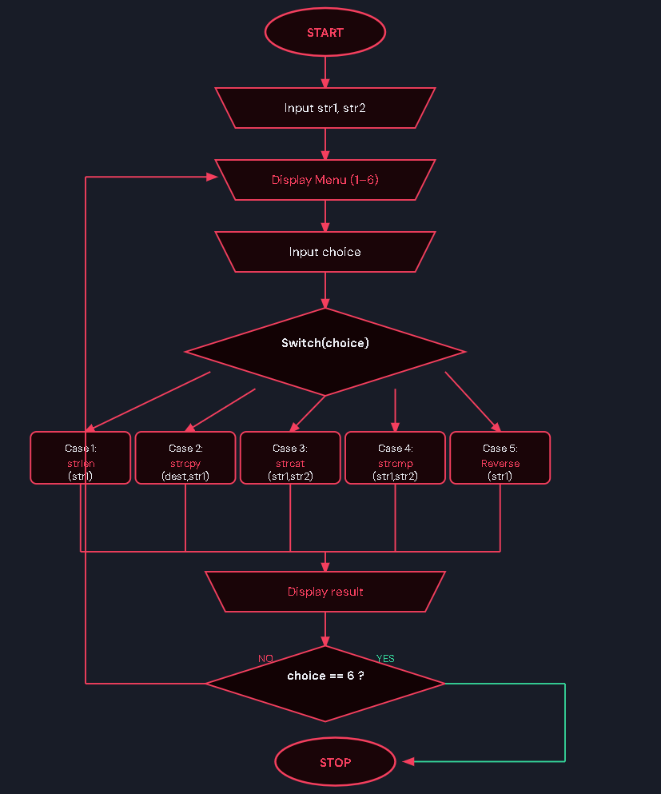C Program Code
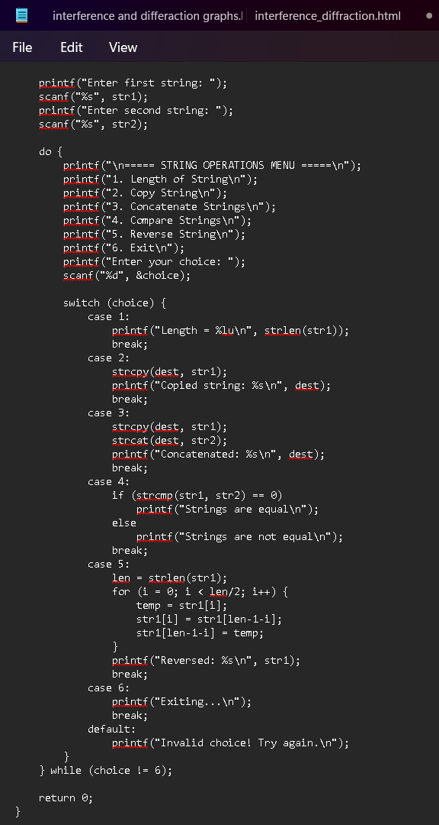
Sample Input / Output
Input: str1 = Hello, str2 = World, Choice = 3
Output: Concatenated string: HelloWorld

