- Foundations of Programming
- Assignment No. 17: Sum of Sine Series
- Problem Statement
- To accept the number of terms and find the sum of the sine series.
- Algorithm
- Step 1: Start
- Step 2: Input value of x (in radians) and number of terms n
- Step 3: Initialize sum = 0
- Step 4: For i from 0 to n-1:
- Compute power = x^(2i+1)
- Compute factorial = (2i+1)!
- Compute term = power / factorial
- If i is even: sum = sum + term
e. Else: sum = sum - term
Step 5: Display sum
Step 6: Stop
Flowchart (Text Representation)
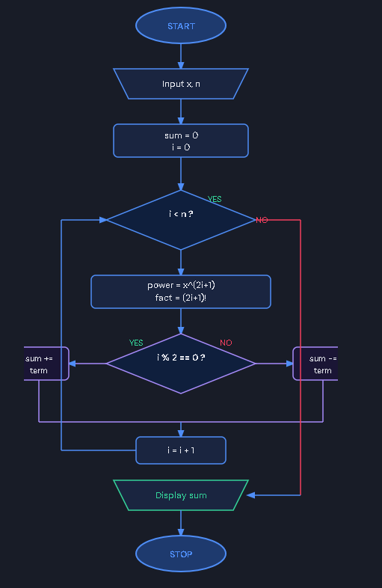
C Program Code
#include <stdio.h>
#include <math.h>

double factorial(int n) {
double fact = 1;
for (int i = 1; i <= n; i++)
fact *= i;
return fact;
}

double power(double x, int n) {
double result = 1;
for (int i = 0; i < n; i++)
result *= x;
return result;
}

int main() {
double x, sum = 0;
int n;
printf("Enter value of x (in radians): ");
scanf("%lf", &x);
printf("Enter number of terms: ");
scanf("%d", &n);
for (int i = 0; i < n; i++) {
double term = power(x, 2*i+1) / factorial(2*i+1);
if (i % 2 == 0)
sum += term;
else
sum -= term;
}
printf("Sum of sine series = %lf\n", sum);
return 0;
}

Sample Input / Output
Input: x = 1 (radians), n = 5
Output: Sum of sine series = 0.841471
Frequently Asked Questions (FAQs)
Q1. What is a sine series in mathematics?
Ans: The sine series is a Taylor/Maclaurin series expansion: sin(x) = x - x³/3! + x⁵/5! - x⁷/7! + ... It represents the sine function as an infinite sum of polynomial terms, useful for numerical computation.
Q2. Why is factorial used in the sine series?
Ans: Each term of the sine series has the form x^(2n+1)/(2n+1)!. The factorial in the denominator grows rapidly and controls convergence of the series, ensuring the sum approaches the actual sine value.
Q3. Why does the sine series have alternating signs?
Ans: The signs alternate (+, -, +, -...) because of the mathematical derivation from successive derivatives of sin(x). This alternation causes partial cancellation that makes the series converge to the true value.
Q4. Which header file is required for power functions in C?
Ans: <math.h> provides pow(), sin(), cos() and other mathematical functions. The file must be included with #include <math.h> and compiled with -lm flag: gcc file.c -lm -o output.
Q5. How does increasing the number of terms affect accuracy?
Ans: More terms mean greater accuracy because more of the infinite series is computed. For small x, even 5 terms gives high accuracy. For large x, more terms are needed since higher-order terms contribute more significantly.

