Feasibility Study
Architectural Design Report
Fault-Tolerant Distributed Lock Service
Chubby / etcd-style lock coordinator with leases and fencing tokens

Project | Fault-Tolerant Distributed Lock Service (Case study 13)
Course | Advanced Cloud System Software Design (CA1)
Phase / activity / deliverable | Feasibility study / Architectural design / Report
Underlying cloud primitives | Cloud VM cluster, Virtual Private Cloud (VPC)
Prepared by | Tanmay Maniyar
Date | 20 October 2026
Version | 1.0
Source code | https://github.com/TanmayManiyar/dist-lock-service (private)

Contents
1. Introduction and purpose
2. Problem statement and scope
3. Requirements and architectural drivers
4. Candidate architectures considered
5. Selected architecture
6. Data and control flows
7. Failure handling in the architecture
8. Feasibility assessment
9. Risks and mitigations
10. Conclusion and recommendation
Appendix A: Evidence from the prototype
Appendix B: Glossary

1. Introduction and purpose
This report documents the architectural design produced during the feasibility study of a fault-tolerant distributed lock service. Its purpose is to answer two questions before full implementation: what architecture should the system have, and is that architecture feasible technically, operationally, economically and within schedule.
A prototype of the selected architecture was built and tested during the study, so the feasibility conclusions in this report rest on measured evidence (Appendix A) and not on assumption alone.

2. Problem statement and scope
Many cloud applications need a single, authoritative answer to the question "who owns this resource right now?": which worker is the primary, which job may write to a file, which node may run a scheduled task. A lock held on a single server answers this question, but the server becomes a single point of failure. If it crashes the lock service is unavailable; if it is restarted carelessly, or a backup takes over without coordination, two clients can believe they hold the same lock and corrupt shared data.
The goal is a system design layer on top of raw cloud primitives (virtual machines, a private network and block storage) that provides:
- Mutual exclusion: at most one holder per lock at any time.
- Fault tolerance: continued correct service when machines crash or the network partitions.
- Liveness: locks are leases that expire, so a crashed client cannot block others forever.
- Safety against stale clients: fencing tokens that let a protected resource reject delayed writers.

2.1 In scope
- A replicated lock coordinator (cluster of 5 replicas) with acquire, renew and release operations.
- Leader election, log replication, durable storage and crash recovery.
- A gateway for client routing and fault injection, a demonstration protected resource, a dashboard and an educational virtual lab.
- Fault-injection tests and benchmarks; Docker and VM deployment guidance.

2.2 Out of scope
- Dynamic cluster membership changes and log compaction (snapshots).
- Byzantine (malicious) fault tolerance.
- Multi-region deployment and geo-replication.
- Authentication, authorisation and TLS on the client and replica interfaces (assumed to be provided by the private network in this study).

3. Requirements and architectural drivers

3.1 Functional requirements
ID | Requirement
FR1 | A client can acquire a named lock with a time limit (lease) and receives a fencing token.
FR2 | A lock is refused while another client holds an unexpired lease; the refusal names the holder.
FR3 | The holder can renew or release the lock; only the holder (owner and token) can.
FR4 | Expired leases are removed automatically.
FR5 | Fencing tokens are unique and strictly increasing across all grants, including across failovers.
FR6 | Operators can inject faults (crash, restart, partition, disk wipe) and observe cluster state.

3.2 Quality attributes (architectural drivers)
Quality | Target | How the architecture addresses it
Safety (consistency) | Never two simultaneous holders of one lock, under crashes and partitions | All lock operations are totally ordered through a Raft-replicated log; commits need a majority.
Availability | Service continues while a majority (3 of 5) of replicas can communicate | Automatic leader election; clients re-route via the gateway.
Durability | Acknowledged grants survive crashes of any minority, and a full restart | Term, vote and log persisted before replying; lock table rebuilt by log replay.
Recovery time | Client-visible failover of about a second | Election timeout 600-1100 ms with 120 ms heartbeats.
Partition behaviour | Choose consistency over availability (CP) | Minority side cannot commit; stale leader steps down (check-quorum).
Operability / testability | Faults reproducible on demand | Built-in fault-injection control plane, chaos test with a history checker.

3.3 Constraints
- Must be built as an abstraction layer over raw cloud primitives (VM cluster, VPC), as required by the course case study.
- Student project: small team, fixed deadline, low budget.
- Implementation language and runtime: Node.js (no third-party dependencies) to keep deployment simple and the code auditable.

4. Candidate architectures considered
Four architectures were evaluated against the drivers in section 3.
Option | Description | Strengths | Weaknesses
A. Single lock server | One VM holds the lock table in memory or on disk. | Simplest to build and operate; lowest cost. | Single point of failure; restart loses or blocks locks; fails the fault-tolerance requirement.
B. Primary-backup with asynchronous replication | Primary serves requests and copies state to a standby; a monitor promotes the standby on failure. | Cheap; moderate complexity. | Failover can lose recent grants; a partition can create two primaries (split brain), violating mutual exclusion.
C. Quorum consensus (Raft) cluster | Odd number of replicas; a leader orders all operations in a replicated log committed by majority vote. | Safe under crashes and partitions; automatic failover; well-documented algorithm; matches Chubby and etcd designs. | More complex; needs 3 or more nodes; every write waits for a majority.
D. Adopt an existing coordinator (etcd, ZooKeeper, managed service) | Use an off-the-shelf quorum service. | Production hardened; no consensus code to write. | Does not satisfy the case-study requirement to design and build the abstraction layer; limited insight and control over fault behaviour for teaching.

4.1 Evaluation
Each option was scored from 1 (poor) to 5 (excellent) against the drivers; weights reflect the importance given to each driver for this project.
Driver (weight) | A. Single | B. Primary-backup | C. Raft cluster | D. Adopt etcd/ZK
Safety under failures (5) | 1 | 2 | 5 | 5
Availability (4) | 1 | 3 | 4 | 5
Durability (4) | 2 | 2 | 5 | 5
Meets case-study scope: build the layer (5) | 4 | 4 | 5 | 1
Feasibility within schedule (3) | 5 | 4 | 3 | 5
Educational / demonstrable value (3) | 1 | 2 | 5 | 2
Weighted total (max 120) | 55 | 68 | 110 | 91

Option C scores highest and is selected. Its main weakness, complexity, is the main risk to be managed during implementation (section 9), and the study shows that risk can be controlled: a working implementation was completed and tested during the feasibility phase.
Scoring note: the weights and scores are the author's judgement based on the stated drivers; they are intended to make the reasoning explicit, not to be a precise measurement.

5. Selected architecture
The selected architecture is a five-replica Raft cluster behind a stateless gateway, deployed on cloud VMs spread over three availability zones inside a private network (VPC). The diagram shows the cloud layer (raw primitives) and the system design layer built on top of it.
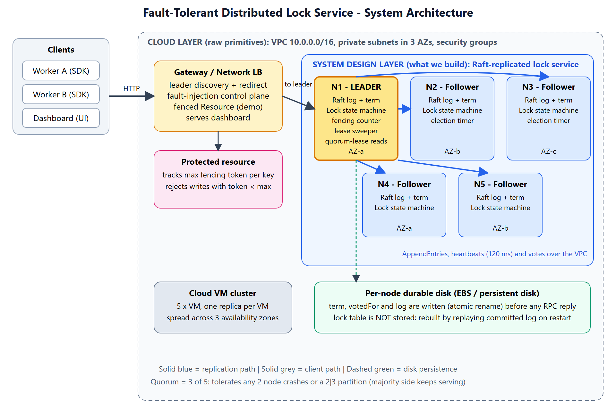
Figure 1: System architecture - cloud primitives and the lock service design layer

5.1 Components
Component | Responsibility | Deployed on
Replica (5 instances) | Runs the Raft protocol (election, replication, commit) and the lock state machine; persists term, vote and log; answers client and peer requests. | One VM per replica, private subnet, spread over availability zones a, b and c
Lock state machine | Deterministic table key -> (owner, token, expiry); applies acquire, renew, release and sweep commands; keeps the fencing counter. | Inside every replica
Gateway / load balancer | Finds the current leader, forwards client requests, retries on leader change, hosts the fault-injection control plane and serves the dashboard. | Public subnet (1 or more instances behind a network load balancer)
Protected resource (demo) | Stores data and rejects writes carrying a fencing token lower than the highest seen. | Application tier; here simulated in the gateway
Durable disk | Holds term, votedFor and the append-only log; the lock table is deliberately not stored. | Block storage volume per replica
Dashboard and virtual lab | Visualises roles, terms and logs; guided experiments with quizzes. | Served by the gateway; a static in-browser simulation is also provided

5.2 Mapping to cloud primitives
Cloud primitive | Use in the design
Cloud VM cluster | Five replicas, one per VM, spread across three availability zones so the loss of one zone removes at most two replicas and quorum (3) survives.
Virtual Private Cloud | Private subnets for replicas; security groups allow replica traffic only between replicas and the gateway, and client traffic only to the gateway; only the gateway is internet-facing.
Block storage | Per-replica durable volume for the term, vote and log.
Load balancer | Single stable entry point; the gateway tier is stateless for the lock API.

5.3 Key design decisions
# | Decision | Rationale
1 | Consensus through a replicated log (Raft) rather than ad hoc replication. | Gives a proven argument for safety under crashes and partitions; easier to explain and test than custom protocols.
2 | Odd cluster size of 5. | Tolerates 2 failures; 3 gives only 1 and 7 adds cost and write latency for little extra benefit in this setting.
3 | Leases with a TTL instead of locks released only explicitly. | Prevents a crashed client from blocking others forever (liveness).
4 | Fencing tokens from a counter inside the replicated state machine. | Tokens stay strictly increasing across failovers; protects resources from delayed (stale) clients that leases alone cannot stop.
5 | Commands carry the leader's timestamp; the leader proposes sweep commands to expire locks. | All replicas make identical expiry decisions regardless of their own clocks (deterministic state machine).
6 | Persist term, vote and log before replying; rebuild the lock table by replay. | Prevents double voting and lost grants after a crash; single source of truth.
7 | PreVote and leader check-quorum. | Isolated nodes cannot inflate terms and disrupt the cluster; a cut-off leader stops acting as leader.
8 | Reads served only by a leader holding a recent majority acknowledgement. | Avoids stale reads from a deposed leader.
9 | Stateless gateway with leader caching and retry. | Clients see a single endpoint; failover is hidden apart from a brief delay.

6. Data and control flows

6.1 Write path (acquire / renew / release)
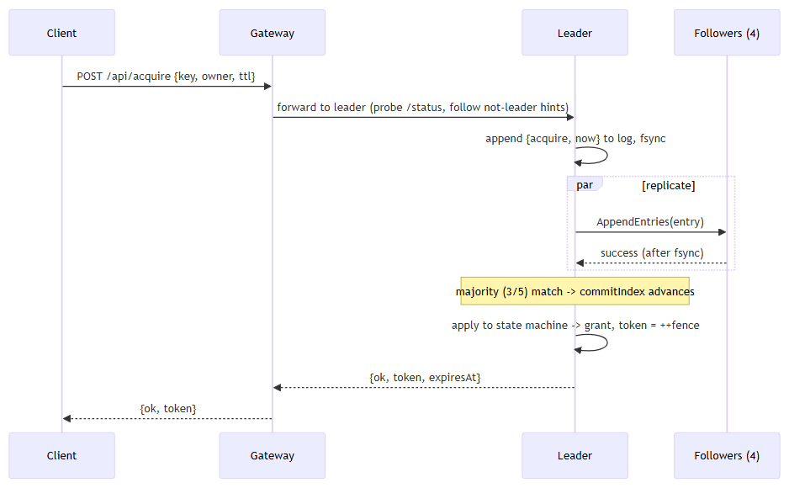
Figure 2: Client write path through the gateway, leader and followers
- The client sends the request to the gateway, which forwards it to the current leader (following a "not leader" hint if needed).
- The leader appends the command to its log, writes it to disk, and sends AppendEntries to all followers.
- When a majority (3 of 5) has stored the entry, the leader advances the commit index and applies the command to the lock state machine.
- Only then is the result (including the fencing token) returned to the client. A grant that was not committed is never acknowledged.

6.2 Read path
The lock table is returned only by a leader that has received acknowledgements from a majority within the last 1.5 seconds. Otherwise the replica answers "not leader" and the gateway looks for the real leader.

6.3 Fencing path
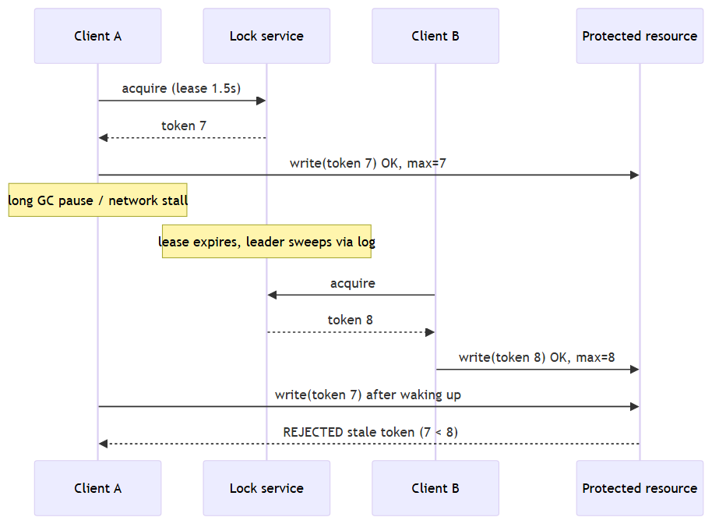
Figure 3: A stale write is rejected by the protected resource
A client that pauses beyond its lease may still try to write. The protected resource remembers the highest token it has accepted and refuses any lower token, so the stale client cannot overwrite data written by the new holder.

6.4 Background activities
Activity | Where | Period | Purpose
Heartbeat and replication | Leader | 120 ms | Replicate log, advance commit, refresh quorum lease
Election timer | Followers | 600-1100 ms (random) | Detect leader failure; PreVote then vote
Check-quorum | Leader | Every tick; limit 1.5 s | Step down if no majority is reachable
Lease sweeper | Leader | 300 ms | Propose a sweep command if any lock has expired
Persistence | All replicas | On every term, vote or log change | Durability before replying

7. Failure handling in the architecture
Failure | Behaviour | Why it is safe
Follower crash | Cluster keeps committing with the remaining majority; the replica catches up from the leader on restart. | Committed entries live on a majority; the restarted replica reloads its log from disk.
Leader crash | A follower times out, wins a majority vote and becomes leader (about 1 second); it commits a no-op to settle earlier entries. | Election restriction: only a replica with an up-to-date log can win, so every committed grant survives.
Two replicas down | Service continues (3 of 5). | Majority still reachable.
Three or more replicas down | Writes fail; the service stops granting locks rather than guess (CP). | No majority, so no commit and no risk of two holders.
Network partition 3 | 2 | Majority side elects or keeps a leader and serves; minority side cannot commit. | Only one side can hold a majority. A cut-off leader steps down via check-quorum.
Isolated replica rejoining | Does not force an election thanks to PreVote; stale entries are overwritten. | Higher term wins; uncommitted conflicting entries are discarded (never acknowledged).
Client crash while holding a lock | Lease expires and the sweeper removes the lock. | Bounded unavailability equal to the lease time.
Client pause beyond lease | Another client gets the lock; the first client's later write is rejected by the resource. | Fencing token comparison at the resource.
Whole-cluster restart | Replicas reload logs, elect a leader and rebuild the lock table; leases that ended meanwhile are swept. | Durable log is the source of truth.
Gateway failure | Run several gateways behind the load balancer; clients retry. | Gateway holds no lock state.

8. Feasibility assessment

8.1 Technical feasibility
Feasible. The consensus algorithm is well documented and widely deployed (Chubby, etcd, Consul). The study confirmed feasibility by implementing the complete design in dependency-free JavaScript (replica and gateway) and testing it:
- 12 scripted scenarios pass: election, mutual exclusion, failover, lease expiry, increasing tokens, partition behaviour, convergence after healing.
- Randomised chaos tests (8 concurrent clients, random crashes, restarts, leader isolation and partitions, 20 to 60 seconds each) passed with no mutual-exclusion violation, unique tokens, identical final logs on all replicas and continued availability afterwards.
- The safety checker was validated by mutation: with the exclusion check deliberately removed it reports many overlaps.
- Docker deployment with one container per replica on a private network was exercised, including restarting all replicas with locks preserved.

8.2 Performance feasibility
Measured on one development machine (replicas as local processes over loopback HTTP; cloud figures will differ):
Measure | Result
Acquire / release latency, single client | about 30 ms median, about 33-35 ms 95th percentile; same for 3, 5 and 7 replicas
Throughput, 32 concurrent clients, no fsync | about 3,600-4,300 operations per second
Throughput, 32 concurrent clients, fsync on every write | about 220 operations per second (disk flush cost; group commit is future work)
Failover time (leader killed until a client can acquire again) | median about 0.84-1.07 s, maximum about 1.12 s

Lock services are coordination infrastructure with modest request rates (hundreds to low thousands per second), so these figures are sufficient. Failover of about a second is within the tolerance of lease-based coordination (lease times of seconds).

8.3 Operational feasibility
- Five small VMs and one gateway are simple to operate; each replica is a single process that can be run as a system service and restarted automatically.
- The dashboard and fault-injection controls make behaviour observable and testable on demand.
- Operators must keep clocks loosely synchronised (NTP/chrony) and protect the replica network with security groups; both are standard practice.
- Known operational gap: no cluster membership changes or log snapshots, so replacing a failed disk and long-term log growth need manual handling.

8.4 Economic feasibility
Item | Quantity | Notes
Replica VMs (small general-purpose, e.g. 2 vCPU / 2 GB) | 5 | Smallest sizes are adequate for the measured load
Gateway VM or container | 1-2 | Stateless
Block storage volumes | 5 | A few GB each for the log
Load balancer | 1 | Single entry point
Data transfer | low | Mostly intra-VPC traffic

Indicative cost: on public on-demand prices this is in the order of USD 100-150 per month if run continuously in one region. This is an estimate from the resource list above, not a quotation; the current cloud pricing calculator should be used before committing. For the study, the whole system runs on a single laptop or in Docker at no cost, and the virtual lab is hosted as a static site.
Reducing cost: three replicas (tolerating one failure) reduce the replica count by two; spot or preemptible instances are not recommended for replicas because of the loss of local state.

8.5 Schedule feasibility
The prototype, tests, documentation, virtual lab and deployment guide were completed within the feasibility phase, which indicates that full implementation is achievable within the course timeline. The remaining Phase 2 work (extended fault-injection tests, benchmarks on cloud VMs) is incremental.

8.6 Legal and security considerations
- No personal data is processed.
- The replica interface has no authentication or TLS; it must only be reachable inside the private network. Production use would add mutual TLS between replicas and authenticated client access.
- The lab's fault-injection controls must be protected (the deployment supports a basic-auth option) because they can stop replicas.

9. Risks and mitigations
# | Risk | Likelihood | Impact | Mitigation
R1 | Subtle consensus bug causes a safety violation | Medium | High | Follow the published algorithm (election restriction, commit rule); chaos test with an independent history checker; mutation-validated checker.
R2 | Clock skew between replicas shortens or lengthens leases | Medium | Medium | Time carried in committed commands so replicas agree; require NTP; use second-scale leases; fencing tokens protect resources regardless.
R3 | Disk loss or corruption on a replica | Low | High | Majority holds committed data; treat a replaced disk as a new member (membership change is future work).
R4 | Write throughput limited by fsync | High | Low-Medium | Acceptable for coordination workloads; group commit and batching planned.
R5 | Unbounded log growth | Certain over time | Medium | Snapshots/compaction are future work; not needed for the study workload.
R6 | Unauthenticated internal interface exposed | Low | High | Security groups restrict access to the VPC; add mutual TLS before production.
R7 | Cloud deployment differs from the local prototype | Medium | Medium | Docker deployment tested; AWS procedure documented but not yet run on a real account; benchmark again on cloud VMs.

10. Conclusion and recommendation
The study recommends Option C, a five-replica Raft quorum cluster behind a stateless gateway on cloud VMs spread over three availability zones in a VPC, with leases and fencing tokens. It is the only evaluated option that satisfies both the safety and fault-tolerance requirements and the case-study scope of building the abstraction layer.
The architecture is feasible: it has been implemented and tested under injected failures, performance is adequate for coordination workloads, the operating model is simple, and the estimated cost is modest. The principal residual risks are the absence of snapshots and membership changes, authentication on internal interfaces, and the fact that the cloud (as opposed to Docker or local) deployment has not yet been exercised.
Recommended next steps: run the benchmarks and chaos tests on real cloud VMs; add log compaction and membership changes; add mutual TLS and client authentication.

Appendix A: Evidence from the prototype
Artefact | What it demonstrates
test.js (12 checks) | Core correctness and failover scenarios.
test-chaos.js | Randomised fault injection with a history-based mutual-exclusion checker; seeds make runs repeatable.
bench.js, BENCHMARKS.md | Latency, throughput and failover for 3, 5 and 7 replicas, with and without fsync.
Docker Compose files | Five replica containers and a gateway on a private network.
Dashboard and virtual lab | Six guided experiments (leases, leader election, log replication, partitions, fencing tokens, crash recovery) with quizzes.
Phase 1 and Phase 2 documents | Detailed architecture, data flow, failure strategy, implementation and test results.

Appendix B: Glossary
Term | Meaning
Raft | A consensus algorithm in which a leader replicates a log to followers and commits entries stored on a majority.
Quorum / majority | More than half of the replicas (3 of 5). Any two majorities overlap.
Term | A logical clock numbering leadership periods; a higher term always wins.
Lease | A lock with an expiry time that must be renewed.
Fencing token | A number that increases with every grant; resources reject lower numbers.
Split brain | Two nodes acting as leader and both able to grant the same lock.
PreVote | A poll before an election that does not change any term, preventing disruption by isolated nodes.
CP | Consistency and partition tolerance chosen over availability (CAP theorem).
VPC | Virtual Private Cloud: an isolated virtual network in the cloud.

