Phase 1: Architecture, Data Flow and Failure Strategy
Topic 13: Fault-Tolerant Distributed Lock Service (Advanced Cloud System Software Design, CA1)
Topic 13: Fault-Tolerant Distributed Lock Service (Chubby / etcd-style coordinator with fencing tokens)
Underlying primitives: Cloud VM cluster, Virtual Private Cloud (VPC).

1. Goal and guarantees
The cloud primitives (VMs, disks, a VPC) give us unreliable machines and an unreliable network. The abstraction layer we build on top provides:
Guarantee | How
Mutual exclusion - at most one holder per key at any logical time | Every lock operation is a command in a Raft-replicated log; the state machine grants a lock only if no unexpired holder exists.
Linearizable operations | All reads and writes go through (or are lease-confirmed by) the single Raft leader.
Fault tolerance | 5 replicas, majority quorum (3). Survives any 2 crashes or a minority partition.
Safety against stale holders (fencing) | Each grant returns a strictly increasing 64-bit-style fencing token; downstream resources reject any token lower than the highest seen.
Liveness of locks (no dead locks) | Locks are leases with a TTL; a crashed client's lock expires and is swept by the leader through the log.

2. System architecture diagram
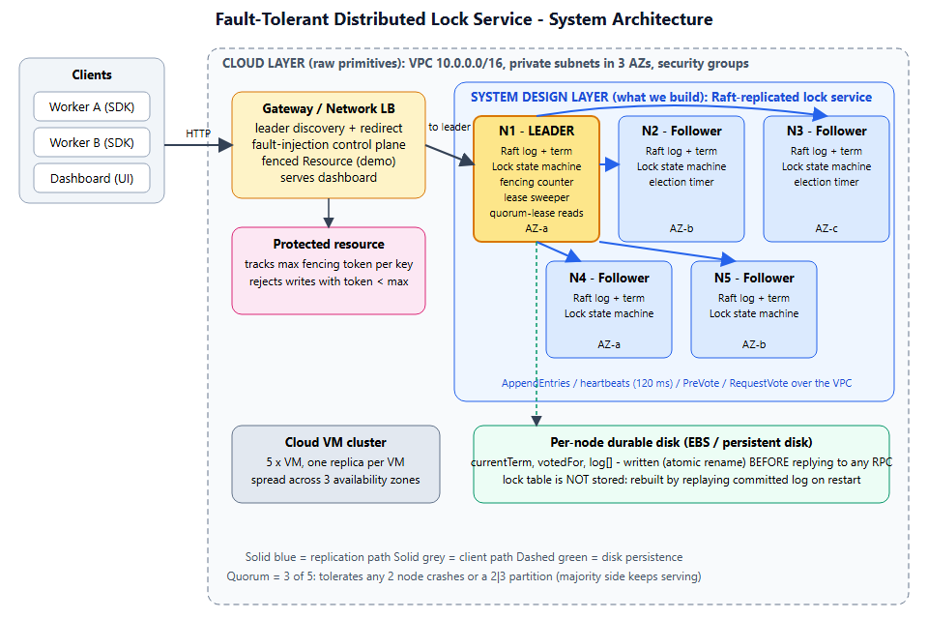
Figure 1: System architecture
Layer responsibilities
Layer | Component | Responsibility
Cloud primitive | VM cluster | Hosts one replica per VM, spread across availability zones so a zone loss costs at most 2 of 5 replicas.
Cloud primitive | VPC / security groups | Private subnets; only the gateway port is public, Raft ports are open only between replicas.
Cloud primitive | Block disk | Durable storage for term, vote and log.
Design layer | Raft module (replica.js) | Leader election (with PreVote), log replication, commit rules, check-quorum, persistence.
Design layer | Lock state machine | acquire / renew / release / sweep, lease expiry, fencing counter. Deterministic: the timestamp is carried inside each command.
Design layer | Gateway (server.js) | Finds the leader, follows redirects, retries; hosts fault-injection and the demo fenced resource.
Design layer | Dashboard (public/) | Live view of roles, terms, logs, locks and events; fault-injection controls.

3. Data and control pathways

3.1 Client write path (acquire / renew / release)
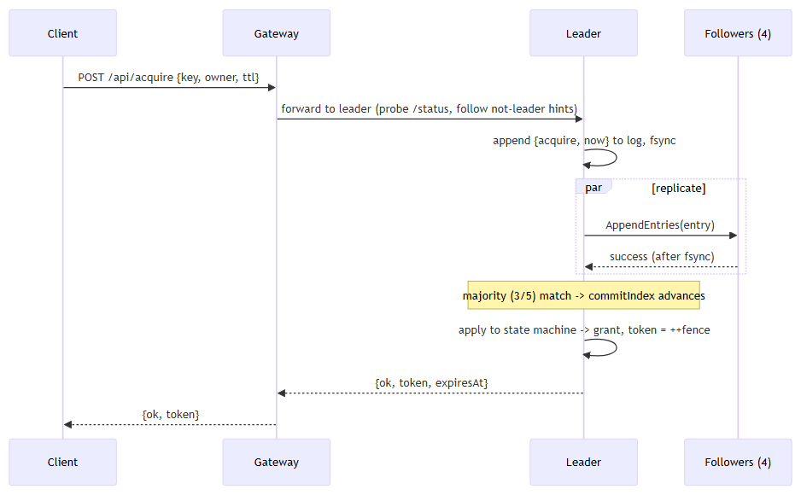
If the leader loses leadership before commit, the pending request is answered leadership-lost (outcome unknown to the client - the client re-reads or retries; acquire is idempotent for the same owner while the lease is live).

3.2 Client read path (lock table / status)
The leader answers only if it has received AppendEntries acknowledgements from a majority within the last 1.5 s (quorum lease). Otherwise it replies not-leader and the gateway re-discovers. This prevents a deposed leader in a minority partition from serving stale reads.

3.3 Fencing path
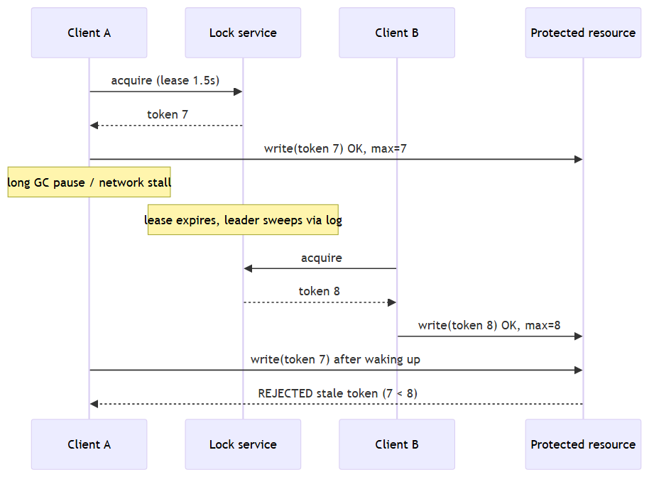

3.4 Background tasks (control plane)
Task | Where | Period | Purpose
Heartbeat / replication | Leader | 120 ms | Replicate log, advance commit, refresh quorum lease.
Election timer | Follower / candidate | randomised 600-1100 ms | Detect leader failure; PreVote then RequestVote.
Check-quorum | Leader | 120 ms tick, 1.5 s limit | Leader steps down if it cannot reach a majority.
Lease sweeper | Leader | 300 ms | If any lock is past expiry, propose sweep{now} through the log so every replica deletes the same locks.
Persistence | Every node | on every term/vote/log change | Atomic write-then-rename of term, votedFor, log.

3.5 Network boundaries
Boundary | Traffic | Rule
Internet / client to Gateway | HTTP client API, dashboard | Only public entry point.
Gateway to replicas | Client commands, status, admin | VPC private subnet.
Replica to replica | Raft RPCs | Allowed only inside the replica security group.
Replica to disk | Local block device | Not network-reachable by other nodes.

4. Failure and edge-case strategy
# | Failure | Behaviour | Recovery / why it is safe
1 | Follower crash | Leader keeps committing with the remaining majority. | On restart the node reloads term/vote/log from disk, receives missing entries via AppendEntries (backtracking nextIndex with a conflict hint), rebuilds the lock table by replay.
2 | Leader crash | Writes stall until a follower's election timer fires (about 0.6-1.1 s). New leader appends a no-op in its term, which commits all earlier entries. | Granted locks survive because they were committed to a majority before the client was acked. Raft election restriction guarantees the new leader has every committed entry.
3 | Up to 2 of 5 nodes down | Service stays available (quorum 3). | Restart nodes any time.
4 | 3+ nodes down | No quorum: writes time out, reads return not-leader. The service chooses consistency over availability (CP). | Restarting enough nodes restores a quorum and the state from disk.
5 | Network partition 2 vs 3 | Majority side elects/keeps a leader and serves. Minority-side leader detects loss of majority (check-quorum) and steps down; it cannot commit anything. | On heal, minority nodes see the higher term, truncate any uncommitted conflicting entries and catch up. No split brain: only one leader can hold a majority per term.
6 | Isolated leader | Same as above: old leader's writes never commit (timeout / leadership-lost); a new leader is elected on the other side. | Old leader steps down on heal.
7 | Partitioned minority disrupting the cluster | PreVote: an isolated node cannot raise the term because nobody grants its pre-vote, so rejoining does not force a needless election. | -
8 | Message loss / delay / duplication | RPCs have 300 ms timeouts and are retried by heartbeat; AppendEntries is idempotent (log-matching check). | -
9 | Client crashes while holding lock | Lock lives until TTL, then the leader's sweeper releases it through the log. | Bounded unavailability = TTL.
10 | Client pause beyond lease (zombie holder) | Another client gets the lock. The zombie's later write carries an old token. | Resource rejects token < max seen (fencing); this is the guarantee mutual exclusion alone cannot give.
11 | Duplicate / retried client request | acquire by the same owner while the lease is live returns the same token; release/renew require matching owner + token, so a stale client cannot release someone else's lock. | -
12 | Leader clock vs. replica clocks | Expiry decisions use the leader's timestamp stored in the committed command, so all replicas apply identical results regardless of local clocks. After a leader change the new leader's clock is used for later commands (assumes loosely synchronised clocks, e.g. NTP/chrony in the VPC; TTLs of seconds make small skew harmless). | Documented assumption.
13 | Disk write interrupted during crash | Persisted via temp file + atomic rename, so the file is either the old or new consistent version. | -
14 | Gateway failure | Stateless apart from the demo resource; run several behind the load balancer. Clients can also contact any replica and follow the leader hint. | -
15 | Split vote | Randomised election timeouts make repeated ties unlikely; a candidate that does not reach a majority retries. | -

Recovery steps summary
- Process restarts, loads term, votedFor, log from disk (state machine is empty, commitIndex = 0).
- Starts as follower; first valid AppendEntries from the leader supplies leaderCommit.
- Log is reconciled (conflicting suffix truncated, missing entries appended).
- Entries up to commitIndex are replayed into the lock table; node is now current.

5. Mapping to the implementation
Design element | File
Raft + lock state machine | replica.js
Gateway, leader routing, fault injection, fenced resource | server.js
Dashboard | public/index.html, app.js, style.css
Fault-injection test suite (Phase 2 seed) | test.js

6. Phase 2 plan
Fault-injection suite (crash, partition, restart storms, clock skew), a linearizability checker on recorded histories, and benchmarks (acquire latency / throughput vs. cluster size, failover time).

