Activity: Architectural design
Architectural Design Report
Fault-Tolerant Distributed Lock Service
Chubby / etcd-style lock coordinator with leases and fencing tokens

Project | Fault-Tolerant Distributed Lock Service (Case study 13)
Course | Advanced Cloud System Software Design (CA1)
Underlying cloud primitives | Cloud VM cluster, Virtual Private Cloud (VPC)
Prepared by | Tanmay Maniyar
Date | 20 October 2026
Version | 1.0
Companion document | Feasibility Study Document (separate document)
Source code | https://github.com/TanmayManiyar/dist-lock-service (private)

Contents
1. Introduction
2. Architectural drivers
3. Architecture overview
4. Components
5. Mapping to cloud primitives
6. Deployment view
7. Key design decisions
8. Data and control flows
9. Failure handling
10. Requirements traceability
11. Limitations and future work
Glossary

1. Introduction
This report describes the architecture of the fault-tolerant distributed lock service: its structure, the responsibilities of each part, how it uses cloud primitives, how data and control flow through it, and how it behaves when components fail. It records the design that the Feasibility Study Document recommends (a five-replica Raft quorum cluster) and the reasons behind its main decisions.

1.1 Scope
The architecture covers the replica cluster, gateway, protected resource, durable storage and the cloud infrastructure they run on. The dashboard and educational virtual lab are clients of this architecture and are not described in detail here.

1.2 System summary
Applications ask the service for named locks. Each lock is a lease (it expires unless renewed) and every grant carries a fencing token that increases forever. Five replicas agree on the order of all lock operations by running the Raft consensus protocol, so the service keeps giving one consistent answer while up to two replicas fail or the network splits.

2. Architectural drivers
Quality | Target | How the architecture addresses it
Safety (consistency) | Never two simultaneous holders of one lock, under crashes and partitions | All lock operations are totally ordered through a Raft-replicated log; commits need a majority.
Availability | Service continues while a majority (3 of 5) of replicas can communicate | Automatic leader election; clients re-route via the gateway.
Durability | Acknowledged grants survive crashes of any minority, and a full restart | Term, vote and log persisted before replying; lock table rebuilt by log replay.
Recovery time | Client-visible failover of about a second | Election timeout 600-1100 ms with 120 ms heartbeats.
Partition behaviour | Choose consistency over availability (CP) | Minority side cannot commit; stale leader steps down (check-quorum).
Operability / testability | Faults reproducible on demand | Built-in fault-injection control plane; chaos test with a history checker.

Constraints: the system is an abstraction layer over a cloud VM cluster and a VPC; it is implemented in Node.js without third-party dependencies.

3. Architecture overview
The system has two layers. The cloud layer provides raw primitives: virtual machines, a private network with security groups, and block storage. On top of it, the system design layer (what is built in this project) turns five unreliable machines into one reliable lock service.
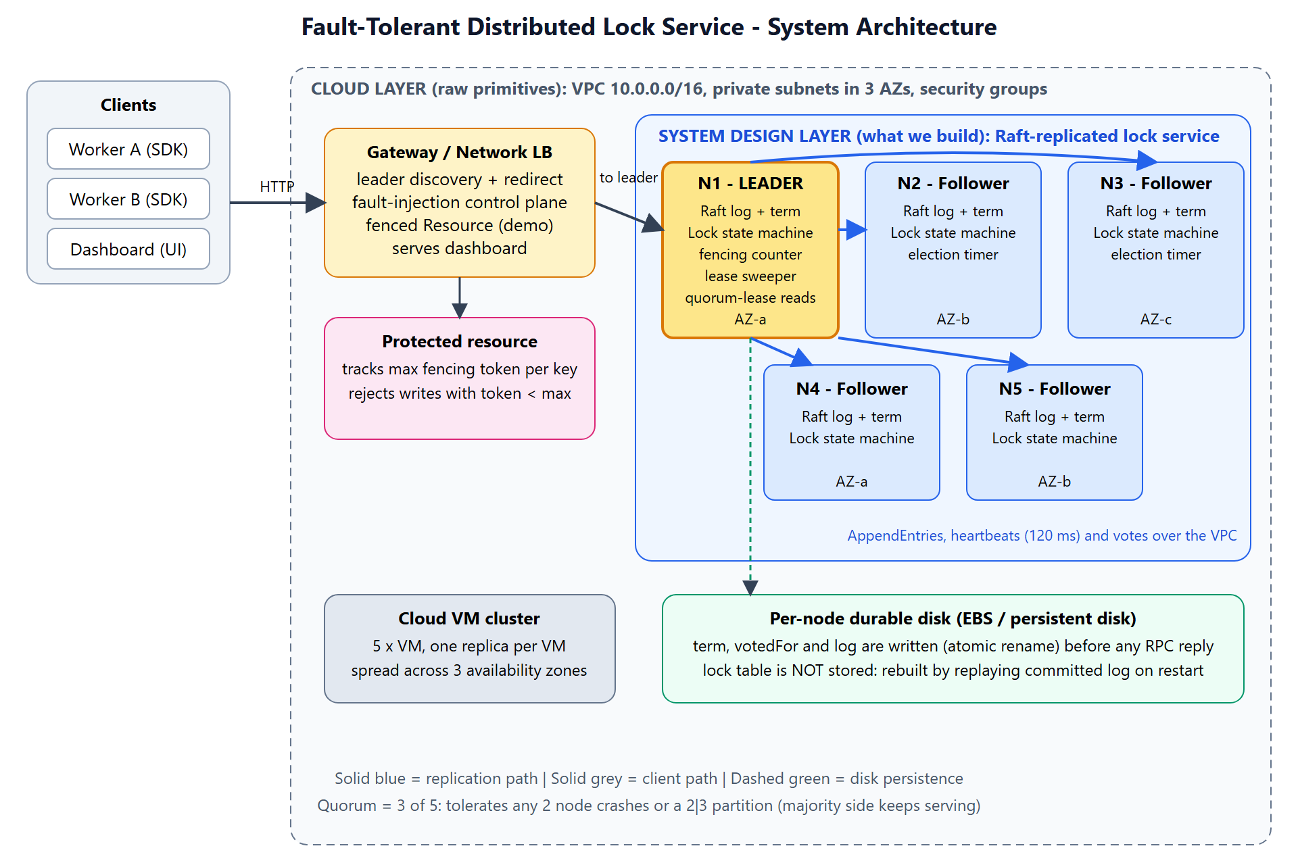
Figure 1: System architecture - cloud primitives and the lock service design layer

3.1 Architectural style
- Replicated state machine: every replica applies the same ordered commands to the same deterministic lock table.
- Leader-based consensus (Raft): one leader orders commands; followers copy the leader's log; a command is committed when a majority has stored it.
- Stateless gateway: a thin tier hides leader changes from clients and hosts the operational tooling.

4. Components
Component | Responsibility | Deployed on
Replica (5 instances) | Runs the Raft protocol (election, replication, commit) and the lock state machine; persists term, vote and log; answers client and peer requests. | One VM per replica, private subnet, spread over availability zones a, b and c
Lock state machine | Deterministic table key -> (owner, token, expiry); applies acquire, renew, release and sweep commands; keeps the fencing counter. | Inside every replica
Gateway / load balancer | Finds the current leader, forwards client requests, retries on leader change, hosts the fault-injection control plane and serves the dashboard. | Public subnet (1 or more instances behind a network load balancer)
Protected resource (demo) | Stores data and rejects writes carrying a fencing token lower than the highest seen. | Application tier; here simulated in the gateway
Durable disk | Holds term, votedFor and the append-only log; the lock table is deliberately not stored. | Block storage volume per replica
Dashboard and virtual lab | Visualises roles, terms and logs; guided experiments with quizzes. | Served by the gateway; a static in-browser simulation is also provided

4.1 Inside a replica
Module | Function
Raft core | Roles (follower, candidate, leader), terms, PreVote and vote handling, AppendEntries, commit index, check-quorum.
Log and persistence | Append-only log file plus a small metadata file (term, vote) updated by atomic rename; optional fsync on every write.
Lock state machine | Applies committed commands; produces results returned to the waiting client request.
Lease sweeper | On the leader, proposes a sweep command when any lock has expired.
HTTP interface | Raft peer RPCs, client operations, status and an admin interface used for fault injection.

5. Mapping to cloud primitives
Cloud primitive | Use in the design
Cloud VM cluster | Five replicas, one per VM, spread across three availability zones so the loss of one zone removes at most two replicas and quorum (3) survives.
Virtual Private Cloud | Private subnets for replicas; security groups allow replica traffic only between replicas and the gateway, and client traffic only to the gateway; only the gateway is internet-facing.
Block storage | Per-replica durable volume for the term, vote and log.
Load balancer | Single stable entry point; the gateway tier is stateless for the lock API.

6. Deployment view
Zone / subnet | Instances | Notes
Availability zone a (private) | Replica N1, Replica N4 | One VM each, own disk
Availability zone b (private) | Replica N2, Replica N5 | One VM each, own disk
Availability zone c (private) | Replica N3 | One VM, own disk
Public subnet | Gateway instance(s), load balancer | Internet-facing entry point

Rule | Source | Destination / port
Client traffic | Internet or load balancer | Gateway, TCP 8080
Client commands and administration | Gateway | Replicas, TCP 7001
Raft traffic | Replicas | Replicas, TCP 7001
Everything else | Any | Denied

Replica addresses are given to each replica as a list (id to host:port); the gateway receives the same list. Each replica has its own persistent volume. In the development setup the same code runs as local processes or as Docker containers on a private bridge network.

7. Key design decisions
# | Decision | Rationale
1 | Consensus through a replicated log (Raft) rather than ad hoc replication. | Gives a proven argument for safety under crashes and partitions; easier to explain and test than custom protocols.
2 | Odd cluster size of 5. | Tolerates 2 failures; 3 gives only 1 and 7 adds cost and write latency for little extra benefit in this setting.
3 | Leases with a TTL instead of locks released only explicitly. | Prevents a crashed client from blocking others forever (liveness).
4 | Fencing tokens from a counter inside the replicated state machine. | Tokens stay strictly increasing across failovers; protects resources from delayed (stale) clients that leases alone cannot stop.
5 | Commands carry the leader's timestamp; the leader proposes sweep commands to expire locks. | All replicas make identical expiry decisions regardless of their own clocks (deterministic state machine).
6 | Persist term, vote and log before replying; rebuild the lock table by replay. | Prevents double voting and lost grants after a crash; single source of truth.
7 | PreVote and leader check-quorum. | Isolated nodes cannot inflate terms and disrupt the cluster; a cut-off leader stops acting as leader.
8 | Reads served only by a leader holding a recent majority acknowledgement. | Avoids stale reads from a deposed leader.
9 | Stateless gateway with leader caching and retry. | Clients see a single endpoint; failover is hidden apart from a brief delay.
10 | Append-only log file with atomic metadata updates. | Constant-time appends; torn final record after a crash is ignored on recovery.

8. Data and control flows

8.1 Write path (acquire / renew / release)
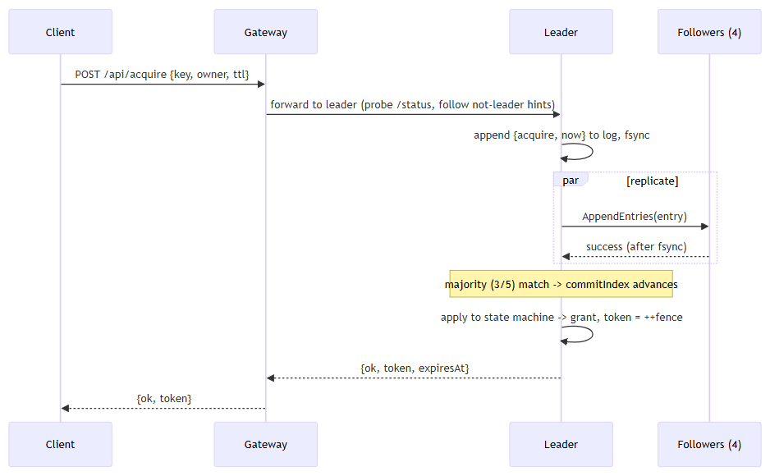
Figure 2: Client write path through the gateway, leader and followers
- The client sends the request to the gateway, which forwards it to the current leader (following a "not leader" hint if needed).
- The leader appends the command to its log, writes it to disk, and sends AppendEntries to all followers.
- When a majority (3 of 5) has stored the entry, the leader advances the commit index and applies the command to the lock state machine.
- Only then is the result (including the fencing token) returned to the client. A grant that was not committed is never acknowledged.

8.2 Read path
The lock table is returned only by a leader that has received acknowledgements from a majority within the last 1.5 seconds. Otherwise the replica answers "not leader" and the gateway looks for the real leader.

8.3 Fencing path
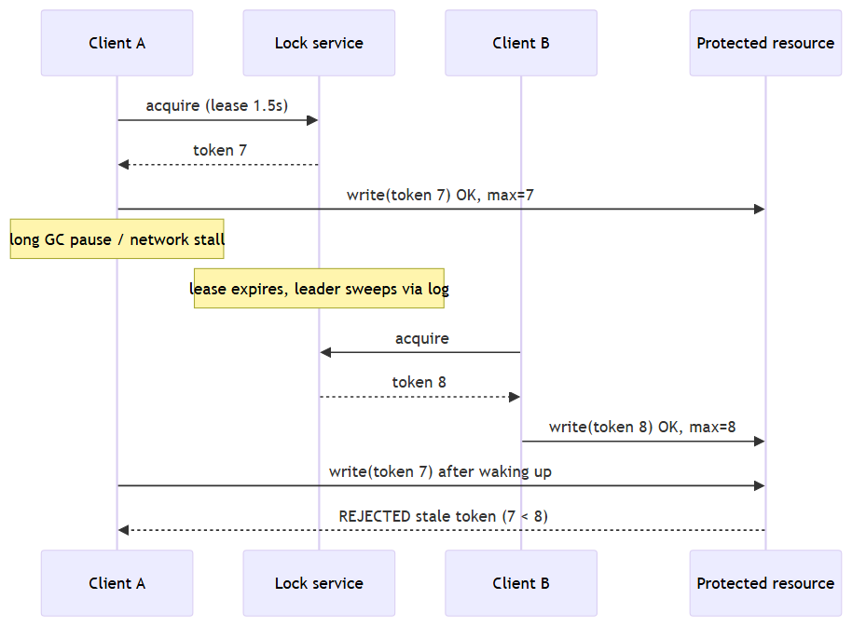
Figure 3: A stale write is rejected by the protected resource
A client that pauses beyond its lease may still try to write. The protected resource remembers the highest token it has accepted and refuses any lower token, so the stale client cannot overwrite data written by the new holder.

8.4 Background activities
Activity | Where | Period | Purpose
Heartbeat and replication | Leader | 120 ms | Replicate log, advance commit, refresh quorum lease
Election timer | Followers | 600-1100 ms (random) | Detect leader failure; PreVote then vote
Check-quorum | Leader | Every tick; limit 1.5 s | Step down if no majority is reachable
Lease sweeper | Leader | 300 ms | Propose a sweep command if any lock has expired
Persistence | All replicas | On every term, vote or log change | Durability before replying

8.5 Network boundaries
Boundary | Traffic | Rule
Internet / client to gateway | HTTP client API, dashboard | Only public entry point
Gateway to replicas | Client commands, status, admin | Private subnet
Replica to replica | Raft RPCs | Allowed only inside the replica security group
Replica to disk | Local block device | Not reachable by other nodes

9. Failure handling
Failure | Behaviour | Why it is safe
Follower crash | Cluster keeps committing with the remaining majority; the replica catches up from the leader on restart. | Committed entries live on a majority; the restarted replica reloads its log from disk.
Leader crash | A follower times out, wins a majority vote and becomes leader (about 1 second); it commits a no-op to settle earlier entries. | Election restriction: only a replica with an up-to-date log can win, so every committed grant survives.
Two replicas down | Service continues (3 of 5). | Majority still reachable.
Three or more replicas down | Writes fail; the service stops granting locks rather than guess (CP). | No majority, so no commit and no risk of two holders.
Network partition 3 | 2 | Majority side elects or keeps a leader and serves; minority side cannot commit. | Only one side can hold a majority. A cut-off leader steps down via check-quorum.
Isolated replica rejoining | Does not force an election thanks to PreVote; stale entries are overwritten. | Higher term wins; uncommitted conflicting entries are discarded (never acknowledged).
Client crash while holding a lock | Lease expires and the sweeper removes the lock. | Bounded unavailability equal to the lease time.
Client pause beyond lease | Another client gets the lock; the first client's later write is rejected by the resource. | Fencing token comparison at the resource.
Whole-cluster restart | Replicas reload logs, elect a leader and rebuild the lock table; leases that ended meanwhile are swept. | Durable log is the source of truth.
Gateway failure | Run several gateways behind the load balancer; clients retry. | Gateway holds no lock state.

9.1 Recovery steps for a restarted replica
- Load term, votedFor and the log from disk; start as a follower with an empty lock table and commit index 0.
- Receive the first valid AppendEntries from the leader, which supplies the commit index.
- Reconcile the log (remove a conflicting suffix, append missing entries).
- Replay committed entries into the lock table; the replica is now current.

10. Requirements traceability
Requirement | Realised by
FR1 Acquire with lease and token | Gateway, leader, lock state machine (acquire command, fencing counter)
FR2 Refusal names the holder | Lock state machine returns "held" with owner and token
FR3 Only the holder renews or releases | Lock state machine checks owner and token
FR4 Automatic expiry | Lease sweeper proposes sweep commands through the log
FR5 Strictly increasing tokens | Counter inside the replicated state machine; survives failover
FR6 Fault injection and observation | Gateway control plane, replica admin interface, dashboard
Safety | Raft log, majority commit, election restriction
Availability and recovery time | Leader election, randomised timeouts, gateway leader discovery
Durability | Write-ahead log and metadata persisted before replying; replay on restart

11. Limitations and future work
- No log compaction (snapshots): the log grows without bound.
- No dynamic membership changes; replacing a lost disk requires care.
- No authentication or TLS on client and replica interfaces; rely on the private network.
- Lease expiry assumes loosely synchronised clocks.
- fsync on every write is available but slow; group commit would raise throughput.
- The cloud (VM) deployment is documented but has been tested only with Docker and local processes.

Glossary
Term | Meaning
Raft | A consensus algorithm in which a leader replicates a log to followers and commits entries stored on a majority.
Quorum / majority | More than half of the replicas (3 of 5). Any two majorities overlap.
Term | A logical clock numbering leadership periods; a higher term always wins.
Lease | A lock with an expiry time that must be renewed.
Fencing token | A number that increases with every grant; resources reject lower numbers.
Split brain | Two nodes acting as leader and both able to grant the same lock.
PreVote | A poll before an election that does not change any term, preventing disruption by isolated nodes.
Check-quorum | A leader steps down if it cannot reach a majority.
CP | Consistency and partition tolerance chosen over availability (CAP theorem).
VPC | Virtual Private Cloud: an isolated virtual network in the cloud.

