COOKBOOK
Fault-Tolerant Distributed Lock Service
Raft consensus, leases and fencing tokens

Part A: How the project was built
Part B: How to deploy it from the GitHub repository

Item | Details
Course | Software System Design (26CMPE52), Semester V, Academic Year 2026-27
Department | Computer Engineering, VESIT
Mentor | Mrs. Priya R.L.
Project group | 13
Student | Tanmay Maniyar, Roll No. 33, D12A
GitHub repository | https://github.com/TanmayManiyar/dist-lock-service

About this cookbook
A cookbook lists, in order, every step needed to carry out a project, in the same way a lab manual lists the steps of an experiment. This one has two parts:
- Part A: Build cookbook. What to install, how the project folders are laid out, and the order in which each piece of the system is built and checked, from an empty folder to a working lock service.
- Part B: Deployment cookbook. How anyone can take the GitHub repository and run the project with a few commands: locally with Node.js, with Docker Compose, the in-browser Virtual Lab, and the cloud layout. It ends with troubleshooting and a command cheat sheet.

What the project is
The system is a lock service in the style of Google Chubby and etcd. Several programs (clients) can ask it for a named lock, and it guarantees that only one client holds a given lock at a time, even when machines crash or the network breaks. To achieve this the lock table is not kept on one server. It is copied across 5 replicas that agree on every change using the Raft consensus algorithm. Two extra safety ideas are used: leases (a lock expires on its own if the holder disappears) and fencing tokens (every grant carries a number that always increases, so a protected resource can reject a stale holder).
The repository holds two independent products:
Folder | What it is | Needs
mini-project/ | The real system: 5 Raft replicas, a gateway with a web dashboard, fault injection, tests, chaos test, benchmark, Dockerfile and Compose file. | Node.js 18 or newer (Docker optional)
vlab/ | The Virtual Lab: six experiments with a cluster simulated in the browser. Static files only. | Any static web server (or just Python)

Contents
- Part A: Build cookbook (A1 prerequisites, A2 folder layout, A3 build steps 1 to 14, A4 build-time checklist)
- Part B: Deployment cookbook (B1 clone, B2 run locally, B3 use the dashboard, B4 tests, B5 Docker Compose, B6 Virtual Lab, B7 cloud, B8 troubleshooting, B9 cheat sheet)

Part A: Build cookbook
This part explains how the project is built, in the order a person would build it. Each step says what is being made, which file it lives in, and how to confirm it works before moving on. The system is deliberately written with no external libraries: only the Node.js standard library is used, so there is no npm install step and nothing to break.

A1. Prerequisites and installation
Tool | Version used | Why it is needed | How to install (Windows)
Node.js | v24 (any 18 or newer works) | Runs the replicas, the gateway and the tests | Download the LTS installer from nodejs.org, or winget install OpenJS.NodeJS.LTS
Git | any recent | Clone and version the code | winget install Git.Git
A web browser | Chrome / Edge | Dashboard and Virtual Lab | Already installed
Code editor | VS Code | Editing; the repo ships .vscode run tasks | winget install Microsoft.VisualStudioCode
Docker Desktop | optional | Run the 5 replicas as containers | docker.com (turn on WSL 2 when asked)
Python 3 | optional | Serve the Virtual Lab with python -m http.server | python.org

Check the installation in a terminal (PowerShell or Command Prompt):
node -v
git --version
docker --version # only if you will use Docker
Expected: node -v prints a version such as v24.19.0. If it says "not recognized", close and reopen the terminal after installing.

A2. Folder layout
dist-lock-service/
mini-project/
replica.js one Raft replica: election, replication, lock state machine, disk
server.js gateway: starts replicas, HTTP API, fault injection, serves dashboard
public/ dashboard (index.html, app.js, style.css, ui.css)
test.js 12 end-to-end tests
test-chaos.js randomised fault-injection test
bench.js latency / throughput benchmark
Dockerfile, docker-compose.yml
docs/ design notes, benchmarks, deployment guide
package.json npm scripts (no dependencies)
vlab/
index.html, lab/ Virtual Lab pages and the six experiment scripts
sim.js in-browser simulation of the 5-replica cluster
vercel.json, package.json
The run-time data/ folder (created automatically) is excluded from Git. It holds each replica's write-ahead log (nodeN.wal) and its saved term and vote (nodeN.json).

A3. Step-by-step build
Create the project and start with an empty folder:
mkdir dist-lock-service
cd dist-lock-service
git init
mkdir mini-project
cd mini-project
npm init -y # then set "scripts" as shown in Step 13

Step 1: Decide the design before writing code
Fix the numbers and rules that everything else depends on. The project uses 5 replicas, so a majority is 3 (formula: floor(N/2)+1). Timing constants: heartbeat 120 ms, election timeout random between 600 and 1100 ms, quorum-loss limit 1500 ms, lease sweep every 300 ms, replica RPC timeout 300 ms, client operation timeout 3 s, lease length clamped to 500 ms to 120 s (default 10 s). Ports: gateway 8080, replicas 7001 to 7005. Draw the architecture (clients, gateway, five replicas, disks).
Files: design notes in docs/PHASE1.md
Check that it works: every later step uses these constants, so write them down first.
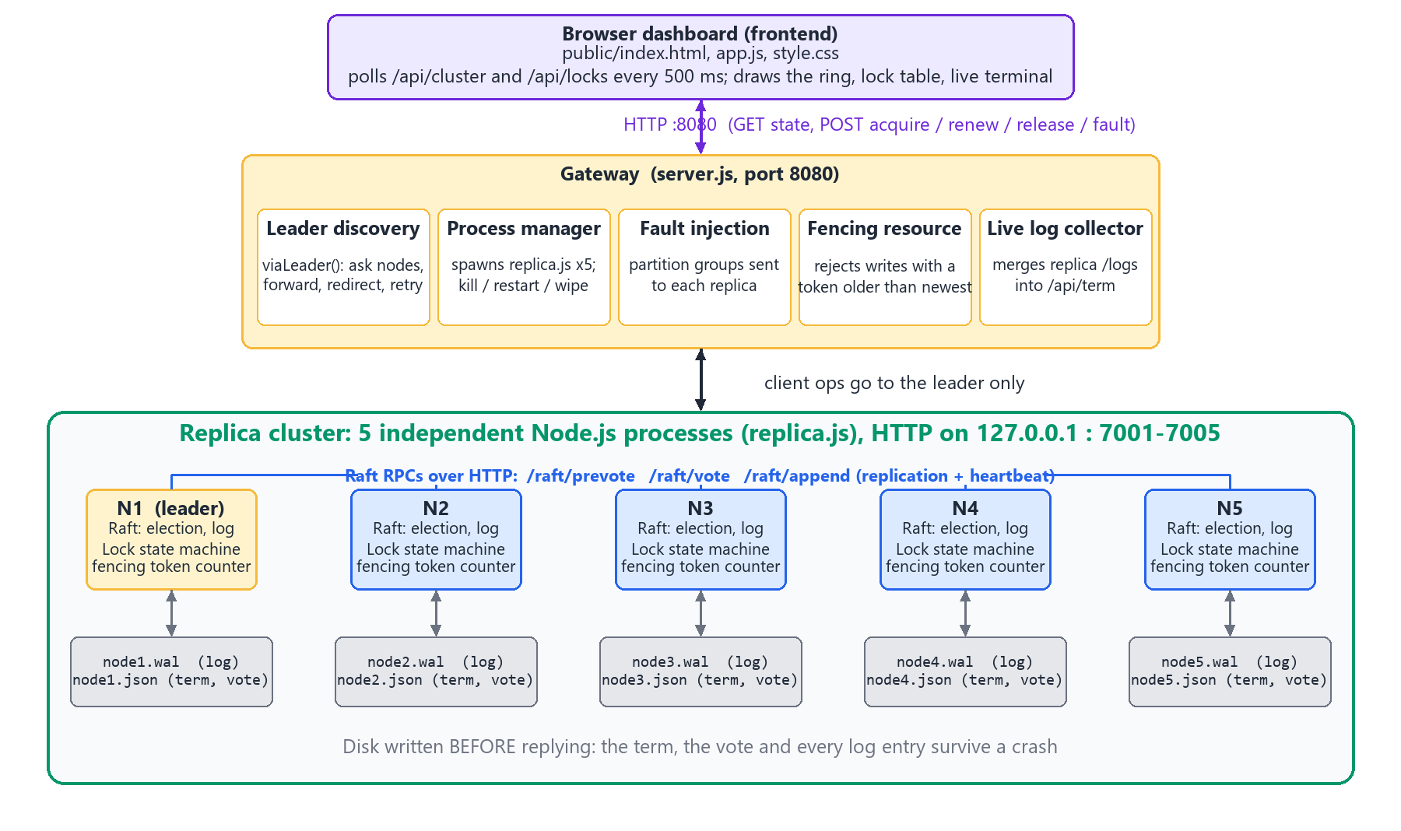
Figure 1: Architecture: clients, gateway, five replicas and their disks

Step 2: Replica skeleton: an HTTP server per replica
Create replica.js. Each replica is a small Node.js HTTP server started as node replica.js <id> <clusterSize> <dataDir>. It exposes /raft/* endpoints for other replicas, /client/* endpoints for lock requests, and /admin/* endpoints for crash, start and wipe. Peers are found from the BASE_PORT (default 7000 + id) or from the NODE_ADDRS variable.
Files: mini-project/replica.js
Check that it works: start one replica with node replica.js 1 5 ./data and open http://localhost:7001/status in a browser; it should return JSON describing the replica.

Step 3: Persistence: write-ahead log and term/vote file
A replica must survive a crash without forgetting. Every log entry is appended to nodeN.wal, and the current term and the vote it cast are saved in nodeN.json using write-to-temp-file then atomic rename. With DURABLE=1 each write is also forced to disk (fsync). On start-up the replica reloads both files.
Files: replica.js (persistence functions)
Check that it works: start a replica, stop it, start it again; the term and log must be the same as before.

Step 4: Raft leader election
Add the three roles (follower, candidate, leader) and the election timer. A follower that hears nothing for a random 600 to 1100 ms becomes a candidate, raises its term and sends RequestVote to the others. A candidate that gets 3 of 5 votes becomes leader and sends heartbeats every 120 ms. A vote is only given to a candidate whose log is at least as up to date. Two improvements are added: pre-vote (ask "would you vote for me?" before raising the term, so a partitioned replica cannot disrupt a healthy cluster) and check-quorum (a leader that cannot reach a majority for 1500 ms steps down).
Files: replica.js (election code, RequestVote, AppendEntries heartbeat)
Check that it works: start five replicas; within about a second exactly one reports leader, the others follower. Kill the leader; another is elected within about 1 to 2 s.
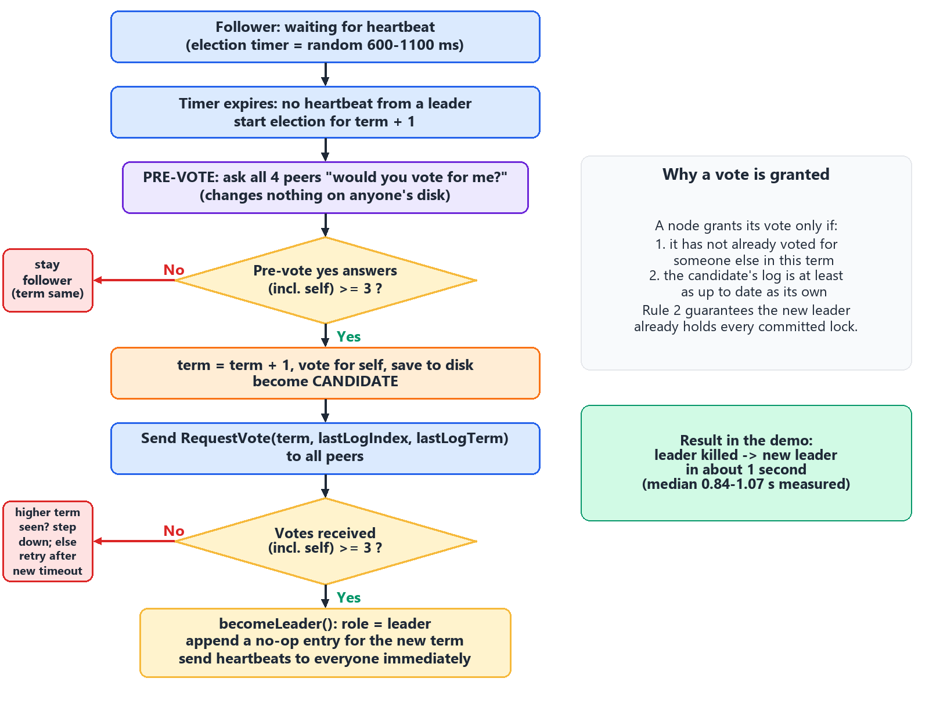
Figure 2: Leader election flow (timeout, candidate, votes, leader)

Step 5: Log replication and commit
The leader appends each new command to its log and sends it to the followers with AppendEntries. Once the entry is stored on a majority (3 of 5), it is committed and may be applied. Followers whose log differs are repaired by the leader (it backs up to the last matching entry and resends). A new leader writes a no-op entry in its own term so it can commit older entries safely.
Files: replica.js (AppendEntries, commit index, apply loop)
Check that it works: send a command; every replica ends up with the same log length (visible on the dashboard).
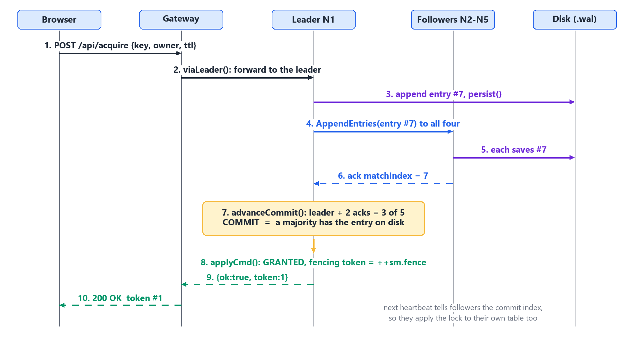
Figure 3: A write is committed once a majority has stored it

Step 6: The lock state machine
On top of the committed log add the lock table: acquire, renew, release and a sweep that expires leases. Each acquire either fails (someone else holds it) or succeeds and returns a fencing token, a counter that only ever increases. The current time is stamped into the command by the leader, so every replica makes the same decision (the state machine is deterministic).
Files: replica.js (apply function)
Check that it works: acquire a lock as client A (granted, token 1), try as client B (refused, shows the holder), release, acquire as B (granted, token 2).

Step 7: Client API with leader redirect
A client may talk to any replica. A follower answers with the current leader, and only the leader accepts writes. A write returns to the client only after the entry is committed and applied, or fails after the 3 s operation timeout.
Files: replica.js (/client/*)
Check that it works: send an acquire to a follower and check you are pointed to the leader.

Step 8: Gateway and process manager
Create server.js. It starts the five replicas as child processes (or, in remote mode, talks to replicas listed in REMOTE_NODES), finds the current leader and retries on failure (viaLeader), exposes a single JSON API on port 8080, serves the dashboard from public/, merges the replicas' logs into one live event stream, and optionally protects everything with BASIC_AUTH.
Files: mini-project/server.js
Check that it works: node server.js --fresh then curl http://localhost:8080/api/cluster shows five nodes and one leader.

Step 9: Fault injection
Add endpoints that let you break the system on purpose: kill a replica, restart it, wipe its disk, and create a network partition between groups of replicas. A partition is implemented by telling each replica which peers it must ignore, so it behaves like a real broken network.
Files: server.js (/api/fault/*), replica.js (/admin/*)
Check that it works: kill the leader through the API and watch a new leader appear; partition into [1,2,3] and [4,5] and see only the 3-node side keep working.
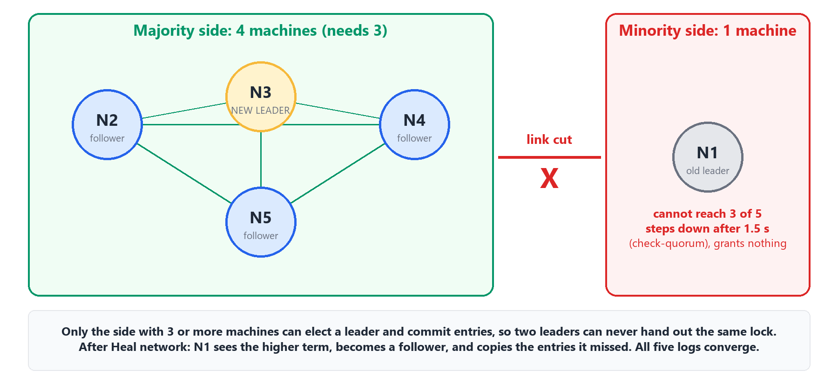
Figure 4: A partition: only the majority side can commit

Step 10: Protected resource and fencing tokens
Add a demo "protected resource" that rejects a write whose token is older than the newest token it has seen. This shows why leases alone are not enough: a paused client that wakes up after its lease expired still believes it has the lock, but its old token is refused.
Files: server.js (/api/resource, /api/resource/write)
Check that it works: write with token 2, then try token 1; the second write must be rejected.
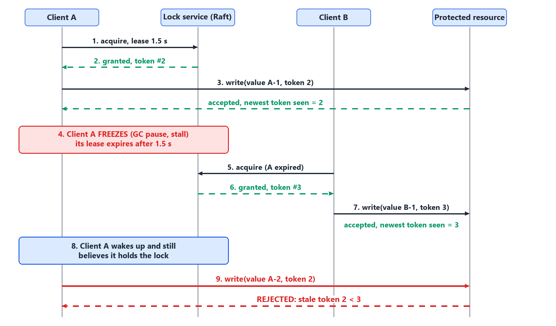
Figure 5: Fencing token rejecting a stale writer

Step 11: Web dashboard
Build the dashboard in public/: the Cluster section (five node cards with role, term and log length), the Lock client card (Acquire, Renew, Release, Write with token), the Held locks table, the Break things buttons (Crash the leader, Isolate leader, Split 3 | 2, Heal network, Restart N1 to N5), the Fencing section with the protected resource and the automatic demo, the Live backend terminal and the Event log. It calls the gateway API and refreshes every few hundred milliseconds.
Files: public/index.html, app.js, style.css, ui.css
Check that it works: open http://localhost:8080 and see five green node cards with one marked leader.
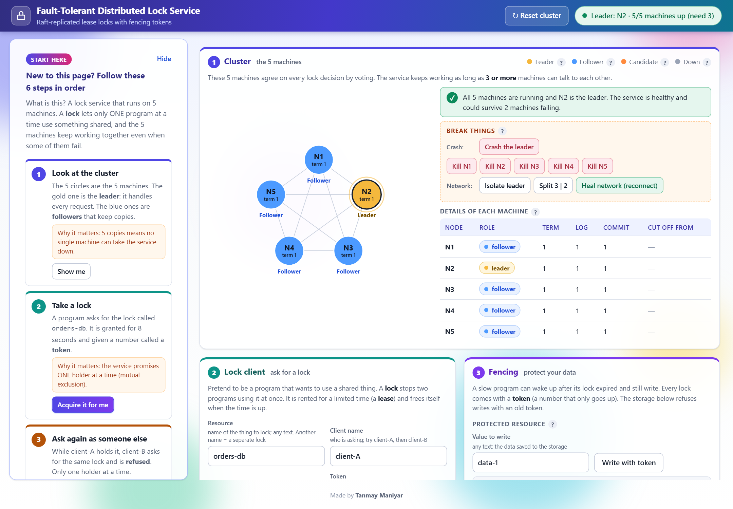
Figure 6: The finished dashboard (healthy cluster)

Step 12: Automated tests, chaos test and benchmark
test.js runs 12 end-to-end tests (election, mutual exclusion, lease expiry, renew, fencing, leader failover, partition, wipe, restart durability and others). test-chaos.js runs clients that fight for locks while random faults are injected, and checks that no two clients ever held the same lock at once. bench.js measures latency and throughput with 1, 8 and 32 clients.
Files: test.js, test-chaos.js, bench.js
Check that it works: npm test prints 12 PASS lines; npm run chaos:quick ends with all checks passing (see Part B4).
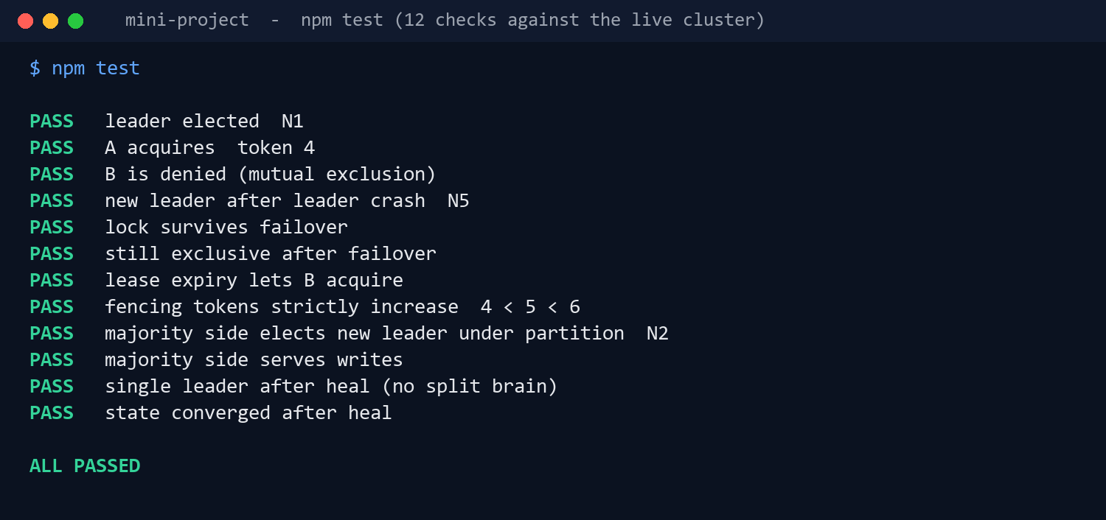
Figure 7: Output of npm test

Step 13: Package scripts
Put short names in package.json so the system is easy to run. There are no dependencies and the engines field requires Node 18 or newer.
Files: mini-project/package.json
Check that it works: npm run lists the scripts.
"scripts": {
"start": "node server.js",
"fresh": "node server.js --fresh",
"demo": "node server.js --fresh --open",
"test": "node test.js",
"chaos": "node test-chaos.js",
"chaos:quick":"node test-chaos.js --quick",
"bench": "node bench.js",
"docker": "docker compose up --build"
}

Step 14: Containers and the Virtual Lab
Add a Dockerfile (based on node:22-alpine) and docker-compose.yml that runs five replica containers plus the gateway on a private network with one volume per replica; only port 8080 is published. Separately, build vlab/: sim.js re-implements the same Raft and lock logic in the browser with an in-memory network, and six experiment pages (leases, election, replication, partitions, fencing, crash recovery) each have Aim, Theory, Pretest, Procedure, Simulation, Posttest, References and Feedback.
Files: Dockerfile, docker-compose.yml, vlab/*
Check that it works: docker compose up --build serves the dashboard on port 8080; python -m http.server 8099 --directory vlab serves the lab on port 8099.
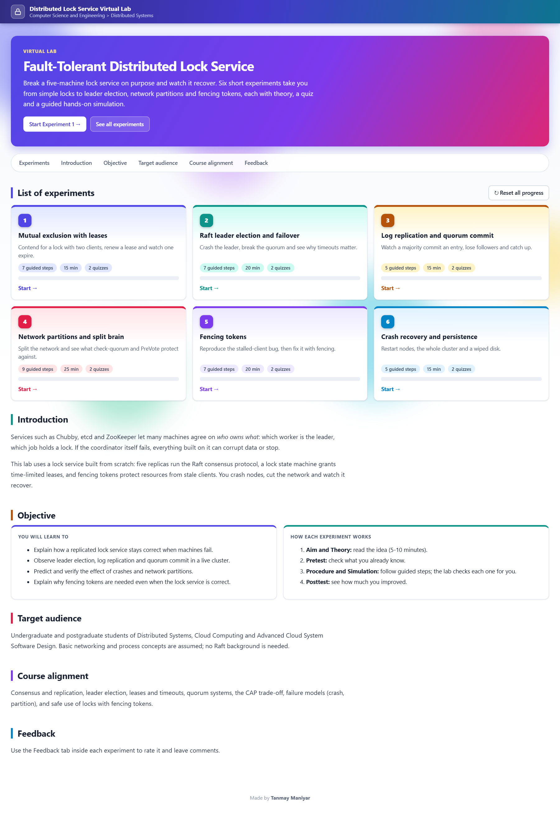
Figure 8: Virtual Lab home page

A4. Build-time checklist
# | Checkpoint | Done when
1 | Single replica starts | It answers on its port
2 | Five replicas elect one leader | One leader, four followers
3 | Leader crash recovers | New leader in about 1 to 2 s
4 | Replication | All nodes show the same log length
5 | Mutual exclusion | Second client is refused while the first holds the lock
6 | Durability | After a restart a lock and its term are still there
7 | Fencing | Stale token is rejected by the resource
8 | Tests | npm test: 12 of 12 pass
9 | Chaos test | No overlapping holders, all checks pass

Part B: Deployment cookbook (using the GitHub repository)
This part is for anyone who only has the repository link. Follow the sections in order; each one ends with a short check so you know it worked. The simplest path is B1, B2 and B3.

B1. Get the code
- Install Node.js 18 or newer and Git (see A1).
- Open a terminal in the folder where you want the project and clone the repository:
git clone https://github.com/TanmayManiyar/dist-lock-service.git
cd dist-lock-service
If you do not want to use Git, open the repository page in a browser, press the green Code button and choose Download ZIP, then extract it. Check the branch: the finished project is on master.
Check: dir mini-project (Windows) or ls mini-project shows server.js, replica.js and package.json.

B2. Run the lock service locally (no installation of packages)
- Go into the project folder:
cd mini-project
- Start a fresh cluster. This launches the gateway on port 8080 and five replicas on ports 7001 to 7005, all on your computer:
npm run fresh # or: node server.js --fresh
--fresh deletes old data and starts clean. Use npm start instead to keep earlier data. npm run demo does the same as fresh and also opens the browser.
- Open http://localhost:8080 in your browser.
Check: the terminal shows messages about elections and a leader. The browser shows five node cards, one of them marked LEADER. You can also run curl http://localhost:8080/api/cluster in a second terminal.

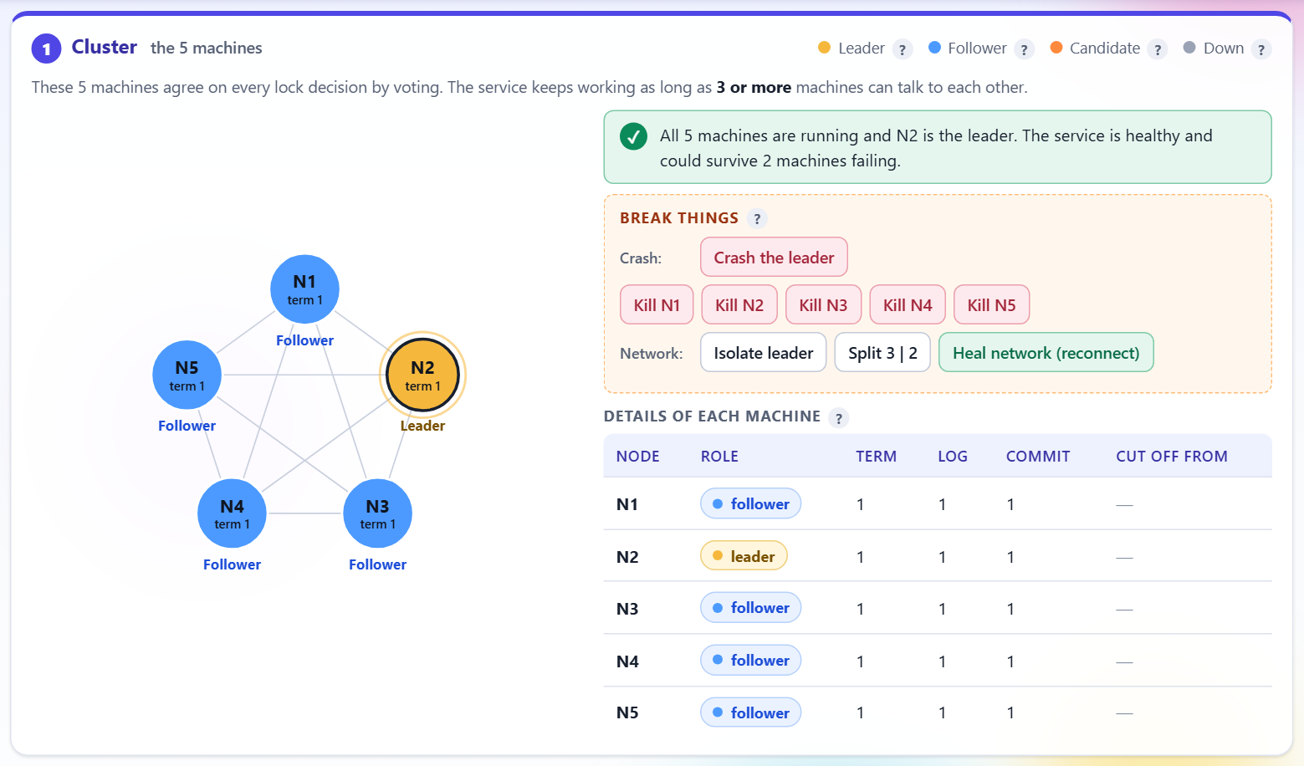
Figure 9: Healthy cluster: five nodes up, one leader
If port 8080 is busy: start on other ports. PowerShell: $env:PORT=8090; $env:BASE_PORT=7100; npm run fresh. Command Prompt: set PORT=8090 && set BASE_PORT=7100 && npm run fresh. Then open http://localhost:8090.

To stop the service, press Ctrl + C in the terminal that is running it. This also stops the five replica processes.

B3. Use the dashboard (a 5-minute walk-through)
Step | What to do | What you should see
1 | In the Lock client card, enter resource printer, client A, press Acquire | Granted, with fencing token 1 and a lease countdown
2 | Change the client name to B and press Acquire again | Refused: the lock is held by A (only one holder at a time)
3 | Press Crash the leader (Break things) | Within about 1 to 2 s another node becomes leader; the lock held by A is still there
4 | Press Restart N<id> for the crashed node | It rejoins as a follower and catches up its log
5 | Press Split 3 | 2 | The 3-node side keeps working; the 2-node side cannot commit
6 | Press Heal network (reconnect) | All five nodes agree again
7 | Press Run the fencing demo (or use Write with token with a newer and then an older token) | The older token is rejected by the protected resource

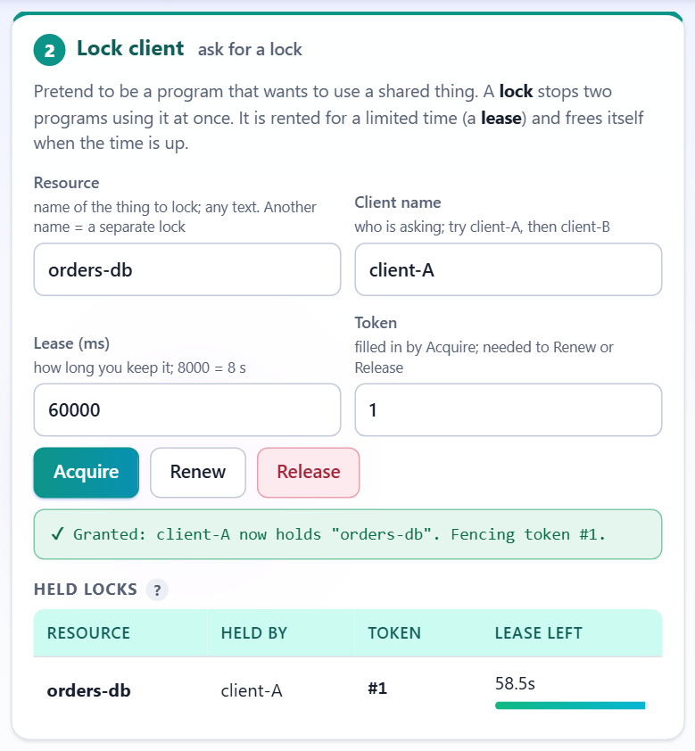
Figure 10: Lock granted with a fencing token
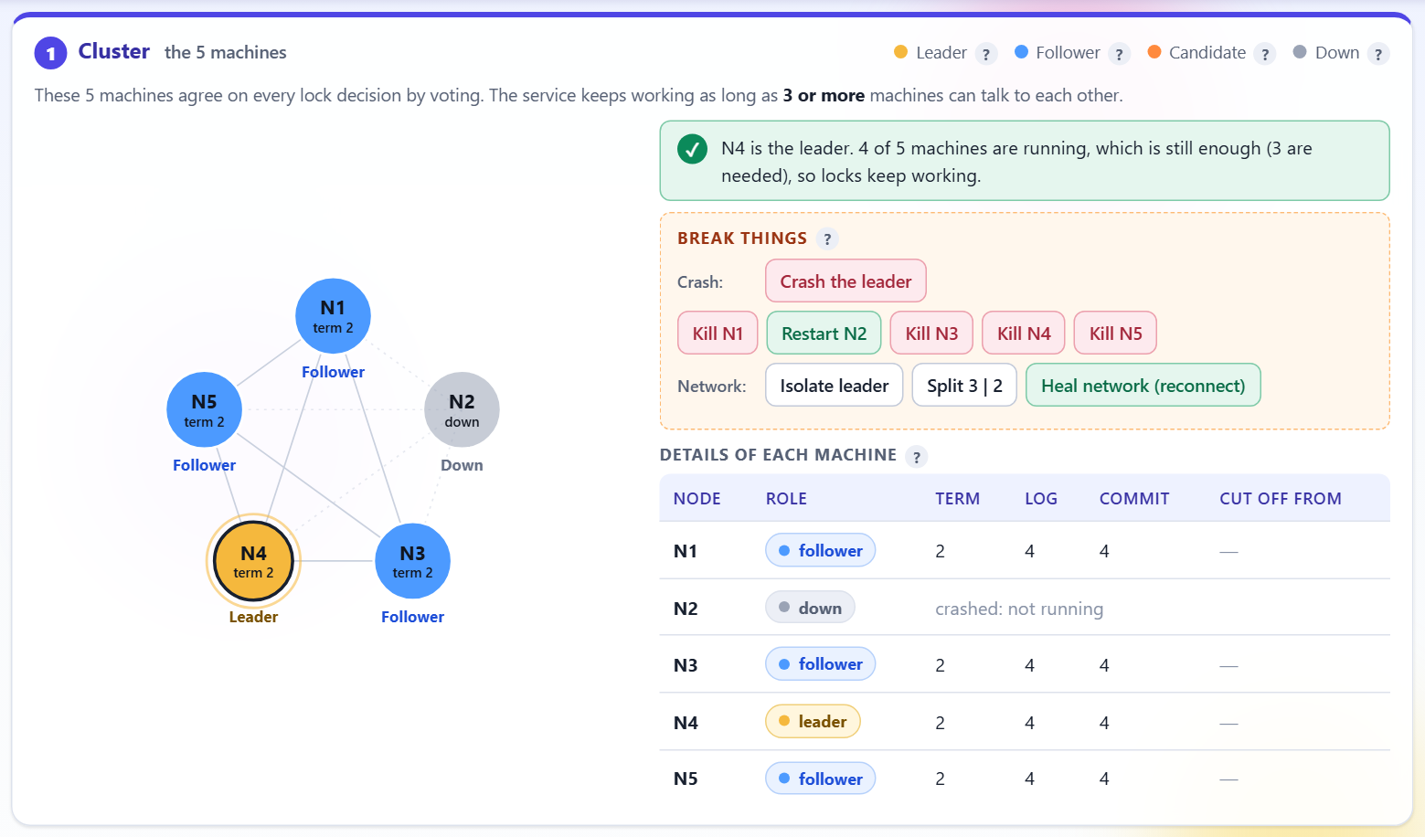
Figure 11: Leader crashed and a new leader elected
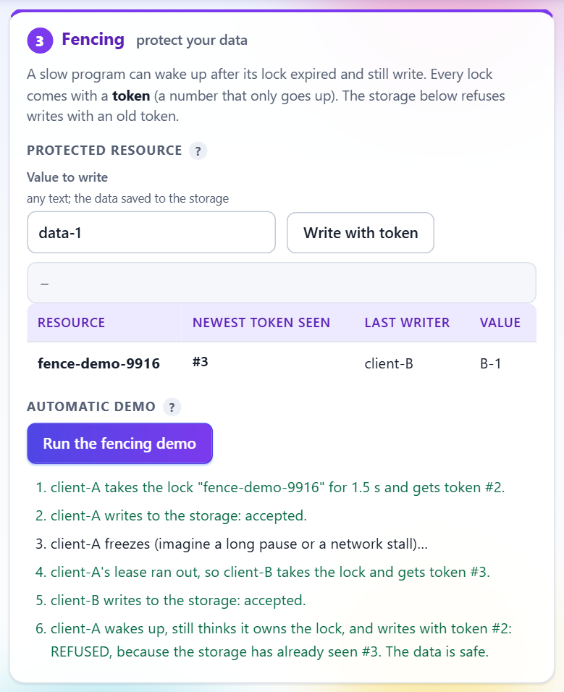
Figure 12: Fencing demo: stale token rejected

B4. Run the automated checks
Keep the service running on port 8080, open a second terminal in mini-project and run:
npm test # 12 end-to-end tests
npm run chaos:quick # short randomised fault-injection test
npm run chaos # longer run
npm run bench # latency and throughput (takes a while)
Check: npm test finishes with 12 lines marked PASS. npm run chaos:quick ends with ALL CHECKS PASSED, including the check that no two clients held the same lock at the same time.

Important: npm test connects to port 8080 and restores the cluster at the end, but it creates a few test locks and injects faults. Run it on a fresh cluster, not one you are using for a demonstration.

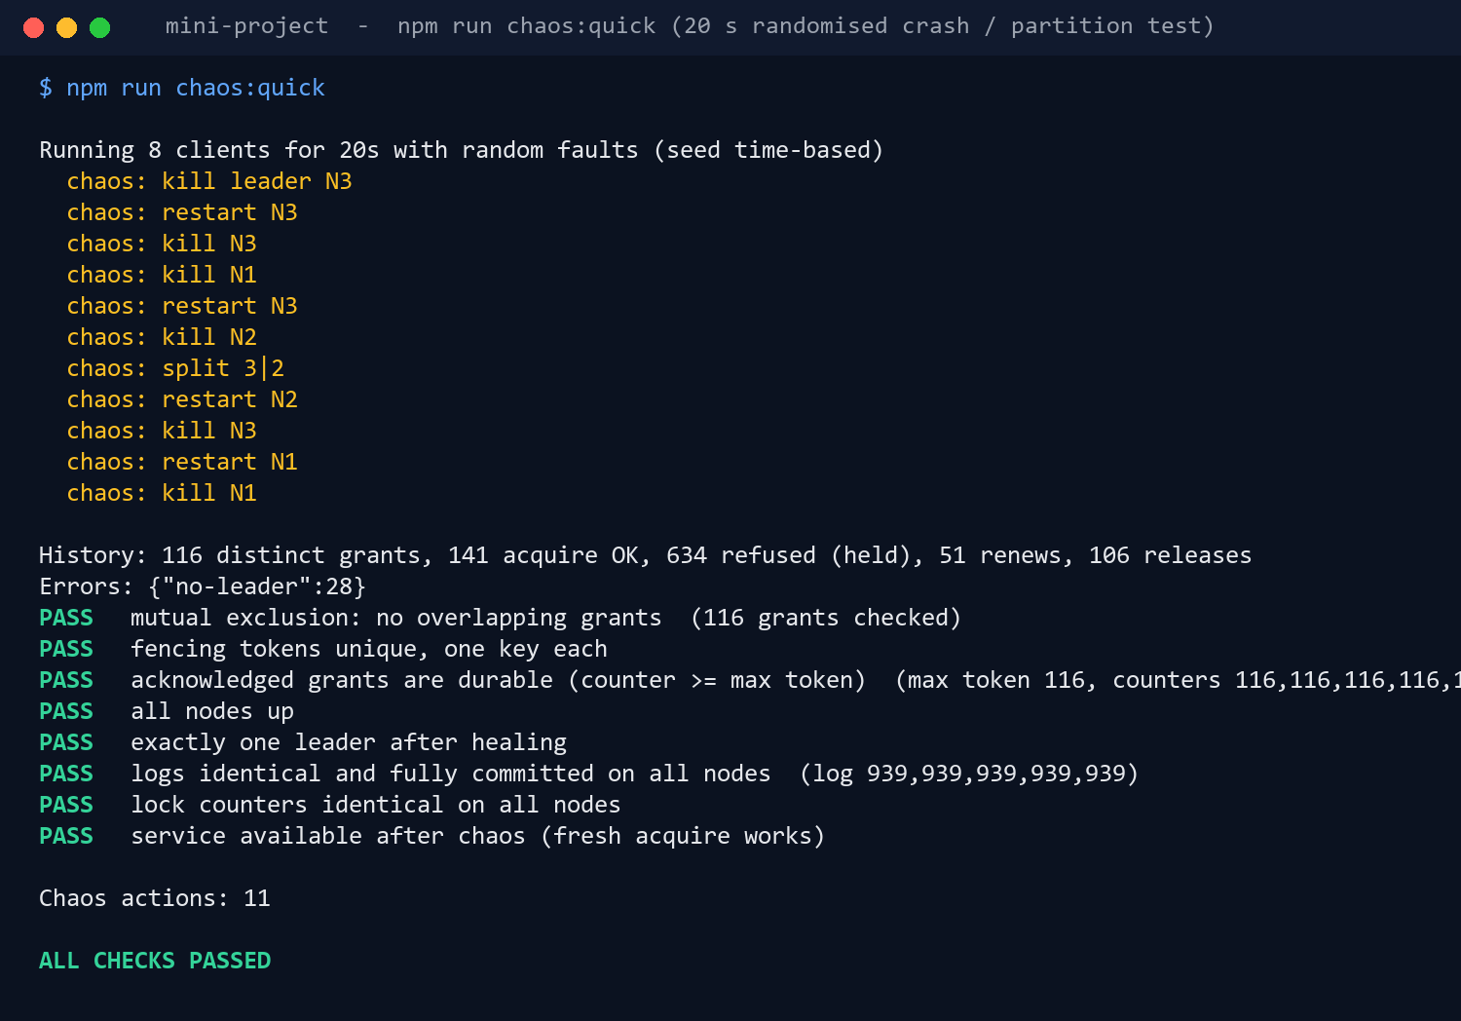
Figure 13: Output of the chaos test

B5. Run with Docker Compose (replicas as containers)
This runs the five replicas and the gateway as six containers on a private network. Only the gateway is reachable from outside, like a small private cloud network. Docker Desktop must be running.
cd mini-project
docker compose up --build
Open http://localhost:8080. Each replica has its own named volume (its disk), so a restart really reloads term, vote and log from disk:
docker compose restart node3 # restart one replica
docker compose restart # restart all five; locks survive
docker compose down # stop (keeps data volumes)
docker compose down -v # stop and delete data
To password-protect the dashboard and the fault-injection API set BASIC_AUTH:
# PowerShell
$env:BASIC_AUTH="lab:choose-a-password"; docker compose up --build
# Linux / macOS
BASIC_AUTH=lab:choose-a-password docker compose up --build
In Docker each replica runs with DURABLE=1, so every write is flushed to disk before it is acknowledged.

B6. Run the Virtual Lab
The Virtual Lab is a separate product with no server: the cluster is simulated inside the browser. Serve the vlab folder with any static server. Two ways:
cd vlab
python -m http.server 8099 # needs Python
# or
npm start # needs Node.js; runs: npx --yes serve . -l 8099
Open http://localhost:8099; it redirects to the lab home. Choose an experiment and go through Aim, Theory, Pretest, Procedure, Simulation, Posttest, References and Feedback.
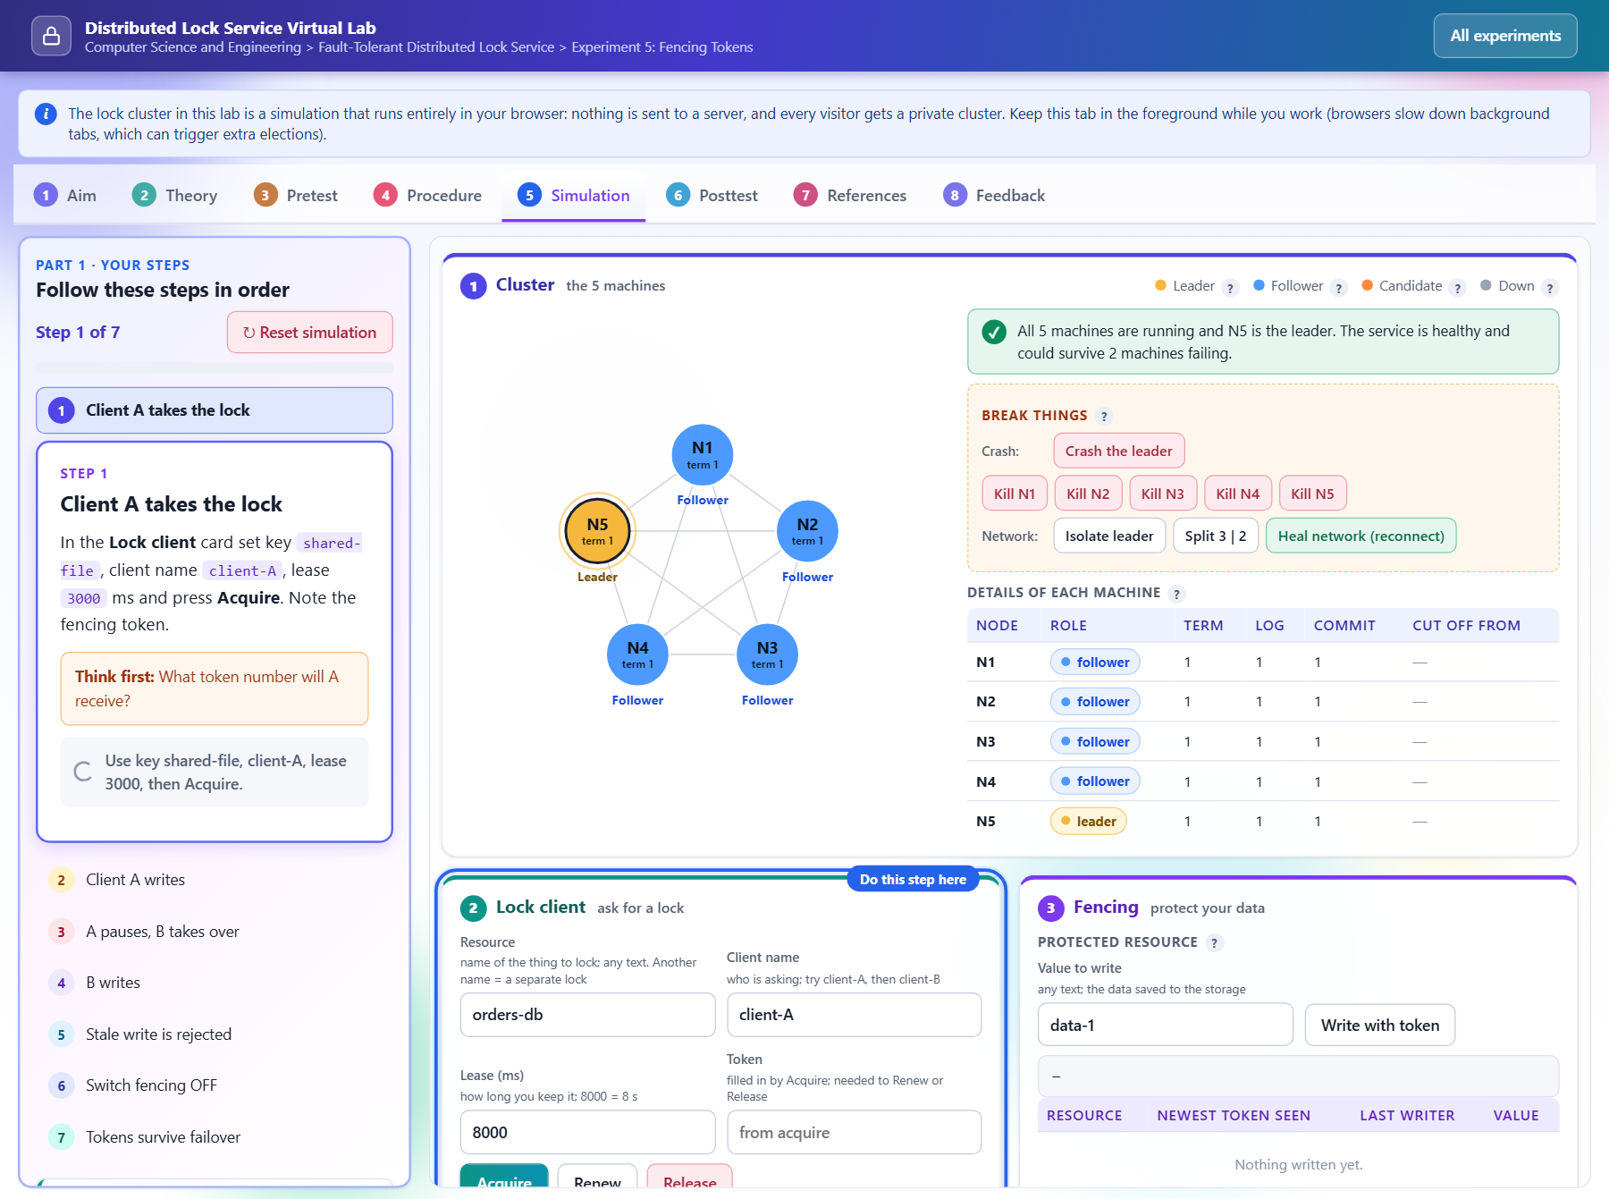
Figure 14: Experiment 5 (fencing tokens) simulation tab

Publishing the Virtual Lab on the internet (Vercel)
- Push the repository to GitHub (already done).
- On vercel.com choose Add New, Project and import dist-lock-service.
- Set Root Directory to vlab. Leave the build command empty (there is no build step).
- Press Deploy. Vercel gives a public link to the lab.
Or from the command line, inside the vlab folder: npx vercel deploy --prod.

B7. Deploy on cloud virtual machines (AWS layout)
Status: this section follows mini-project/docs/DEPLOYMENT.md. It was written from the design and has not been run on a real AWS account. The Docker Compose route in B5 is the tested deployment.

The same code runs on separate machines. The only difference is how replicas find each other, using environment variables:
Variable | Used by | Meaning
NODE_ADDRS | replica | List of all replicas, e.g. 1=10.0.1.11:7001,2=10.0.2.12:7001,...
NODE_HOST | replica | Network interface to listen on (0.0.0.0 on a VM)
DURABLE=1 | replica | Force every write to disk (production setting)
REMOTE_NODES | gateway | Same list as above; makes the gateway use remote replicas
BASIC_AUTH=user:pass | gateway | Password for the dashboard and API
PORT, BASE_PORT, DATA_DIR | both | Gateway port, local replica base port, data folder

- Create a VPC with private subnets in three availability zones and a public subnet for the gateway.
- Create 5 virtual machines (for example t3.small) spread across the zones; install Node.js and copy replica.js and package.json onto each.
- Allow port 7001 between replicas and the gateway only (security group); keep replicas off the public internet.
- On each VM set the environment above and run node replica.js <id> 5 /var/lib/lock (a systemd service with Restart=always is given in the deployment guide).
- On the gateway machine set REMOTE_NODES and BASIC_AUTH and run node server.js. Put a load balancer with HTTPS in front.
- Verify with curl -u lab:pass https://<address>/api/cluster: five nodes up, one leader.
Security: the replica API has no login and no encryption. Never expose ports 7001 to the internet. Always set BASIC_AUTH on a public gateway, because the dashboard can crash and wipe nodes.

B8. Troubleshooting
Problem | Cause | Fix
node is not recognized | Node.js not installed or terminal not restarted | Install Node.js, reopen the terminal, run node -v
EADDRINUSE / port 8080 already in use | Another copy of the service or another program uses the port | Stop it, or use PORT and BASE_PORT as shown in B2
npm run says script missing | Terminal is in the wrong folder | cd mini-project (scripts are in that folder's package.json)
Dashboard blank or "cannot reach server" | Service not running | Check the terminal for errors; restart with npm run fresh
No leader appears | Fewer than 3 replicas running, or a partition is active | Press Heal network (reconnect) and restart killed nodes
Old locks or terms appear after restart | npm start keeps data | Use npm run fresh or delete the data/ folder
Docker build fails | Docker Desktop not running | Start Docker Desktop, rerun docker compose up --build
Windows blocks npm.ps1 | PowerShell script policy | Use Command Prompt, or run node server.js --fresh directly
Tests fail right after a manual demo | Leftover locks or partitions | Restart with npm run fresh and rerun npm test

B9. Command cheat sheet
Goal | Command (from `mini-project/` unless stated)
Clone | git clone https://github.com/TanmayManiyar/dist-lock-service.git
Start clean cluster | npm run fresh
Start and open browser | npm run demo
Keep previous data | npm start
Stop | Ctrl + C
12 tests | npm test
Chaos test (short / long) | npm run chaos:quick / npm run chaos
Benchmark | npm run bench
Docker | docker compose up --build; stop with docker compose down
Virtual Lab (from vlab/) | python -m http.server 8099 or npm start
Dashboard / lab address | http://localhost:8080 / http://localhost:8099

