 | VIVEKANAND EDUCATION SOCIETY’S INSTITUTE OF TECHNOLOGY  DEPARTMENT OF COMPUTER ENGINEERING

MICRO PROJECT REPORT
Project Title : Fault-Tolerant Distributed Lock Service (Raft consensus, leases and fencing tokens)
SDG Aligned & Logo : SDG 9 (Industry, Innovation and Infrastructure); SDG 4 (Quality Education)
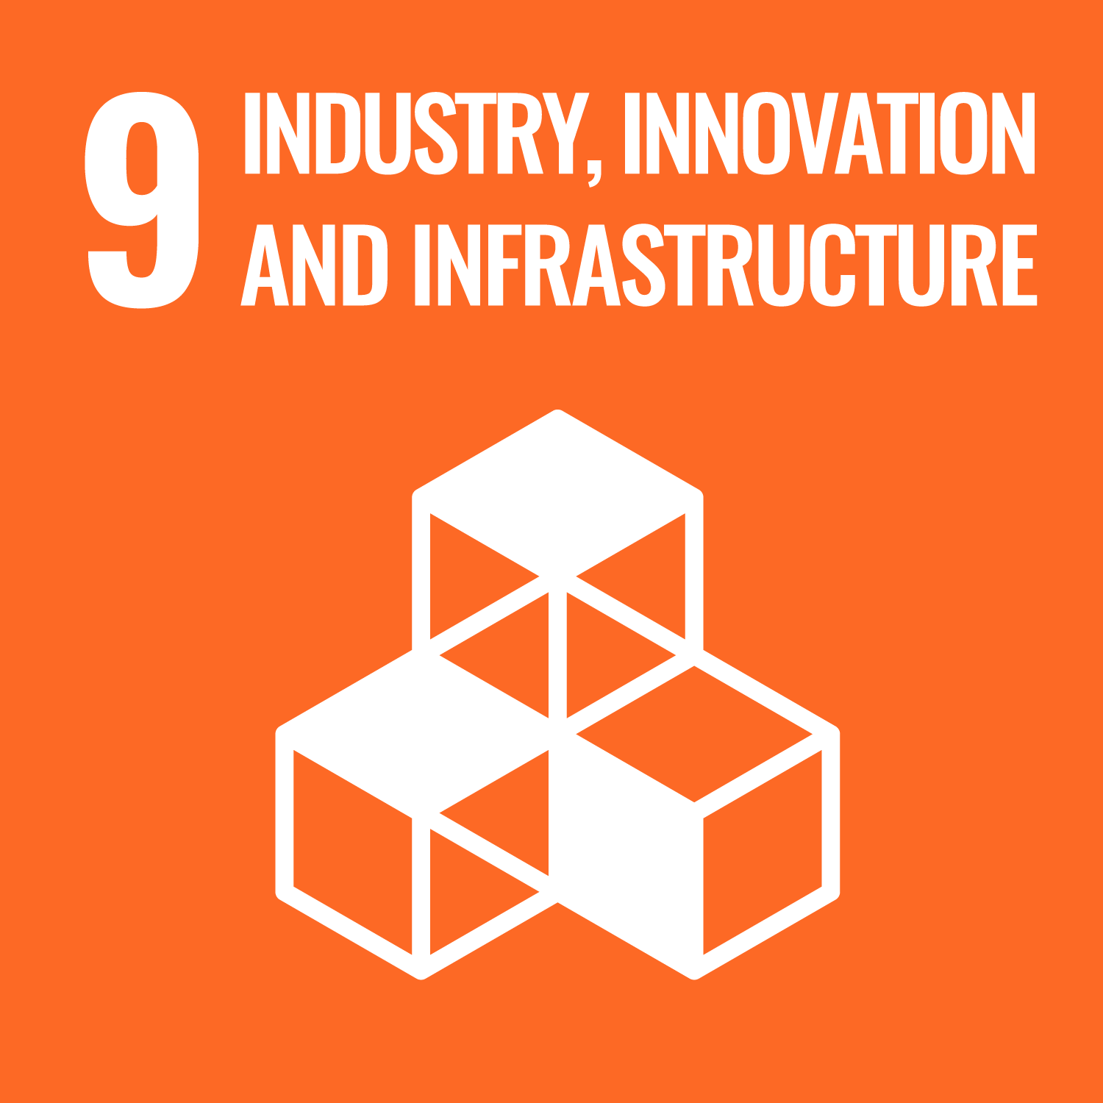

Project / Course Details | To be filled by students
Course / Subject Name | Software System Design
Course Code / Semester / Academic Year | 26CMPE52 / V / 2026-27
Faculty Incharge / Project Mentor | Mrs. Priya R.L.
Project Group No. (if applicable) | 13
Submission Date

Project Team Details
Student Name | Roll No. | Class / Division | Institute Email ID
Tanmay Maniyar | 33 | D12A | 2024.tanmay.maniyar@ves.ac.in

Department of Computer Engineering
Academic Year: 2026-27

Table of Contents
Abstract 4
1. Introduction 4
1.1 Background and Motivation 4
1.2 Problem Context 4
1.3 Intended Users / Stakeholders 5
2. Problem Definition, Objectives and Scope 5
2.1 Problem Statement 5
2.2 Objectives 5
2.3 Scope and Deliverables 6
2.4 Assumptions and Constraints 6
3. Background / Literature Review 6
3.1 Identified Gap and Project Contribution 7
4. Proposed Solution and System Design 7
4.1 Proposed Solution 7
4.2 System Architecture 7
4.3 Module Description 9
4.4 Data / Inputs / Dataset 9
4.5 Algorithm / Design Decisions 10
5. Methodology and Implementation 13
5.1 Workflow / Development Method 13
5.2 Technologies, Tools and Resources 13
5.3 Implementation Details 13
5.4 User Interface / Prototype / Output 14
5.5 Team Contribution 21
6. Testing, Evaluation and Results 21
6.1 Test Plan and Test Cases 21
6.2 Evaluation Metrics 23
6.3 Results and Discussion 24
6.4 Validation / Demonstration Evidence 24
7. Sustainability and SDG Alignment 25
7.1 Sustainability Assessment 25
7.2 UN Sustainable Development Goals (SDGs) 25
7.3 Sustainability Measures and Trade-offs 25
7.4 Sustainability Indicator / Follow-up 26
8. Feasibility, Limitations and Risk Considerations 26
8.1 Feasibility 26
8.2 Limitations 26
8.3 Risks, Ethics, Privacy and Security 26
9. Conclusion and Future Scope 27
9.1 Summary 27
9.2 Future Scope 27
References 28
Appendices 29
Appendix A: Additional screenshots / outputs 29
Appendix B: Selected pseudocode or code excerpts 31
Appendix C: Additional test cases 32
Appendix D: Repository / demo / deployment information 32
Note: if you edit the report, right-click the table of contents in Word and choose "Update Field" to refresh the page numbers.

Abstract
Programs that share a resource must take turns, and a lock service is the component that decides whose turn it is. A single lock server is itself a point of failure: if it crashes nobody can work, and if it errs two programs can enter the critical section together. This micro project designs, builds and evaluates a fault-tolerant distributed lock service in the style of Google Chubby and etcd. Five replica processes written in Node.js with no external libraries keep an identical log of lock operations using the Raft consensus algorithm: leader election with pre-vote, log replication, majority commit, check-quorum and a write-ahead log on disk. On top of the log sits a deterministic lock state machine that offers leases (locks that expire on their own) and strictly increasing fencing tokens, so that a client that was paused past its lease cannot damage the protected resource. A gateway finds the leader, retries safe operations, injects crashes, restarts and network partitions, and serves a browser dashboard with a live terminal that streams the real log lines of every process. The system was evaluated with 12 scripted fault-injection checks, a randomised 20-second chaos test that verified mutual exclusion over 116 grants, and benchmarks that measured about 31 ms per operation, up to about 4,300 committed operations per second and a failover time of roughly 0.8 to 1.1 seconds. All 12 checks and all 8 chaos checks passed in the runs reported here. A static Virtual Lab with six experiments, whose cluster is simulated in the browser, supports teaching. The project supports SDG 9 (resilient digital infrastructure) and SDG 4 (quality education).
Keywords: distributed systems, Raft consensus, distributed lock, lease, fencing token, fault tolerance, network partition.

1. Introduction

1.1 Background and Motivation
Modern applications run as many cooperating processes on many machines. Whenever two of them may change the same record, file or device, they need a way to take turns. A lock gives one process at a time the right to use the shared thing; this property is called mutual exclusion. On one computer the operating system provides locks. Across machines a separate service must provide them, and that service must keep working when machines crash or the network breaks.
This project applies core distributed-systems ideas to that problem: replication, consensus, leader election, quorums, failure detection with timeouts, durability through write-ahead logging, and the safe use of time through leases [2], [6]. It follows the design of production coordination services such as Chubby [2], ZooKeeper [4] and etcd [8], built on the Raft consensus algorithm [1].

1.2 Problem Context
The simplest design is one lock server. It is easy to build but it fails badly: when it crashes every client is blocked, and if it is restarted from stale data it may grant a lock that is already held. Copying the server to several machines creates a new problem, because the copies can disagree, and during a network split two of them may each believe they are in charge (split brain) and grant the same lock to different clients.
A second, subtler problem exists even with a correct lock service. A client can be paused for a long time (for example by a garbage-collection pause or a network stall) after it checked that it holds the lock. Its lease then expires, another client takes the lock, and when the first client wakes up it still writes to the shared resource [3]. The gap this project addresses is therefore a lock service that stays correct under crashes, partitions and slow clients, and that can be shown working, step by step, to a student or an examiner.

1.3 Intended Users / Stakeholders
- Application developers who need mutual exclusion or leader election between their own processes.
- Operators who must see which machine leads, what failed and how the cluster healed (the dashboard and the live terminal serve this need).
- Students and instructors of distributed systems, who use the guided dashboard and the Virtual Lab to see Raft behave.
- Course evaluators, who need evidence that each claim (safety, recovery, performance) is backed by a test or a measurement.

2. Problem Definition, Objectives and Scope

2.1 Problem Statement
Design and implement a lock service for client programs that (a) never grants the same lock to two clients at the same time, (b) keeps granting and releasing locks while up to two of five machines crash or while the network splits, (c) frees locks held by crashed clients automatically, and (d) gives resources a way to reject writes from clients that no longer hold the lock. The result must be observable (a dashboard and logs) and testable (automated fault-injection checks).

2.2 Objectives
Table 1: Project objectives and how each is verified
ID | Objective (measurable) | How it is verified
O1 | Design a 5-replica cluster that agrees on every lock operation through Raft. | Commit lines "stored on 3/5 nodes" in the live terminal; test TC-01 to TC-03
O2 | Implement leases and strictly increasing fencing tokens. | TC-07, TC-08; fencing demo; chaos check "tokens unique"
O3 | Elect a new leader automatically after a crash and keep committed locks. | TC-04 to TC-06; failover benchmark
O4 | Remain safe under network partitions and heal without split brain. | TC-09 to TC-12; partition screenshots
O5 | Persist term, vote and log so a restarted node recovers its state. | Disk lines in the terminal; chaos check "logs identical"
O6 | Evaluate latency, throughput and failover time, and test safety under random faults. | docs/BENCHMARKS.md; chaos test
O7 | Provide a dashboard with a live backend terminal and a Virtual Lab with six experiments. | Screenshots in Section 5.4

2.3 Scope and Deliverables
Included: the replica (Raft and lock state machine), the gateway, the dashboard, fault injection, the fenced resource, tests, a chaos test, benchmarks, deployment notes (Docker Compose and a multi-host option), and the Virtual Lab (a separate static website).
Excluded: log compaction and snapshots, changing the cluster membership while running, Byzantine (malicious) faults, TLS and user accounts, and a validated cloud deployment. These are listed again as limitations and future scope.
Deliverables: the working prototype (mini-project/), the Virtual Lab (vlab/), the test and benchmark scripts, the written design documents, a demo script, and this report.

2.4 Assumptions and Constraints
- Fault model: machines fail by crashing and may recover; messages may be lost or delayed but are not forged (crash-fault model, not Byzantine).
- Clocks: lease times are stamped by the leader into each command, so all replicas apply the same decision; the design assumes the leader's clock is reasonably accurate compared with the lease length.
- Environment: all five replicas run as local processes on one laptop and talk over loopback HTTP; partitions and crashes are injected in software. The code can be pointed at several hosts, but that was not tested for this report.
- Constraint: no third-party libraries; Node.js 18 or newer is the only requirement.
- Privacy: the system stores only lock names and client names that the user types; it holds no personal data.

3. Background / Literature Review
The design draws on the sources below. Each row says what the source contributes and how it shaped the project.
Table 2: Review of related work
Source / Year | Approach or Key Finding | Strength / Limitation | Relevance to This Project
Ongaro and Ousterhout, "In Search of an Understandable Consensus Algorithm", 2014 [1] | Raft: leader election, log replication and safety rules, split into small understandable parts. | Clear and complete; the paper leaves practical details (storage, client interface) to the implementer. | Basis of replica.js: terms, votes, AppendEntries, majority commit.
Burrows, "The Chubby Lock Service", 2006 [2] | Coarse-grained locks and small files on a 5-replica cell used by Google. | Proven in production; closed source. | Model for the service: 5 replicas, leases, a lock service used for coordination.
Hunt et al., "ZooKeeper", 2010 [4] | Wait-free coordination service with ordered updates and ephemeral nodes. | Very general; a heavy dependency for a small system. | Comparison point; shows why a focused lock API is simpler.
Kleppmann, "How to do distributed locking", 2016 [3] | A lease alone is unsafe because a paused client does not know it expired; use fencing tokens checked by the resource. | Practical argument; needs a resource that can check tokens. | Source of the fencing-token design and the stale-write demo.
Gray and Cheriton, "Leases", 1989 [6] | Time-limited grants let a server recover from failed clients without waiting forever. | Assumes bounded clock drift. | Locks are leases that expire and are swept through the log.
Ongaro, PhD dissertation, 2014 [5] | Extends Raft with refinements such as Pre-Vote and leaders stepping down when they lose their majority. | Detailed; some refinements add code. | Pre-vote and check-quorum are implemented and can be switched on and off.
etcd documentation [8] | A production key-value store that uses Raft for leases and locks. | Mature; hides most internals. | Reference for expected behaviour of leases and leader failover.

3.1 Identified Gap and Project Contribution
Production systems [2], [4], [8] are reliable but are large, and their internal behaviour is hidden from a learner. Teaching implementations of Raft often stop at election and replication and do not connect them to a lock service with leases and fencing. This project contributes a small, dependency-free, complete path from a click on a button to a committed lock, with every step visible in a live log, plus a way to break the system on purpose and a check that proves it stayed safe. This is an implementation and demonstration contribution, not a new algorithm.

4. Proposed Solution and System Design

4.1 Proposed Solution
The solution has three layers. Replicas (replica.js, five processes) run Raft and a lock state machine. The gateway (server.js) is the front door: it finds the leader, retries safely, starts and stops the replicas and injects faults. The dashboard (public/) is a single web page that polls the gateway every 500 ms and draws the cluster, the locks and the live terminal.
Workflow of a user: open the dashboard, look at the ring of five machines, acquire a lock as client-A, ask for it again as client-B and be refused, crash the leader and watch a new one take over with the lock intact, cut the network and watch only the majority side keep working, and finally run the fencing demo in which a stale write is rejected.

4.2 System Architecture
Figure 1 shows the components. The browser talks only to the gateway. The gateway talks to the replicas over HTTP on 127.0.0.1:7001 to 7005. The replicas talk to each other with three Raft messages (/raft/prevote, /raft/vote, /raft/append). Each replica owns two files on disk, a write-ahead log (nodeN.wal) and a small term-and-vote file (nodeN.json), written before the replica replies.
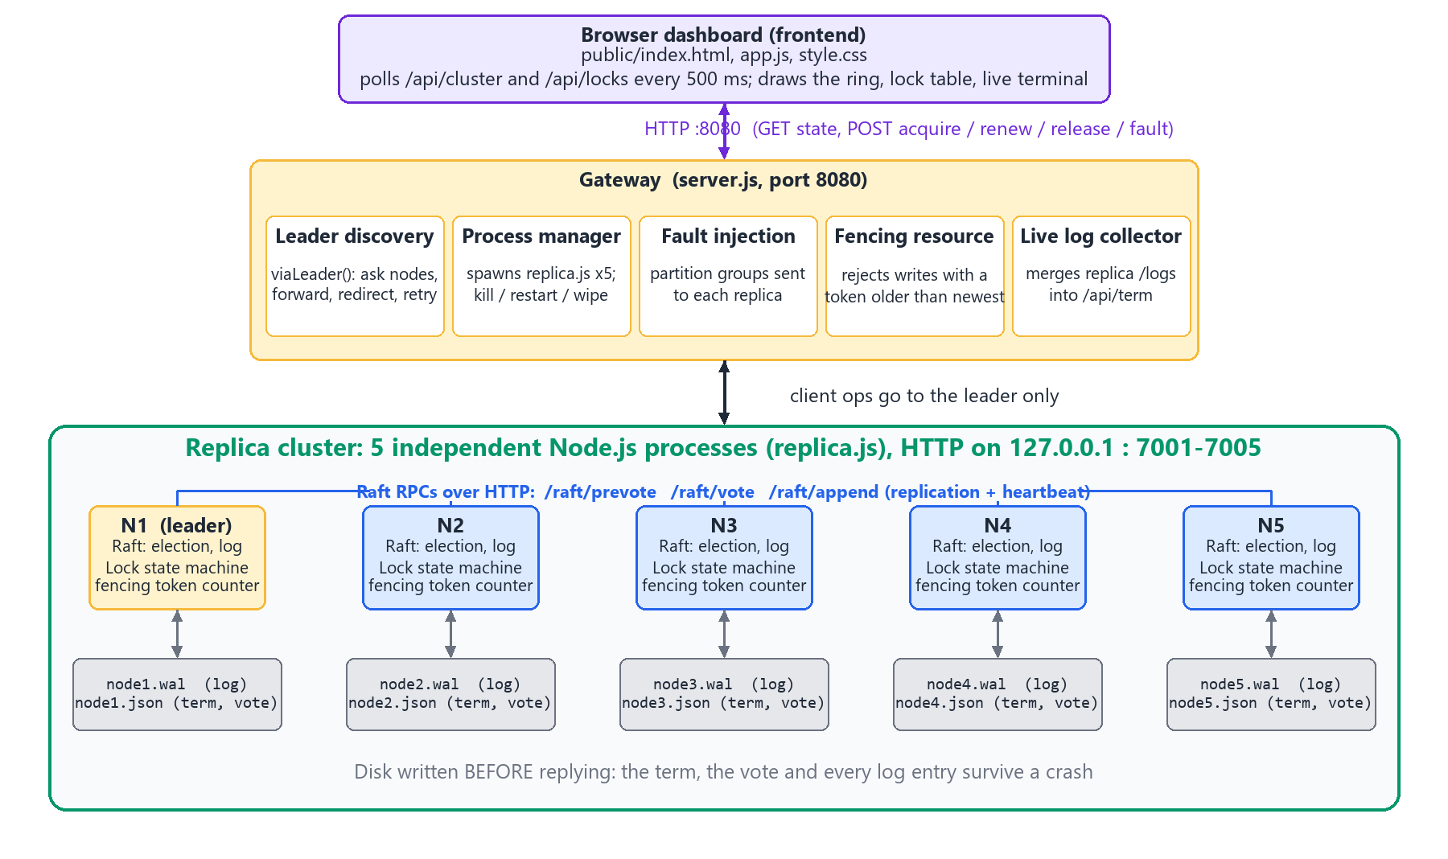
Figure 1: System architecture: browser, gateway and the five replica processes with their disk files
Every node is in one of three states (Figure 2). A node starts as a follower. If it hears no heartbeat for a random 600 to 1100 ms it becomes a candidate and asks for votes. With 3 of 5 votes (a majority) it becomes the leader. A leader that sees a higher term, or that cannot reach a majority for 1.5 s, steps down.
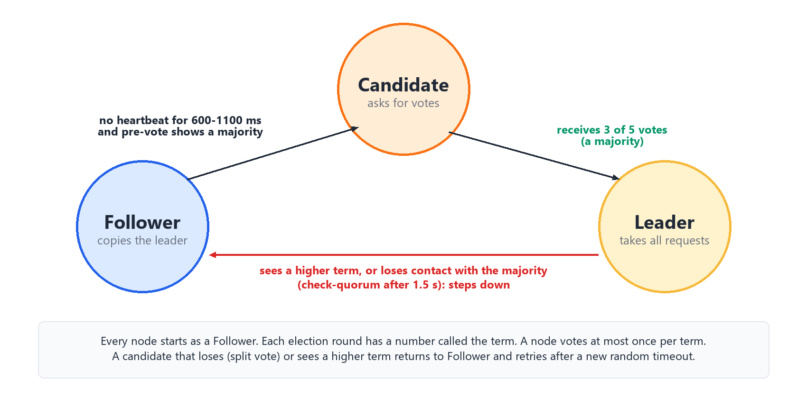
Figure 2: Raft node states and the events that move a node between them
Figure 3 follows one Acquire request. The leader writes the entry to its own disk, sends it to the four followers, and each follower saves it and acknowledges. When the leader has the entry on 3 of 5 machines the entry is committed; only then is the lock granted and the client answered. Any later leader is elected by at least 3 machines, and any 3 machines overlap with the 3 that stored the entry, so a committed lock is never lost.
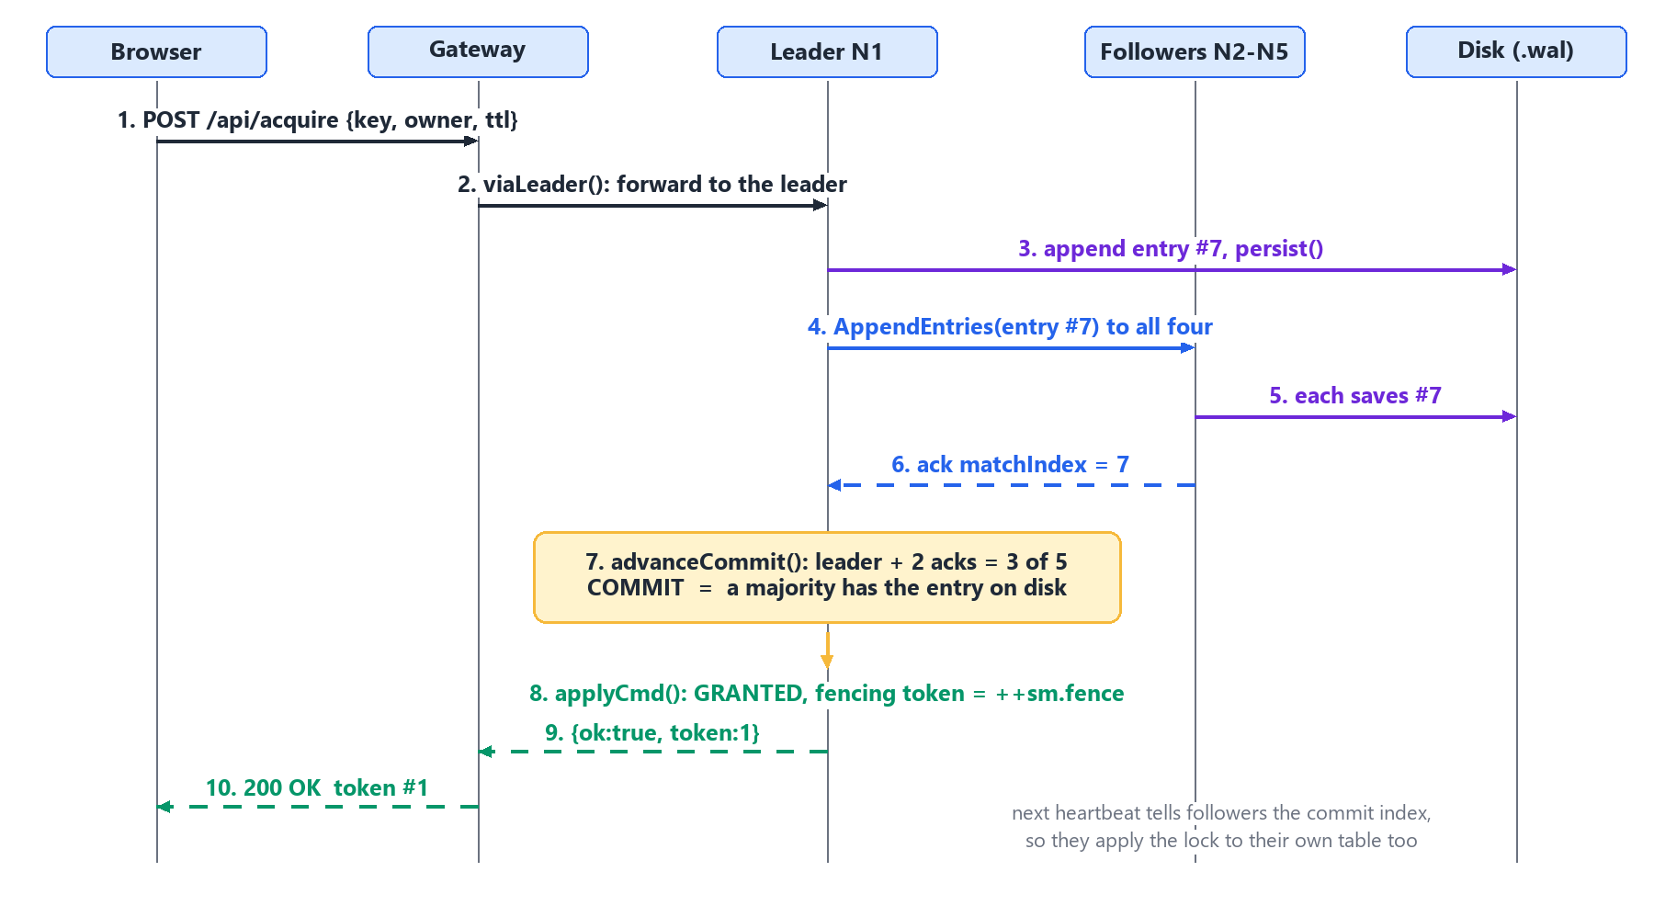
Figure 3: Life of one Acquire request: append, replicate, commit, apply, reply

4.3 Module Description
Table 3: Modules and their responsibilities
Module / Component | Responsibility | Input | Output
Replica: Raft (replica.js) | Election with pre-vote, log replication, majority commit, check-quorum, step-down. | Raft RPCs from peers; client commands from the gateway | Replicated, committed log; role and term
Lock state machine (applyCmd) | Applies acquire, renew, release and sweep deterministically; issues fencing tokens. | Committed log entries | Grant, refusal or expiry; token number
Persistence (persist, loadDisk) | Writes term, vote and log before replying; rebuilds state after a crash. | State changes | nodeN.wal, nodeN.json; recovered state
Gateway (server.js) | Finds the leader, forwards and retries, spawns and kills replicas, injects partitions, hosts the fenced resource, merges logs. | HTTP calls from the dashboard and test scripts | JSON answers; live log feed
Protected resource | Stores the highest token seen per key and rejects writes with an older token. | {key, token, owner, value} | Accepted or REJECTED stale-token
Dashboard (public/) | Draws the ring, role table, locks, fencing demo, live terminal and event log; has the "Break things" buttons. | Gateway JSON every 500 ms | The web page
Tests (test.js, test-chaos.js, bench.js) | Smoke and fault-injection checks, randomised safety test, benchmarks. | A running or self-started cluster | PASS/FAIL lines; BENCHMARKS.md
Virtual Lab (vlab/) | Six experiments with theory, quizzes and a guided simulation of the cluster in the browser. | Visitor actions | Explanations and simulated cluster

4.4 Data / Inputs / Dataset
The project uses no dataset. Its inputs are API requests and fault commands. A lock request carries a resource name (any text), a client name, a lease length (ttlMs, clamped to 500 to 120,000 ms, default 10,000) and, for renew and release, the fencing token returned by the grant. Test inputs are the scripted scenarios in test.js, the random schedule of crashes, restarts and partitions in test-chaos.js, and the client counts in bench.js. No personal or confidential data is processed.
Table 4: Gateway API summary
Endpoint (gateway, port 8080) | Method | Purpose
/api/acquire, /api/renew, /api/release | POST | Lock operations, forwarded to the leader
/api/cluster, /api/locks, /api/resource, /api/term | GET | Cluster state, held locks, protected resource, live log lines
/api/resource/write | POST | Write with a token; rejected if the token is older than the newest seen
/api/fault/kill, /restart, /wipe, /partition, /heal | POST | Fault injection
/api/config, /api/reset | GET/POST | Protocol switches (pre-vote, check-quorum, fencing); reset to a clean cluster

4.5 Algorithm / Design Decisions
Leader election
Figure 4 shows tryElection. A pre-vote round changes nothing on any disk and decides whether a real election is worthwhile. Only if 3 of 5 machines would vote does the node increase its term, vote for itself, save that to disk and ask for votes. A node grants a vote only if it has not voted for someone else in that term and the candidate's log is at least as up to date as its own; this guarantees that the winner already holds every committed lock.
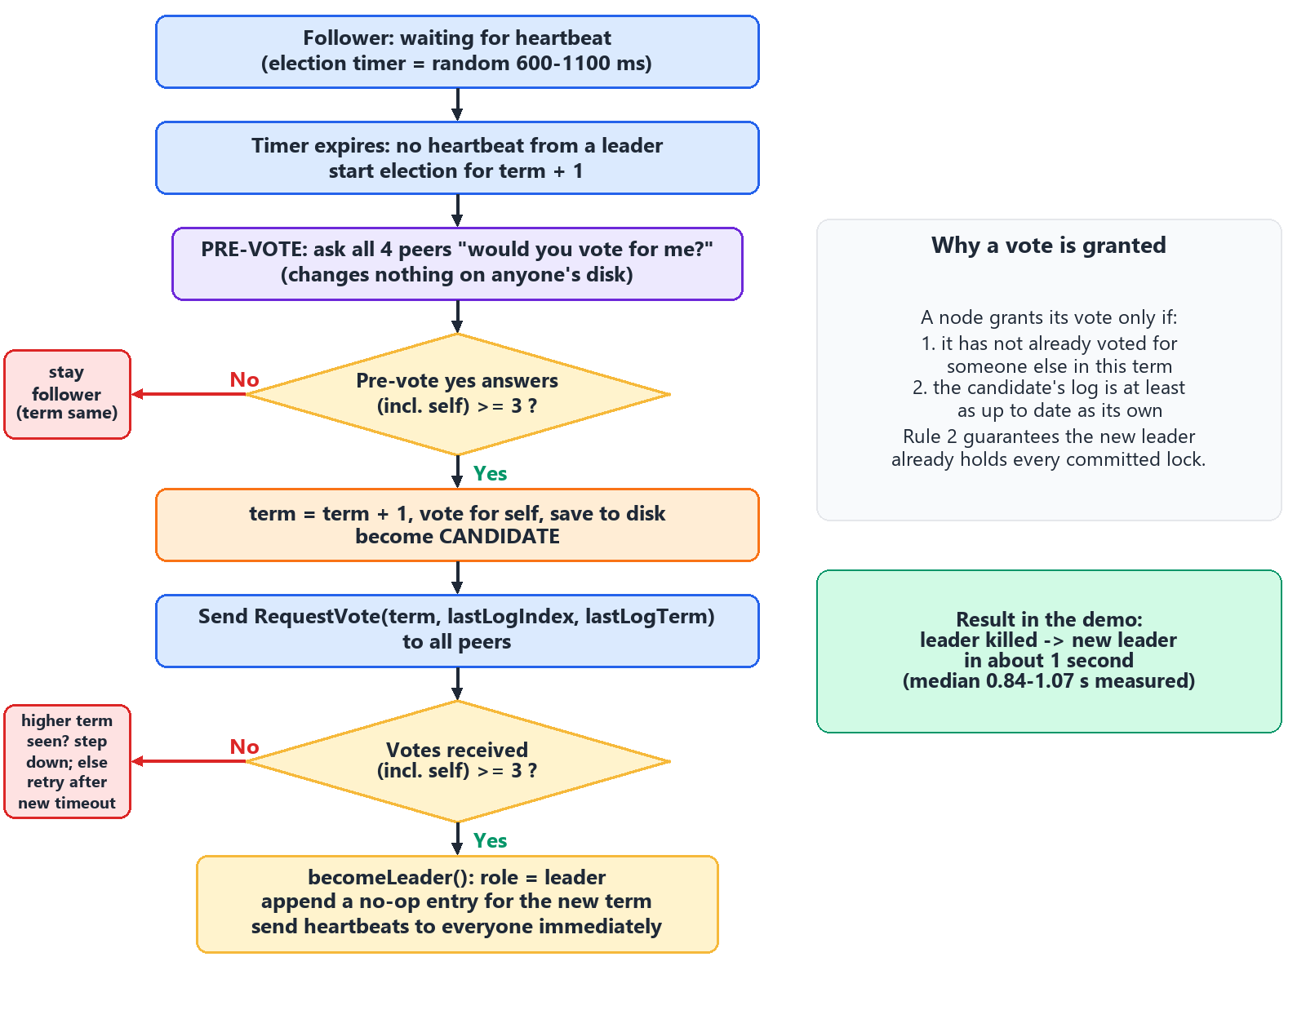
Figure 4: Leader election flow (pre-vote, vote, become leader)
Lock state machine
The lock table is a deterministic function of the committed log. The time used by a command is stored inside the command, not read from each machine's clock, so all five replicas decide identically. The table is not saved: it is rebuilt by replaying the log.
case 'acquire': {
const l = sm.locks[cmd.key];
if (l && l.expiresAt > cmd.now) { // still held
if (l.owner === cmd.owner) return { ok: true, token: l.token, reentrant: true };
return { ok: false, error: 'held', holder: l.owner };
}
const token = ++sm.fence; // strictly increasing fencing token
sm.locks[cmd.key] = { owner: cmd.owner, token, expiresAt: cmd.now + cmd.ttlMs };
return { ok: true, token, expiresAt: cmd.now + cmd.ttlMs };
}
Fencing
Figure 5 shows the stale-client case. Client A holds token 2 and freezes. Its lease expires, client B receives token 3 and writes. When A wakes up and writes with token 2, the protected resource rejects it because it has already seen token 3.
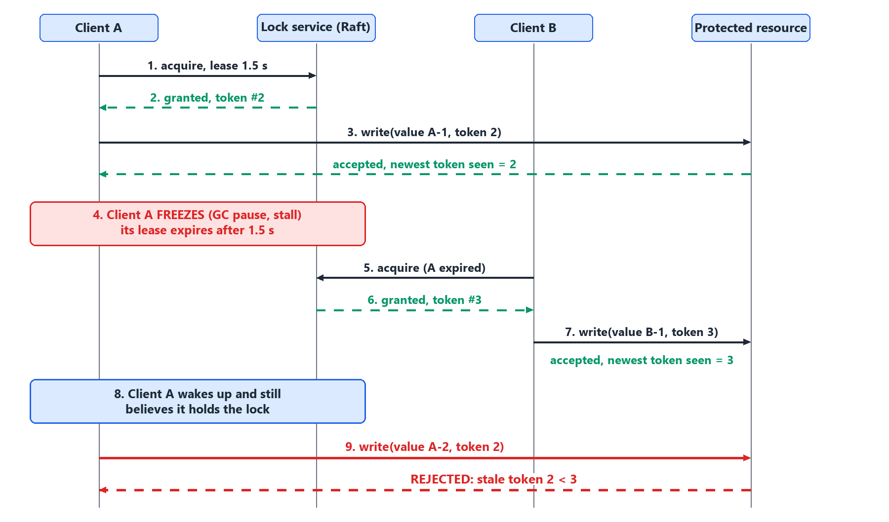
Figure 5: Fencing token rejecting a write from a client whose lease expired
Partitions
When the network splits (Figure 6) only the side with 3 or more machines can elect a leader and commit entries. The old leader on the small side cannot collect acknowledgements, so after 1.5 s it steps down and grants nothing. After the network heals it sees the higher term and copies the entries it missed.
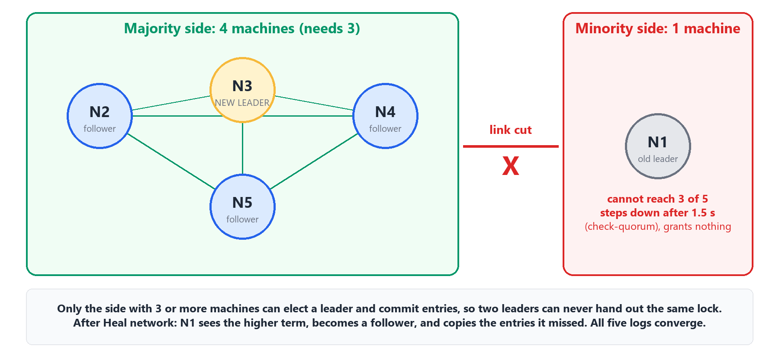
Figure 6: Network partition: the majority side elects a new leader, the cut-off leader steps down
Key design decisions and constants
Table 5: Design decisions
Decision | Reason
Raft messages and client calls over plain HTTP and JSON | Easy to read in logs and to test; no libraries.
Append-only write-ahead log; term and vote saved with write-to-temp-file then atomic rename | A crash cannot leave a half-written term file; a torn last log line is ignored on load.
Lock table rebuilt from the log, not saved | One source of truth; recovery is just replay.
New leader appends a no-op entry | Lets it commit entries from earlier terms safely.
Leader proposes a "sweep" entry to expire leases | Expiry is replicated like any command, so every replica removes the lock at the same point.
Gateway retries acquire and renew but not release | Acquire and renew are safe to repeat; a repeated release could free someone else's lock.
Pre-vote and check-quorum can be switched on or off | Lets the Virtual Lab and tests show what each one prevents.

Table 6: Protocol constants used by the replicas
Constant | Value | Meaning
Heartbeat interval | 120 ms | Leader contacts every follower
Election timeout | 600 to 1100 ms (random) | Follower waits this long before starting an election
Quorum-loss limit | 1500 ms | Leader steps down if no majority has answered
Lease sweep check | 300 ms | Leader looks for expired leases
Peer RPC timeout / client operation timeout | 300 ms / 3000 ms | Gives up on a silent peer / on an uncommitted request
Majority | floor(N/2) + 1 = 3 for N = 5 | Votes or copies needed

5. Methodology and Implementation

5.1 Workflow / Development Method
Work followed five stages. (1) Requirements and design: the safety goals (one holder per lock, no lost grants), the failure model, the data flow and the failure strategy were written first. (2) Implementation: the replica came first (persistence, then election, then replication and the lock state machine), followed by the gateway and then the dashboard. (3) Fault injection: crash, restart, wipe and partition controls were added so that every failure could be triggered from a button. (4) Evaluation: scripted checks, a randomised chaos test with a history checker, and benchmarks. (5) Teaching material: the Virtual Lab and the demo script. Each stage was checked by running the system before the next began.

5.2 Technologies, Tools and Resources
Table 7: Technologies and tools
Category | Technology / Tool | Purpose / Justification
Programming language / runtime | Node.js 18 or newer (v24.19.0 used for the runs in this report) | Built-in http, fetch, fs and child_process are enough, so there are no dependencies [9].
Frontend | HTML, CSS and plain JavaScript | A single static page; no build step.
Storage | Local files: JSON-lines write-ahead log and a small JSON term file | Simple, inspectable durability.
Development / testing tools | VS Code; test.js, test-chaos.js, bench.js; headless Google Chrome for the report screenshots | Editing, automated checks, and repeatable screenshots.
Packaging | Dockerfile and docker-compose.yml (provided; not run for this report) | Replicas as containers on a private network.
Hardware / cloud | One Windows 11 laptop (benchmarks recorded on an Intel Core i7-12700H); no cloud | Everything runs locally at no cost.

5.3 Implementation Details
Replica process. replica.js (about 440 lines) is started as node replica.js <id> <clusterSize> <dataDir>. It serves HTTP for peers, the gateway and the log feed. A 120 ms timer sends heartbeats if the node leads, or starts an election if the election timer ran out.
Persistence. Before replying to any message the replica saves its term and vote (write to a temporary file, then rename) and appends new log entries to the write-ahead log. On boot, loadDisk reloads both and the lock table is rebuilt as the log is re-applied. Setting DURABLE=1 adds an fsync to every write.
Replication and commit. propose appends a client command to the leader's log and wakes replicate for each follower, which sends up to 64 entries per message. advanceCommit counts how many nodes have stored the newest entry of the current term and commits it at 3. Followers that are behind are repaired by backing up nextIndex until the logs match; conflicting entries on a follower are removed.
Gateway. viaLeader keeps a cached leader, asks all nodes when the cache is empty, follows "not-leader" hints and retries up to five times. startNode and stopNode spawn and kill replica processes, which is how the Kill and Restart buttons really work. Partitions are injected by telling each replica which peers to ignore.
Dashboard. public/app.js polls /api/cluster and /api/locks every 500 ms and redraws. It contains no lock logic. The live terminal reads /api/term, which merges the gateway's own log lines with the log lines of all five replicas in time order.
Challenges and fixes. A replica that stepped down had pending client requests, which now return "leadership lost" instead of hanging. A cut-off leader used to answer lock-table reads, so reads now require a recent majority. The replica file was renamed from node.js to replica.js so that npm run works on Windows. A torn last line in the log after a crash is ignored when loading.

5.4 User Interface / Prototype / Output
The screenshots below were captured from the running system (a clean cluster on ports 8090 and 7101 to 7105) using headless Chrome driven through the DevTools protocol. Each one shows a real state of the running processes.
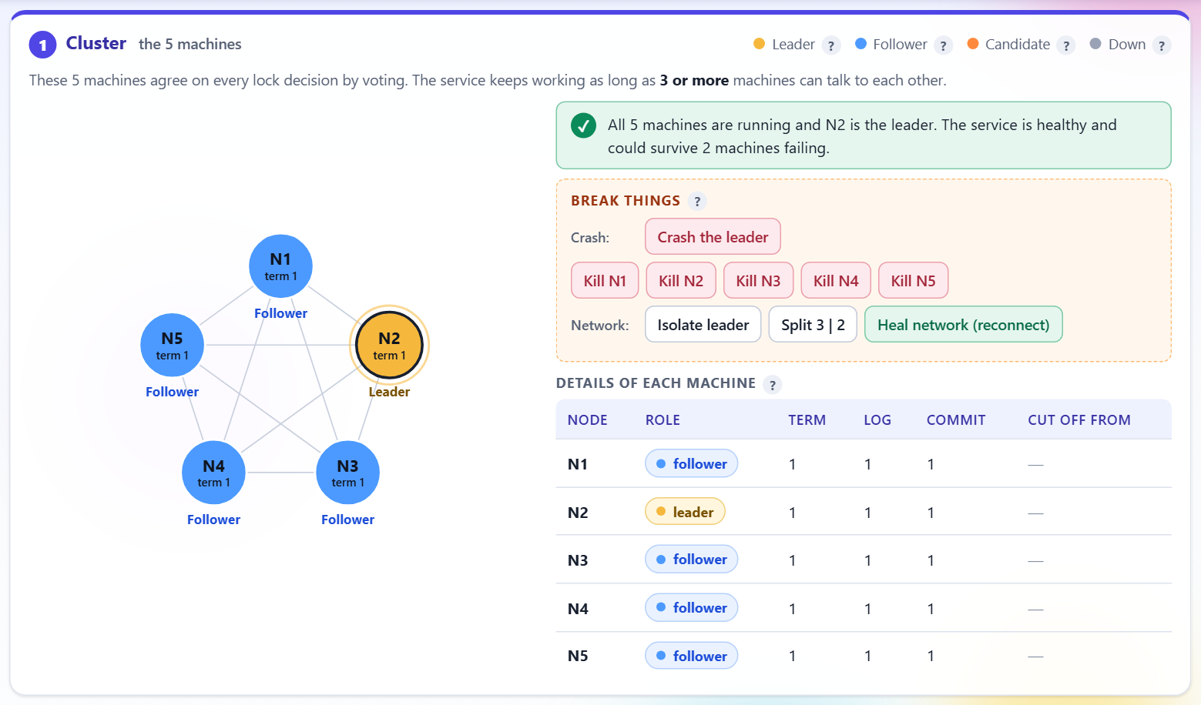
Figure 7: Dashboard, Cluster card: five machines, one leader (gold), same term and commit index, "Break things" controls
Figure 7 shows the healthy cluster: the leader in gold, four blue followers, identical term, log and commit values in the table, and the buttons used to cause failures.
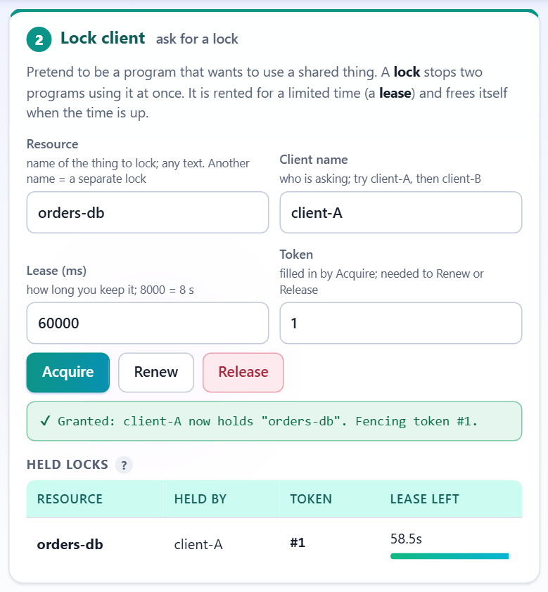 | 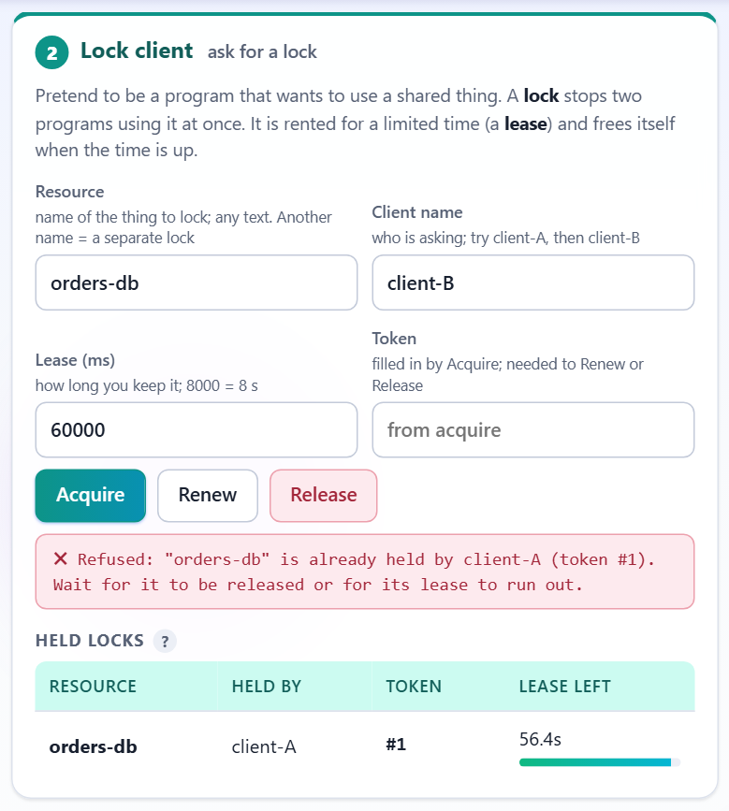
Figure 8: client-A acquires "orders-db" and gets token 1 | Figure 9: client-B is refused: held by client-A

Figures 8 and 9 demonstrate mutual exclusion. The same resource name is requested by two clients; only the first is granted. The lease bar counts down the remaining lease.
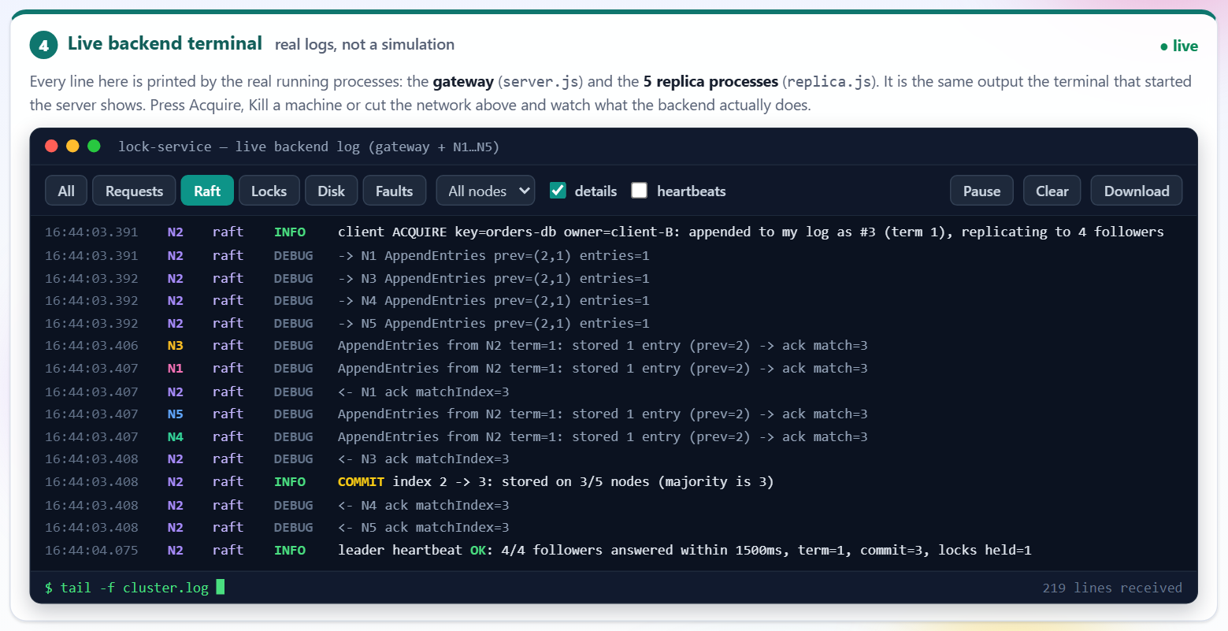
Figure 10: Live backend terminal, Raft filter: AppendEntries to followers and "COMMIT ... stored on 3/5 nodes (majority is 3)"
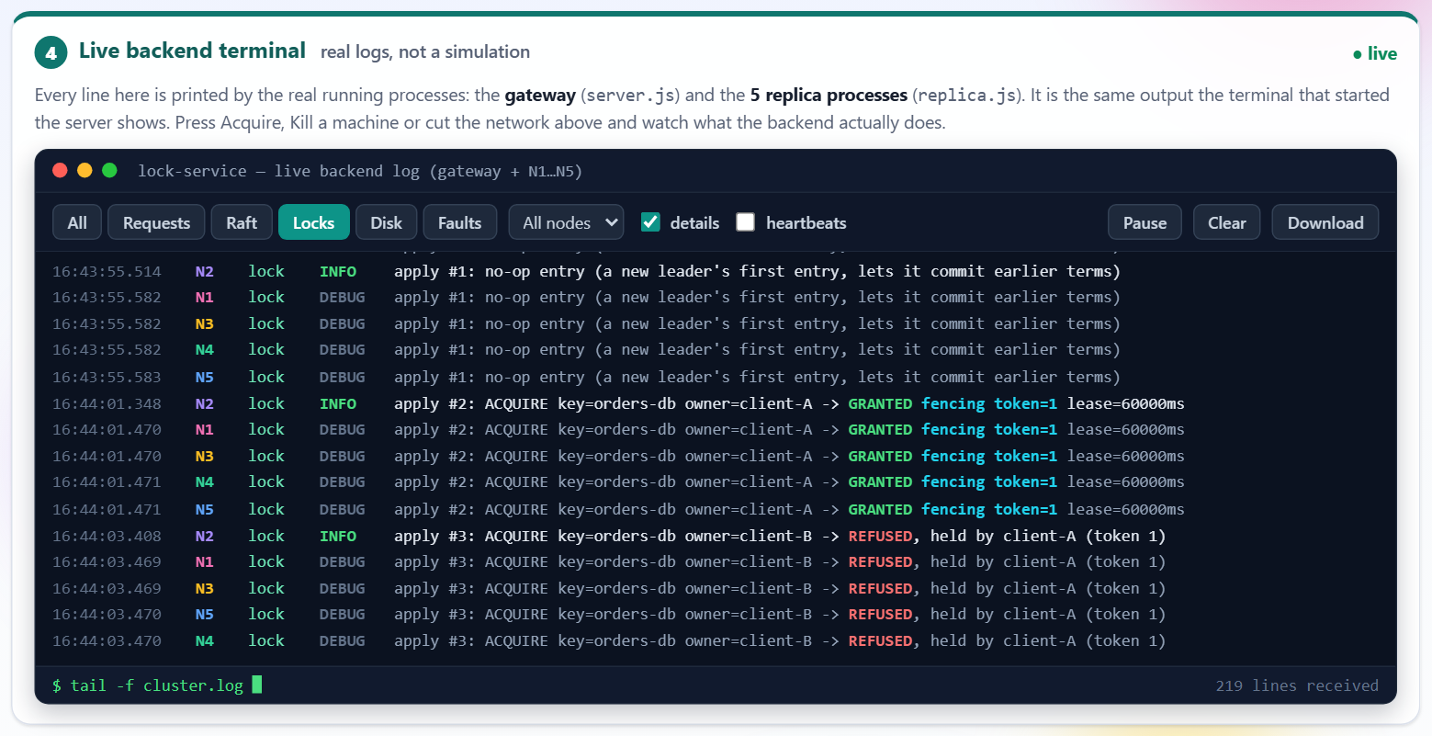
Figure 11: Live backend terminal, Locks filter: GRANTED and REFUSED applied on the replicas
Figures 10 and 11 are the real log lines of the replica processes: the leader replicates, commits at 3 of 5, and the lock decision is applied.
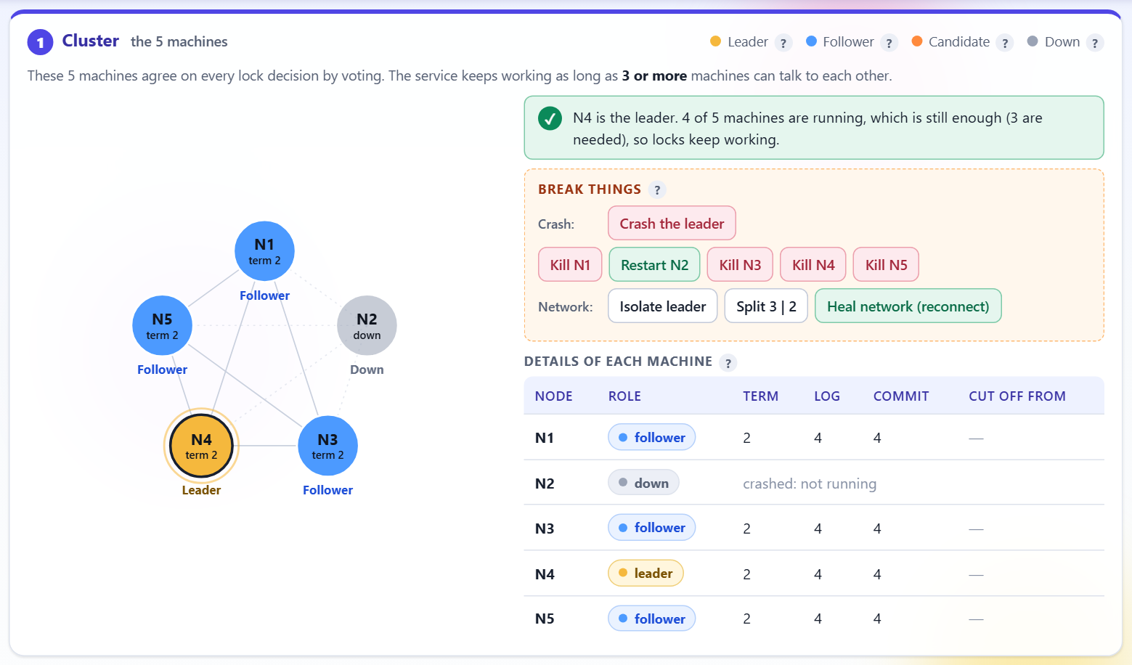
Figure 12: After "Crash the leader": the old leader is down and a new leader has been elected in a higher term
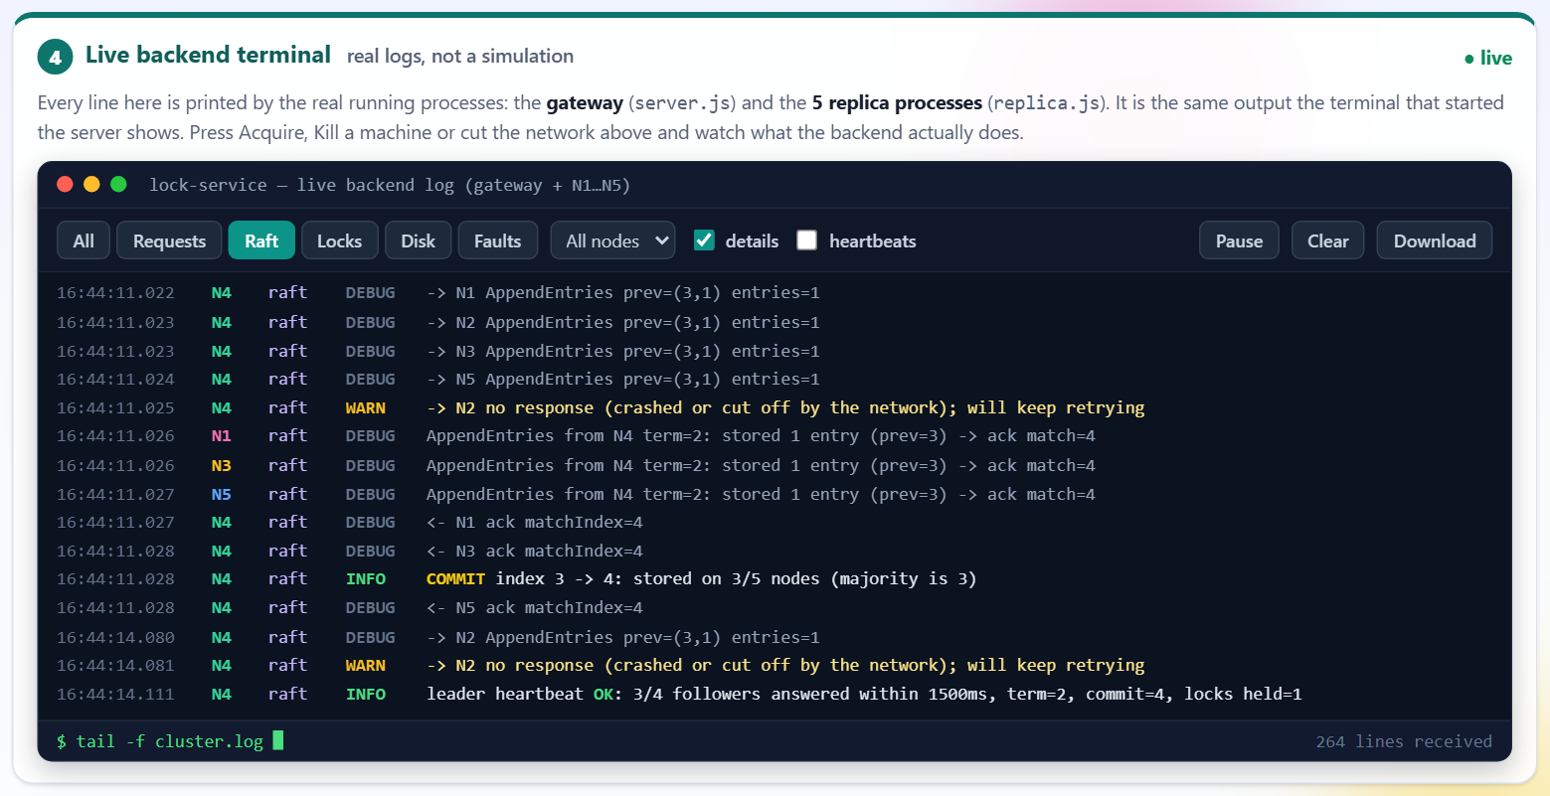
Figure 13: Live terminal during failover: replication to the surviving followers and the new leader's heartbeat
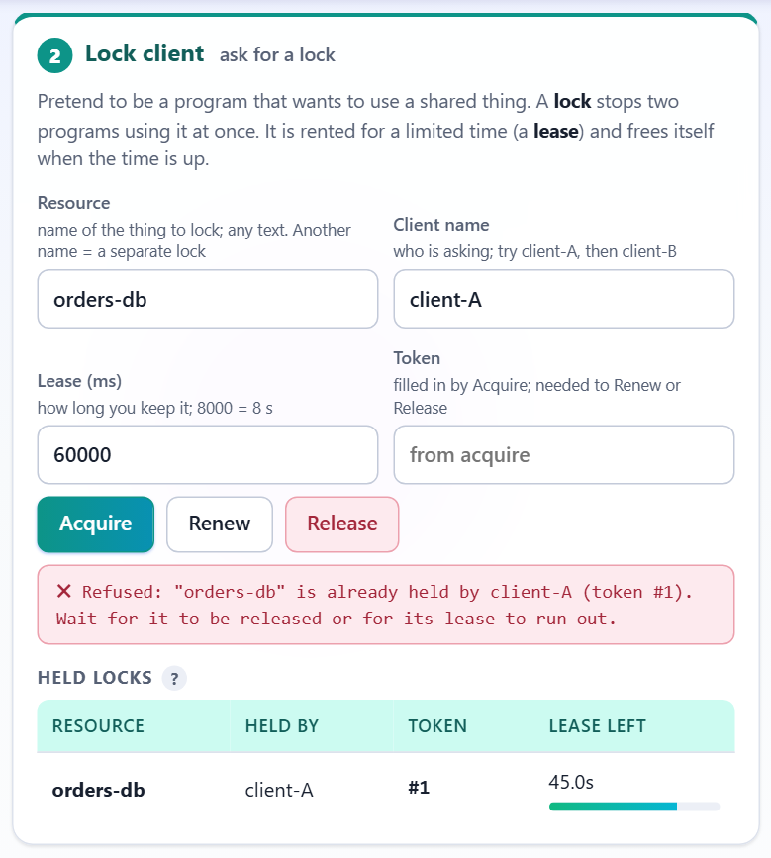
Figure 14: The lock is still held by client-A after the leader crashed
Figures 12 to 14 show failover. The ring shows the new leader, the terminal shows the cluster working with four nodes, and the lock table still holds the lock, because the grant was committed on a majority before the crash.
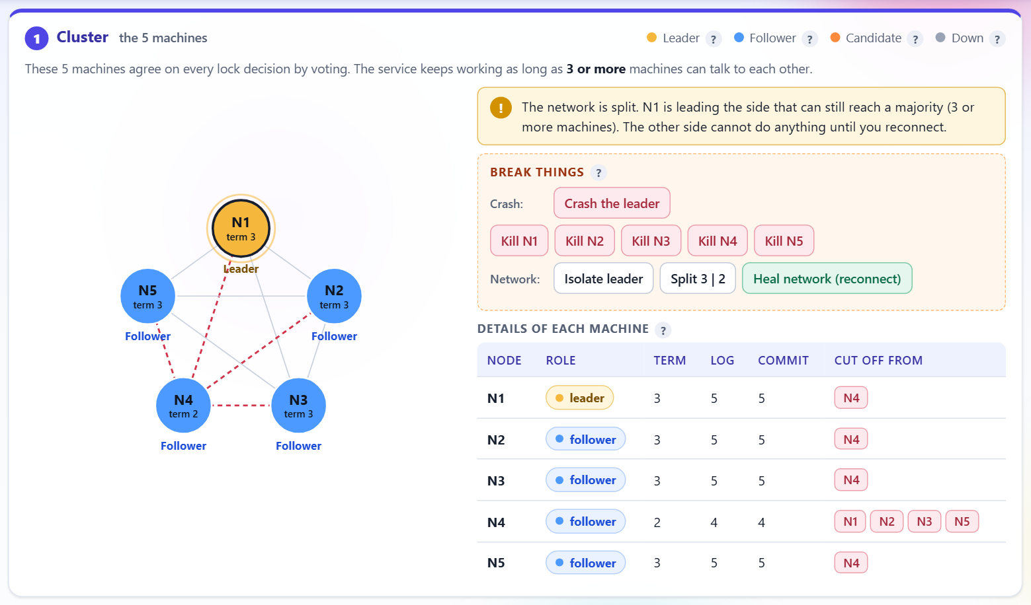
Figure 15: Partition: red dashed links show the cut; the table lists which machines each node cannot reach
Figure 15 shows a partition in progress. The side that kept a majority elected a leader and continues; the isolated node shows an older term and a shorter log until the network is healed.
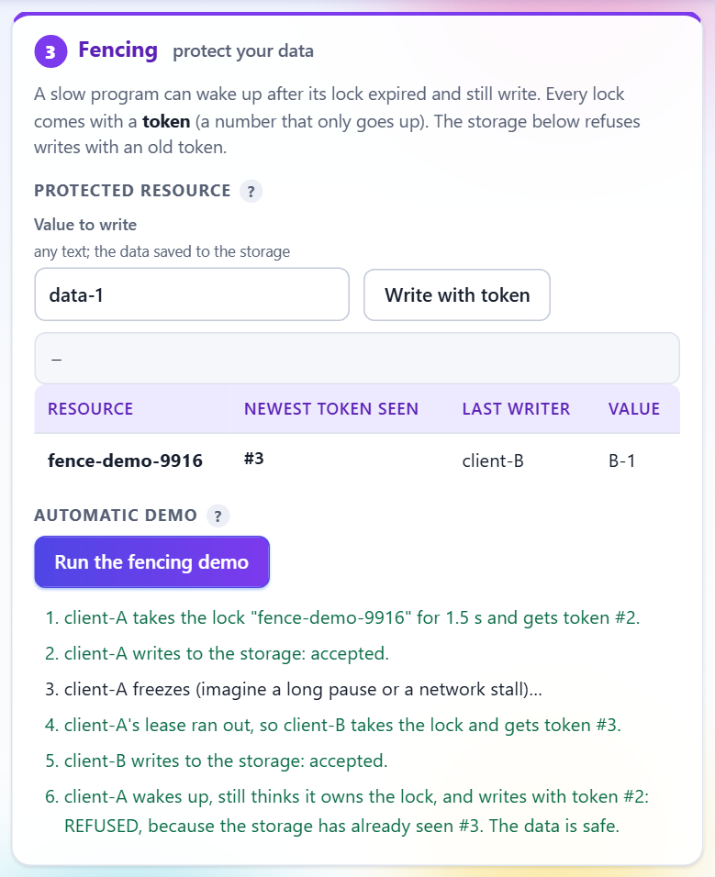
Figure 16: Fencing demo: the write by client-A with the old token is REFUSED because the resource has already seen a newer token
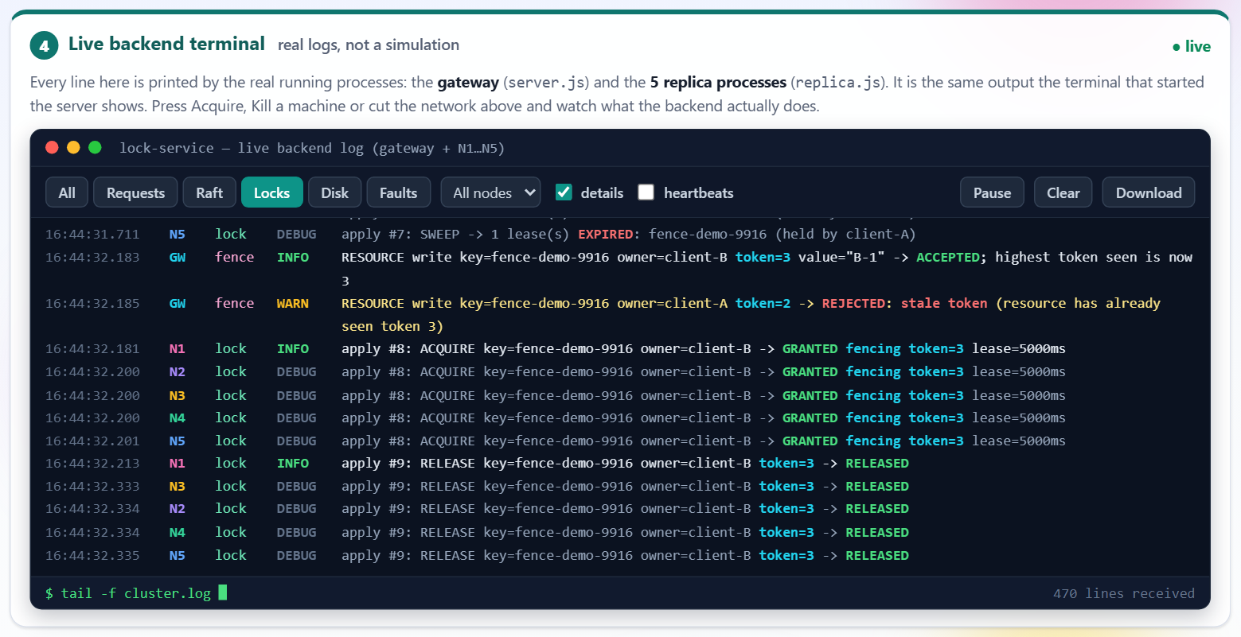
Figure 17: Live terminal: the protected resource logs accepted writes and the rejected stale write
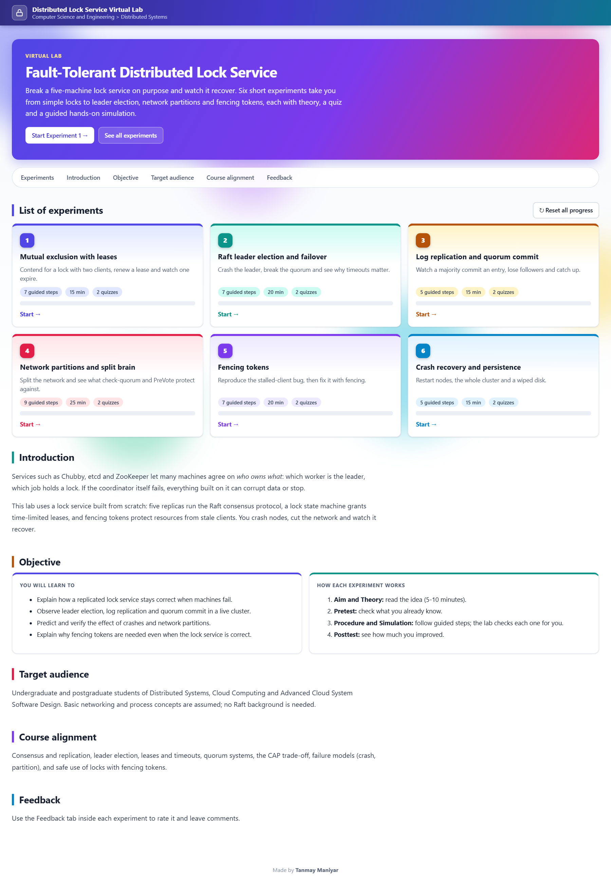
Figure 18: Virtual Lab home page: six experiments
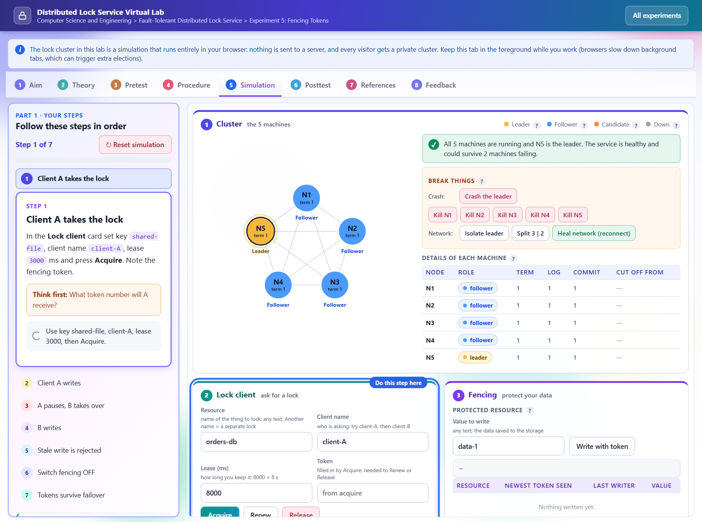
Figure 19: Virtual Lab, Experiment 5 (Fencing Tokens), Simulation tab with guided steps
Figures 18 and 19 show the Virtual Lab. Its cluster is a simulation that runs entirely in the visitor's browser, so nothing is sent to a server.

5.5 Team Contribution
Table 8: Team contribution
Team Member | Assigned Responsibility | Work Completed / Evidence
Tanmay Maniyar | Design, implementation, testing and documentation (add other members here if the project was done in a group) | Replica (Raft and lock state machine), gateway, dashboard, tests, chaos test, benchmarks, Virtual Lab, this report

6. Testing, Evaluation and Results

6.1 Test Plan and Test Cases
Test environment: Windows 11, Node.js v24.19.0, all processes on one laptop. The tests were run on 5 November 2026 against a freshly started cluster (gateway on port 8090, replicas on 7101 to 7105). Expected results come from the safety goals in Section 2. The scripted checks cover normal use (acquire, release), failure cases (leader crash, partition) and invalid use (a second client asking for a held lock, a stale token). Token numbers in the table depend on how many locks the cluster had already granted.
Table 9: Scripted fault-injection test cases (npm test, 12 checks)
Test ID | Test Input / Scenario | Expected Result | Observed Result | Status
TC-01 | Start the cluster | A leader is elected | N1 elected | Pass
TC-02 | client A acquires a lock | Granted with a fencing token | Granted, token 4 | Pass
TC-03 | client B asks for the same lock | Refused, held by A (mutual exclusion) | Refused (held) | Pass
TC-04 | Kill the leader | A different node becomes leader | N5 became leader | Pass
TC-05 | Read the lock after failover | A still holds the lock | Lock present, owner A | Pass
TC-06 | B asks again after failover | Still refused | Refused | Pass
TC-07 | Let the lease expire, B acquires | B is granted the lock | Granted | Pass
TC-08 | Compare tokens of successive grants | Strictly increasing | 4 < 5 < 6 | Pass
TC-09 | Isolate the leader from the network | Majority side elects a new leader | N2 elected on the majority side | Pass
TC-10 | Acquire during the partition | Served by the majority side | Served by a majority-side node | Pass
TC-11 | Heal the network | Exactly one leader | One leader | Pass
TC-12 | Read the lock table after healing | Same state everywhere, nothing lost | Lock granted during the partition is present | Pass

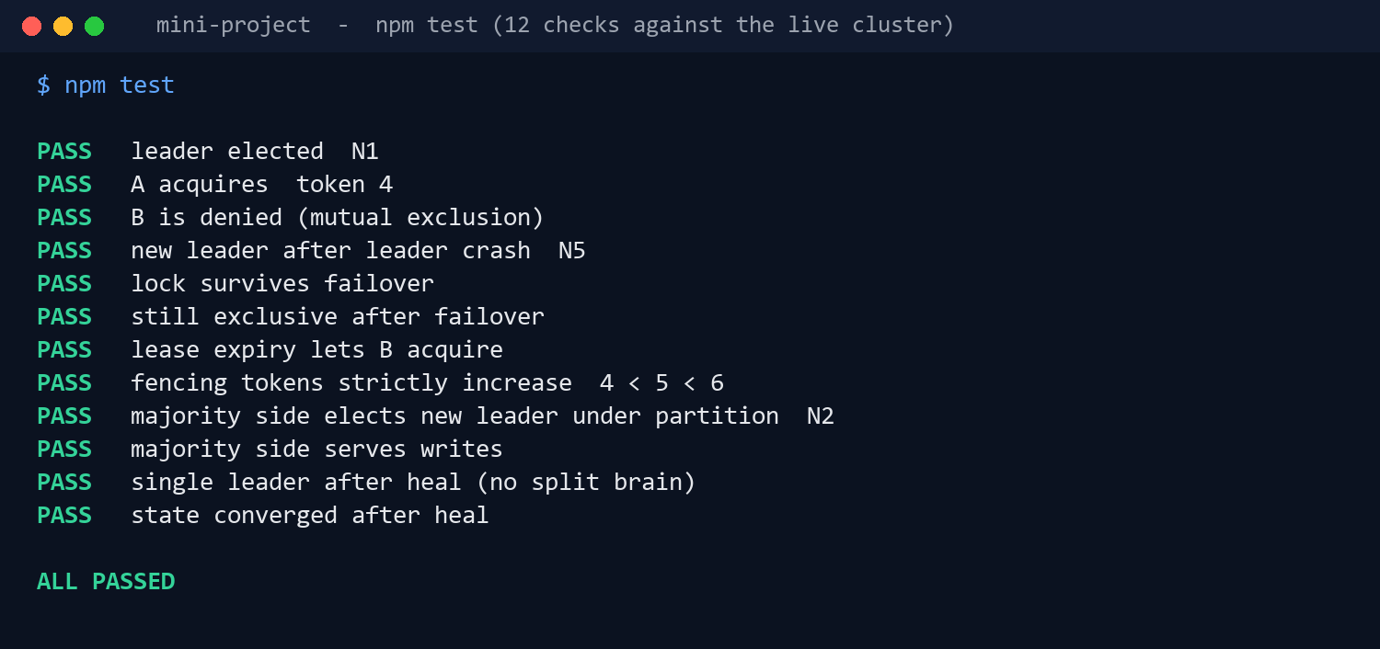
Figure 20: Output of the 12-check test script: all checks pass
The randomised chaos test (test-chaos.js) starts its own cluster, runs 8 clients that acquire, renew and release 3 locks while crashes, restarts, partitions and leader isolations are injected at random, and then checks the recorded history. The 20-second quick version was run for this report. It injected 11 faults (including killing the leader, killing nodes and a 3 | 2 split).
Table 10: Chaos test checks (npm run chaos:quick)
Check | What it proves | Observed | Status
Mutual exclusion | No two grants of the same key overlap in time | 116 grants checked, no overlap | Pass
Fencing tokens unique | Each token belongs to one key and is used once | Unique | Pass
Grants durable | Final counters are at least the highest token seen | Max token 116, counters 116 on all 5 nodes | Pass
All nodes up | Crashed nodes recover after healing | All 5 up | Pass
One leader | No split brain after healing | Exactly one leader | Pass
Logs identical | Replication converged and committed | Log length 939 on all 5 nodes | Pass
Counters identical | State machines agree | Identical | Pass
Liveness | A fresh lock can be acquired after the chaos | Acquire succeeded | Pass

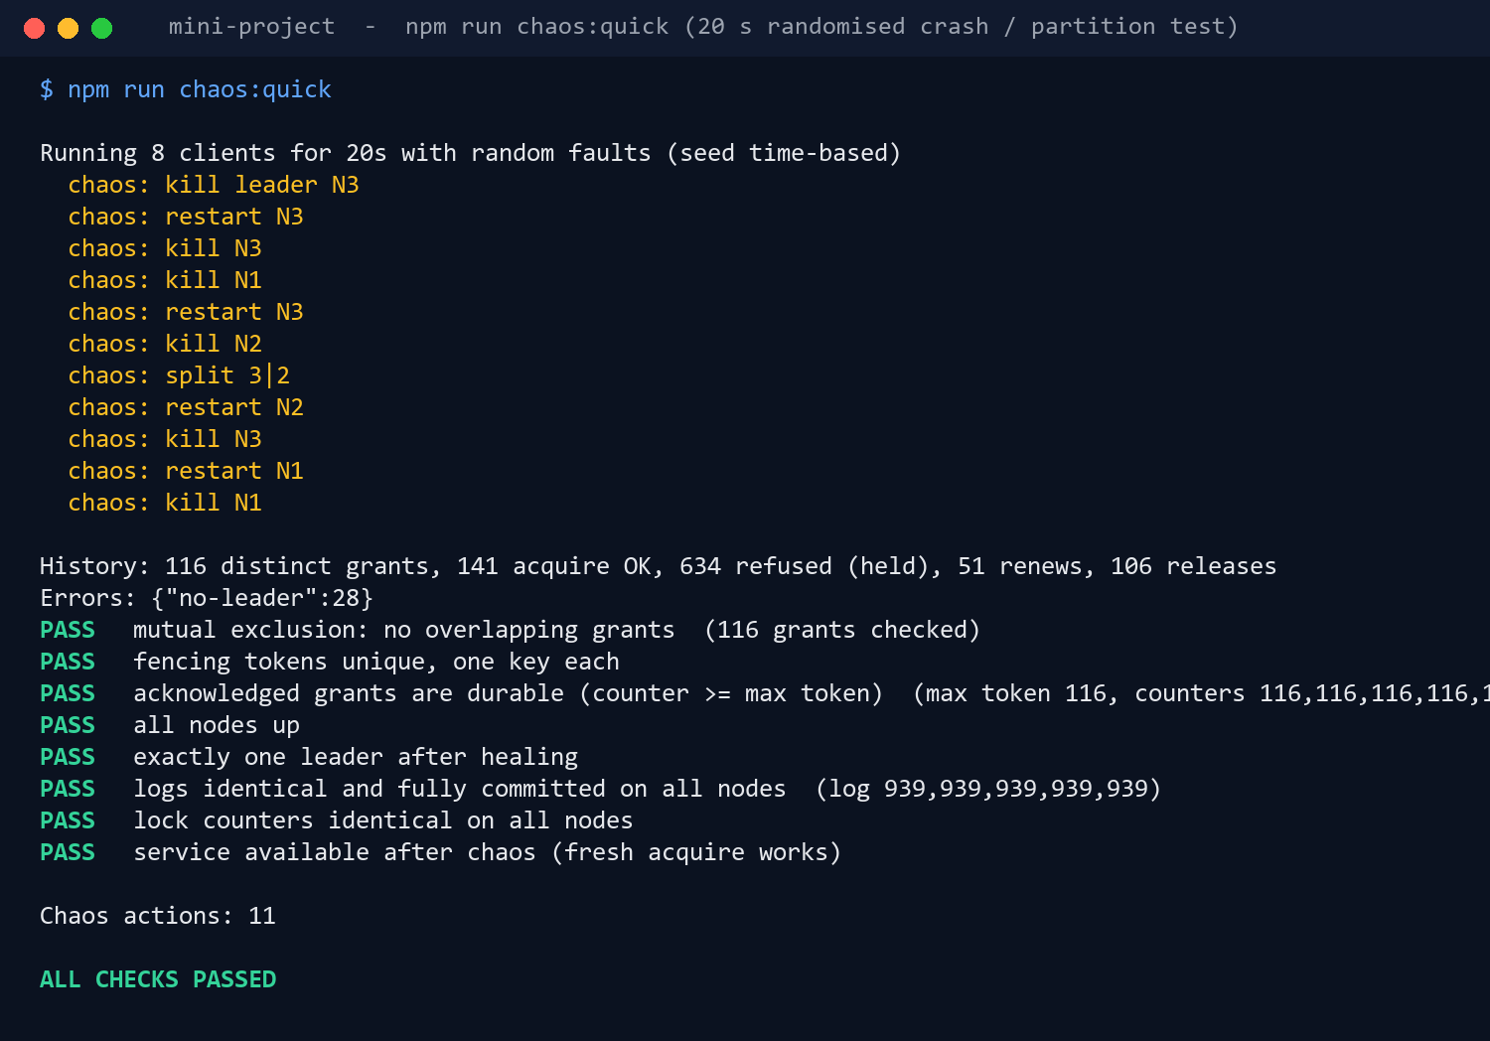
Figure 21: Output of the 20-second chaos test with 11 injected faults

6.2 Evaluation Metrics
Table 11: Evaluation metrics
Metric | Measurement Method / Formula | Observed Value | Interpretation
Operation latency (acquire) | Time from request to committed answer, sequential client, 5 replicas, fsync off | p50 30.6 ms, p95 34.3 ms, p99 45.4 ms | About 31 ms per lock operation; it does not grow with 3, 5 or 7 replicas in these runs
Throughput | Committed operations per second with 1, 8 and 32 concurrent clients (5 replicas, fsync off) | 38, 924 and 3,616 ops/s | Throughput rises with concurrency because entries are batched
Throughput with fsync | Same, 5 replicas, fsync on | 36, 424 and 219 ops/s | Durable writes cost throughput at high concurrency
Failover time | Leader killed until a client can acquire again; 5 trials | Median 1,073 ms (min 835, max 1,117) | Dominated by the 600 to 1100 ms election timeout
Safety violations | History checker in the chaos test | 0 overlapping grants in 116 | Mutual exclusion held under random faults
Fault tolerance | Cluster size and majority rule | Survives 2 of 5 crashed machines | Needs 3 machines to commit

The benchmark numbers come from docs/BENCHMARKS.md, produced by node bench.js on 20 October 2026 on an Intel Core i7-12700H laptop under Windows with Node v24.19.0. They were not re-run for this report, and each configuration was run once, so small differences between rows are within run-to-run variation.

6.3 Results and Discussion
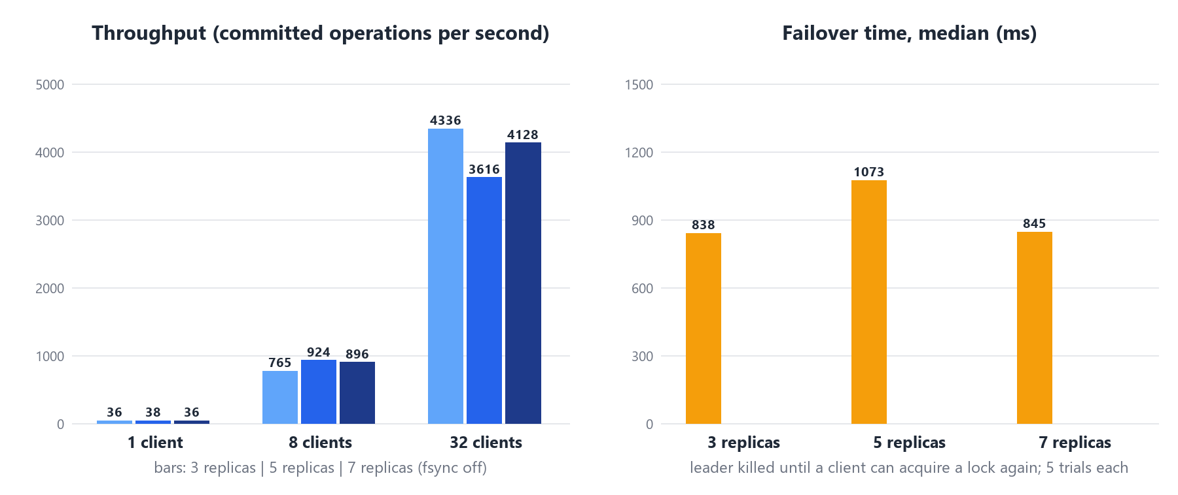
Figure 22: Throughput by cluster size and number of clients, and median failover time
- Safety held in every run. All 12 scripted checks and all 8 chaos checks passed, including a run with 11 random faults. No two clients held the same lock at the same time.
- Failover is about one second. The median was 0.84 to 1.07 s for 3, 5 and 7 replicas. It is set mainly by the election timeout, not by the cluster size.
- Latency is flat, throughput depends on concurrency. A single client sees about 30 ms per operation whatever the cluster size; with 32 clients the cluster commits 3,600 to 4,300 operations per second. The 5-replica run is lower than the 3- and 7-replica runs at 32 clients, which is most likely run-to-run variation because each point was measured once.
- Durability has a price. With fsync on, throughput at 32 clients dropped to 219 ops/s, so the default keeps fsync off and offers DURABLE=1 for stricter durability.
- Availability is traded for safety. In the chaos run 28 requests failed with "no-leader" while the cluster had no leader or no majority. These requests were refused, never granted wrongly.

6.4 Validation / Demonstration Evidence
Demo steps: (1) start with npm run demo in mini-project/ and open http://localhost:8080; (2) acquire orders-db as client-A, then as client-B and see the refusal; (3) press "Crash the leader" and watch a new leader and the surviving lock; (4) press "Isolate leader", acquire another lock, then "Heal network"; (5) run the fencing demo; (6) run npm test in a second terminal. The live terminal shows the real log lines of each process, and the same lines are printed in the terminal that started the server.
Source code, documents and scripts are in the project repository https://github.com/TanmayManiyar/dist-lock-service. No passwords, keys or personal data are stored in it or in this report.

7. Sustainability and SDG Alignment

7.1 Sustainability Assessment
Table 12: Sustainability assessment
Dimension | Questions to Consider | Project-Specific Assessment / Evidence
Environmental | Energy and compute use; paper/material use; e-waste; resource efficiency; emissions; lifecycle impacts. | Neutral to slightly negative, not measured. The system runs on an existing laptop, with six small Node.js processes and no extra hardware, so no new devices or e-waste are created. Five replicas use about five times the compute of one server in exchange for availability, and timers wake every 120 ms. Energy was not measured (see 7.4).
Social | Accessibility and inclusion; user safety; privacy; fairness; digital divide; community benefit. | Positive. The Virtual Lab is a static site that needs no installation or account, so students on modest devices can use it. The dashboard explains terms in plain language, has tooltips, and uses live regions for status messages. No personal data is collected; only lock and client names typed by the user are stored. Safeguard: the admin controls of the gateway can be protected with BASIC_AUTH.
Economic | Development and operating cost; maintenance; affordability; productivity; long-term viability. | Positive. Development cost was zero (free tools, existing laptop). There are no licences or dependencies to maintain, which lowers long-term cost. Running five real replicas in the cloud would cost money; that cost was not estimated here.

7.2 UN Sustainable Development Goals (SDGs)
Table 13: SDG alignment
SDG No. and Name | Project Feature / Activity Linked to SDG | Expected or Observed Contribution | Evidence / Indicator
SDG 9: Industry, Innovation and Infrastructure (target 9.1, reliable and resilient infrastructure) | Replicated lock service that tolerates crashes and partitions without granting a lock twice. | Observed in tests: a small, open design of the kind used to keep digital infrastructure dependable. | 12 of 12 checks and 8 of 8 chaos checks passed; survives 2 of 5 machine failures; failover about 1 s.
SDG 4: Quality Education (target 4.4, relevant technical skills) | Guided dashboard, live backend terminal, demo script and a Virtual Lab with six experiments. | Expected: helps learners see consensus and fencing working. Learner outcomes were not measured. | 6 experiments, each with aim, theory, pretest, procedure, simulation, posttest; no installation needed.

Other goals were considered and not claimed. The project has no direct link to SDG 7 or SDG 13: it does not reduce energy use or emissions, and its own energy use was not measured.

7.3 Sustainability Measures and Trade-offs
- No dependencies and no build step keep the software small and easy to maintain for years.
- Bounded memory: each replica keeps only its last 600 log lines in memory and the gateway keeps 2,500; per-heartbeat lines are off unless the "heartbeats" box is ticked.
- Data minimisation: only lock names, client names and tokens are stored.
- Static hosting for the Virtual Lab: the simulation runs in the visitor's browser, so no server compute is needed per visitor.
- Trade-off (availability against resources): five replicas cost more compute than one but remove the single point of failure; three replicas would tolerate only one failure.
- Trade-off (durability against speed): fsync on every write protects against power loss but cut throughput from 3,616 to 219 ops/s at 32 clients.

7.4 Sustainability Indicator / Follow-up
Measured in this project: failover time (about 1 s), operations per second, and the number of safety violations (zero). Proposed future measures (not measured): energy used per 1,000 committed operations, idle CPU use of a replica, Virtual Lab page weight and load time, and the share of learners who complete the six experiments.

8. Feasibility, Limitations and Risk Considerations

8.1 Feasibility
Technical: feasible; the full system is about 440 lines for the replica and 240 lines for the gateway, and it ran correctly in all tests. Operational: one command starts it; one browser tab operates it. Cost: no cost for development, as shown below. A real deployment would need five machines in three availability zones; the deployment notes describe this but it was not built or validated.
Table 14: Cost estimate
Item / Resource | Estimated Cost (₹) | Basis / Notes
Hardware / hosting / cloud | 0 | Existing laptop; no cloud used. A five-VM cloud deployment is not costed here.
Software / API / dataset | 0 | Node.js, VS Code and Chrome are free; no dataset; no licensed libraries.
Other resources | 0 | Virtual Lab can be served by any static host; hosting plan and price not verified.
Total estimated cost | 0 | One-time development cost only; recurring cost is zero when run locally.

8.2 Limitations
- The log has no compaction or snapshots, so it grows without limit.
- The cluster size is fixed; machines cannot be added or removed while running.
- Crashes and partitions are simulated in software on one machine. The multi-host and Docker set-ups are provided but were not validated for this report.
- Benchmarks use loopback HTTP on one laptop, were run once per configuration, and are not cloud numbers.
- The chaos test is randomised and time-limited (20 s here). It finds bugs but is not a formal proof of correctness.
- Leases rely on the leader's clock being reasonably accurate.
- The Virtual Lab's simulation is a separate implementation of the same logic, not the real replica code.

8.3 Risks, Ethics, Privacy and Security
Table 15: Risks and safeguards
Risk | Impact | Safeguard / Note
Admin endpoints (/api/fault/*, /api/reset) have no login by default | Anyone who can reach the gateway could crash nodes or wipe data | Run on localhost; set BASIC_AUTH; do not expose the gateway to the internet
Traffic and disk files are plain text; no TLS | Lock names and tokens could be read on a shared network | Local demo only; add TLS and file permissions before real use
Clock error on the leader | A lease could end too early or too late | Lease times are stamped once by the leader; keep leases long compared with clock error
Client skips the token check | A stale client could damage data | Resources must verify tokens (demonstrated by the protected resource)
Wrong claims about reliability | Users trust a prototype with real data | Limitations stated; all evidence in this report comes from runs shown here

Privacy and ethics: no personal data or credentials are processed or stored. Responsible use of AI tools: AI-assisted tools were used during development and when preparing this report; the code was run and the results, screenshots and test output shown here come from those runs.

9. Conclusion and Future Scope

9.1 Summary
The project built a working fault-tolerant lock service from scratch: five Raft replicas, a deterministic lock state machine with leases and fencing tokens, a gateway with leader discovery and fault injection, a dashboard with a live backend terminal, and a Virtual Lab. All seven objectives were met. The service granted each lock to one client at a time in all runs, kept committed locks through leader crashes and partitions, recovered nodes from disk, and failed over in about one second. The evidence is the 12 passing scripted checks, a chaos run with 116 grants and no overlap, the benchmark tables and the screenshots. The project supports SDG 9 through resilient infrastructure design and SDG 4 through the Virtual Lab; it has no demonstrated effect on energy or emissions.

9.2 Future Scope
- Add log compaction and snapshots so the log does not grow forever.
- Support changing the cluster membership while running.
- Validate the Docker and multi-host deployment on real machines or cloud VMs and measure real network latency.
- Add TLS, authentication and access control to the gateway and replicas.
- Provide a client library that renews leases in the background and carries tokens automatically.
- Run longer and more varied chaos tests and a formal specification check.
- Measure energy per committed operation and learner outcomes for the Virtual Lab.

References
[1] D. Ongaro and J. Ousterhout, “In search of an understandable consensus algorithm,” in Proc. USENIX Annual Technical Conf. (USENIX ATC ’14), Philadelphia, PA, USA, Jun. 2014, pp. 305–319.
[2] M. Burrows, “The Chubby lock service for loosely-coupled distributed systems,” in Proc. 7th USENIX Symp. Operating Systems Design and Implementation (OSDI ’06), Seattle, WA, USA, Nov. 2006, pp. 335–350.
[3] M. Kleppmann, “How to do distributed locking,” Blog post, Feb. 8, 2016. [Online]. Available: https://martin.kleppmann.com/2016/02/08/how-to-do-distributed-locking.html
[4] P. Hunt, M. Konar, F. P. Junqueira, and B. Reed, “ZooKeeper: Wait-free coordination for Internet-scale systems,” in Proc. USENIX Annual Technical Conf. (USENIX ATC ’10), Boston, MA, USA, Jun. 2010.
[5] D. Ongaro, “Consensus: Bridging theory and practice,” Ph.D. dissertation, Dept. Comput. Sci., Stanford Univ., Stanford, CA, USA, 2014.
[6] C. Gray and D. Cheriton, “Leases: An efficient fault-tolerant mechanism for distributed file cache consistency,” in Proc. 12th ACM Symp. Operating Systems Principles (SOSP ’89), Litchfield Park, AZ, USA, Dec. 1989, pp. 202–210.
[7] M. Kleppmann, Designing Data-Intensive Applications. Sebastopol, CA, USA: O’Reilly Media, 2017.
[8] The etcd Authors, “etcd documentation.” [Online]. Available: https://etcd.io/docs/
[9] OpenJS Foundation, “Node.js documentation.” [Online]. Available: https://nodejs.org/docs/latest/api/

Appendices

Appendix A: Additional screenshots / outputs
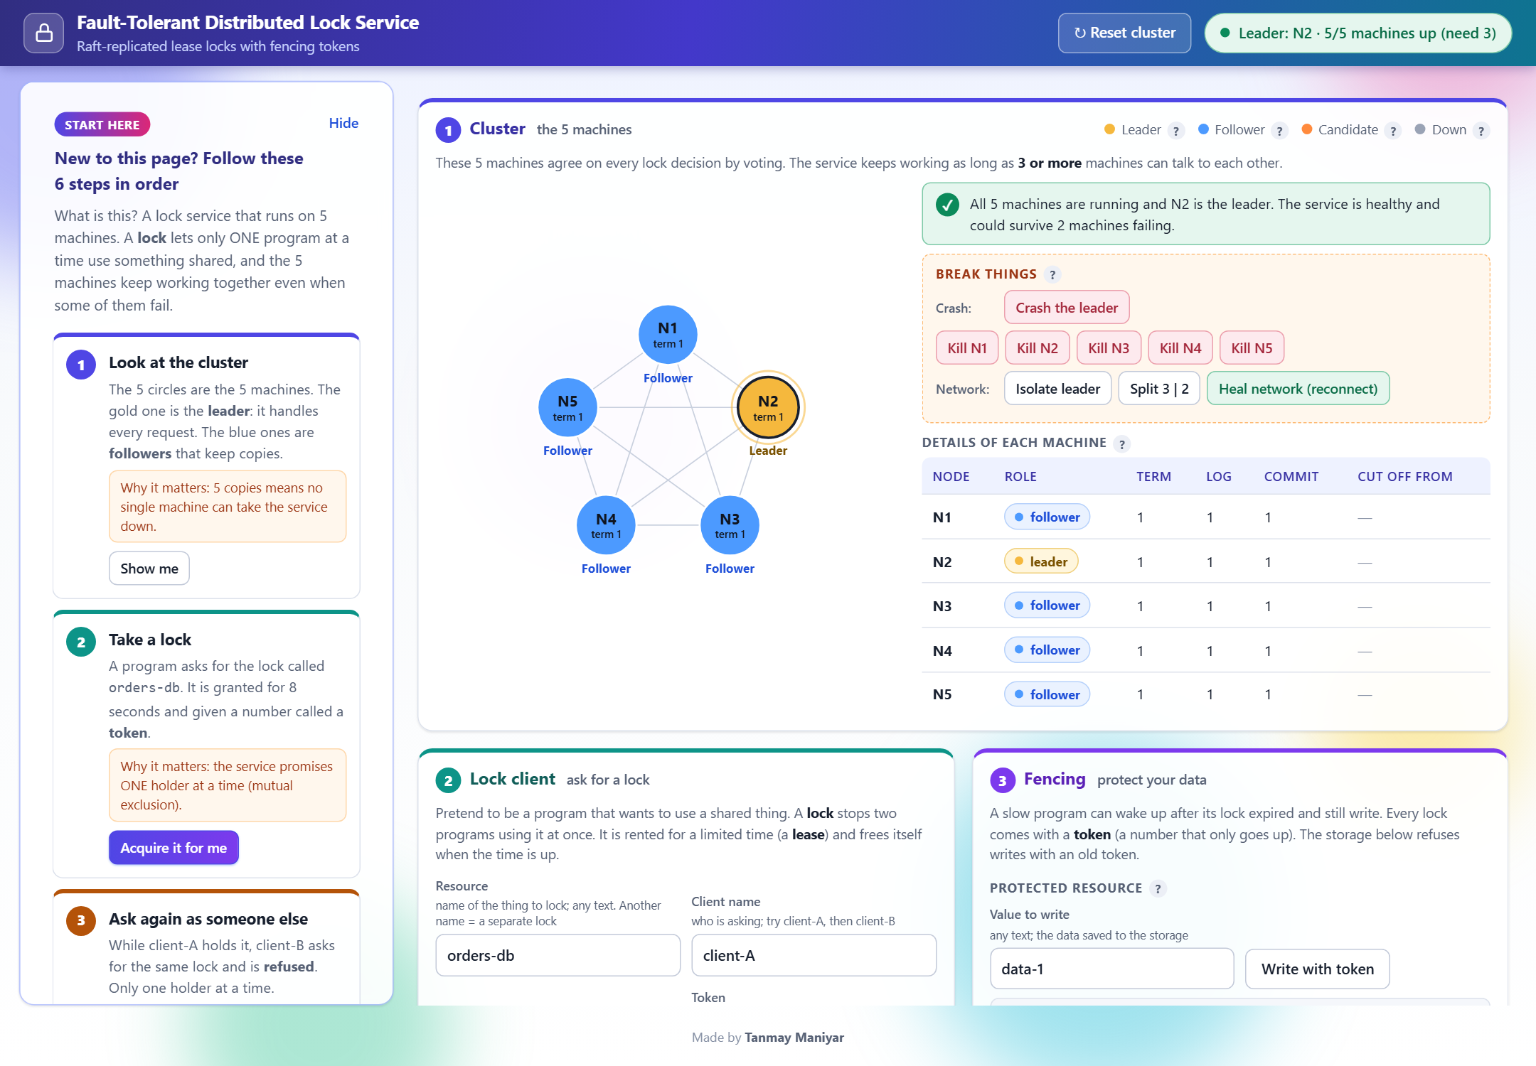
Figure A1: Full dashboard with the "Start here" guide and the three working cards.
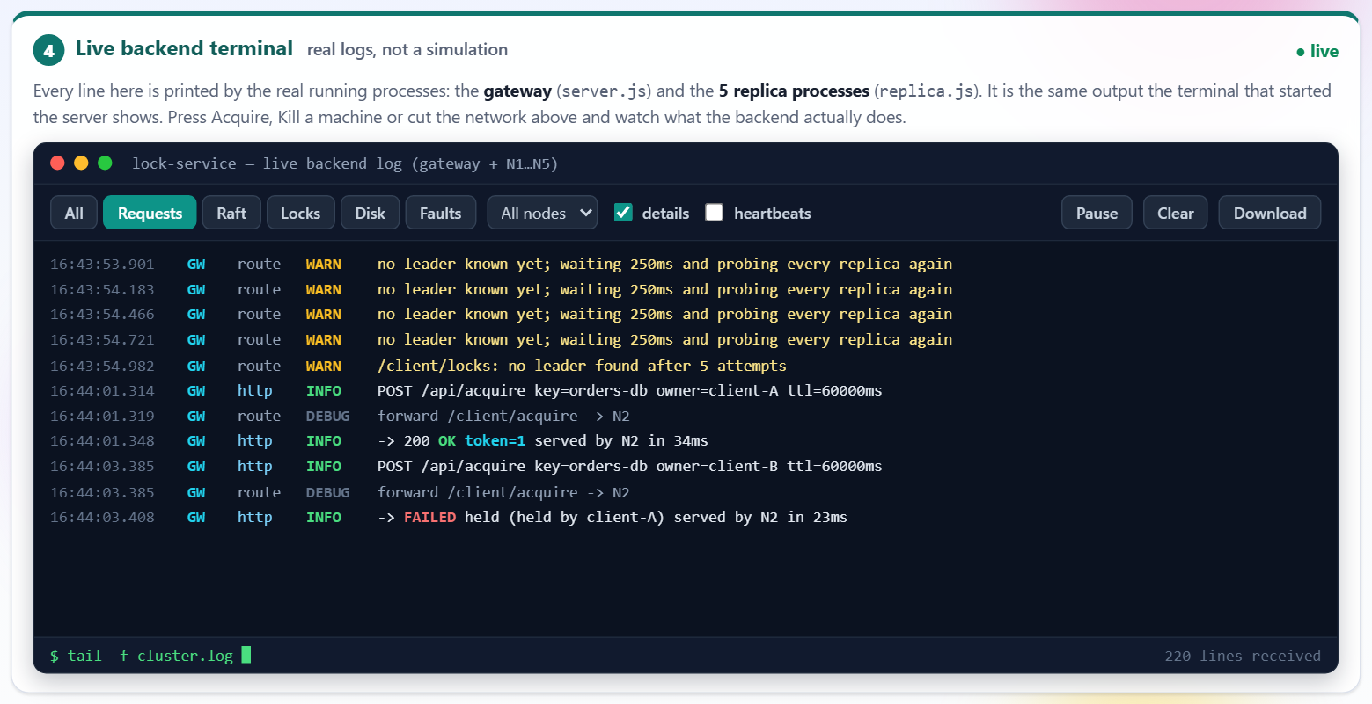
Figure A2: Live terminal, Requests filter: the gateway routes each HTTP request to the leader.
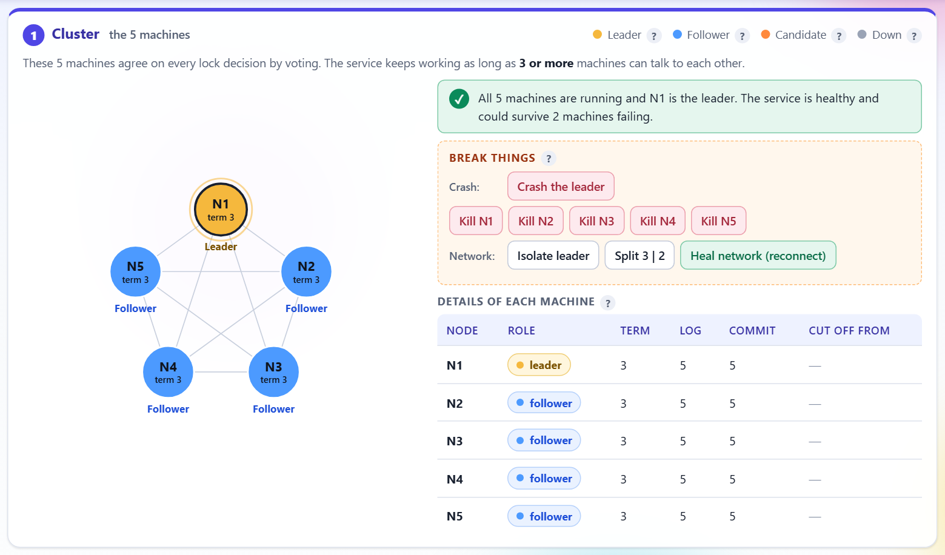
Figure A3: After "Heal network": one leader and the details table with no cut links.
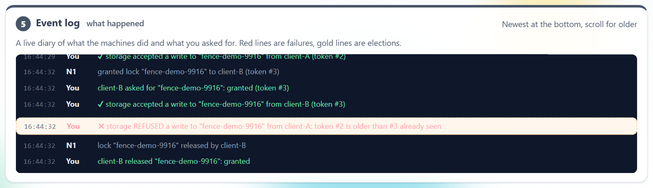
Figure A4: Event log in plain language: faults in red, elections in gold.
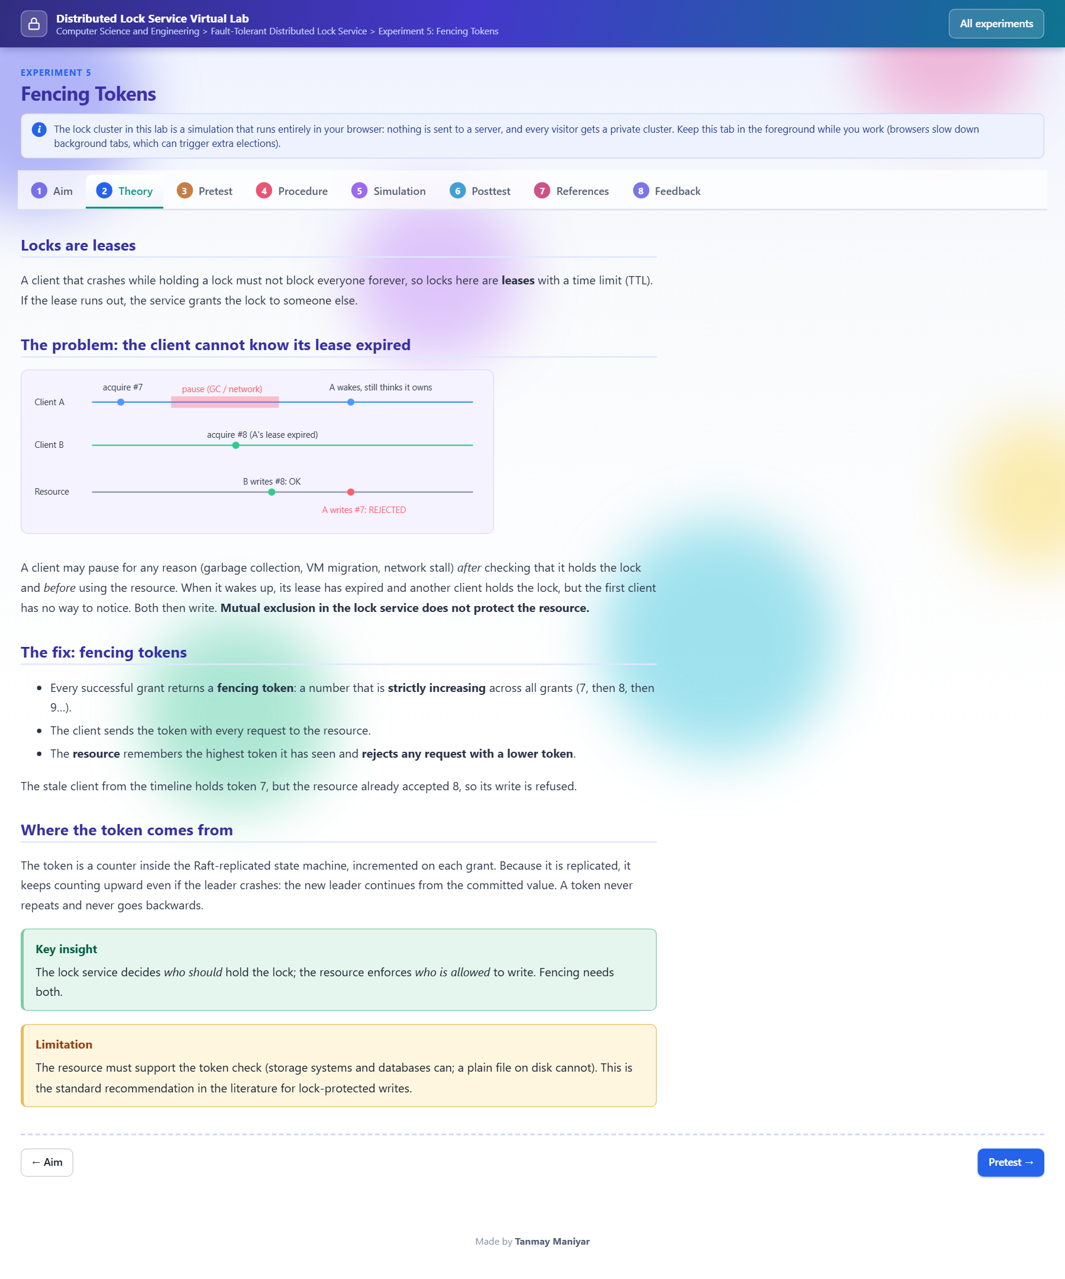
Figure A5: Virtual Lab, Experiment 5 Theory tab: lease timeline and the fencing-token fix.

Appendix B: Selected pseudocode or code excerpts
Majority and commit rule (replica.js):
const MAJORITY = Math.floor(N / 2) + 1; // 3 when N = 5

function advanceCommit() {
for (let n = lastIndex(); n > commitIndex; n--) {
if (st.log[n].term !== st.term) break; // only commit entries of the current term
const count = 1 + peers.filter(p => matchIndex[p] >= n).length;
if (count >= MAJORITY) { commitIndex = n; applyCommitted(); break; }
}
}
Fencing check in the gateway (server.js):
const cur = resource[key] || { maxToken: 0 };
if (config.fencing && token < cur.maxToken)
return json(res, 200, { ok: false, error: 'stale-token', maxToken: cur.maxToken });
resource[key] = { maxToken: Math.max(cur.maxToken, token), value, writer: owner };
Vote rule (replica.js, simplified):
// grant a vote only if: same term, not yet voted for someone else, candidate log at least as up to date
if (b.term === st.term && (st.votedFor === null || st.votedFor === b.from) && upToDate(b.lastLogIndex, b.lastLogTerm)) {
st.votedFor = b.from; persist(); grant = true; resetElectionTimer();
}

Appendix C: Additional test cases
The 8 chaos checks are in Table 10 and the 12 scripted checks in Table 9. Further runs can be repeated with npm run chaos (60 s) and npm run bench. The fault-injection test cases of the Virtual Lab are given in its six experiment pages.

Appendix D: Repository / demo / deployment information
- Repository: https://github.com/TanmayManiyar/dist-lock-service (folders mini-project/ and vlab/).
- Run the service: cd mini-project, then npm run demo (opens http://localhost:8080); run the tests with npm test in a second terminal.
- Run the Virtual Lab: cd vlab, then npm start (serves http://localhost:8099); it can be deployed as static files.
- Ports used: 8080 for the gateway and 7001 to 7005 for the replicas. Environment variables: PORT, NODES, BASE_PORT, DATA_DIR, DURABLE, BASIC_AUTH, REMOTE_NODES. No credentials are needed or stored.

