Lifeline
IT Support for Healthcare
Progress Report
Version 0.1
Prepared for
Mayuresh
Prepared by
Sahil Sawant and Tanmay Nerurkar
Date
15 May 2026

1. What this app is
Lifeline is an internal IT support ticketing system built for hospitals and healthcare staff. When a doctor, nurse, or administrator at a hospital cannot print, cannot sign in, or has a network issue, they raise a ticket in Lifeline. A central IT team picks up those tickets, comments back and forth with the reporter, and marks them resolved once fixed.
The product is in active development. This document describes what works today, what is still pending, and how the various roles interact with the system.

2. Who uses it
Lifeline has four user roles. Each role sees a different view of the application:
- Client — Hospital staff who raise tickets. They see only their own tickets and can comment on them.
- Technician — IT staff who pick up tickets, work with the reporter, and resolve them.
- Manager — IT lead who oversees the technician team and can see the full queue.
- Admin — Manages users and organisations. Can create new accounts, assign roles, reset passwords, and activate or deactivate users.
Roles are enforced both in the navigation (Clients do not see admin links) and at the API level (a Client cannot access admin endpoints even by typing the URL directly).

3. What the app can do today

For clients
- Sign in with email and password.
- Submit a new ticket with category, sub-category, description, urgency, contact preferences, and a follow-up date.
- See a list of their own tickets with status and priority.
- Open a ticket and read its resolution once a technician has fixed it.
- Add comments on a ticket (back-and-forth conversation with the technician).
- Change their own password while signed in.

For technicians
- See tickets assigned to them on a queue dashboard.
- Pick up unassigned tickets from the queue.
- Comment on tickets and have a conversation with the reporter.
- Mark tickets resolved with a resolution note.
- See the full ticket history including all comments.

For admins
- See every user in the system, filtered by role.
- Create new user accounts (Client, Technician, Manager, or Admin).
- Edit a user’s name, role, and organisation.
- Reset any user’s password (generates a temporary password to share with the user).
- Deactivate and reactivate users.
- See all tickets across all organisations.

Authentication features
- Sign in with email and password.
- Self-service Change password while signed in.
- Forgot password? sends a reset link by email; the link expires in 30 minutes.
- Reset links are single-use and rate-limited (3 requests per 15 minutes per email).

4. Test accounts
The local development environment ships with four accounts. Passwords for the seeded users are reset to “password” on every backend startup, so they are intended for development only and must not be reused in production.
Email | Role | Password
priya@apollo.in | Client | password
rahul@remoteit.in | Technician | password
sunita@remoteit.in | Technician | password
admin@lifeline.local | Admin | password

The admin account was added during this round of development to demonstrate the new admin features.

5. How the app looks
Below is a tour of the main screens in the application, organised by what each role sees.

Signing in
Every user starts at the same sign-in screen. A Forgot password? link is available below the form.
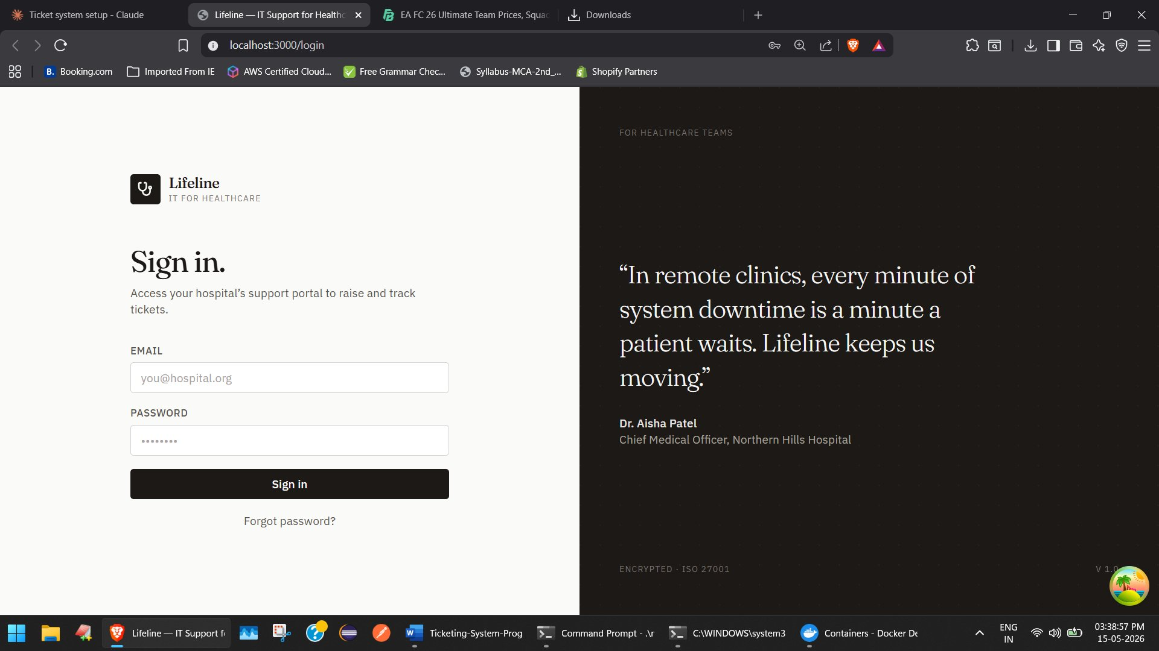
Figure 5.1 — Sign in page

Client dashboard
Once signed in, a client lands on their dashboard. It shows their open ticket count and a list of their recent tickets.
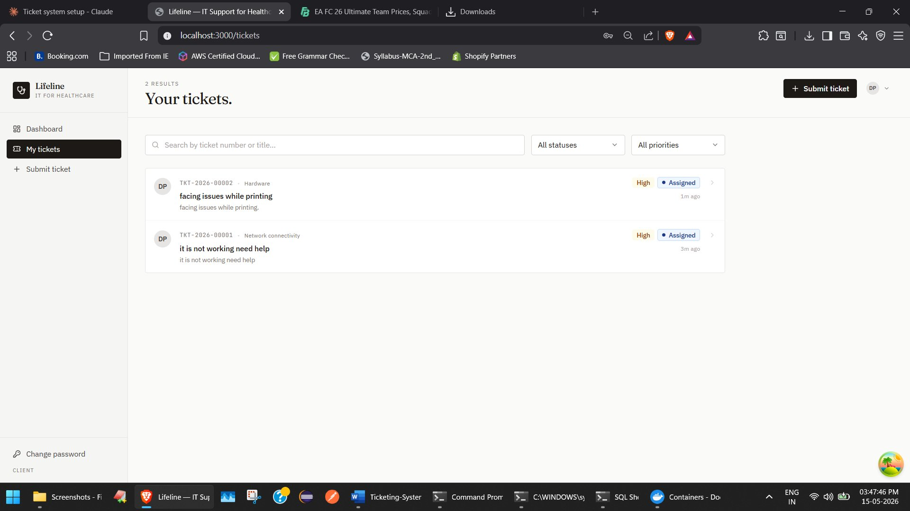
Figure 5.2 — Client dashboard with two open tickets

Client ticket list
From the dashboard, the client can open their ticket list at any time. Each row shows the ticket number, title, status, and priority.
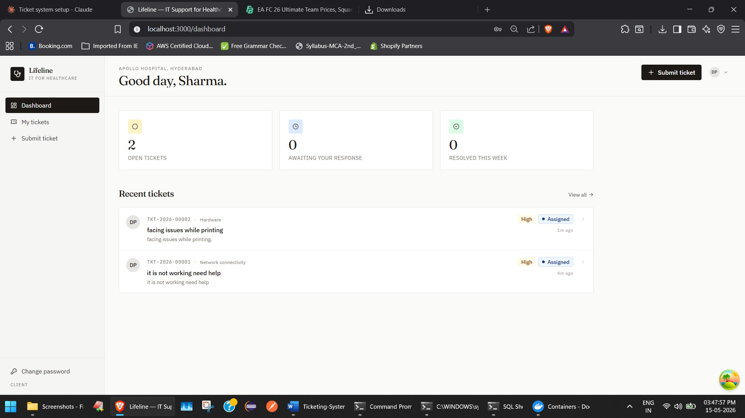
Figure 5.3 — Client ticket list

Ticket detail
Clicking a ticket opens the detail page. The client can read the description, see the assigned technician, follow the conversation, and add comments.
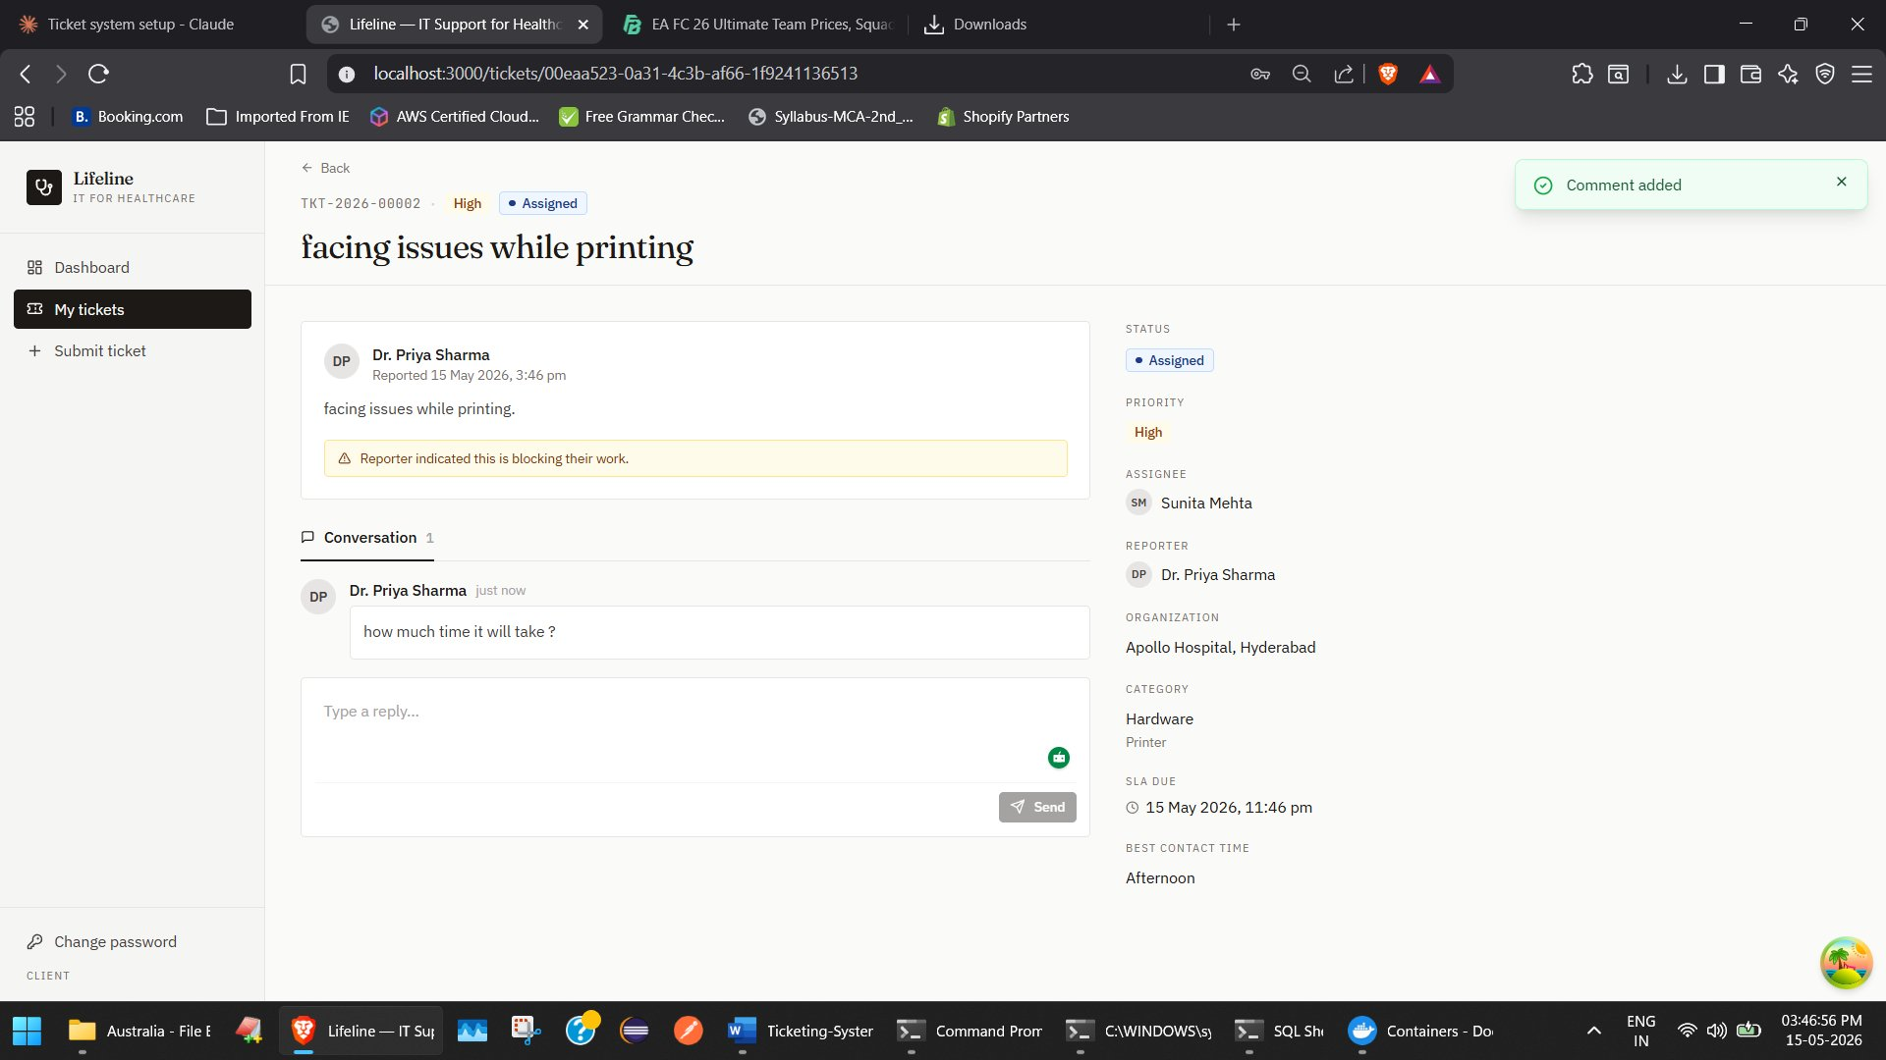
Figure 5.4 — Ticket detail page (client view)

Admin dashboard
Admins see a different dashboard with team-level metrics: total active tickets, resolved today, SLA risk, and a weekly activity chart.
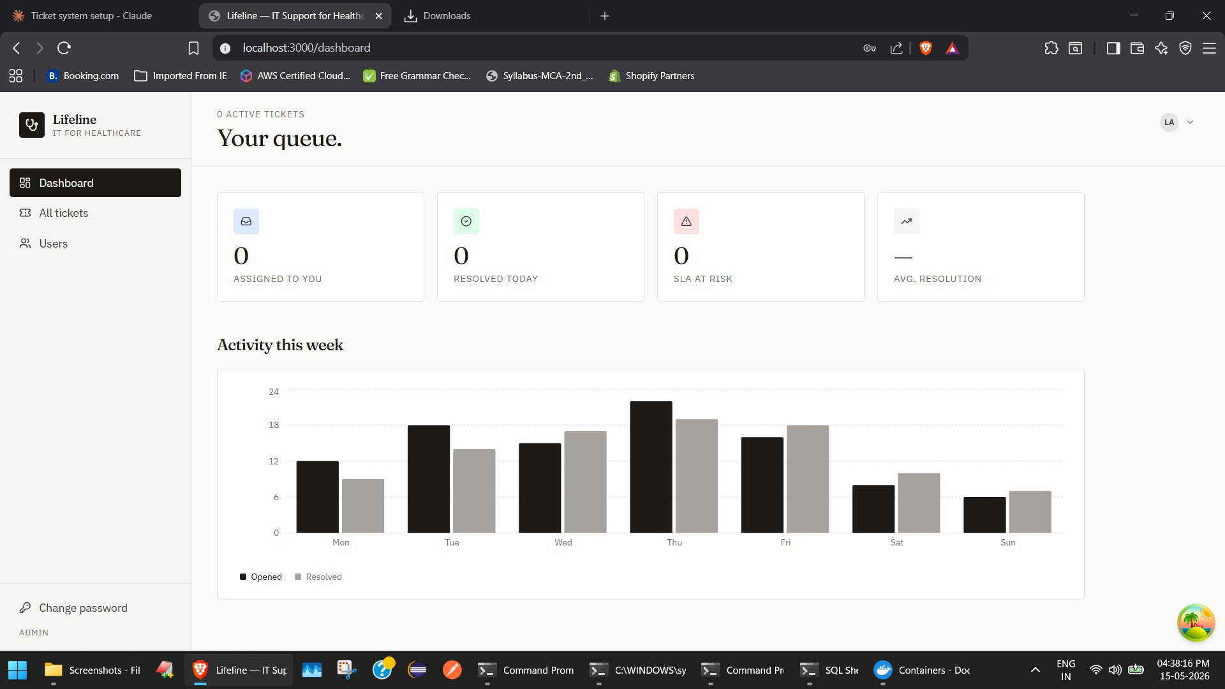
Figure 5.5 — Admin dashboard

Admin Users page
The Users page is admin-only. It lists every user in the system with a search box and a role filter.
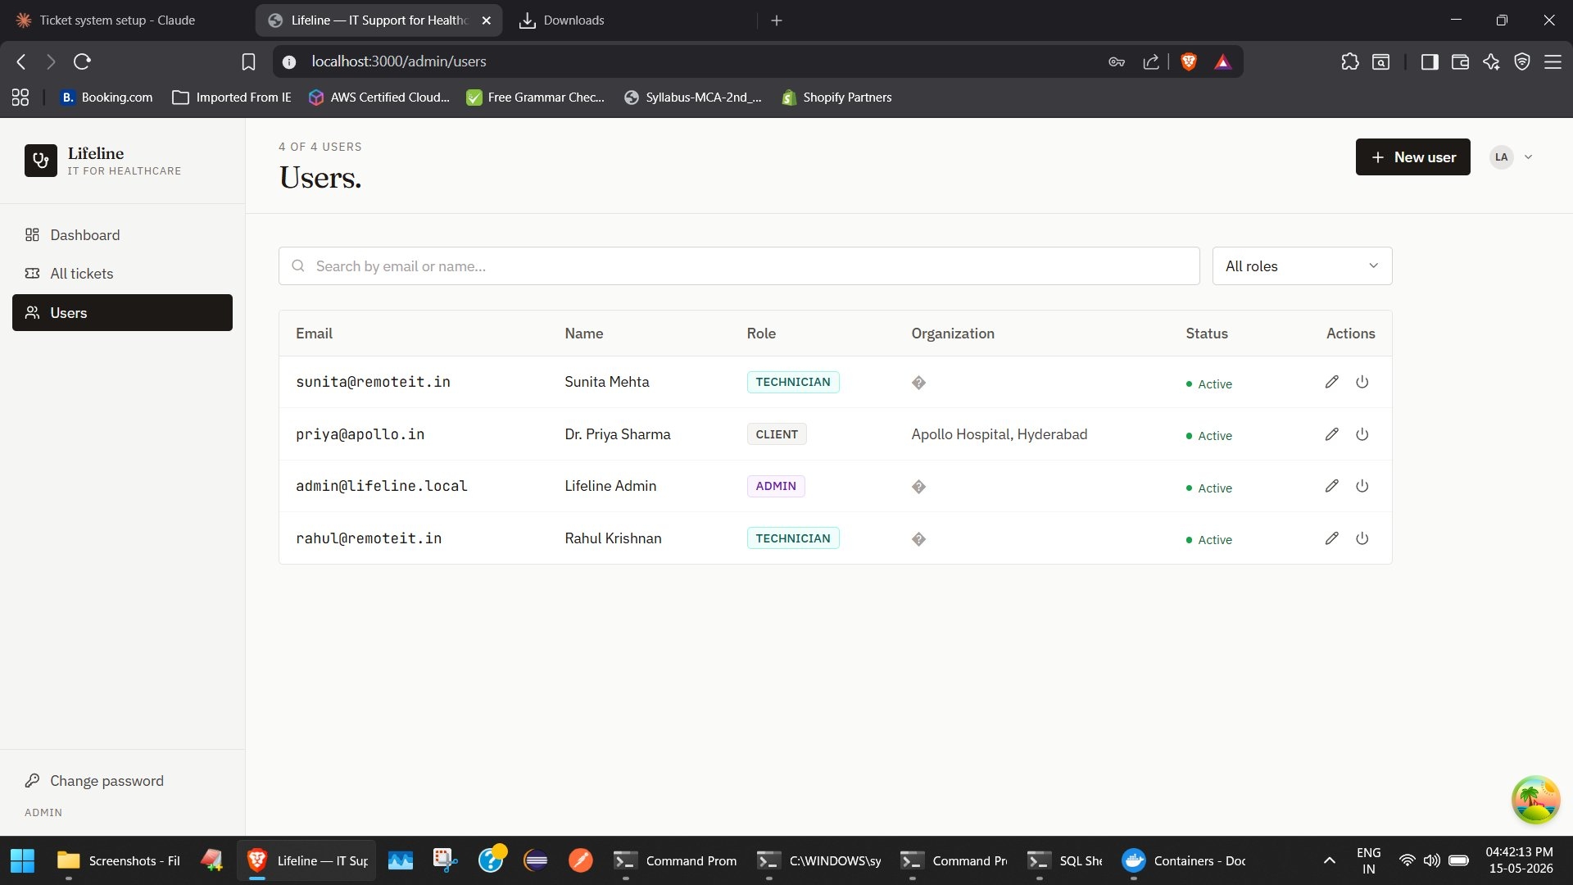
Figure 5.6 — Admin Users page

Creating a new user
Clicking “New user” opens a modal. The admin sets the email, name, role, organisation, and a temporary password to share with the user.
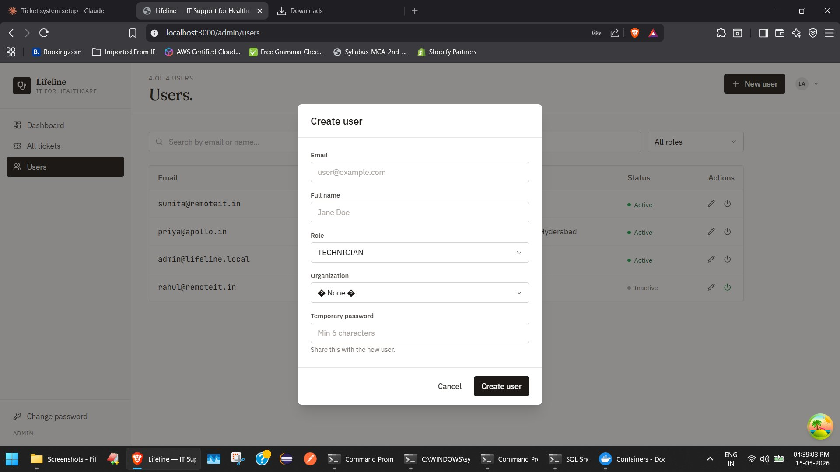
Figure 5.7 — Create user modal

Editing a user
Each row has an edit icon. The Edit user modal allows changing the name, role, and organisation. A Reset password button generates a fresh temporary password for that user.
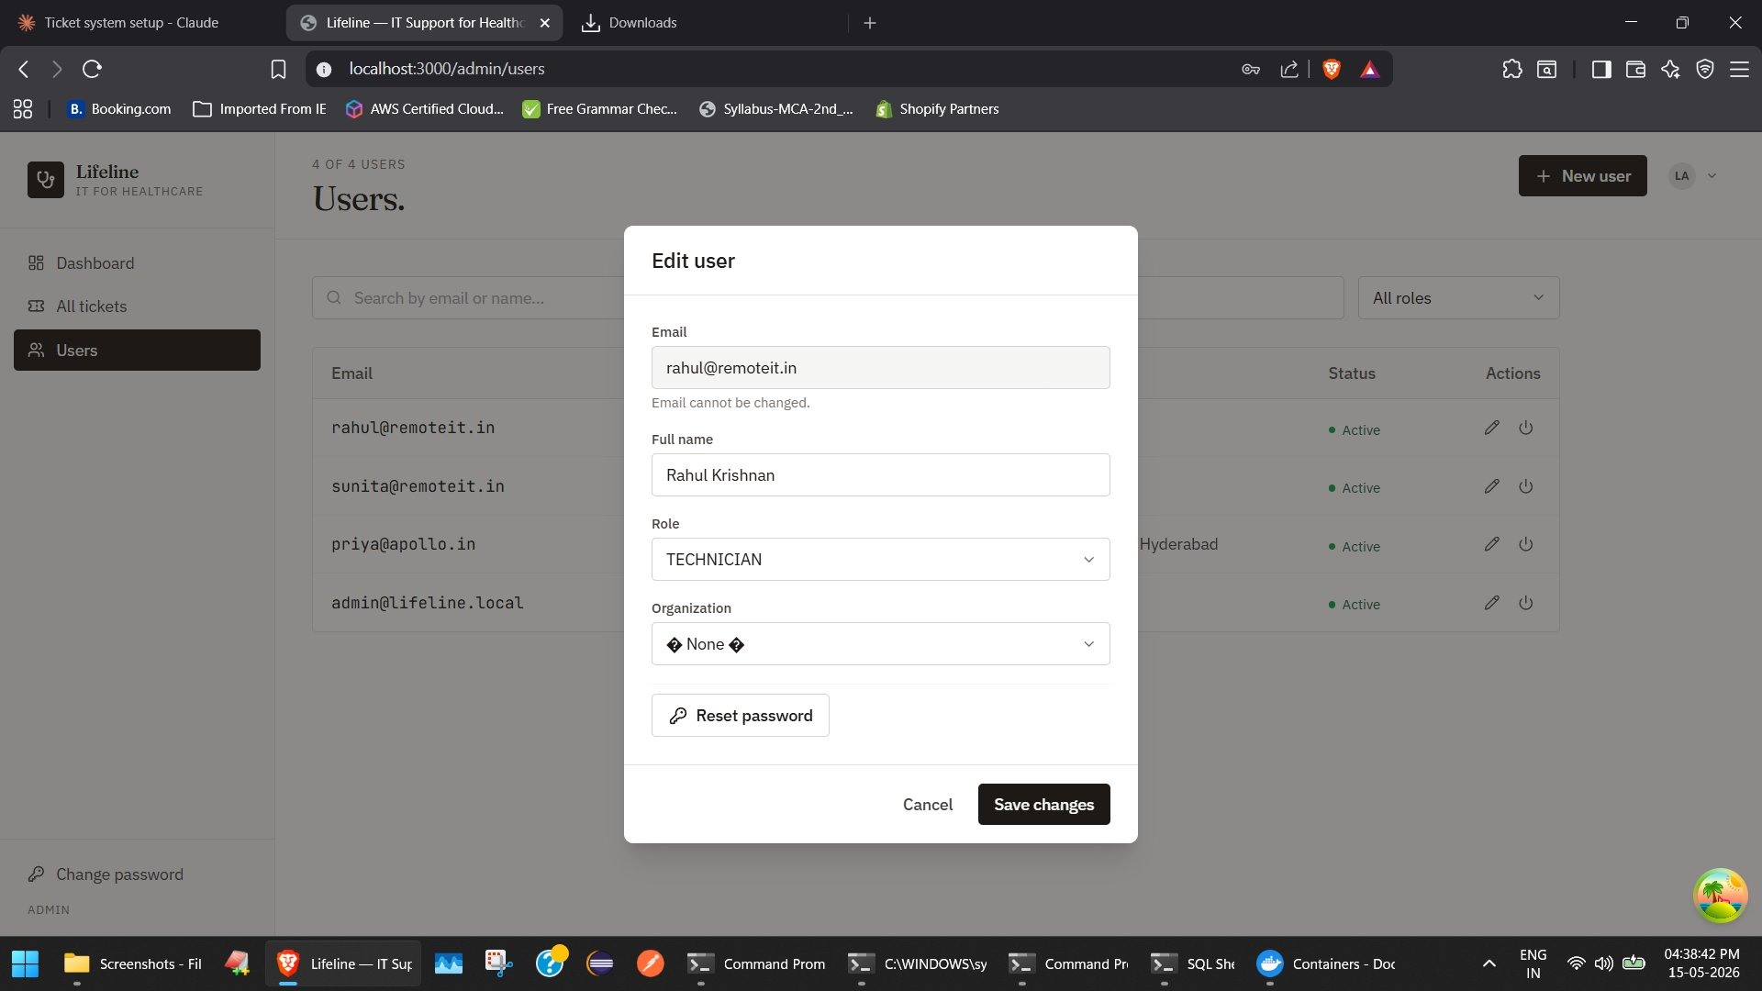
Figure 5.8 — Edit user modal

Deactivating a user
The power icon in the Actions column deactivates a user. The user remains in the database (to preserve their ticket history) but cannot sign in. They appear as Inactive in the list and can be reactivated with one click.
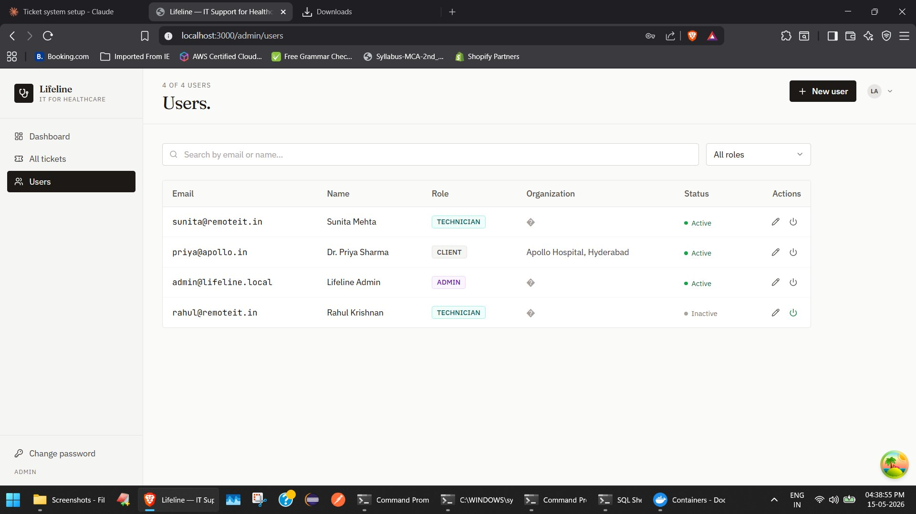
Figure 5.9 — Users list with one deactivated user

Change password
Every signed-in user can change their own password from the sidebar link.
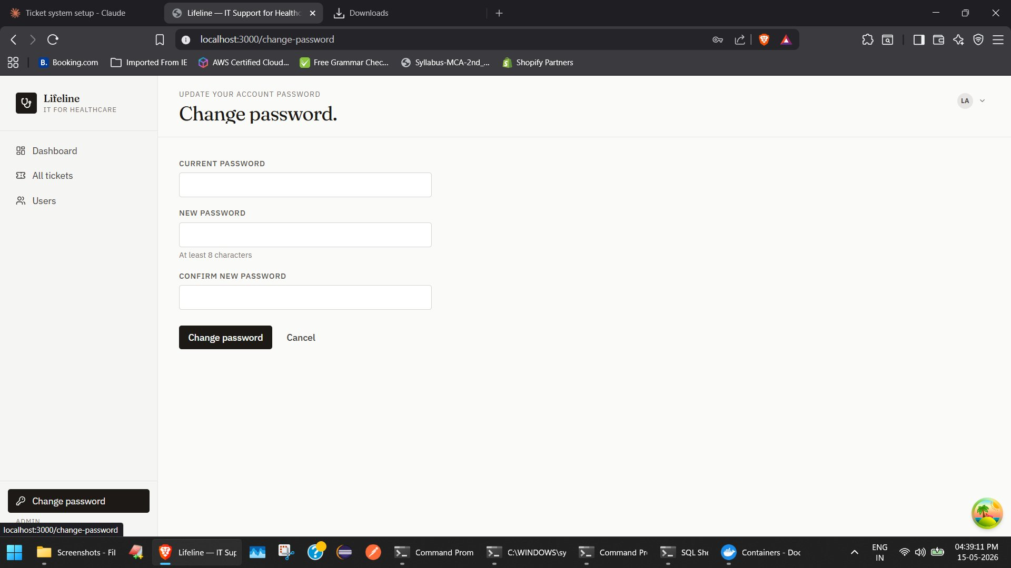
Figure 5.10 — Change password page

Admin view of all tickets
Admins also see a list of every ticket in the system, across all organisations.
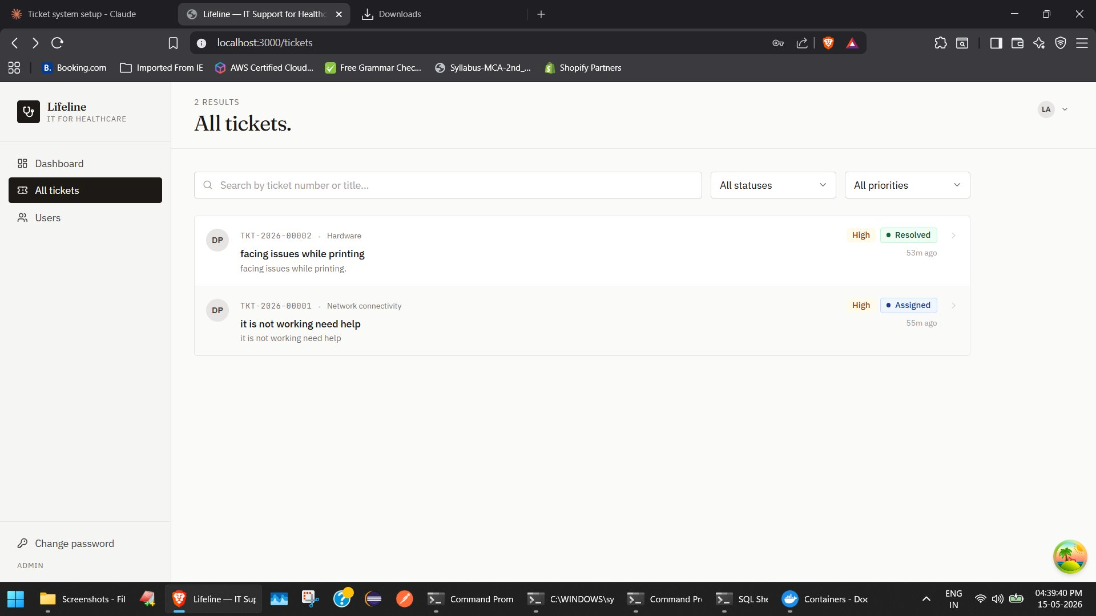
Figure 5.11 — All tickets (admin view)

6. How it works in practice
This section walks through three end-to-end journeys to show how the pieces fit together.

Journey A — A client raises a ticket
Dr. Priya Sharma at Apollo Hospital, Hyderabad cannot get her department’s printer to work. She signs in to Lifeline and clicks “New ticket”. The form has three steps.

Step 1 — Pick a category
Priya picks Hardware. A second dropdown appears for the specific issue. She picks Printer.
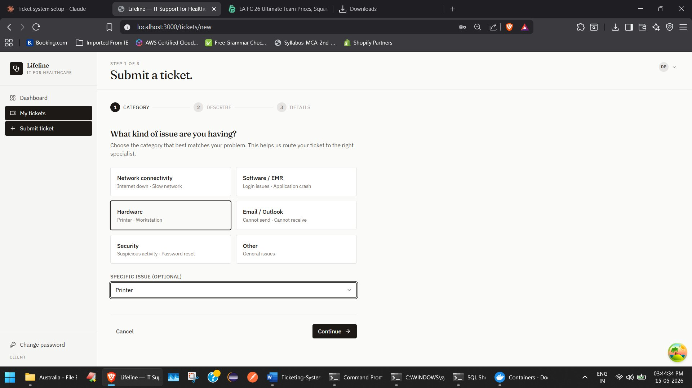
Figure 6.1 — Submit ticket, Step 1: category and sub-category

Step 2 — Describe the problem
Priya writes a short title and a longer description so the technician knows what they are dealing with.
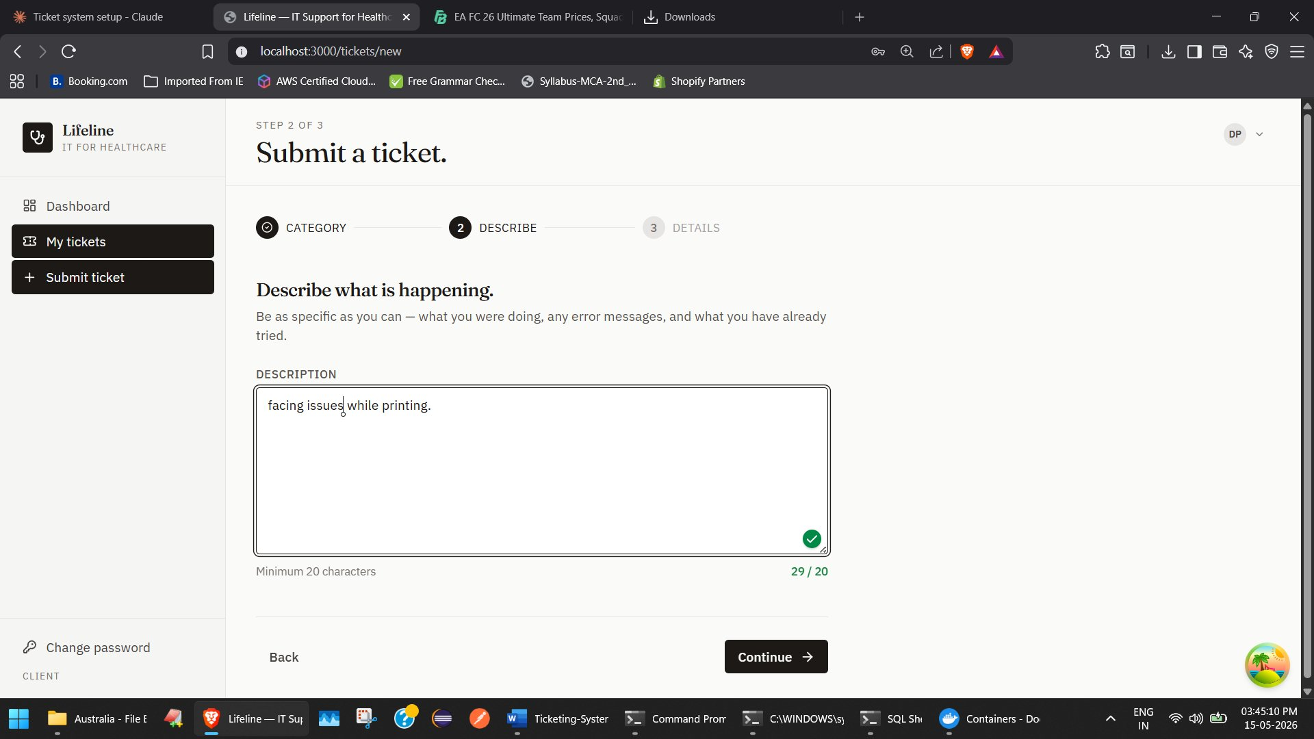
Figure 6.2 — Submit ticket, Step 2: description

Step 3 — Add details
Priya picks an urgency, indicates her best contact time, and optionally adds a follow-up date by when she needs this fixed. She submits the ticket.
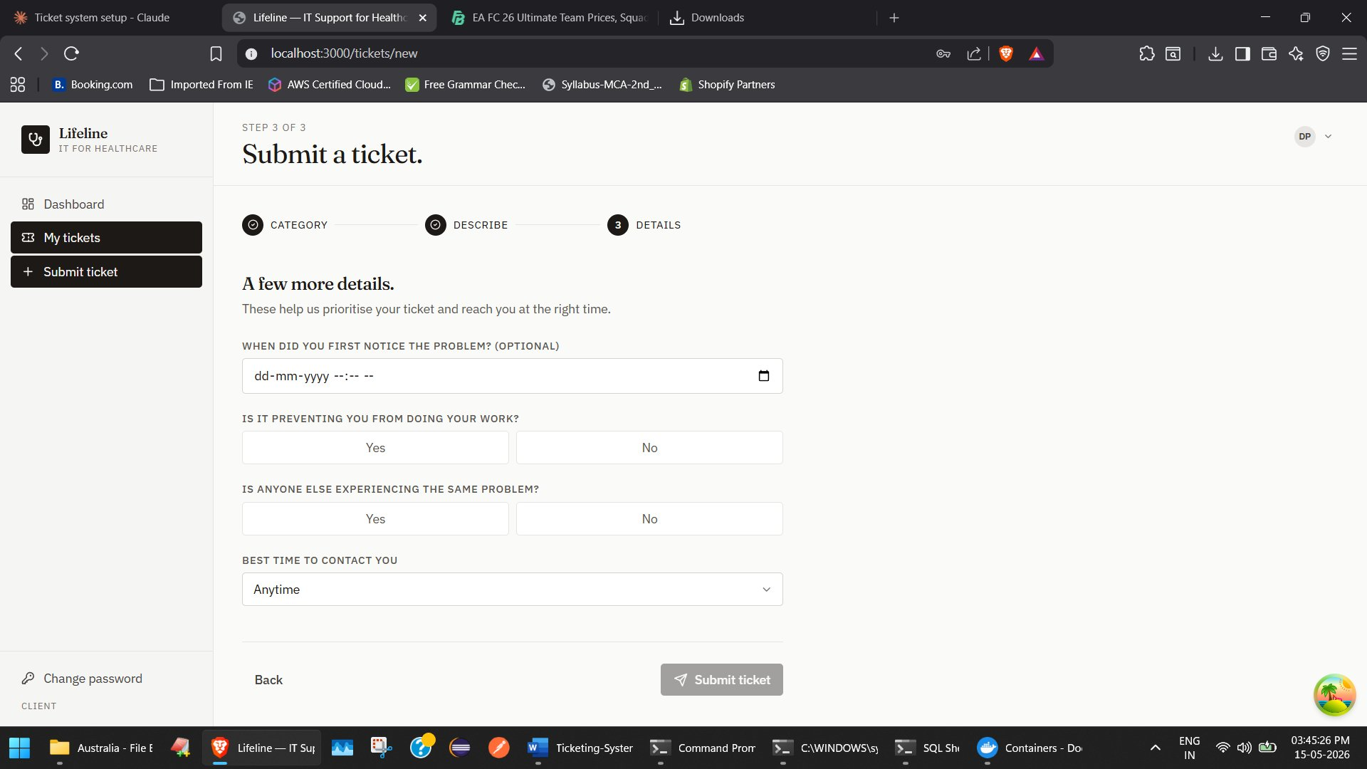
Figure 6.3 — Submit ticket, Step 3: details and submission

Journey B — A technician resolves the ticket
On the technician side, Sunita picks up the printer ticket from her queue. She works with Priya through ticket comments. Once the issue is fixed, she clicks Mark resolved, types a short resolution note, and confirms.
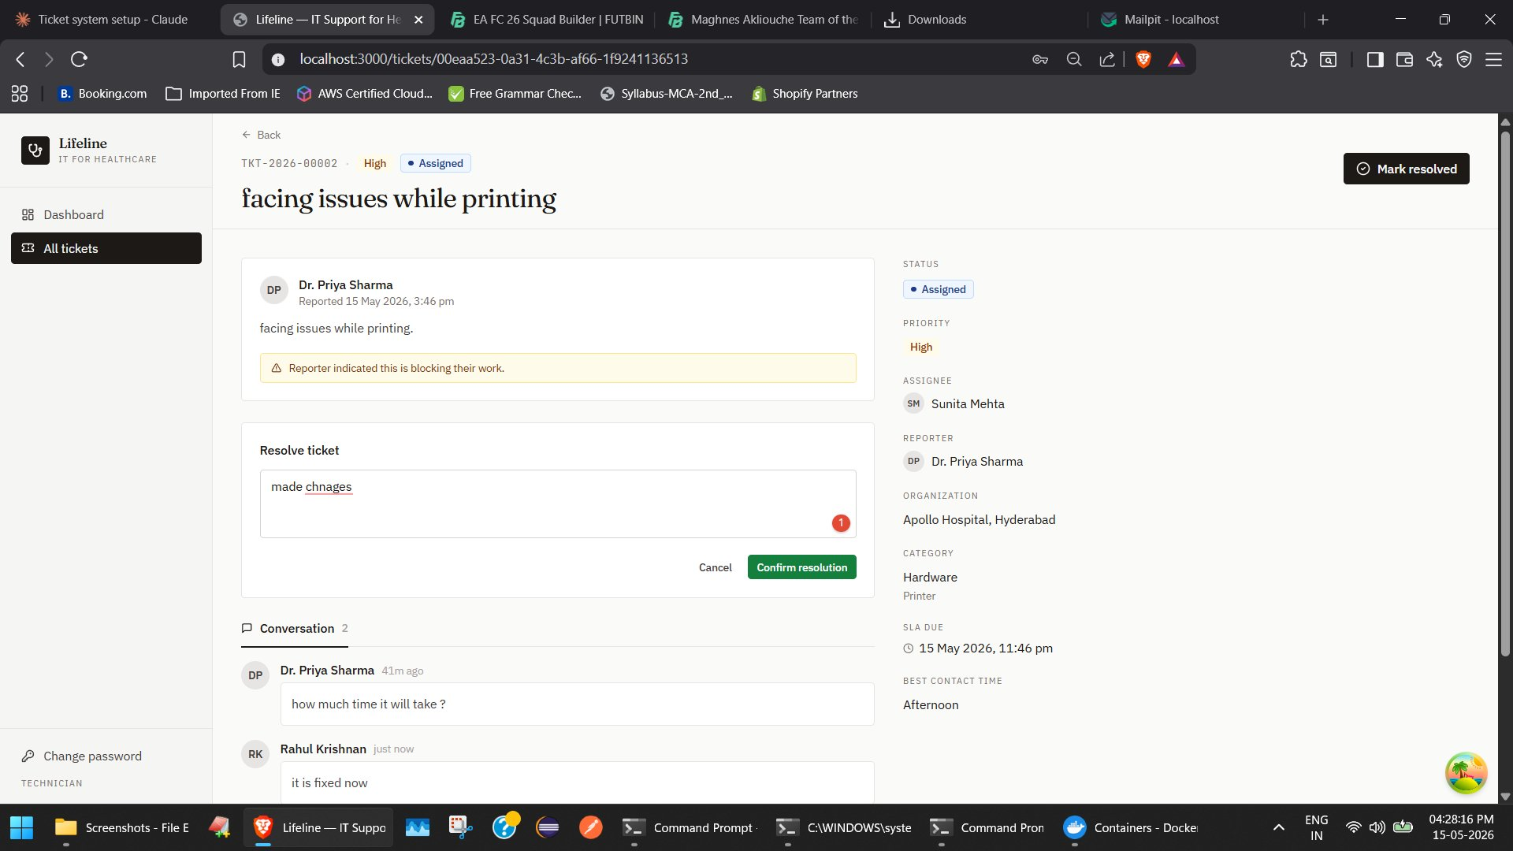
Figure 6.4 — Technician resolving a ticket
The ticket moves to Resolved. The resolution note is visible to the reporter, and the conversation stays preserved for reference.
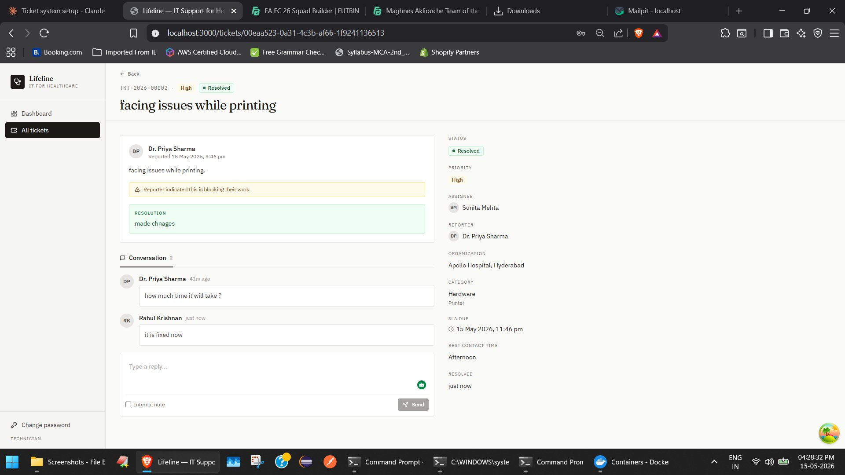
Figure 6.5 — Resolved ticket with resolution note

Journey C — Forgot password
A user who has forgotten their password can recover access without contacting an admin.

Step 1 — Request a reset
From the sign-in page, the user clicks Forgot password? and enters their email.
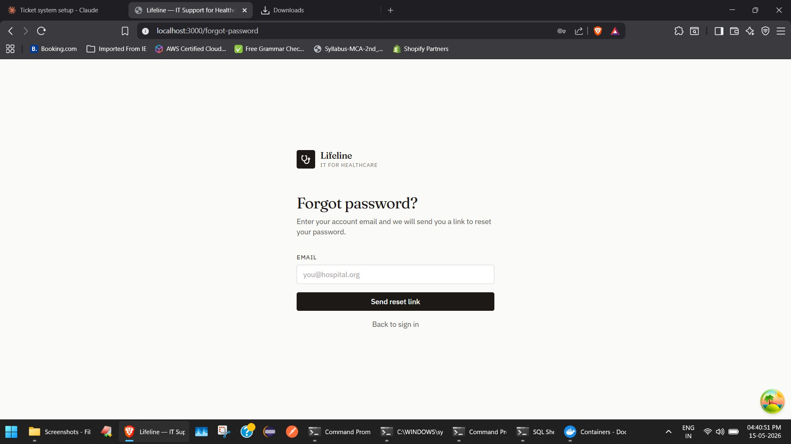
Figure 6.6 — Forgot password page

Step 2 — Confirmation
The app shows a confirmation message. For security, the same message is shown whether or not the email is actually registered.
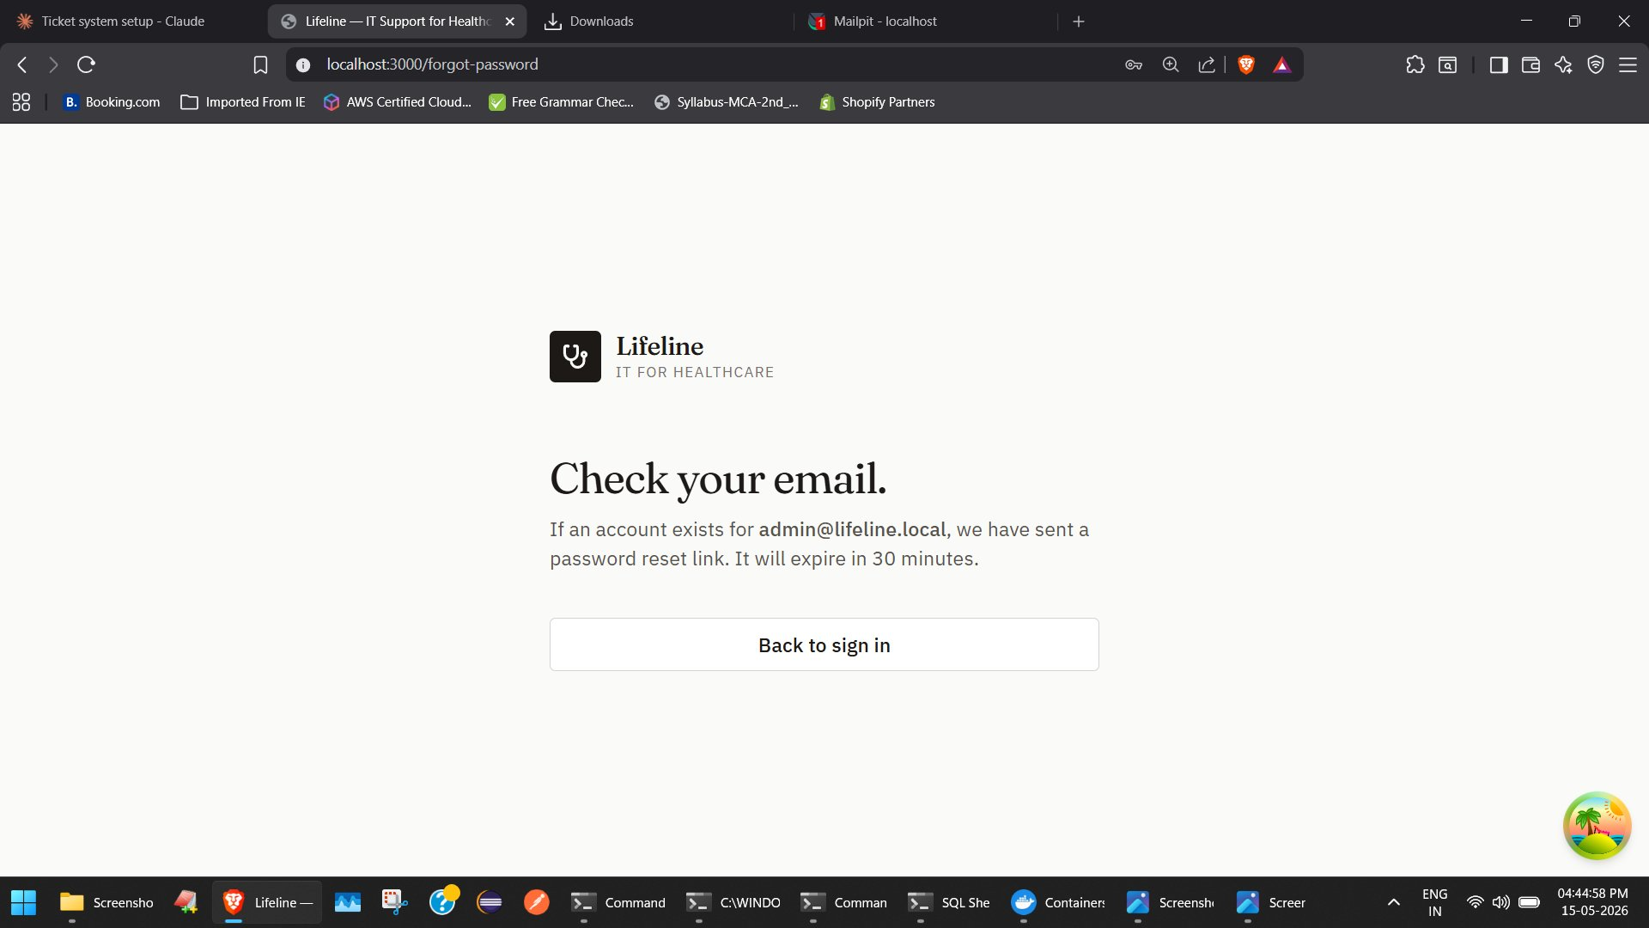
Figure 6.7 — Check your email confirmation

Step 3 — The reset email
A reset email arrives with a single-use link that expires in 30 minutes. (In the development environment shown here, the email is captured by Mailpit instead of being sent to a real inbox.)
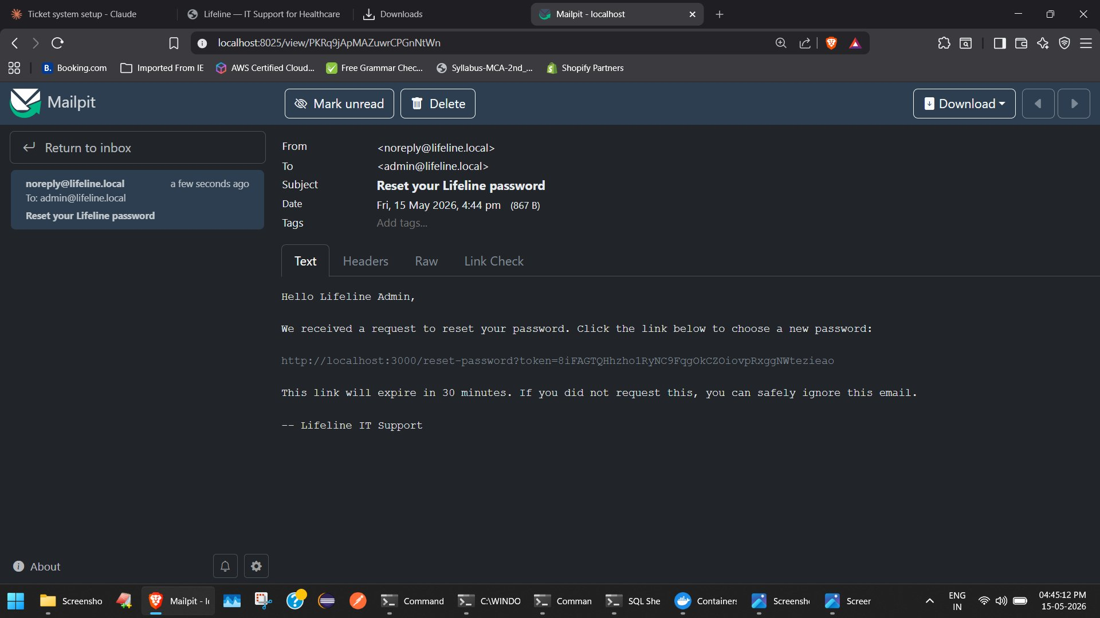
Figure 6.8 — Password reset email (captured in Mailpit)

Step 4 — Set a new password
Clicking the link opens the Set a new password page. The user types a new password and confirms it.
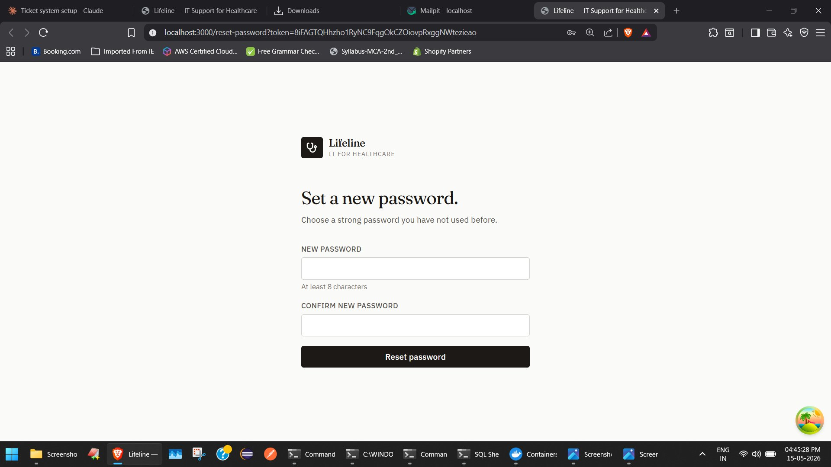
Figure 6.9 — Set a new password page

Step 5 — Done
The user sees a confirmation and can sign in with the new password. The reset link is marked used and cannot be reused.
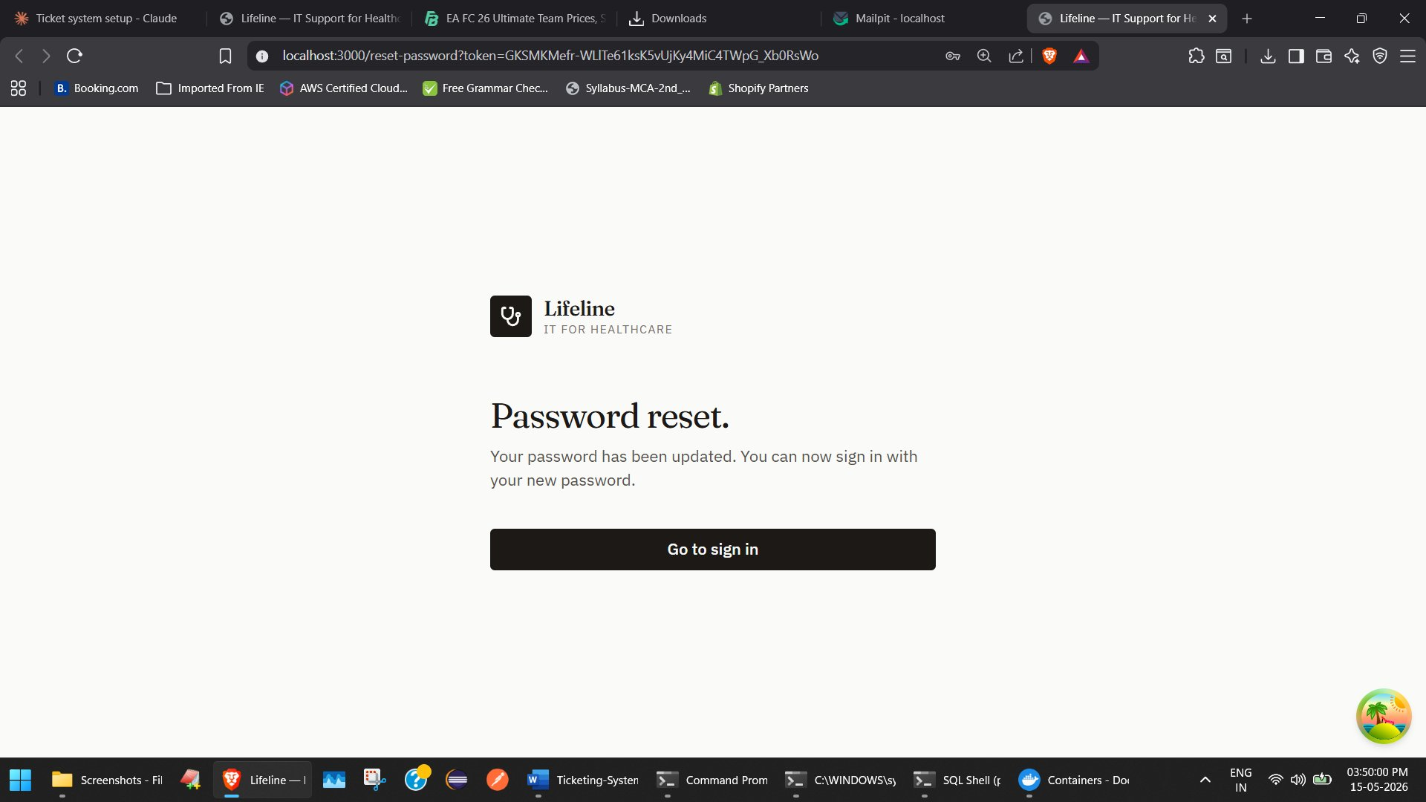
Figure 6.10 — Password reset success

7. What’s still pending
The following items are known gaps and should be addressed before the application is ready for production deployment.

Developer onboarding and configuration
- The repository has no README. A new developer needs to be walked through setup manually.
- Configuration files (application*.properties, .env.*) are not in the repository; they are shared separately. A new developer must obtain them out-of-band before the app will start.
- Docker compose database credentials must be aligned manually with the application config (POSTGRES_USER and POSTGRES_PASSWORD in docker-compose.yml must match spring.datasource.username and spring.datasource.password in application-local.properties).
- On Windows, a JVM timezone option must be set before starting the backend, because the Docker PostgreSQL image rejects the legacy timezone name that Windows reports by default.
- If a native PostgreSQL service is also running on the developer machine on port 5432, it can intercept connections meant for the Dockerised database. The native service must be stopped before starting the backend.

Application gaps
- The GET /users endpoint returns an empty list for non-admins. It should return HTTP 403 instead.
- DataInitializer resets seeded test user passwords on every backend startup. This is convenient for development but means a manually changed password for a seeded user will not survive a restart.
- Production SMTP is not configured. Password reset emails are sent only to Mailpit, a local catcher. A real SMTP provider must be configured for the app to send real emails.
- There is no audit log UI for admins to see who created, modified, or deactivated which users.

8. Tech stack

Backend
- Spring Boot 3.3.5 on Java 21.
- PostgreSQL 16 for the application database, with Flyway managing schema migrations.
- Redis 7 for caching and rate-limiting (used by the forgot-password feature).
- JWT-based authentication, stateless API.
- BCrypt password hashing.

Frontend
- React 18 with Vite 5 as the build tool.
- Tailwind CSS for styling.
- React Query for server state management.
- React Router for navigation.

Local development
- Docker Compose runs PostgreSQL, Redis, and Mailpit (an SMTP catcher for testing emails).
- Backend runs locally with Maven (mvnw spring-boot:run).
- Frontend runs locally with Vite (npm run dev).

Deployment target
- Azure App Service. Configuration is profile-based (local for development, azure for production).

