**TITLE :**

A Movie Recommender System Web App

Table of contents: Page no

1.Introduction 2

2.Method used and Code 3-4

3.References 5

Submitted By : Tanmay Rauthan

Section : C

Section Roll No : 63

University Roll No : 2013595

**Introduction:**

Recommender systems are information filtering tools that aspire to predict the rating for users and items, predominantly from big data to recommend their likes. Movie recommendation systems provide a mechanism to assist users in classifying users with similar interests. This makes recommender systems essentially a central part of websites and e-commerce applications.

There are two types of recommender system:

1.Content-based recommender system

2.Collaberative based recommender system.

I have made a item based collaborative filtering algorithm to recommend movies.

Advantages:

* Is better than user based collaborative filtering method as in item based system the property of item doesn’t change unlike users which have different behavioral patterns.
* The use of correlation helps in finding the strength of relation between two movies.

Tech Stack:

1.Python

2.HTML

3.CSS

4.Django

**Method Used:**

Similarity between movies is found with the help of pearson’s coefficient which finds the strength of relation between Movies X and Movie Y.

Correlation(X,Y)=Covariance(X,Y)/(Std.Deviation(X)*Std.Deviation(Y)).

The range of correlation is between [-1,1] where 1 is positive correlation,-1 is negative correlation and 0 is no correlation.

Library used:

1.Pandas.

2.Numpy.

3.Joblib

->Dataset is taken from movielens.com

**CODE SNIPPET:**

1.Creating a correlation matrix

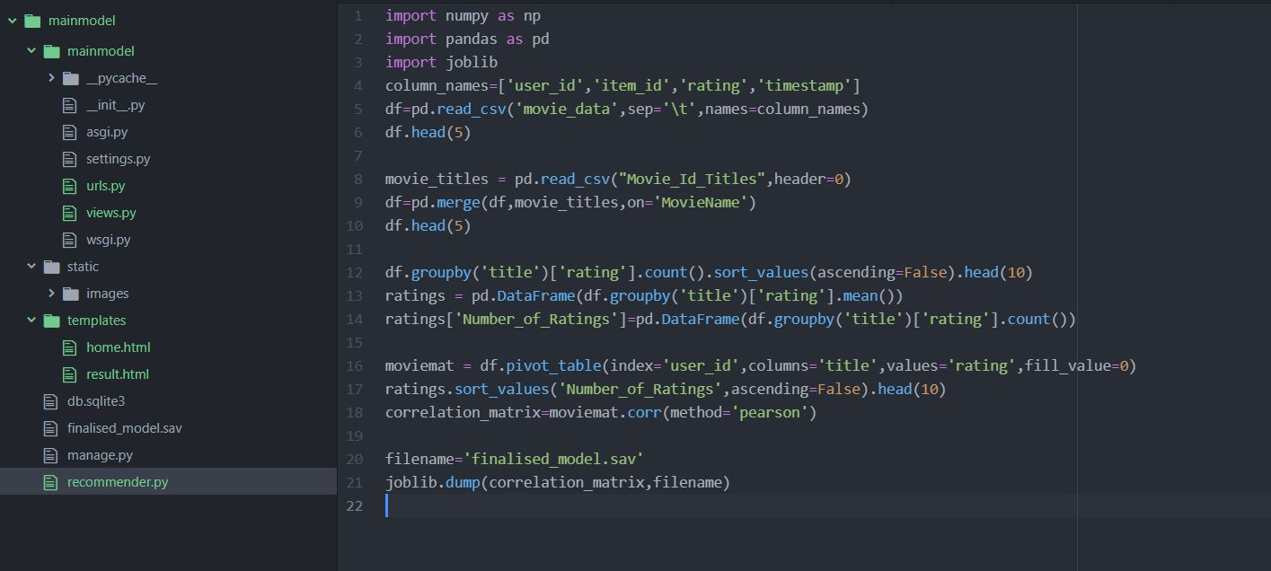

2.finding most similar movies according to input and adding our model to our webapp.

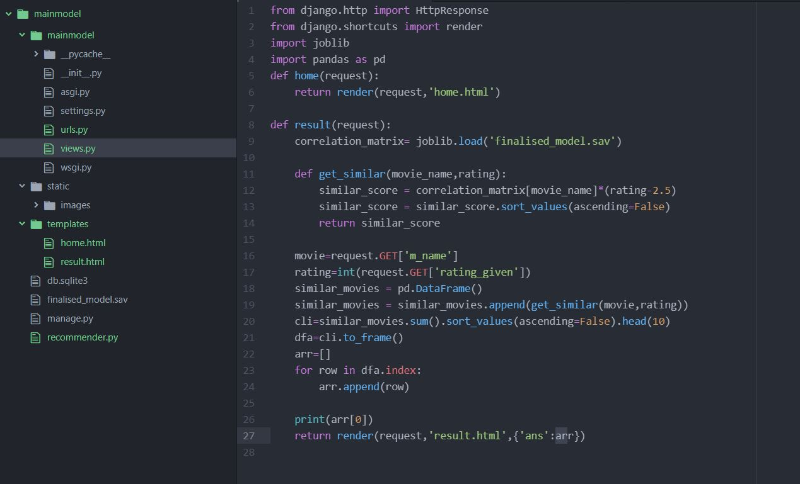

3.Home Page

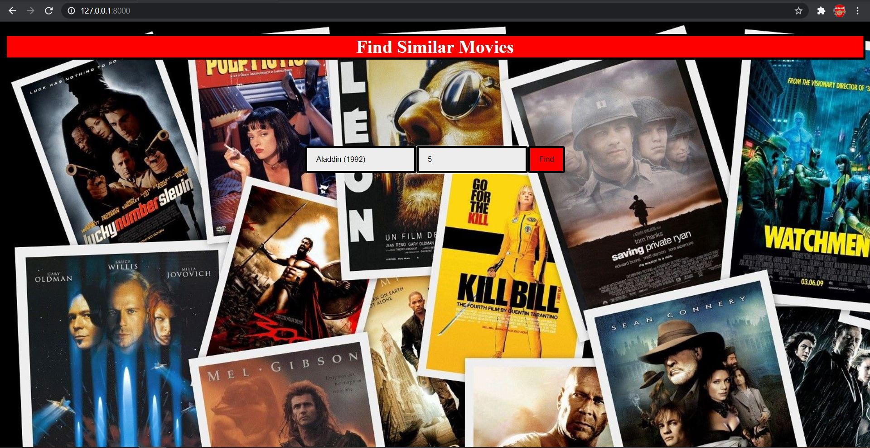

4.Result page



**CONCLUSION:**

The recommender gives us the movies which are most similar to the movie we have given in the input.

**REFERENCES:**

-><https://www.youtube.com/watch?v=h9gpufJFF-0>

->https://www.youtube.com/watch?v=d_4r0f72FRI

->Articles from where I have taken help: <https://www.mygreatlearning.com/blog/masterclass-on-movie-recommendation-system/#:~:text=The%20popularity%2Dbased%20recommendation%20system,generate%20a%20scalable%20recommendation%20system>.