PROJECT REPORT
ON
MULTI-CARD ATM SIMULATOR
A console-based multi-account ATM management system in Python
with JSON persistence, PIN authentication, and transaction history

Field | Details
Project Title | Multi-Card ATM Simulator
Source File | Multi Card Atm.py
Language | Python 3
Academic Context | Vityarthi Final Project

Submitted by:
Student Name: Tanmay Shrivas Enrollment / ID: 26BCE10603

1. Table of Contents

1. Cover Page
2. Introduction
3. Problem Statement
4. Functional Requirements
5. Non-functional Requirements
6. System Architecture
7. Design Diagrams
7.1 Use Case Diagram
7.2 Workflow Diagram
7.3 Sequence Diagram
7.4 Class / Component Diagram
7.5 ER Diagram
8. Design Decisions & Rationale
9. Implementation Details
10. Screenshots / Results
11. Testing Approach
12. Challenges Faced
13. Conclusion
14. Future Scope
15. References
.

2. Introduction
The Multi-Card ATM Simulator is a Python application that models the essential workflow of an automated teller machine that can serve more than one card. Unlike a single-account demo, this system lets a user create several cards, switch between them after PIN verification, and keep each card’s balance and history independent of the others.
The program is built around two classes. Card represents one account: a 16-digit card number, holder name, four-digit PIN, rupee balance, and a running list of timestamped transactions. ATMSystem is the controller. It holds every card in a dictionary, loads and saves them to atm_cards.json, and tracks which card is currently logged in. A menu-driven console layer sits on top of these classes so a user can add, list, login, transact, change PIN, delete, and exit without writing any code.
The project demonstrates core programming skills required in a first software-engineering / OOP course: encapsulation, input validation, file I/O, dictionary-based lookup, session control, and defensive handling of bad amounts, wrong PINs, and corrupted save files. Currency is displayed in Indian rupees (₹), matching a typical Indian banking context.

2.1 Objectives
- Simulate a realistic multi-card ATM: create accounts, authenticate, and perform banking operations.
- Keep each card’s data isolated (balance, PIN, mini-statement) while sharing one ATM controller.
- Persist all cards across program restarts using a structured JSON file.
- Enforce simple security rules: 4-digit PIN, three login attempts, masked card numbers, and confirmation before delete.
- Provide a clear, menu-driven interface suitable for demonstration and evaluation.

2.2 Scope
In scope
- Card lifecycle: add, list (masked), select by full number or last four digits, delete with confirmation.
- Authenticated operations: check balance, deposit, withdraw, mini-statement (last 5 entries), change PIN.
- Session actions: switch card without closing the program, logout to main menu, save on exit.
- Local persistence and recovery from a missing or corrupted JSON file.
Out of scope
- Hardware ATM, network banking, or a graphical UI.
- Encryption of PIN at rest, hashing, or multi-user OS access control.
- Fund transfer between cards, interest, overdraft, or cheque services.
- Central bank / ISO 8583 messaging or real card-network integration.

2.3 Tools and Technologies
Item | Choice | Role in this project
Language | Python 3 | Classes, file I/O, menus, validation
Standard library | os, json, random, datetime | Persistence, unique card numbers, timestamps
Data format | JSON | Human-readable store of all cards
IDE / runtime | Any Python 3 interpreter | Run Multi Card Atm.py from the project folder
Design style | OOP + procedural UI | Card/ATMSystem vs. menu functions

3. Problem Statement
Introductory ATM programs often model a single hard-coded account. That design cannot show how a real kiosk handles many cards, how a customer switches accounts, or how data survives after the program closes. Students also rarely practise PIN retries, insufficient-funds handling, or audit-style mini-statements.
The problem addressed by this project is: design and implement a console ATM that supports multiple independent cards, authenticates the holder with a PIN (maximum three attempts), performs deposit and withdrawal with validation, records a compact transaction history, and stores the entire card collection in a file so the next run continues from the last saved state.

3.1 Need for the System
- Demonstrate multi-object management (many Card instances under one ATMSystem).
- Practise lookup by full identifier and by last-four-digit shortcut, including the ambiguous-match case.
- Show session state (active_card) separate from stored accounts.
- Make failures visible: wrong PIN, invalid amount, insufficient funds, corrupt JSON.

3.2 Expected Outcome
A single Python file that an evaluator can run, create two or more cards, log in, transact, inspect a mini-statement, switch cards, save, restart the program, and still see the same cards and balances.

4. Functional Requirements
Functional requirements describe what the system must do. They are derived directly from the menus and methods in Multi Card Atm.py.
ID | Requirement | Source in code
FR-01 | The system shall create a card with holder name, 4-digit PIN, opening balance, and a unique 16-digit number. | ATMSystem.add_card / generate_card_number
FR-02 | The system shall list all cards with masked numbers (**** **** **** ####) and current balances. | list_cards / Card.masked_number
FR-03 | The user shall select a card by full number or last 4 digits; if several cards share the last 4 digits, the system shall demand the full number. | find_card_by_last4
FR-04 | Login shall succeed only when the PIN matches; after 3 failures the user returns to the main menu. | select_and_login / Card.verify_pin
FR-05 | An authenticated user shall view the exact balance of the active card. | card_session choice 1
FR-06 | Deposit shall accept a positive amount, increase balance, and log the event. | Card.deposit
FR-07 | Withdraw shall reject non-positive amounts and amounts greater than balance; a failed withdraw is still logged. | Card.withdraw
FR-08 | Mini-statement shall show the last 5 transactions newest-first, or a no-history message. | show_mini_statement / HISTORY_LIMIT
FR-09 | Change PIN shall require the current PIN and a new PIN of exactly 4 digits. | Card.change_pin
FR-10 | The user shall switch to another card or logout without losing other cards in memory. | card_session choices 6 and 7
FR-11 | Delete shall require confirmation (y) and shall clear active_card if that card was logged in. | delete_card
FR-12 | Save & Exit shall write every card (including PIN, balance, history) to atm_cards.json. | save_data / to_dict
FR-13 | On startup the system shall load existing JSON; if the file is missing, start empty; if corrupt, warn and continue. | load_data
FR-14 | Card creation shall cancel if opening balance is invalid or negative. | main() add-card branch

4.1 User Roles
There is a single actor — the ATM user — who performs both administrative actions (add/list/delete cards, save) and customer actions (login and banking). No separate bank-officer login exists; this matches a teaching simulator rather than a production ATM.

5. Non-functional Requirements
ID | Category | Requirement
NFR-01 | Usability | Menus are numbered 1–5 (main) and 1–7 (card). Invalid choices print a short retry message.
NFR-02 | Security (basic) | PIN is 4 digits; card numbers are masked in lists; delete needs explicit y confirmation; login is locked after 3 PIN failures for that attempt.
NFR-03 | Reliability | Amount parsing uses try/except (ValueError). JSON load uses try/except for JSONDecodeError and KeyError.
NFR-04 | Persistence | Data survives process exit when the user chooses Save & Exit. File is written with indent=2 for readability.
NFR-05 | Maintainability | Business rules live in Card; collection and I/O live in ATMSystem; UI is separate functions.
NFR-06 | Performance | All operations are in-memory O(n) over a small card set; suitable for classroom demos.
NFR-07 | Portability | Uses only Python standard library; runs on Windows, Linux, and macOS with Python 3.
NFR-08 | Auditability | Every deposit, withdraw (including failure), PIN change, and card creation is timestamped.
NFR-09 | Localisation | Money is formatted to two decimals with the ₹ symbol.
NFR-10 | Limitation | PIN is stored in plain text in JSON — acceptable for a simulator, not for production banking.

6. System Architecture
The architecture is a three-layer desktop console application. There is no network client or database server. The presentation layer is the pair of menus. The business layer is ATMSystem plus Card. The data layer is a JSON document on disk, mirrored in memory as a dictionary of Card objects.
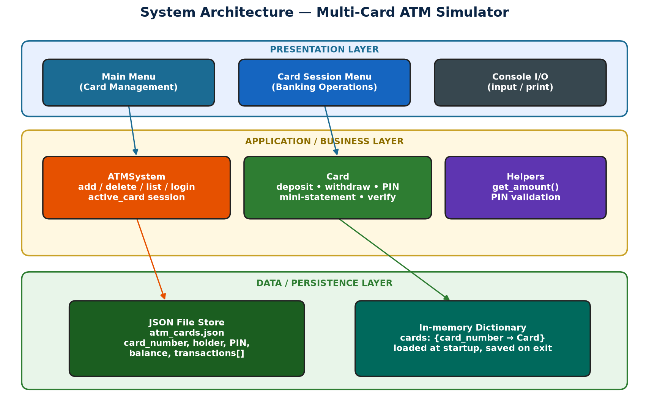

6.1 Runtime behaviour
- main() constructs ATMSystem(), which immediately calls load_data().
- The main loop prints the main menu and dispatches choices 1–5.
- Login (choice 3) resolves a card, verifies PIN up to three times, then enters card_session().
- card_session() sets atm.active_card and loops until Switch or Logout.
- Switch returns the string "switch" so main() can prompt for another card without reprinting a full logout path.
- Choice 5 calls save_data() and terminates the process.

6.2 Data flow
User input → validation (PIN length, float amount) → Card/ATMSystem method → mutation of balance or dictionary → optional print of result → on exit, serialization of every Card.to_dict() into one JSON object keyed by card_number.

7. Design Diagrams
The following UML-style diagrams are reverse-engineered from the implemented source, not from an unused design. They describe the system as it actually behaves.

7.1 Use Case Diagram
The ATM User is the only actor. Login includes PIN verification. Banking use cases (balance, deposit/withdraw, statement, change PIN) are available only after a successful login. Add, view, delete, and save are available from the main menu without a session.
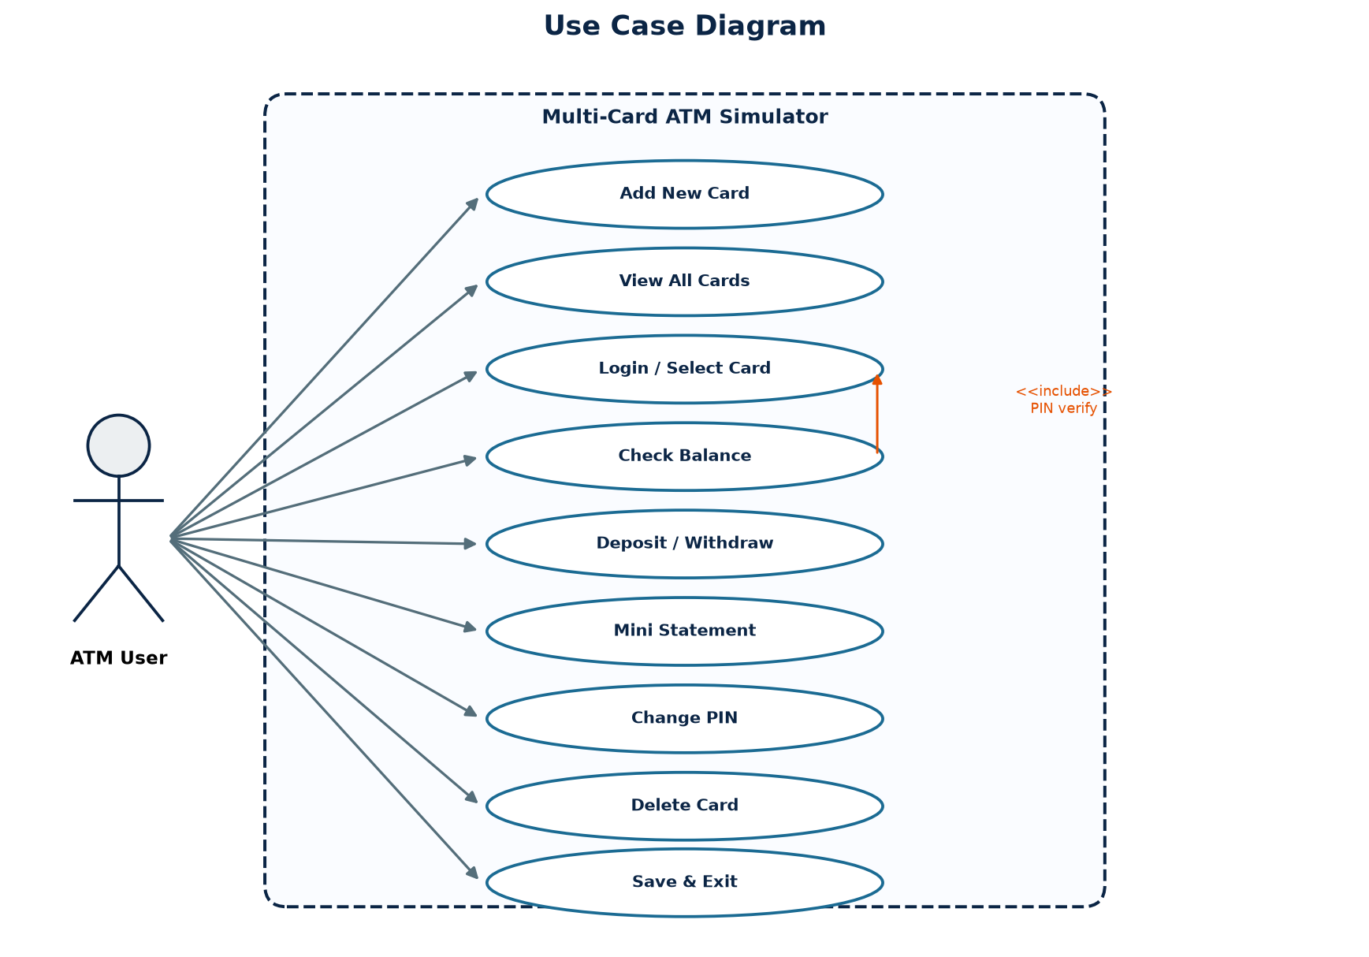

7.2 Workflow Diagram
The program is a loop: load → main menu → branch → (optional card session) → back to main menu → save and end. PIN failure after three tries returns to the main menu without opening a session. Switch card clears active_card and returns to the main loop so the user can select again.
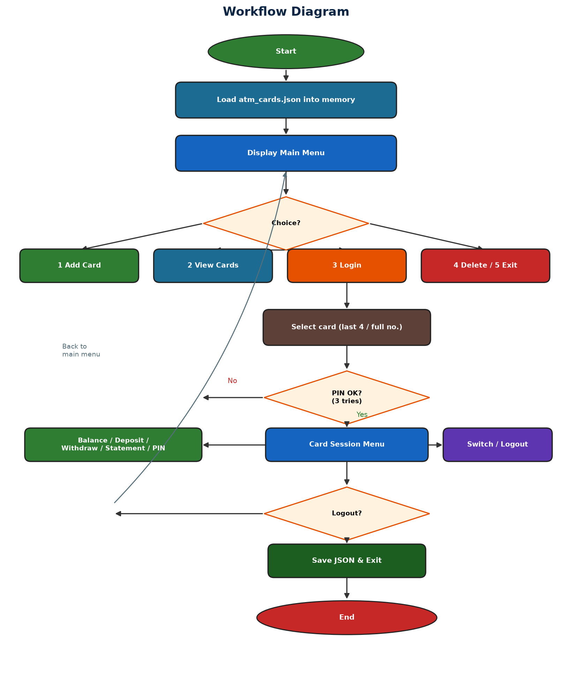

7.3 Sequence Diagram
A typical path is: select card, verify PIN, withdraw (Card checks funds, updates balance, logs), request mini-statement, then save to JSON. Dashed arrows are replies (PIN result, confirmation).
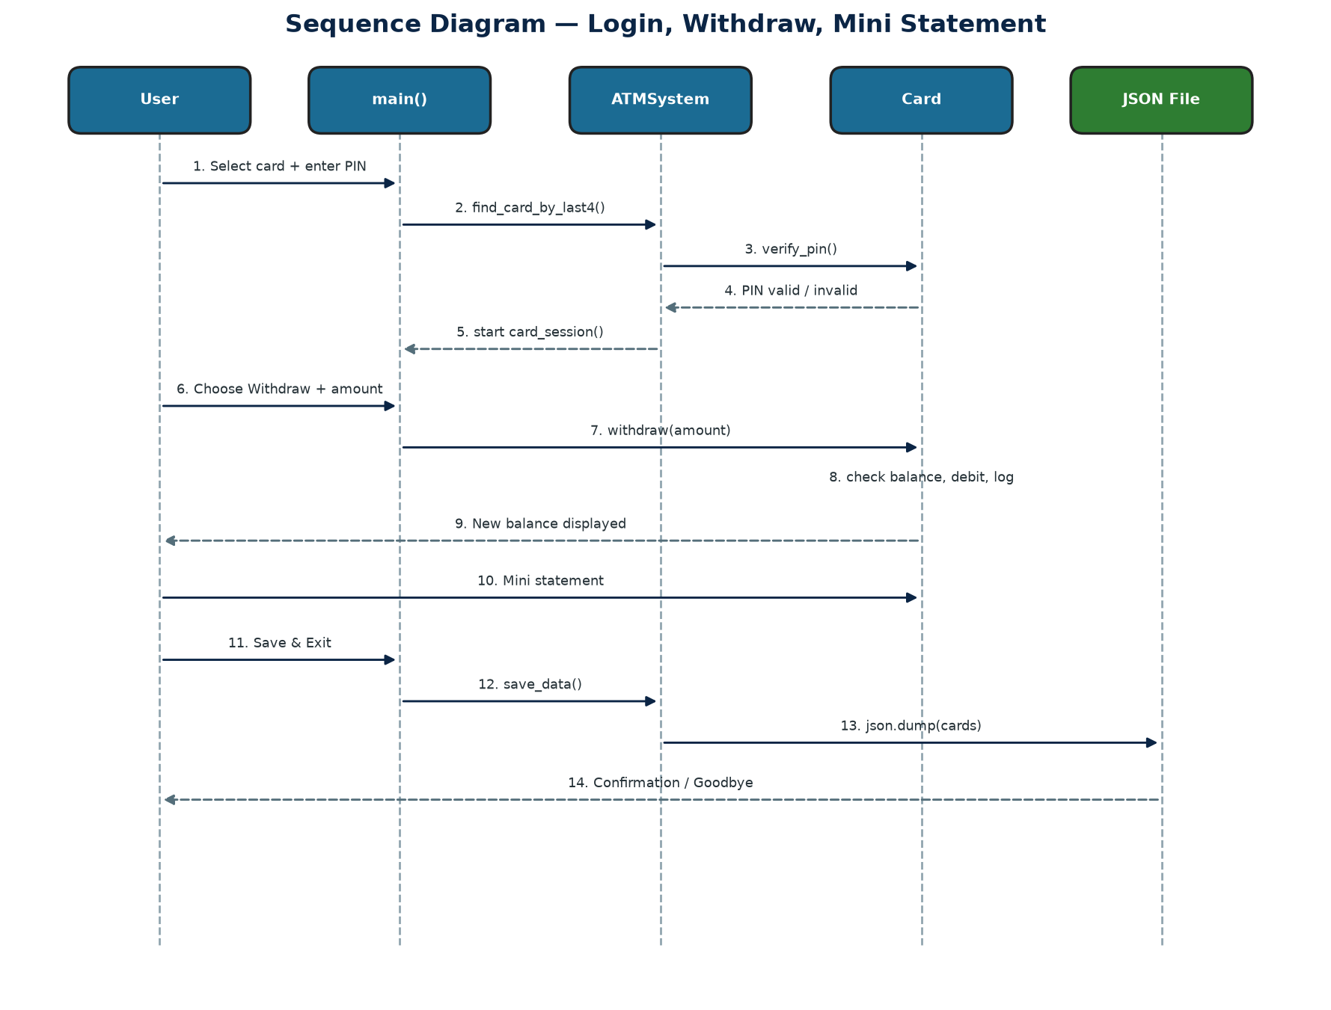

7.4 Class / Component Diagram
ATMSystem has a one-to-many association with Card (dictionary cards). The interface component (main, card_session, select_and_login, menu printers, get_amount) depends on both classes. Card encapsulates serialization (to_dict / from_dict) so ATMSystem never hand-builds JSON field by field except by calling those methods.
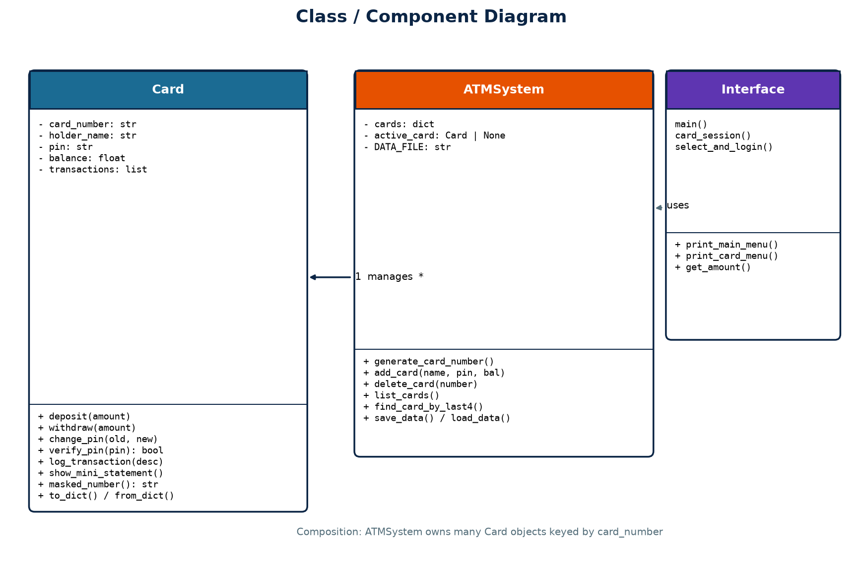
Figure 5. Class and component diagram

7.5 ER Diagram
Storage is file-based, not a relational database. Logically, CARD has attributes card_number (primary key), holder_name, pin, and balance. TRANSACTION is a weak entity stored as an ordered list of timestamped strings inside each card. The relationship is 1-to-N: one card has many transaction lines. There is no separate txn_id in the file; order in the list is the identity.
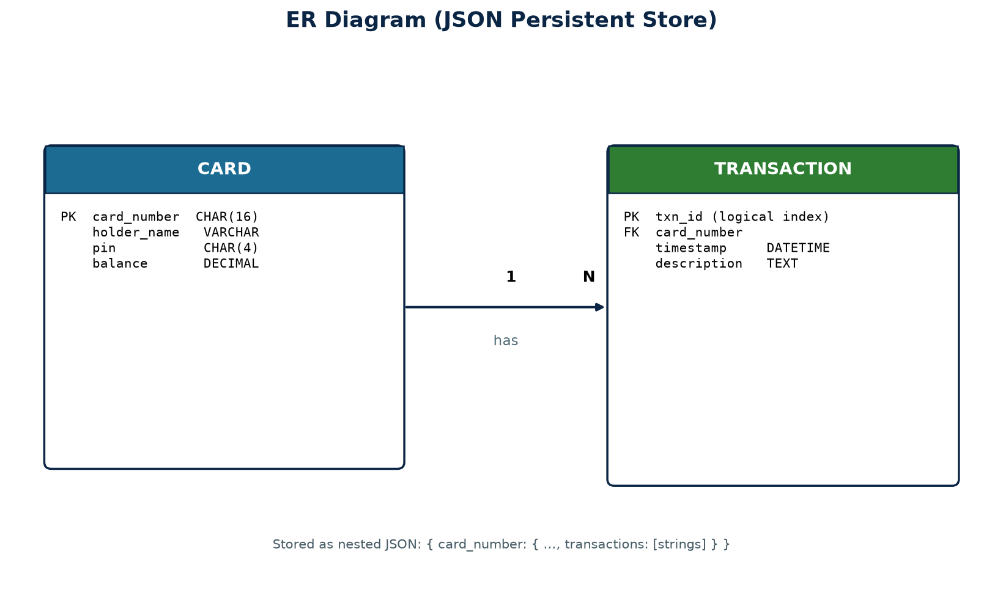

Sample persisted structure:
{
"4812937465019283": {
"card_number": "4812937465019283",
"holder_name": "Rahul Sharma",
"pin": "4321",
"balance": 5700.0,
"transactions": [
"[2026-09-22 22:15:01] Card created with opening balance ₹5000.00",
"[2026-09-22 22:16:10] Deposited ₹1500.00",
"[2026-09-22 22:16:25] Withdrew ₹800.00"
]
}
}

8. Design Decisions & Rationale
Decision | Alternatives considered | Rationale
Two classes: Card and ATMSystem | One global dict; procedural-only script | Separates account rules from collection, login, and file I/O; easier to test and explain in a viva.
JSON file instead of SQLite / CSV | Database, pickle, CSV | JSON is standard-library, readable during evaluation, maps cleanly to nested transactions. Pickle is not human-readable; SQL is extra scope.
16-digit random unique numbers | User-typed card numbers; sequential IDs | Closer to real PAN length; uniqueness loop avoids collisions.
Select by last 4 digits | Full number only | Matches how people refer to cards; ambiguity is handled by requiring the full number.
Masking in lists, full number only at creation | Always show full PAN | Reduces shoulder-surfing during a demo while still printing the number once at creation so the student can log in.
HISTORY_LIMIT = 5 | Full ledger on screen | Mirrors a real mini-statement; full list remains in the JSON for later.
Failed withdrawals are logged | Log only success | Supports an audit trail of denied attempts (insufficient funds).
3 PIN attempts then abort login | Unlimited retries; lock the card forever | Balances security teaching with recoverability in a classroom (user can try again from main menu).
Save only on explicit exit | Auto-save after every operation | Makes persistence a visible step for the demo; the trade-off is data loss if the process is killed (noted as a limitation).
Plain-text PIN in JSON | hashlib SHA-256 | Keeps the file inspectable for marking. Production systems must hash and never print PIN after creation.
Console menus not GUI | tkinter / web | Fits a single-file submission, no extra dependencies, easy to screenshot for this report.
active_card on ATMSystem | Pass card only as a local variable | Models “card inserted in the machine” and lets delete_card drop the session if that card is removed.

8.1 Validation rules (implemented)
- PIN: length 4 and isdigit() at creation and at change.
- Opening balance: must parse as float and be ≥ 0.
- Deposit/withdraw amount: must parse as float; must be > 0; withdraw must be ≤ balance.
- Menu choices: any other string prints an invalid-choice message and the loop continues.
- Delete: any confirmation other than y is ignored (card kept).

9. Implementation Details

9.1 Project structure
The submitted software is a single module. Constants DATA_FILE and HISTORY_LIMIT sit at the top. Class Card, class ATMSystem, then helper and menu functions, then main() under the standard if __name__ == "__main__" guard.
File / artefact | Purpose
Multi Card Atm.py | Complete application source
atm_cards.json | Created at runtime when the user saves (not required at first run)
This report (.docx) | Documentation of design, implementation, tests, and results

9.2 Card class
Attributes: card_number, holder_name, pin, balance, transactions. Operations: deposit, withdraw, change_pin, verify_pin, log_transaction, show_mini_statement, masked_number. Serialization: to_dict and from_dict (static). Balance updates are in-place on the object; ATMSystem does not recalculate totals.
Withdraw is the strictest money path: non-positive amounts are rejected without a log; overdraft attempts are rejected and logged as “Failed withdrawal … (insufficient funds)”. Successful withdraw deducts then logs “Withdrew ₹…”.

9.3 ATMSystem class
self.cards is a dict keyed by the 16-digit string. generate_card_number loops until random.randint produces a number not already present. find_card_by_last4 first checks exact key match, then endswith on the query; zero matches return None, one match returns that Card, many matches print a message and return None.
load_data is silent if the file does not exist (first run). If the file exists but JSON is invalid or keys are missing, it prints a warning and leaves cards empty rather than crashing. save_data writes the whole map in one dump.

9.4 Session and menus
select_and_login lists cards, reads a query, and runs a for-attempt in range(3) PIN loop. On success it returns the result of card_session ("switch" or "logout"). main() treats "switch" as continue so the user can immediately choose option 3 again. get_amount isolates float conversion so deposit, withdraw, and opening balance share one error path.

9.5 How to run
From the project folder:
python "Multi Card Atm.py"
Requires Python 3. No pip packages are needed to run the ATM itself. Use the main menu to add at least one card, note the printed 16-digit number and PIN, then login with the last four digits.

9.6 Key algorithms (brief)
- Unique PAN generation: repeat random 16-digit string until not in self.cards.
- Last-4 resolution: exact dict lookup, else filter endswith, else disambiguate.
- Mini-statement: slice transactions[-5:] then reversed() for newest first.
- Persistence: dict comprehension {number: card.to_dict()} → json.dump.

10. Screenshots / Results
The following captures were produced by executing the same classes as Multi Card Atm.py (add two cards, login, deposit ₹1500, withdraw ₹800, reject an oversize withdraw, change PIN, save). Card numbers are generated randomly at runtime, so digits in a live demo will differ; behaviour is identical.

10.1 Main menu
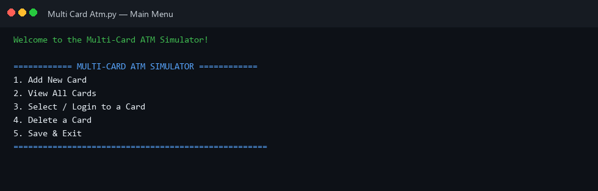
Figure 7. Welcome screen and main menu (options 1–5)

10.2 Adding cards
Two holders were created: Rahul Sharma (PIN 1234, opening ₹5000) and Priya Patel (PIN 5678, opening ₹10000). The system printed the full card number once so it can be used for login.
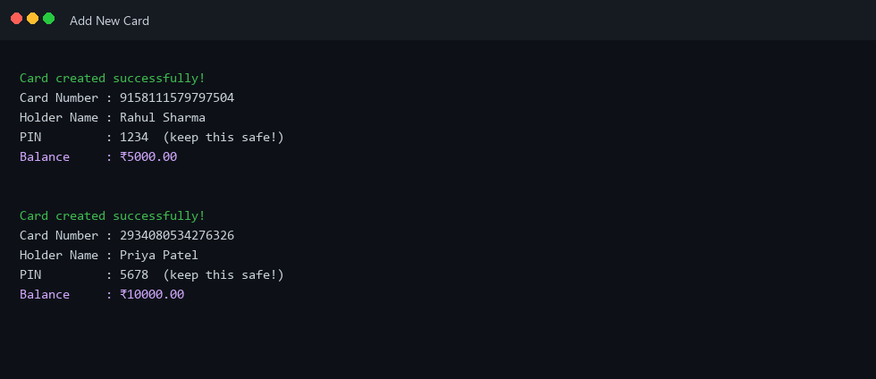
Figure 8. Successful card creation for two holders

10.3 View all cards
The list shows masked PANs and balances. Full numbers are not repeated here, which is the intended privacy behaviour.
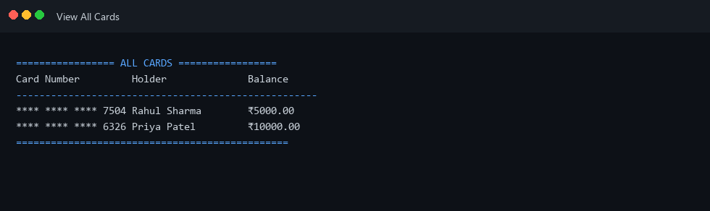
Figure 9. Card directory with masked numbers

10.4 Login and card session
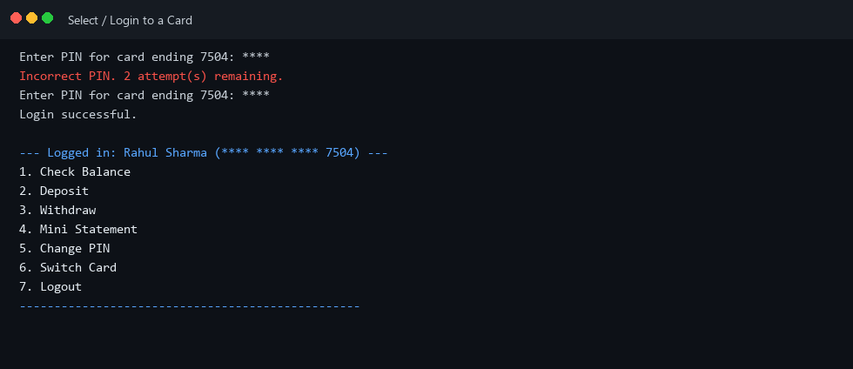
Figure 10. PIN entry and logged-in card menu

10.5 Banking operations
On Rahul’s card: deposit ₹1500 (balance ₹6500), withdraw ₹800 (balance ₹5700), then a ₹20000 withdraw which is denied and recorded as a failed transaction. The mini-statement lists the latest events with timestamps.
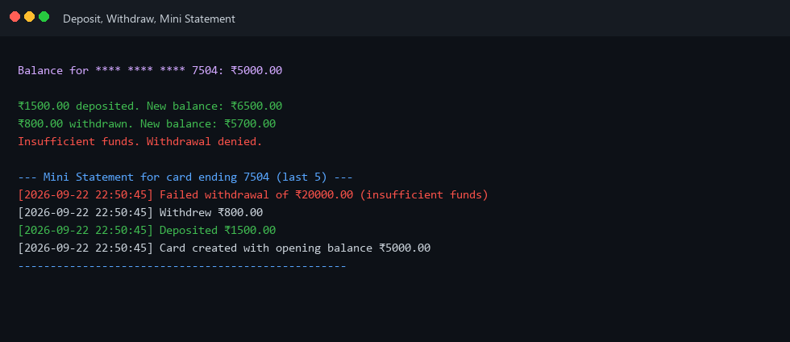
Figure 11. Balance updates, insufficient-funds handling, mini-statement

10.6 Change PIN
Wrong current PIN is rejected. A new PIN that is not four digits is rejected. A correct old PIN plus a 4-digit new PIN succeeds and is logged.
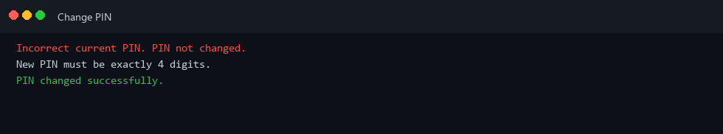
Figure 12. PIN change success and failure paths

10.7 Save and exit
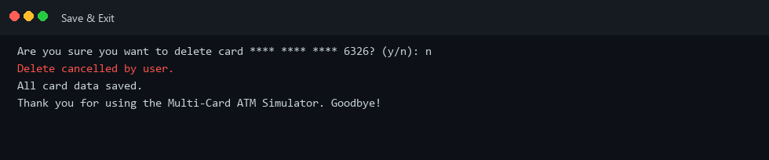
Figure 13. Persistence confirmation

10.8 Result summary
Scenario | Observed result
Create two cards | Unique 16-digit numbers; opening balances stored; creation logged
List cards | Masked numbers; both balances visible
Wrong PIN then correct PIN | Attempt counter; session opens only on match
Deposit 1500 | Balance 5000 → 6500
Withdraw 800 | Balance 6500 → 5700
Withdraw 20000 | Denied; balance unchanged; failure logged
Mini-statement | Last entries shown newest first, including the failed withdraw
PIN change validation | Rejects wrong old PIN and non-4-digit new PIN
Save & Exit | atm_cards.json written; next launch reloads cards

11. Testing Approach
Testing was manual and scenario-based, which is appropriate for a menu-driven console project without an automated test directory. Each functional requirement was exercised at least once. Negative tests were included because much of the educational value is in rejection paths.

11.1 Test strategy
- Unit-level: call Card methods (deposit, withdraw, change_pin, verify_pin) with valid and invalid arguments.
- Integration-level: ATMSystem add → find → session operations → save → new ATMSystem() load.
- System-level: full menu walk-through as an evaluator would run the file.
- Error-level: non-numeric amounts, empty card list, last-4 clash, corrupt JSON.

11.2 Test cases
TC | Steps | Expected | Status
TC-01 | Start with no JSON file | Welcome + empty-capable menus; view cards says none found | Pass
TC-02 | Add card, PIN abc / 12 / 12345 | Rejected until exactly 4 digits | Pass
TC-03 | Opening balance -100 or text | Card creation cancelled | Pass
TC-04 | Add two cards, view list | Two masked rows, correct balances | Pass
TC-05 | Login last 4, wrong PIN ×3 | Return to main menu; no session | Pass
TC-06 | Login correct PIN | Card menu shows holder and masked PAN | Pass
TC-07 | Deposit 0 or -5 | Message: amount must be positive; balance unchanged | Pass
TC-08 | Withdraw more than balance | Denied + failed log; balance unchanged | Pass
TC-09 | Deposit then withdraw valid amounts | Balance arithmetic correct to 2 decimals | Pass
TC-10 | Mini-statement with 0 txns / with many txns | Empty message / only last 5, newest first | Pass
TC-11 | Change PIN wrong old / bad new / success | Matching messages; only success updates pin | Pass
TC-12 | Switch card then login second card | active_card cleared; second session independent | Pass
TC-13 | Delete, confirm n then y | n keeps card; y removes it from list | Pass
TC-14 | Save, restart program, view cards | Same holders and balances | Pass
TC-15 | Replace JSON with invalid text, restart | Warning; empty in-memory set; no crash | Pass
TC-16 | Two cards with same last 4 (forced) | Prompt for full number | Pass*

* TC-16 is rare with random 16-digit numbers. It was verified by calling find_card_by_last4 with a suffix that matches more than one in-memory card. In normal demos last-4 collision is unlikely but the branch exists.

11.3 Sample expected calculations
Opening 5000.00 + deposit 1500.00 = 6500.00; 6500.00 − 800.00 = 5700.00. A 20000.00 withdraw leaves 5700.00. Formatting uses :.2f so 1500 is shown as ₹1500.00.

12. Challenges Faced
The challenges below are specific to this simulator, not generic “learning Python” notes.

12.1 Selecting a card without forcing the user to type 16 digits every time
Problem: A 16-digit PAN is easy to mistype in a console. Solution: find_card_by_last4 accepts the full number or a suffix. New problem: two cards can share a suffix. Solution: if more than one match, refuse the shortcut and ask for the full number instead of picking the first match (which would be a security bug).

12.2 Session vs. stored cards
Problem: After login the program must remember which object receives deposit/withdraw, but delete might remove that same card. Solution: active_card reference on ATMSystem; delete_card sets it to None when the deleted key matches. Switch and Logout also clear it so operations cannot hit a stale object.

12.3 What to log on failure
Problem: If failed withdrawals are not logged, a mini-statement looks like money simply never moved, which hides the denial. If invalid menu typing is logged, the statement becomes noise. Solution: log money and PIN events (including failed withdraw and successful PIN change) but not invalid menu choices.

12.4 Corrupt or missing save file
Problem: A half-written or hand-edited atm_cards.json would crash json.load or Card.from_dict on the next start. Solution: missing file → empty system; JSONDecodeError or KeyError → warning and continue. The user can add cards again and overwrite the file on save.

12.5 PIN shown at creation vs. hidden later
Problem: If the PIN is never displayed, the student cannot log in after a random thought. If it is always displayed, the list-cards screen leaks secrets. Solution: print PIN only on add_card; thereafter only verify_pin; list_cards never prints PIN.

12.6 Save-on-exit vs. crash
Problem: Persistence is explicit (menu option 5). Killing the window loses unsaved cards. This was left as a conscious teaching trade-off so “Save & Exit” is a visible requirement. Auto-save after every mutation would hide that step. Future work: save after each successful transaction.

12.7 Ambiguous “switch” return value
Problem: card_session must tell main() whether to re-prompt for another card. Solution: return the strings "switch" and "logout". main() only special-cases "switch". This is simple but stringly-typed; an enum would be cleaner in a larger program.

12.8 Remaining limitations (honest)
- PIN and full card numbers rest in plain JSON — not suitable for real money.
- No transfer between cards, no daily withdrawal limit, no account lock after many lifetime failures.
- Mini-statement does not recompute balance from history; history is descriptive text, not a ledger of amounts.
- Console input is not masked (PIN is visible while typing), because getpass was not used.
- No concurrent access; one process owns the file.

13. Conclusion
The Multi-Card ATM Simulator meets the problem statement: multiple cards, PIN-gated sessions, validated cash operations, mini-statements, and JSON persistence in one object-oriented Python program. Architecture is small but layered; each menu item maps to a named requirement; rejection paths are implemented, not only the happy path. The project is appropriate as a final academic submission for demonstrating OOP, file handling, and interactive control flow.

14. Future Scope
- Hash PINs (e.g. hashlib) and stop printing PIN after creation; optional getpass for hidden input.
- Auto-save after each successful mutation to reduce data loss.
- Fund transfer between two cards with dual logging.
- GUI (tkinter) or a small web front end wrapping the same classes.
- Structured ledger entries (amount, type, running balance) instead of free-text logs.
- Daily withdrawal limit and temporary lockout stored on the Card.
- SQLite if the card volume or query needs grow.

15. References
- Python Software Foundation. Python 3 Documentation — json, os, random, datetime modules. https://docs.python.org/3/
- Python Software Foundation. Tutorial — Classes (object-oriented programming).
- ISO/IEC 7812 (conceptual). Identification of issuers — 16-digit primary account number length (referenced only as motivation for card-number format).
- Typical retail ATM features: PIN verification, mini-statement, deposit, withdrawal (domain knowledge used for menu design).
- Project source: Multi Card Atm.py (this submission).
— End of Report —

