**CIS 360 Lab #9: Dynamic Programming - Floyd’s Shortest Path Algorithm**

**Name __Tanmay Sonawane_____ ID ____01996456_______**

**Implement** the Floyd’s Shortest Path Algorithms: Algorithm 3.4 (“*Floyd*”) calculates the shortest path length and the highest intermediate node used, and Algorithm 3.5 (“*getPath*”) prints out the actual path.

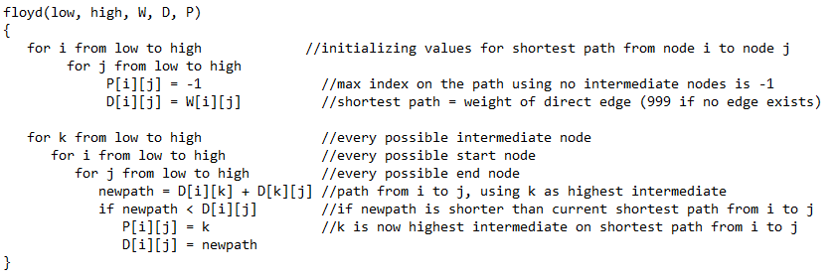

Test your code on the two graphs below. For each graph, do the following steps:

1. Create W, D, and P. These will each be a two-dimensional array where each dimension has length n (where n = number of nodes in our graph)
2. Set each value W[i][j] equal to the weight of the edge between i and j
   1. If i = = j, set W[i][j] equal to 0
   2. If no edge connects i to j, set W[i][j] equal to 999
3. Call *floyd* using 0 for low and n-1 for high
4. Print contents of W, D, and P
5. Call *getPath* using 0 for first and n-1 for last

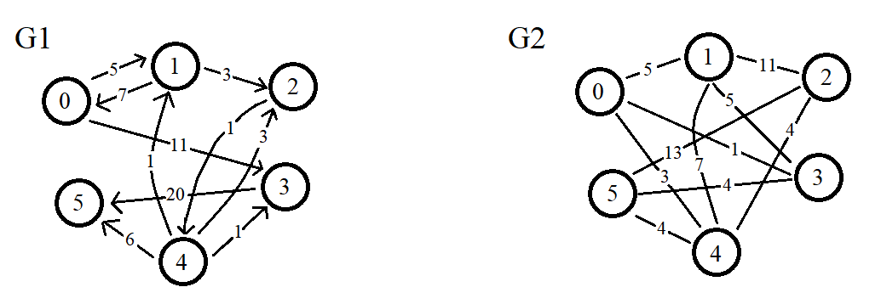

Results screenshot:

