# **INDUSTRIAL TRAINING**

***Submitted by:***

**Tanmay Thapliyal**

**RA1611003010817**

**ACADEMIC YEAR: 2018-19**

**AT**

**KRITSNAM TECHNOLOGIES, IIT KANPUR**

***This report is submitted to Computer Science and Engineering Department***

***as partial fullfillment of the requirement for the award of the degree of***

### BACHELOR OF TECHNOLOGY

in

**COMPUTER SCIENCE AND ENGINEERING**

of

### FACULTY OF ENGINEERING AND TECHNOLOGY



**S.R.M. Nagar, Kattankulathur, Kancheepuram District, Chennai.**

Acknowledgement

It is a matter of great pleasure and privilege for me to present this report of one month industrial training. Through this report, I would like to thank numerous people whose consistent support and guidance has been the standing pillar in architecture of this report.

To begin with, my sincere thanks to **Dr.C.Muthamizhchelvan, (Director E&T).** I express thanks to **Dr.B.Amutha, HOD - CSE** who gave encouragement and valuable suggestions throughout the training. Next, I would like to express my sincere gratitude to **Dr.A.Jeyasekar, Academic Adviser,** to experience a sustained enthusiastic and involved interest from his side. I would like to thank **Mrs.J.V.Vidhya**, **Faculty Advisor** for positive attitude she showed for my work**.**

I would like to express my sincere thanks to **Mr. Shivam Sharma, Technical Head**, **and Mr.Sri Harsha, CEO, Kritsnam Technologies IITK**, for guiding me during the course of the training.

**TANMAY THAPLIYAL**

**CONTENTS**

***About Kritsnam Technologies***

***Current Projects***

***Executive Summary***

***Internship Plan***

***Literature Review***

***Weekly Work Details***

***Methodology Adopted***

***Delivered Outcomes***

***Conclusion and Summary***

***References***

***Sample Code***

***Screenshots***

About Kritsnam Technologies

Kritsnam Technologies is a company in the field of IoT with focus on water resource management systems. There main goal is to provide minimal cost, lightweight and efficient infrastructural devices that can monitor and handle water resources, be it natural or man-made. Their vision is to empower developing nations with cost effective and data-driven water resource management techniques. The company will strive to protect and ensure optimal use of water resources across the globe using state of the art low experimental hydrology and low-cost real time water quality/quantity monitoring systems and infrastructure. To provide, implement and sustain these holistic solutions, the company will engage in multi-disciplinary collaboration with academia, governmental agencies and industries working in field of water resources.

The need for low cost water monitering systems can be emphasized by various accounts and instances mentioned in their blog ,one of which is summarized below:-

On the Public Record- Water issues in UP, citizen’s point of view.

Brief about Uttar Pradesh Water Resources: Uttar Pradesh is a very rich water resource state of India. Location near the Himalayas makes it more water abundant. The soil of UP is also very sensitive to moisture, makes it suitable for producing a wide range of agricultural food products. Agriculture and Animal Farming is the main source of income for approx. 75% population of the Rural UP, making UP highest quantity milk producer in India. UP is also a good exporter of Sugarcane.

The Problem from the public perspective: Since 7 decades, UP saw a series of unplanned urbanization and heavy industrialization that ignored conservation and proper management of water of UP. Whether its Rotting Yamuna water or Holy Ganges water pollution or water scarcity in rural and urban areas are the biggest water-related issue for UP. In villages water for agriculture & safe drinking water and for urban areas sewage management & safe drinking water is the biggest challenge for the local governing authorities of UP. To protect our ground and surface water from the water pollution from toxic industrial effluent, we need a smart and scientific water management approach. The groundwater is polluted with Chromium, Uranium, and Fluoride on the other side the ponds & rivers are polluted with domestic and industrial wastes. The effect of polluted water is that we will get all impurities thorough food and drinking water to our body and we will get increased medical bills, immature deaths and loss of biodiversity. Let’s take the example of Unnao District. The district is facing sewage water management problem, tannery effluent problem, safe drinking water problem along with solid waste (create groundwater pollution) & high air pollution problem. All pollution problems (including) is due to unplanned industrialization and urbanization. We lack scientific planning of cities and towns.

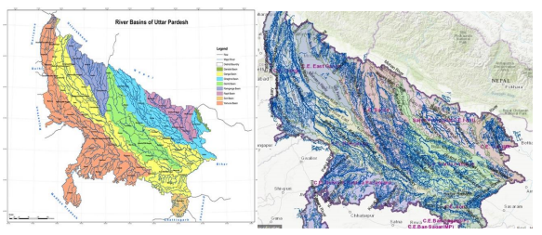

The Solution: The problem is not so complex but we made it complex by neglecting it. We should stop blame games and need an immediate action to conserve our ponds, wells, and rivers along with groundwater and protect them from contamination. If we connect environment losses of water to our economy, by which we can create awareness among the public. Suppose if we are successful to quantify if we waste 1 kg of groundwater, then how much rupees to be spent to get it back to the ground. The government should install smart wastewater, sewage water, and irrigation water treatment plants to the affect areas.

Current Projects:-

Continuous Discharge measurement using ultrasonic tomography-*f Scientific & Industrial Research (DSIR), MHRD & IIT Kanpur*

* Non-intrusive
* Cost-effective and real-time
* Very accurate velocity profiles
* Deployable on pipes, rivers and canals

Wireless communication infrastructure for Rural Settings:-

* LPWAN standards: Proprietary and LoRa
* Low-cost long-range nodes and gateways (DCU)
* Low-power nodes (2 Years on 2 AA batteries)
* Bidirectional communication
* Maintenance free monitoring and automation

Low-cost Low-power water quality monitoring infrastructure:-

* Low-cost but well calibrated accurate sensors
* pH, conductivity, turbidity, absorbance, dissolved oxygen, trace metals, micro-organisms and bacteria
* Tracking water quality with backend analytics for timely alerts and triggers

Executive Summary :-

During my work as an intern in the company, I worked on developing an android app for a handheld device, which would collect data from four different sensor on it namely PH, Dissolved Oxygen, Temperature and Electrical Conductivity sensors .It would then display the collected data for four sensors along with the one point or two point calibration as per the users choice.

It also plots a real time graph between the stream of the current calibrated reading versus time, and allows the user to generate the coordinates of the place where the readings are being taken. One can also take a snapshot of the location where the readings are being taken. The skills required for the assigned task were a deep thorough knowledge of java programming, with a good idea of networking and Django framework (including Python) .The app can further be developed to send the data from the handheld device to a server under the users account who is taking the readings. Likewise, the location coordinates can also be send to the server so that the location where the readings are being taken is recorded under the users account.

Internship Plan :-

1. The task at hand was to develop an android application for receiving data for four different sensors namely Phsensor, Electrical Conductivity, Temperature and Dissolved Oxygen sensors and display the data with calibration.
2. The basic functionalities for Phsensor with one point calibration and graph mapping were already added by the person previously working on the project.
3. I worked on the Graphic User Interface (GUI) for every activity on the app.
4. Developed two point calibration feature for the phsensor.
5. Added functionalities for Electrical Conductivity, Dissolved Oxygen and Temperature sensors.
6. Provided implementation to store one point and two point calibration values for all the four sensors in different ‘shared preferences’ so that when the app is closed and restarted later , the calibration values for each sensor are stored so that the user doesn’t have to recalibrate the app.
7. Added extra features to take photo and coordinates of the location where the readings are being taken , although these features can be improved.

Literature Review :-

1. The app was tested for handling 4 different streams of data from dummy servers assigned to give the same, and it was showing data from the server with the desired calibration successfully.
2. The location feature to give the latitude and longitude of the place where the reading are being taken is also working perfectly.

Weekly Work Details :-

Week 1:-

* Studied about the work done by the previous intern on the project, about the working of the phsensor which was already implemented on the app along with one point calibration.
* Worked on the basic GUI of the app.
* Studied how two point calibration works and added its implementation.

Week 2:-

* Added the implementations for other 3 sensors.
* Used Shared Preferences to store the required calibration data for different sensors.

Week 3:-

* Added the location and camera feature to the app.
* Removed bugs pertaining to fixed two point calibration feature.

Week 4:-

* Further improvements in the app.
* Office Presentation.

Improvements that can me made :-

1. The camera feature can be made to save the image clicked to the desired location in the internal storage or to a server.
2. Both camera and location features are to be implemented at a single start button click simultaneously, when the sensor starts to read the data. This may be implemented by using “Async Task” to ensure that all 3 activities take place on a single button click across different threads.

Methodology Adopted :-

1. I used Shared Preferences to store calibration values so that those values are not lost when the app is closed. One may argue that saving data into text files would have been easier , but given the minimal number of values to be stored, I preferred to save them in Shared Preferences rather than in text file.
2. The location feature uses libraries that utilize the functionalities offered by both GPS service and the network service of the app (whichever is better) to get the coordinates of the place where the readings are being taken.

Delivered Outcomes :-

1. The app is working perfectly displaying data from the dummy servers for four different sensors , with the assigned calibrations for the sensors.
2. Location feature is working properly displaying the coordinates where the readings are being taken. Camera still needs storage of clicked images to be implemented.

Conclusion and Summary :-

The internship at Kritsnam Technologies helped me to further learn and clear my concepts of programming in android and also to implement them in real time. They also helped me to acquire a real time experience about the company workspace environment which is for sure going to help me in my future endeavour.

References :-

1. Android Developers site (Documentation)
2. StackOverflow
3. Udacity Online Course for Android App Development
4. Swaroopch.com for Python
5. Django official site for Django documentation and tutorials
6. Link to Github Server :- https://git.kritsnam.in/summer18/programming/wq-handheld-androidapp

**Sample Code:-**

package com.example.cguzel.nodemcu_app;

import android.content.Intent;

import android.provider.MediaStore;

import android.support.v7.app.AppCompatActivity;

import android.os.Bundle;

import android.view.View;

public class MainActivity extends AppCompatActivity {

// Variables to point which activity is initiated

private int Phpointer, ECpointer, DO, TEMP;

@Override

protected void onCreate(Bundle savedInstanceState) {

super.onCreate(savedInstanceState);

setContentView(R.layout.activity_main);

}

public void CameraClick (View view)

{

Intent intent = new Intent(MediaStore.ACTION_IMAGE_CAPTURE);

startActivityForResult(intent,0);

}

// display location updates

public void getLocation(View view){

Intent intent = new Intent(MainActivity.this,LocationActivity.class);

startActivity(intent);

}

public void PhSensorCLick(View view)

{

Phpointer = 1; ECpointer = 0; DO = 0; TEMP = 0;

// Shared Preferences used for storing values

getSharedPreferences("MY_POINTERS", MODE_PRIVATE).edit().putInt("Phpointer", Phpointer).commit();

getSharedPreferences("MY_POINTERS", MODE_PRIVATE).edit().putInt("ECpointer", ECpointer).commit();

getSharedPreferences("MY_POINTERS", MODE_PRIVATE).edit().putInt("DO", DO).commit();

getSharedPreferences("MY_POINTERS", MODE_PRIVATE).edit().putInt("TEMP", TEMP).commit();

Intent intent = new Intent(MainActivity.this, SensorActivity.class);

startActivity(intent);

}

public void ElectricalConductivityCLick (View view)

{

Phpointer = 0; ECpointer = 1; DO = 0; TEMP = 0;

getSharedPreferences("MY_POINTERS", MODE_PRIVATE).edit().putInt("Phpointer", Phpointer).commit();

getSharedPreferences("MY_POINTERS", MODE_PRIVATE).edit().putInt("ECpointer", ECpointer).commit();

getSharedPreferences("MY_POINTERS", MODE_PRIVATE).edit().putInt("DO", DO).commit();

getSharedPreferences("MY_POINTERS", MODE_PRIVATE).edit().putInt("TEMP", TEMP).commit();

Intent intent = new Intent(MainActivity.this, SensorActivity.class);

startActivity(intent);

}

public void DissolvedOxygenClick (View view)

{

Phpointer = 0; ECpointer = 0; DO = 1;TEMP = 0;

getSharedPreferences("MY_POINTERS", MODE_PRIVATE).edit().putInt("Phpointer", Phpointer).commit();

getSharedPreferences("MY_POINTERS", MODE_PRIVATE).edit().putInt("ECpointer", ECpointer).commit();

getSharedPreferences("MY_POINTERS", MODE_PRIVATE).edit().putInt("DO", DO).commit();

getSharedPreferences("MY_POINTERS", MODE_PRIVATE).edit().putInt("TEMP", TEMP).commit();

Intent intent = new Intent(MainActivity.this, SensorActivity.class);

startActivity(intent);

}

public void TemperatureClick (View view)

{

Phpointer = 0; ECpointer = 0; DO = 0;TEMP = 1;

getSharedPreferences("MY_POINTERS", MODE_PRIVATE).edit().putInt("Phpointer", Phpointer).commit();

getSharedPreferences("MY_POINTERS", MODE_PRIVATE).edit().putInt("ECpointer", ECpointer).commit();

getSharedPreferences("MY_POINTERS", MODE_PRIVATE).edit().putInt("DO", DO).commit();

getSharedPreferences("MY_POINTERS", MODE_PRIVATE).edit().putInt("TEMP", TEMP).commit();

Intent intent = new Intent(MainActivity.this, SensorActivity.class);

startActivity(intent);

}

}

package com.example.cguzel.nodemcu_app;

import android.content.Intent;

import android.support.v7.app.AppCompatActivity;

import android.os.Bundle;

import android.util.Log;

import android.view.View;

import android.widget.EditText;

import android.widget.Toast;

// One point calibration activity

public class CalActivity extends AppCompatActivity {

private EditText phValue;

private JalApplication app;

@Override

protected void onCreate(Bundle savedInstanceState) {

super.onCreate(savedInstanceState);

setContentView(R.layout.activity_cal);

app = ((JalApplication) this.getApplication());

phValue = (EditText) findViewById(R.id.pH_val);

Intent intent = getIntent();

// String message = intent.getStringExtra(com.example.cguzel.nodemcu_app.MainActivity.EXTRA_MESSAGE);

}

public void buttonClick(View view) {

double val;

try {

val = Double.parseDouble(phValue.getText().toString());

Log.d("Exception", "No exceptions here");

double dum = val - app.getphSensor_read();

String str = Double.toString(dum);

if (getSharedPreferences("MY_POINTERS", MODE_PRIVATE).getInt("Phpointer", 0) == 1) {

getSharedPreferences("MY_PREFERENCE_PhSensor", MODE_PRIVATE).edit().putString("oneptcalibval", str).commit();

Log.d("Check", String.valueOf(app.getCalibration()));

} else if (getSharedPreferences("MY_POINTERS", MODE_PRIVATE).getInt("ECpointer", 0) == 1) {

getSharedPreferences("MY_PREFERENCE_ElectricalConductivity", MODE_PRIVATE).edit().putString("oneptcalibval", str).commit();

Log.d("Check", String.valueOf(app.getCalibration()));

}

else if (getSharedPreferences("MY_POINTERS", MODE_PRIVATE).getInt("DO", 0) == 1) {

getSharedPreferences("MY_PREFERENCE_DO", MODE_PRIVATE).edit().putString("oneptcalibval", str).commit();

Log.d("Check", String.valueOf(app.getCalibration()));

}

else if (getSharedPreferences("MY_POINTERS", MODE_PRIVATE).getInt("TEMP", 0) == 1) {

getSharedPreferences("MY_PREFERENCE_TEMP", MODE_PRIVATE).edit().putString("oneptcalibval", str).commit();

Log.d("Check", String.valueOf(app.getCalibration()));

}

else {

Toast.makeText(CalActivity.this, "Please enter a valid number", Toast.LENGTH_SHORT).show();

}

}

catch(Exception e){

Toast.makeText(CalActivity.this, "Please enter a valid number", Toast.LENGTH_SHORT).show();

}

}

}

**Screenshots**

Main Activity

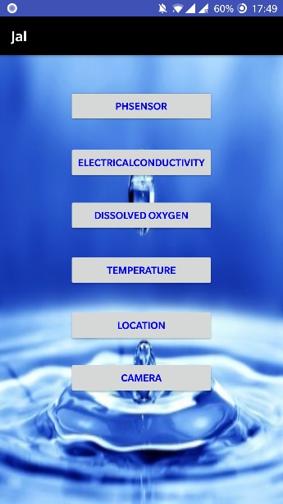

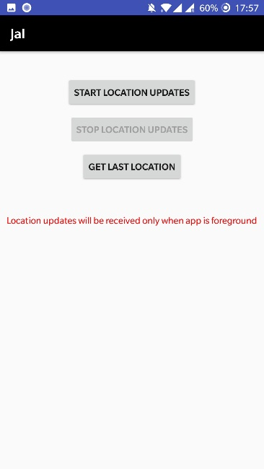 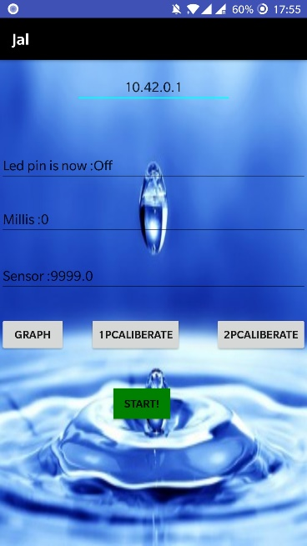

Location Activity Common Activity for all sensors