**UE20CS303 - Software Engineering**

**DESIGN DOCUMENT**

*ATM SIMULATOR*

Team #: __T_____

|  |  |  |  |  |  |  |  |  |  |
| --- | --- | --- | --- | --- | --- | --- | --- | --- | --- |
| |  |  | | --- | --- | | PES1UG21CS662 | Tanmay Praveen Udupa | | PES1UG21CS659 | T P Shriambhikesh | | |  |  | | --- | --- | | PES1UG21CS618 | Srikrishna B | | PES1UG21CS652 | Swaraj MK | |

General Instructions ( Delete these instructions from the document before submission) :

* Formatting Guidelines : Submit in pdf format
* Naming convention : **Design SRN1-SRN2-SRN3-SRN4** (Write SRNs in ascending order)
* Don’t forget to fill the Project Title on the **first page** as well as the **footer**

*Design Diagrams*

Diagrams of Levels of DFD

0-level DFD

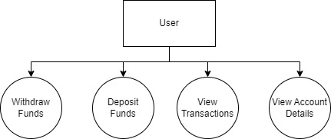

1-level DFD

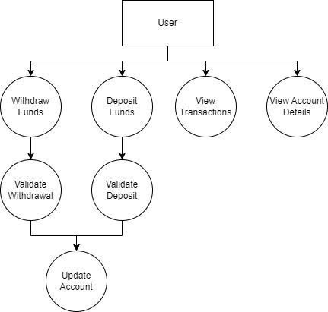

2-level DFD

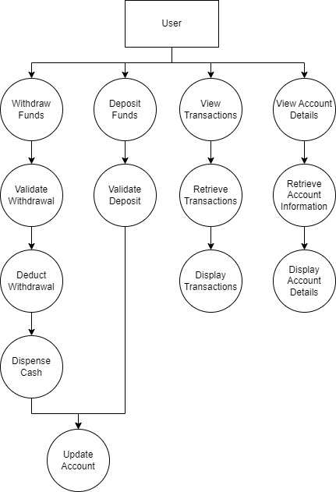

*Architectural Design*

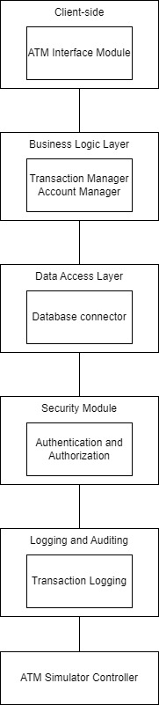

*UML*

*Use Case Diagram*

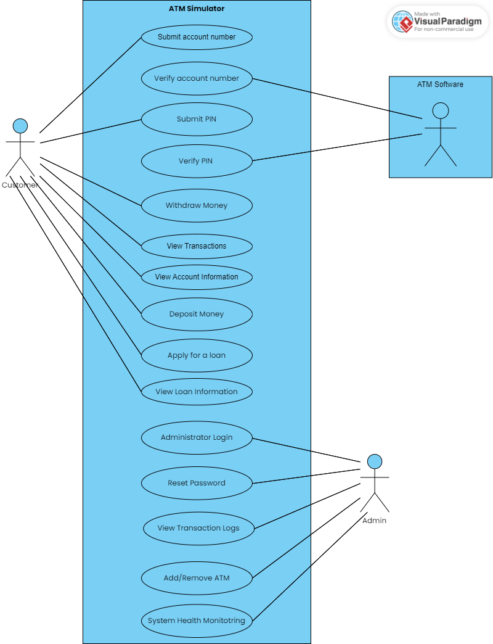

*Class Diagram*