**UE21CS341A - Software Engineering**

**Test Plan Documentation**

*PROJECT TITLE*

Team #: __T_____

|  |  |  |  |  |  |  |  |  |  |
| --- | --- | --- | --- | --- | --- | --- | --- | --- | --- |
| |  |  | | --- | --- | | SRN 1 | Name 1 | | SRN 2 | Name 2 | | |  |  | | --- | --- | | SRN 3 | Name 3 | | SRN 4 | Name 4 | |





Test Screenshots

TEST CASE: LOGIN_001

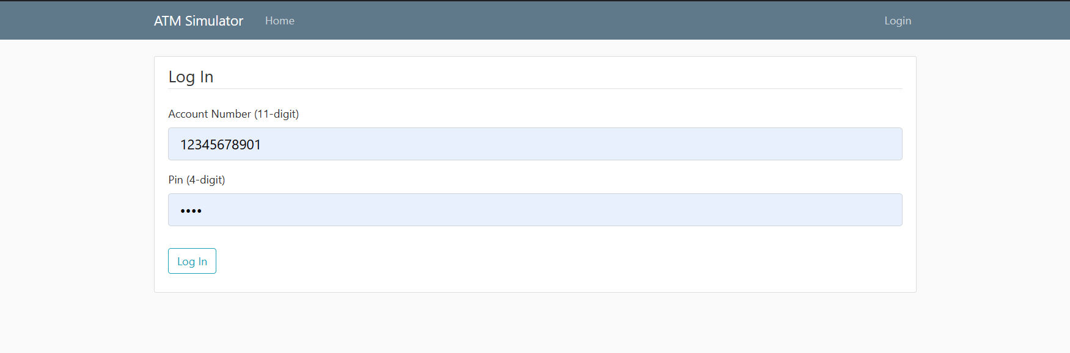

TEST CASE: LOGIN_002

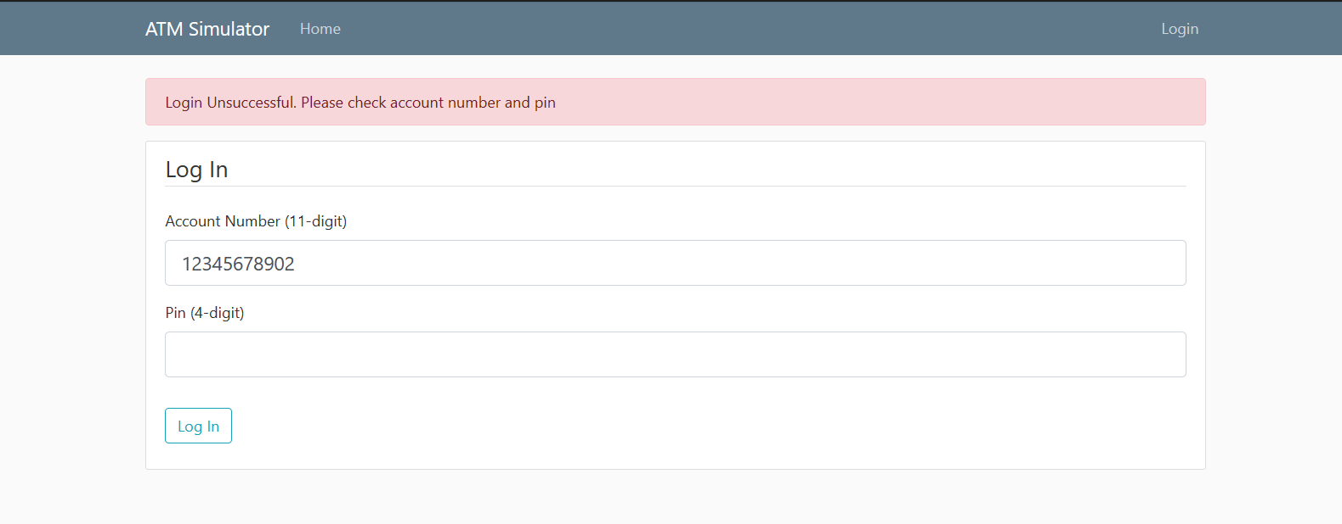

TEST CASE: LOGIN_003

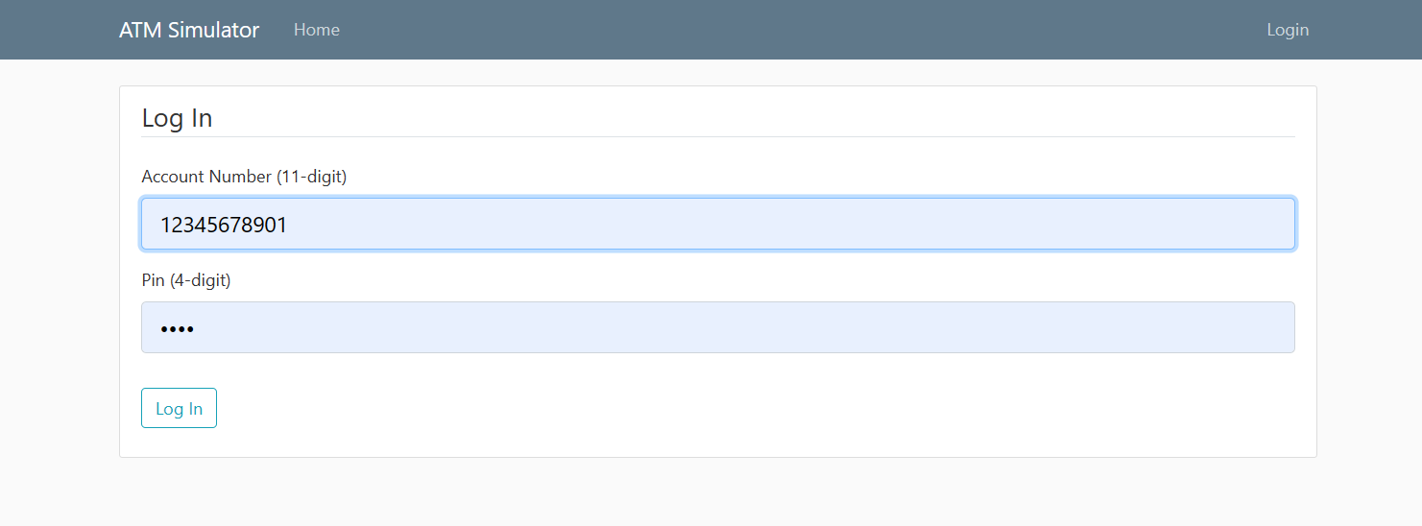

TEST CASE: LOGIN_004

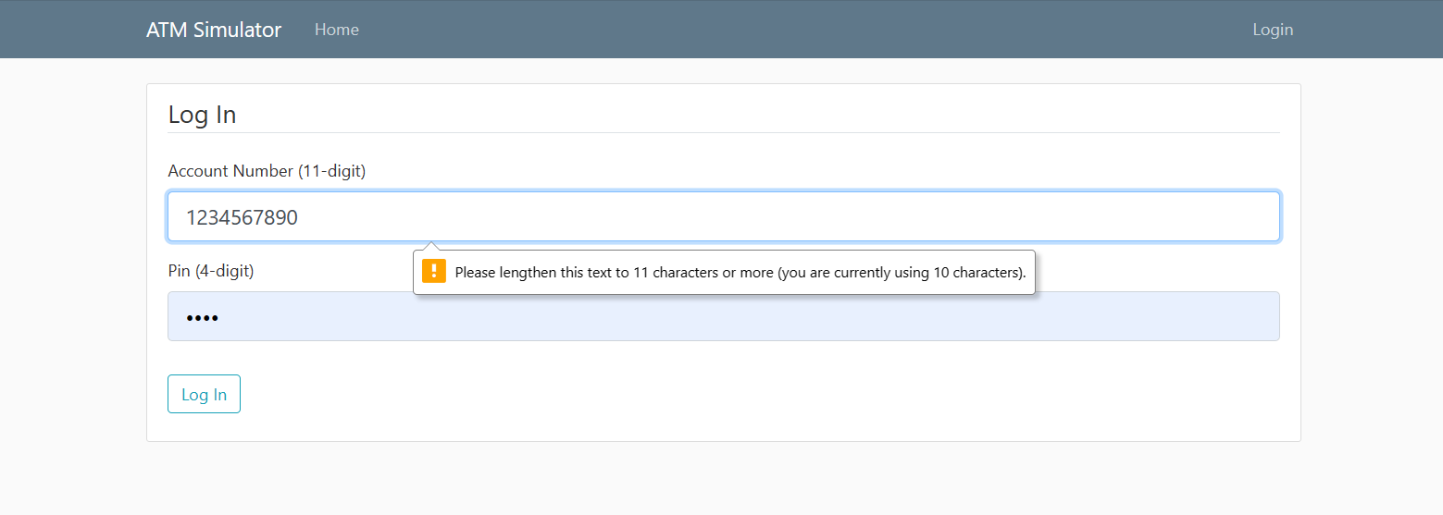

TEST CASE: WITH_001

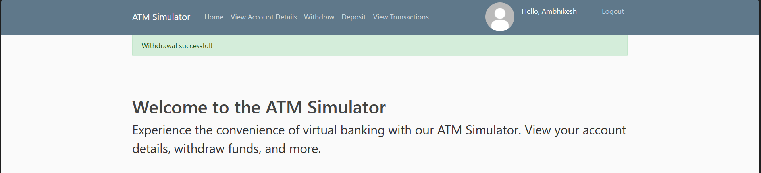

TEST CASE: WITH_002

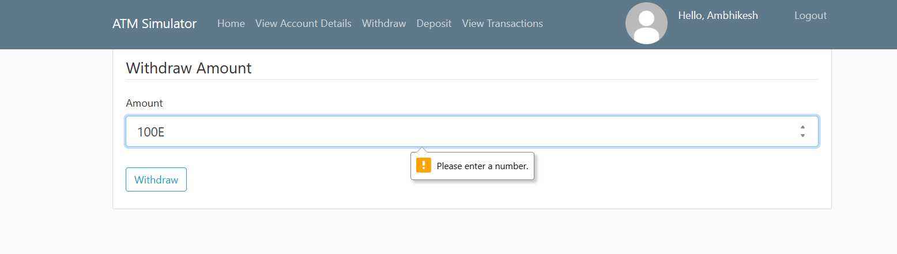

TEST CASE: WITH_003

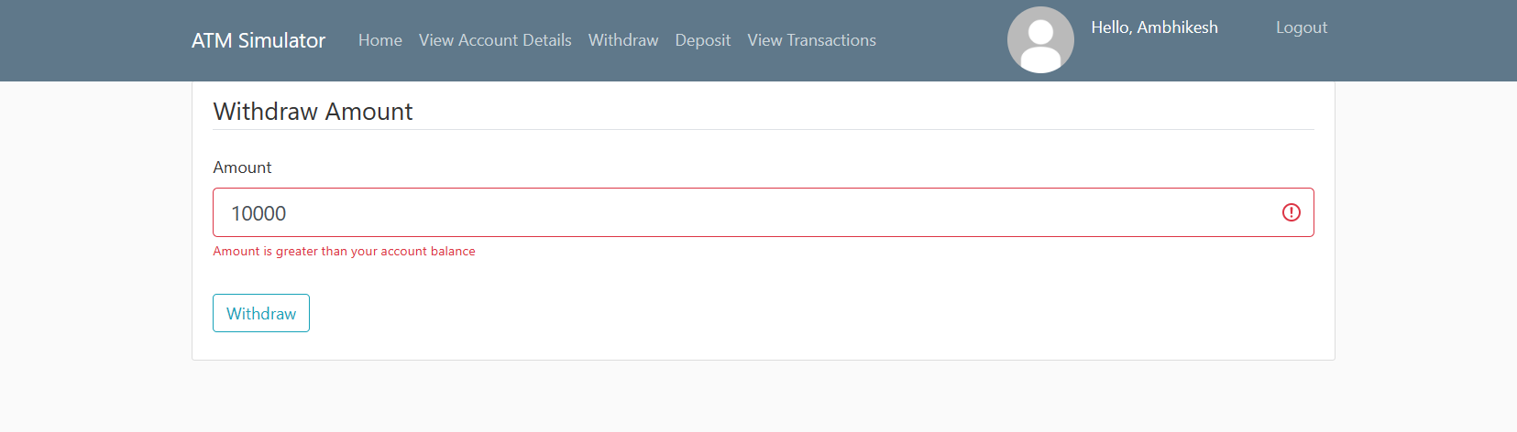

TEST CASE: DEP_001

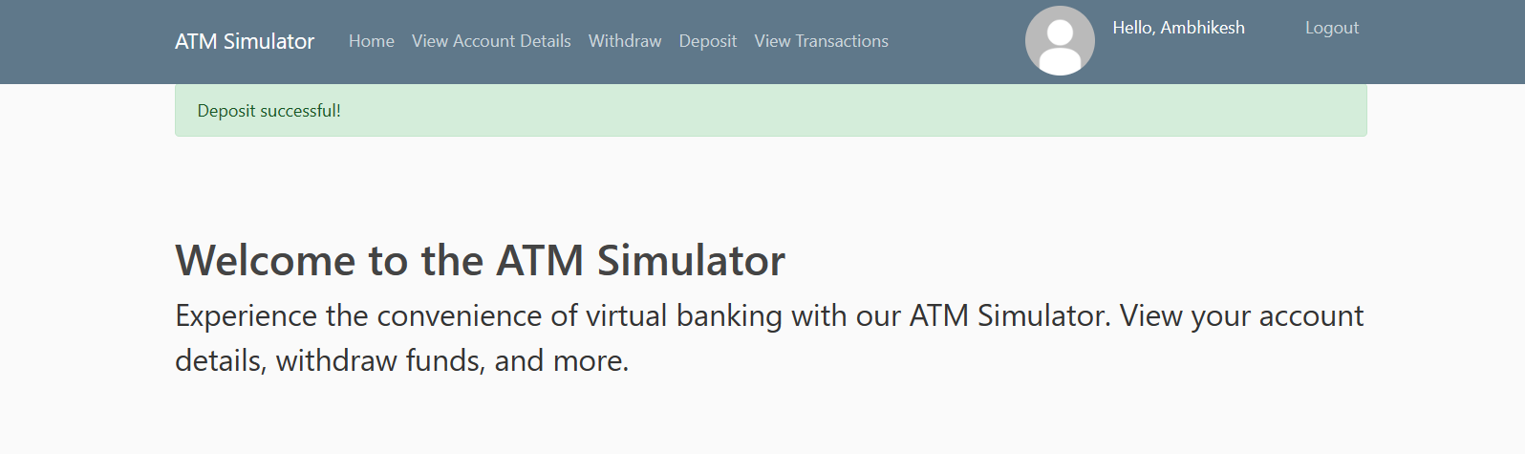

TEST CASE: DEP_002

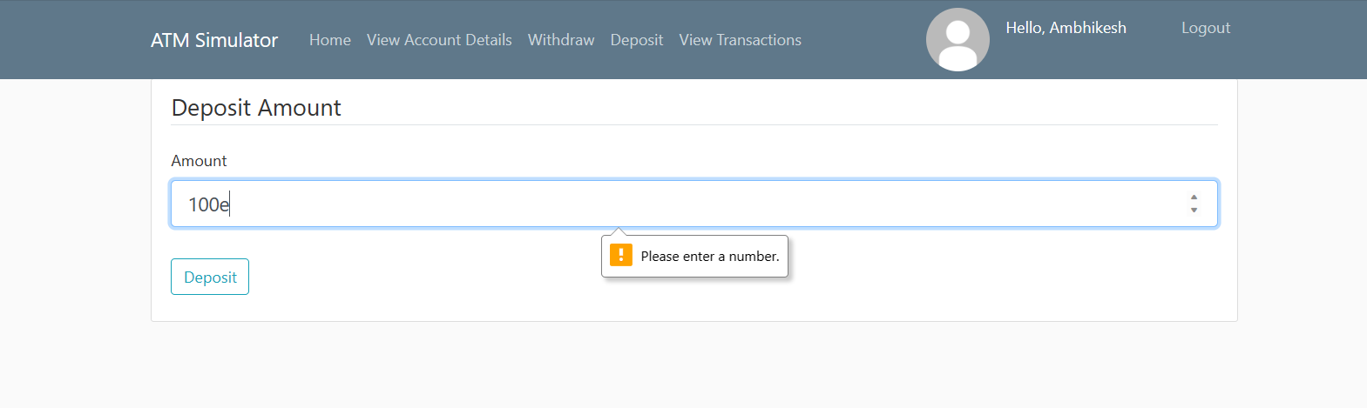

TEST CASE: BAL_001

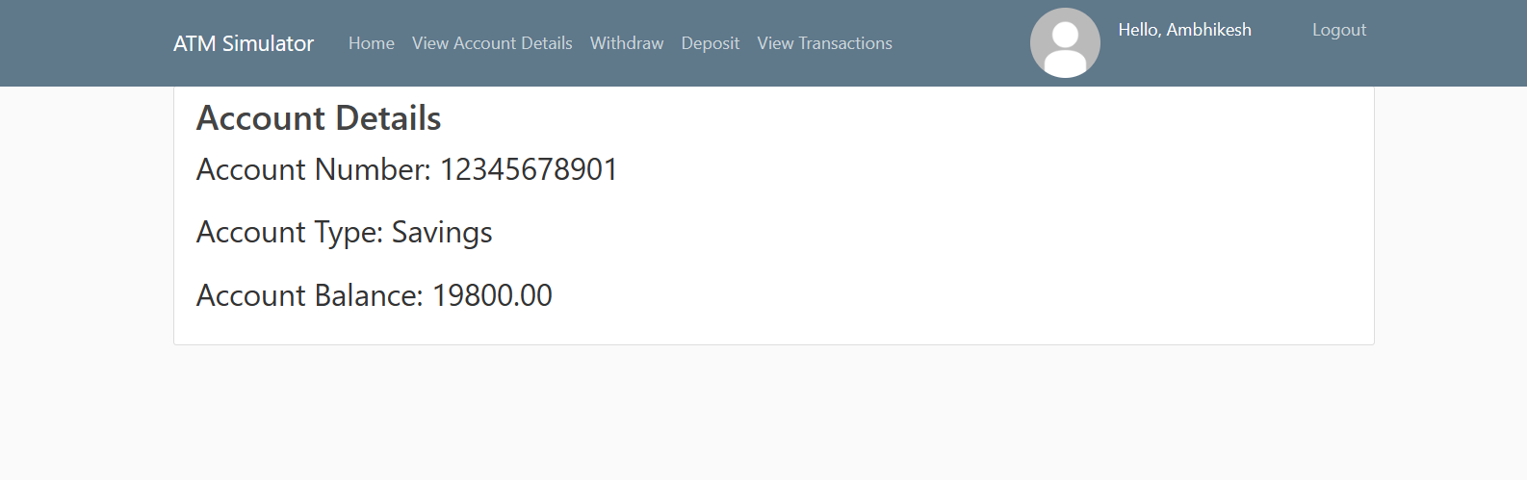

TEST CASE: TRANSAC_001

