Name: Tanmay Vig
Roll Num: 19BCS061
Class: 3rd year
Ans 1:
Code
#include <stdio.h>
#include <iostream>
#include<bits/stdc++.h>
using namespace std;

class Node {
public:
int id;
string name data;
int salary;
Node* next;
Node(int id,string name,int salary)
{
this->id = id;
this->name = name;
this->salary = salary;
this->next = NULL;
}
};
class Linkedlist {
Node* head;
public:
Linkedlist() { head = NULL; }
void insertNode();
void printList();
void deleteNode();
void udateNode();
};
void Linkedlist::updateNode()
{
int s;
cout<<"Enter Employee Id: ";
cin>>s;
Node *temp = head;
while (temp != NULL) {
if(temp>id==s)
{
string name;int salary;
cout<<"Enter Employee Name: ";
cin>>name;
cout<<"Enter Employee Salary: ";
cin>>salary;
temp->name = name;
temp->salary = salary;
break;
}
temp = temp->next;
}
}
void Linkedlist::deleteNode()
{
int s;
cout<<"Enter Employee Id: ";
cin>>s;
Node *temp = head, *temp2 = NULL;
while (temp->next != NULL) {
if(temp->next->id==s)
{
temp2 = temp->next;
if(temp->next->next==NULL)
temp->next = NULL;
else
temp->next = temp->next->next;

break;
}
temp = temp->next;
}
delete temp2;
}

void Linkedlist::insertNode()
{
int id;string name;int salary;
cout<<"Enter Employee Id: ";
cin>>id;
cout<<"Enter Employee Name: ";
cin>>name;
cout<<"Enter Employee Salary: ";
cin>>salary;
Node* newNode = new Node(id,name,salary);
if (head == NULL) {
head = newNode;
return;
}
Node* temp = head;
while (temp->next != NULL) {

temp = temp->next;
}
temp->next = newNode;
}
void Linkedlist::printList()
{
Node* temp = head;

if (head == NULL) {
cout << "List empty" << endl;
return;
}

while (temp != NULL) {
cout<<"Employee Id: "<<temp->id<<endl;
cout<<"Employee Name: "<<temp->name<<endl;
cout<<"Employee Salary: "<<temp->salary<<endl;
temp = temp->next;
}
}
int main()
{
Linkedlist list;
int n,ch,t,found,s;
do {
cout << "\n\n1:Display All Employee\n2:Add Employee\n3: Update Employee\n4:Delete Employee\n5:Exit" << endl;
cout << "Please input your choice: ";
cin >> ch;
cout<<endl;
switch (ch) {
case 1:
list.printList();
break;
case 2:
list.insertNode();
break;
case 3:
list.updateNode();
break;
case 4:
list.deleteNode();
default:
cout << "Wrong Option" << endl;
}
} while (ch != 5);
return 0;
}

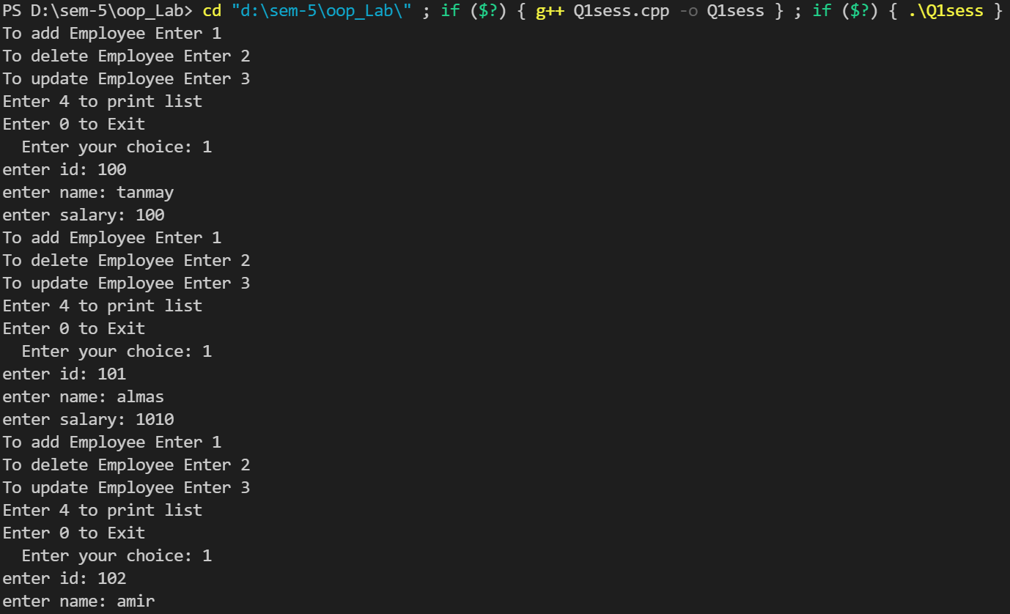
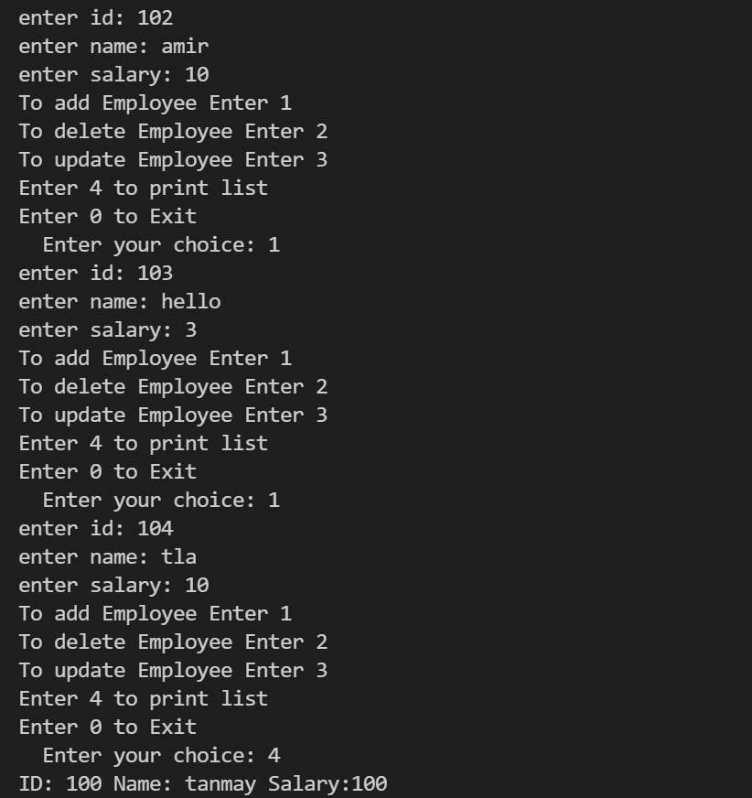
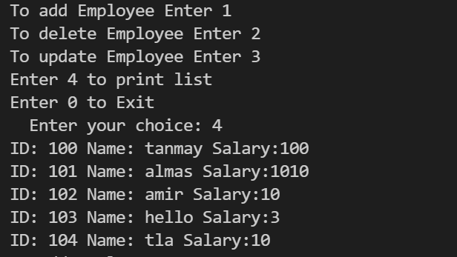
Ans 2
Code:
#include <iostream>
using namespace std;

int N;
class Matrix {

int arr[100][100];

public:
void operator>>(Matrix);
void operator<<(Matrix);
void operator+(Matrix );
void operator-(Matrix );
void operator*(Matrix );
void operator~();
};
void Matrix::operator>>(Matrix temp)
{
cout<<"Enter the elements of Matrix:\n";

for (int i = 0; i < N; i++) {

for (int j = 0; j < N; j++) {

cin>>arr[i][j];
}
}
}
void Matrix::operator<<(Matrix temp)
{
for (int i = 0; i < N; i++) {

for (int j = 0; j < N; j++) {
cout << arr[i][j] << ' ';
}
cout << endl;
}
}
void Matrix::operator+(Matrix ob)
{
Matrix mat,temp;
for (int i = 0; i < N; i++) {
for (int j = 0; j < N; j++) {

mat.arr[i][j] = arr[i][j]
+ ob.arr[i][j];
}
}
cout<<"Sum of matrix is::\n";
mat<<temp;
}
void Matrix::operator-(Matrix ob)
{
Matrix mat,temp;
for (int i = 0; i < N; i++) {
for (int j = 0; j < N; j++) {

mat.arr[i][j] = arr[i][j]
- ob.arr[i][j];
}
}
cout<<"Subtraction of matrix is::\n";
mat<<temp;
}
void Matrix::operator*(Matrix ob)
{
Matrix mat,temp;
for (int i = 0; i < N; i++) {

for (int j = 0; j < N; j++) {

mat.arr[i][j] = 0;

for (int k = 0; k < N; k++) {
mat.arr[i][j] += arr[i][k]
* (ob.arr[k][j]);
}
}
}
cout<<"Multiplication of matrix is::\n";
mat<<temp;
}
void Matrix::operator~()
{
Matrix mat,temp;
for (int i = 0; i < N; i++) {
for (int j = 0; j < N; j++) {

mat.arr[j][i] = arr[i][j];
}
}
cout<<"Transpose of matrix is::\n";
mat<<temp;
}
int main()
{
Matrix temp;
cout<<"Enter the size of matrix: ";
cin>>N;
Matrix mat1;
cout<<"Matrix 1:\n";
mat1>>temp;
int f;
do{
cout<<"Enter:";
cout<<"\tTo Add:1\n\tTo Subtract:2\n\tTo Multiplication:3\n\tTo find Transpose of matrix:4\n\tExit:5\n";

cin>>f;
if(f==1)
{
Matrix mat2;
cout<<"Matrix 2:\n";
mat2>>temp;
mat1 + mat2;
}
else if(f==2)
{
Matrix mat2;
cout<<"Matrix 2:\n";
mat2>>temp;
mat1 - mat2;
}
else if(f==3)
{
Matrix mat2;
cout<<"Matrix 2:\n";
mat2>>temp;
mat1 * mat2;
}
else if(f==4)
{
~mat1;
}
else
break;
}while(f<=4);
return 0;
}
