OBJECT ORIENTED PROGRAMMING LAB
Submitted By: Tanmay Vig
Roll No.: 19BCS061
Batch: B. Tech 3rd year

Submitted to: -
Dr. Mumtaz Ahmed
Mr. Shamim Ahmad
Department Of Computer Engineering
S no. | Program title | Date Submitted
1 | Enter some Students data like Name, Roll no, Class, subject code, sub name, marks obtained, max marks etc. | 10/08/21
2 | Implement Program p1 using Default Constructor and Parameterized Constructor | 17/08/21
3 | Implement Array of Objects in given problem | 24/08/21
4 | Implement Bank Account | 31/08/21
5 | Implement Friend Function | 07/9/21
6 | Implement Book Store | 14/9/21
7 | Implement Employee | 21/9/21
8 | Implement Operator Overloading: String Operations | 5/10/21
9 | Implement Stack using classes and objects | 26/10/21
10 | Implement Inheritance in given problem | 16/11/21
11 | Implement Inheritance in given problem | 23/11/21
12 | Templates-Write a program in C++ to implement a generic Stack. | 30/11/21
13 | Templates-Write a program in C++ to implement a generic Stack. | 7/12/21

P1: Enter some Students data like Name, roll no, Class, subject code, subname, marks obtained, max marks etc. Print their Grades according to following rule Grade A if marks obtained are in range 75-100. Grade B if marks obtained are in range 60-74. Grade C if marks obtained are in range 45-59 Grade D if marks obtained are in range 35-44 Grade F if marks obtained are in range 0-34.
Source Code:
#include<iostream>
#include<vector>
#include<string>
#include <iomanip>
#include<vector>

using namespace std;

class Student{
private:
string name;
string _class;
string roll_num;
int num;
string *subject_code;
string *subject_name;
float *marks;
float max_marks;
public:

Student() {}

Student(string na,string cl,string r_n,int n, string s_c[],string s_n[], float m[]){
name=na;
_class=cl;
roll_num=r_n;
num=n;
subject_code=s_c;
subject_name=s_n;
marks=m;
max_marks=-1;
for(int i=0;i<num;i++){
if(max_marks<marks[i]) max_marks=marks[i];
}
}
void marksheet(){
cout<<"Name: "<<name<<"\nRoll Number: "<<roll_num<<"\nClass: "<<_class<<endl;
cout<<"-------------------------------------------\n";
cout<<"| Subject code| Subject Name| Marks| Grade|\n";
cout<<"-------------------------------------------\n";
for(int i=0;i<num;i++){
cout<<"| "<<setw(12)<<subject_code[i]<<"| "<<setw(12)<<subject_name[i]<<"| "<<setw(5)<<marks[i]<<"| "<<setw(5)<<grade(marks[i])<<"|\n";
}
cout<<"-------------------------------------------\n";
cout<<"Max_marks: "<<max_marks<<endl;
cout<<"Net Grade: "<<grade(total(marks,num)/num)<<endl;
}

float total(float m[],int n){
float sum=0;
for(int i=0;i<n;i++) sum+=m[i];
return sum;
}

string grade(float m){
if(m>=75) return "A";
else if(m<75 && m>=60) return "B";
else if(m<60 && m>=45) return "C";
else if(m<45 && m>=35) return "D";
return "F";
}
};

int main(){
int n;
cout<<"Enter Number of students:\t";
cin>>n;
Student arr[100];
for(int i=0;i<n;i++){
string name,clas,r_n,s_c[20],s_n[20]; int num; float m[20];
cout<<"Enter Name and Roll Number of student:\t";
cin>>name>>r_n;
cout<<"Enter Class of student:\t";
cin>>clas;
cout<<"Enter Number of subjects:\t";
cin>>num;
cout<<"Enter the Subject codes, Subject Name, marks obtained\n";
for(int j=0;j<num;j++) cin>>s_c[j]>>s_n[j]>>m[j];
Student s(name,clas,r_n,num,s_c,s_n,m);
cout<<endl;
s.marksheet();
}
return 0;
}
Output:

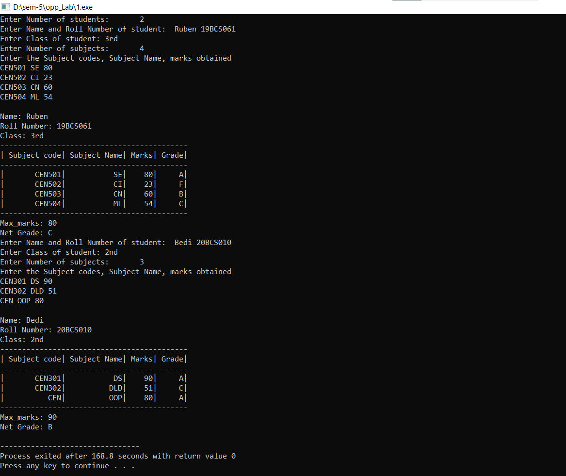

P2: implement Program P1 using Default Constructor and Parameterized constructor.

Source Code:

#include <bits/stdc++.h>

using namespace std;

class Student {

public:

string name;

int _class, rollNum, totalSubjects;

string subjectNames[100], subjectCodes[100];

int marks[100], maxMarks[100];

// Default Constructor

Student() {

this->name="";

this->_class=0;

this->rollNum=0;

}

// Parameterized Constructor

Student(string name, int _class, int rollNum) {

this->name=name;

this->_class=_class;

this->rollNum=rollNum;

}

// Student data setter, in case of default constructor

void setStudentData(string name, int _class, int rollNum) {

this->name=name;

this->_class=_class;

this->rollNum=rollNum;

}

void setData() {

int n;

cout << "Enter the number of subjects" << endl;

cin >> n;

this->totalSubjects = n;

for(int i=0;i<n;i++) {

string subName, subCode;

int marks, maxMarks;

cout << "Enter the name, code, marks and max marks for subject " << i+1 << endl;

cin >> subName;

cin >> subCode;

cin >> marks;

cin >> maxMarks;

this->subjectNames[i] = subName;

this->subjectCodes[i] = subCode;

this->marks[i] = marks;

this->maxMarks[i] = maxMarks;

}

}

void getData() {

cout << "Subject wise marks of " << this->name << " are" <<endl;

cout << "Name\t\t" << "Code\t\t" << "Max Marks\t\t" << "Marks Obtained" << endl;

int totalMarks = 0, totalMaxMarks = 0;

double avg;

for(int i=0;i<this->totalSubjects;i++) {

cout << this->subjectNames[i] << "\t\t" << this->subjectCodes[i] << "\t\t" << this-

>maxMarks[i] << "\t\t\t" << this->marks[i] << endl;

totalMarks += this->marks[i];

totalMaxMarks += this->maxMarks[i];

}

avg = ((double)totalMarks/(double)totalMaxMarks)*100.0;

cout << endl << "Grade of student " << this->name << " is: ";

if(avg >= 75.0) cout << "A" << endl << endl;

else if(avg >= 60.0) cout << "B" << endl << endl;

else if(avg >= 45.0) cout << "C" << endl << endl;

else if(avg >= 35.0) cout << "D" << endl << endl;

else cout << "F" << endl << endl;

}

};

int main() {

cout << "Enter the number of students" << endl;

int n;

cin >> n;

for(int i=1;i<=n;i++) {

string name;

int _class, rollNum;

cout << "Enter the name, class and roll number of student " << i << endl;

cin >> name;

cin >> _class;

cin >> rollNum;

int choice;

cout << "Enter 0 to use default constructor, 1 to use parameterized constructor" << endl;

cin >> choice;

if(choice == 0) {

Student* student = new Student();

student->setStudentData(name, _class, rollNum);

student->setData();

student->getData();

} else {

Student* student = new Student(name, _class, rollNum);

student->setData();

student->getData();

}

}

return 0;

}

Output:

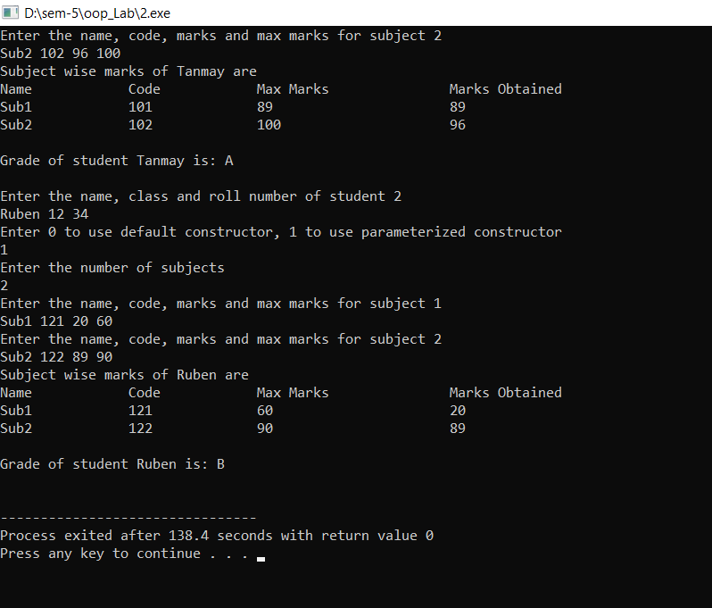

P3 a: Create a class called Employee that contains employee number (type long), name (an object of class string) and salary (integer). Include a member function called getData() to get data from the user for insertion into the object, and another function called putData() to display the data. Define both the functions outside the class. Assume the name has embedded blanks (like Rakesh Kumar Mehta). Write a main() program to execute this class. It should create an array of type Employee, and then invite the user to input data for up to 10 employees. Finally, it should print out the data for all the employees in proper format.
Source code:
#include<iostream>
#include<string>
#include <iomanip>

using namespace std;

class Employee{
public:
long long int employee_number;
string name;
int salary;
void getData();
void putData();
};

void Employee::getData(){
cout<<"Enter employee number\t";
cin>>employee_number;
cin.clear();
cin.sync();
cout<<"Enter Name of employee"<<endl;
getline(cin,name);
cout<<"Enter Salary\t";
cin>>salary;
}

void Employee::putData(){
cout<<left<<"|"<<setw(15)<<employee_number<<"|"<<setw(15)<<name<<"|"<<setw(15)<<salary<<endl;
}

int main(){
Employee arr[10];
cout<<"Enter details:\n";
for(int i=0;i<10;i++){
cout<<"Enter data for employee "<<i+1<<endl;
arr[i].getData();
}
cout<<"Employee Details:\n"<<
"_________________________________________________\n|Employee Number|Name |Salary |\n_________________________________________________\n";
for(int i=0;i<10;i++){
arr[i].putData();
cout<<"_________________________________________________\n";
}
return 0;
}
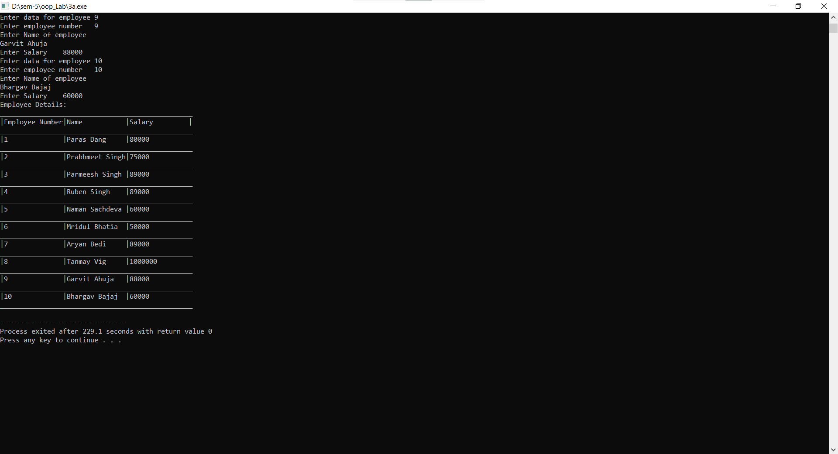
Output: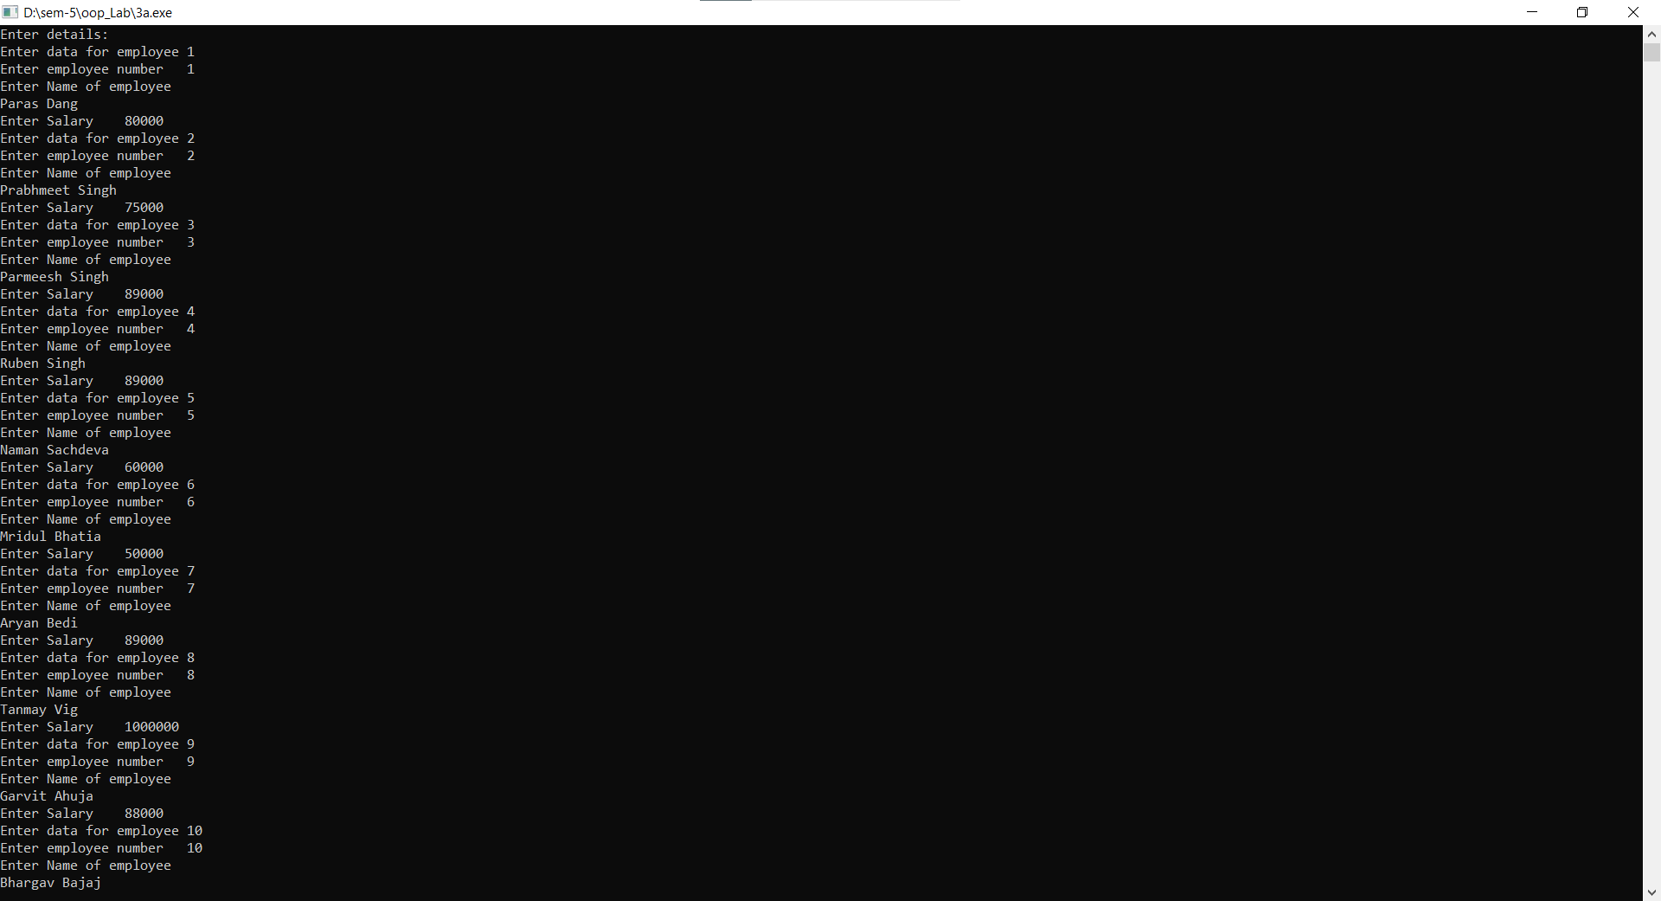

P3 b: Create a class called Student that contains a Student id (type int), name (char array ) and marks (integer). Include a member function called getStudent() to get data from the user for insertion into the object, and another function called printStudent() to display the data. Define both the functions inside the class. Assume the name has no embedded blanks. Write a main() program to execute this class. It should create an array of type Student, and then invite the user to input data for up to 10 students. Finally, it should print out the data for all the students in proper format.
Source Code:
#include<iostream>
#include<string>
#include <iomanip>
#define M 10

using namespace std;

class Student{
public:
int student_id;
char name[30];
int marks;
void getData(){
cout<<"Enter student number\t";
cin>>student_id;
cin.clear();
cin.sync();
cout<<"Enter Name of student"<<endl;
cin.getline(name,30);
cout<<"Enter Marks\t";
cin>>marks;
}
void putData(){
cout<<left<<"|"<<setw(15)<<student_id<<"|"<<setw(15)<<name<<"|"<<setw(15)<<marks<<"|"<<endl;
}
};

int main(){
Student arr[M];
cout<<"Enter details:\n";
for(int i=0;i<M;i++){
cout<<"Enter data for student "<<i+1<<endl;
arr[i].getData();
}
cout<<"Student Details:\n"<<
"_________________________________________________\n|Student Number |Name |Marks |\n_________________________________________________\n";
for(int i=0;i<M;i++){
arr[i].putData();
cout<<"_________________________________________________\n";
}
return 0;
}
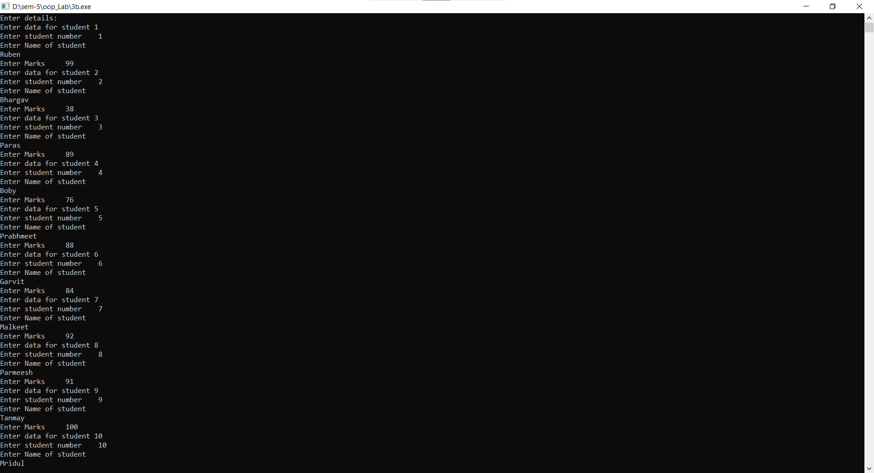
output:
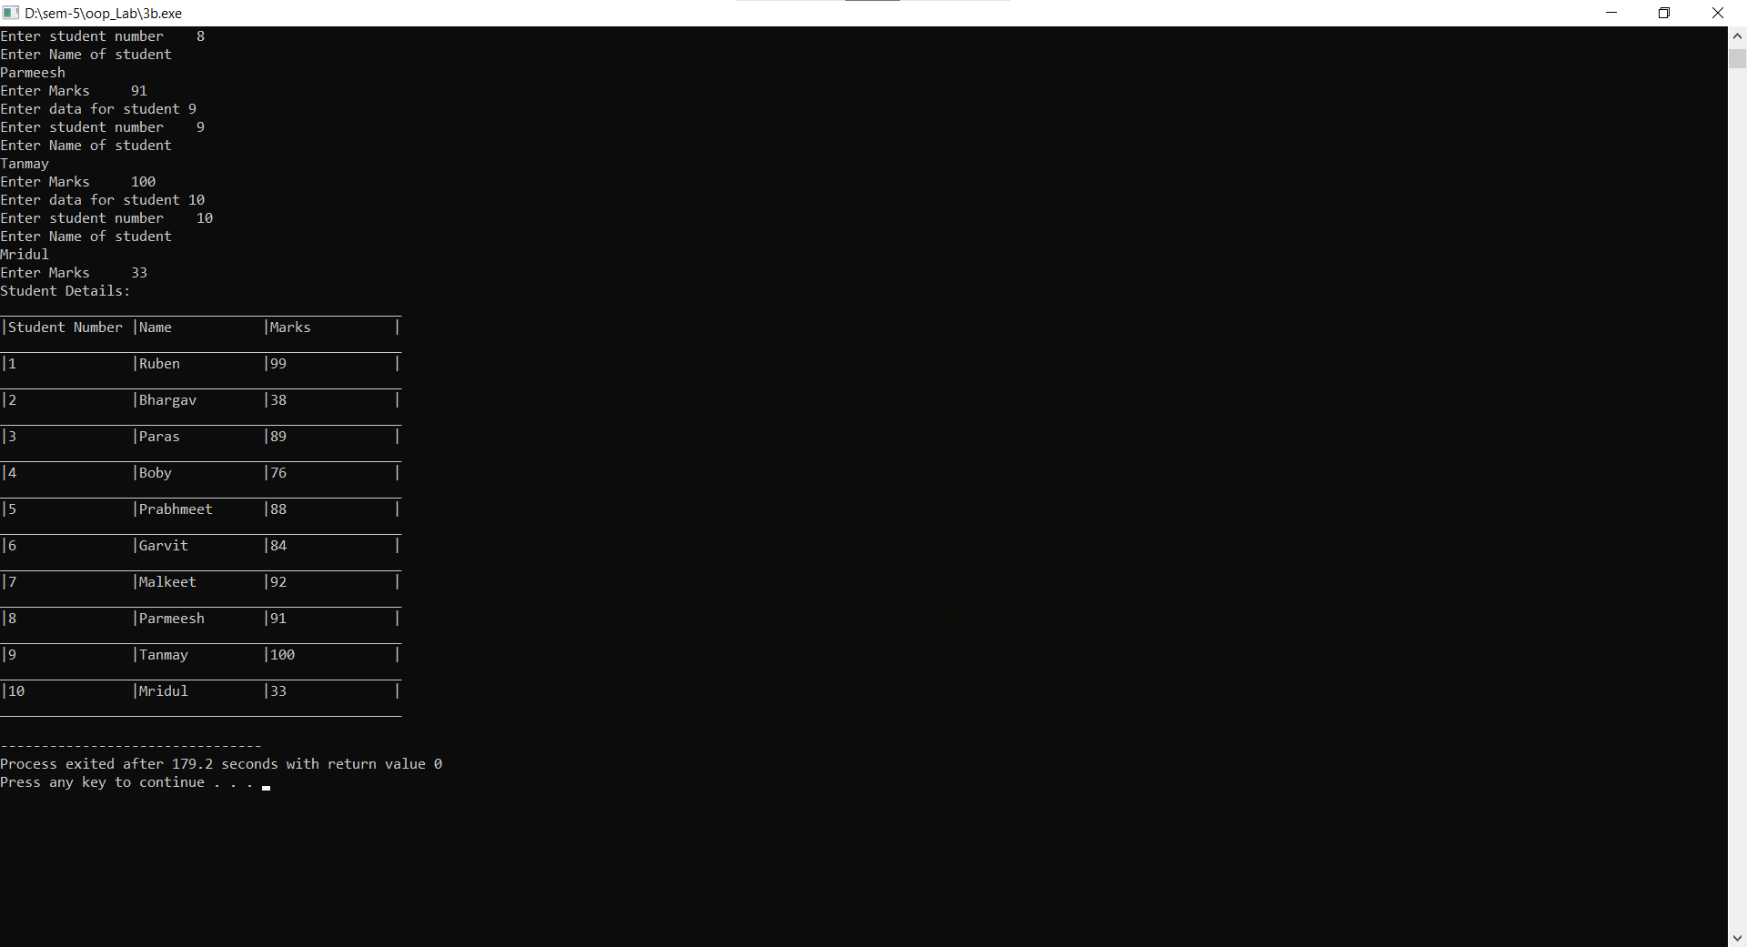

P4: Write a program in C++ to represent a Bank Account.
Data members:
- Account number
- Name of the depositor
- Type of account
- Balance amount in the account
Member functions:
- To assign initial values
- To deposit an amount
- To withdraw an amount after checking the balance
- To display name and balance of a single customer if account number is entered through
- the keyboard
- To display the details of all customers
- Sort the customers according to their balance
Write a main program to test the class. Your program must be able to handle at least 10 customers.
Source Code:
#include<iostream>
#include<string>
#define M 10

using namespace std;

class Account{
private:
long long int account_number;
string name;
string account_type;
int balance;

public:
void putDetails(){
cout<<"Enter Account Number:\t";
cin>>account_number;
cin.ignore();
cout<<"Enter Name of depositor:\t";
getline(cin, name);
cout<<"Enter Type of Account(Current, Saving, Salary):\t";
getline(cin, account_type);
cout<<"Enter Balance amount in the account:\t";
cin>>balance;
}

void deposite(int amt){
balance=balance+amt;
cout<<"Amount deposited: "<<amt<<". Total balance: "<<balance<<endl;
}

void withdraw(int amt){
if(balance<amt) cout<<"Error: please input Valid amount.\nYour current balance is: "<<balance<<endl;
else{
balance=balance-amt;
cout<<"Amount withdraw: "<<amt<<". Total balance: "<<balance<<endl;
}
}
void display(){
cout<<"Name: "<<name<<".\nAccount Type: "<<account_type<<".\nBalance: "<<balance<<endl;
}
int getbalance(){
return balance;
}
long long int getAccNum(){
return account_number;
}
};

int findAcc(Account arr[],long long int num) {
for(int i=0;i<M;i++) {
if(arr[i].getAccNum()==num) return i;
}
return -1;
}

int main(){
Account arr[M];
int n;
long long int accNum;
for(int i=0;i<M;i++){
cout<<"Enter Details of Account "<<i+1<<endl;
arr[i].putDetails();
}
do{
cout<<"Enter 1 to Deposit. \nEnter 2 to Withdraw. \nEnter 3 to see your Details.\nEnter 0 to exit.\n";
cin>>n;
if(n){
cout<<"Enter Account Number:\t";
cin>>accNum;
}
int index=findAcc(arr,accNum),amt;
if(index!=-1){
switch (n)
{
case 1:
cout<<"Enter Amount to Deposite:\t";
cin>>amt;
cout<<endl;
arr[index].deposite(amt);
break;
case 2:
cout<<"Enter Amount to withdraw:\t";
cin>>amt;
cout<<endl;
arr[index].withdraw(amt);
break;
case 3:
cout<<endl;
arr[index].display();
break;
default:
cout<<"Enter valid input or 0 to Exit\n";
break;
}
}else if(index==-1){
cout<<"\nError: no account found.\n";
}
}while(n!=0);
cout<<"Enter 1 to see all account details in sorted order\nEnter 2 to see all details in unsorterd order\n";
cin>>n;
if(n==1){
int i,j;
for(i=0;i<M-1;i++){
for(j=0;j<M-i-1;j++){
if(arr[j].getbalance()>arr[j+1].getbalance()){
Account temp=arr[j];
arr[j]=arr[j+1];
arr[j+1]=temp;
}
}
}
cout<<"Showing Details in unsorted order:\n";
cout<<"____________"<<endl;
for(int i=0;i<M;i++){
arr[i].display();
cout<<"____________"<<endl;
}
}else{
cout<<"Showing Details in unsorted order:\n";
cout<<"____________"<<endl;
for(int i=0;i<M;i++){
arr[i].display();
cout<<"____________"<<endl;
}
}
return 0;
}
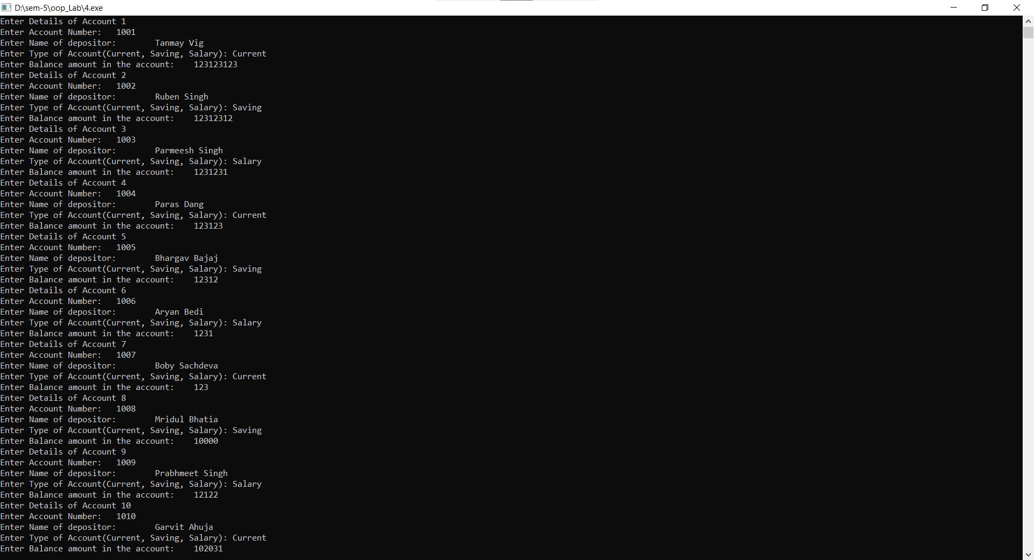
Output:
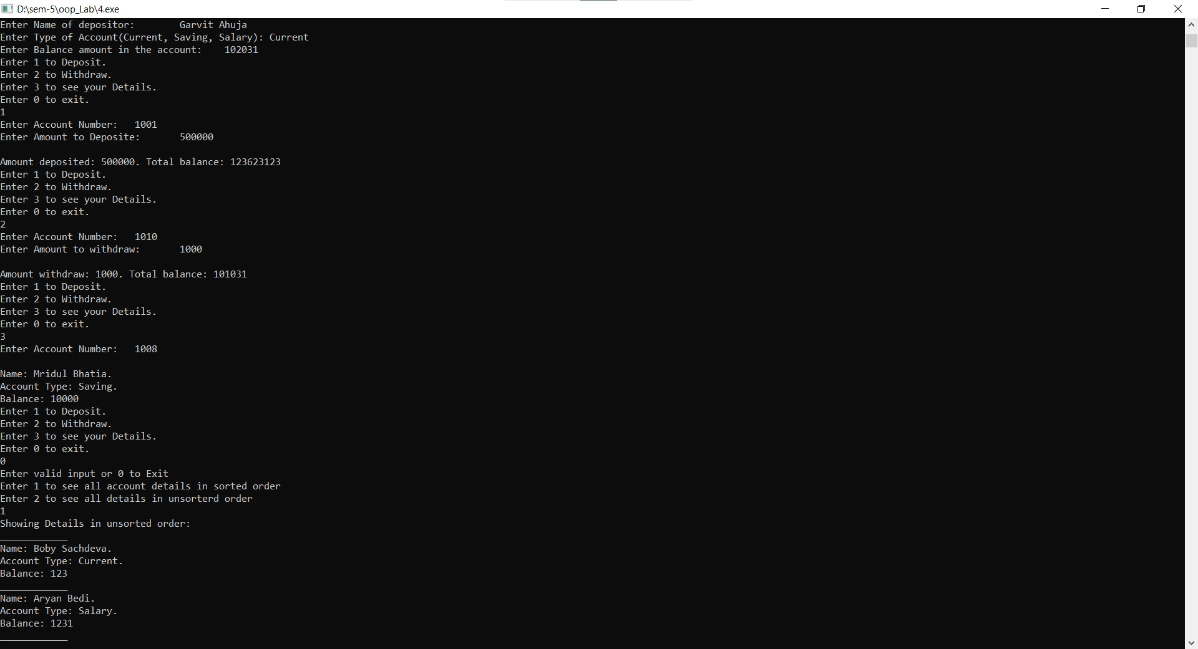
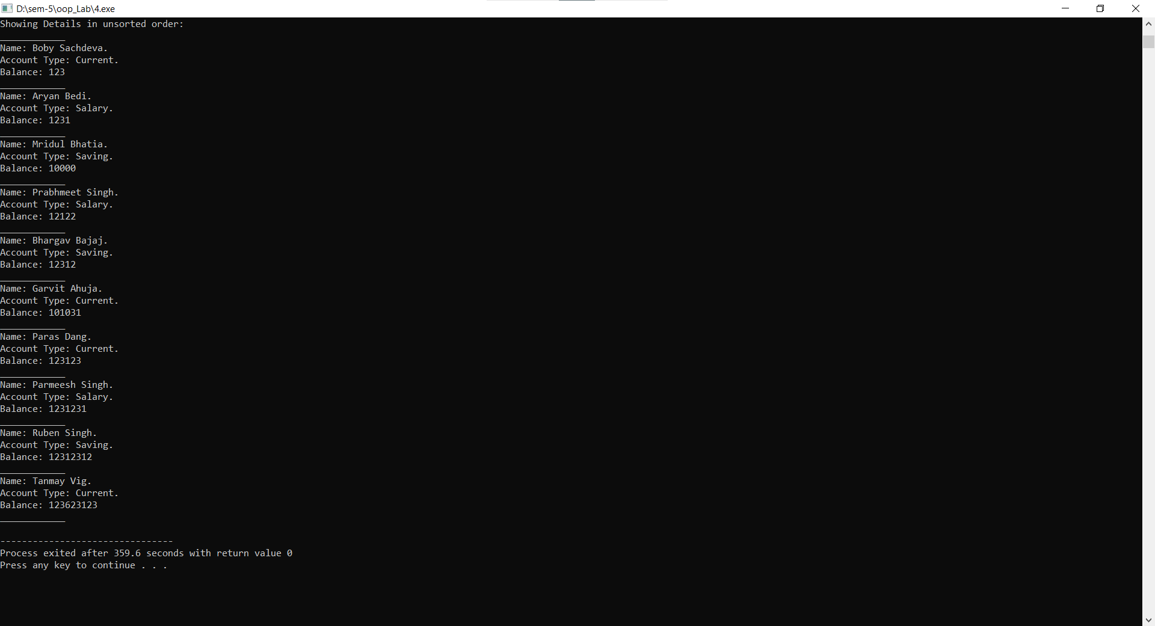

P5 a: Write the definition for a class called Rectangle that has floating point data members length and width. The class has the following member functions:
void setlength(float) to set the length data member
void setwidth(float) to set the width data member
float perimeter() to calculate and return the perimeter of the rectangle
float area() to calculate and return the area of the rectangle
void show() to display the length and width of the rectangle
int sameArea(Rectangle) that has one parameter of type Rectangle. sameArea() returns 1 if the two Rectangles have the same area, and returns 0 if they don't.
Write the definitions for each of the above member functions.
Write main function to create two rectangle objects. Set the length and width of the first rectangle to 5 and 2.5. Set the length and width of the second rectangle to 5 and 18.9. Display each rectangle and its area and perimeter.
3. Check whether the two Rectangles have the same area and print a message indicating the result. Set the length and width of the first rectangle to 15 and 6.3. Display each Rectangle and its area and perimeter again. Again, check whether the two Rectangles have the same area and print a message indicating the result.
Source Code:
#include<iostream>

using namespace std;

class Rectangle{
private:
float length;
float width;
public:
void setLength(float);
void setWidth(float);
float perimeter();
float area();
void show();
int sameArea(Rectangle);
};

void Rectangle::setLength(float l){
length=l;
cout<<"Length of rectangle is set to "<<l<<endl;
}

void Rectangle::setWidth(float w){
width=w;
cout<<"Width of rectangle is set to"<<w<<endl;
}

float Rectangle::perimeter(){
return 2*(length+width);
}

float Rectangle::area(){
return length*width;
}

void Rectangle::show(){
cout<<"Length of Rectangle: "<<length<<"\nWidth of Rectangle: "<<width<<endl;
}

int Rectangle::sameArea(Rectangle r){
return area()==r.area() ? 1 : 0;
}

int main(){
Rectangle r1,r2;
cout<<"Setting dimentions of Rectangle 1.\n";
r1.setLength(5); r1.setWidth(2.5);
cout<<endl;

cout<<"Setting dimentions of Rectangle 2.\n";
r2.setLength(5); r2.setWidth(18.9);
cout<<endl;

cout<<"Showing details of Rectangles\n\n";
cout<<"Rectangle 1:\n";
r1.show();
cout<<"Area: "<<r1.area()<<endl;
cout<<"Perimeter: "<<r1.perimeter()<<endl;
cout<<endl;
cout<<"Rectangle 2:\n";
r2.show();
cout<<"Area: "<<r1.area()<<endl;
cout<<"Perimeter: "<<r1.perimeter()<<endl;
cout<<endl;

if(r1.sameArea(r2)) cout<<"Both Rectangles have the same area.\n\n";
else cout<<"Both Rectangles have different area.\n\n";

cout<<"Changing dimentions of Rectangle 1.\n";
r1.setLength(15);
r1.setWidth(6.3);
cout<<endl;

cout<<"Showing details of Rectangles\n\n";
cout<<"Rectangle 1:\n";
r1.show();
cout<<"Area: "<<r1.area()<<endl;
cout<<"Perimeter: "<<r1.perimeter()<<endl;
cout<<endl;
cout<<"Rectangle 2:\n";
r2.show();
cout<<"Area: "<<r1.area()<<endl;
cout<<"Perimeter: "<<r1.perimeter()<<endl;
cout<<endl;

if(r1.sameArea(r2)) cout<<"Both Rectangles have the same area.\n\n";
else cout<<"Both Rectangles have different area.\n\n";

return 0;
}
Output:
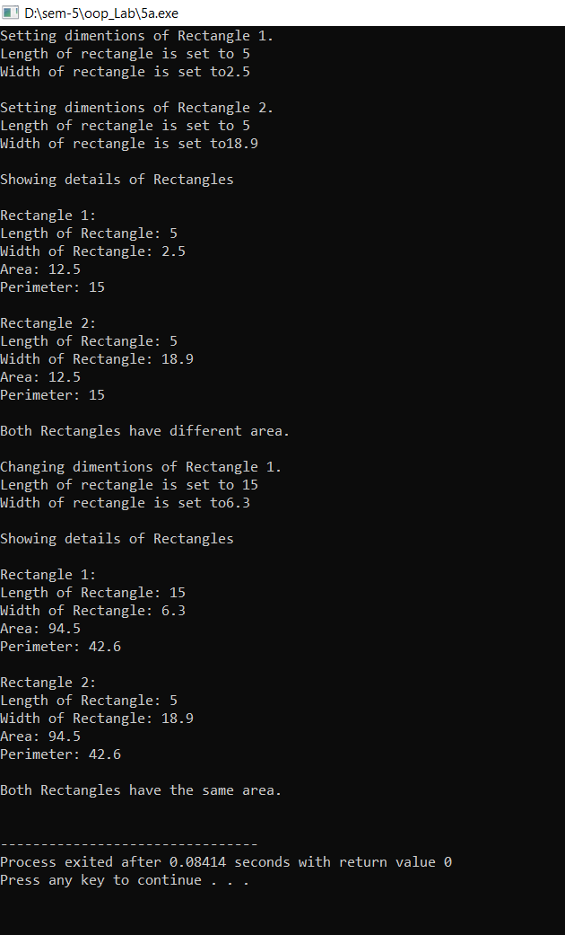

P5 b: Write the definition for a class called complex that has floating point data members for storing
real and imaginary parts. The class has the following member functions:
void set(float, float) to set the specified value in object
void disp() to display complex number object
complex sum(complex) to sum two complex numbers & return complex number
1. Write the definitions for each of the above member functions.
2. Write main function to create three complex number objects. Set the value in two objects and
call sum() to calculate sum and assign it in third object. Display all complex numbers.
Source code:
#include<iostream>

using namespace std;

class Complex{
private:
float real;
float imag;
Complex friend sum(Complex,Complex);
public:
void set(float r,float i){
real = r; imag = i;
}
void display(){
cout<<real<<" + "<<imag<<"i\n";
}
};

Complex sum(Complex x,Complex y){
Complex c;
c.real = x.real+y.real; c.imag = x.imag+y.imag;
return c;
}

int main(){
Complex a,b,c;
float r,i;
cout<<"Enter value of complex number 1.\nreal part:\t";
cin>>r;
cout<<"imaginary part:\t"; cin>>i;
a.set(r,i);

cout<<"Enter value of complex number 2.\nreal part:\t";
cin>>r;
cout<<"imaginary part:\t"; cin>>i;
b.set(r,i);

c = sum(a,b);
cout<<"Displaying values of complex numbers:\n";
cout<<"number 1:\n";
a.display();
cout<<"number 2:\n";
b.display();
cout<<"number 3:\n";
c.display();
return 0;
}
Output:
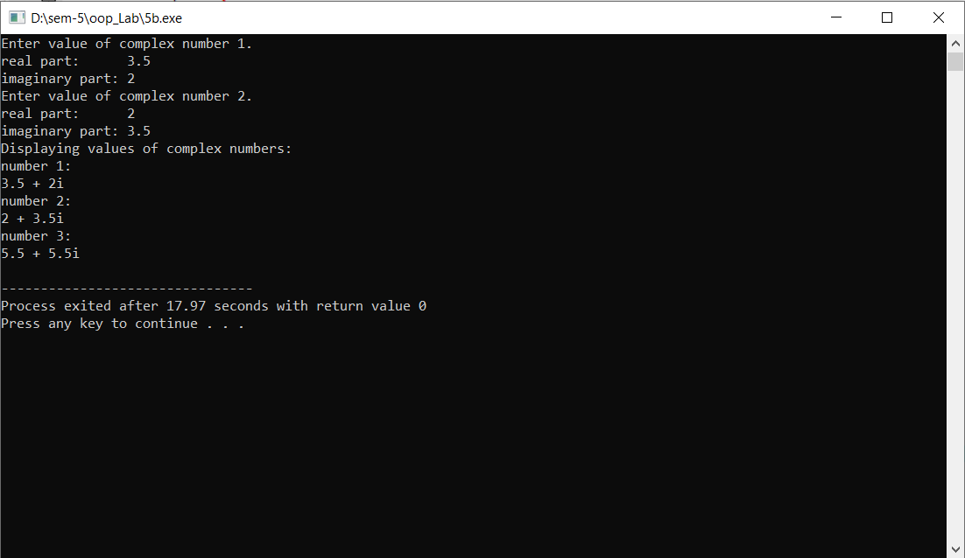

P5 c: Write the definition for a class called Distance that has data member feet as integer and inches as float. The class has the following member functions:
void set(int, float) to give value to object
void disp() to display distance in feet and inches
Distance add(Distance) to sum two distances & return distance
1. Write the definitions for each of the above member functions.
2. Write main function to create three Distance objects. Set the value in two objects and call add() to calculate sum and assign it in third object. Display all distances.
Source Code:
#include <iostream>
#include <cmath>
using namespace std;

class Distance
{
private:
int feet;
int inch;
Distance friend add(Distance,Distance);
public:
void set ();
void disp ();
};

void Distance:: set()
{
cout << "Enter Value of feets : "; cin >> feet;
cout << "Enter value of inches : "; cin >> inch;

}

void Distance:: disp()
{
cout << endl << "\tFeets : " << feet;
cout << endl << "\tInches: " << inch;
}

Distance add(Distance d1,Distance d2){
Distance temp;
int totdist = d2.inch+ d1.inch;
temp.feet = totdist/12+ d2.feet + d1.feet;
temp.inch = totdist%12;
return temp;
}

int main()
{
Distance d1;
Distance d2;
Distance d3;
Distance d4;

cout << "Enter Distance1 : " << endl;
d1.set();

cout << "Enter Distance2 : " << endl;
d2.set();

d3 = add(d1,d2);

cout << endl << "Distance1 : " ;
d1.disp();

cout << endl << "Distance2 : " ;
d2.disp();

cout << endl << "Distance3 : " ;
d3.disp();

cout << endl;
return 0;
}
Output:
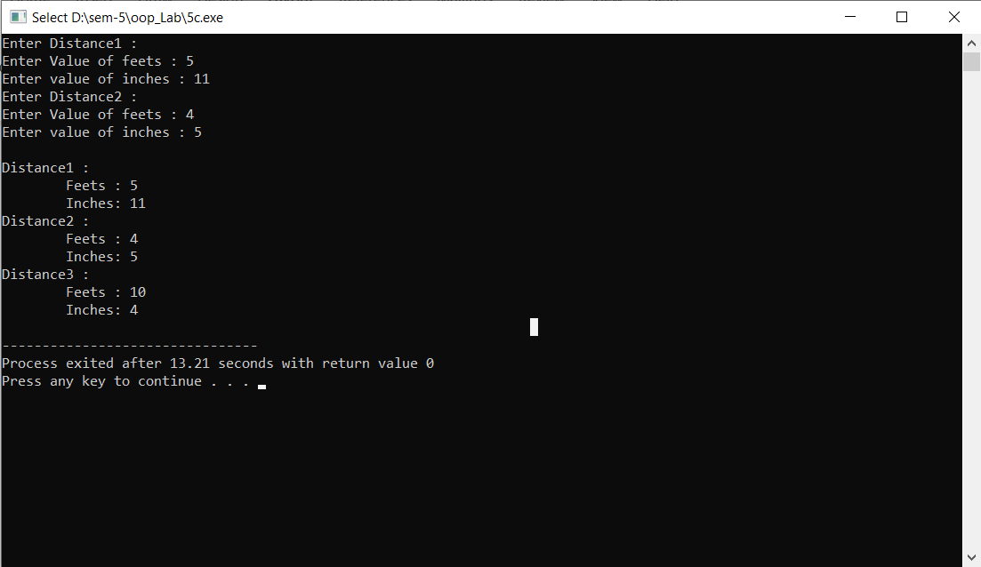

P5 d. Write the definition for a class called time that has hours and minutes as integer. The class has the following member functions:
void settime(int, int) to set the specified value in object
void showtime() to display time object
time sum(time &,time &) to sum two time object & return time
1. Write the definitions for each of the above member functions.
2. Write main function to create three time objects. Set the value in two objects and call sum() to
calculate sum and assign it in third object. Display all time objects.
Source Code:
#include<iostream>

using namespace std;

class Time{
private:
int hrs,min;
Time friend sum(Time&,Time&);
public:
void setTime(int h,int m){
hrs=h%24;min=m;
}
void showTime(){
cout<<"hrs: "<<hrs<<"min: "<<min<<endl;
}
};

Time sum(Time &t1, Time &t2){
Time t;
t.hrs = (t1.hrs + t2.hrs + (t1.min + t2.min)/60)%24;
t.min = (t1.min + t2.min)%60;
return t;
}

int main(){
Time t1,t2,t3;
int hrs,min;
cout<<"Enter time 1\nEnter hrs:\t";
cin>>hrs;
cout<<"Enter min:\t";
cin>>min;
t1.setTime(hrs,min);

cout<<"Enter time 2\nEnter hrs:\t";
cin>>hrs;
cout<<"Enter min:\t";
cin>>min;
t2.setTime(hrs,min);

t3 = sum(t1,t2);

cout<<"Displaying times:\n";
cout<<"Time 1 = \t";
t1.showTime();

cout<<"Time 2 = \t";
t2.showTime();

cout<<"Time 3 = \t";
t3.showTime();
return 0;
}
Output: 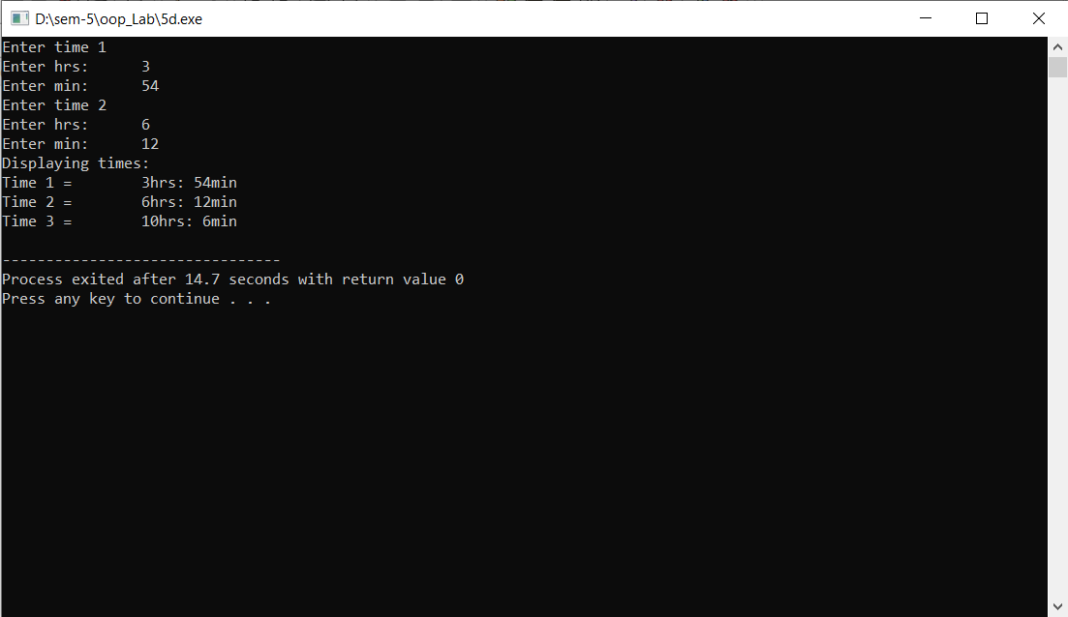

P6: A book shop maintains the inventory of books that are being sold at the shop. The list includes details such as author, title, price, publisher and stock position. Whenever a customer wants a book, the sales person inputs the title and author and the system searches the list and displays whether it is available or not. If it is not, an appropriate message is displayed. If it is, then the system displays the book details and requests for the number of copies required. If the requested copies book details and requests for the number of copies required. If the requested copies are available, the total cost of the requested copies is displayed; otherwise the message "Required copies not in stock" is displayed. Design a system using a class called Books with suitable member functions and Constructors. Implement C++ program for the system.
Source Code:
#include<iostream>
#include<string>
#include<iomanip>
#define M 5
using namespace std;

class Books{
private:
string author;
string title;
float price;
string publisher;
int stock_position;
void friend add_to_array(Books &,Books,int);
void friend bill(Books arr[],int);
void friend search_by_author(Books arr[],string);
void friend search_by_title(Books arr[],string);
void friend show_all_books(Books arr[]);
public:
Books(){}
Books(string a, string t, float pr, string pub, int st){
author = a;
title=t;
price=pr;
publisher=pub;
stock_position = st;
}
bool match(string,string);
void details();
float query(int);
void update_price(float);
};

bool Books::match(string t, string auth){
if(title==t && auth==author) return true;
return false;
}

void Books::details(){
cout<<"Title: "<<title<<endl<<"Author: "<<author<<endl;
cout<<"Publisher: "<<publisher<<endl<<"Price: "<<price<<endl;
}

float Books::query(int q){
if(q<=stock_position){
stock_position-=q;
return q*price;
}
return 0.0;
}

void Books::update_price( float p){
price=p;
}

void add_to_array(Books &a,Books b,int q){
a=b;
a.stock_position = q;
}

void bill(Books arr[],int n){
float total=0;
for(int i=0;i<n;i++){
total+=arr[i].price * arr[i].stock_position;
cout<<"Item: "<<i+1<<endl;
cout<<"Title: "<<arr[i].title<<endl;
cout<<"Author: "<<arr[i].author<<endl;
cout<<"Price: "<<arr[i].price<<endl;
cout<<"Quantity: "<<arr[i].stock_position<<endl;
}
cout<<"----------------------------------\nTotal: "<<total<<endl;
}

void show_all_books(Books arr[]){
cout<<"___________________________________________________________________________________\n";
cout<<"|Title |Author |Publisher |Price |Stock Position|\n";
cout<<"___________________________________________________________________________________\n";
for(int i=0;i<M;i++){
cout<<left<<"|"<<setw(18)<<arr[i].title<<"|"<<setw(17)<<arr[i].author<<"|"<<setw(18)<<arr[i].publisher<<"|"<<setw(10)<<arr[i].price<<"|"<<setw(14)<<arr[i].stock_position<<"|\n";
cout<<"___________________________________________________________________________________\n";
}
}

void search_by_author(Books arr[],string a){
cout<<"_________________________________________________________________\n";
cout<<"|Title |Publisher |Price |Stock Position|\n";
cout<<"_________________________________________________________________\n";
for(int i=0;i<M;i++){
if(arr[i].author==a){
cout<<left<<"|"<<setw(18)<<arr[i].title<<"|"<<setw(18)<<arr[i].publisher<<"|"<<setw(10)<<arr[i].price<<"|"<<setw(14)<<arr[i].stock_position<<"|\n";
cout<<"_________________________________________________________________\n";
}
}
}

void search_by_title(Books arr[],string a){
cout<<"__________________________________________________________________\n";
cout<<"|Author |Publisher |Price |Stock Position|\n";
cout<<"__________________________________________________________________\n";
for(int i=0;i<M;i++){
if(arr[i].title==a){
cout<<left<<"|"<<setw(18)<<arr[i].title<<"|"<<setw(18)<<arr[i].publisher<<"|"<<setw(10)<<arr[i].price<<"|"<<setw(14)<<arr[i].stock_position<<"|\n";
cout<<"__________________________________________________________________\n";
}
}
}

int main(){
Books arr[M],bought[M];
string author,title,publisher;
float price;
int stock,n=0;
bool flag;
cout<<"Eneter Details of books in stock.\n";
for(int i=0;i<M;i++){
cout<<"Details of book "<<i+1<<endl;
cout<<"Enter Title\n";
cin.clear();
cin.sync();
getline(cin,title);
cout<<"Enter Author's name\n";
getline(cin,author);
cout<<"Enter Publisher\n";
getline(cin,publisher);
cout<<"Enter Price\n";
cin>>price;
cout<<"Enter Stock Position\n";
cin>>stock;
arr[i]=Books(author,title,price,publisher,stock);
}
while(1){
int choice=0;
cout<<"Enter 1 to buy Book\nEnter 2 to see all book details\nEnter 3 to update price of a book\nEnter 4 to search all books by an author\nEnter 5 to search books by Title\nEnter 0 to exit.\n";
cin>>choice;
switch(choice){
case 1:
cout<<"Enter the Title and Author of the book\n";
cin.clear();
cin.sync();
getline(cin,title);
getline(cin,author);
for(int i=0;i<M;i++){
flag = arr[i].match(title,author);
if(flag){
int q,amt;
cout<<"Congratulations!! We have the required book in stock.\n";
arr[i].details();
cout<<"Enter the Number of Books you want? \t";
cin>>q;
amt=arr[i].query(q);
if(amt!=0){
add_to_array(bought[n],arr[i],q);
cout<<"Cost of books: "<<amt<<endl;
n++;
}else{
cout<<"Stock Unavailable.\n";
flag=false;
}
break;
}
}
if(!flag) cout<<"We Do not have the book you require\n";
break;
case 2:
show_all_books(arr);
break;
case 3:
cout<<"Enter the Title and Author of Book\n";
cin.clear();
cin.sync();
getline(cin,title);
getline(cin,author);
flag=false;
for(int i=0;i<M;i++){
if(arr[i].match(title,author)){
float price=0;
flag=true;
cout<<"Enter new price: ";
cin>>price;
arr[i].update_price(price);
break;
}
}
if(!flag){
cout<<"Book not found"<<endl;
}
break;
case 4:
cout<<"Enter Name of Author: ";
cin.clear();
cin.sync();
getline(cin,author);
search_by_author(arr,author);
break;
case 5:
cout<<"Enter Title of Book: ";
cin.clear();
cin.sync();
getline(cin,title);
search_by_title(arr,title);
break;
default:
cout<<"Enter valid input\n";
break;
}
if(choice==0) break;
}
bill(bought,n);
return 0;
}
Output:
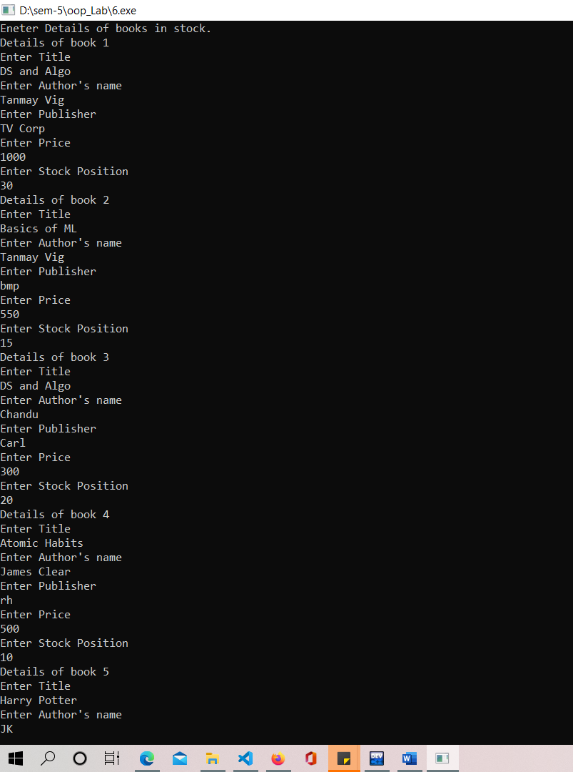
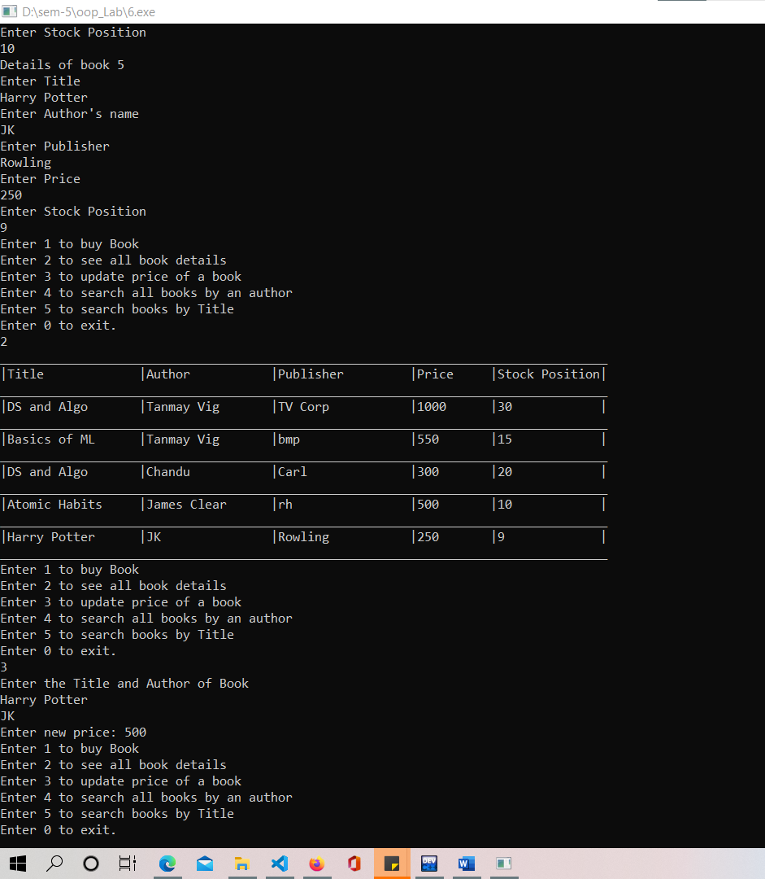
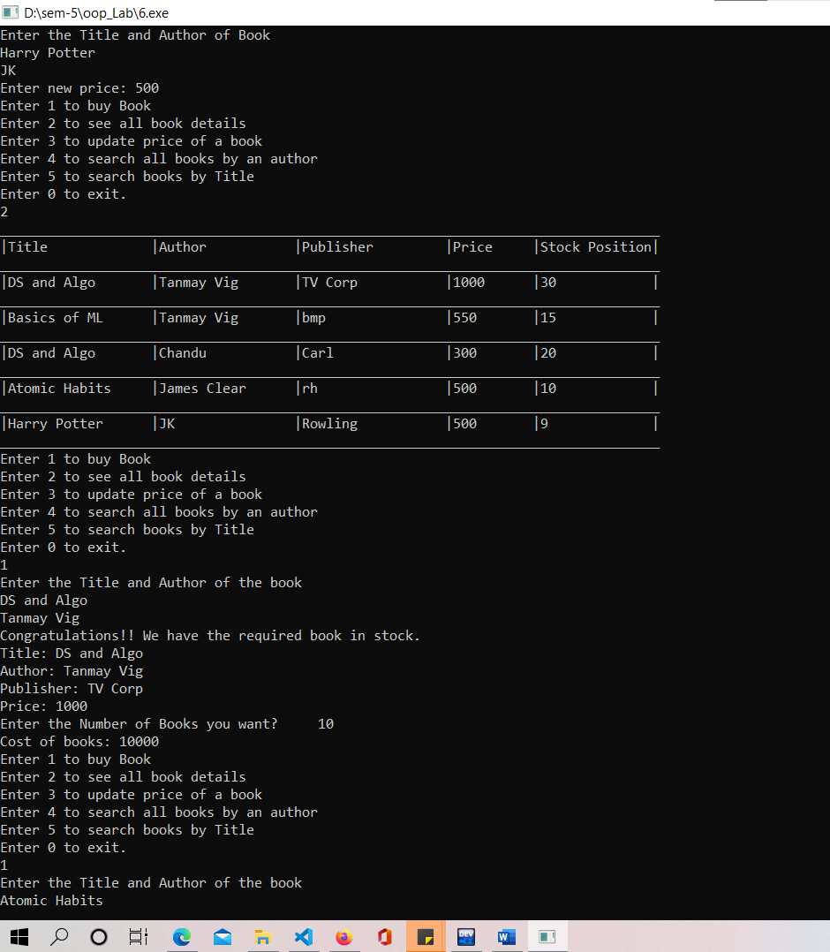
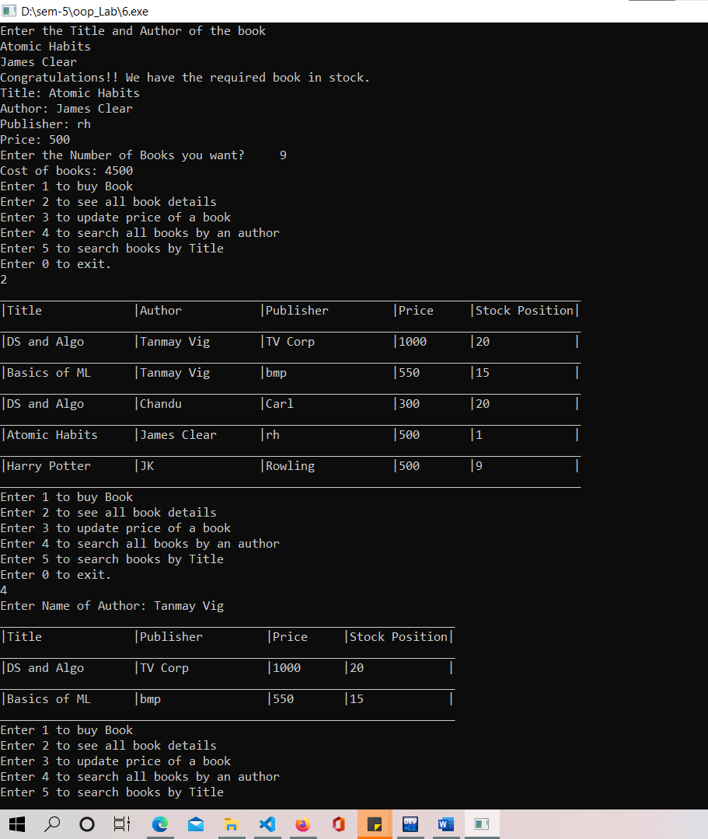
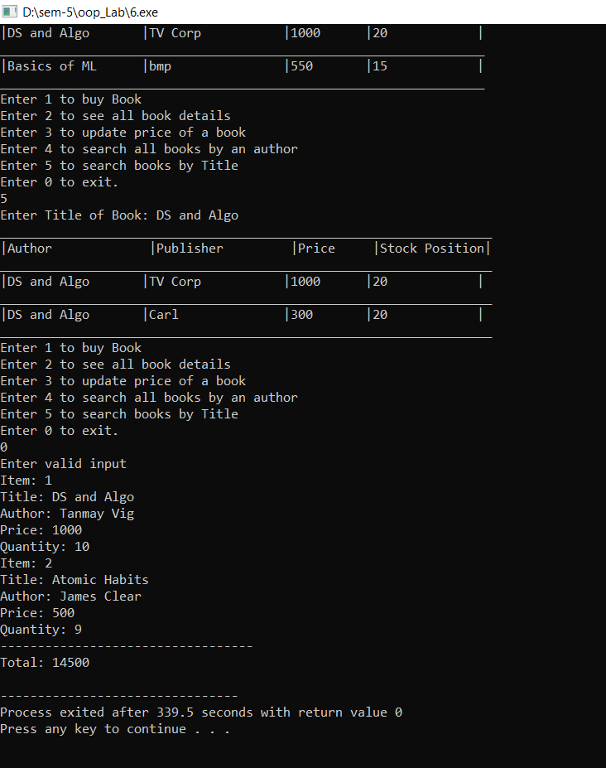

P7: Write a program in C++ to implement a class Employee using following concepts:
Pointer to Objects, Dynamic Memory Allocation using new and delete, Dynamic constructors, Destructors
Source Code:
#include<iostream>
#include<string>
#include<iomanip>
using namespace std;

class Employee{
private:
// int holidays;
long long int id,salary;
string name;
int friend find(Employee *arr[], int n, string name,long long int id, bool mode_id, bool print);
void friend display(Employee *arr[],int , bool );
void friend sort(Employee *arr[],int n,int form);
void friend del(Employee *arr[], int n,int pos);
public:
Employee(){}
Employee(int i, string n,long long int s){
id = i;
name = n;
salary = s;
// holidays = h;
}
};

int find(Employee *arr[],int n,string name,long long int id,bool mode_id, bool print){
bool found=false;
for(int i=0;i<n;i++){
if((!mode_id && arr[i]->name==name) || (mode_id && arr[i]->id == id)){
found = true;
if(print)display(arr,i,found);
return i;
break;
}
}
if(!found) cout<<"No related data found.\n";
return -1;
}

void display(Employee *arr[],int n, bool single){
cout<<"---------------------------------------\n";
cout<<"|id |Name |Salary |\n";
cout<<"---------------------------------------\n";
if(single){
cout<<left<<"|"<<setw(10)<<(*arr[n]).id<<"|"<<setw(15)<<(*arr[n]).name<<"|"<<setw(10)<<(*arr[n]).salary<<"|\n";
cout<<"---------------------------------------\n";
}else{
for(int i=0;i<n;i++){
cout<<left<<"|"<<setw(10)<<(*arr[i]).id<<"|"<<setw(15)<<(*arr[i]).name<<"|"<<setw(10)<<(*arr[i]).salary<<"|\n";
cout<<"---------------------------------------\n";
}
}
}

void sort(Employee *arr[],int n,int form){
for(int i=0;i<n-1;i++){
for(int j=0;j<n-i-1;j++){
if((form == 1 && arr[j]->id>arr[j+1]->id) || (form==2 && arr[j]->name.compare(arr[j+1]->name)>0) || (form==3 && arr[j]->salary>arr[j+1]->salary)){
Employee temp = *arr[j];
*arr[j] = *arr[j+1];
*arr[j+1] = temp;
}

}
}
display(arr,n,false);

}

void del(Employee *arr[],int n,int pos){
for(int i=pos;i<n-1;i++){
Employee temp = *arr[i];
*arr[i] = *arr[i+1];
*arr[i+1] = temp;
}
cout<<"Deleted\n";
}

int main(){
int n=5;
Employee *arr[100];
cout<<"Enter the employee Details:\n";
for(int i=0;i<n;i++){
long long int id, salary; string name;
cout<<"Enter the details of employee "<<(i+1)<<endl;
cout<<"Enter id, name salary\n";
cin>>id;
cin.ignore();
getline(cin,name);
cin>>salary;
arr[i] = new Employee(id,name,salary);
}
while(true){
int choice=0,s=0;
long long int id,salary;
string name;
cout<<"to display data of all employees Enter 1\nto display data of one employee Enter 2\nto sort data Enter 3\nto delete Enter 4\nto insert new employee Enter 5\nto exit Enter 0\n";
cin>>choice;
switch (choice)
{
case 2:
cout<<"to search by name Enter 1\nto search by id Enter 2\n";
cin>>s;
if(s==1){
cout<<"Enter name: ";
cin.clear();
cin.sync();
getline(cin,name);
find(arr,n,name,-1,false,true);
}else{
cout<<"Enter id: ";
cin>>s;
find(arr,n,"",s,true,true);
}
break;
case 1:
display(arr,n,false);
break;
case 3:
cout<<"to sort by id Enter 1\nto sort by name Enter 2\nto sort by salary Enter 3\n";
cin>>s;
sort(arr,n,s);
break;
case 4:
cout<<"to find by id Enter 1\nto find by name Enter 2\n";
cin>>s;
if(s==1){
cout<<"Enter id: ";cin>>s;
s=find(arr,n,"",s,true,false);
}else{
cin.clear();
cin.sync();
getline(cin,name);
s=find(arr,n,name,-1,false,false);
}
if(s!=-1){
del(arr,n,s);
n--;
}
break;
case 5:
cout<<"Enter id, name, salary\n";
cin>>id;
cin.ignore();
getline(cin,name);
cin>>salary;
arr[n++] = new Employee(id,name,salary);
break;
default:
choice =0;
break;
}
if(!choice) break;
}
return 0;
}
Output:
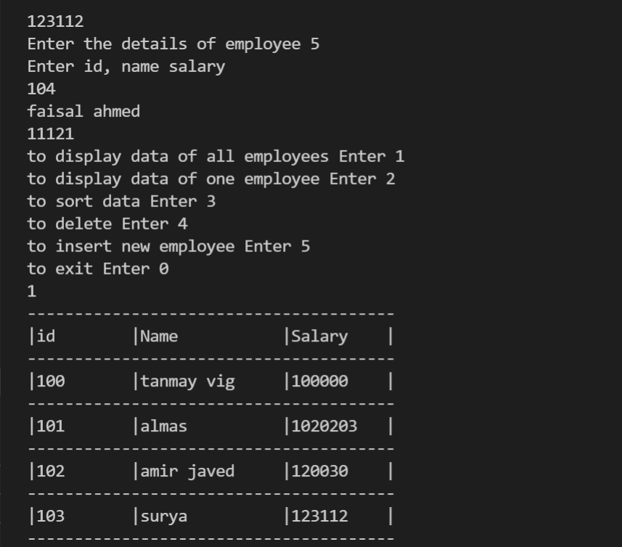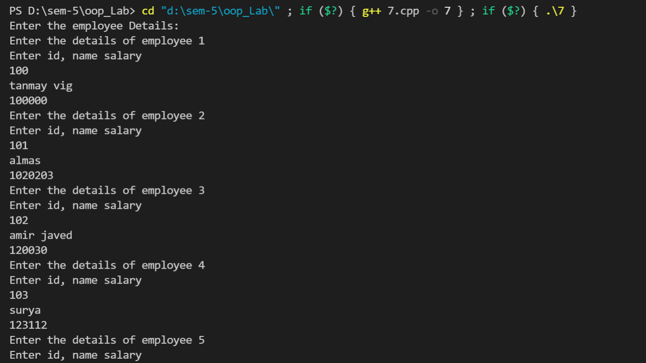
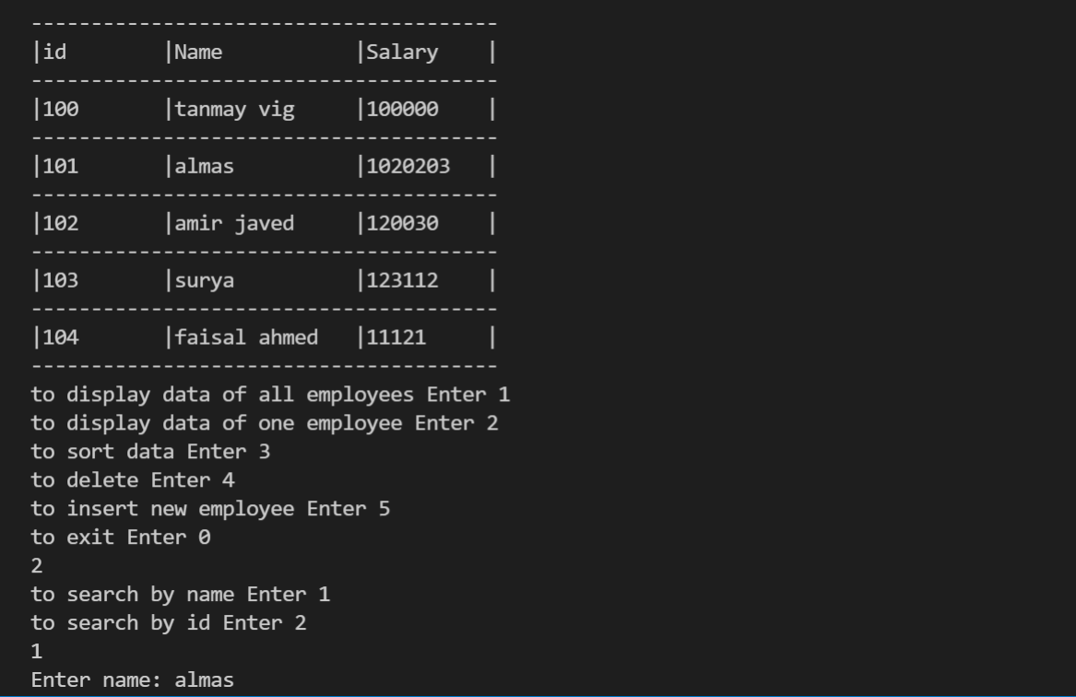
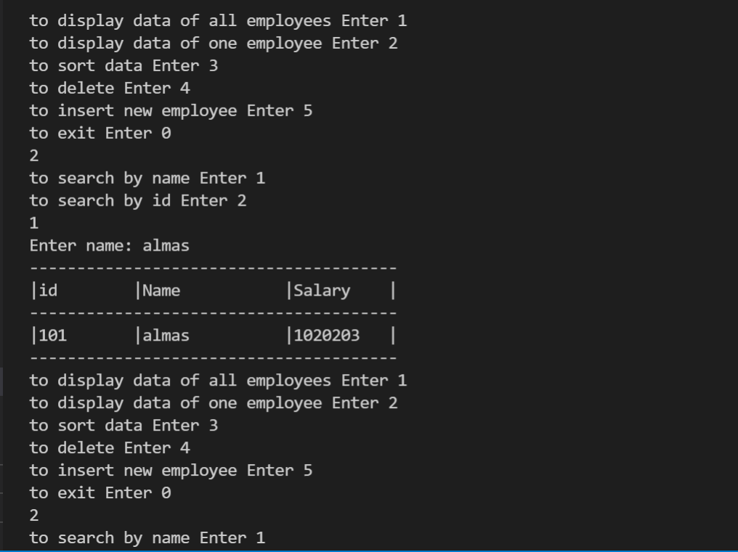
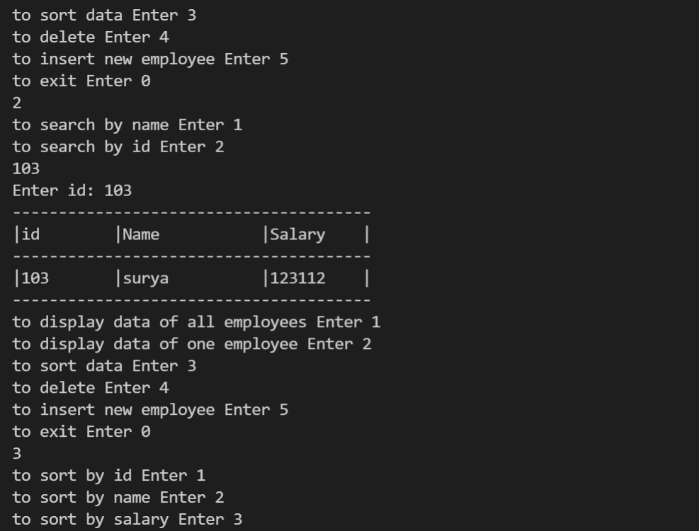
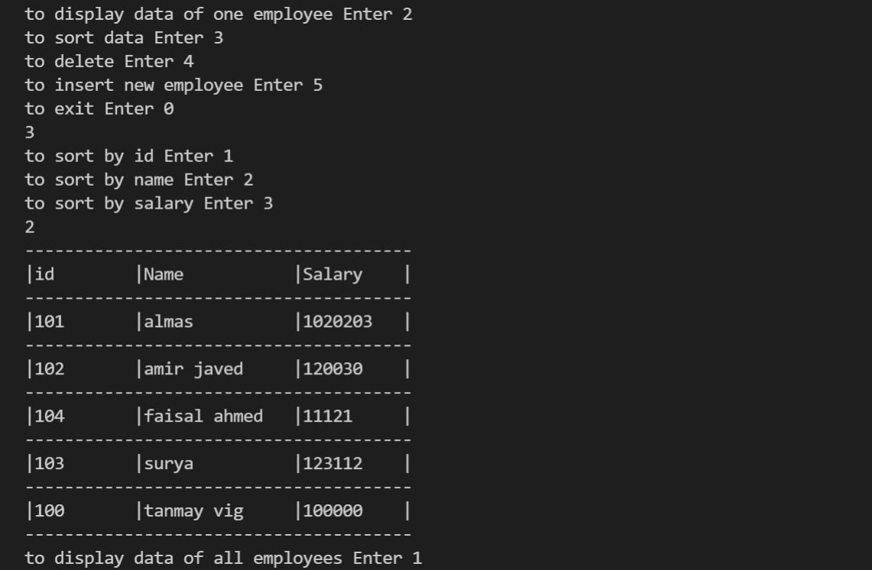
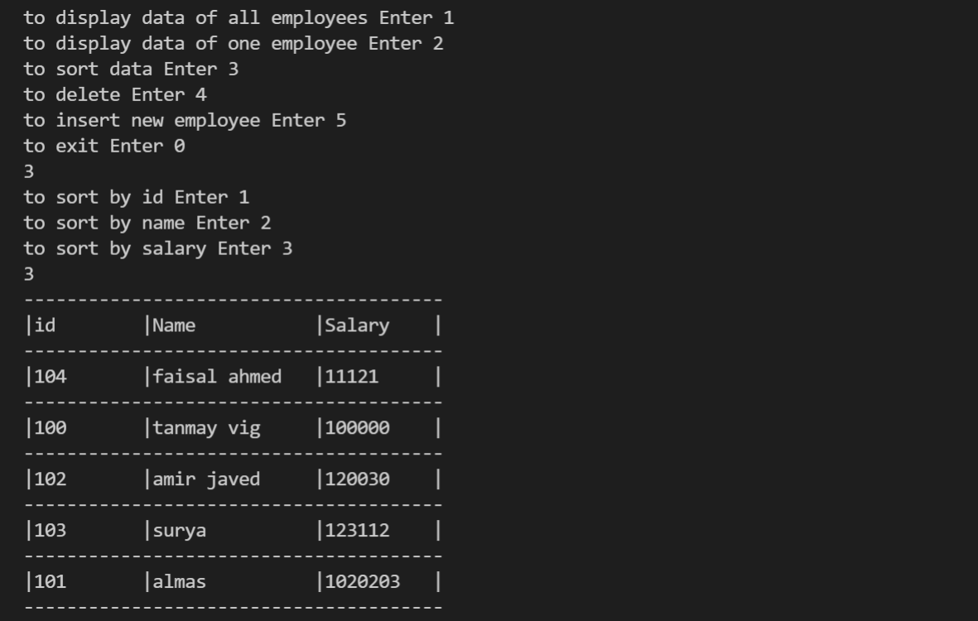
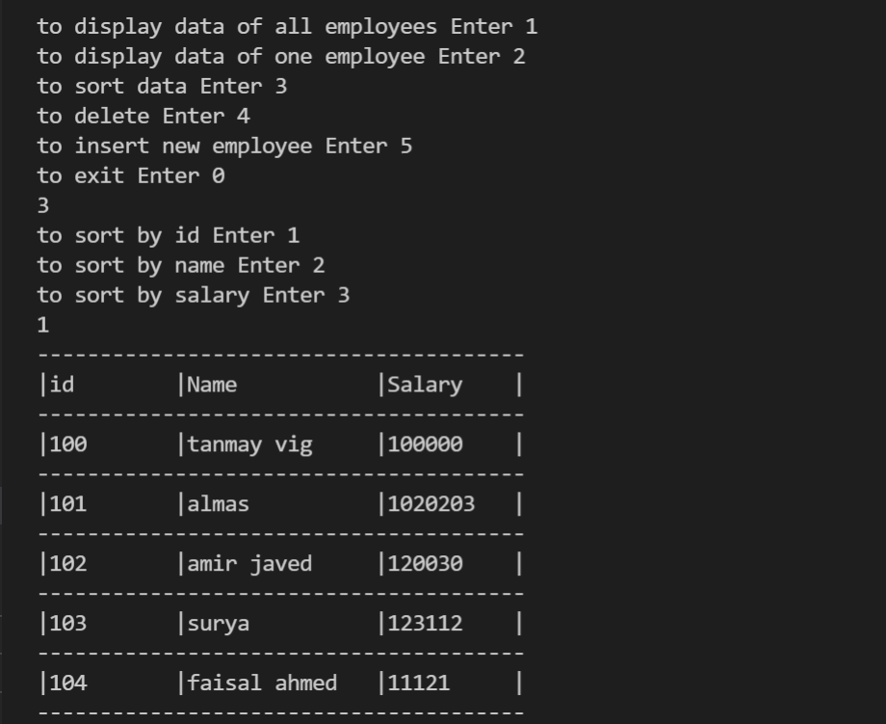
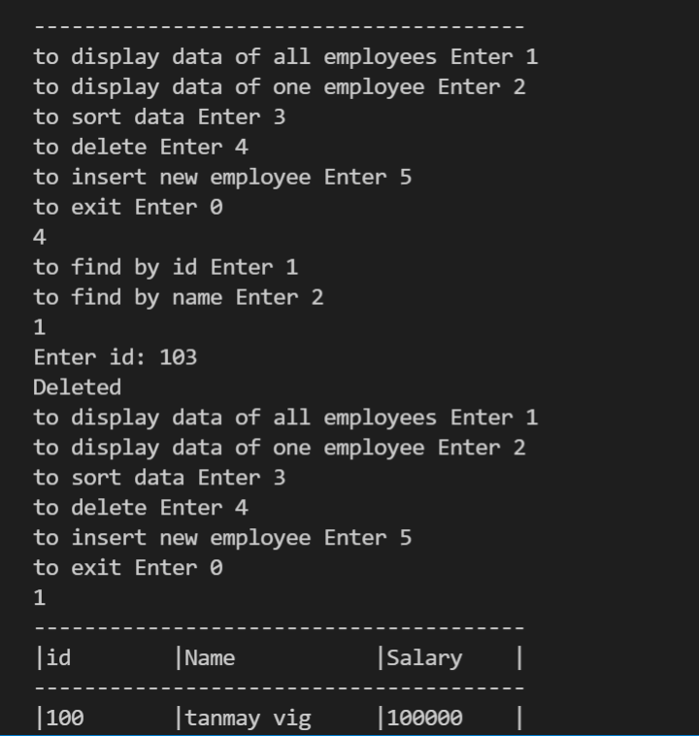
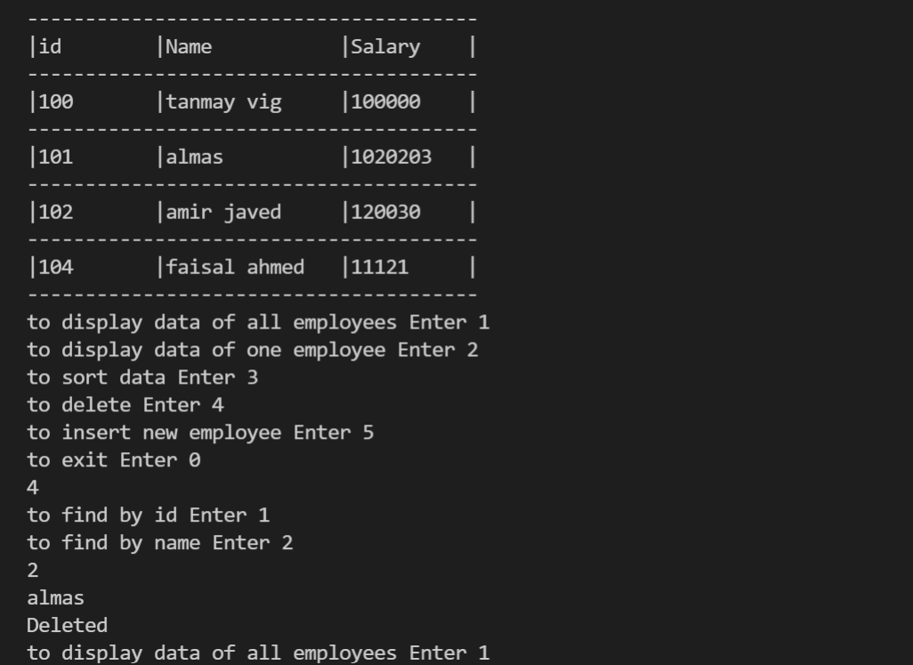
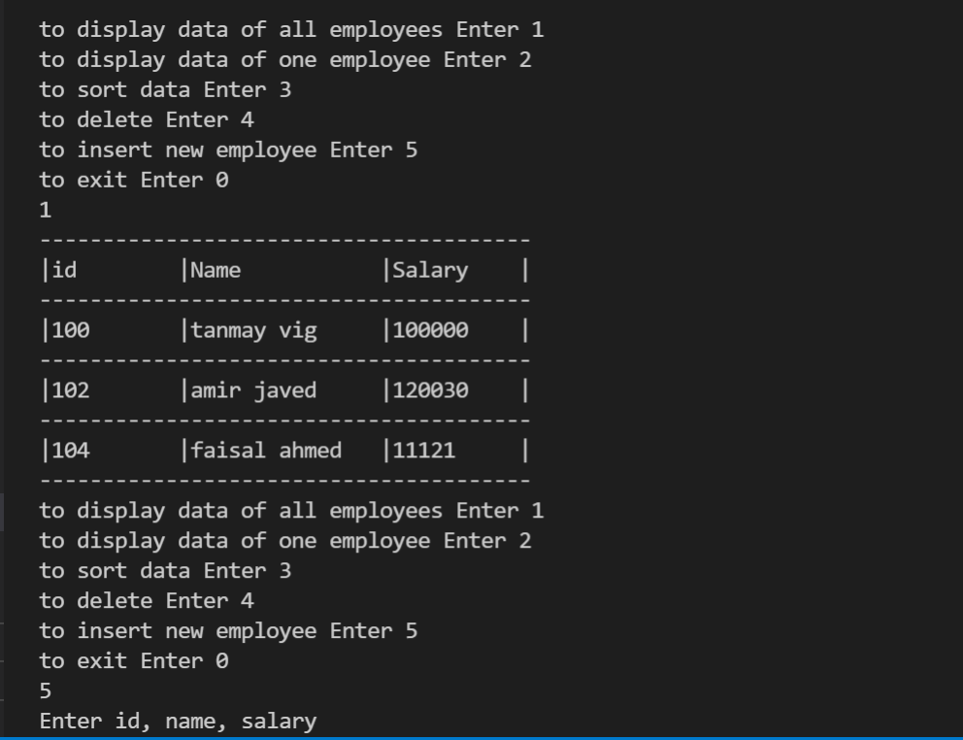
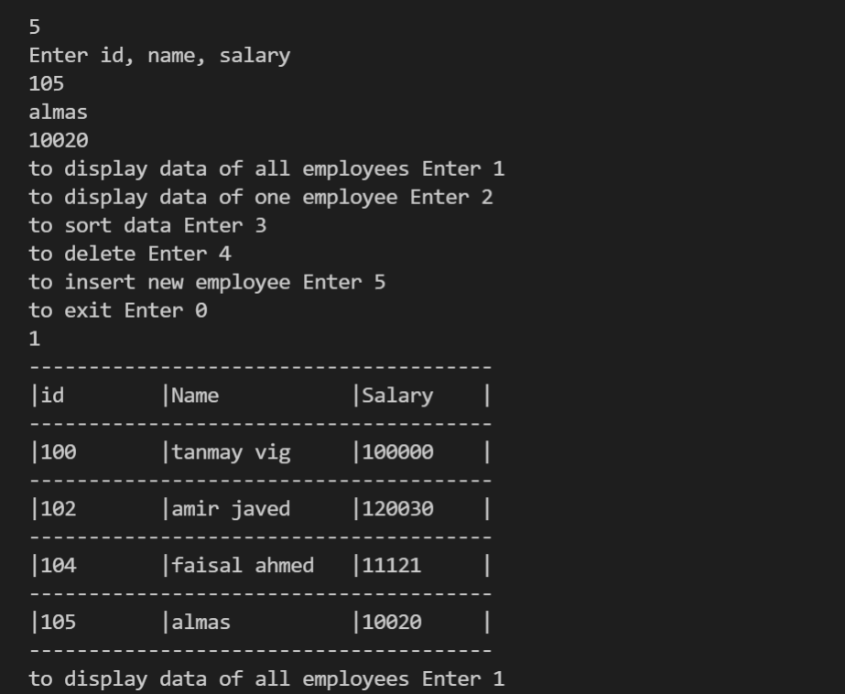
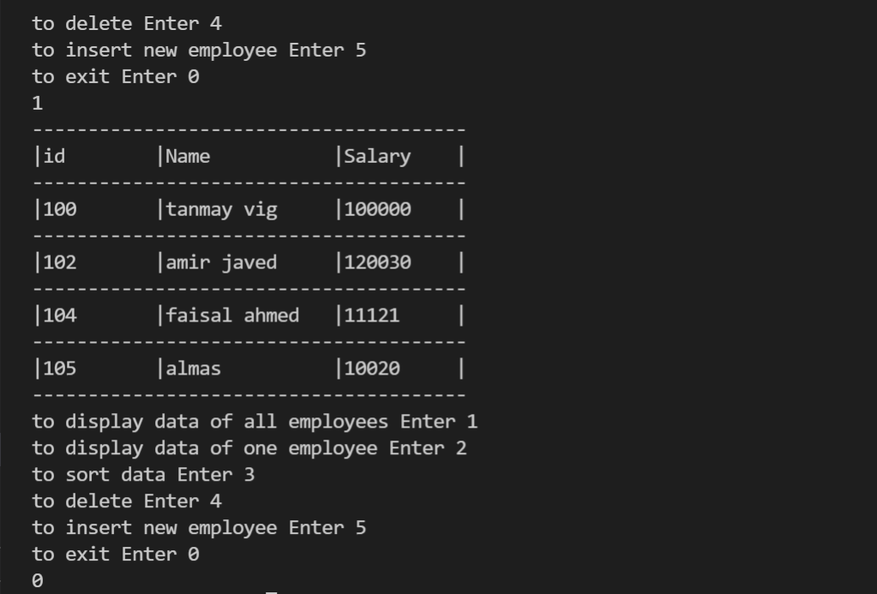

P8: Use operator overloading to do complete the following functions:
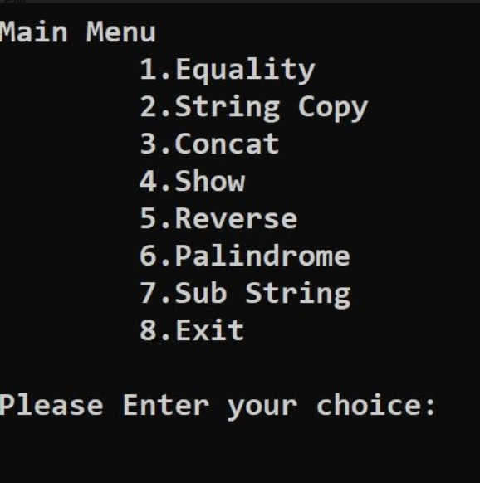
Source Code:
#include<iostream>
#include<cstring>
using namespace std;

class String{
private:
char str[30];
public:
void input();
void show();
void operator==(String s);
void operator=(String s);
void operator+(String s);
void operator<<(String s);
void operator>>(String s);
void operator~();
int operator/(String s);
};

void String::input(){
cout<<"Enter String: ";
cin.clear();
cin.sync();
cin.getline(str,30);
}

void String::show(){
for(int i=0;str[i]!='\0';i++){
cout<<str[i];
}
}

void String::operator==(String s){
int i=0;
bool equal=true;
while(*(str+i)!='\0' && *(s.str + i)!='\0' ){
if(*(str+i)!=*(s.str+i)){
equal=false;
break;
}
i++;
}
if(equal && *(str+i)!='\0' && *(s.str+i)!='\0') cout<<"Both String are equal\n";
else cout<<"Strings are not equal\n";
}

void String::operator=(String s){
int i=0,len= sizeof(s.str)/sizeof(char);
for(int i=0;i<len;i++){
*(str+i)= *(s.str+i);
// str[i]=s.str[i];
}
*(str+len )='\0';
}

void String::operator+(String s){
int len=0;
while(this->str[len]!='\0') len++;
for(int i=0;s.str[i]!='\0';++i,++len){
this->str[len] = s.str[i];
}
this->str[len] = '\0';
}

void String::operator<<(String s){
cout<<"Sring:\t";
s.show();
cout<<"\n";
}

void String::operator>>(String s){
cout<<"Reverse String:\t";
for(int i=strlen(s.str);i>=0;i--){
cout<<s.str[i];
}
cout<<"\n";
}

void String::operator~(){
bool ans=true;
int len = strlen(str)-1;
for(int i=0;i<=len/2;i++){
// cout<<str[i]<<" "<<str[len-i]<<endl;
if(str[i]!=str[len-i]){
ans=false;
break;
}
}
if(ans) cout<<"Yes It is palindrome\n";
else cout<<"No it is not palindrome\n";
}

int String::operator/(String s)
{
int flag=0,k,i,j,len=strlen(str),len1=strlen(s.str)-1;
for(i=0;i<len;i++)
{
if(str[i]==s.str[0])
{
if(str[i+len1]==s.str[len1])
{
for(j=i,k=0;j<i+len1+1,k<len1;j++,k++)
{
if(str[j]==s.str[k])
flag=1;
else
{
flag=0;
break;
}
}
}
}
}
if(flag==0)
return 0; //not a substring

return 1; //it is a substring
}

int main(){
while(true){
int choice=8,br=0,c;
String a,b;
a.input();
b.input();
cout<<"Main Menu\n\t1. Equality\n\t2. String copy\n\t3. Concat\n\t4. Show\n\t5. Reverse\n\t6. Palindrome\n\t7. Sub String\n\t8. Exit\nPlease enter your choice\t";
cin>>choice;
switch (choice)
{
case 1:
a==b;
break;
case 2:
b=a;
cout<<"The String is copied: ";
b.show();
cout<<endl;
break;
case 3:
a+b;
a.show();
cout<<"\n";
break;
case 4:
b<<a;
break;
case 5:
b>>a;
break;
case 6:
~a;
break;
case 7:
c=a/b;
if(c){
cout<<"YES\n";
}else cout<<"NO\n";
break;
case 8:
br=1;
break;
default:
cout<<"Enter Valid option\n";
break;
}
if(br) break;
}
return 0;
}
Output:
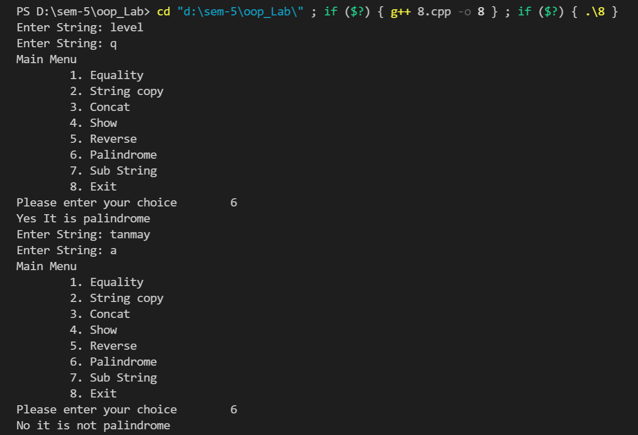

P9: Write a program to implement a class Stack using Linked List.
Source code:
#include <iostream>
using namespace std;

class Stak_Node {
private:
int data;
Stak_Node* next;
public:
Stak_Node* newNode(int);
void push(Stak_Node**, int);
int pop(Stak_Node**);
int isempty(Stak_Node*);
int front(Stak_Node*);
void print(Stak_Node*);
};

Stak_Node* Stak_Node::newNode(int data){
Stak_Node* stackNode = new Stak_Node();
stackNode->data = data;
stackNode->next = NULL;
return stackNode;
}

void Stak_Node::push(Stak_Node** root, int data){
Stak_Node* stackNode = newNode(data);
stackNode->next = *root;
*root = stackNode;
cout<<data<<" pushed to the stack";
}

int Stak_Node::pop(Stak_Node** root){
if (isempty(*root))
return INT_MIN;

Stak_Node* temp = *root;
*root = (*root)->next;
int popped = temp->data;
return popped;
}

int Stak_Node::isempty(Stak_Node* root){
return !root;
}

int Stak_Node::front(Stak_Node* root){
if (isempty(root))
return INT_MIN;
return root->data;
}

void Stak_Node::print(Stak_Node* root){
cout<<"Elements present in stack are (top to bottom) : ";
while(!isempty(root)) {
cout<<front(root)<<"\t";
pop(&root);
}
}

int main(){
Stak_Node* root = NULL;
int choice,item;

while(1){
cout<<"\n\n1.To Push\n2.To Pop\n3.To Display the top element\n4.To Display all stack elements\n5.To Quit\n\nEnter your choice : ";
cin>>choice;
switch(choice){
case 1 :
cout<<"\nEnter data for the stack element: ";
cin>>item;
root->push(&root, item);
break;
case 2:
cout<<root->pop(&root)<<" is popped from stack\n";
break;
case 3:
cout<<"\n"<<root->front(root)<<" is on the top\n"<<endl;
break;
case 4:
root->print(root);
break;
case 5:
exit(1);
default:
cout<<"\nINCORRECT INPUT\n";
}
}

return 0;
}
Output:
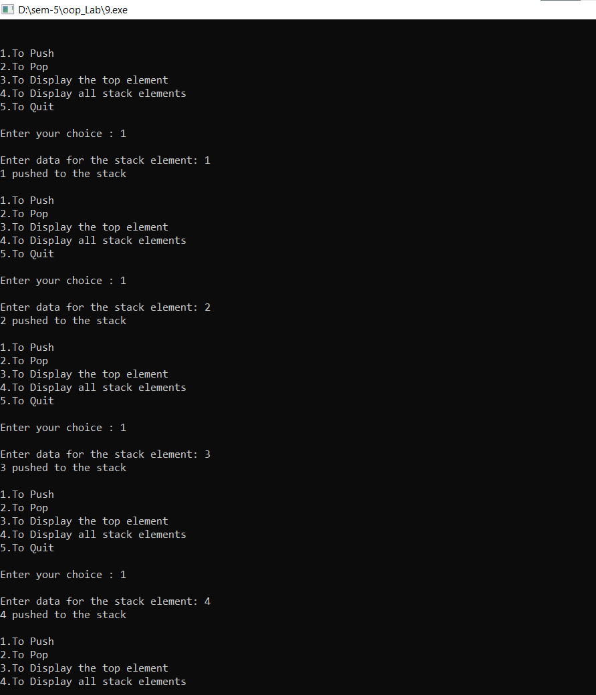
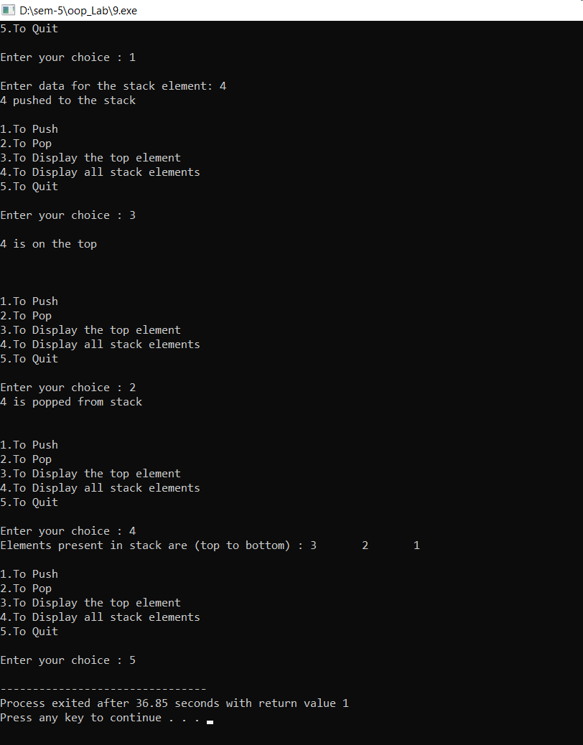

P10: Implementation of Inheritance
Source Code
#include <iostream>
#include <string>

using namespace std;

class Employee{
private:
string name;
string id;
int salary;

public:
Employee() {}
Employee(string n, string i, int s){
id=i;
name=n;
salary = s;
}
~Employee(){
}
void getEmployee(){
cout<<"Employee id: "<<id<<"\nEmployee Name: "<<name<<"\nEmployee salary: "<<salary<<endl;
}
};

class Scientist: protected Employee{
private:
int num_publications;
int num_awards;
string *publications;
string *awards;
public:
Scientist() {}
Scientist(int num_pub, string *pub, string *aw,int n_a, string name, string id, int salary):Employee(name,id,salary){
num_publications = num_pub;
num_awards = n_a;
publications = new string[num_publications];
for(int i=0;i<num_publications;i++){
publications[i] =pub[i];
}
awards = new string[n_a];
for(int i=0;i<n_a;i++){
awards[i] =aw[i];
}
}
~Scientist(){
delete[] publications;
delete[] awards;
}
void getScientist(){
cout<<"\nScientist Details:\n";
getEmployee();
cout<<"\nTotal publications: "<<num_publications<<endl;
cout<<"Publications:\n";
for(int i=0;i<num_publications;i++){
cout<<" "<<publications[i]<<endl;
}
cout<<"\nTotal Awards: "<<num_awards<<endl;
cout<<"Awards:\n";
for(int i=0;i<num_awards;i++){
cout<<" "<<awards[i]<<endl;
}cout<<"\n";
}

};

class Manager : protected Employee{
private:
string title;
int yrs_of_exp;
int teams;
public:
Manager(){}
Manager(string t, int yrs, int tm,string name, string id, int salary):Employee(name,id,salary){
title=t;
yrs_of_exp=yrs;
teams = tm;
}
~Manager(){
}
void getManager(){
cout<<"\nManager Details: \n";
getEmployee();
cout<<"Title as Manager: "<<title<<endl;
cout<<"Years of Experience: "<<yrs_of_exp<<endl;
cout<<"Teams Managed: "<<teams<<endl;
}
};

class Laborer : protected Employee{
private:
int overtime;
int wage_over;
int leaves;
public:
Laborer(){}
Laborer(int o, int w_o, int l,string name, string id, int salary) :Employee(name,id,salary){
overtime = o;
wage_over = w_o;
leaves = l;
}
~Laborer(){
}
void getLaborer(){
cout<<"\nLabourer Details: \n"<<endl;
getEmployee();
cout<<"Overtime: "<<overtime<<endl;
cout<<"Wage in overtime: "<<wage_over<<endl;
cout<<"Total leaves: "<<leaves<<endl;
}
};

int main(){

int sci_num=0,man_num=0, lab_num=0;
Scientist *arr_s[100];
Manager *arr_m[100];
Laborer *arr_l[100];

while(true){
int choice=0,c, yrs, teams;
int salary;
int n_p,n_a,n_o, wage, leaves;
string name, id,title;
cout<<"\nEnter:\n 1 to add Scientist\n 2 to add Manager\n 3 to add Laborer\n 4 to show all Scientists\n 5 to show all Managers\n 6 to show all Laborer\n any num to exit\n";
cin>>choice;
switch(choice){
case 1:
{
sci_num++;
cout<<"Enter Employee ID, Name and Salary\n";
cin.clear();
cin.sync();
getline(cin, id);
getline(cin, name);
cin>>salary;
cout<<"Enter number of publications\t";
cin>>n_p;
string *a_p = new string[n_p];
cout<<"Enter publications name\n";
for(int i=0;i<n_p;i++){
string s;
cin.clear();
cin.sync();
getline(cin, s);
a_p[i]=s;
}
cout<<"Enter number of awards\t";
cin>>n_a;
string *a_a = new string[n_a];
cout<<"Enter awards name\n";
for(int i=0;i<n_a;i++){
string s;
cin.clear();
cin.sync();
getline(cin, s);
a_a[i] = s;
}
arr_s[sci_num-1] = new Scientist(n_p,a_p,a_a, n_a,name,id, salary);
break;
}
case 4:
{
for(int i=0;i<sci_num;i++){
(*arr_s[i]).getScientist();
}
break;
}
case 2:
{
man_num++;
cout<<"Enter Employee ID, Name and Salary\n";
cin.clear();
cin.sync();
getline(cin, id);
getline(cin, name);
cin>>salary;
cout<<"Choose any position:\n 1. General Manager\n 2. Assistant Manager\n 3. Production Manager\n";
cin>>c;
// cin.clear();
// cin.sync();
switch(c){
case 1:
title = "General Manager";
break;
case 2:
title = "Assistant Manager";
break;
case 3:
title="Production Manager";
break;
default:
title="Unknown Manager";
break;
}
cout<<"Enter number of teams managed\t";
cin>>teams;
cout<<"Enter numbers of years of experience\t";
cin>>yrs;
arr_m[man_num-1] = new Manager(title,yrs,teams, name,id,salary);
break;
}
case 5:
{
for(int i=0;i<man_num;i++){
(*arr_m[i]).getManager();
}
break;
}
case 3:
{
lab_num++;
cout<<"Enter Employee ID, Name and Salary\n";
cin.clear();
cin.sync();
getline(cin, id);
getline(cin, name);
cin>>salary;
cout<<"Enter overtime hours\t";
cin>>n_o;
cout<<"Enter wage in overtime\t";
cin>>wage;
cout<<"Enter number of leaves\t";
cin>>leaves;
arr_l[lab_num-1] = new Laborer(n_o,wage,leaves,name, id, salary);
break;
}
case 6:
{
for(int i=0;i<lab_num;i++){
(*arr_l[i]).getLaborer();
}
break;
}
default:
{
choice = 0;
break;
}
}
if(choice == 0) break;
}

return 0;
}

Output:
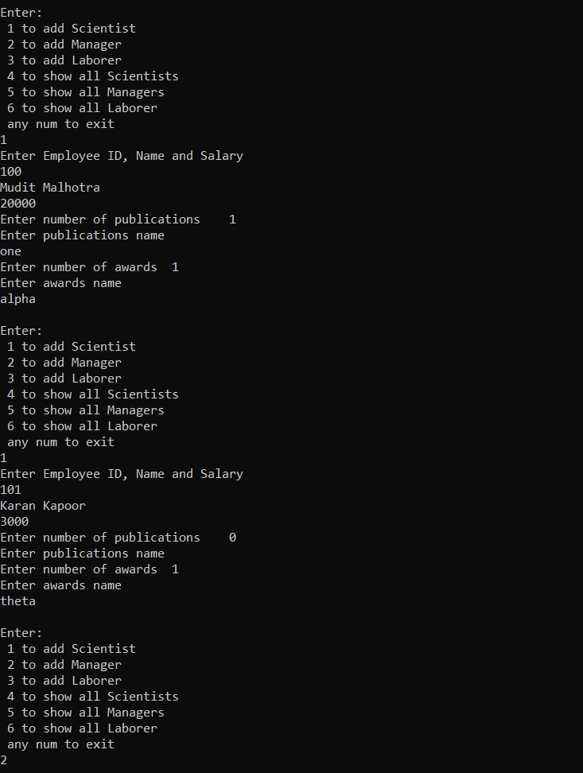
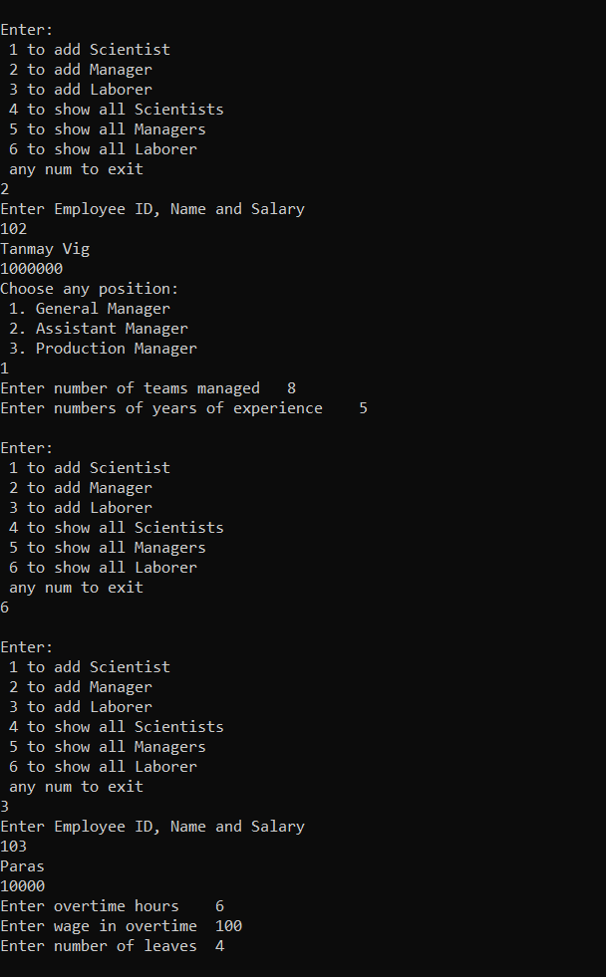
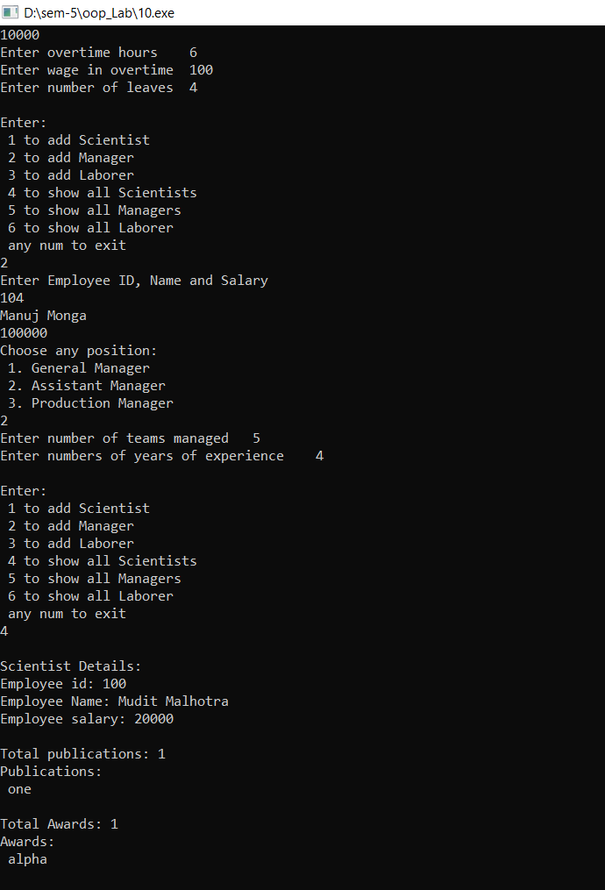
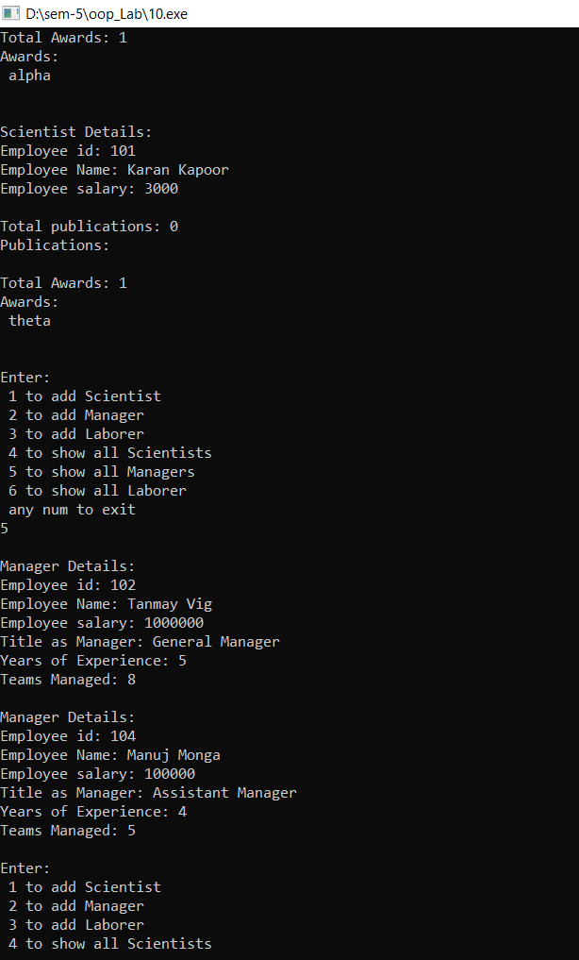
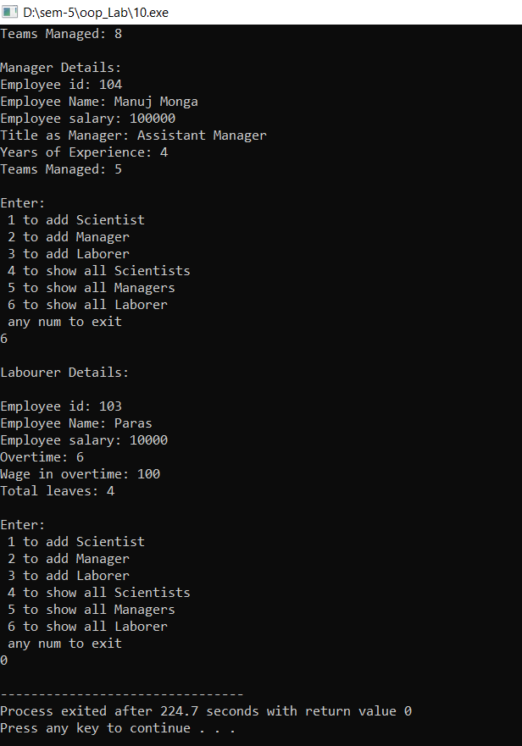

P11: A company pays its employees on a weekly basis. The employees are of four types: Salaried employees are paid a fixed weekly salary regardless of the number of hours worked, hourly employees are paid by the hour and receive overtime pay (i.e., 1.5 times their hourly salary rate) for all hours worked in excess of 40 hours, commission employees are paid a percentage of their sales and base-salaried commission employees receive a base salary plus a percentage of their sales. For the current pay period, the company has decided to reward salaried commission employees by adding 10% to their base salaries. Write a c++ program that performs payroll calculations of the company polymorphically.
Source Code:
#include<iostream>
#include<string>

using namespace std;

class Employee {
protected:
string name;
float salary;
public:
Employee(){ }
Employee(string n, float s){
name=n;salary=s;
}
virtual void getDetail(){
cout<<"\nEmployee Name: "<<name<<"\nSalary: "<<salary<<"\n\n";
}
virtual float getSalary(){
return salary;
}
};

class SalariedEmployee : public Employee {
public:
SalariedEmployee(string name, float salary): Employee(name, salary){ }
void getDetail(){
cout<<"\nEmployee Name: "<<name<<"\nType: "<<"Salaried\nSalary: "<<salary<<"\n\n";
}
};

class HourlyEmployee : public Employee
{
protected:
int hours;
public:
HourlyEmployee(string name, float salary, int hrs): Employee(name, salary){
hours=hrs;
}
float getsalary(){
if(hours<=40) return salary*hours;
else return salary*40 +1.5*salary*(hours-40);
}
void getDetail(){
cout<<"\nEmployee Name: "<<name<<"\nType: "<<"Hourly\nSalary: "<<getsalary()<<"\n\n";
}
};

class CommissionEmployee : public Employee {
protected:
float commission;
public:
CommissionEmployee(string name,float salary,float c):Employee(name, salary){
commission = c;
}
virtual float getSalary(){
return salary*commission/100;
}
virtual void getDetail(){
cout<<"\nEmployee Name: "<<name<<"\nType: Commissioned\nSalary: "<<getSalary()<<"\n\n";
}

};

class BasePlusCommissionEmployee : public CommissionEmployee{
protected:
float base_amount;
float increment;
public:
BasePlusCommissionEmployee(string name, float salary, float base, float c, float incr):CommissionEmployee(name, salary,c){
base_amount = base;
increment = incr;
}
float getSalary(){
return base_amount + base_amount*increment/100 + salary*commission/100;
}
void getDetail(){
cout<<"\nEmployee Name: "<<name<<"\nType: Commissioned\nSalary: "<< getSalary()<<"\n\n";
}

};

int main(){
Employee* arr[100];
int count=0;
while(true){
int choice = 0;
cout<<"Enter:\n 1. to create a Salaried Employee\n 2. to create a Hourly Employee\n 3. to create a Comission Employee\n 4. to create a Base Plus Commission Employee\n 5. to get payroll of all employees\n any other number to exit\n";
cin>>choice;
string name;
float salary;
switch(choice){
case 1:{
count++;
cout<<"Enter name: ";
cin.clear();
cin.sync();
getline(cin,name);
cout<<"Enter salary: ";
cin>>salary;
arr[count-1]=new SalariedEmployee(name, salary);
cout<<"Employee Details:\n";
arr[count-1]->getDetail();
break;
}
case 2: {
count++;
int hrs;
cout<<"Enter name: ";
cin.clear();
cin.sync();
getline(cin,name);
cout<<"Enter Hourly salary: ";
cin>>salary;
cout<<"Enter Hours worked: ";
cin>>hrs;
arr[count-1]=new HourlyEmployee(name, salary,hrs);
cout<<"Employee Details:\n";
arr[count-1]->getDetail();
break;
}
case 3: {
count++;
float com;
cout<<"Enter name: ";
cin.clear();
cin.sync();
getline(cin,name);
cout<<"Enter sales made: ";
cin>>salary;
cout<<"Enter commission: ";
cin>>com;
arr[count-1]=new CommissionEmployee(name, salary,com);
cout<<"Employee Details:\n";
arr[count-1]->getDetail();
break;
}
case 4: {
count++;
float com, base;
cout<<"Ente name: ";
cin.clear();
cin.sync();
getline(cin,name);
cout<<"Enter sales made: ";
cin>>salary;
cout<<"Enter commission: ";
cin>>com;
cout<<"Enter base salary: ";
cin>>base;
arr[count-1]=new BasePlusCommissionEmployee(name, salary,base, com, 10.0);
cout<<"Employee Details:\n";
arr[count-1]->getDetail();
break;
}
case 5:{
float sum=0;
for(int i=0;i<count;i++){
arr[i]->getDetail();
sum+=arr[i]->getSalary();
}
cout<<"Total spenditure: "<<sum<<endl;
break;
}
default:{
choice=0;
break;
}
}
if(choice==0) break;
}

return 0;
}
Output:
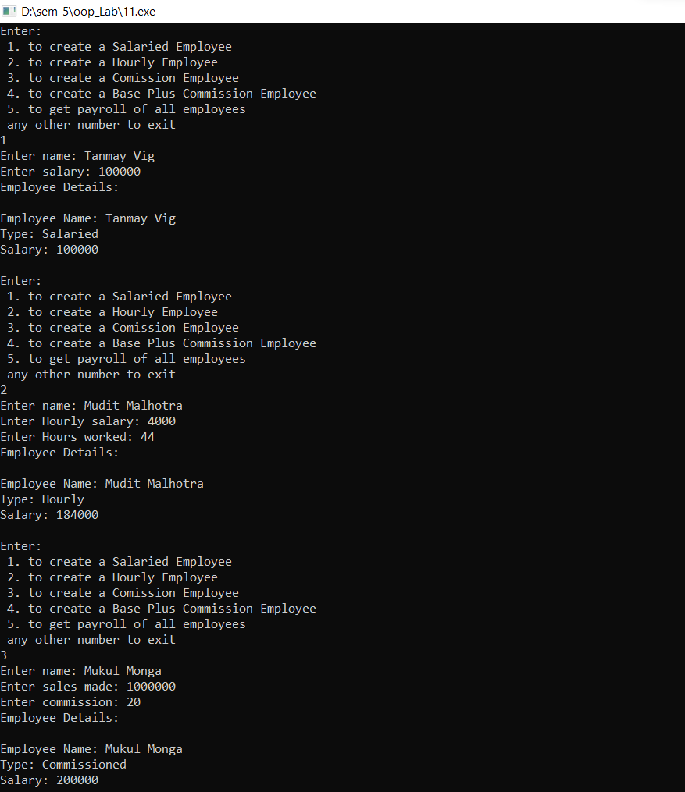
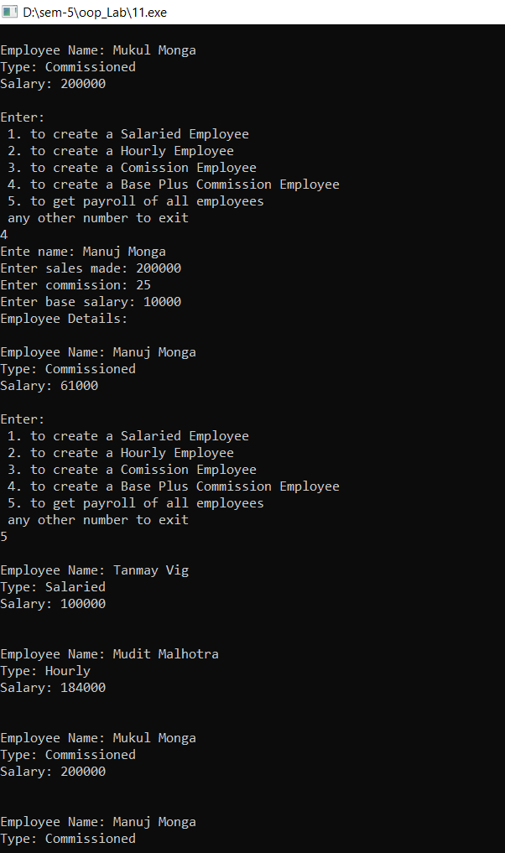
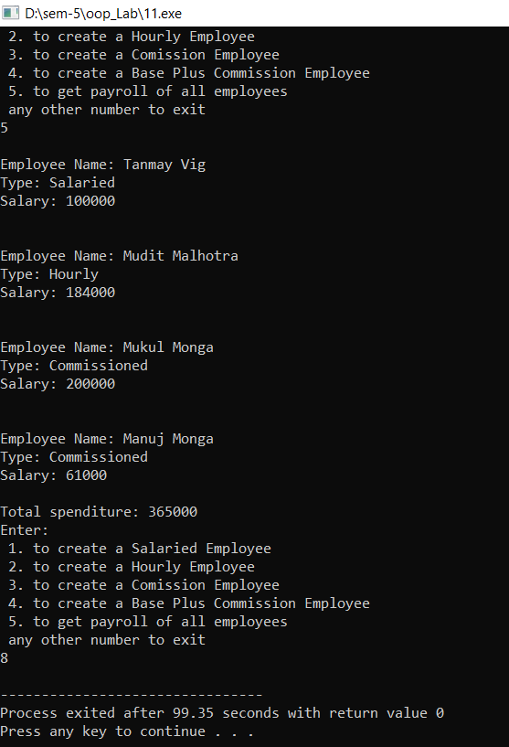

P12: Templates-Write a program in C++ to implement a generic Stack.

Source code:

#include<iostream>

#include<string>

#define SIZE 5

using namespace std;

template <class T>

class Stack{

private:

int top, capacity;

T* arr;

public:

Stack(int size=SIZE);

void push(T k);

T pop();

T peek();

int size();

bool isEmpty();

bool isFull();

~Stack(){

delete[] arr;

}

};

template <class T>

Stack<T>::Stack(int size){

arr = new T[size];

capacity = size;

top = -1;

}

template <class T>

void Stack<T>::push(T k){

if(isFull()){

cout<<"Stack is Full!"<<endl;

}else{

cout<<"Pushing "<<k<<" to the stack\n";

arr[++top]=k;

}

}

template <class T>

T Stack<T>::pop(){

T top_ele;

if(isEmpty()){

cout<<"Stack is Empty!"<<endl;

}else{

top_ele = arr[top--];

cout<<"removing "<<top_ele<<" from Stack\n";

}

return top_ele;

}

template<class T>

T Stack<T>::peek(){

return arr[top];

}

template<class T>

int Stack<T>::size(){

return top+1;

}

template<class T>

bool Stack<T>::isEmpty(){

return top==-1;

}

template<class T>

bool Stack<T>::isFull(){

return top==capacity-1;

}

int main(){

Stack<string> st;

st.pop();

st.push("Hey");

st.push("two");

cout<<st.pop()<<endl;

cout<<"size of stack: "<<st.size()<<endl;

st.push("three");

st.push("four");

st.push("five");

cout<<"size of stack: "<<st.size()<<endl;

st.push("six");

if(st.isFull()){

cout<<"Stack is full\n";

}

st.push("seven");

st.pop();

return 0;

}

Output:
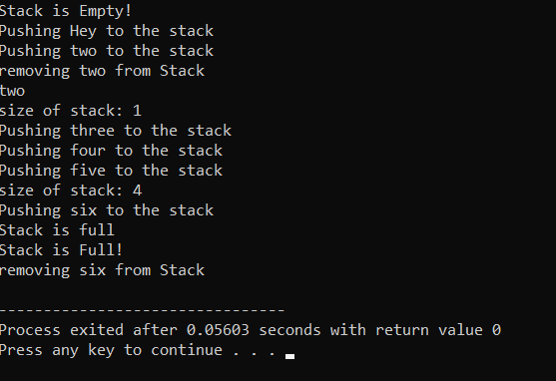

P13: Inheritance in Java: Implement a manager class that inherits from the Employee class in Java. Implement the relevant constructors also.

Source Code:

import java.util.*;

class Employee{

int sNo;

String name;

long salary;

public Employee(int sNo, String name, long salary) {

this.sNo = sNo;

this.name = name;

this.salary = salary;

}

}

class Manager extends Employee{

String position;

public Manager(int sNo, String name, long salary, String position){

super(sNo,name,salary);

this.position = position;

}

public void getData(){

System.out.println("Emoplyee Details:\nSerial Number: "+ this.sNo+"\nName: "+ this.name+"\nPosition: "+ this.position + "\nSalary "+this.salary);

}

}

public class inherit{

public static void main(String[] args){

Manager m = new Manager(100,"Tanmay Vig",1000000,"General Manager");

m.getData();

}

}

Output:

