Q: Create a class called Employee that contains employee number (type long), name (an object of class string)
and salary (integer). Include a member function called getData() to get data from the user for insertion
into the object, and another function called putData() to display the data. Define both the functions
outside the class.
Assume the name has embedded blanks (like Rakesh Kumar Mehta).
Write a main() program to execute this class. It should create an array of type Employee,
and then invite the user to input data for up to 10 employees. Finally, it should print out
the data for all the employees in proper format.
Ans:
Source code:
#include<iostream>
#include<string>
#include <iomanip>

using namespace std;

class Employee{
public:
long long int employee_number;
string name;
int salary;
void getData();
void putData();
};

void Employee::getData(){
cout<<"Enter employee number\t";
cin>>employee_number;
cin.clear();
cin.sync();
cout<<"Enter Name of employee"<<endl;
getline(cin,name);
cout<<"Enter Salary\t";
cin>>salary;
}

void Employee::putData(){
cout<<left<<"|"<<setw(15)<<employee_number<<"|"<<setw(15)<<name<<"|"<<setw(15)<<salary<<endl;
}

int main(){
Employee arr[10];
cout<<"Enter details:\n";
for(int i=0;i<10;i++){
cout<<"Enter data for employee "<<i+1<<endl;
arr[i].getData();
}
cout<<"Employee Details:\n"<<
"_________________________________________________\n|Employee Number|Name |Salary |\n_________________________________________________\n";
for(int i=0;i<10;i++){
arr[i].putData();
cout<<"_________________________________________________\n";
}
return 0;
}
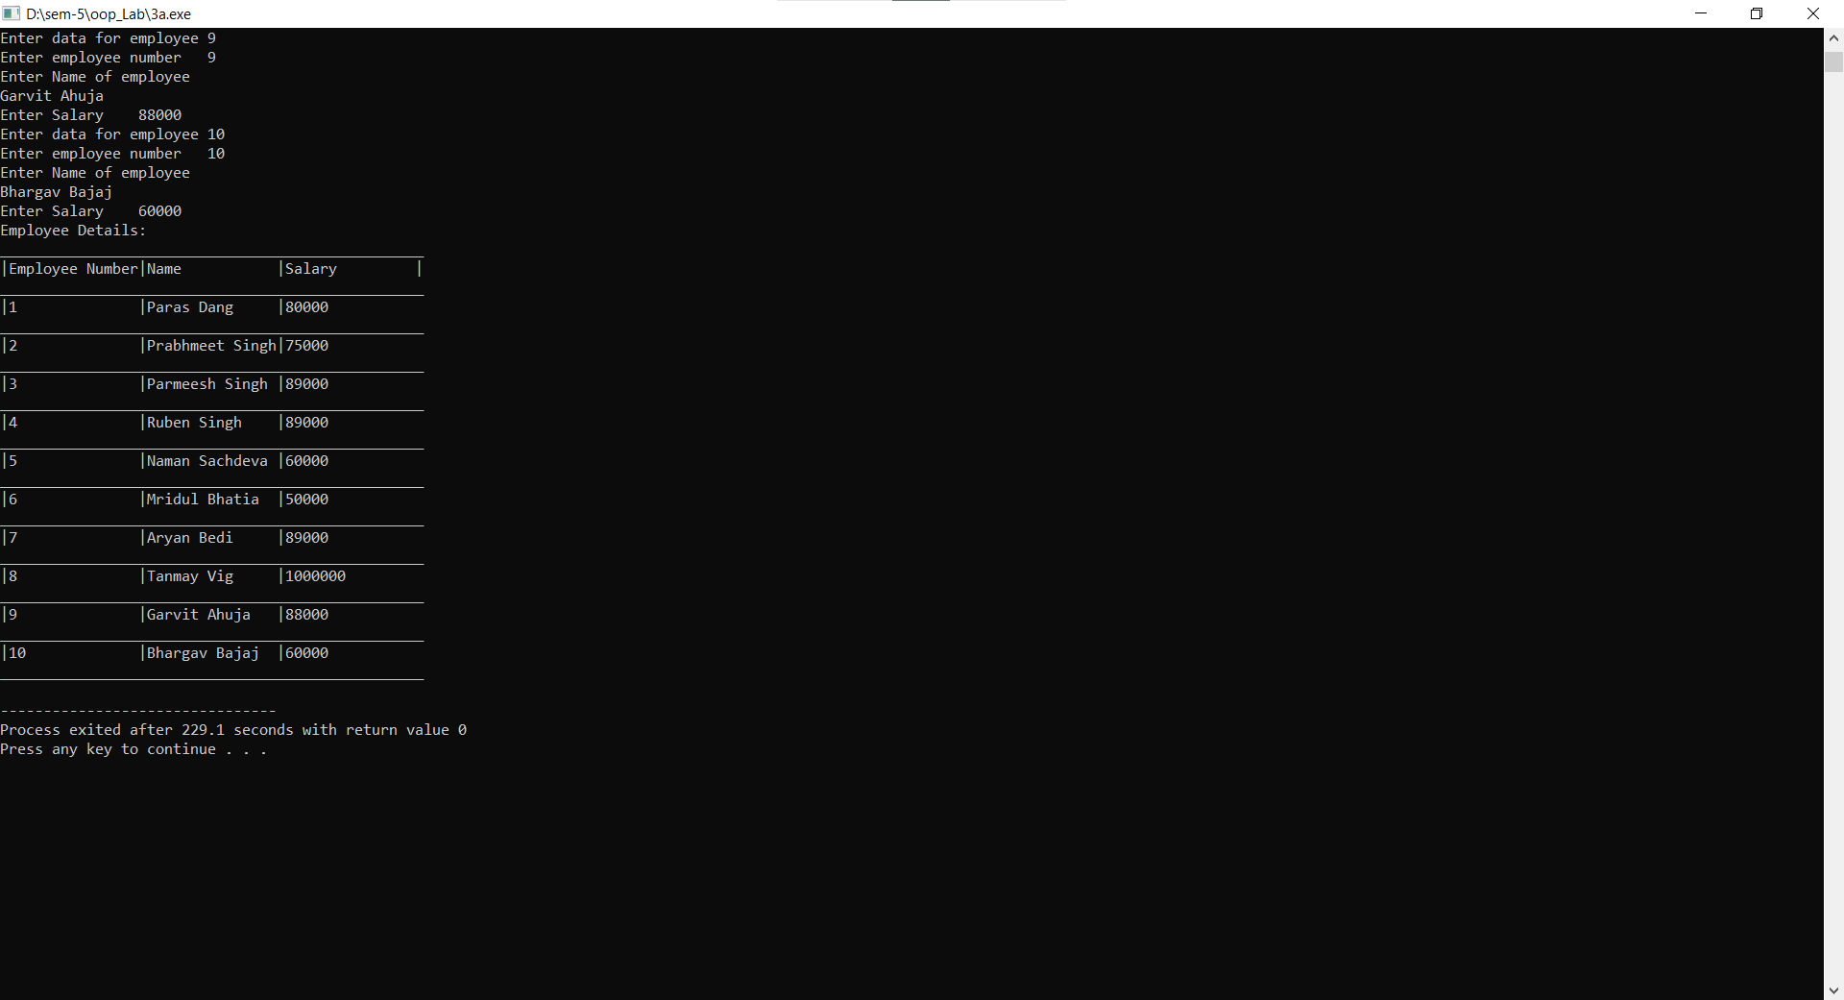
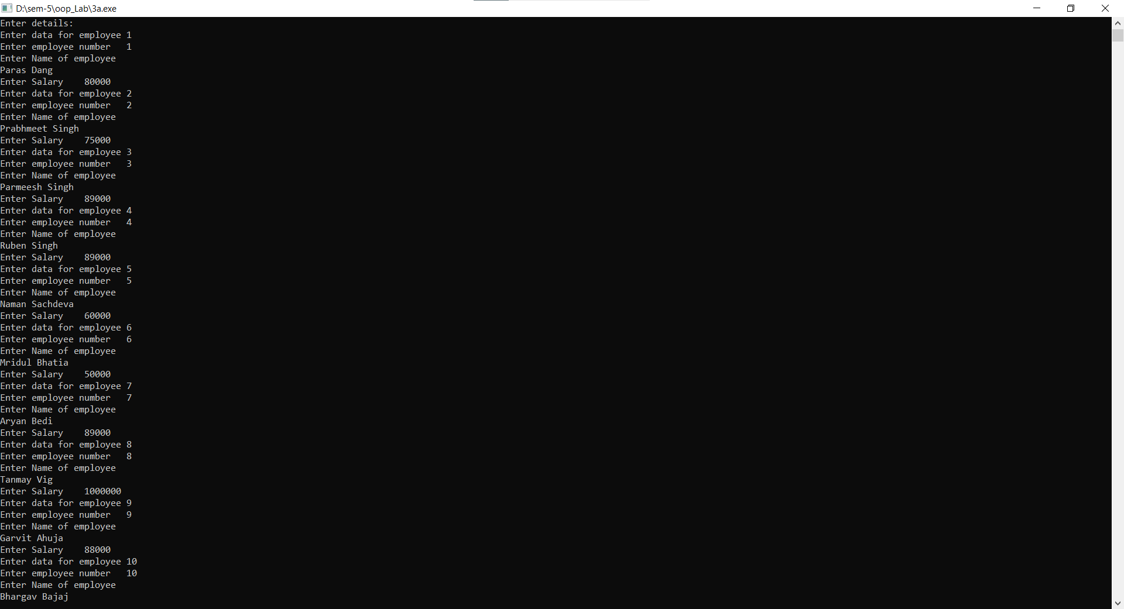
Output:

Q: Create a class called Student that contains a Student id (type int), name (char array ) and marks (integer).
Include a member function called getStudent() to get data from the user for insertion into the object, and
another function called printStudent() to display the data. Define both the functions inside the class.
Assume the name has no embedded blanks.
Write a main() program to execute this class. It should create an array of type Student,
and then invite the user to input data for up to 10 students. Finally, it should print out
the data for all the students in proper format.
Ans:
Source Code:
#include<iostream>
#include<string>
#include <iomanip>
#define M 10

using namespace std;

class Student{
public:
int student_id;
char name[30];
int marks;
void getData(){
cout<<"Enter student number\t";
cin>>student_id;
cin.clear();
cin.sync();
cout<<"Enter Name of student"<<endl;
cin.getline(name,30);
cout<<"Enter Marks\t";
cin>>marks;
}
void putData(){
cout<<left<<"|"<<setw(15)<<student_id<<"|"<<setw(15)<<name<<"|"<<setw(15)<<marks<<"|"<<endl;
}
};

int main(){
Student arr[M];
cout<<"Enter details:\n";
for(int i=0;i<M;i++){
cout<<"Enter data for student "<<i+1<<endl;
arr[i].getData();
}
cout<<"Student Details:\n"<<
"_________________________________________________\n|Student Number |Name |Marks |\n_________________________________________________\n";
for(int i=0;i<M;i++){
arr[i].putData();
cout<<"_________________________________________________\n";
}
return 0;
}
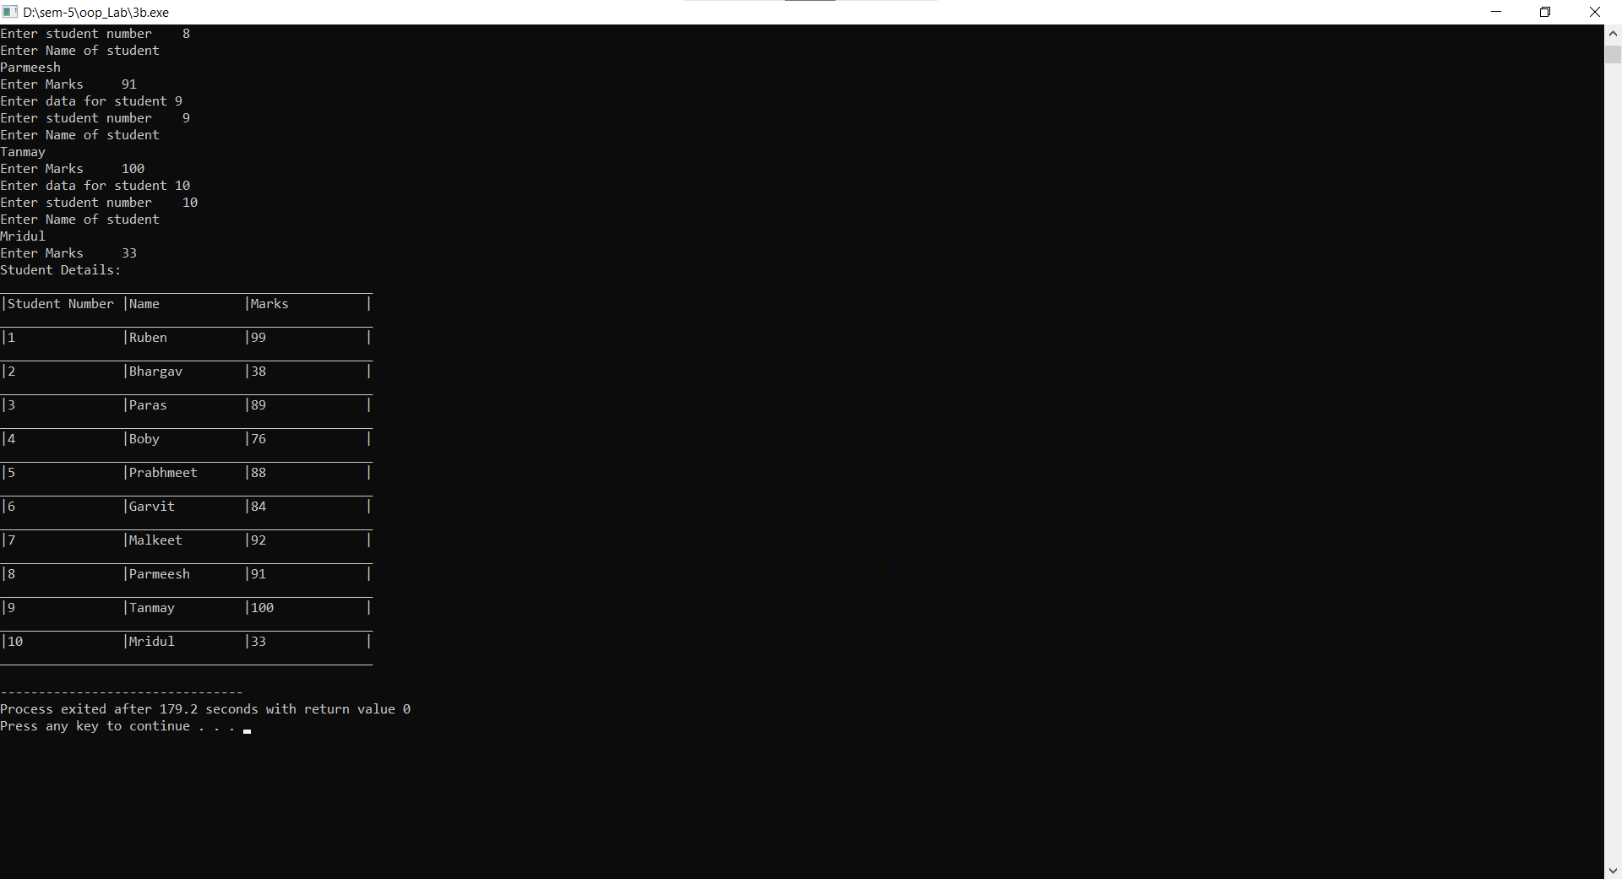
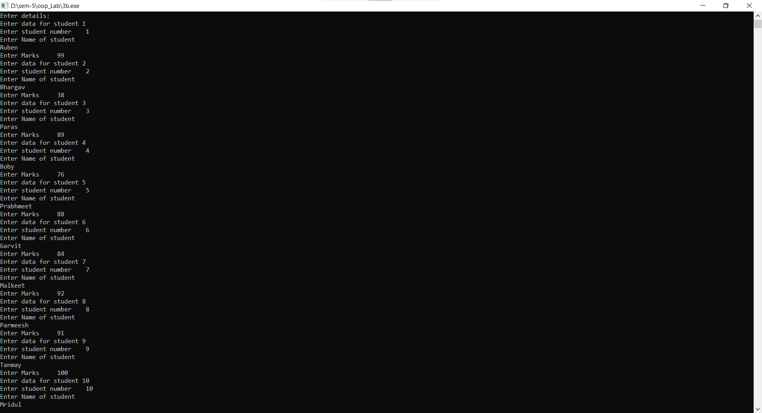
output:

