Q: Write a program in C++ to represent a Bank Account.
Data members:
- Account number
- Name of the depositor
- Type of account
- Balance amount in the account
Member functions:
- To assign initial values
- To deposit an amount
- To withdraw an amount after checking the balance
- To display name and balance of a single customer if account number is entered through
- the keyboard
- To display the details of all customers
- Sort the customers according to their balance
Write a main program to test the class. Your program must be able to handle at least 10 customers.
Ans:
Source Code:
#include<iostream>
#include<string>
#define M 10

using namespace std;

class Account{
private:
long long int account_number;
string name;
string account_type;
int balance;

public:
void putDetails(){
cout<<"Enter Account Number:\t";
cin>>account_number;
cin.ignore();
cout<<"Enter Name of depositor:\t";
getline(cin, name);
cout<<"Enter Type of Account(Current, Saving, Salary):\t";
getline(cin, account_type);
cout<<"Enter Balance amount in the account:\t";
cin>>balance;
}

void deposite(int amt){
balance=balance+amt;
cout<<"Amount deposited: "<<amt<<". Total balance: "<<balance<<endl;
}

void withdraw(int amt){
if(balance<amt) cout<<"Error: please input Valid amount.\nYour current balance is: "<<balance<<endl;
else{
balance=balance-amt;
cout<<"Amount withdraw: "<<amt<<". Total balance: "<<balance<<endl;
}
}
void display(){
cout<<"Name: "<<name<<".\nAccount Type: "<<account_type<<".\nBalance: "<<balance<<endl;
}
int getbalance(){
return balance;
}
long long int getAccNum(){
return account_number;
}
};

int findAcc(Account arr[],long long int num) {
for(int i=0;i<M;i++) {
if(arr[i].getAccNum()==num) return i;
}
return -1;
}

int main(){
Account arr[M];
int n;
long long int accNum;
for(int i=0;i<M;i++){
cout<<"Enter Details of Account "<<i+1<<endl;
arr[i].putDetails();
}
do{
cout<<"Enter 1 to Deposit. \nEnter 2 to Withdraw. \nEnter 3 to see your Details.\nEnter 0 to exit.\n";
cin>>n;
if(n){
cout<<"Enter Account Number:\t";
cin>>accNum;
}
int index=findAcc(arr,accNum),amt;
if(index!=-1){
switch (n)
{
case 1:
cout<<"Enter Amount to Deposite:\t";
cin>>amt;
cout<<endl;
arr[index].deposite(amt);
break;
case 2:
cout<<"Enter Amount to withdraw:\t";
cin>>amt;
cout<<endl;
arr[index].withdraw(amt);
break;
case 3:
cout<<endl;
arr[index].display();
break;
default:
cout<<"Enter valid input or 0 to Exit\n";
break;
}
}else if(index==-1){
cout<<"\nError: no account found.\n";
}
}while(n!=0);
cout<<"Enter 1 to see all account details in sorted order\nEnter 2 to see all details in unsorterd order\n";
cin>>n;
if(n==1){
int i,j;
for(i=0;i<M-1;i++){
for(j=0;j<M-i-1;j++){
if(arr[j].getbalance()>arr[j+1].getbalance()){
Account temp=arr[j];
arr[j]=arr[j+1];
arr[j+1]=temp;
}
}
}
cout<<"Showing Details in unsorted order:\n";
cout<<"____________"<<endl;
for(int i=0;i<M;i++){
arr[i].display();
cout<<"____________"<<endl;
}
}else{
cout<<"Showing Details in unsorted order:\n";
cout<<"____________"<<endl;
for(int i=0;i<M;i++){
arr[i].display();
cout<<"____________"<<endl;
}
}
return 0;
}
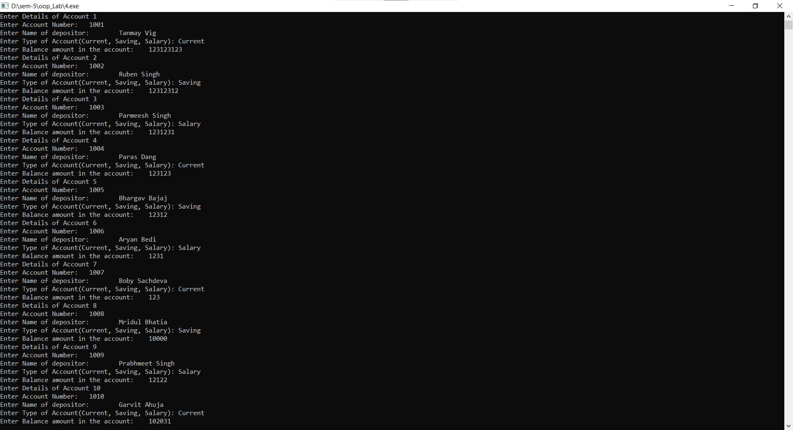
Output:

