Q1. Write the definition for a class called Rectangle that has floating point data members length and width. The class has the following member functions:
void setlength(float) to set the length data member
void setwidth(float) to set the width data member
float perimeter() to calculate and return the perimeter of the rectangle
float area() to calculate and return the area of the rectangle
void show() to display the length and width of the rectangle
int sameArea(Rectangle) that has one parameter of type Rectangle. sameArea() returns 1 if the two Rectangles have the same area, and returns 0 if they don't.
Write the definitions for each of the above member functions.
Write main function to create two rectangle objects. Set the length and width of the first rectangle to 5 and 2.5. Set the length and width of the second rectangle to 5 and 18.9. Display each rectangle and its area and perimeter.
3. Check whether the two Rectangles have the same area and print a message indicating the result. Set the length and width of the first rectangle to 15 and 6.3. Display each Rectangle and its area and perimeter again. Again, check whether the two Rectangles have the same area and print a message indicating the result.
Answer:
Source Code:
#include<iostream>

using namespace std;

class Rectangle{
private:
float length;
float width;
public:
void setLength(float);
void setWidth(float);
float perimeter();
float area();
void show();
int sameArea(Rectangle);
};

void Rectangle::setLength(float l){
length=l;
cout<<"Length of rectangle is set to "<<l<<endl;
}

void Rectangle::setWidth(float w){
width=w;
cout<<"Width of rectangle is set to"<<w<<endl;
}

float Rectangle::perimeter(){
return 2*(length+width);
}

float Rectangle::area(){
return length*width;
}

void Rectangle::show(){
cout<<"Length of Rectangle: "<<length<<"\nWidth of Rectangle: "<<width<<endl;
}

int Rectangle::sameArea(Rectangle r){
return area()==r.area() ? 1 : 0;
}

int main(){
Rectangle r1,r2;
cout<<"Setting dimentions of Rectangle 1.\n";
r1.setLength(5); r1.setWidth(2.5);
cout<<endl;

cout<<"Setting dimentions of Rectangle 2.\n";
r2.setLength(5); r2.setWidth(18.9);
cout<<endl;

cout<<"Showing details of Rectangles\n\n";
cout<<"Rectangle 1:\n";
r1.show();
cout<<"Area: "<<r1.area()<<endl;
cout<<"Perimeter: "<<r1.perimeter()<<endl;
cout<<endl;
cout<<"Rectangle 2:\n";
r2.show();
cout<<"Area: "<<r1.area()<<endl;
cout<<"Perimeter: "<<r1.perimeter()<<endl;
cout<<endl;

if(r1.sameArea(r2)) cout<<"Both Rectangles have the same area.\n\n";
else cout<<"Both Rectangles have different area.\n\n";

cout<<"Changing dimentions of Rectangle 1.\n";
r1.setLength(15);
r1.setWidth(6.3);
cout<<endl;

cout<<"Showing details of Rectangles\n\n";
cout<<"Rectangle 1:\n";
r1.show();
cout<<"Area: "<<r1.area()<<endl;
cout<<"Perimeter: "<<r1.perimeter()<<endl;
cout<<endl;
cout<<"Rectangle 2:\n";
r2.show();
cout<<"Area: "<<r1.area()<<endl;
cout<<"Perimeter: "<<r1.perimeter()<<endl;
cout<<endl;

if(r1.sameArea(r2)) cout<<"Both Rectangles have the same area.\n\n";
else cout<<"Both Rectangles have different area.\n\n";

return 0;
}
Output:
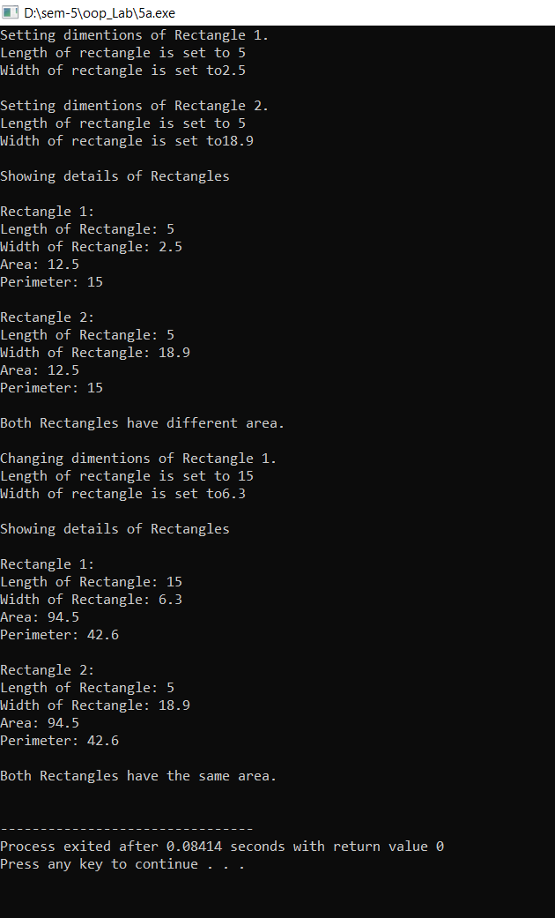

Q2. Write the definition for a class called complex that has floating point data members for storing
real and imaginary parts. The class has the following member functions:
void set(float, float) to set the specified value in object
void disp() to display complex number object
complex sum(complex) to sum two complex numbers & return complex number
1. Write the definitions for each of the above member functions.
2. Write main function to create three complex number objects. Set the value in two objects and
call sum() to calculate sum and assign it in third object. Display all complex numbers.
Answer:
Source code:
#include<iostream>

using namespace std;

class Complex{
private:
float real;
float imag;
Complex friend sum(Complex,Complex);
public:
void set(float r,float i){
real = r; imag = i;
}
void display(){
cout<<real<<" + "<<imag<<"i\n";
}
};

Complex sum(Complex x,Complex y){
Complex c;
c.real = x.real+y.real; c.imag = x.imag+y.imag;
return c;
}

int main(){
Complex a,b,c;
float r,i;
cout<<"Enter value of complex number 1.\nreal part:\t";
cin>>r;
cout<<"imaginary part:\t"; cin>>i;
a.set(r,i);

cout<<"Enter value of complex number 2.\nreal part:\t";
cin>>r;
cout<<"imaginary part:\t"; cin>>i;
b.set(r,i);

c = sum(a,b);
cout<<"Displaying values of complex numbers:\n";
cout<<"number 1:\n";
a.display();
cout<<"number 2:\n";
b.display();
cout<<"number 3:\n";
c.display();
return 0;
}
Output:
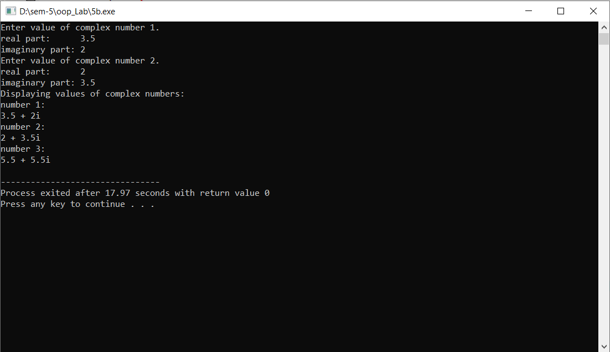

Q3. Write the definition for a class called Distance that has data member feet as integer and
inches as float. The class has the following member functions:
void set(int, float) to give value to object
void disp() to display distance in feet and inches
Distance add(Distance) to sum two distances & return distance
1. Write the definitions for each of the above member functions.
2. Write main function to create three Distance objects. Set the value in two objects and call add() to calculate sum and assign it in third object. Display all distances.
Answer:
Source Code:
#include <iostream>
#include <cmath>
using namespace std;

class Distance
{
private:
int feet;
int inch;
Distance friend add(Distance,Distance);
public:
void set ();
void disp ();
};

void Distance:: set()
{
cout << "Enter Value of feets : "; cin >> feet;
cout << "Enter value of inches : "; cin >> inch;

}

void Distance:: disp()
{
cout << endl << "\tFeets : " << feet;
cout << endl << "\tInches: " << inch;
}

Distance add(Distance d1,Distance d2){
Distance temp;
int totdist = d2.inch+ d1.inch;
temp.feet = totdist/12+ d2.feet + d1.feet;
temp.inch = totdist%12;
return temp;
}

int main()
{
Distance d1;
Distance d2;
Distance d3;
Distance d4;

cout << "Enter Distance1 : " << endl;
d1.set();

cout << "Enter Distance2 : " << endl;
d2.set();

d3 = add(d1,d2);

cout << endl << "Distance1 : " ;
d1.disp();

cout << endl << "Distance2 : " ;
d2.disp();

cout << endl << "Distance3 : " ;
d3.disp();

cout << endl;
return 0;
}
Output;
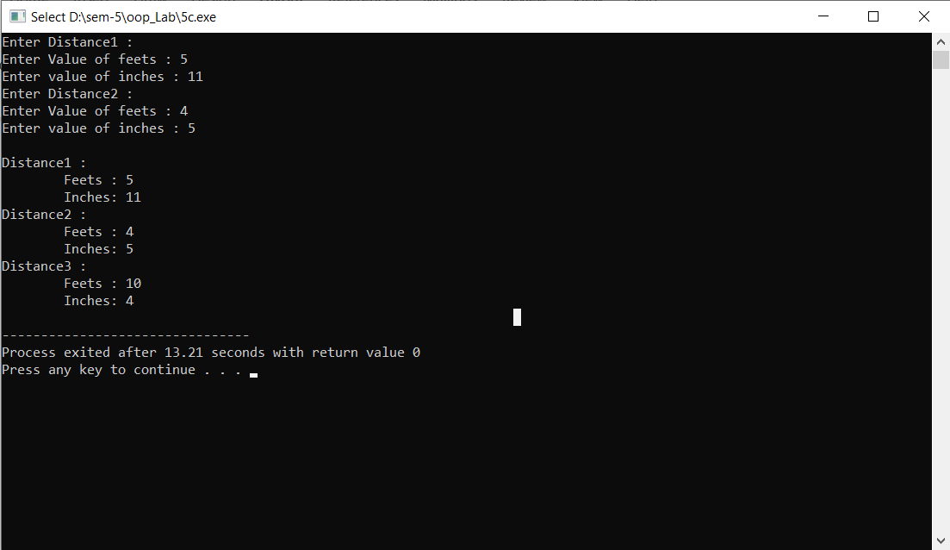

Q4. Write the definition for a class called time that has hours and minutes as integer. The class has the following member functions:
void settime(int, int) to set the specified value in object
void showtime() to display time object
time sum(time &,time &) to sum two time object & return time
1. Write the definitions for each of the above member functions.
2. Write main function to create three time objects. Set the value in two objects and call sum() to
calculate sum and assign it in third object. Display all time objects.
Answer:
Source Code:
#include<iostream>

using namespace std;

class Time{
private:
int hrs,min;
Time friend sum(Time&,Time&);
public:
void setTime(int h,int m){
hrs=h%24;min=m;
}
void showTime(){
cout<<"hrs: "<<hrs<<"min: "<<min<<endl;
}
};

Time sum(Time &t1, Time &t2){
Time t;
t.hrs = (t1.hrs + t2.hrs + (t1.min + t2.min)/60)%24;
t.min = (t1.min + t2.min)%60;
return t;
}

int main(){
Time t1,t2,t3;
int hrs,min;
cout<<"Enter time 1\nEnter hrs:\t";
cin>>hrs;
cout<<"Enter min:\t";
cin>>min;
t1.setTime(hrs,min);

cout<<"Enter time 2\nEnter hrs:\t";
cin>>hrs;
cout<<"Enter min:\t";
cin>>min;
t2.setTime(hrs,min);

t3 = sum(t1,t2);

cout<<"Displaying times:\n";
cout<<"Time 1 = \t";
t1.showTime();

cout<<"Time 2 = \t";
t2.showTime();

cout<<"Time 3 = \t";
t3.showTime();
return 0;
}
Output: 