Q: Use operator overloading to do complete the following functions:
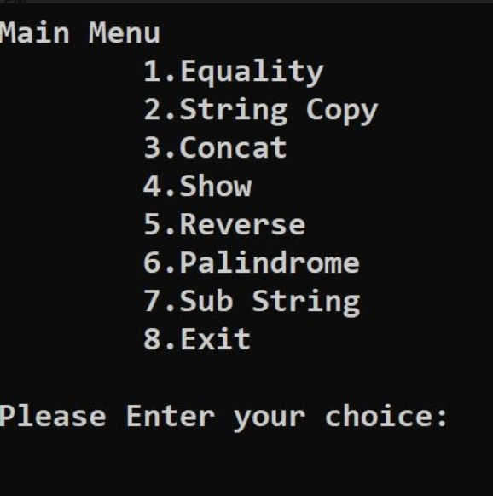
Answer:
Source Code:
#include<iostream>
#include<cstring>
using namespace std;

class String{
private:
char str[30];
public:
void input();
void show();
void operator==(String s);
void operator=(String s);
void operator+(String s);
void operator<<(String s);
void operator>>(String s);
void operator~();
int operator/(String s);
};

void String::input(){
cout<<"Enter String: ";
cin.clear();
cin.sync();
cin.getline(str,30);
}

void String::show(){
for(int i=0;str[i]!='\0';i++){
cout<<str[i];
}
}

void String::operator==(String s){
int i=0;
bool equal=true;
while(*(str+i)!='\0' && *(s.str + i)!='\0' ){
if(*(str+i)!=*(s.str+i)){
equal=false;
break;
}
i++;
}
if(equal && *(str+i)!='\0' && *(s.str+i)!='\0') cout<<"Both String are equal\n";
else cout<<"Strings are not equal\n";
}

void String::operator=(String s){
int i=0,len= sizeof(s.str)/sizeof(char);
for(int i=0;i<len;i++){
*(str+i)= *(s.str+i);
// str[i]=s.str[i];
}
*(str+len )='\0';
}

void String::operator+(String s){
int len=0;
while(this->str[len]!='\0') len++;
for(int i=0;s.str[i]!='\0';++i,++len){
this->str[len] = s.str[i];
}
this->str[len] = '\0';
}

void String::operator<<(String s){
cout<<"Sring:\t";
s.show();
cout<<"\n";
}

void String::operator>>(String s){
cout<<"Reverse String:\t";
for(int i=strlen(s.str);i>=0;i--){
cout<<s.str[i];
}
cout<<"\n";
}

void String::operator~(){
bool ans=true;
int len = strlen(str)-1;
for(int i=0;i<=len/2;i++){
// cout<<str[i]<<" "<<str[len-i]<<endl;
if(str[i]!=str[len-i]){
ans=false;
break;
}
}
if(ans) cout<<"Yes It is palindrome\n";
else cout<<"No it is not palindrome\n";
}

int String::operator/(String s)
{
int flag=0,k,i,j,len=strlen(str),len1=strlen(s.str)-1;
for(i=0;i<len;i++)
{
if(str[i]==s.str[0])
{
if(str[i+len1]==s.str[len1])
{
for(j=i,k=0;j<i+len1+1,k<len1;j++,k++)
{
if(str[j]==s.str[k])
flag=1;
else
{
flag=0;
break;
}
}
}
}
}
if(flag==0)
return 0; //not a substring

return 1; //it is a substring
}

int main(){
while(true){
int choice=8,br=0,c;
String a,b;
a.input();
b.input();
cout<<"Main Menu\n\t1. Equality\n\t2. String copy\n\t3. Concat\n\t4. Show\n\t5. Reverse\n\t6. Palindrome\n\t7. Sub String\n\t8. Exit\nPlease enter your choice\t";
cin>>choice;
switch (choice)
{
case 1:
a==b;
break;
case 2:
b=a;
cout<<"The String is copied: ";
b.show();
cout<<endl;
break;
case 3:
a+b;
a.show();
cout<<"\n";
break;
case 4:
b<<a;
break;
case 5:
b>>a;
break;
case 6:
~a;
break;
case 7:
c=a/b;
if(c){
cout<<"YES\n";
}else cout<<"NO\n";
break;
case 8:
br=1;
break;
default:
cout<<"Enter Valid option\n";
break;
}
if(br) break;
}
return 0;
}
Output:
