**STOCK MARKET PREDICTOR - PredictO**

***Submitted by***

**TANMAY SHUKLA [RA2011003010119]**

**KHUSHI SURI [RA2011003010129]**

**MITRAANSH RAAJ KHANNA [RA2011003010133]**

***Under the Guidance of***

**Dr.T.K.SIVAKUMAR**

**Asst.Prof.(Sr.Grade) / Computing Technologies**

***In partial satisfaction of the requirements for the degree of***

## **BACHELOR OF TECHNOLOGY**

**in**

**COMPUTER SCIENCE ENGINEERING**

**SCHOOL OF COMPUTING**

# **COLLEGE OF ENGINEERING AND TECHNOLOGY**

**SRM INSTITUTE OF SCIENCE AND TECHNOLOGY**

**KATTANKULATHUR - 603203**

**JULY 2022**

SRM INSTITUTION OF SCIENCE AND TECHNOLOGY

KATTANKULATHUR-603203

**BONAFIDE CERTIFICATE**

Certified that this lab report titled **“..Stock Market Predictor-PredictO......”** is the bonafide work done by TANMAY SHUKLA [RA2011003010119] KHUSHI SURI [RA2011003010129] MITRAANSH RAAJ KHANNA [RA2011003010133]who carried out the lab exercises under my supervision. Certified further, that to the best of my knowledge the work reported herein does not form part of any other work.

| **Staff-in-charge**  **Dr.T.K.SIVAKUMAR**  **Asst.Prof.(Sr.Grade) / Computing Technologies** |  |
| --- | --- |

University Examination held on ………….………….

**INTERNAL EXAMINAR – 1 INTERNAL EXAMINAR - 2**

**ABSTRACT**

With the advent of technological marvels like global digitization, the prediction of the stock market has entered a technologically advanced era, revamping the old model of trading. With the ceaseless increase in market capitalization, stock trading has become a center of investment for many financial investors. Many analysts and researchers have developed tools and techniques that predict stock price movements and help investors in proper decision-making. Advanced trading models enable researchers to predict the market using non-traditional textual data from social platforms. The application of advanced machine learning approaches such as text data analytics and ensemble methods have greatly increased the prediction accuracies. Meanwhile, the analysis and prediction of stock markets continue to be one of the most challenging research areas due to dynamic, erratic, and chaotic data. This study explains the systematics of machine learning-based approaches for stock market prediction based on the deployment of a generic framework. Findings from the last decade (2011–2021) were critically analyzed, having been retrieved from online digital libraries and databases like ACM digital library and Scopus. Furthermore, an extensive comparative analysis was carried out to identify the direction of significance. The study would be helpful for emerging researchers to understand the basics and advancements of this emerging area, and thus carry-on further research in promising directions.

**TABLE OF CONTENTS**

|  |  |  |  |
| --- | --- | --- | --- |
| **CHAPTER NO** | **TITLE** | **DATE** | **PAGE No** |
|  | **ABSTRACT** |  | **3** |
|  | **LIST OF FIGURES** |  | **5** |
|  | **LIST OF ABBREVIATIONS** |  | **7** |
| **1** | **PROBLEM STATEMENT** | **15.03.2022** | **8** |
| **2** | **STAKEHOLDERS & PROCESS MODELS** | **22.03.2022** | **11** |
| **3** | **IDENTIFYING REQUIREMENTS** | **29.03.2022** | **15** |
| **4** | **PROJECT PLAN & EFFORT** | **05.04.2022** | **17** |
| **5** | **WORK BREAKDOWN STRUCTURE & RISK ANALYSIS** | **12.04.2022** | **24** |
| **6** | **SYSTEM ARCHITECTURE, USE CASE & CLASS DIAGRAM** | **21.04.2022** | **28** |
| **7** | **ENTITY RELATIONSHIP DIAGRAM** | **06.05.2022** | **32** |
| **8** | **DATA FLOW DIAGRAM** | **13.05.2022** | **34** |
| **9** | **SEQUENCE & COLLABORATION DIAGRAM** | **20.05.2022** | **38** |
| **10** | **DEVELOPMENT OF TESTING FRAMEWORK/USER INTERFACE** | **27.05.2022** | **40** |
| **11** | **TEST CASES & REPORTING** | **11.06.2022** | **43** |
| **12** | **ARCHITECTURE/DESIGN/FRAMEWORK/IMPLE-MENTATION** | **17.06.2022** | **46** |
|  | **APPENDIX (CODE)** |  | **49** |
|  | **CONCLUSION** |  | **62** |
|  | **REFERENCES** |  | **63** |

**LIST OF FIGURES**

|  |  |  |
| --- | --- | --- |
| **FIGURE NO.** | **TITLE** | **PAGE NO.** |
| Figure 1 | To identify the Software Project, Create Business Case, Arrive at a Problem statement. | **9** |
| Figure 2.1 | Stakeholder Register | **12** |
| Figure 4.1 | Project Plan | **14** |
| Figure 4.2 | Project Plan | **15** |
| Figure 4.3 | Project Plan | **16** |
| Figure 5.1 | Prepare Work breakdown structure, Timeline chart, Risk identification table | **18** |
| Figure 5.2 | Prepare Work breakdown structure, Timeline chart, Risk identification table | **19** |
| Figure 5.3 | Prepare Work breakdown structure, Timeline chart, Risk identification table | **19** |
| Figure 6.1 | Prepare Class, Use Case and Architecture Diagrams | **22** |
| Figure 6.2 | Prepare Class, Use Case and Architecture Diagrams | **23** |
| Figure 6.3 | Prepare Class, Use Case and Architecture Diagrams | **24** |
| Figure 7.1 | Design a Entity relationship diagram | **33** |
| Figure 8.1 | Develop a Data Flow Diagram | **34** |
| Figure 8.2 | Develop a Data Flow Diagram | **35** |
| Figure 8.3 | Develop a Data Flow Diagram | **36** |
| Figure 9.1 | Design a Sequence and Collaboration Diagram | **39** |
| Figure 9.2 | Design a Sequence and Collaboration Diagram | **39** |
| Figure 10.1 | Develop a Testing Framework/User Interface | **42** |
| Figure 10.2 | Develop a Testing Framework/User Interface | **42** |
| Figure 11.1 | Test Cases | **44** |
| Figure 11.2 | Test Cases | **45** |
| Figure 12.1 | Manual Test Case Reporting | **47** |
| Figure 13.1 | Provide          the       details of        Architecture Design/Framework/Implementation | **53** |
| Figure 13.2 | Provide          the       details of        Architecture Design/Framework/Implementation | **55** |
| Figure 13.3 | Provide          the       details of        Architecture Design/Framework/Implementation | **57** |
| Figure 13.4 | Provide          the       details of        Architecture Design/Framework/Implementation | **61** |

**LIST OF ABBREVIATIONS**

1. **Dept. :** Department
2. **App :** Application
3. **DBMS :** Databas**e** Management System
4. **ER :** Entity Relationship
5. **DFD :** Data Flow Diagram
6. **ML :** Machine Learning

|  |
| --- |
|  |
|  |

**CHAPTER - 1**

**Course Code: 18CSC206J**

**Course Name: Software Engineering and Project Management**

|  |  |
| --- | --- |
| **Experiment No** | 1 |
| **Title of Experiment** | To identify the Software Project, Create Business Case, Arrive at a  Problem Statement. |
| **Name of the candidate** | Tanmay Shukla |
| **Team Members** | Tanmay Shukla,Mitraansh Raaj Khanna,Khushi Suri |
| **Register Number** | RA2011003010119, RA2011003010133, RA2011003010129 |
| **Date of Experiment** | March 20, 2022 |

**Mark Split Up**

|  |  |  |  |
| --- | --- | --- | --- |
| **S.No** | **Description** | **Maximum Mark** | **Mark Obtained** |
| 1 | Exercise | 5 |  |
| 2 | Viva | 5 |  |
| **Total** | | **10** |  |

**Team Members:**

|  |  |  |  |
| --- | --- | --- | --- |
| 1. **No** | **Register No** | **Name** | **Role** |
| **1** | RA2011003010119 | Tanmay Shukla | **Lead/Rep** |
| **2** | RA2011003010133 | Mitraansh Raaj Khanna | **Member** |
| **3** | RA2011003010129 | Khushi Suri | **Member** |

**Aim:**

To Frame a project team, analyze and identify a Software project. To create a business

* case and Arrive at a Problem Statement to Predict the stock prices in order to make more informed and accurate investment decisions.

**Project Title:** Predict the stock prices in order to make more informed and accurate investment decisions.

**Project Description**

It also plans on joining 2 trading areas to make it better accessible for both crypto and stock investor.



Figure 1.1

|  |  |
| --- | --- |
| **DATE** | 20/03/22 |
| **SUBMITTED BY** | Khushi Suri, Tanmay Shukla, Mitraansh Raaj Khanna |
| **TITLE / ROLE** | Predict the stock prices |

**THE PROJECT**

In bullet points, describe the problem this project aims to solve or the opportunity it aims to develop.

This project aims towards solving the problems:

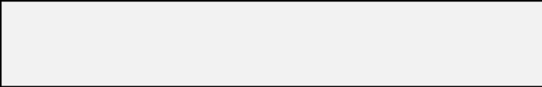

* Predict the stock prices in order to make more informed and accurate investment decisions.
* It also plans on joining 2 trading areas to make it better accessible for both crypto and stock investors.

**THE HISTORY**

In bullet points, describe the current situation.

In the current situation the resources available for forecasting and analyzing are complex to understand and also new users are not used to complex procedures, thus to seize this problem we came up with this, which would also help join the two different market platforms.

**LIMITATIONS**

List what could prevent the success of the project, such as the need for expensive equipment, bad weather,

lack of **s**pecial training, etc.

The project shouldn’t fail, but the only restricting factors are that the linkage of two separate markets might lead to a little unstable projection.

**to a little unstable projection,**

**APPROACH**

List what is needed to complete the project.

The project won’t require any specific tools or equipment, it can be accomplished with the already available setup and assistance from the web.

**BENEFITS**

In bullet points, list the benefits that this project will bring to the organization.

* Better analyze the stock prices in order to make more informed and accurate investment decisions.

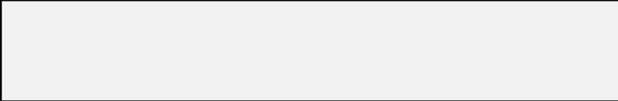

* Trying to determine the future value of a company or any other successful prediction/investment could yield significant profit.

**Result:**

Thus, the project team formed, the project is described, the business case was prepared and the problem statement was arrived.

**CHAPTER - 2**

**Course Code: 18CSC206J**

**Course Name: Software Engineering and Project Management**

|  |  |
| --- | --- |
| **Experiment No** | 2 |
| **Title of Experiment** | Stakeholder Register |
| **Name of the candidate** | Tanmay Shukla |
| **Team Members** | Tanmay Shukla, Khushi Suri, Mitraansh Raaj Khanna |
| **Register Number** | RA2011003010119, RA2011003010129, RA2011003010133 |
| **Date of Experiment** | **22.03.2022** |

**Mark Split Up**

|  |  |  |  |
| --- | --- | --- | --- |
| **S. No** | **Description** | **Maximum Mark** | **Mark Obtained** |
| 1 | Exercise | 5 |  |
| 2 | Viva | 5 |  |
| **Total** | | **10** |  |

**Team Members:**

|  |  |  |  |
| --- | --- | --- | --- |
| **S No** | **Register No** | **Name** | **Role** |
| **1** | RA2011003010119 | **Tanmay Shukla** | **Rep/Member** |
| **2** | RA2011003010129 | **Khushi Suri** | **Member** |
| **3** | RA2011003010133 | **Mitraansh Raaj Khanna** | **Member** |

**Aim:**

To develop the stakeholder, register for PredictO.

**Stakeholder Register**

**Project Name:** (PridictO) – Stock market forecasting with dynamic applications.

**Prepared by:** Tanmay Shukla, Mitraansh Raaj Khanna, Khushi Suri.

**Date:** 29/03/2022

|  |  |  |  |  |
| --- | --- | --- | --- | --- |
| **Project Stakeholder Name:** | **Specific Information needs (Types & Frequency of communication)** | **Project Interest (Specific area of interest and participation)** | **Impact on project (Positive, Negative, Influencer, Supporter, Roadblock)** | **Role** |
| **Tanmay Shukla** | Design and development of website and code for website (Weekly) | Backend | Positive impact | Designer and software Developer |
| **Khushi Suri** | Development and presentation of website (Weekly) | Frontend (HTML CSS JavaScript) | Positive impact | Manager and software Developer |
| **Mitraansh Raaj Khanna** | Development of workspace and code for website (Weekly) | Backend | Positive impact | Designer and software Developer |

*Figure 2.1*

**Q1- Who is affected positively and negatively by the project?**

This project is aimed and focused only for positive impact towards society as our project is mainly targeting people who are investing their money in stock market and crypto. Which will not only help people to know now how good it will be to invest money in that certain company.

**Q2- Who has the power to make it succeed (or fail)?**

The success of our project depends on team and meticulous efforts on the project in order to make it convenient and beneficial for the people.

**Q3- Who makes the decisions about money?**

The decisions regarding monetary issues are taken up by the team members and stakeholders. In our case the stakeholders and team members are us itself. Therefore we (team members) make the majority monetary decisions.

**Q4- Who are the suppliers?**

The suppliers are websites which would provide us with necessary data for the project. **Q5- Who are the end users?**

The end users are those who analyse and invest their assets in markets to sequentially achieve a handsome portfolio.

**Q6- Who has influence over other stakeholders?**

The stakeholders are independent and each individual has their own say on the project. **Q7- Who could solve potential problems with the project?**

Since the project follows agile methodology, the problems are solved as the problems are faced along the path with applied expertise.

**Q8- Who is in charge of assigning or procuring resources or facilities?**

Resources and content us team members are responsible and we’ll be taking guidance for the content from our mentor Dr T.K. Siva Kumar and other respected faculties.

**Q9- Who has specialist skills which are crucial to the project?**

Every member in the team has their own special skills which will contribute to the success of project, and if any issues are encountered, Dr T.K. Siva Kumar would guide us through.

**Course Code: 18CSC206J**

**Course Name: Software Engineering and Project Management**

|  |  |
| --- | --- |
| **Experiment No** | 3 |
|  |  |
| **Title of Experiment** |  |
|  | System, Functional and Non-Functional Requirements of the |
|  | Project |
|  |  |
| **Name of the candidate** | Tanmay Shukla |
|  |  |
| **Team Members** | Tanmay Shukla, Mitraansh Raaj Khanna,Khushi Suri |
|  |  |
| **Register Number** | RA2011003010119, RA2011003010133, RA2011003010129 |
|  |  |
| **Date of Experiment** | 9Th April 2022 |
|  |  |

**Mark Split Up**

|  |  |  |  |
| --- | --- | --- | --- |
| **S.No** | **Description** | **Maximum Mark** | **Mark Obtained** |
|  |  |  |  |
| 1 | Exercise | 5 |  |
|  |  |  |  |
| 2 | Viva | 5 |  |
|  |  |  |  |
|  | **Total** | **10** |  |
|  |  |  |  |
|  |  |  |  |
|  |  |  |  |
|  |  |  |  |

**Team Members:**

|  |  |  |  |
| --- | --- | --- | --- |
| **S No** | **Register No** | **Name** | **Role** |
|  |  |  |  |
| **1** | **RA2011003010119** | **Tanmay Shukla** | **Rep/Member** |
|  |  |  |  |
| **2** | **RA2011003010129** | **Khushi Suri** | **Member** |
|  |  |  |  |
| **3** | **RA2011003010133** | **Mitraansh Raaj Khanna** | **Member** |
|  |  |  |  |

**CHAPTER - 3**

**Aim:**

To identify the system, functional and non-functional requirements for the project.

**Project Title: Stock market forecasting with dynamic applications.**

**System Requirements:**

1. Laptop
2. Windows 10 and above
3. Internet Connection
4. VS Code
5. Python 3.8 and above
6. Machine Learning
7. Html, Css, JavaScript

**Functional Requirements**

1. The system should be able to generate an approximate share price.
2. The system should collect accurate data from the stock market website in consistent manner.
3. The prediction shall abide by the following functional requirements:
4. Prior to application of stock recommendations, the database is updated by the latest values.
5. The charts and comparison of the companies would be done only on the latest data stock market data.
6. The user can look previous data Information which was collected.
7. The user can also be recommended on the basis of the trending stocks which would require the data regarding the stocks.

**Non-Functional Requirements:**

1. The system should provide better accuracy.
2. The system should have simple interface for users to use.
3. To perform efficiently in short amount of time.

**Result**

Thus, the requirements were identified and accordingly described.

**CHAPTER - 4**

**Course Code: 18CSC206J**

**Course Name: Software Engineering and Project Management**

|  |  |
| --- | --- |
| **Experiment No** | 4 |
| **Title of Experiment** | Project Plan |
| **Name of the candidate** | Tanmay Shukla |
| **Team Members** | Tanmay Shukla, Khushi Suri, Mitraansh Raaj Khanna |
| **Register Number** | RA2011003010119, RA2011003010129, RA2011003010133 |
| **Date of Experiment** | 05/04/2022 |

**Mark Split Up**

|  |  |  |  |
| --- | --- | --- | --- |
| **S. No** | **Description** | **Maximum Mark** | **Mark Obtained** |
| 1 | Exercise | 5 |  |
| 2 | Viva | 5 |  |
| **Total** | | **10** |  |

**Team Members:**

|  |  |  |  |
| --- | --- | --- | --- |
| **S No** | **Register No** | **Name** | **Role** |
| **1** | RA2011003010119 | **Tanmay Shukla** | **Rep/Member** |
| **2** | RA2011003010129 | **Khushi Suri** | **Member** |
| **3** | RA2011003010133 | **Mitraansh Raaj Khanna** | **Member** |

**Aim:**

To develop the project plan for PredictO

**PROJECT PLAN**

**Steps to create a project plan:**

1. **Explain the project plan to key stakeholders and discuss its key?**

This project takes the data or specifically stock data from different companies and several sites as well. In this we are going to use SVR model which is a supervised learning technique. With the help of SVR we are going to train the continuous data which would be received from different platforms and use this trained model for further prediction. Hereafter, we will use dash so that we can have better transmission from model to website where we will predict.

In a project, there’re both internal and external stakeholders.

Internal stakeholders may include top management, project team members, your manager, peers, resource manager, and internal customers.

External stakeholders may include external customers, government, contractors and subcontractors, and suppliers

1. **Define roles and responsibilities.**

* Tanmay Shukla (Project Leader, Supplier, Developer)
* Mitraansh Raaj Khanna (Developer, Analyst)
* Khushi Suri (Front-end Developer, Manager)

1. **Hold a kick-off meeting.**

A meeting is scheduled every Saturday.

An internal kick-off meeting is a meeting with the project manager and the team members. This meeting is held to get to know about your team members and allow them to interact. The ground rules are defined, work culture is explained and project objectives are also set in the same duration.

1. Introductions
2. What’s the background of the project
3. Why are you doing it
4. What is the project scope?
5. What’s the action plan?
6. Who’s doing what?
7. How are we going to work together?
8. What does success look like?
9. **Develop a Scope Statement.**

A project scope statement provides a detailed description of the work that must be done to deliver the output of a project on time and within the allotted budget

Work duration 6 months.

Till now there is no requirement of budget

1. **Develop scope baseline.**

The main goals of this project is to save time, proper management of data, transparency, cost-effective, increased security and the main thing is automated time tracking system and so on thus we can provide the management as per user needs.

1. **Develop the schedule and cost baselines.**

* Identify Activities and Dependencies
* Estimate Durations and Resources Needs
* Create a Schedule Model
* Seek Approval
* Communicate the Schedule Baseline Use and Maintain the Schedule Baseline
* Use and maintain the Schedule Baseline
* A cost baseline is the budget that has been approved for the project, (but at that time budget is not required and fixed

1. **Create baseline management plans.**

Management plans for modifying baselines usually include:

* A review
* An approval process (different approval levels are normally required for different types of changes).

A process is needed to consider any new requests, to determine their impact on the project, however, not all requests will result in changes to the scope, schedule or budget.

1. **Develop the staffing plan?**

Approach: There are various algorithms used for stock prediction. We can use high-frequency trading (HFT).

**Goals---**

The main goals of this project is to save time, proper management of data, transparency, cost-effective, increased security and the main thing is automated time tracking system and so on thus we can provide the management as per user needs

**IDENTIFY JOB ROLES AND RESPONSIBILITIES:**

1. **PROJECT SPONSOR-** Tanmay Shukla
2. **SUBJECT MATTER EXPERTS (SME)-**

Tanmay Shukla, Mitraansh Raaj Khanna, Khushi Suri

1. **PRODUCT OWNER-** None
2. **PROJECT MANAGER (PM)-** Khushi Suri
3. **TECHNICAL LEAD-** Tanmay Shukla
4. **SOFTWARE DEVELOPERS-**

Tanmay Shukla, Mitraansh Raaj Khanna, Khushi Suri

1. **SOFTWARE TESTERS-** Mitraansh Raaj Khanna
2. **USER ACCEPTANCE TESTERS-**

Public (that is manage by head of department)

**COCOMO MODEL:**

*Figure 1*

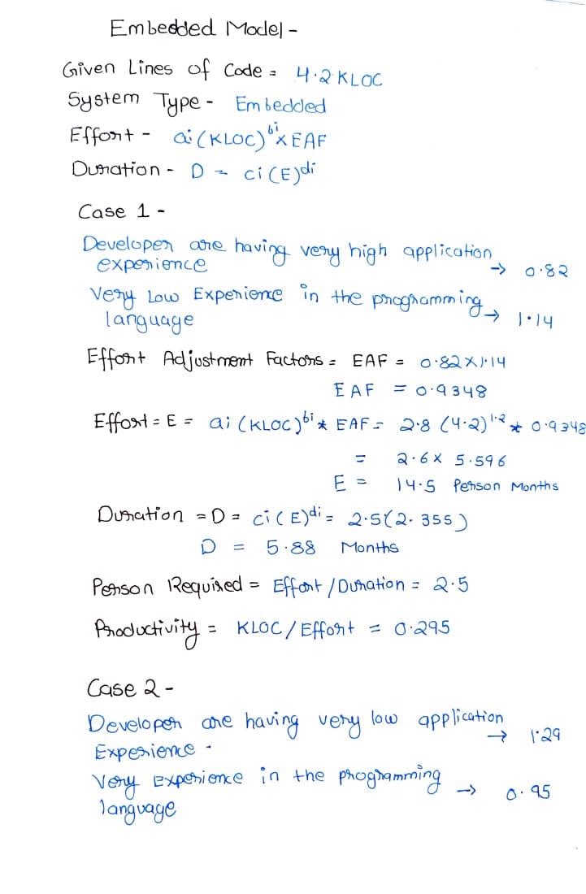

*Figure 4.1*

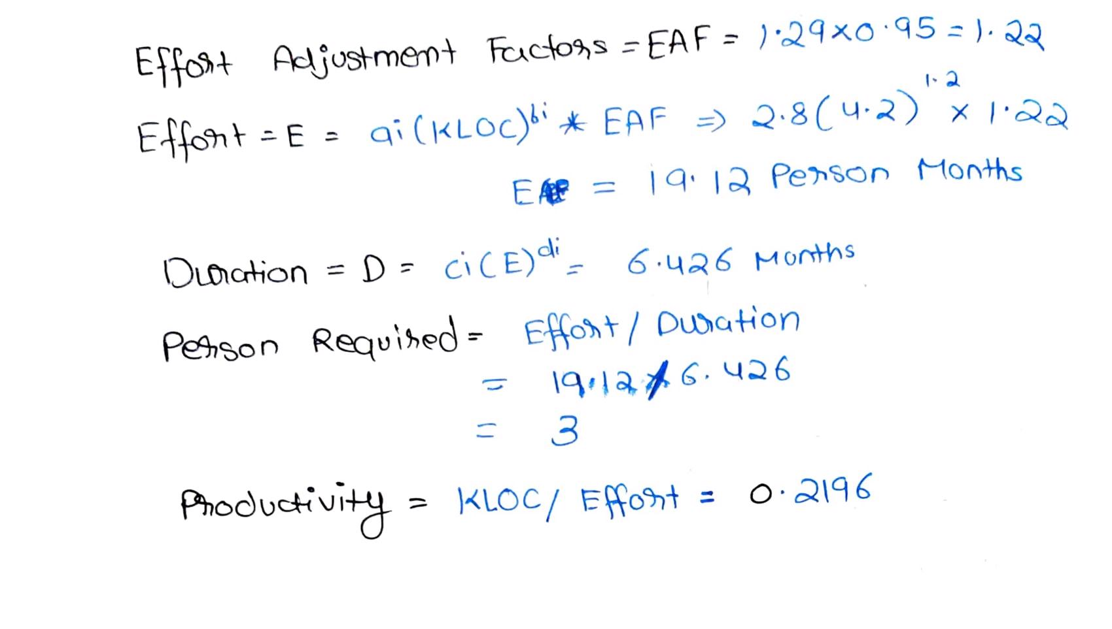

*Figure 4.2*

*Case 2 requires more effort and time than Case 1 but still we prefer Case 2 as Developers will have more experience in programming language which in turn will be more useful as they can grasp the application knowledge easily. Also, the difference between the Case 1 and Case 2 is not that vast.*

*Figure 4.3*

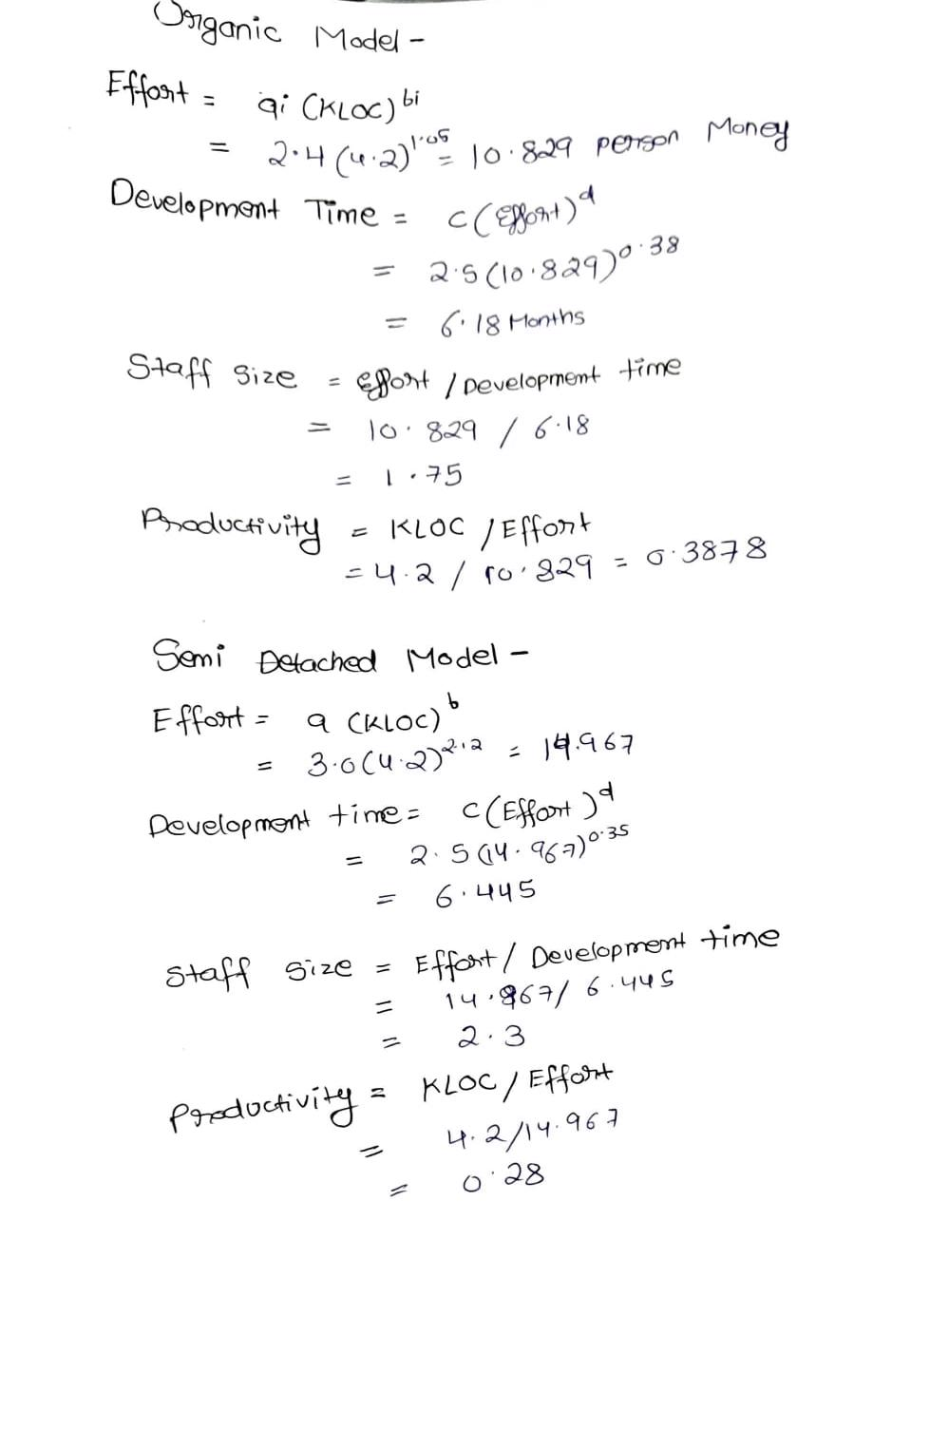

**CHAPTER - 5**

**Course Code: 18CSC206J**

**Course Name: Software Engineering and Project Management**

|  |  |
| --- | --- |
| **Experiment No** | 5 |
| **Title of Experiment** | Prepare Work breakdown structure, Timeline chart, Risk identification table |
| **Name of the candidate** | Tanmay Shukla |
| **Team Members** | Tanmay Shukla, Mitraansh Raaj Khanna, Khushi Suri |
| **Register Number** | RA2011003010119, RA2011003010133, RA2011003010129 |
| **Date of Experiment** | 12th MAY 2022 |

**Mark Split Up**

|  |  |  |  |
| --- | --- | --- | --- |
| **S.No** | **Description** | **Maximum Mark** | **Mark Obtained** |
| 1 | Exercise | 5 |  |
| 2 | Viva | 5 |  |
| **Total** | | **10** |  |

**Team Members:**

|  |  |  |  |
| --- | --- | --- | --- |
| **Sl No** | **Register No** | **Name** | **Role** |
| **1** | RA2011003010119 | Tanmay Shukla | **Rep** |
| **2** | RA2011003010129 | Khushi Suri | **Member** |
| **3** | RA2011003010133 | Mitraansh Raaj Khanna | **Member** |

**Aim:**

To Prepare Work breakdown structure, Timeline chart and Risk identification table

**WORK BREAKDOWN STRUCTURE:**

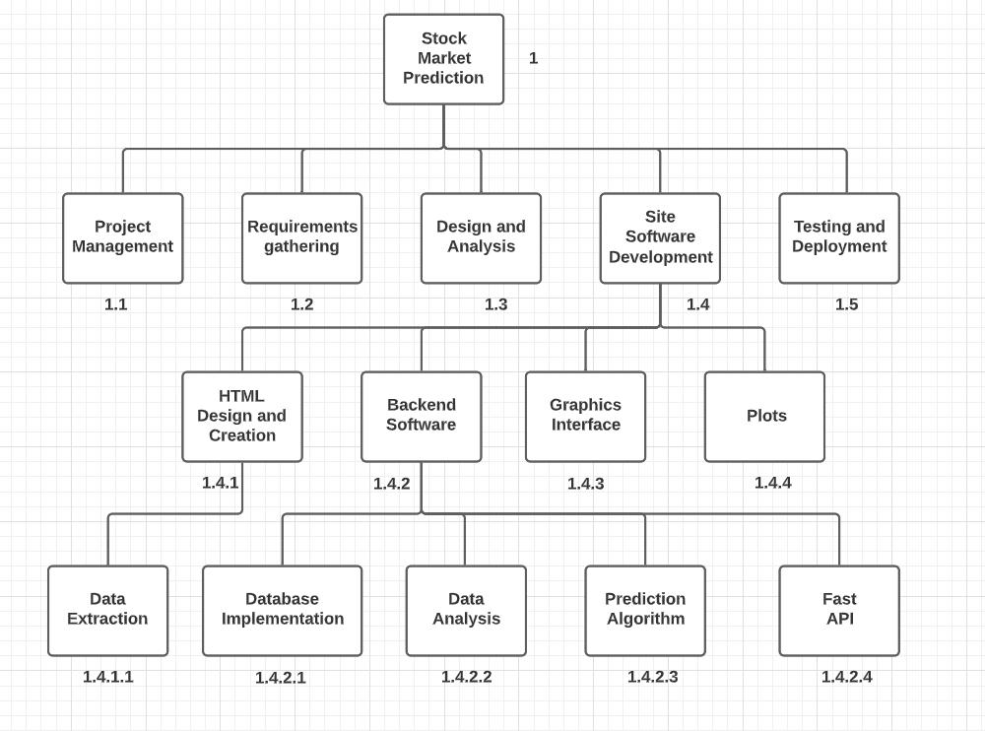

*Figure 5.1*

**GHANTT CHART:**

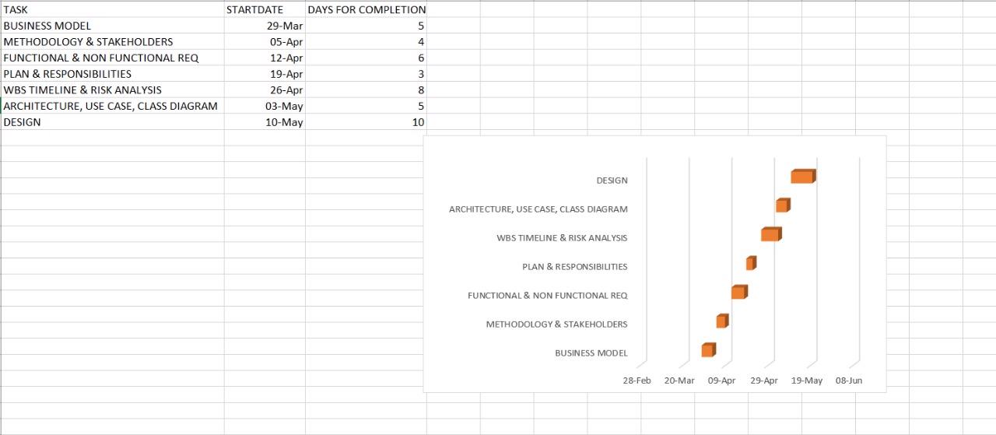

*Figure 5.2*

**RISK ANALYSIS**

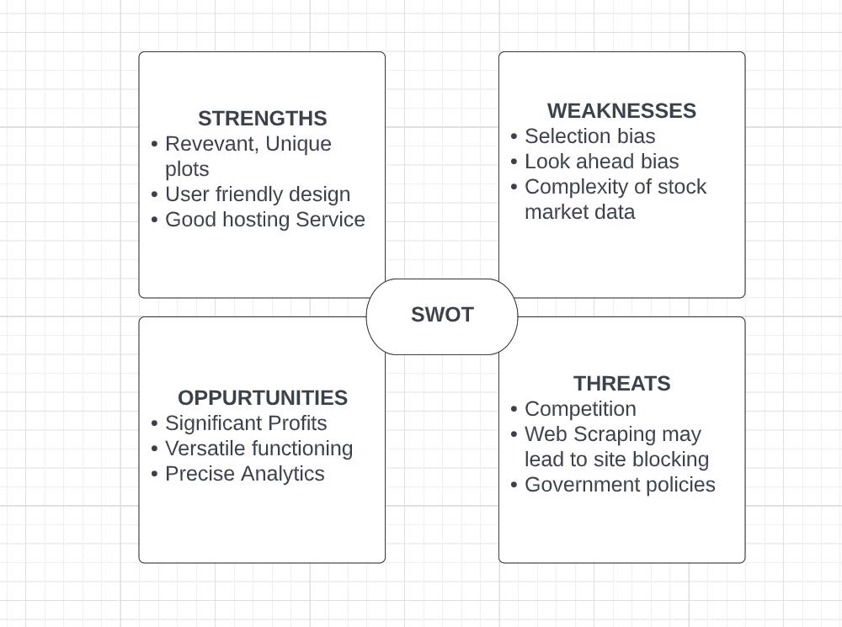

*Figure 5.3*

**Result:**

Thus, the work breakdown structure with timeline chart and risk table were formulated successfully.

**CHAPTER - 6**

**Course Code: 18CSC206J**

**Course Name: Software Engineering and Project Management**

|  |  |
| --- | --- |
| **Experiment No** | 6 |
| **Title of Experiment** | Prepare Class, Use Case and Architecture Diagrams. |
| **Name of the candidate** | Tanmay Shukla |
| **Team Members** | Tanmay Shukla, Mitraansh Raaj Khanna, Khushi Suri |
| **Register Number** | RA2011003010119, RA2011003010133, RA2011003010129 |
| **Date of Experiment** | 12th MAY 2022 |

**Mark Split Up**

|  |  |  |  |
| --- | --- | --- | --- |
| **S.No** | **Description** | **Maximum Mark** | **Mark Obtained** |
| 1 | Exercise | 5 |  |
| 2 | Viva | 5 |  |
| **Total** | | **10** |  |

**Team Members:**

|  |  |  |  |
| --- | --- | --- | --- |
| **Sl No** | **Register No** | **Name** | **Role** |
| **1** | RA2011003010119 | Tanmay Shukla | **Rep** |
| **2** | RA2011003010129 | Khushi Suri | **Member** |
| **3** | RA2011003010133 | Mitraansh Raaj Khanna | **Member** |

**Aim:**

To Prepare architecture, use case and class diagrams.

**Class Diagram:**

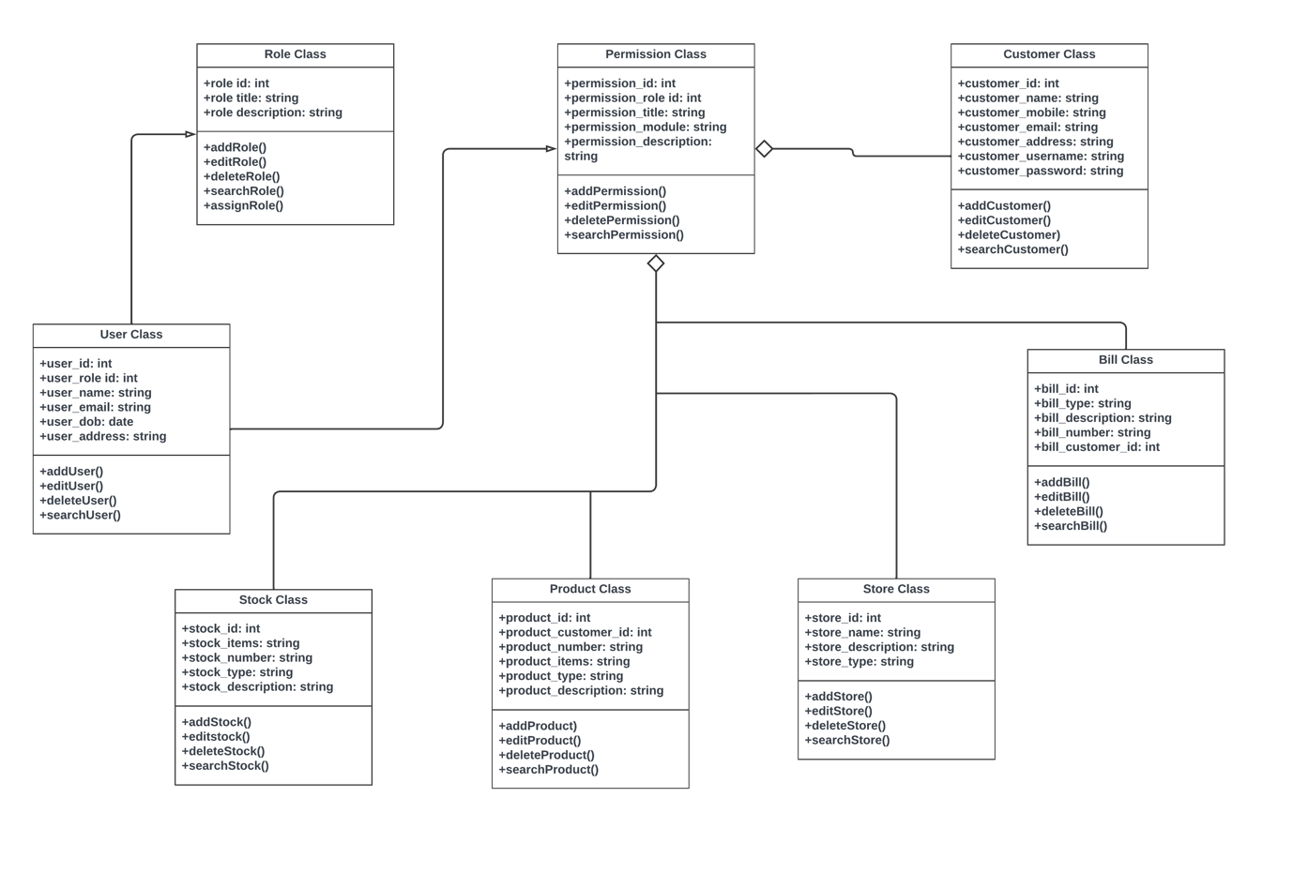

*Figure 6.1*

**Use – Case Diagram**

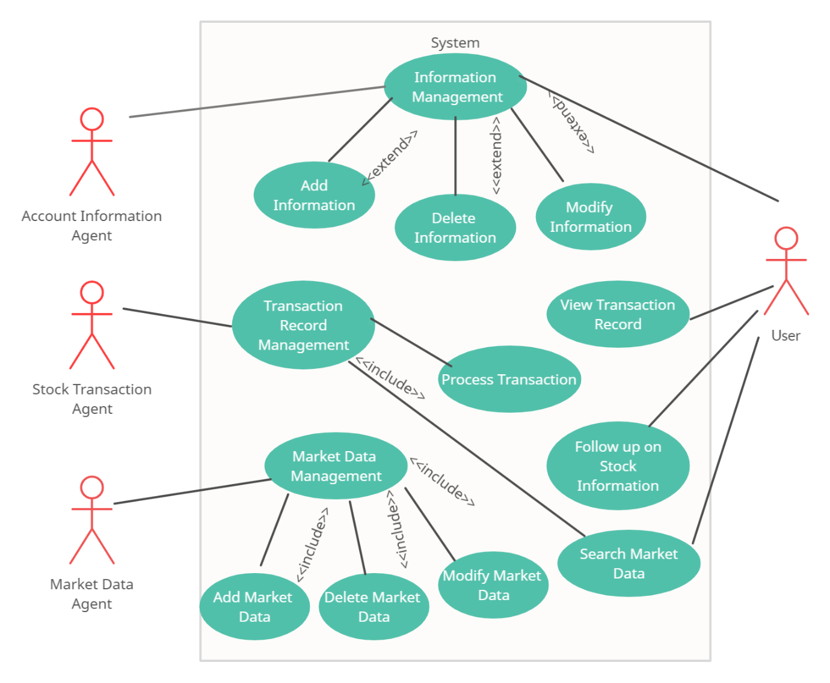

*Figure 6.2*

**Architecture Diagram:**

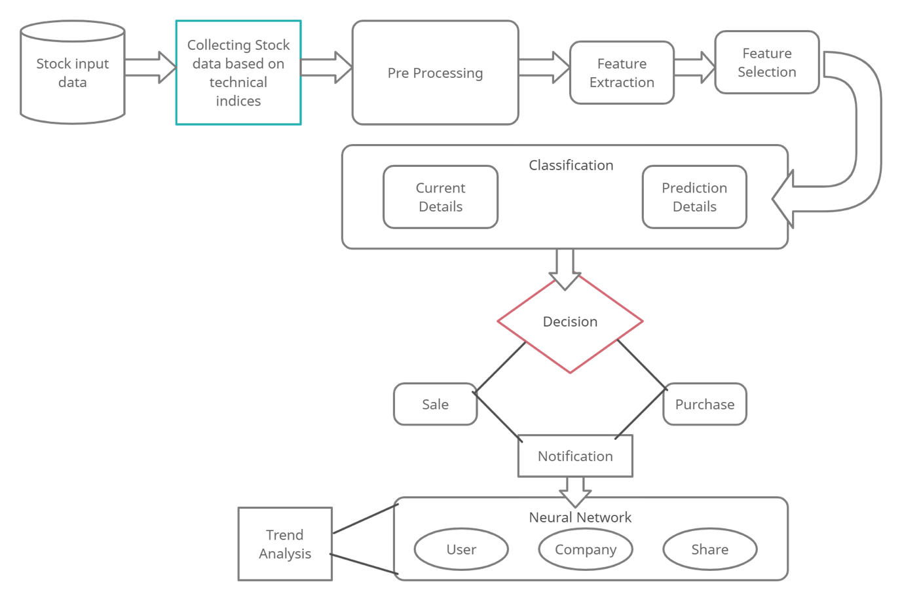

*Figure 6.3*

**CHAPTER - 7**

**Course Code: 18CSC206J**

**Course Name: Software Engineering and Project Management**

|  |  |
| --- | --- |
| **Experiment No** | 7 |
| **Title of Experiment** | Design a Entity relationship diagram |
| **Name of the candidate** | Tanmay Shukla |
| **Team Members** | Tanmay Shukla, Mitraansh Raaj Khanna, Khushi Suri |
| **Register Number** | RA2011003010119, RA2011003010133, RA2011003010129 |
| **Date of Experiment** | 25 May 2022 |

**Mark Split Up**

|  |  |  |  |
| --- | --- | --- | --- |
| **S. No** | **Description** | **Maximum Mark** | **Mark Obtained** |
| 1 | Exercise | 5 |  |
| 2 | Viva | 5 |  |
| **Total** | | **10** |  |

**Team Members:**

|  |  |  |  |
| --- | --- | --- | --- |
| **S No** | **Register No** | **Name** | **Role** |
| **1** | RA2011003010119 | Tanmay Shukla | **Rep** |
| **2** | RA2011003010129 | Khushi Suri | **Member** |
| **3** | RA2011003010133 | Mitraansh Raaj Khanna | **Member** |

**Aim**

To create the Entity Relationship Diagram

*Figure 7.1*

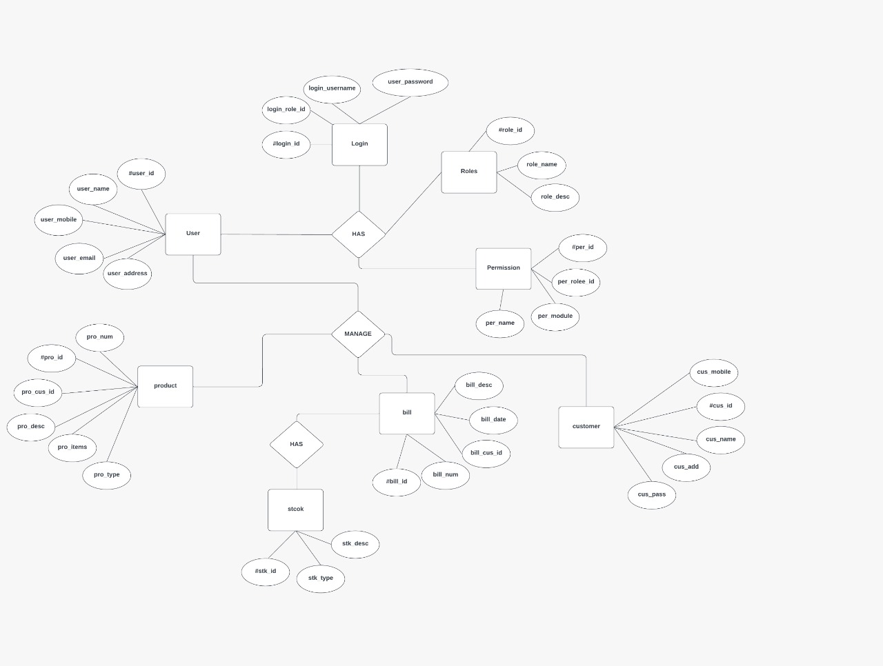

**Result:**

Thus, the entity relationship diagram was created successfully.

**CHAPTER - 8**

**Course Code: 18CSC206J**

**Course Name: Software Engineering and Project Management**

|  |  |
| --- | --- |
| **Experiment No** | 8 |
| **Title of Experiment** | Develop a Data Flow Diagram (Process-Up to Level 1) |
| **Name of the candidate** | Tanmay Shukla |
| **Team Members** | Tanmay Shukla, Khushi Suri, Mitraansh Raaj Khanna |
| **Register Number** | RA2011003010119, RA2011003010129, RA2011003010133 |
| **Date of Experiment** | 09/06/2022 |

**Mark Split Up**

|  |  |  |  |
| --- | --- | --- | --- |
| **S. No** | **Description** | **Maximum Mark** | **Mark Obtained** |
| 1 | Exercise | 5 |  |
| 2 | Viva | 5 |  |
| **Total** | | **10** |  |

**Team Members:**

|  |  |  |  |
| --- | --- | --- | --- |
| **S No** | **Register No** | **Name** | **Role** |
| **1** | RA2011003010119 | **Tanmay Shukla** | **Rep/Member** |
| **2** | RA2011003010129 | **Khushi Suri** | **Member** |
| **3** | RA2011003010133 | **Mitraansh Raaj Khanna** | **Member** |

**Aim:**

To develop the data flow diagram up to level 1 for the <project name>

**DATA FLOW DIAGRAM:**

**LEVEL 0:**

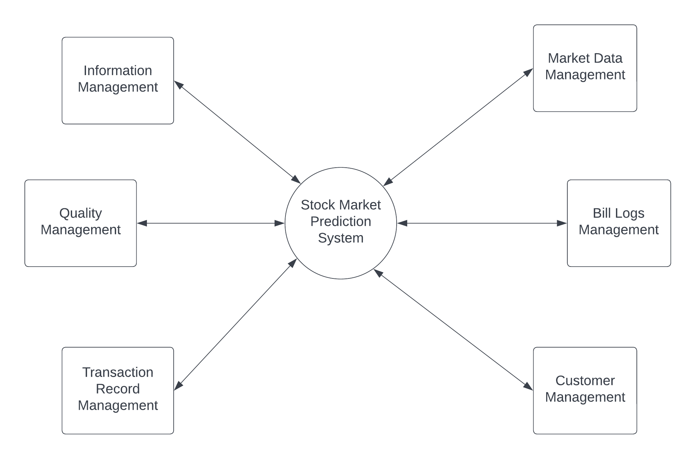

*Figure 8.1*

**LEVEL 1:**

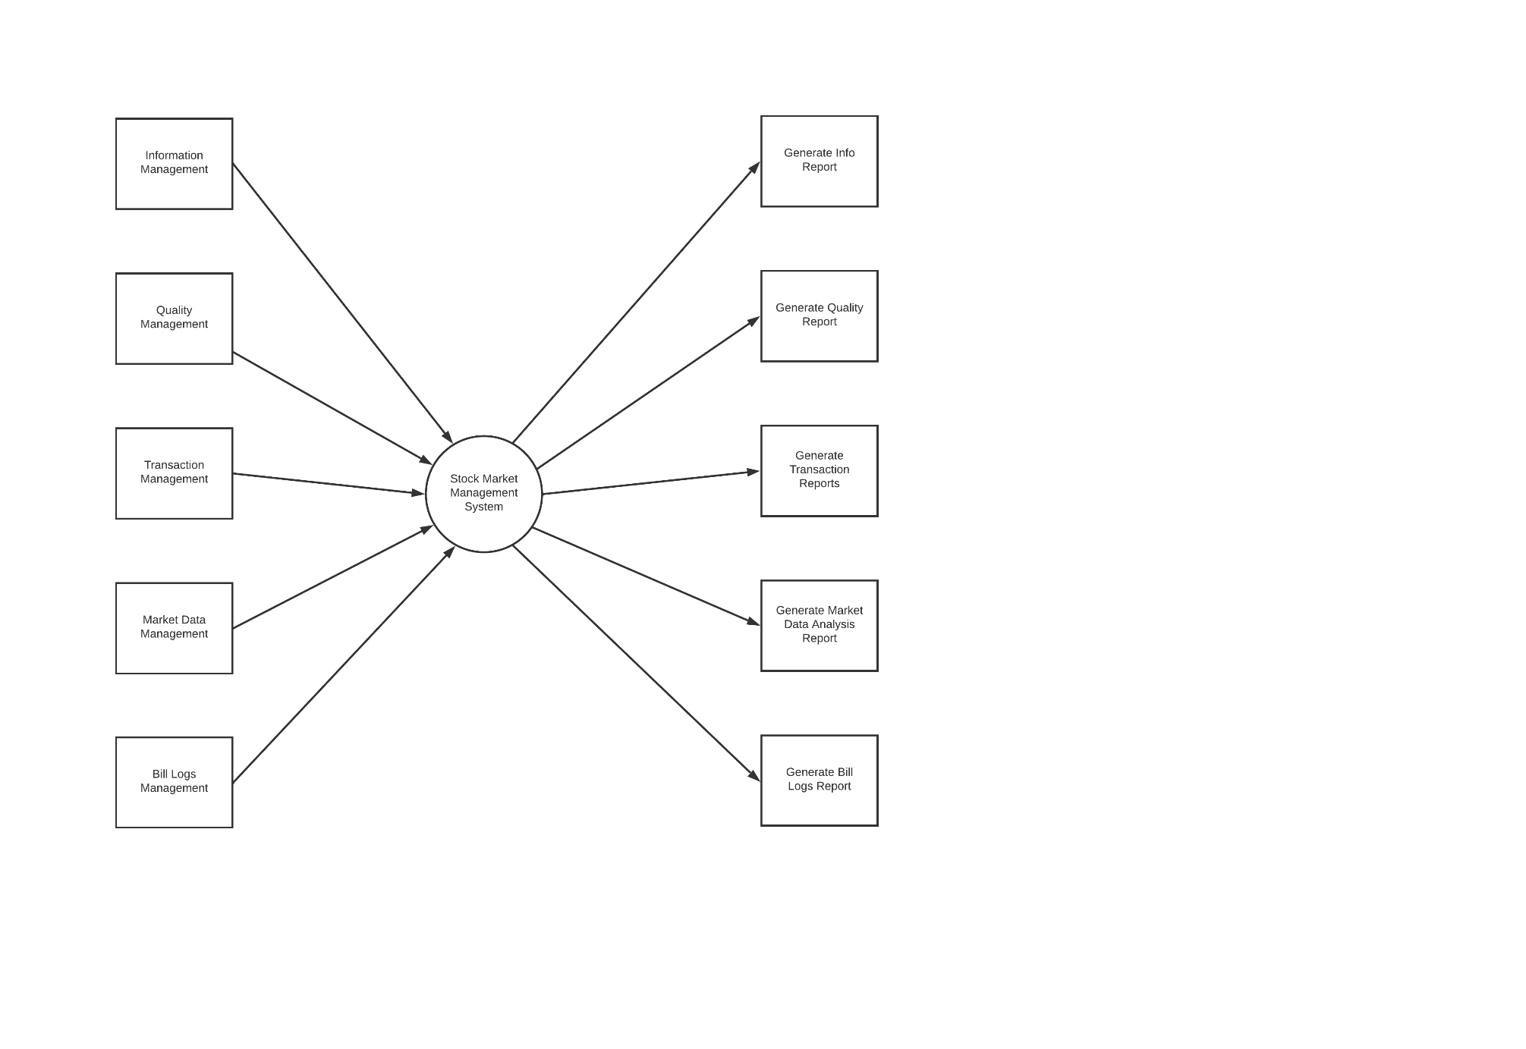

*Figure 8.2*

**LEVEL 2:**

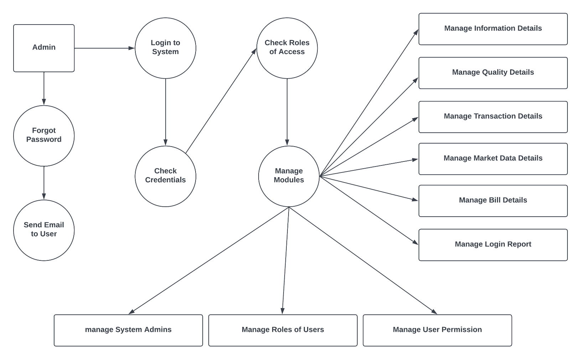

*Figure 8.3*

**Result:**

Thus, the data flow diagrams have been created for the Stock Market Prediction

**CHAPTER - 9**

**Course Code: 18CSC206J**

**Course Name: Software Engineering and Project Management**

|  |  |
| --- | --- |
| **Experiment No** | 9 |
| **Title of Experiment** | Design a Sequence and Collaboration Diagram |
| **Name of the candidate** | Tanmay Shukla |
| **Team Members** | Tanmay Shukla, Khushi Suri, Mitraansh Raaj Khanna |
| **Register Number** | RA2011003010119, RA2011003010129, RA2011003010133 |
| **Date of Experiment** | 09/06/2022 |

**Mark Split Up**

|  |  |  |  |
| --- | --- | --- | --- |
| **S. No** | **Description** | **Maximum Mark** | **Mark Obtained** |
| 1 | Exercise | 5 |  |
| 2 | Viva | 5 |  |
| **Total** | | **10** |  |

**Team Members:**

|  |  |  |  |
| --- | --- | --- | --- |
| **S No** | **Register No** | **Name** | **Role** |
| **1** | RA2011003010119 | **Tanmay Shukla** | **Rep/Member** |
| **2** | RA2011003010129 | **Khushi Suri** | **Member** |
| **3** | RA2011003010133 | **Mitraansh Raaj Khanna** | **Member** |

**Aim:**

To create the sequence and collaboration diagram for the <project name>

**Sequence Diagram**

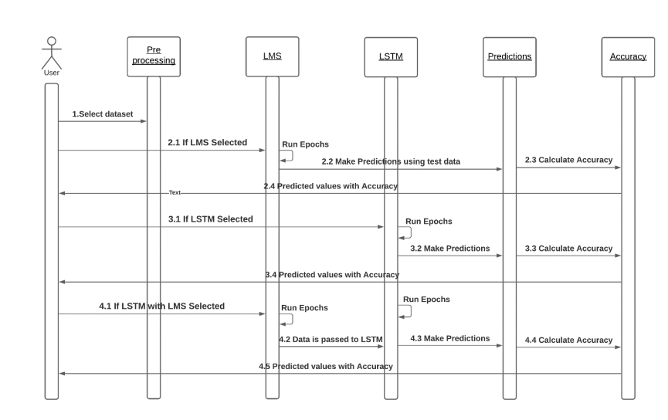

*Figure 9.1*

**Collaboration Diagram**

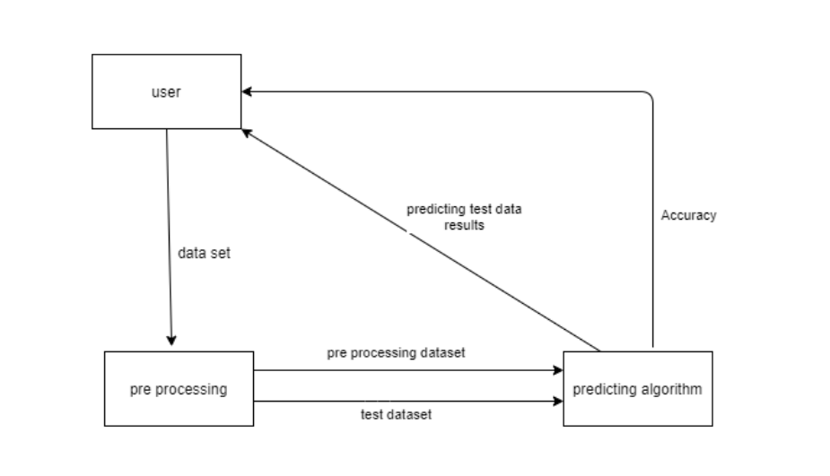

*Figure 9.2*

**Result:**

Thus, the sequence and collaboration diagrams were created for the Stock market Prediction.

**CHAPTER - 10**

**Course Code: 18CSC206J**

**Course Name: Software Engineering and Project Management**

|  |  |
| --- | --- |
| **Experiment No** | 10 |
| **Title of Experiment** | Develop a Testing Framework/User Interface |
| **Name of the candidate** | Tanmay Shukla |
| **Team Members** | Tanmay Shukla, Khushi Suri, Mitraansh Raaj Khanna |
| **Register Number** | RA2011003010119, RA2011003010129, RA2011003010133 |
| **Date of Experiment** | 16/06/2022 |

**Mark Split Up**

|  |  |  |  |
| --- | --- | --- | --- |
| **S. No** | **Description** | **Maximum Mark** | **Mark Obtained** |
| 1 | Exercise | 5 |  |
| 2 | Viva | 5 |  |
| **Total** | | **10** |  |

**Team Members:**

|  |  |  |  |
| --- | --- | --- | --- |
| **S No** | **Register No** | **Name** | **Role** |
| **1** | **RA2011003010119** | **Tanmay Shukla** | **Rep/Member** |
| **2** | **RA2011003010129** | **Khushi Suri** | **Member** |
| **3** | **RA2011003010133** | **Mitraansh Raaj Khanna** | **Member** |

**Aim:**

To develop the testing framework and/or user interface framework for the stock market predictor

**User Interface:** User interface design is concerned with dialogue between a user and the computer. It is concerned with everything from starting the system or logging into the system to the eventually presentation of desired inputs and outputs. The overflow of screens and messages is called a dialogue.

* **The following steps are various guidelines for User Interface Design:**
  + The system user should always be aware of what to do next.
  + The screen should be formatted so that various types of information, instructions and messages always appear in the same general display area.
  + Message, instructions or information should long enough to allow the system user to rea them.
  + Use display attributed sparingly.
  + Default values for fields and answers to be entered by the user should be  
    specified.
  + A user should not be allowed to proceed without correcting an error.
  + The system user should never get an operating system message or fatal error.

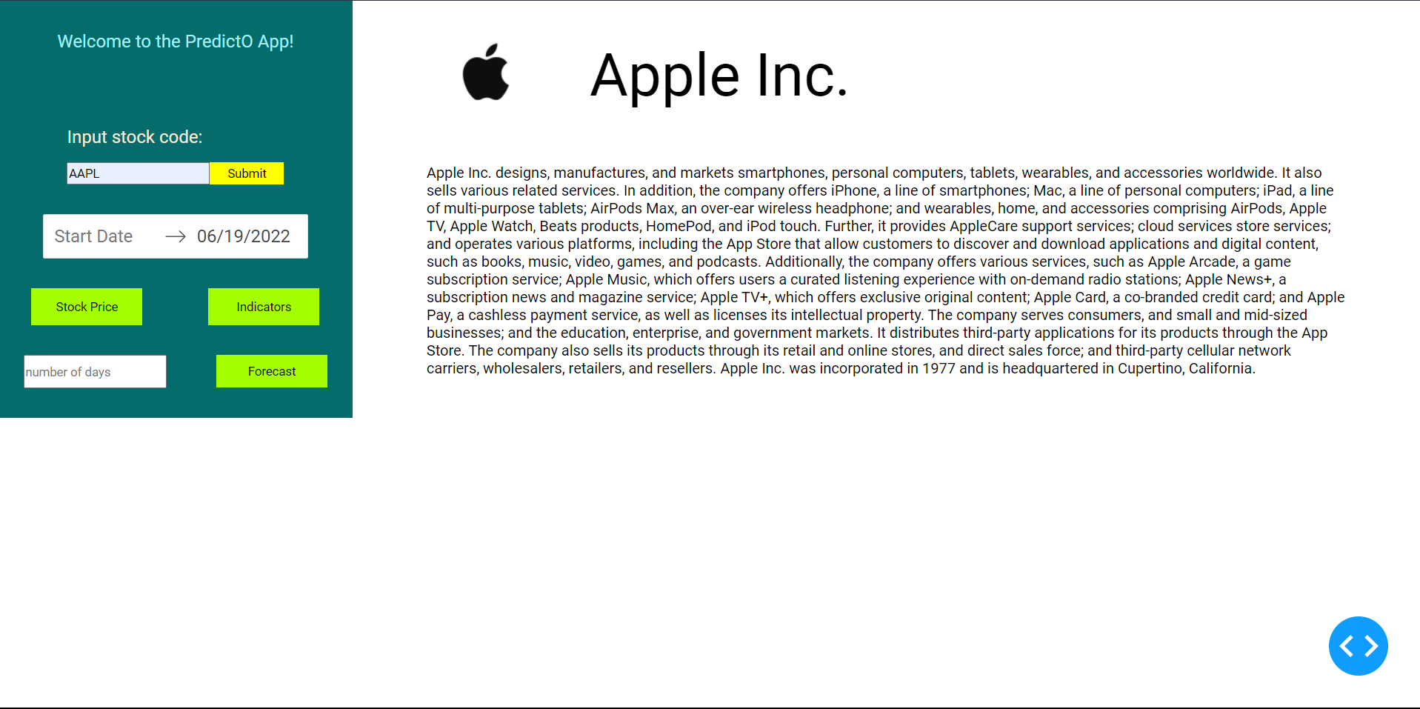

*Figure 10.1*

**Testing Framework:**

|  |  |  |
| --- | --- | --- |
| **Category** | **Methodology** | **Tool Required** |
| Functional Requirements: •Login   * Start date •Stock Code •Number of Days | Manual | Word Template |
| Non-Functional Requirements | Automatic | Katalon Studio |

*Figure 10.2*

**Result:**

Thus, the testing framework/user interface framework has been created for the  
stock market predictor



**CHAPTER - 11**

**Course Code: 18CSC206J**

**Course Name: Software Engineering and Project Management**

|  |  |
| --- | --- |
| **Experiment No** | 11 |
| **Title of Experiment** | Test Cases |
| **Name of the candidate** | Tanmay Shukla |
| **Team Members** | Tanmay Shukla, Khushi Suri, Mitraansh Raaj Khanna |
| **Register Number** | RA2011003010119, RA2011003010129, RA2011003010133 |
| **Date of Experiment** | 19/06/2022 |

**Mark Split Up**

|  |  |  |  |
| --- | --- | --- | --- |
| **S. No** | **Description** | **Maximum Mark** | **Mark Obtained** |
| 1 | Exercise | 5 |  |
| 2 | Viva | 5 |  |
| **Total** | | **10** |  |

**Team Members:**



|  |  |  |  |
| --- | --- | --- | --- |
| **S No** | **Register No** | **Name** | **Role** |
| **1** | **RA2011003010119** | **Tanmay Shukla** | **Rep/Member** |
| **2** | **RA2011003010129** | **Khushi Suri** | **Member** |
| **3** | **RA2011003010133** | **Mitraansh Raaj Khanna** | **Member** |

**Aim:**

To develop the test cases manual for the **Stock Market Predictor.**

**Functional Test Case:**

|  |  |  |  |  |  |  |
| --- | --- | --- | --- | --- | --- | --- |
| **101** | Verify User Login | Accept valid Username and Password | * User click on User Login Button * Ener the username and   password | User should be taken to the main page of the website | * Pass * Fail | Successfully logged in  Wrong Credentials |

**Test Id**

**Test**

**Scenario**

**Test Case**

**Execution Steps**

**Expected**

**Output**

**Status**

**Remarks**

*Figure 11.1*

**Non-Functional Test Case:**



**Test Id**

**Test**

**Scenario**

**Test Case**

**Execution Steps**

**Expected**

**Output**

**Status**

**Remarks**

|  |  |  |  |  |  |  |
| --- | --- | --- | --- | --- | --- | --- |
| **102** | Verify there is a minimum of one users should be available | * Many users available * Only one user available | * User asks for the future analysis * User asks for the past analysis * User asks for the present analysis | User get the reply | * Pass | * Got the   analysis in the form of graphs |

*Figure 11.2*

**Result:**

Thus, the test case manual has been created for the **Stock Market Predictor.**

**CHAPTER - 12**

**Course Code: 18CSC206J**

**Course Name: Software Engineering and Project Management**

|  |  |
| --- | --- |
| **Experiment No** | 12 |
| **Title of Experiment** | Manual Test Case Reporting |
| **Name of the candidate** | Tanmay Shukla |
| **Team Members** | Tanmay Shukla, Khushi Suri, Mitraansh Raaj Khanna |
| **Register Number** | RA2011003010119, RA2011003010129, RA2011003010133 |
| **Date of Experiment** | 8/6/22 |

**Mark Split Up**

|  |  |  |  |
| --- | --- | --- | --- |
| **S. No** | **Description** | **Maximum Mark** | **Mark Obtained** |
| 1 | Exercise | 5 |  |
| 2 | Viva | 5 |  |
| **Total** | | **10** |  |

**Team Members:**

|  |  |  |  |
| --- | --- | --- | --- |
| **S No** | **Register No** | **Name** | **Role** |
| **1** | **RA2011003010119** | **Tanmay Shukla** | **Rep/Member** |
| **2** | **RA2011003010129** | **Khushi Suri** | **Member** |
| **3** | **RA2011003010133** | **Mitraansh Raaj Khanna** | **Member** |

**Aim:**

To prepare the manual test case report for the PredictO.

|  |  |  |
| --- | --- | --- |
| **Category** | **Progress Against Plan** | **Status** |
| Functional Testing | Green | Completed |
| Non-Functional Testing | Amber | In-Progress |

|  |  |  |
| --- | --- | --- |
| **Functional** | **Test Case Coverage (%)** | **Status** |
| Admin Login | 10% | Completed |
| Verify User ID and Pass | 10% | Completed |
| Check available user | 15% | In-Progress |
| Enter Stock Details | 25% | In-Progress |
| Trend Analysis | 30% | In-Progress |
| Display Details | 10% | In-Progress |

*Figure 12.1*

**Result:**

Thus, the test case report has been created for the PredictO.

**CHAPTER - 13**



**Course Code: 18CSC206J**

**Course Name: Software Engineering and Project Management**

|  |  |
| --- | --- |
| **Experiment No** | 13 |
| **Title of Experiment** | Provide the details of Architecture Design/Framework/Implementation |
| **Name of the candidate** | Tanmay Shukla |
| **Team Members** | Tanmay Shukla, Khushi Suri, Mitraansh Raaj Khanna |
| **Register Numbers** | RA2011003010119, RA2011003010129, RA2011003010133 |
| **Date of Experiment** | 26 June,2022 |

**Mark Split Up**

|  |  |  |  |
| --- | --- | --- | --- |
| **S. No** | **Description** | **Maximum Mark** | **Mark Obtained** |
| 1 | Exercise | 5 |  |
| 2 | Viva | 5 |  |
| **Total** | | **10** |  |

**Team Members:**



|  |  |  |  |
| --- | --- | --- | --- |
| **S No** | **Register No** | **Name** | **Role** |
| **1** | RA2011003010119 | Tanmay Shukla | Rep/Member |
| **2** | RA2011003010129 | Khushi Suri | Member |
| **3** | RA2011003010133 | Mitraansh Raaj Khanna | Member |

**Aim:**

To provide the details of architectural design/framework/implementation

PROJECT LINK: [PredictO](https://github.com/TanmayX07/Stock_Market_Prediction)

**CODE OF THE PROJECT:**

**App .py**

import dash

from dash import dcc

from dash import html

from datetime import datetime as dt

import yfinance as yf

from dash.dependencies import Input, Output, State

from dash.exceptions import PreventUpdate

import pandas as pd

import plotly.graph_objs as go

import plotly.express as px

# model

from model import prediction

from sklearn.svm import SVR

def get_stock_price_fig(df):

    fig = px.line(df,

                  x="Date",

                  y=["Close", "Open"],

                  title="Closing and Openning Price vs Date")

    return fig

def get_more(df):

    df['EWA_20'] = df['Close'].ewm(span=20, adjust=False).mean()

    fig = px.scatter(df,

                     x="Date",

                     y="EWA_20",

                     title="Exponential Moving Average vs Date")

    fig.update_traces(mode='lines+markers')

    return fig

app = dash.Dash(

    __name__,

    external_stylesheets=[

        "https://fonts.googleapis.com/css2?family=Roboto&display=swap"

    ])

server = app.server

# html layout of site

app.layout = html.Div(

    [

        html.Div(

            [

                # Navigation

                html.P("Welcome to the PredictO App!", className="start"),

                html.Div([

                    html.P("Input stock code: "),

                    html.Div([

                        dcc.Input(id="dropdown_tickers", type="text"),

                        html.Button("Submit", id='submit'),

                    ],

                             className="form")

                ],

                         className="input-place"),

                html.Div([

                    dcc.DatePickerRange(id='my-date-picker-range',

                                        min_date_allowed=dt(1995, 8, 5),

                                        max_date_allowed=dt.now(),

                                        initial_visible_month=dt.now(),

                                        end_date=dt.now().date()),

                ],

                         className="date"),

                html.Div([

                    html.Button(

                        "Stock Price", className="stock-btn", id="stock"),

                    html.Button("Indicators",

                                className="indicators-btn",

                                id="indicators"),

                    dcc.Input(id="n_days",

                              type="text",

                              placeholder="number of days"),

                    html.Button(

                        "Forecast", className="forecast-btn", id="forecast")

                ],

                         className="buttons"),

                # here

            ],

            className="nav"),

        # content

        html.Div(

            [

                html.Div(

                    [  # header

                        html.Img(id="logo"),

                        html.P(id="ticker")

                    ],

                    className="header"),

                html.Div(id="description", className="decription_ticker"),

                html.Div([], id="graphs-content"),

                html.Div([], id="main-content"),

                html.Div([], id="forecast-content")

            ],

            className="content"),

    ],

    className="container")

# callback for company info

@app.callback([

    Output("description", "children"),

    Output("logo", "src"),

    Output("ticker", "children"),

    Output("stock", "n_clicks"),

    Output("indicators", "n_clicks"),

    Output("forecast", "n_clicks")

], [Input("submit", "n_clicks")], [State("dropdown_tickers", "value")])

def update_data(n, val):  # inpur parameter(s)

    if n == None:

        return "Hey there! Please enter a legitimate stock code to get details.", "https://i.ibb.co/x6wqHBk/stonk-img.png", "PredictO", None, None, None

        # raise PreventUpdate

    else:

        if val == None:

            raise PreventUpdate

        else:

            ticker = yf.Ticker(val)

            inf = ticker.info

            df = pd.DataFrame().from_dict(inf, orient="index").T

            df[['logo_url', 'shortName', 'longBusinessSummary']]

            return df['longBusinessSummary'].values[0], df['logo_url'].values[

                0], df['shortName'].values[0], None, None, None

# callback for stocks graphs

@app.callback([

    Output("graphs-content", "children"),

], [

    Input("stock", "n_clicks"),

    Input('my-date-picker-range', 'start_date'),

    Input('my-date-picker-range', 'end_date')

], [State("dropdown_tickers", "value")])

def stock_price(n, start_date, end_date, val):

    if n == None:

        return [""]

        #raise PreventUpdate

    if val == None:

        raise PreventUpdate

    else:

        if start_date != None:

            df = yf.download(val, str(start_date), str(end_date))

        else:

            df = yf.download(val)

    df.reset_index(inplace=True)

    fig = get_stock_price_fig(df)

    return [dcc.Graph(figure=fig)]

# callback for indicators

@app.callback([Output("main-content", "children")], [

    Input("indicators", "n_clicks"),

    Input('my-date-picker-range', 'start_date'),

    Input('my-date-picker-range', 'end_date')

], [State("dropdown_tickers", "value")])

def indicators(n, start_date, end_date, val):

    if n == None:

        return [""]

    if val == None:

        return [""]

    if start_date == None:

        df_more = yf.download(val)

    else:

        df_more = yf.download(val, str(start_date), str(end_date))

    df_more.reset_index(inplace=True)

    fig = get_more(df_more)

    return [dcc.Graph(figure=fig)]

# callback for forecast

@app.callback([Output("forecast-content", "children")],

              [Input("forecast", "n_clicks")],

              [State("n_days", "value"),

               State("dropdown_tickers", "value")])

def forecast(n, n_days, val):

    if n == None:

        return [""]

    if val == None:

        raise PreventUpdate

    fig = prediction(val, int(n_days) + 1)

    return [dcc.Graph(figure=fig)]

if __name__ == '__main__':

    app.run_server(debug=True)

*Figure 13.1*

**MODEL.PY**



def prediction(stock, n_days):

    import dash

    import dash_core_components as dcc

    import dash_html_components as html

    from datetime import datetime as dt

    import yfinance as yf

    from dash.dependencies import Input, Output, State

    from dash.exceptions import PreventUpdate

    import pandas as pd

    import plotly.graph_objs as go

    import plotly.express as px

    # model

    from model import prediction

    from sklearn.model_selection import train_test_split

    from sklearn.model_selection import GridSearchCV

    import numpy as np

    from sklearn.svm import SVR

    from datetime import date, timedelta

    # load the data

    df = yf.download(stock, period='60d')

    df.reset_index(inplace=True)

    df['Day'] = df.index

    days = list()

    for i in range(len(df.Day)):

        days.append([i])

    # Splitting the dataset

    X = days

    Y = df[['Close']]

    x_train, x_test, y_train, y_test = train_test_split(X,

                                                        Y,

                                                        test_size=0.1,

                                                        shuffle=False)

    gsc = GridSearchCV(

        estimator=SVR(kernel='rbf'),

        param_grid={

            'C': [0.001, 0.01, 0.1, 1, 100, 1000],

            'epsilon': [

                0.0001, 0.0005, 0.001, 0.005, 0.01, 0.05, 0.1, 0.5, 1, 5, 10,

                50, 100, 150, 1000

            ],

            'gamma': [0.0001, 0.001, 0.005, 0.1, 1, 3, 5, 8, 40, 100, 1000]

        },

        cv=5,

        scoring='neg_mean_absolute_error',

        verbose=0,

        n_jobs=-1)

    y_train = y_train.values.ravel()

    y_train

    grid_result = gsc.fit(x_train, y_train)

    best_params = grid_result.best_params_

    best_svr = SVR(kernel='rbf',

                   C=best_params["C"],

                   epsilon=best_params["epsilon"],

                   gamma=best_params["gamma"],

                   max_iter=-1)

    # Support Vector Regression Models

    # RBF model

    #rbf_svr = SVR(kernel='rbf', C=1000.0, gamma=4.0)

    rbf_svr = best_svr

    rbf_svr.fit(x_train, y_train)

    output_days = list()

    for i in range(1, n_days):

        output_days.append([i + x_test[-1][0]])

    dates = []

    current = date.today()

    for i in range(n_days):

        current += timedelta(days=1)

        dates.append(current)

    # plot Results

    # fig = go.Figure()

    # fig.add_trace(

    #     go.Scatter(x=np.array(x_test).flatten(),

    #                y=y_test.values.flatten(),

    #                mode='markers',

    #                name='data'))

    # fig.add_trace(

    #     go.Scatter(x=np.array(x_test).flatten(),

    #                y=rbf_svr.predict(x_test),

    #                mode='lines+markers',

    #                name='test'))

    fig = go.Figure()

    fig.add_trace(

        go.Scatter(

            x=dates,  # np.array(ten_days).flatten(),

            y=rbf_svr.predict(output_days),

            mode='lines+markers',

            name='data'))

    fig.update_layout(

        title="Predicted Close Price of next " + str(n_days - 1) + " days",

        xaxis_title="Date",

        yaxis_title="Closed Price",

        # legend_title="Legend Title",

    )

    return fig

*Figure 13.2*

STYLE.CSS

* {

  margin: 0;

  padding: 0;

  box-sizing: 0;

  font-family: "Roboto", sans-serif;

}

body {

  overflow-x: hidden;

}

.container {

  display: flex;

}

.nav {

  /*position: fixed;*/

  width: 25vw;

  /* height: 100%; */

  align-items: center;

  display: flex;

  justify-content: flex-start;

  flex-direction: column;

  background-color: rgb(5, 107, 107);

}

.content {

  width: 65vw;

  padding: 1rem 5rem;

}

.start {

  margin-top: 2rem;

  margin-bottom: 5rem;

  text-align: center;

  font-size: larger;

  color: rgb(166, 243, 248);

}

.input-place p {

  color: antiquewhite;

  font-size: larger;

}

.form {

  display: flex;

  margin-top: 1rem;

  margin-bottom: 2rem;

  height: 1.5rem;

}

.form button {

  width: 5rem;

  background-color: yellow;

  color: black;

  border: none;

}

.buttons {

  margin: 2rem;

  width: 100%;

  display: flex;

  flex-wrap: wrap;

  position: relative;

  justify-content: space-around;

}

#forecast {

  margin-top: 2rem;

  height: 2.2rem;

}

#n_days {

  height: 2rem;

  margin-top: 2rem;

}

.buttons button {

  width: 7.5rem;

  height: 2.5rem;

  border: none;

  background-color: rgb(166, 255, 0);

  color: rgb(0, 0, 0);

}

.header {

  display: flex;

  justify-content: flex-start;

  align-items: center;

  margin-bottom: 2rem;

}

.header p {

  font-size: 4rem;

  margin-left: 3rem;

  line-height: 80%;

}

#logo {

  max-width: 15rem;

  height: auto;

}

*Figure 13.3*

**SCREEN SHOTS**

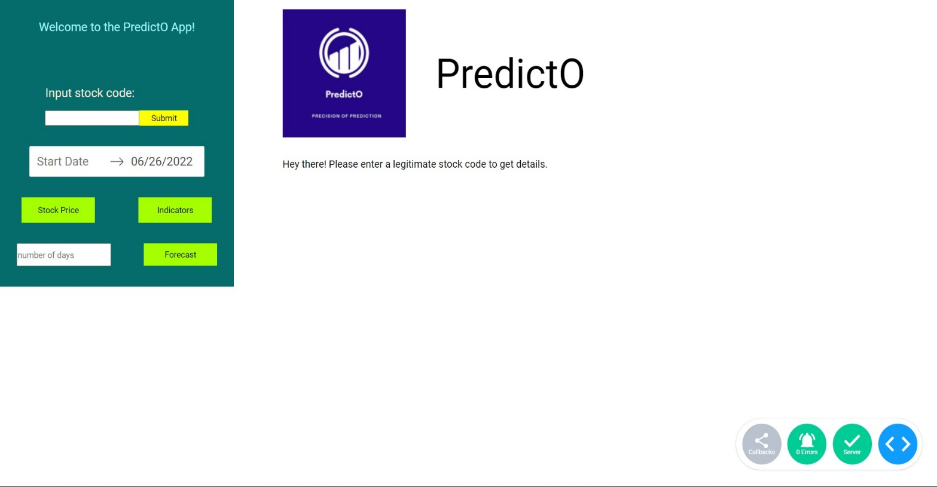

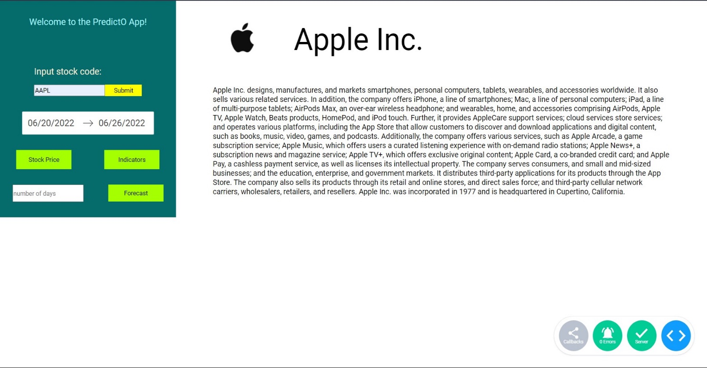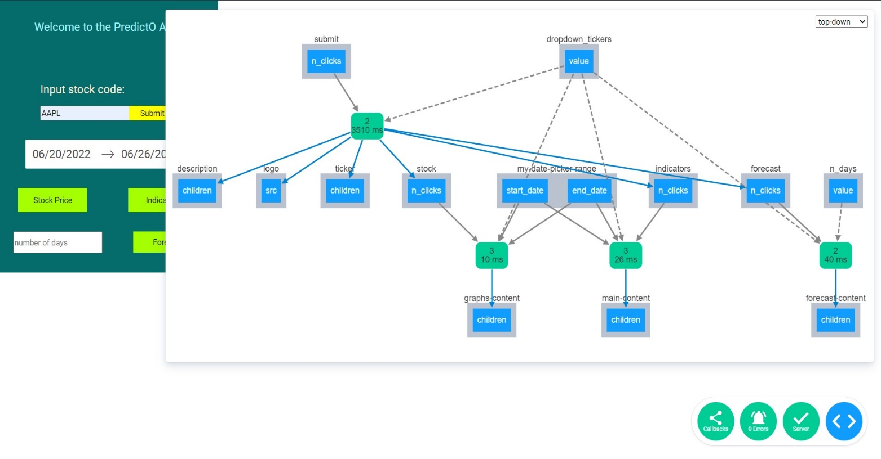

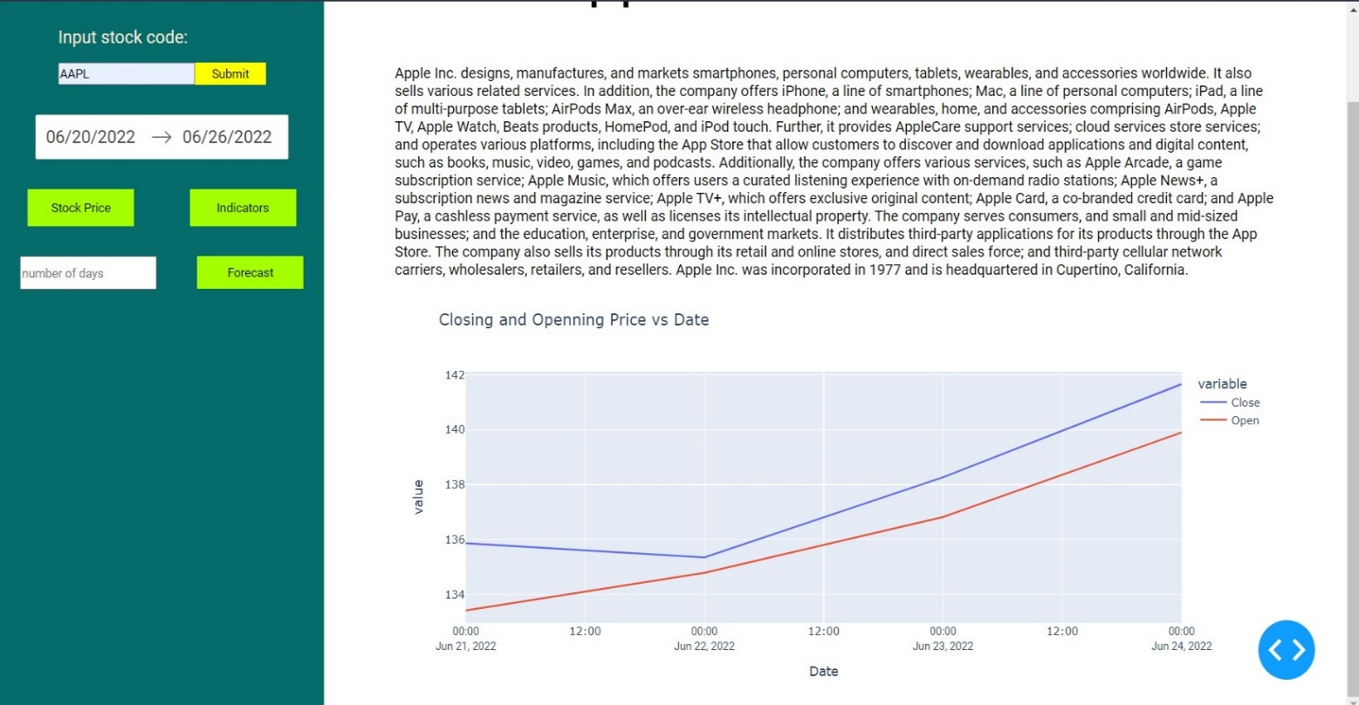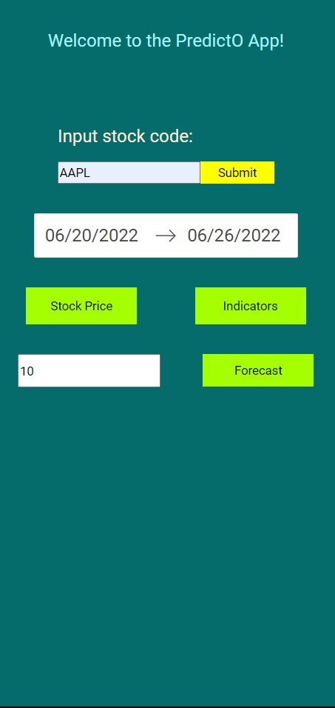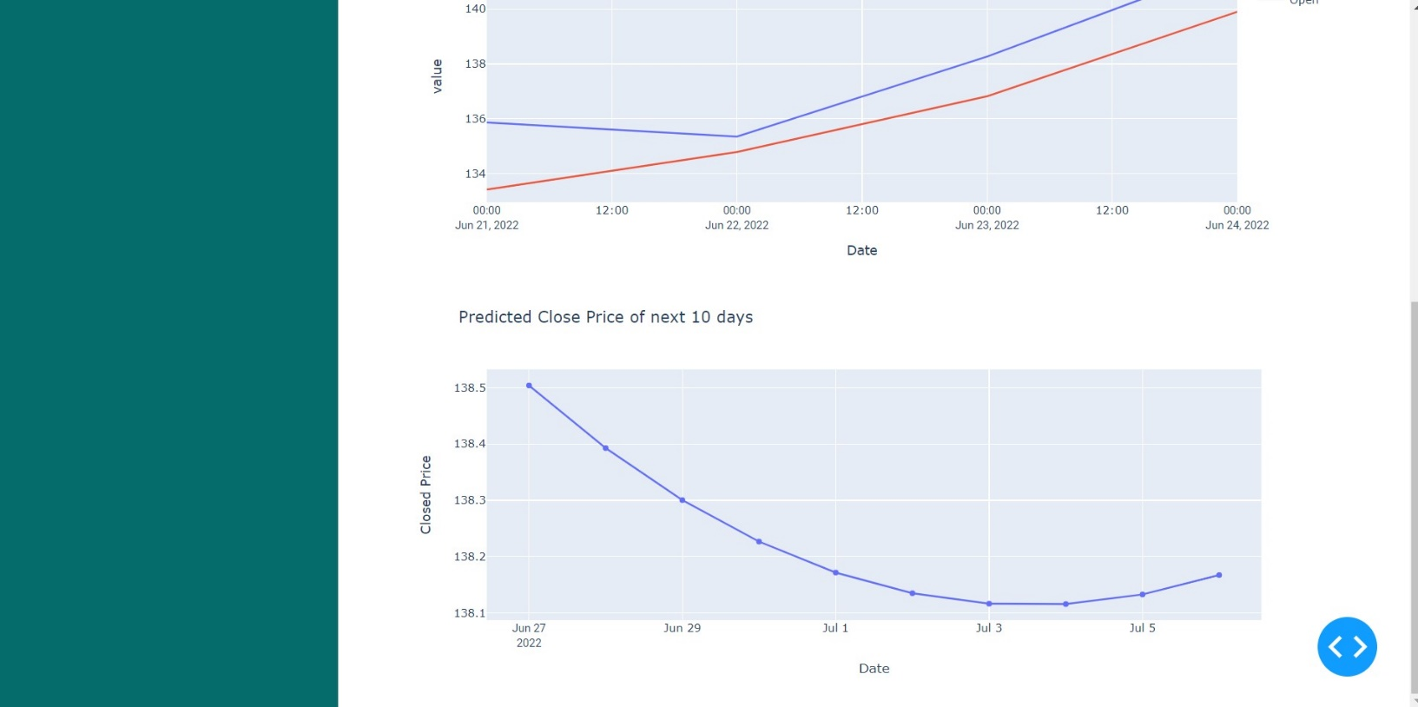

*Figure 13.4*

**Result:**

Thus, the details of architectural design/framework/implementation along with the screenshots were provided.

***===================================================================================***

**CONCLUSION**

Through this project we are able to demonstrate how Machine Learning and efficient algorithms and models can be used such that it combined together with a proper design and functionality, can highly benefit the users and customers as of today’s date when people for generating a passive income are highly reliant on sources and services like these.

The companies already involved in improving machine learning or Artificial Intelligence based products or services like training data, automated machine learning and more will get technological advancement, and in the near future can come up with more useful applications in this sector, helping the world and generating fine analytic products.

Irrespective of any education or background just with knowledge about the market and some investment and analysis strategies, this can be used by anyone around the globe.

**References**

1. <https://www.analyticsvidhya.com/blog/2021/05/stock-price-prediction-and-forecasting-using-stacked-lstm/>
2. <https://towardsdatascience.com/lstm-for-google-stock-price-prediction-e35f5cc84165>
3. <https://www.datacamp.com/tutorial/lstm-python-stock-market>
4. <https://neptune.ai/blog/predicting-stock-prices-using-machine-learning>
5. <https://www.youtube.com/watch?v=H6du_pfuznE>
6. <https://towardsdatascience.com/cryptocurrency-analysis-with-python-buy-and-hold-c3b0bc164ffa>