**Table – EmployeeDetails**

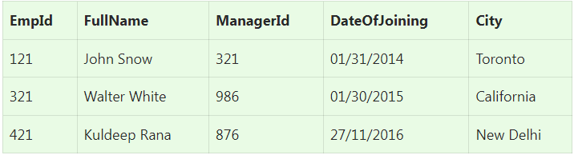

**Table – EmployeeSalary**

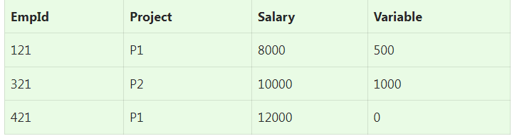

**Ques.1. Write an SQL query to fetch the EmpId and FullName of all the employees working under Manager with id – ‘876’.**

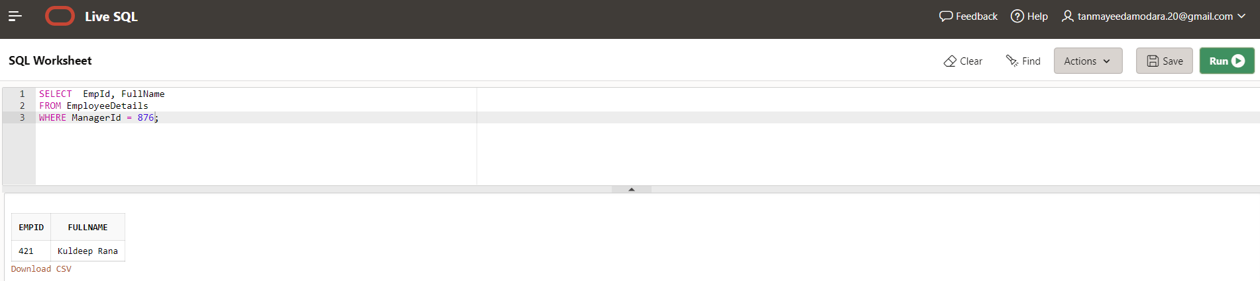

**Ques.2. Write an SQL query to fetch the different projects available from the EmployeeSalary table.**

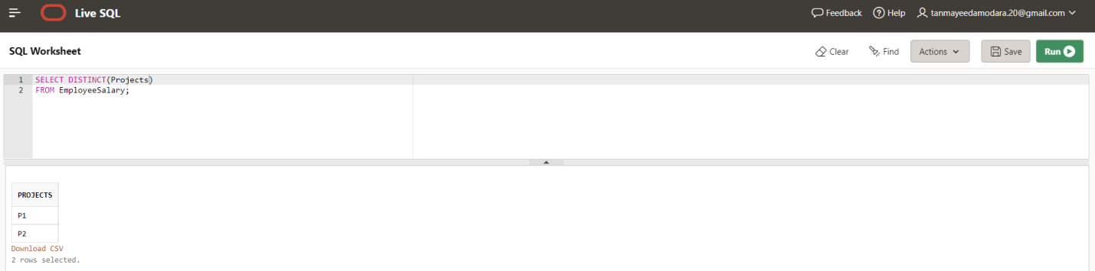

**Ques.3. Write an SQL query to fetch the count of employees working in project ‘P2’.**

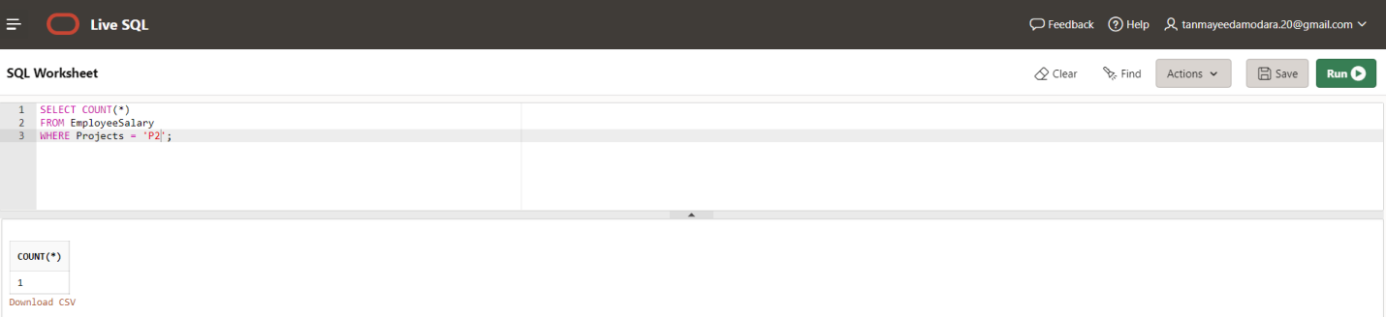

**Ques.4. Write an SQL query to find the maximum, minimum, and average salary of the employees.**

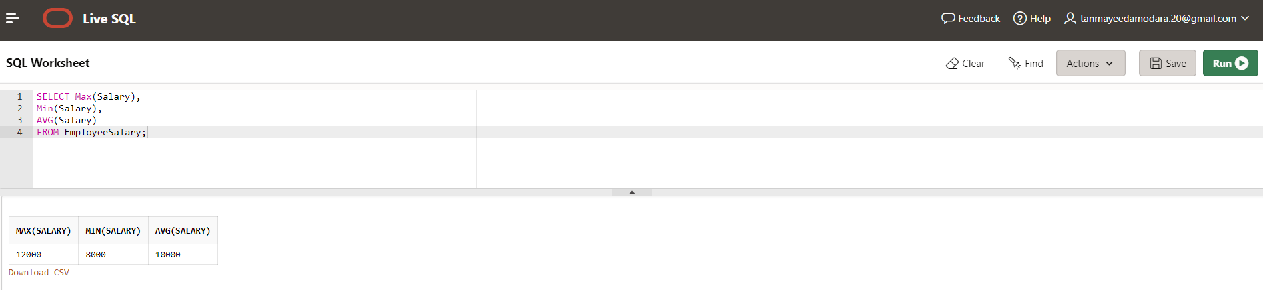

**Ques.5. Write an SQL query to find the employee id whose salary lies in the range of 10000 and 15000.**

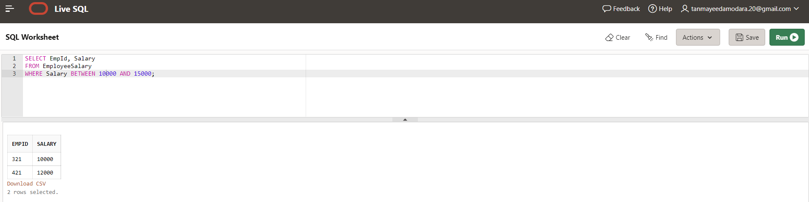

**Ques.6. Write an SQL query to fetch those employees who live in Toronto and work under manager with ManagerId – 121.**

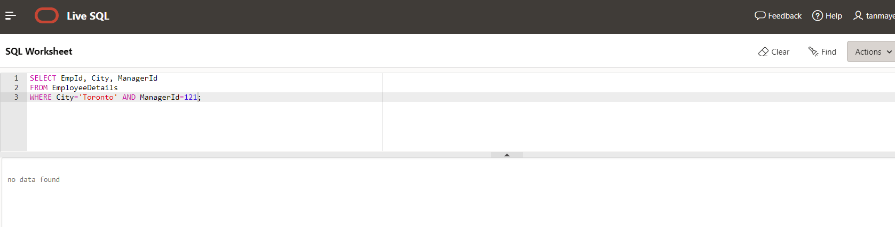

**Ques.7. Write an SQL query to** f**etch all the employees who either live in New Delhi or work under a manager with ManagerId – 321.**

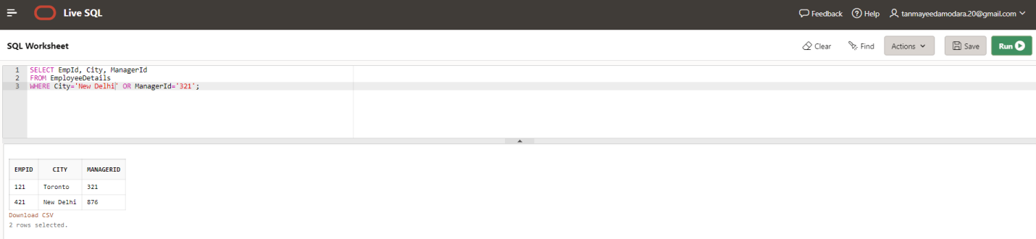

**Ques.8. Write an SQL query to fetch all those employees who work on Project other than P3.**

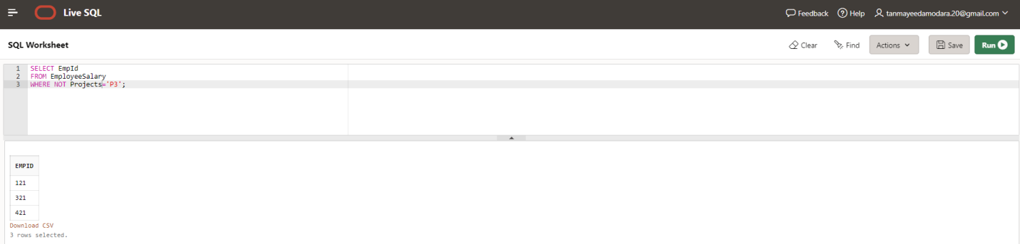

**Ques.9. Write an SQL query to display the total salary of each employee adding the Salary with Variable value.**

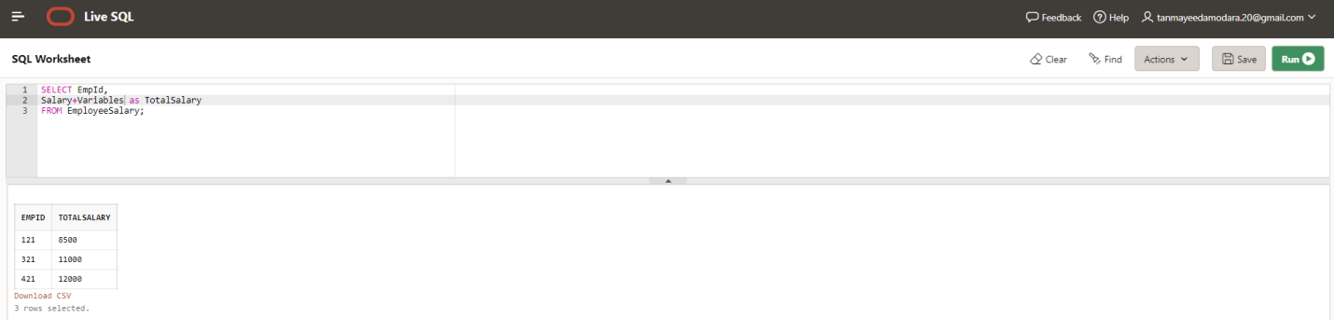

**Ques.10. Write an SQL query to fetch the employees whose name begins with any two characters, followed by a text “lt” and ending with any sequence of characters.**

