UE24MA242A
MATHEMATICS FOR COMPUTER SCIENCE ENGINEERS

Orange Level Problem:

Name: Tanmayi Nagabhairava
SRN: PES1UG24CS493
Section: I
Date: 27/10/2025

- Project Objective and Dataset Selection
This report details the end-to-end data analysis process undertaken for the "Orange Problem" assignment. The project's core objective is to demonstrate proficiency in web data acquisition, data preprocessing, descriptive analysis, and visualization.

For this project, the dataset train.csv was selected. This rich dataset provides a real-world opportunity to analyze time-series data, handle missing values, and derive meaningful insights about the progression.

- Results: Analysis and Visualizations

1. What kind of pre-processing methods are applied?

Missing Value Imputation: The dataset was checked for missing values.

Numeric Imputation: The median value of each corresponding column was used to fill in the missing values in the numeric columns (LoanAmount, Loan_Amount_Term, and Credit_History). Because the median is resilient to outliers, which are frequent in financial data, this approach was selected.

Categorical Imputation: The mode, or most frequent value, of each category column—Gender, Married, Dependents, and Self-Employed—was used to fill in the missing values. To fill in non-numeric data without adding bias, this is standard procedure.

2. Descriptive statistics results and inferences

ApplicantIncome:

Result: Mean (5403.46) >> Median (3812.50) >> Mode (2500.0)

Inference: The data has a significant right-skewed distribution. While the majority of applicants (the median/mode) earn substantially less, a small number of extremely high-income applicants are pulling up the mean. This wide spread is confirmed by the large standard deviation (6109.04), which is even greater than the mean.

CoapplicantIncome:

Result: Mean (1621.25) > Median (1188.50). Mode is 0.

Inference: This is likewise skewed to the right. Many applicants (probably those who are single) have no co-applicant or a co-applicant who is unemployed, as indicated by the significant mode of 0.

LoanAmount:

Result: Mean (145.75) > Median (128.00) = Mode (128.0)

Inference: This is likewise skewed to the right. A few very large loans are pushing the average up, but the majority of loans are grouped around the $128k mark.

Credit_History:

Result: Mean (0.86), Median (1.0), Mode (1.0)

Inference: This is not a true continuous number; rather, it is a binary categorical feature. Approximately 86% of applicants have a credit history (value = 1.0), according to the data.

3. Visualization results and inferences

Histograms:

Inference: The ApplicantIncome, CoapplicantIncome, and LoanAmount histograms all display a similar pattern, with a long, thin "tail" extending to the right and a sizable pile of data on the far left. This visually verifies that they are not normally distributed and are all right-skewed.
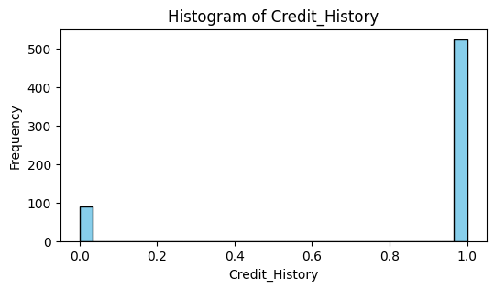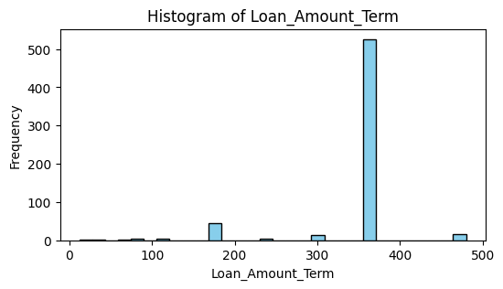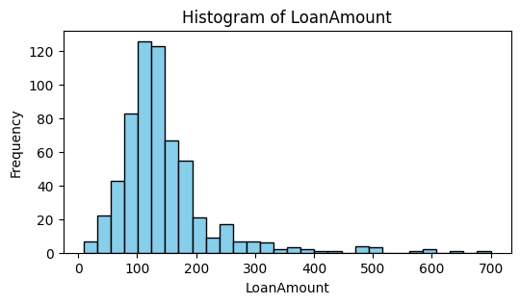

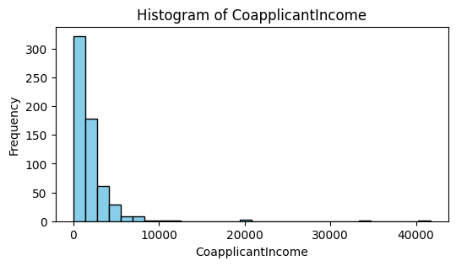
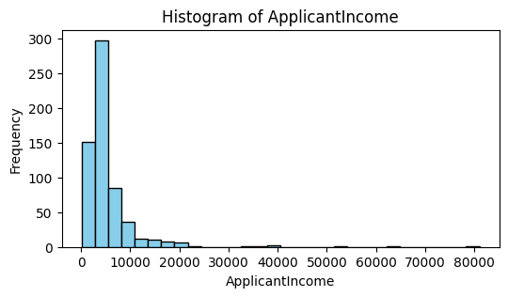

Boxplots:

Inference: The box on the left side of the boxplots for Applicant Income and Loan Amount is extremely compressed. On the right side, they also display a lot of individual points, or outliers. This attests to the skew and the existence of noteworthy outliers.
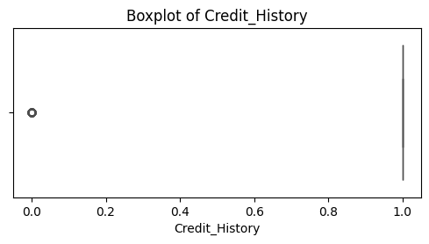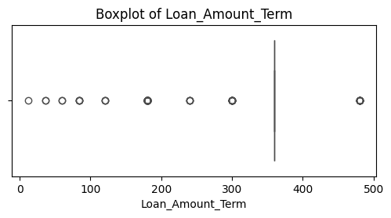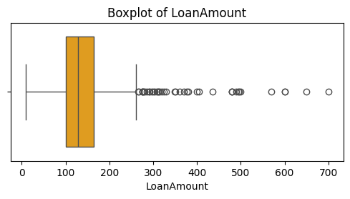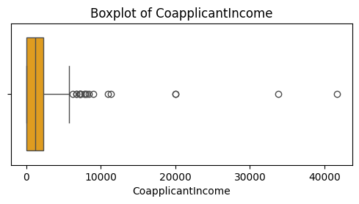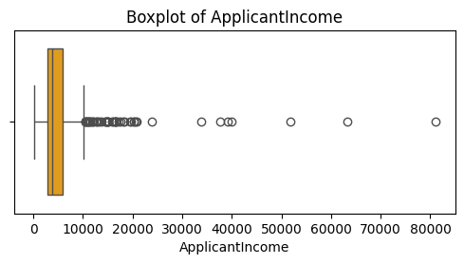

Correlation Heatmap:

Inference: The heatmap illustrates how all numerical variables have a linear relationship with one another. It can be concluded that there is very little (nearly zero) correlation between the target (Credit_History) and the predictors (ApplicantIncome, LoanAmount, etc.).
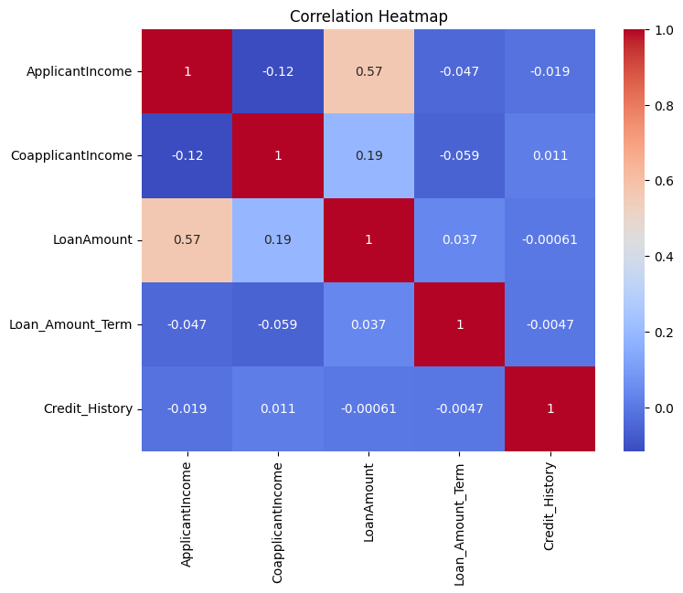

Scatterplot:
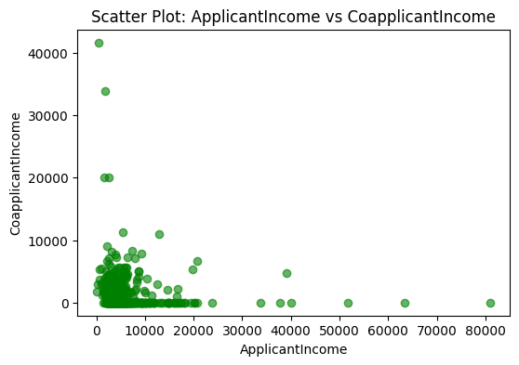

4. Inferences drawn from the descriptive statistics and visualizations

Data is Not Normal: The main conclusion is that the applicant income, loan amount, and coapplicant income—the three main financial variables—do not follow a normal distribution. All of them have a strong right skew.

Outliers Drive the Mean: Large loans and high-income earners are two examples of the many outliers that contribute to the skew. The mean is constantly higher than the median because of this. As a result, it was appropriate to use the median rather than the mean for estimation.

Credit History is Binary: The majority of applicants (the mode) have a value of 1.0 for the Credit_History variable, which is a binary rather than a continuous measure.

5. Conclusion from Q-Q plot

The data points in the ApplicantIncome Q-Q plot exhibit a significant curvature from the straight line, which denotes a perfect normal distribution. At the high end, the points extend far above the line after beginning below it and curved above it. This form unequivocally demonstrates that the ApplicantIncome data is significantly skewed to the right and is not normally distributed.
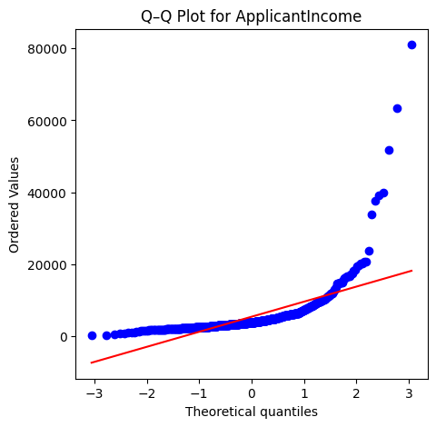

6. Conclusions from the correlation and linear regression

Model Performance

Result: The model has an R squared has a value of -0.0071.

Conclusion: In summary, this model is incredibly subpar. A $R^2$ of 0 indicates that the target's variability cannot be explained by the model. The model is statistically worse than simply estimating the average Credit_History for each applicant if R squared is negative.

Reason for Poor Performance (The Main Conclusion)

Wrong Model for the Problem: The main mistake is logical. The binary categorical variable Credit_History has two possible values: 0 and 1, which stand for "No" and "Yes," respectively. Since linear regression is meant to predict continuous numbers (such as salary or loan amount), it is not the appropriate tool for this.

Correct Model: A classification model called a logistic regression would be the best choice to forecast a yes/no result like Credit_History.
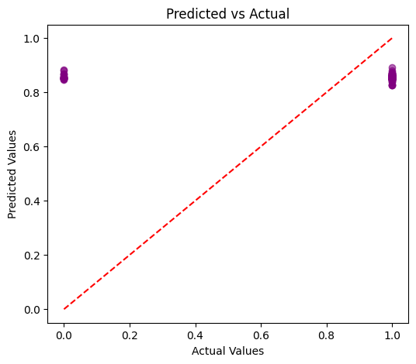

Summary
For this issue, the linear regression model is neither appropriate nor valid. The model's failure to predict the outcome is confirmed by the R squared value of -0.0071, which shows that the selected predictors (ApplicantIncome, LoanAmount, etc.) have no significant linear relationship with Credit_History.

- Python Implementation

import pandas as pd
import numpy as np
import matplotlib.pyplot as plt
import seaborn as sns
from scipy import stats
from sklearn.model_selection import train_test_split
from sklearn.linear_model import LinearRegression
from sklearn.metrics import mean_squared_error, r2_score
import math
import warnings
warnings.filterwarnings('ignore')

DATA_PATH = "train.csv"
df = pd.read_csv(DATA_PATH)

print("Data Loaded Successfully!")
print("Shape of Dataset:", df.shape)
df.head()

print("\n--- DATA CLEANING ---")

print("\nMissing Values in Each Column:\n")
print(df.isnull().sum())

numeric_cols = df.select_dtypes(include=[np.number]).columns.tolist()
cat_cols = df.select_dtypes(exclude=[np.number]).columns.tolist()

print("\nNumeric Columns:", numeric_cols)
print("Categorical Columns:", cat_cols)

for col in numeric_cols:
if df[col].isnull().sum() > 0:
df[col].fillna(df[col].median(), inplace=True)

for col in cat_cols:
if df[col].isnull().sum() > 0:
df[col].fillna(df[col].mode()[0], inplace=True)

print("\n Missing Values Handled.")
print(df.isnull().sum())

print("\n--- DESCRIPTIVE STATISTICS ---")
desc = df[numeric_cols].describe().T
desc['mode'] = df[numeric_cols].mode().iloc[0]
desc.rename(columns={'50%': 'median'}, inplace=True)
print(desc[['mean', 'median', 'mode', 'std', 'min', 'max']])

print("\nInterpretation:")
for col in numeric_cols:
print(f"- {col}: Mean={df[col].mean():.2f}, Median={df[col].median():.2f}, Std={df[col].std():.2f}")

print("\n--- VISUALIZATION ---")

# Histograms
for col in numeric_cols:
plt.figure(figsize=(6, 3))
plt.hist(df[col], bins=30, color='skyblue', edgecolor='black')
plt.title(f"Histogram of {col}")
plt.xlabel(col)
plt.ylabel("Frequency")
plt.show()

# Boxplots
for col in numeric_cols:
plt.figure(figsize=(6, 2.5))
sns.boxplot(x=df[col], color='orange')
plt.title(f"Boxplot of {col}")
plt.show()

# Correlation heatmap
plt.figure(figsize=(8, 6))
sns.heatmap(df[numeric_cols].corr(), annot=True, cmap='coolwarm')
plt.title("Correlation Heatmap")
plt.show()

#scatterplot
if len(numeric_cols) >= 2:
plt.figure(figsize=(6, 4))
plt.scatter(df[numeric_cols[0]], df[numeric_cols[1]], alpha=0.6, color='green')
plt.xlabel(numeric_cols[0])
plt.ylabel(numeric_cols[1])
plt.title(f"Scatter Plot: {numeric_cols[0]} vs {numeric_cols[1]}")
plt.show()

print("\n--- NORMALITY CHECK (Q-Q Plot) ---")

selected_col = numeric_cols[0]
plt.figure(figsize=(5, 5))
stats.probplot(df[selected_col], dist="norm", plot=plt)
plt.title(f"Q–Q Plot for {selected_col}")
plt.show()

print("\n--- CONFIDENCE INTERVAL & HYPOTHESIS TEST ---")

feature = numeric_cols[0]
alpha = 0.05
specified_value = 1000

data = df[feature].dropna()
n = len(data)
mean = data.mean()
std = data.std(ddof=1)
se = std / math.sqrt(n)
t_crit = stats.t.ppf(1 - alpha/2, df=n-1)

ci_lower = mean - t_crit * se
ci_upper = mean + t_crit * se

print(f"\nFeature Selected: {feature}")
print(f"Sample Size: {n}")
print(f"Mean: {mean:.4f}, Std Dev: {std:.4f}")
print(f"95% Confidence Interval: ({ci_lower:.4f}, {ci_upper:.4f})")

t_stat, p_val = stats.ttest_1samp(data, popmean=specified_value)
print(f"\nHypothesis Test for mean({feature}) = {specified_value}")
print(f"t-statistic = {t_stat:.4f}, p-value = {p_val:.6f}")

if p_val < alpha:
print("Reject Null Hypothesis: Mean differs significantly from the specified value.")
else:
print("Fail to Reject Null Hypothesis: No significant difference from the specified value.")

print("\n--- SIMPLE LINEAR REGRESSION ---")

target_col = numeric_cols[-1]
predictors = numeric_cols[:-1]

X = df[predictors]
y = df[target_col]

# Split data
X_train, X_test, y_train, y_test = train_test_split(X, y, test_size=0.2, random_state=42)

# Fit model
model = LinearRegression()
model.fit(X_train, y_train)

# Predictions
y_pred = model.predict(X_test)

# Evaluate model
mse = mean_squared_error(y_test, y_pred)
rmse = math.sqrt(mse)
r2 = r2_score(y_test, y_pred)

print(f"Target Variable: {target_col}")
print(f"Predictor Variables: {predictors}")
print(f"Coefficients: {model.coef_}")
print(f"Intercept: {model.intercept_:.4f}")
print(f"\nModel Performance:")
print(f"MSE = {mse:.4f}")
print(f"RMSE = {rmse:.4f}")
print(f"R² = {r2:.4f}")

# Plot predicted vs actual
plt.figure(figsize=(6, 5))
plt.scatter(y_test, y_pred, alpha=0.6, color='purple')
plt.plot([y_test.min(), y_test.max()], [y_test.min(), y_test.max()], 'r--')
plt.xlabel("Actual Values")
plt.ylabel("Predicted Values")
plt.title("Predicted vs Actual")
plt.show()

