COMPUTER NETWORKS - UE24CS252B
Lab 2: Understanding Persistent and Non-persistent HTTP Connections

SRN: PES1UG24CS493
NAME: Tanmayi Nagabhairava
SEC: I

HTTP Connection

Output:

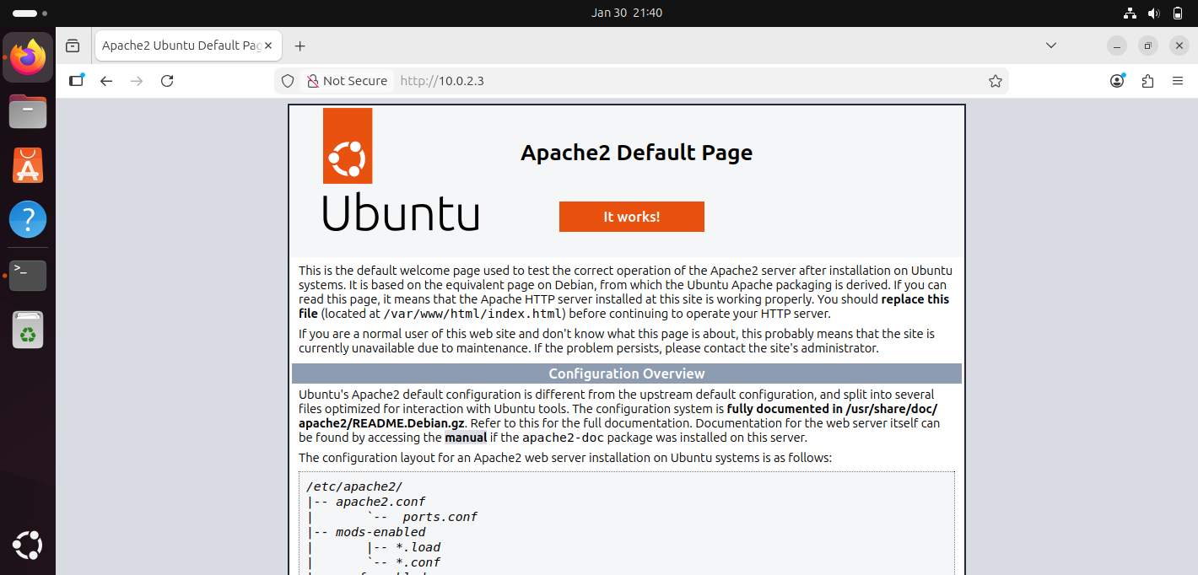



Non Persistent Connections

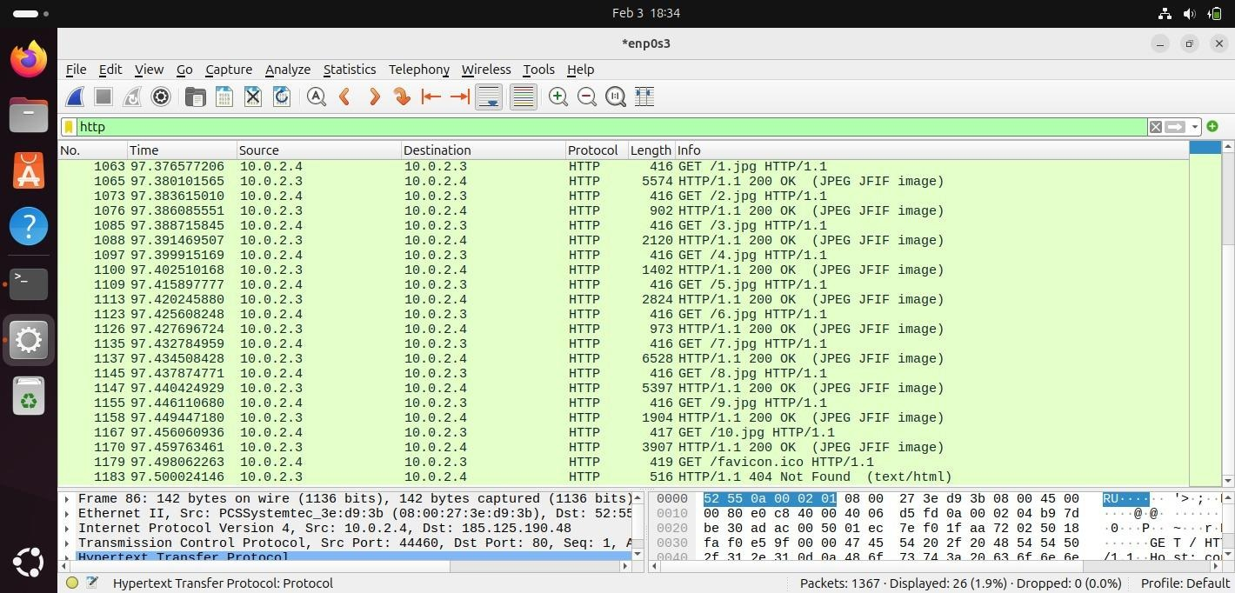
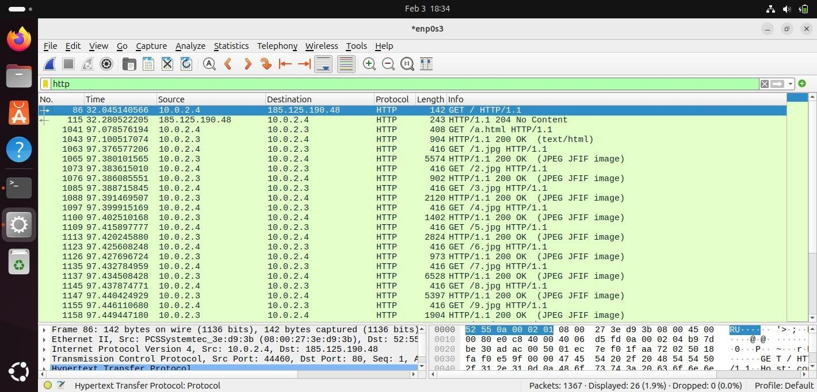

Start Time: 97.078576
End Time: 97.500024
Load Time: 97.500024 - 97.078576 = 0.421448 seconds

Persistent Connections

Case A: 2 Persistent Connections

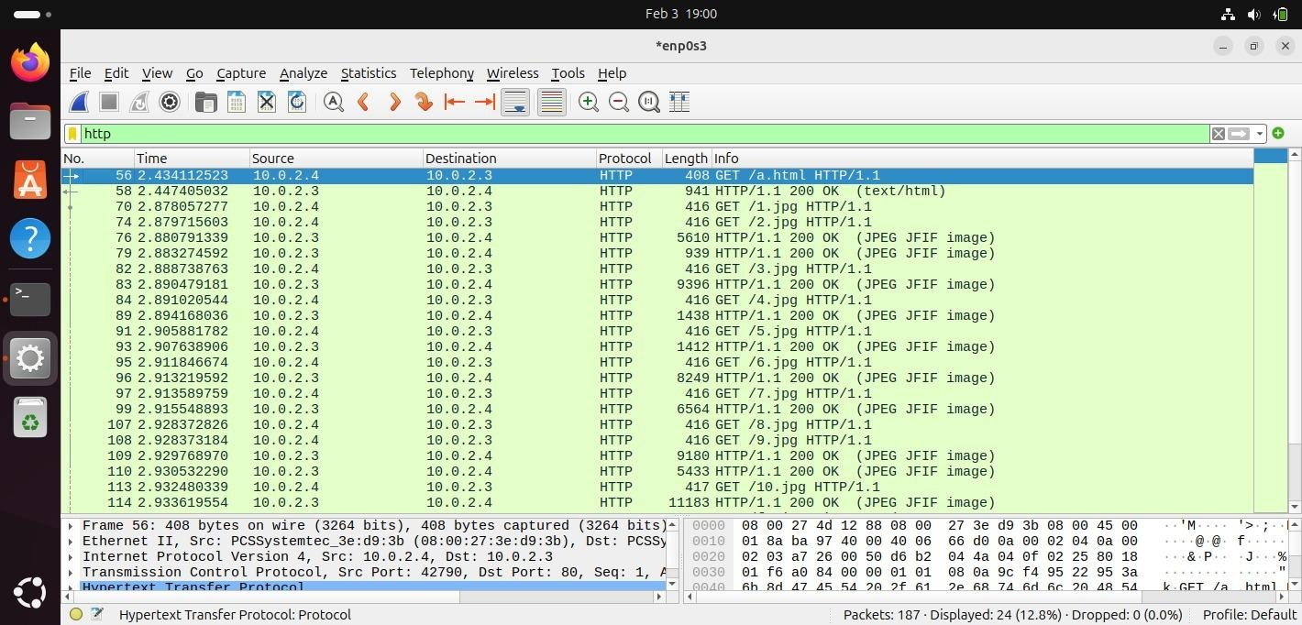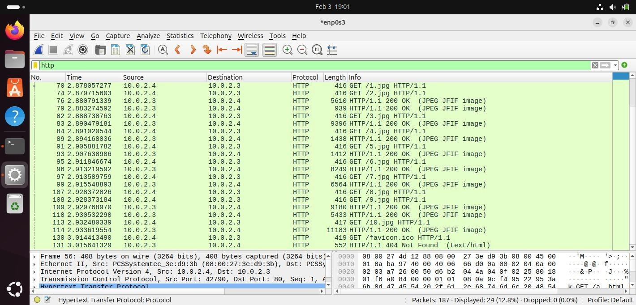
Start Time: 2.434112
End Time: 3.015641
Load Time: 3.015641 - 2.434112 = 0.581529 seconds

Case B: 4 Persistent Connections
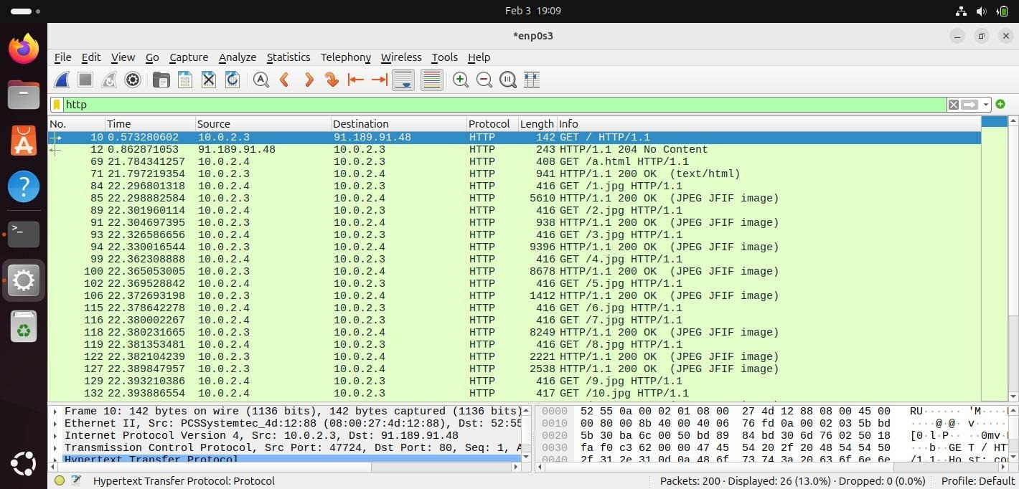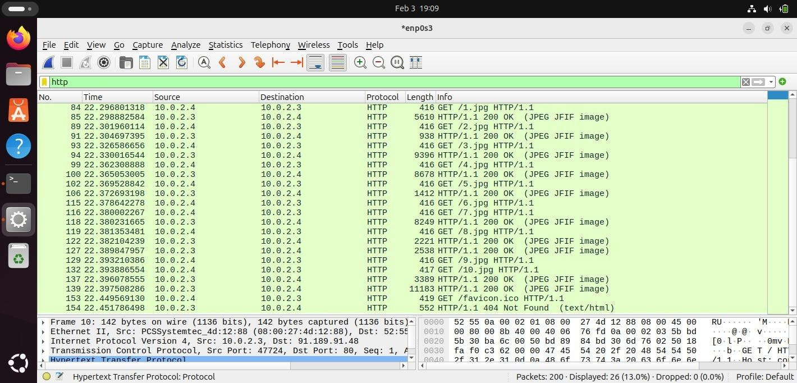
Start Time: 21.784341
End Time: 22.451786
Load Time: 22.451786 - 21.784341 = 0.667445 seconds

Case C: 6 Persistent Connections
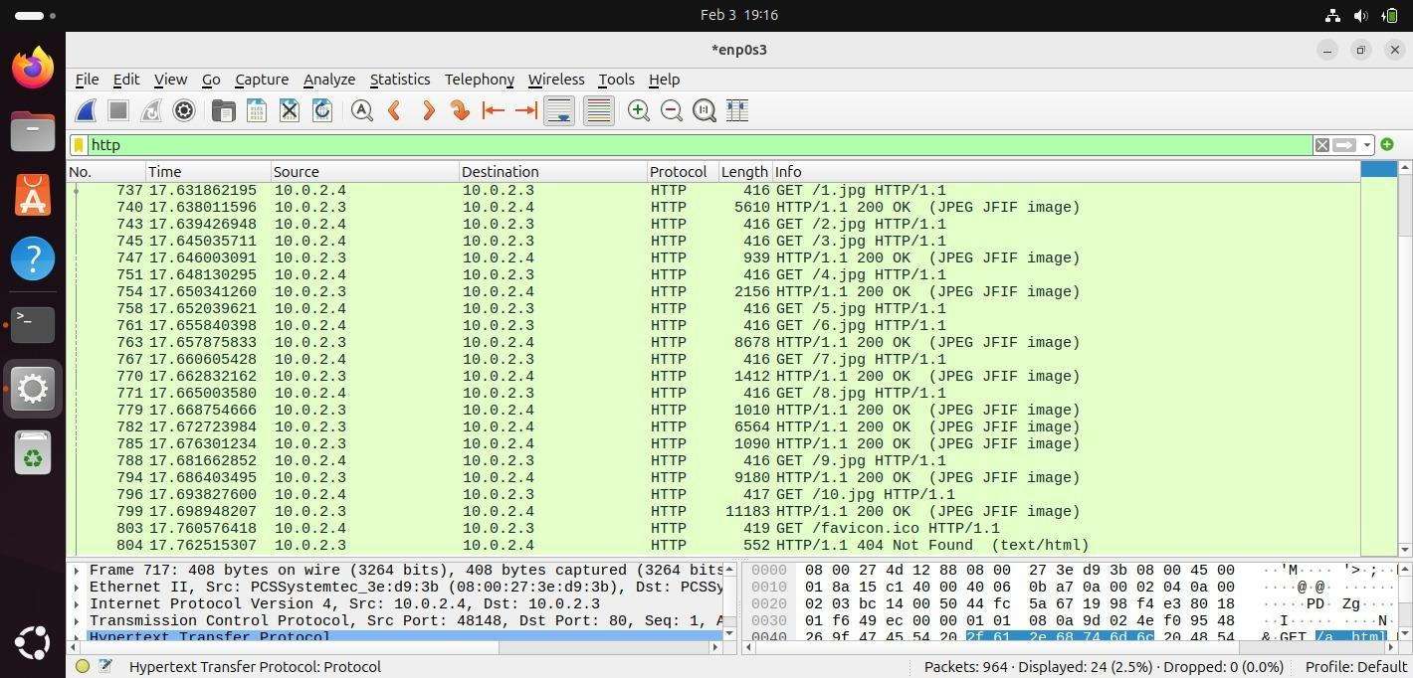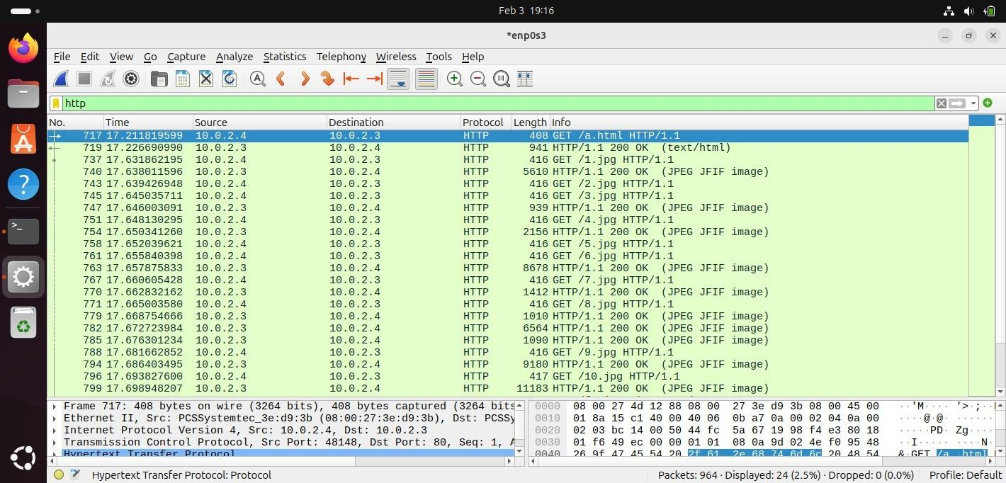
Start Time: 17.211819
End Time: 17.762515
Load Time: 17.762515 - 17.211819 = 0.550696 seconds

Case D: 8 Persistent Connections
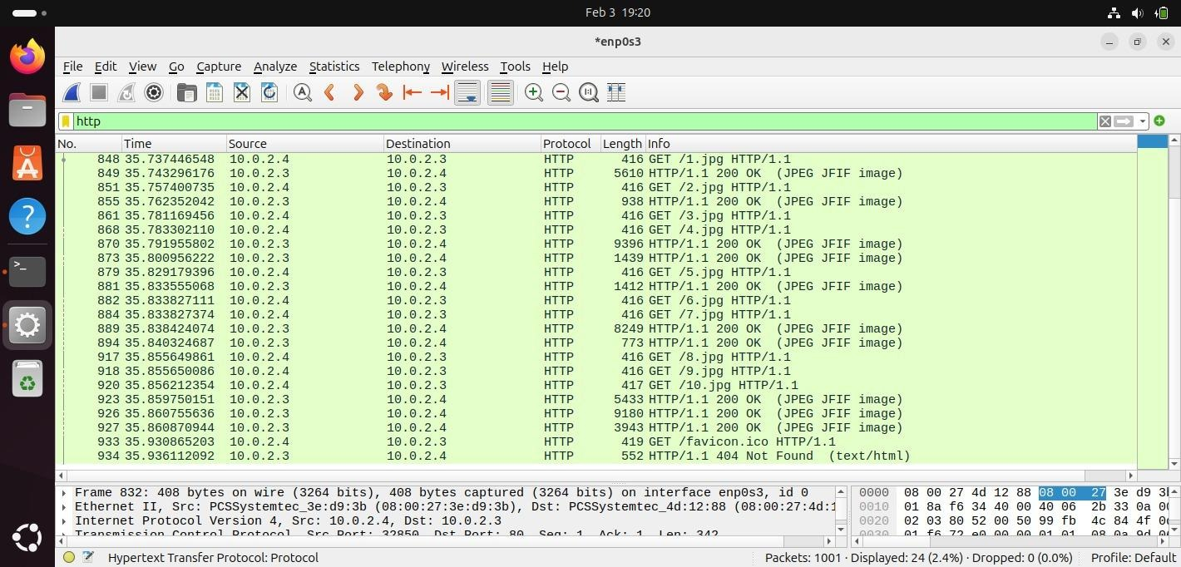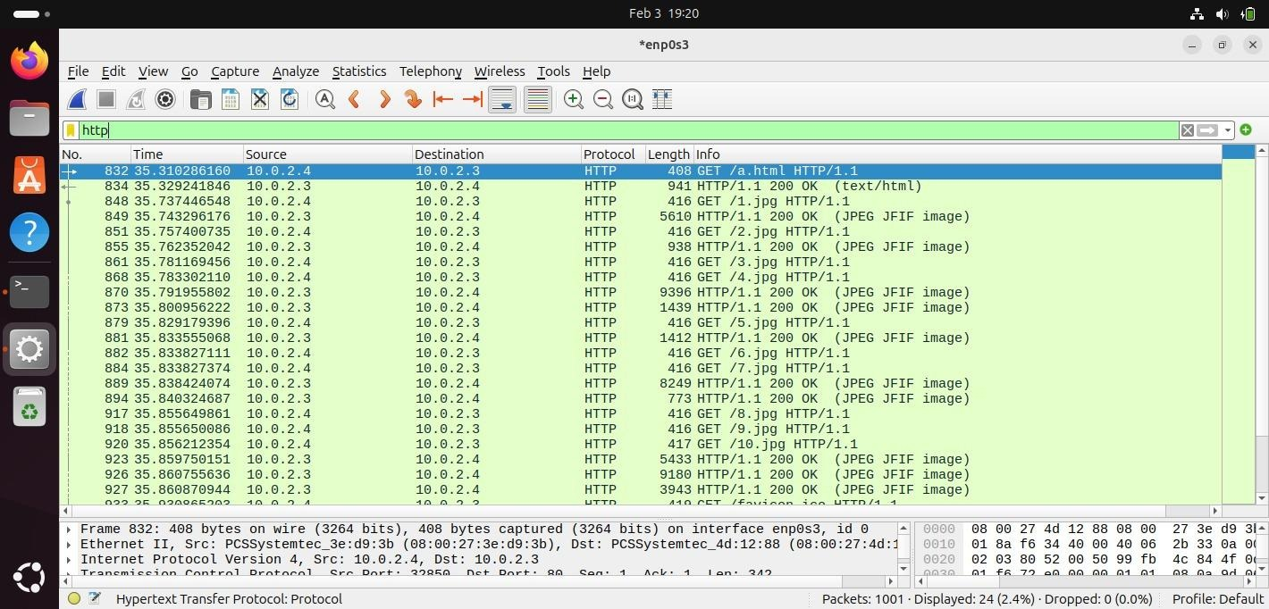
Start Time: 35.310286
End Time: 35.936112
Load Time: 35.936112 - 35.310286 = 0.625826 seconds

Case E: 10 Persistent Connections
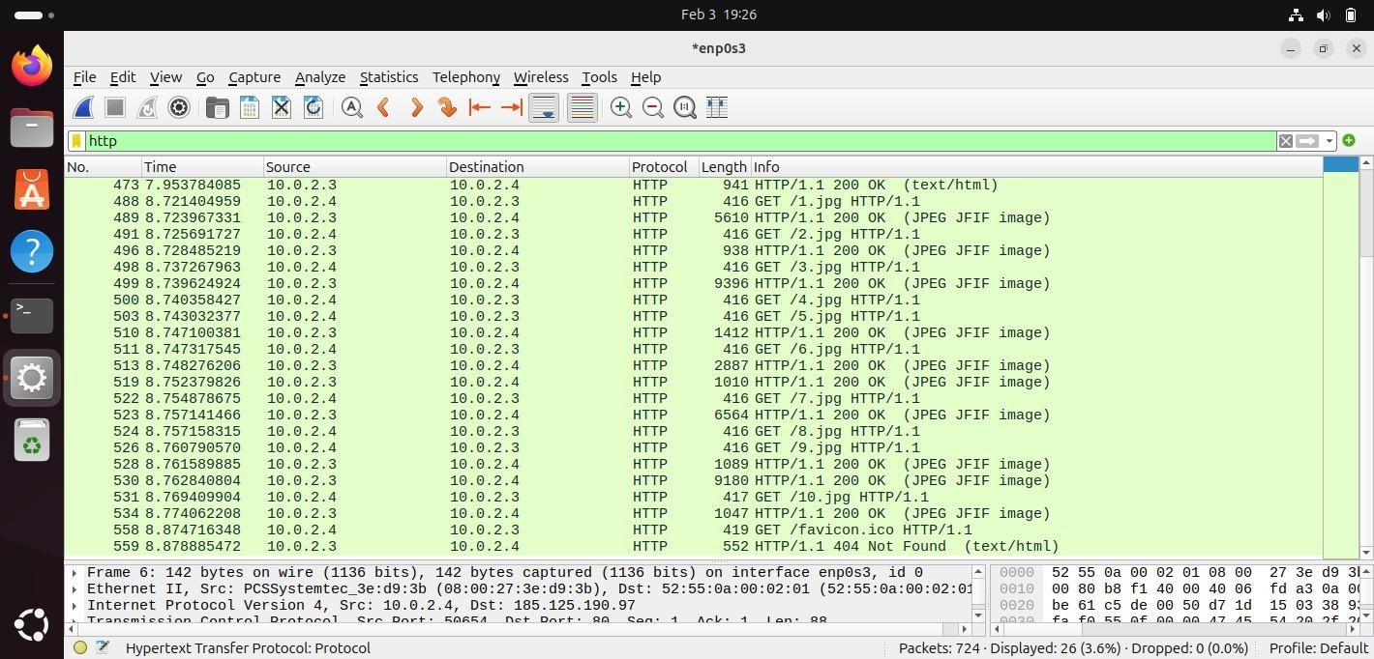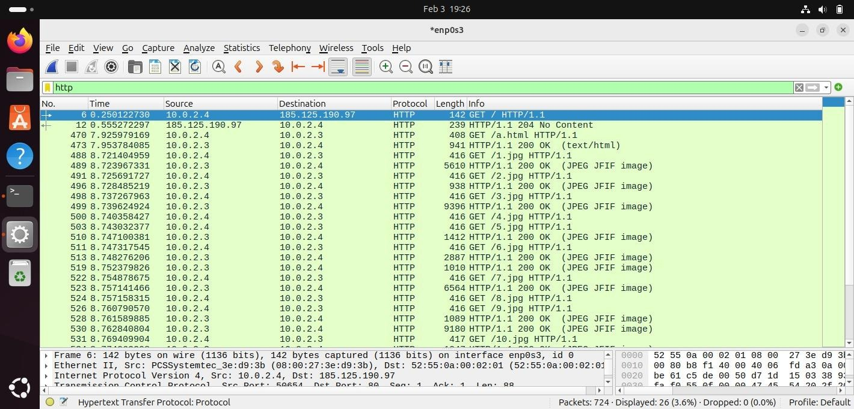
Start Time: 7.925979
End Time: 8.878885
Load Time: 8.878885 - 7.925979 = 0.952906 seconds

Graph:

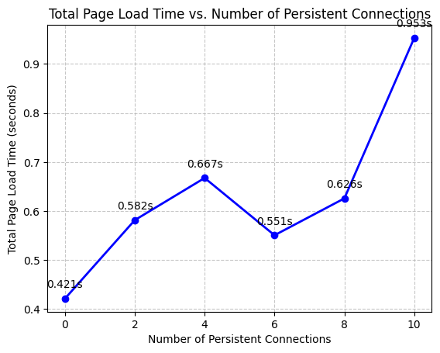

Conclusion
HTTP connection persistence significantly affects page load time and network efficiency. In non-persistent HTTP, a new TCP connection is created for every object, leading to repeated handshakes, higher protocol overhead, and inefficient use of network resources. Persistent HTTP reduces this overhead by reusing existing TCP connections for multiple requests, which lowers latency and improves bandwidth utilization. This generally results in faster page loading and better efficiency. However, allowing too many simultaneous persistent connections can introduce processing overhead and network congestion, especially on limited systems, which may reduce performance gains.
Therefore, HTTP persistence improves page load time and efficiency up to an optimal number of connections, beyond which the benefits may diminish.

